Appendix
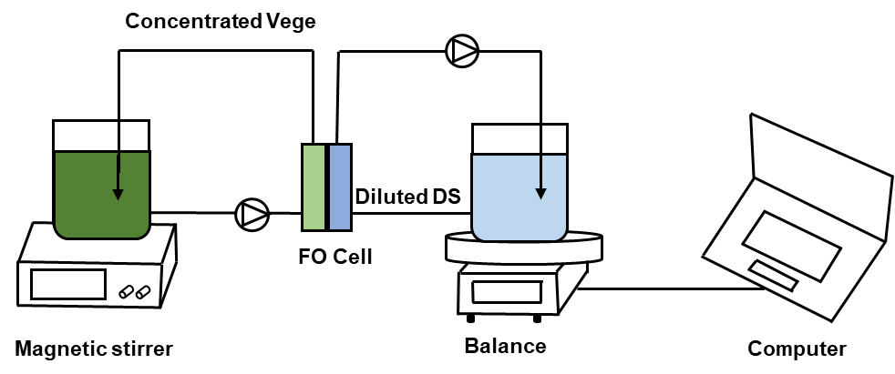
Figure S1. Schematic diagram of forward osmosis bench-scale system

Table S1. Analysis of raw vegetable liquor before and after preparation
 | Zeta potential (mv) | Turbidity (NTU) | Conductivity (mS/cm)
Before | -4.98 | 283.0 | 14.50
After | -4.19 | 18.1 | 14.43

Table S2. Vegetable composition
Component | Values
pH | 6~7
Conductivity | 13~15 (mS/cm）
COD_{Cr} | 1500~2000 (mg/L)
Water | 94.5 (g/100g)
Protein | 1.3 (g/100g)
Fat | 0.3 (g/100g)
Carbohydrate | 2.3 (g/100g)
Crude fiber | 0.6 (g/100g)
Phytochrome | 1.49 (g/100g)
Nicotinic acid | 0.006 (g/100g)
Calcium | 0.056 (g/100g)
Phosphorus | 0.032 (g/100g)
Iron | 0.012 (g/100g)
Potassium | 0.346 (g/100g)
Sodium | 0.066 (g/100g)
Magnesium | 0.0234 (g/100g)
chloride | 0.120 (g/100g)

