Supplementary material
Figure S1. Elevation and spatial distribution of Great Skua nests in the Bergið colony, southeastern Skúvoy. Nests where an adult was caught are indicated by a number (i.e. the tail feather elongation in mm, males: blue, females: red), nests where no adult was caught by a black circle.
Figure S2. Growth curve of Great Skua chicks on Skúvoy in 2013. In total 73 chicks with known age are included, measured in total 129 times. Therefore, this growth curve is mainly based on cross-sectional data. Body mass was modelled over age, using a vertically shifted Gompertz function (see Materials and Methods).

Figure S3. Chick body condition (body mass / predicted body mass based on age) plotted over age does not show a systematic bias in our body condition measure. For small chicks however, body condition had a larger range than in older chicks. This may be the result of a relatively larger effect of crop filling and possible measurement errors, but also of selective disappearance of chicks in bad condition (e.g. the starving outlier at 30% of its predicted mass had a dead sibling).
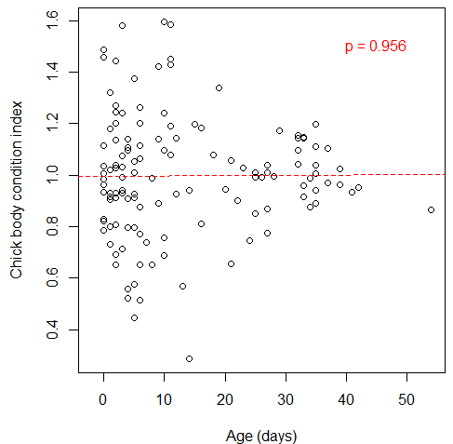

Figure S4. Head length and diet in relation to laying date. (a) Head length of breeding Great Skuas increased with laying date, both in males and females. Red (circles): females, blue (triangles): males. (b) The proportion of bird-based food in a pair’s diet decreased with laying date. Circle surface corresponds to sample size of prey remains.
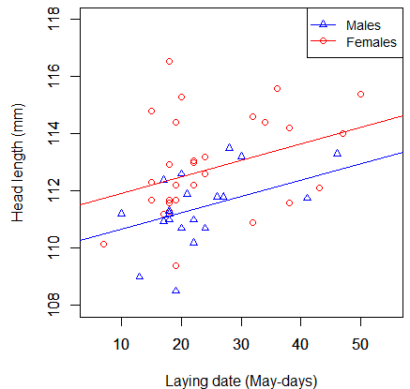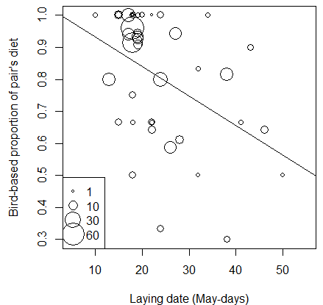

Figure S5. Chick body condition (body mass / predicted body mass based on age) in relation to the volume of the egg from which the chick hatched. A positive relation was found, depicted by the line.
