Supplementary Table S1:



Supplementary Figure S1

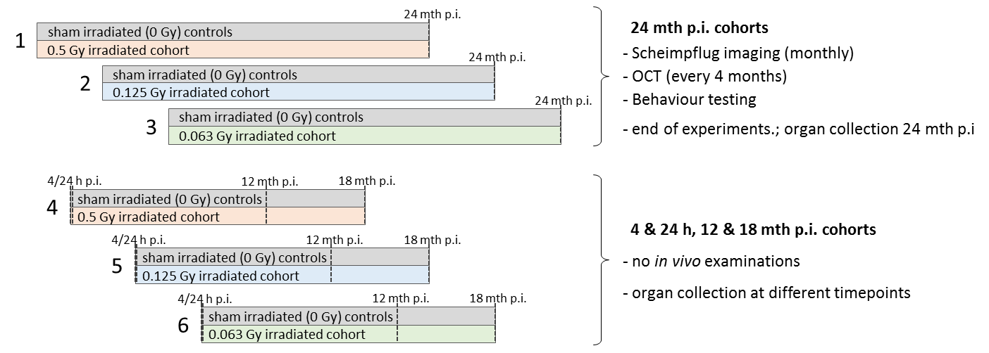

Figure S1: **Irradiation cohorts**

Mice were bred and irradiated in 6 independent groups (1-6) within a period of 15 months. All irradiation groups include the same numbers of male and female as well as wild types and *Ercc2+/-* mutants. For the 24 mth p.i. cohorts (1, 2, 3) 76 mice were irradiated with the same dose (0, 0.063, 0.125, 0.5 Gy) and doserate (0.063 Gy/min). The 76 sham irradiated (0 Gy) mice were split between the irradiation groups to be observed within the same time frame. Long-term cohorts received regular examinations by Scheimpflug imaging for lens clouding, OCT (optical coherence tomography) for retinal degeneration and behaviour testing (presented in another publication, Ung et al.) until 24 months post irradiation (p.i.). For the 4 & 24 h, 12 & 18 mth p.i. cohorts (4, 5, 6) 64 mice were exposed to the same dose (0, 0.063, 0.125, 0.5 Gy); the number of sham irradiated mice was split between the groups. At different timepoints (4 and 24 hours, 12 and 18 months p.i.; represented by dotted lines) 16 mice (4 male wt, 4 female wt, 4 male *Ercc2+/-*, 4 female *Ercc2+/-*) from each dose group were killed and eyes were taken for further analyses.