Appendix

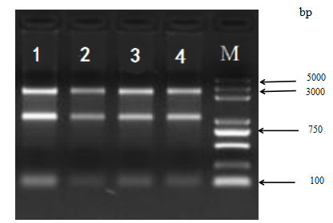
Fig 1 Results of total RNA electrophoresis in four samples
Note: 1,2,3, and 4, respectively represent the M2_72H, M2_24H, M1_24H, and the control groups; 0.5 µl of sample 4 and the control were loaded 0.5 µl, samples 1 and 2 were diluted 5 and 3 times, respectively, after which 1 µl was loaded.
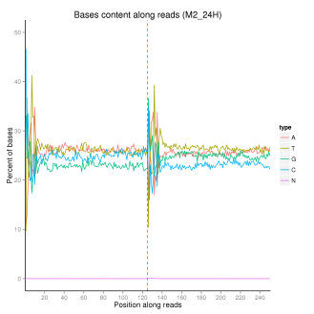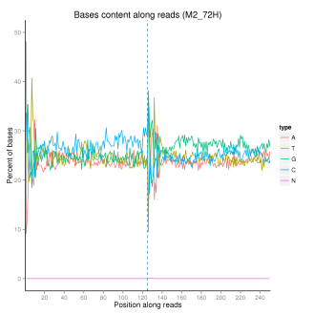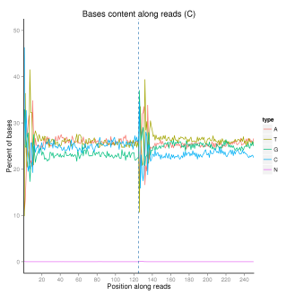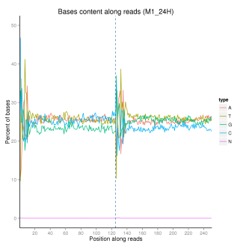
Fig 2 Sample GC content distribution
Note: the abscissa base location along reads,ordinate for percent of bases; Different color represents different base types.

M A B C
Fig 8 RNA extraction electrophoregram
Note: M is Marker2000;A is skin fibroblasts ; B is 0.2 g/L (MT);C is the blank cells

Fig 9 Electrophoregram QPCR products
Note: the sample order: ACTB, Marker2000, IL - 6, TNF-α, NOD2, RIPK2, TNFAIP3, PYCARD, NFKBIA and MAP3K8

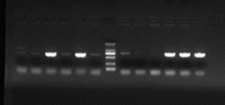
Fig 11 PCR identification of recombinant vector colonies
Note: Lanes 1-6: IL-6 primer pair recombinant PCR amplification; Lane 7: Marker DL2000 (2000, 1000, 750, 500, 250, 100 bp from top to bottom); Lanes 8-13: TNF-α primer pair recombinant PCR amplification

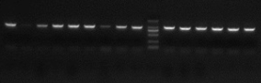
Fig 12 PCR identification of recombinant vector colonies of IL-6-1#, IL-6-2#, IL-6-3#, TNF-α-1#, TNF-α-2#, and TNF-α-3#
Note: Lanes 1-9 were identified by PCR for IL-6-1#, IL-6-2#, and IL-6-3# recombinant vector colonies; Lane 10 was Marker DL2000 (2000 to 1000 from top to bottom, respectively (750, 500, 250, and 100 bp); Lanes 11-16 were TNF-α-1#, TNF-α-2#, and TNF-α-3# recombinant vector colonies

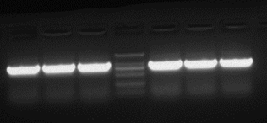
Fig 13 PCR identification of IL-6-1#, IL-6-2#, IL-6-3#, TNF-α-1#, TNF-α-2#, and TNF-α-3# recombinant vector colonies
Note: Lanes 1-3 are PCR amplifications of the target fragments of three interfering targets of IL-6; Lane 4 is Marker DL2000 (2000, 1000, 750, 500, 250, and 100 bp from top to bottom); Lanes 5-7 are TNF-α PCR amplification of fragments of interest that interfere with the target

Tab 6 Total RNA concentration and 28S: 18S value and RIN value
Location Sample OD260/OD280 28S/18S RIN Total RNA concentration（ng/uL)
A M2_72H 2.000 2.1 9.6 885
B M2_24H 2.000 2.4 8.9 352
C M1_24H 1.955 2.5 9.3 344
D Control(c) 1.964 3.2 8.6 326

Tab 7 Sequencing error rate
Sample name | Error rate(%)
C_1 | 0.03
C_2 | 0.04
M1_24H_1 | 0.03
M1_24H_2 | 0.04
M2_24H_1 | 0.03
M2_24H_2 | 0.03
M2_72H_1 | 0.03
M2_72H_2 | 0.04

