Table S1: New GenBank accessions for epi-endophyte sequences, including whole organellar genome data in Alaria and the phaeophycean parasite. s.l.=sensu lato, s.s.=sensu stricto; M=mitochondrial, P=plastid. Annotations for plastid contigs of TTB000062 can be accessed via https://doi.org/10.6084/m9.figshare.13140464.

Species | Specimen ID | Date collected | Lat. | Long. | Organellar  genome (M/P) | cox1 | rbcL
Alaria esculenta s.l. (crispa type) | A8 | 21-Aug-2018 | 52.913 | 158.637 | MT767059/  MT767060
Alaria esculenta s.s. | AT001 | 06-Jun-2019 | 45.044 | -66.809 | MT767061/  MT767062
Alaria esculenta s.s. | TTB000192 | 06-Jun-2019 | 45.044 | -66.809 | NA
Alaria esculenta s.s. | TTB000062 | 23-Aug-2019 | 64.079 | -51.467 | Short-read files: SAMN16729885
Alaria esculenta s.s. | TTB000067 | 23-Aug-2019 | 64.079 | -51.467 | NA
Alaria esculenta s.s. | TTB000079 | 23-Aug-2019 | 64.079 | -51.467 | NA
Acrochaetium alariae | A8_1 | 21-Aug-2018 | 52.913 | 158.637 |  | MT766282 | MT766297
Coilodesme japonica | A8_2 | 21-Aug-2018 | 52.913 | 158.637 |  | MT766283 | MT766298
Laminariocolax aecidioides | A8_3 | 21-Aug-2018 | 52.913 | 158.637 |  | MT766284 | MT766299
Microspongium globosum | A8_4 | 21-Aug-2018 | 52.913 | 158.637 |  | MT766285 | MT766300
Hecatonema maculans | AT001_1 | 06-Jun-2019 | 45.044 | -66.809 |  | MT766286 | MT766301
Phaestroma pustulosum | AT001_2 | 06-Jun-2019 | 45.044 | -66.809 |  | MT766287 | MT766302
Thallasiosira sp. | AT001_3 | 06-Jun-2019 | 45.044 | -66.809 |  |  | MT766303
Hecatonema maculans | TTB000192_1 | 06-Jun-2019 | 45.044 | -66.809 |  | MT766295 | MT766306
Phaeostroma pustulosum | TTB000192_2 | 06-Jun-2019 | 45.044 | -66.809 |  | MT766296 | MT766307
Putative phaeophycean parasite | TTB000062_1 | 23-Aug-2019 | 64.079 | -51.467 | MT747832/  MW266086-97 | MT766288
Phaestroma pustulosum | TTB000062_2 | 23-Aug-2019 | 64.079 | -51.467 |  | MT766289 | MT766304
Phaeostroma sp. | TTB000062_3 | 23-Aug-2019 | 64.079 | -51.467 |  | MT766290
Protectocarpus sp. | TTB000062_4 | 23-Aug-2019 | 64.079 | -51.467 |  | MT766291 | MT766305
Obelia longissima | TTB000062_5 | 23-Aug-2019 | 64.079 | -51.467 |  | MT766292
Obelia longissima | TTB000067_1 | 23-Aug-2019 | 64.079 | -51.467 |  | MT766293
Obelia longissima | TTB000079_1 | 23-Aug-2019 | 64.079 | -51.467 |  | MT766294
Coilodesme californica | GWS036767 | 15-May-2014 | 48.454 | -122.963 |  | MT806364 | MT806365
Microspongium globosum | GWS004596 | 28-Jun-2006 | 48.786 | -125.119 |  | MT520140 | MT520141

Table S2: GenBank accession information for sequences used in phylogenetic analyses. Molecular data from multiple strains of Nemoderma were combined on the basis of being a monotypic genus. Data for Chorda asiatica also included nad2 (LC148200) and nad5 (LC148258).

Species (strain ID for amplicon data) | Mitochondria | Plastid | atp9 | cox1 | cox3 | nad1 | nad4
Fragilariales (Bacillariophyceae)
Nanofrustulum shiloi |  | MN276191
Vaucheriales (Xanthophyceae)
Vaucheria litorea |  | EU912438
Ishigeales
Ishige okamurae | MG940857
Onslowiales
Verosphacela sylvae (GR11-s#8-3) |  |  |  | LM995421
Dictyotales
Dictyopteris divaricata | MG940856 | NC 036804
Dictyota dichotoma | AY500368
Syringodermatales
Syringoderma phinneyi (FRA0140) |  |  |  | EU681429 |  | EU681512 | EU681543
Cladostephus spongiosus (FRA0511) |  |  |  | EU681396 |  |  | EU681520
Sphacelariales
Sphacelaria sp. | SAMN10026787 | SAMN10026787
Nemoderma tingitanum (atp9, nad1, nad4: FRA0530; cox1: KU-d13284) |  |  | EU681567.1 | LC065621 |  | EU681496 | EU681530
Fucales
Fucus distichus | KY678904 | MG922855
Coccophora langsdorfii | KU255794
Sargassum muticum | KJ938301
Sargassum horneri |  | MN265366
Turbinaria ornata | KM501562
Tilopteridales
Saccorhiza dermatodea (FRA0144) |  |  | EU681576 | EU681421 |  | EU681506 | EU681538
Sporochnales
Carpomitra costata (TJS0096) |  |  |  |  | EU681437 | EU681478
Perithalia caudata (TJS0095) |  |  |  |  |  | EU681500
Bellotia eriophorum (TJS0128) |  |  | GQ368298 | GQ368255 | GQ368270 | GQ368284
Sporochnus pedunculatus (FRA0494) |  |  | EU681583 | EU681428 | EU681466 | EU681511 | EU681542
Stschapoviales
Halosiphon tomentosus (KU-1171) |  |  |  | AB776652 | AB543505
Ralfsiales
Analipus japonicus (TJS0188) | SAMN10026788 | SAMN10026788 | EU681545 | EU681389 | EU681432 | EU681472 | EU681516
Scytothamnales
Splachnidium sp. (KU-1176) |  |  |  | AB776661 | AB776719
Splachnidium rugosum (FRA0086) |  |  | EU681582 | EU681427 | EU681465
Scytothamnus fasciculatus (KU-713) |  |  |  | AB776660 | AB776718
Stereocladon rugulosus (STEREO4) |  |  |  | JF796547 | JF796560
Scytothamnus australis (FRA0085) |  |  | EU681580 | EU681425 |  |  | EU681541
Desmarestiales
Desmarestia viridis | AY500367
Desmarestia aculeata |  | SAMN10026789
Ascoseirales
Ascoseira mirabilis (FRA0145) |  |  |  | EU681391 |  | EU681474 | EU681547
Ectocarpales
Cladosiphon okamuranus | MG488292 | NC 046005
Pylaiella littoralis | AJ277126
Colpomenia peregrina | KM244739
Scytosiphon lomentaria | KJ995702
Scytosiphon canaliculatus |  | NC 044758
Endarachne binghamiae | MF374731
Petalonia fascia | KJ957769
Pleurocladia lacustris | KU164873 | NC 032045
Ectocarpus siliculosus | NC_030223 | NC 013498
Laminariales
Alaria marginata |  | SAMN09506685
Arthrothamnus bifidus |  | SAMN09516535
Pterygophora californica |  | SAMN09506688
Postelsia palmaeformis |  | SAMN09516532
Undaria pinnatifida | KF319031
Saccharina japonica | AP011493
Egregia menziesii |  | SAMN09516496
Ecklonia radicosa |  | SAMN09516498
Hedophyllum subsesille |  | SAMN09516536
Macrocystis integrifolia | MH411105
Macrocystis pyrifera |  | SAMN09516533
Nereocystis luetkeana | MH392199
Lessonia spicata | MK965907 | SAMN09516495
Lessoniopsis littoralis |  | SAMN09506687
Laminaria digitata | AJ344328
Laminaria solidungula |  | NC 044690
Costaria costata | KF384641 | SAMN09516490

Chordales
Akkesiphycus lubricus |  | SAMN09506682
Chorda asiatica (KU-503) |  | SAMN09506684 |  | AB775224 | AB775241 |  | LC148230
Pseudochorda nagaii |  | SAMN09506683
Asterocladales
Asterocladon rhodochortonoides (SAP089220) |  |  |  |  | AB302287

Table S3. Epi-endophytes detected in specimens of Alaria.
Epi-endophyte ID (Phylum: species) | Marker: length (mean read-depth) | Host species, loation(s) | Notes
Bacillariophyta: Thalassiosira sp. | rbcL: 1445 bp (13) | A. esculenta s.s., Bay of Fundy, Canada | The contig was a close match to the diatoms Thalassiosira aestivalis Gran 1931 and T. pacifica Gran & Angst 1931 (99.75%).
Cnidaria: Obelia longissima Pallas | cox1: 648 bp (7.2-69.6) | A. esculenta s.s., Nuuk, Greenland | Detected in all three specimens from Greenland, the contigs were a 99.38% match to O. longissima.
Ochrophyta: Coilodesme japonica Yamada | rbcL: 721 bp (8.1);  cox1: 591 bp (7.8) | A. esculenta s.l. (type crispa), Kamchatka, Russia | The rbcL contig is a 100% match to C. japonica, and a second close match to C. californica (Ruprecht) Kjellman, while the cox1 was a close match to C. californica (Ruprecht) Kjellman (98.97%; Fig. 2).
Ochrophyta: Hecatonema maculans (Collins) Sauvageau | rbcL: 1315-1357 bp (13.9-14.4);  cox1: 629-642 bp (7.1-14.7) | A. esculenta s.s., Bay of Fundy | Present in both Bay of Fundy specimens, the cox1 contig was a 100% match to H. maculans. Though rbcL data are not available for H. maculans, rbcL contigs were a 99.85% match to an unknown species of Hecatonema (Fig. 2).
Ochrophyta: Laminariocolax aecidioides Rosenvinge (A.F. Peters) | rbcL: 617 bp (3.4);  cox1: 608 bp (13) | A. esculenta s.l. (type crispa), Kamchatka, Russia | The cox1 contig was a 100% match to L. aecidioides (Chodariaceae). Scant read depth failed to resolve the 3’ end of rbcL, but the few reads available indicated closer affinity to a genetic group sampled in Hokkaido, Japan, which also likely represents L. aecidioides (Fig. 2).
Ochrophyta: Microspongium globosum Reinke | rbcL: 701 bp (5.1);  cox1: 630 bp (9.6) | A. esculenta s.l. (type crispa), Kamchatka, Russia | The cox1 contig was a close match to M. globosum sampled from British Columbia (99.22%), Canada, while rbcL was a 99.86% match. The cox1 contig was also a close match to Microspongium alariae (P.M.Pedersen) A.F.Peters reported from Nome, Bering Sea, Alaska (97.7%; Bringloe and Saunders 2019; Fig. 2).
Ochrophyta: Phaeophyceae sp. (putative parasite) | cox1: 658 bp (14) | A. esculenta s.s., Nuuk, Greenland | Though the contig appeared to be brown algal, it was not a clear match to anything, even at the ordinal level. Numerous gene rearrangements, duplications, the presence of pseudogenes, overall substitution saturation, and the lack of an accompanying plastome suggests this novel brown algae is parasitic (Fig. 1).
Ochrophyta: Phaeostroma spp. | rbcL: 1410-1497 bp (6.6-10.0);  cox1 (1): 447-656 bp (5.3-12.6)  cox1 (2): 533 bp (12.7) | A. esculenta s.s., Bay of Fundy, Canada; Nuuk, Greenland | Contigs for Phaestroma pustulosum were widely resolved, appearing in both Bay of Fundy specimens and one specimen from Greenland. A second cox1 genetic group was resolved from Greenland, and is a 93.56% match to the first resolved Phaeostroma contig (Fig. 2). Mapping revealed closely related rbcL reads, but we were unable to confidently resolve them into a second Phaestroma rbcL contig.
Ochrophyta: Protectocarpus sp. | rbcL: 1357 bp (14.8); cox1: 664 bp (12.9) | A. esculenta s.s., Nuuk, Greenland | The rbcL contig was a 99.18% match to Protectocarpus speciosus (Børgesen) Kornmann. At least two other North Atlantic species of Protectocarpus are recognized, Protectocarpus faeroeensis (Børgesen) Kornmann and Protectocarpus hecatonemoides Kornmann, of which the contig could represent either. The cox1 contig is assigned here based on phylogenetic placement (Fig. 2).
Rhodophyta: Acrochaetium alariae (Jónsson) Bornet | rbcL: 1353 bp (7.6);  cox1: 593 bp (2.5) | A. esculenta s.l. (type crispa), Kamchatka, Russia | The rbcL contig matched closest to Acrochaetium secundatum (Lyngbye) Nägeli (93.5%; rbcL data were not available for A. alariae). Though read depth was scant for cox1, name assignment was based on this marker (99.5% match to A. alariae). Note A. alariae cox1 data is an 88% match to A. secundatum, mirroring our results with rbcL.

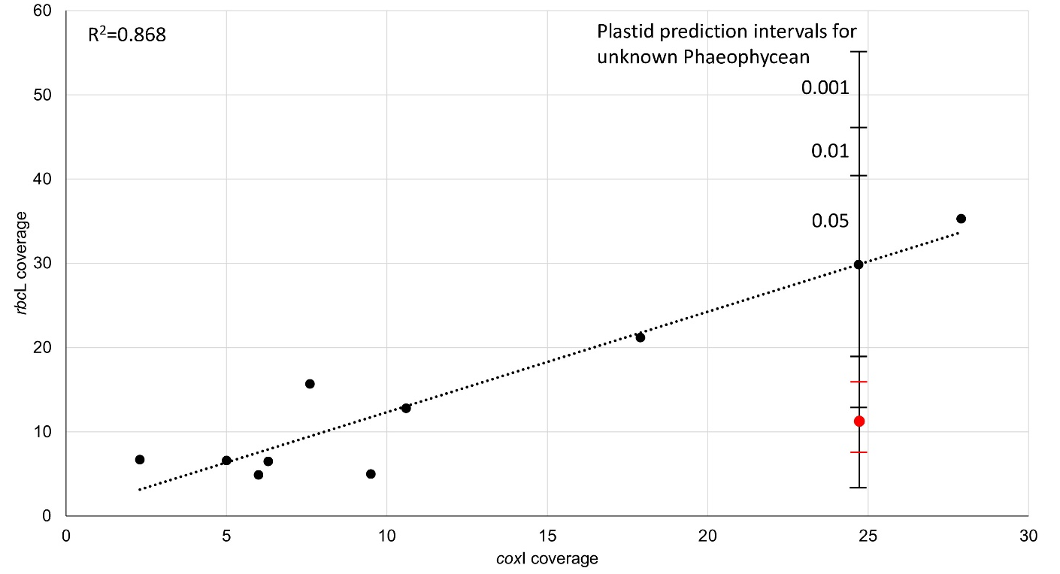
Fig. S1. Regression analysis of coxI and rbcL contig coverage for epi- endophytes detected in shotgun sequencing libraries for Alaria. Also depicted is the predicted rbcL coverage for a novel Phaeophycean coxI contig along with prediction intervals at 95, 99, and 99.9% confidence. The value in red represents the observed value of coverage for recovered plastid scaffolds belonging to the novel Phaeophycean (note, not rbcL), with an interval of 2 standard deviations.

Fig. S2. Maximum-Likelihood tree depicting placement of the phaeophycean parasite. The tree is based on whole mitochondrial genome data (21,721 bp alignment of 32 coding genes, as indicated by †), and otherwise available mitochondrial genes (atp9, cox1, cox3, nad1, nad2, nad4, and nad5). Trimmed from the tree is the root clade Ishige okamurae (Ishigeales; whole mitochondrial genome data) and Verosphacela silvae (Onslowiales; cox1 data). Bootstrap values are depicted at nodes; * indicates full support, - indicates a bootstrap value less than 50. GenBank accessions are available in Table S2.

