Supplementary Content
Table 1S. Comparison of pseudo first order kinetic data the NAP Degradation and TOC Removal rates during UV-TiO₂ and UV-TiO₂ + Membrane processes
PHE Concentration (mg/L) | NAP Degradation |  |  |  | TOC Removal
 | (UV-TiO₂) |  | (UV-TiO₂) + Membrane |  | (UV-TiO₂) |  | (UV-TiO₂) + Membrane
 | K (min⁻¹) | R² | K (min⁻¹) | R² | K (min) ⁻¹ | R² | K (min⁻¹) | R²
5 | 0.008 | 0.9978 | 0.014 | 0.9896 | 0.004 | 0.9559 | 0.0124 | 0.9912
10 | 0.0068 | 0.9993 | 0.0089 | 0.9941 | 0.0035 | 0.9609 | 0.0087 | 0.9954
15 | 0.0059 | 0.9992 | 0.0069 | 0.9894 | 0.0027 | 0.9473 | 0.0071 | 0.9859
20 | 0.0051 | 0.997 | 0.005 | 0.9768 | 0.002 | 0.9241 | 0.0049 | 0.9818
25 | 0.0045 | 0.9979 | 0.0035 | 0.9732 | 0.0015 | 0.9096 | 0.0042 | 0.9472

Figure 1S. Effect of (a) NAP concentrations and (b) pH on NAP removal during membrane separation; [NAP] =5 mg/L, Time = 180 minutes
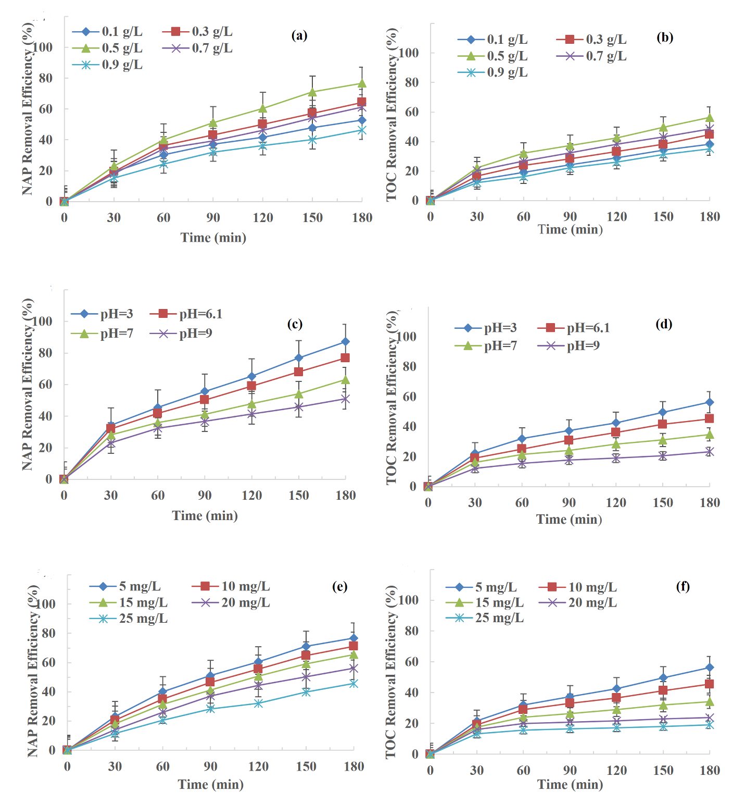
Figure 2S. Effect of TiO₂ dosage, feed solution pH and NAP concentrations on NAP degradation (a), (c) & (e) and TOC removal efficiencies (b), (d) & (f); [NAP] =5 mg/L, [TiO₂] = 0.5 g/L, Time = 180 minutes.

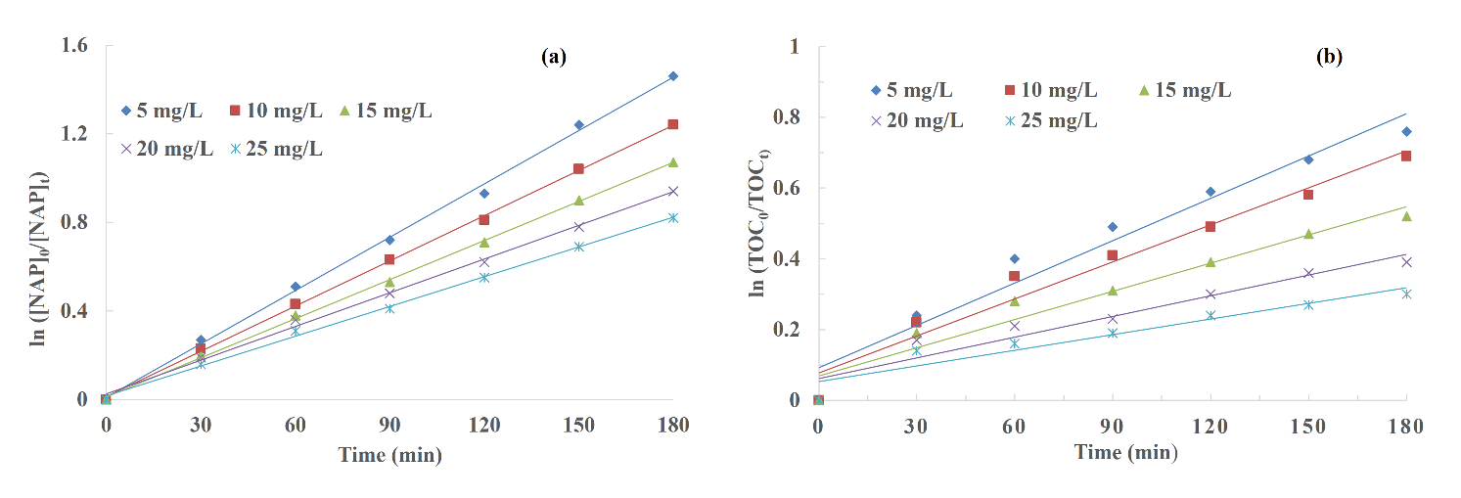
Figure 3S. The pseudo first order kinetic plot of (a) ln ([NAP]₀/[NAP]_{t}) and (b) ([TOC]₀/[TOC]_{t} ) versus time for NAP degradation during UV-TiO₂ process

