Circulating Vitamin D levels and colorectal cancer risk: a meta-analysis and systematic review of case-control and prospective cohort studies
Pablo Hernandez-Alonso^{1,2,3,4,5,⸷}, Hatim Boughanem^{4,⸷}, Silvia Canudas^{1,2,3,6*}, Nerea Becerra-Tomás^{1,2,3,7,8,*}, María Fernández de la Puente^{1,2}, Nancy Babio^{1,2,3}, Manuel Macias-Gonzalez^{3,4,#}, Jordi Salas-Salvadó^{1,2,3,#}
† These authors contributed equally to this work; * Corresponding authors; # Senior authors
Affiliations:
¹ Universitat Rovira i Virgili, Departament de Bioquímica i Biotecnologia, Unitat de Nutrició Humana. Hospital Universitari San Joan de Reus, Reus, Spain.
² Institut d'Investigació Sanitària Pere Virgili (IISPV). Reus, Spain.
³ Consorcio CIBER, M.P. Fisiopatología de la Obesidad y Nutrición (CIBERObn), Instituto de Salud Carlos III (ISCIII), Madrid, Spain.
⁴ Unidad de Gestión Clínica de Endocrinología y Nutrición del Hospital Virgen de la Victoria, Instituto de Investigación Biomédica de Málaga (IBIMA). Málaga, Spain.
⁵ Open Evidence Research Group, Universitat Oberta de Catalunya, Barcelona, Spain.
⁶ Department of Nutrition, Food Sciences and Gastronomy, School of Pharmacy and Food Sciences. Food Torribera Campus. University of Barcelona, E-08921 Santa Coloma de Gramenet, Spain.
⁷ Department of Preventive Medicine and Public Health, School of Medicine, University of Valencia, 46010 Valencia, Spain.
⁸ MRC Centre for Environment and Health, Department of Epidemiology & Biostatistics, School of Public Health, Faculty of Medicine, Imperial College London, St Mary's Campus, Norfolk Place, London W2 1PG.

MOOSE checklist 4
Supplementary Table 1. Search strategy 7
Supplementary Table 2. Influence analysis using the leave-one out approach for the meta-analyses assessing the association between circulating vitamin D levels (highest versus lowest categories) and the risk of colon, rectal and colorectal cancer. 8
Supplementary Table 3. Subgroup analyses considering the methodological procedure and source of sample for circulating vitamin D determination. 10
Supplementary Figure 1. Forest plot for the association between circulating vitamin D levels (highest versus lowest categories) and risk of colorectal cancer (case-control and prospective studies). 13
Supplementary Figure 2. Forest plot for the association between circulating vitamin D levels (highest versus lowest categories) and risk of colon cancer (case-control and prospective studies).. 15
Supplementary Figure 3. Forest plot for the association between circulating vitamin D levels (highest versus lowest categories) and risk of rectal cancer (case-control studies). 17
Supplementary Figure 4. Funnel plot for detecting publication bias in the meta-analysis of case-control studies assessing the association between 25(OH)D and colorectal cancer in all the subjects 18
Supplementary Figure 5. Graphic display of heterogeneity (GOSH) plot analyses for the different meta-analyses of circulating vitamin D levels.. 20
Supplementary Figure 6. Graphic display of heterogeneity (GOSH) plot analyses for the case-control meta-analysis evaluating colorectal cancer and circulating vitamin D levels in men.. 21

MOOSE checklist
From: Stroup DF, Berlin JA, Morton SC, et al (2000) Meta-analysis of observational studies in epidemiology: A proposal for reporting. JAMA 283:2008–2012. doi:10.1001/jama.283.15.2008.
 | Reported on page | Comments
Reporting of background should include
Problem definition | 4-5
Hypothesis statement | 5
Description of study outcome(s) | 8
Type of exposure or intervention used | 6-7
Type of study designs used | 6-7
Study population | 6-7
Reporting of search strategy should include
Qualifications of searchers (e.g. librarians and investigators) |  | The qualifications of searchers are reported in the protocol, which is free available at PROSPERO.
Search strategy, including time period used in the synthesis and key words | 6 and Supp. Table 1
Effort to include all available studies, including contact with authors | 7
Databases and registries searched | 6
Search software used, name and version, including special features used (e.g. explosion) | 6
Use of hand searching (e.g. reference lists of obtained articles) | 6-7
List of citations located and those excluded, including justification |  | The PRISMA flow chart describes the process of the literature search process. The citation list of excluded articles is available upon request
Method of addressing articles published in languages other than English |  | Our search strategy did not identify any article published in languages other than English
Method of handling abstracts and unpublished studies | 7
Description of any contact with authors | 7 | We did not contact any author for asking extra information
Reporting of methods should include
Description of relevance or appropriateness of studies assembled for assessing the hypothesis to be tested | 8
Rationale for the selection and coding of data (e.g. sound clinical principles or convenience) | 8-10
Documentation of how data were classified and coded (e.g. multiple raters, blinding and interrater reliability) | 8-10
Assessment of confounding (e.g. comparability of cases and controls in studies where appropriate) |  | We use the Study Quality Assessment of Case-Control Studies from the National Heart, Lung, and Blood institute and the Newcastle-Ottawa scale to rate the quality of the included studies. Both tools have items to evaluate confounding in the original articles.
Assessment of study quality, including blinding of quality assessors, stratification or regression on possible predictors of study results | 7-8 | The study quality of prospective cohort studies was assessed using the Newcastle-Ottawa scale. For case-control studies, we used The Study Quality Assessment of Case-Control Studies from the National Heart, Lung, and Blood Institute
Assessment of heterogeneity | 9-10 | Inter-study heterogeneity was assessed using the Cochran Q statistic and quantified using the I² statistic, where I²>50% at P_{Q}<0.10 was considered evidence of substantial heterogeneity
Description of statistical methods (e.g. complete description of fixed or random effects models, justification of whether the chosen models account for predictors of study results, dose-response models, or cumulative meta-analysis) in sufficient detail to be replicated | 9-10
Provision of appropriate tables and graphics | Tables 1-2, figures 1-5 and supp. material
Reporting of results should include
Graphic summarizing individual study estimates and overall estimate | Figure 2-5 and supp. figures 1-3 and 6
Table giving descriptive information for each study included | Table 1 and 2
Results of sensitivity testing (e.g. subgroup analysis) | 16-19 and  Supp. tables 2 and 3
Indication of statistical uncertainty of findings | 15, 19-20
Reporting of discussion should include
Quantitative assessment of bias (e.g. publication bias) | 15-16
Justification for exclusion (e.g. exclusion of non-English language citations) | 6-7 | Exclusion criteria are stated in material and methods section
Assessment of quality of included studies | 20 | Quality assessment is indicated in the Results’ section
Reporting of conclusions should include
Consideration of alternative explanations for observed results | 23-24
Generalization of the conclusions (i.e. appropriate for the data presented and within the domain of the literature review) | 23-24
Guidelines for future research | 24
Disclosure of funding source | 25

Supplementary Table 1. Search strategy
PUBMED SEARCH
(using R packages “pubmed.mineR” and “RISmed”)
'("colorectal neoplasms"[MeSh] OR
("colorectal"[ALL] AND "neoplasms"[ALL]) OR
"colorectal neoplasms"[ALL] OR
("colorectal"[ALL] AND "cancer"[ALL]) OR
"colorectal cancer"[ALL] OR
"colon cancer"[ALL] OR
"rectal cancer"[ALL] OR
"colon neoplasm"[ALL] OR
"rectal neoplasm"[ALL] OR
"colon polyp"[ALL] OR
"rectum polyp"[ALL] OR
"rectum adenocarcinoma"[ALL] OR
"colon adenocarcinoma"[ALL]) AND
("vitamin d"[MeSh] OR
"vitamin d"[ALL] OR
"ergocalciferols"[MeSh] OR
"ergocalciferols"[ALL] OR
"25-hydroxyvitamin D"[ALL] OR
"vitamin D2"[ALL] OR
"vitamin D3"[ALL] OR
"cholecalciferol"[ALL])'
COCHRANE SEARCH
#1 MeSH descriptor: [Colorectal Neoplasms] explode all trees
#2 (colorectal neoplasms):ti,ab,kw
#3 (colorectal cancer):ti,ab,kw
#4 (colon cancer):ti,ab,kw
#5 (rectal cancer):ti,ab,kw
#6 (colon neoplasm):ti,ab,kw
#7 (rectal neoplasm):ti,ab,kw
#8 (colon polyp):ti,ab,kw
#9 (rectum polyp):ti,ab,kw
#10 (rectum adenocarcinoma):ti,ab,kw
#11 (colon adenocarcinoma):ti,ab,kw
#12 #1 OR #2 OR #3 OR #4 OR #5 OR #6 OR #7 OR #8 OR #9 OR #10 OR #11
#13 MeSH descriptor: [Hydroxycholecalciferols] explode all trees
#14 (vitamin d):ti,ab,kw
#15 (ergocalciferols):ti,ab,kw
#16 (25(OH)D):ti,ab,kw
#17 ("25-hydroxyvitamin-D"):ti,ab,kw
#18 (vitamin D2):ti,ab,kw
#19 (vitamin D3):ti,ab,kw
#20 (cholecalciferol):ti,ab,kw
#21 #13 OR #14 OR #15 OR #16 OR #17 OR #18 OR #19 OR #20
#22 #12 AND #21

Supplementary Table 2. Influence analysis using the leave-one out approach for the meta-analyses assessing the association between circulating vitamin D levels (highest versus lowest categories) and the risk of colon, rectal and colorectal cancer.
Author | OR/HR (95% CI) | % change OR/HR | I² | Tau²
CCS – CRC – 25(OH)D – All subjects | 0.61 (0.52; 0.71) | NA | 21 | 0.0125
Omitting McCullough et al. 2018 | 0.58 (0.49; 0.68) | -4.95 | 11 | 0.0089
Omitting Otani et al. 2007 [Women] | 0.59 (0.51; 0.68) | -2.53 | 11 | 0.0055
Omitting Andersen et al. 2017 | 0.60 (0.51; 0.71) | -1.47 | 24 | 0.0155
Omitting Ordóñez-Mena et al. 2015 [EPIC] | 0.60 (0.51; 0.70) | -1.29 | 24 | 0.0143
Omitting Otani et al. 2007 [Men] | 0.60 (0.51; 0.71) | -0.46 | 27 | 0.0167
Omitting Acikgoz et al. 2020 | 0.61 (0.52; 0.71) | 0.04 | 28 | 0.0170
Omitting Woolcott et al. 2010 | 0.61 (0.52; 0.72) | 0.62 | 28 | 0.0185
Omitting Weinstein et al. 2015 | 0.61 (0.52; 0.73) | 0.87 | 28 | 0.0191
Omitting Jenab et al. 2010 | 0.61 (0.52; 0.73) | 0.98 | 28 | 0.0191
Omitting Ying et al. 2015 | 0.62 (0.53; 0.72) | 2.03 | 22 | 0.0129
Omitting Theodoratou et al. 2012 | 0.66 (0.58; 0.76) | 9.55 | 0 | 0
CCS – CRC – 25(OH)D – Men | 0.78 (0.55; 1.11) | NA | 78* | 0.1959
Omitting Anic et al. 2014 | 0.69 (0.51; 0.93) | -11.85 | 63* | 0.1008
Omitting Weinstein et al. 2011 | 0.72 (0.50; 1.05) | -7.13 | 78* | 0.1821
Omitting McCullough et al. 2018 | 0.77 (0.50; 1.19) | -0.68 | 81* | 0.2616
Omitting Otani et al. 2007 | 0.79 (0.53; 1.16) | 0.88 | 81* | 0.2180
Omitting Hiraki et al. 2014 [PHS] | 0.80 (0.53; 1.20) | 2.32 | 81* | 0.2286
Omitting Hiraki et al. 2014 [HPFS] | 0.80 (0.53; 1.21) | 2.59 | 81* | 0.2400
Omitting Tangrea et al. 1997 | 0.81 (0.54; 1.20) | 3.43 | 81* | 0.2190
Omitting Theodoratou et al. 2012 ¥ | 0.88 (0.66; 1.18) | 12.69 | 55* | 0.0813
CCS – CRC – 25(OH)D – Women | 0.52 (0.41; 0.67) | NA | 39 | 0.0333
Omitting McCullough et al. 2018 | 0.51 (0.35; 0.73) | -3.16 | 49⸸ | 0.0815
Omitting Otani et al. 2007 | 0.51 (0.42; 0.61) | -3.05 | 12 | 0.0061
Omitting Song et al. 2016 | 0.52 (0.38; 0.70) | -1.23 | 51⸸ | 0.0562
Omitting Theodoratou et al. 2012 | 0.53 (0.38; 0.73) | 0.46 | 50⸸ | 0.0673
Omitting Chandler et al. 2015 | 0.53 (0.40; 0.70) | 1.34 | 50⸸ | 0.0476
Omitting Neuhouser et al. 2012 | 0.55 (0.47; 0.65) | 5.47 | 0 | 0
CCS – CC – 25(OH)D – Men | 1.06 (0.62; 1.83) | NA | 70* | 0.2684
Omitting Weinstein et al. 2011 | 0.87 (0.53; 1.44) | -18.03 | 52 | 0.1374
Omitting Lee et al. 2011 | 0.99 (0.49; 1.99) | -6.83 | 76* | 0.3834
Omitting Otani et al. 2007 | 1.03 (0.53; 2.01) | -2.85 | 77* | 0.359
Omitting Tangrea et al. 1997 | 1.14 (0.58; 2.23) | 6.95 | 76* | 0.3522
Omitting Wu et al. 2007 | 1.35 (0.88; 2.05) | 26.63 | 36 | 0.0657
CCS – RC – 25(OH)D – Men | 0.73 (0.30; 1.79) | NA | 64* | 0.6142
Omitting Wu et al. 2007 | 0.53 (0.22; 1.30) | -26.85 | 55⸸ | 0.4294
Omitting Weinstein et al. 2011 | 0.57 (0.16; 2.06) | -21.60 | 68* | 1.1099
Omitting Lee et al. 2011 | 0.81 (0.26; 2.45) | 10.57 | 68* | 0.8105
Omitting Tangrea et al. 1997 | 0.84 (0.29; 2.46) | 15.11 | 67* | 0.7393
Omitting Otani et al. 2007 | 0.91 (0.40; 2.08) | 25.21 | 59⸸ | 0.4090
PCS – CRC – 25(OH)D – All subjects | 0.80 (0.66; 0.97) | NA | 0 | 0
Omitting Ordóñez-Mena et al. 2015 [ESTHER] | 0.77 (0.63; 0.95) | -3.72 | 0 | 0
Omitting Zhu et al. 2019 | 0.78 (0.64; 0.96) | -2.60 | 0 | 0
Omitting Skaaby et al. 2014 | 0.80 (0.65; 0.99) | -0.35 | 0 | 0
Omitting Ordóñez-Mena et al. 2015 [Tromsø] | 0.81 (0.66; 0.99) | 0.76 | 0 | 0
Omitting Ordóñez-Mena et al. 2013 | 0.81 (0.66; 1.00) | 1.11 | 0 | 0
Omitting Heath et al. 2020 | 0.86 (0.68; 1.09) | 6.71 | 0 | 0
Data show the leave-one out approach for the different meta-analyses with more than 4 study comparisons from independent studies. Red font denotes influential studies (i.e., study changing the evidence of heterogeneity or the magnitude by more than 20%, the significance and/or direction of the association). Meta-analyses were performed using generic inverse-variance random effects models. Legend for studies: ¥, reported as an outlier (i.e., study’s original confidence interval does not overlap with the confidence interval of the pooled effect). Legend for I² column: *, P-value ≤0.05; ⸸, P-value >0.05 and <0.10. Abbreviations: CC, colon cancer; CCS, case-control studies; CI, confidence interval; CRC, colorectal cancer; NA, not applicable; PCS, prospective cohort studies; RC, rectal cancer; Vit, vitamin.

Supplementary Table 3. Subgroup analyses considering the methodological procedure and source of sample for circulating vitamin D determination.
Study | OR/HR (95% CI) | I² | Relevant change versus overall
CCS – CRC – 25(OH)D – All subjects | 0.61 [0.52; 0.71] | 21 | NA
METHOD (Subgroup differences: P=0.08)
CLIA: 4 studies | 0.67 [0.57; 0.78] | 0 | No
SAMPLE (Subgroup differences: P=0.51)
Plasma: 5 studies | 0.56 [0.41; 0.75] | 37.9 | No
Serum: 4 studies | 0.63 [0.47; 0.85] | 0 | No
Circulating: 2 studies | 0.69 [0.57; 0.82] | 0 | No
CCS – CRC – 25(OH)D – Men | 0.78 [0.55; 1.11] | 78* | NA
METHOD (Subgroup differences: P=0.004)
CLIA: 3 studies | 1.20 [0.75; 1.89] | 66.3* | No
RISA: 2 studies | 0.67 [0.47; 0.95] | 0 | Yes
SAMPLE (Subgroup differences: P=0.07)
Plasma: 4 studies | 0.56 [0.41; 0.77] | 42.2 | Yes
Serum: 3 studies | 1.14 [0.63; 2.05] | 67.7* | No
CCS – CRC – 25(OH)D – Women | 0.52 [0.41; 0.67] | 39 | NA
METHOD (Subgroup differences: P=0.24)
CLIA: 2 studies | 0.39 [0.16; 0.92] | 77* | No
RIA: 2 studies | 0.51 [0.35; 0.75] | 0 | No
SAMPLE (Subgroup differences: P=0.11)
Plasma: 4 studies | 0.56 [0.42; 0.75] | 19.6 | No
CCS – CC – 25(OH)D – Men | 1.06 [0.62; 1.83] | 70* | NA
METHOD (Subgroup differences: P=0.02)
RIA: 2 studies | 0.60 [0.35; 1.03] | 22.7 | No
SAMPLE (Subgroup differences: P=0.52)
Plasma: 3 studies | 0.90 [0.44; 1.84] | 67.6* | No
Serum: 2 studies | 1.33 [0.51; 3.43] | 78* | No
CCS – RC – 25(OH)D – Men | 0.73 [0.30; 1.79] | 64* | NA
METHOD (Subgroup differences: P=0.13)
RIA: 2 studies | 1.13 [0.14; 8.96] | 81.2* | No
SAMPLE (Subgroup differences: P=0.82)
Plasma: 3 studies | 0.61 [0.09; 3.98] | 76.5* | No
Serum: 2 studies | 0.78 [0.28; 2.18] | 58.7* | No
PCS – CRC – 25(OH)D – All subjects | 0.80 [0.66; 0.97] | 0 | NA
METHOD (Subgroup differences: P=0.93)
Immunosssays: 2 studies | 0.89 [0.61; 1.32] | 0 | Yes
LC-MS/MS: 2 studies | 0.77 [0.58; 1.02] | 0 | Yes
SAMPLE (Subgroup differences: P=0.36)
Serum: 5 studies | 0.86 [0.68; 1.09] | 0 | Yes
Only subgroups with 2 or more studies are included. Note that the term “circulating” means that sample source was not described in their methods section. Abbreviations: CLIA, competitive chemiluminescence immunoassay; CI, confidence interval; HR, hazard ratio; I², heterogeneity; LC-MS/MS, liquid chromatography-mass spectrometry; NA, not applicable; OR, odds ratio; RIA, radioimmunoassay; RISA, radioimmunosorbent assay. *, P<0.05.
A) Case-control studies – Free 25(OH)D - All subjects

B) Case-control studies – 25(OH)D – Women

C) Case-control studies – 25(OH)D – Men

D) Prospective cohort studies - 25(OH)D – Men

E) Case-control studies – 1,25(OH)2D - Men

Supplementary Figure 1. Forest plot for the association between circulating vitamin D levels (highest versus lowest categories) and risk of colorectal cancer (case-control and prospective studies). Meta-analyses were constructed using generic inverse-variance fixed-effects model (for meta-analysis with less than 5 studies) or random-effects model (for meta-analysis with 5 or more studies). Abbreviations: CI, confidence interval; OR, odds ratio.

A) Case-control studies - 25(OH)D – All subjects

B) Case-control studies - 25(OH)D – Men

C) Case-control studies - 25(OH)D – Women
D) Prospective cohort studies - 25(OH)D – All subjects

E) Case-control studies – 1,25(OH)₂D - Men

Supplementary Figure 2. Forest plot for the association between circulating vitamin D levels (highest versus lowest categories) and risk of colon cancer (case-control and prospective studies). Meta-analyses were constructed using generic inverse-variance fixed-effects model (for meta-analysis with less than 5 studies) or random-effects model (for meta-analysis with 5 or more studies). Abbreviations: CI, confidence interval; HR, hazard ratio; OR, odds ratio.

A) Case-control studies – 25(OH)D – All subjects

B) Case-control studies - 25(OH)D – Men

C) Case-control studies - 25(OH)D - Women

D) Case-control studies – 1,25(OH)₂D - Men

Supplementary Figure 3. Forest plot for the association between circulating vitamin D levels (highest versus lowest categories) and risk of rectal cancer (case-control studies). Meta-analyses were constructed using generic inverse-variance fixed-effects model (for meta-analysis with less than 5 studies) or random-effects model (for meta-analysis with 5 or more studies). Abbreviations: CI, confidence interval; OR, odds ratio.

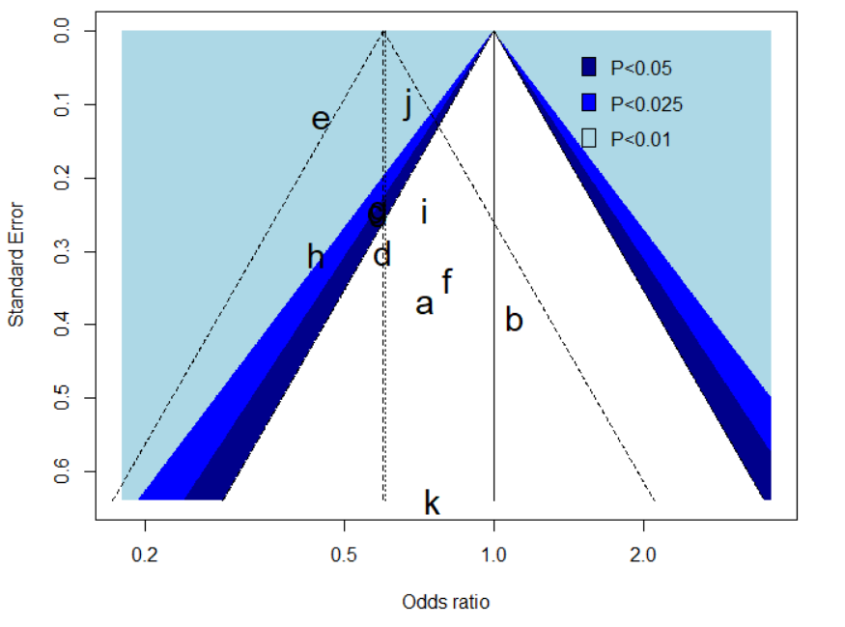

Supplementary Figure 4. Funnel plot for detecting publication bias in the meta-analysis of case-control studies assessing the association between 25(OH)D and colorectal cancer in all the subjects. This contour-enhanced funnel plot shows the standard error and odds ratio for each of the studies of the meta-analysis. The different contour colors indicate the significance level (see legend in the plot) into which the effects size of each study falls. Egger’s test for funnel plot asymmetry was not significant (P=0.385). Legend: (a) Otani et al. 2007 [Men]; (b) Otani et al. 2007 [Women]; (c) Jenab et al. 2010; (d) Woolcott et al. 2010; (e) Theodoratou et al. 2012; (f) Ordóñez-Mena et al. 2015 [EPIC]; (g) Weinstein et al. 2015; (h) Ying et al. 2015; (i) Andersen et al. 2017; (j) McCullough et al. 2018; (k) Acikgoz et al. 2020. Note that studies: c and g overlap in the plot.

A)  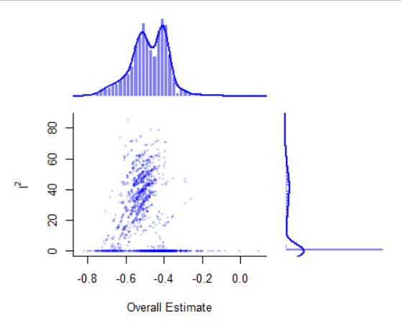 | B)  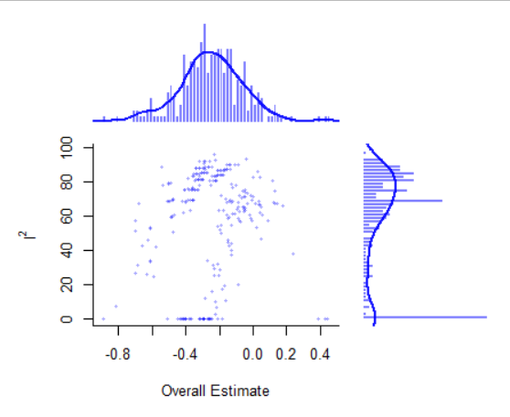
C)  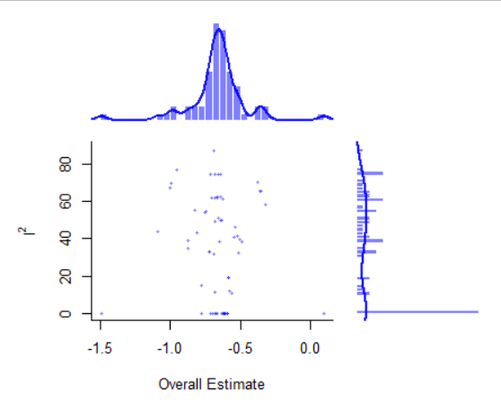 | D)  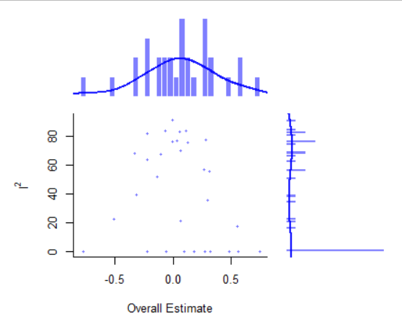
E)  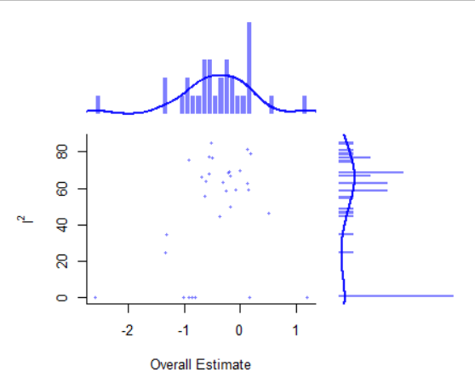 | F)  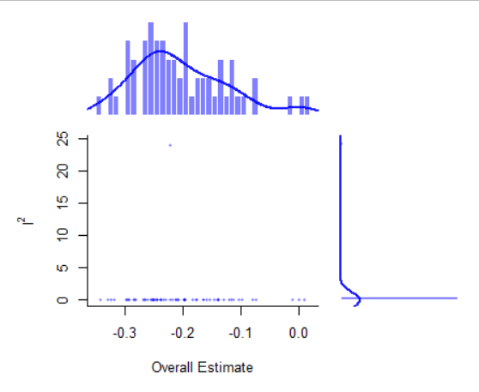

Supplementary Figure 5. Graphic display of heterogeneity (GOSH) plot analyses for the different meta-analyses of circulating vitamin D levels. All the iterative meta-analyses (2^{studies} – 1 individual analyses) were constructed using generic inverse-variance random-effects model. Plots are for: A) CCS – CRC – 25(OH)D – All subjects (11 studies, thus including 2047 possible subsets); B) CCS – CRC – 25(OH)D – Men (8 studies, thus including 255 possible subsets; please see Supplementary Figure 5 for more details); C) CCS – CRC – 25(OH)D – Women (6 studies, thus including 63 possible subsets); D) CCS – CC – 25(OH)D – Men (5 studies, thus including 31 possible subsets); E) CCS – RC – 25(OH)D – Men (5 studies, thus including 31 possible subsets); F) PC – CRC – 25(OH)D – All (6 studies, thus including 63 possible subsets). Abbreviations: CC, colon cancer; CCS, case-control studies; CRC, colorectal cancer; GOSH, graphic display of heterogeneity; PC, prospective cohort; RC, rectal cancer.

A)  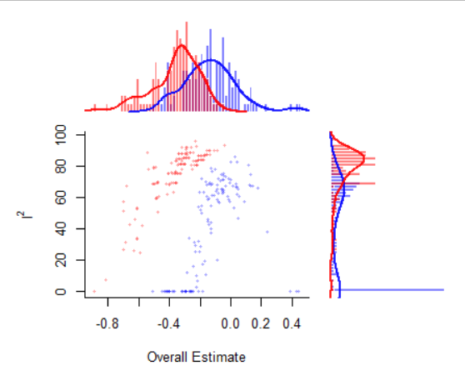 | B)  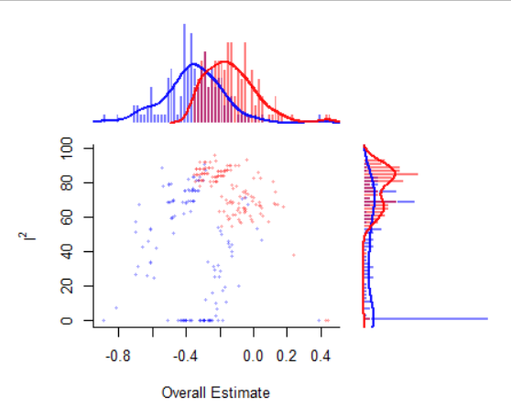

Supplementary Figure 6. Graphic display of heterogeneity (GOSH) plot analyses for the case-control meta-analysis evaluating colorectal cancer and circulating vitamin D levels in men. All the iterative meta-analyses (2^{studies} – 1 individual analyses) were constructed using generic inverse-variance random-effects model. Plots are for: CCS – CRC – 25(OH)D – Men (8 studies, thus including 255 possible subsets), where blue was used for plotting results considering iterative combinations excluding the influence studies/outliers (Theodoratou et al. 2012 in A); and, Anic et al. 2014 in B)), whereas red color is used to plot results including each respective outlier. Abbreviations: GOSH, graphic display of heterogeneity.

