Supplementary Material for:

**The presence of a foreign microbial community promotes plant growth and reduces filtering of root fungi in the arctic-alpine plant *Silene acaulis.***

Conor V. Meade1,2,a, Clifton P. Bueno de Mesquita2,3,a, Steven K. Schmidt3, Katharine N. Suding2,3

1Biology Department, Maynooth University, W23 F2H6, Ireland

2Institute of Arctic and Alpine Research, University of Colorado, Boulder, CO, USA 80309-0450

3Department of Ecology and Evolutionary Biology, University of Colorado, Boulder, CO, USA 80309-0334

aThese authors contributed equally to the work

*Corresponding author: [Conor.V.Meade@mu.ie](mailto:Conor.V.Meade@mu.ie)

**Appendix 1: *Silene acaulis* background information and genotype information.**

Phylogeographic analysis identifies 5 principal haplotype refugia across the range of the species after the Pleistocene/Holocene transition: Beringia/Alaska; the Southwestern Rocky Mountains; Northeastern Canada; the Eastern Atlantic and Greenland; and South Central Europe; which together comprise a history of radiation and dispersal that began approximately 1 million years BP (Gussarova et al. 2015). The current range of *S. acaulis* extends over diverse geological and soil environments, creating a complex selective landscape for the species metapopulation. In addition, while populations in the northern arctic range of *S. acaulis* are relatively abundant and contiguous, many southern populations persist in isolation, restricted to sky-island habitats where cold conditions prevail in otherwise temperate landscapes. Adult plants mature to form dome-shaped cushions that are self-protective against both freezing and wind-desiccation, and strong stress-tolerance capacity combined with repeated seasonal dieback allow established plants to survive for several hundred years (Morris and Doak 1998). However, although seedling germination rates are nominally high, annual recruitment of seedlings into stable adult populations is very limited, and is associated with rapid initial accumulation of above-ground biomass in surviving seedlings (Doak & Morris, 2010).

*DNA Sequencing – Plant Markers*

Validation of genetic identity for the target plant populations was completed using the chloroplast matK and *trn*L(UAA) intron barcode loci. A common sterile sampling protocol was used at both sites for the collection of green shoot tissue from 20 individual adult plants in each population. At the Ben Bulben site in Ireland, adult plants comprising a single-plant rosette of between 10 and 20 cm diameter were identified along a 2 km southeast-northwest transect beginning at the Glencarbury mine rubble quarry, 480 m.a.s.l. and ending at the saddle between BenWiskin and Slievmore at 540 m.a.s.l. At an interval of minimum 50 m apart, identified sexually mature plants were checked for disease. Wearing sterile nitrile gloves and using a pre-sterilised stainless steel spatula, the central root was loosened and removed, and the entire plant placed in a labelled sterile polyethylene collection bag with silica gel desiccant. At the Niwot Ridge LTER site in Colorado, sampling was completed using the same protocol along a 2 km east-west transect beginning at the LTER Tundra lab, at 3528 m.a.s.l. and ending at the D-1 meteorological station at 3739 m.a.s.l.

Green shoot tissue was desiccated for 96 hours with silica gel crystals (Sigma 10087). For each sample, whole genome DNA was extracted from 50 mg of dried tissue using the Qiagen Plant DNeasy kit (Qiagen 69104). Specimen identity was validated via PCR amplification with MatK-5'*trn*K primers '390F' (Cuenoud *et al.,* 2002) and '1440R' (Fior et al. 2006), and *trn*L(UAA) intron primers 'TabC' and 'TabD' (Taberlet et al. 1991). Sequence analysis was completed by GATC Biotech AG (Germany). Sequences were compiled, trimmed and concatenated using Geneious 9.1.3 (Biomatters Ltd.), and comparison of identity was completed using Neighbor-Joining algorithm applied in Mega 7.0.26 (Kumar et al. 2016). A GenBank BLAST search of consensus sequences was completed to confirm *S. acaulis* genetic identity among all samples.

With the MatK sequence matrix trimmed to 783bp, and the trnL intron matrix trimmed to 616bp, a GenBank BLAST search of the consensus identity of each individual returned multiple >99% content and length similarity hits for a range of *S. acaulis* accessions from across Europe, the Arctic, and North America, unambiguously placing the two target ecotypes within the *S. acaulis* metapopulation. Neighbor-Joining analysis of expanded data matrices for both loci that included accessions retrieved in the BLAST search reveal a shared, paraphyletic, haplotype array among Irish, Colorado and Arctic populations that postdates divergence from basal *S. acaulis* populations in the European Alps [data not shown]. Evaluation of sequence overlap (in the trnL intron and trnL-F regions) to the Gussarova et al., (2015) *S. acaulis* dataset identified the Irish haplotypes as ‘L’ and ‘K’, part of the Northeastern Atlantic group, and the Colorado haplotypes as ‘J’, part of the Southwestern Rocky Mountains group. No unique or private haplotypes were observed in either site.

References:

Fior S, Karis PO, Casazza G, et al. 2006. Molecular phylogeny of the Caryophyllaceae (Caryophyllales) inferred from chloroplast matK and nuclear rDNA ITS sequences. Am J Bot 93:399–411. https://doi.org/10.3732/ajb.93.3.399

Gussarova G, Allen GA, Mikhaylova Y, et al. 2015. Vicariance, long-distance dispersal, and regional extinction-recolonization dynamics explain the disjunct circumpolar distribution of the arctic-alpine plant *Silene acaulis*. Am J Bot 102:1703–1720. https://doi.org/10.3732/ajb.1500072

Kumar S, Stecher G, Tamura K. 2016. MEGA7: Molecular Evolutionary Genetics Analysis Version 7.0 for Bigger Datasets. Mol Biol Evol 33:1870–1874

Morris WF, Doak DF. 1998. Life history of the long-lived gynodioecious cushion plant *Silene acaulis* (Caryophyllaceae), inferred from size-based population projection matrices. Am J Bot 85:784–793. https://doi.org/10.2307/2446413

Taberlet P, Gielly L, Pautou G, Bouvet J. 1991. Universal primers for amplification of three non-coding regions of chloroplast DNA. Plant Mol Biol 17:1105–1109

**Appendix 2: Photographs of the study organisms.**

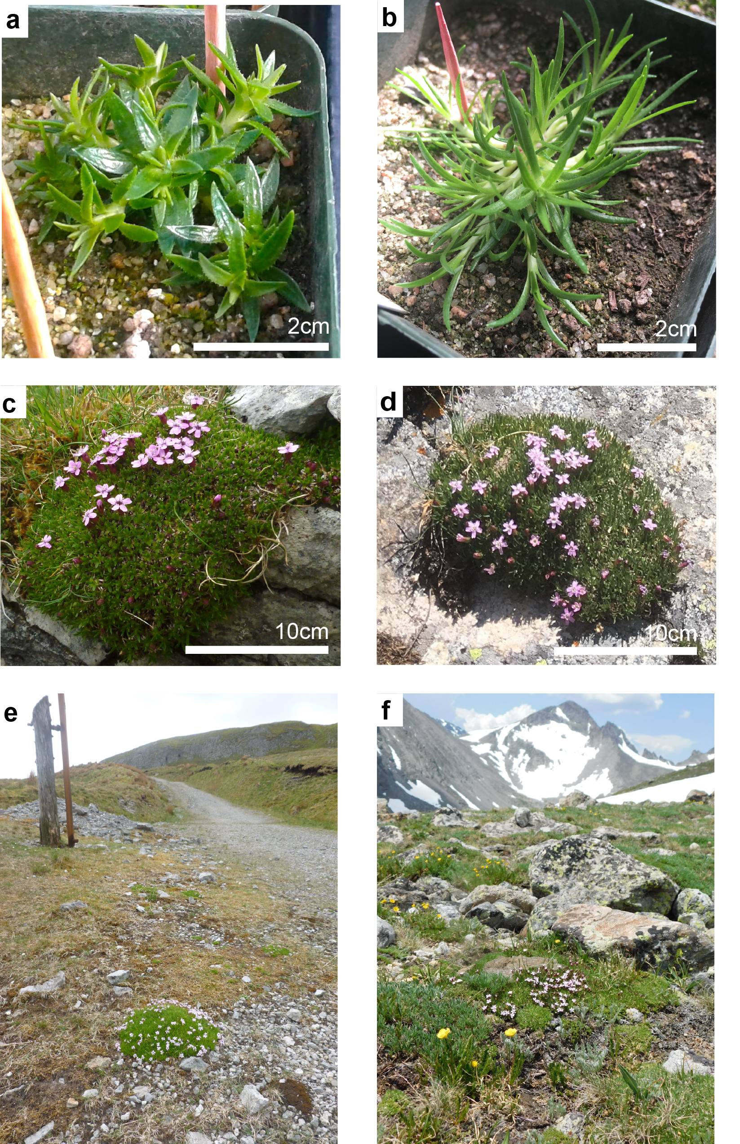

Photographs of *Silene acaulis* plants used in the present study. a) Ireland seedling growing in the alpine room of the greenhouse at the University of Colorado Boulder. b) Colorado seedling in greenhouse. c) Adult Irish plant in the field, c. 500 masl at Ben Bulben Special Area of Conservation, Ireland. d) Adult Colorado plant in the field, c3700 masl at Niwot Ridge LTER, Colorado, USA. e) Habitat setting with *Silene acaulis*, foreground, adjacent to disused Glencarbury Mine access path, Ben Bulben, Ireland. f), Habitat setting with *Silene acaulis*, foreground, near D1 station, Niwot Ridge, Colorado.



Supplementary Figure 1. Relative abundances and OTU richness of fungal mutualists and fungal pathogens in the Silene acaulis seedlings. Mutualists and pathogens were assigned using FUNguild and include all confidence levels. Mutualists include taxa classified as arbuscular mycorrhizal fungi, orchid mycorrhizal fungi, ectomycorrhizae, and dark septate endophytes. Pathogens include taxa classified as plant pathogens. ANOVA identified no significant differences in microbial OTU abundance between the indicated treatments (p > 0.05 in all cases).



Supplementary Figure 2. Percent root length colonized by a) Arbuscular mycorrhizal fungi (AMF) and b) Dark septate endophytes (DSE). ANOVA identified no significant differences in percent root colonization between the indicated treatments (p > 0.05 in all cases).