Supplementary online material

Numerical modelling of permafrost dynamics under climate change and evolving ground surface conditions: Application to an instrumented permafrost mound at Umiujaq, Nunavik (Québec), Canada
Julie Perreault, Richard Fortier, John W. Molson
Infrared imaging was carried out with a FLIR T400 infrared camera to characterize the spatial variability of surface temperature and identify characteristic ground surface conditions of the two permafrost mounds at the study site (Figure 2c). Examples of infrared photographs of permafrost mounds 1 and 2 are provided in Figures SM1b and SM1c, respectively. These photographs were taken during a sunny day when the surface temperatures representative of different surface conditions were easier to distinguish compared to cloud cover conditions which affect solar radiation and illumination.
In both infrared photographs of Figures SM1b and SM1c, which can be compared to the photograph in the visible range (Figure SM1a), several surface conditions with different surface temperatures can be distinguished: (1) a gravel road with warmer shoulders than the roadway and with surface temperatures around 19°C, (2) thermokarst ponds with surface temperatures between 10°C and 12°C, (3) depressions between the permafrost mounds which have been invaded by shrubs and black spruce with surface temperatures around 19-20°C, and (4) permafrost mounds covered with mosses and lichens with surface temperatures from 24°C to 31°C. For this last surface condition, the areas of low vegetation on the top of the permafrost mounds are colder than the areas with mosses and lichens. The shading effect of low vegetation on the underlying surface can explain the relatively colder condition compared to the areas free of vegetation or with mosses and lichens.
In summary, the different ground surface conditions of the study site identified with the thermal imaging are the vegetation types on top and sides of the permafrost mounds, thermokarst ponds, topographic depressions between the permafrost mounds, and bare surfaces resulting from anthropic activities (e.g. the road).
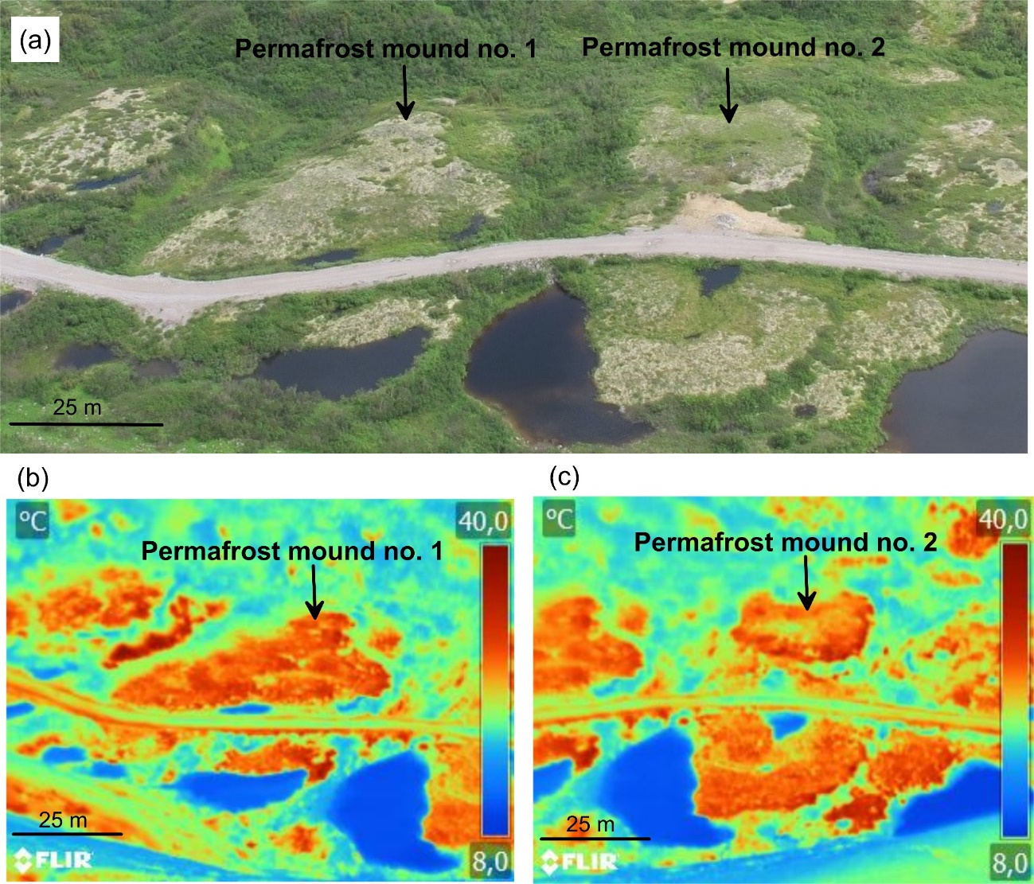
Figure SM1. Photographs of the study site in the Tasiapik Valley at Umiujaq taken with a FLIR T400 infrared camera on a sunny day (on 2020-07-09 at 13h00; Tair = 19 °C). (a) Photograph in the visible range of permafrost mounds 1 and 2. Infrared photographs of permafrost mounds 1 (b) and 2 (c). The color of the top of the permafrost mounds is greenish-beige in the visible range. The surface of the permafrost mounds is warmest, identified in orange, with surface temperatures from 24°C to 31°C in the infrared range.

Based on these infrared photographs and field observations, permafrost mounds 1 and 2 were subsequently instrumented with temperature probes buried a few centimeters below the ground surface to monitor the surface temperature of characteristic ground surface conditions. The location of these temperature probes is provided in Figures SM2 and SM3. Photographs of temperature probe sites which provide insights on ground surface conditions are given in Figure SM4. Time series of hourly air temperatures and ground surface temperatures and graphs of ground surface temperature as a function of air temperature are provided in Figures SM5 to SM10 for different ground surface conditions. Finally, the results of the predictive simulations showing impacts of slight climate warming without any change in ground surface conditions (reference case scenario S1; Table 2) on permafrost degradation are presented in Figure SM11 as spatial distributions of ground temperature differences (ΔT) with respect to the simulated ground temperatures within the 2D domain at the end of the spin-up period in 2019 (Figures 9a and 9b). This last figure is provided for comparison purposes with Figure 12.

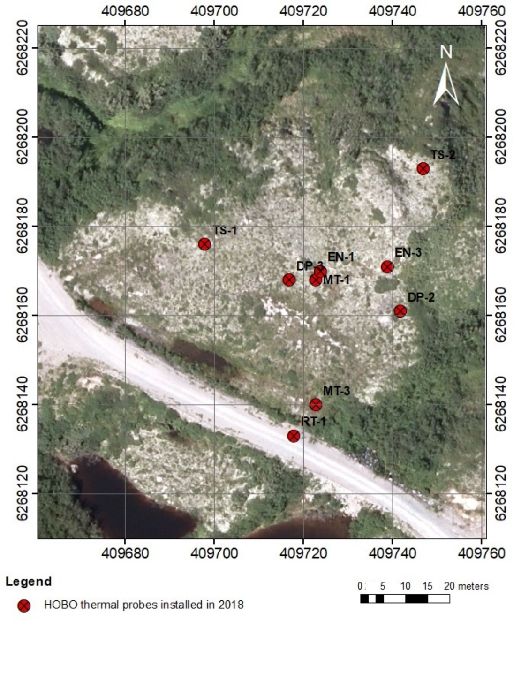
Figure SM2. Location of the temperature probes on permafrost mound 1.

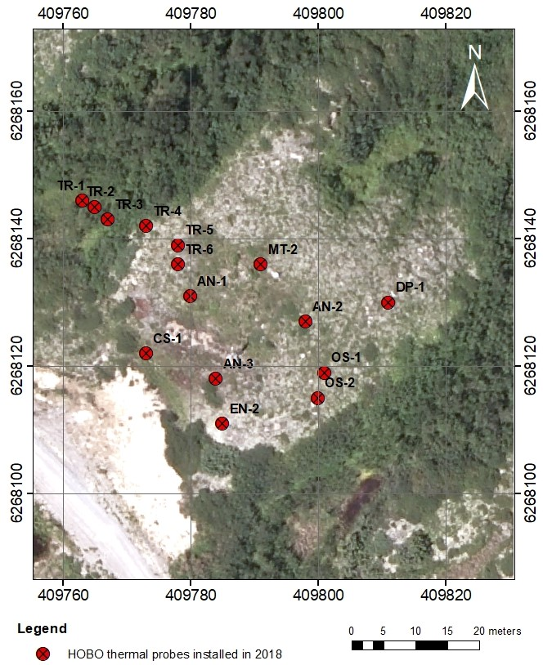
Figure SM3. Location of the temperature probes on permafrost mound 2.

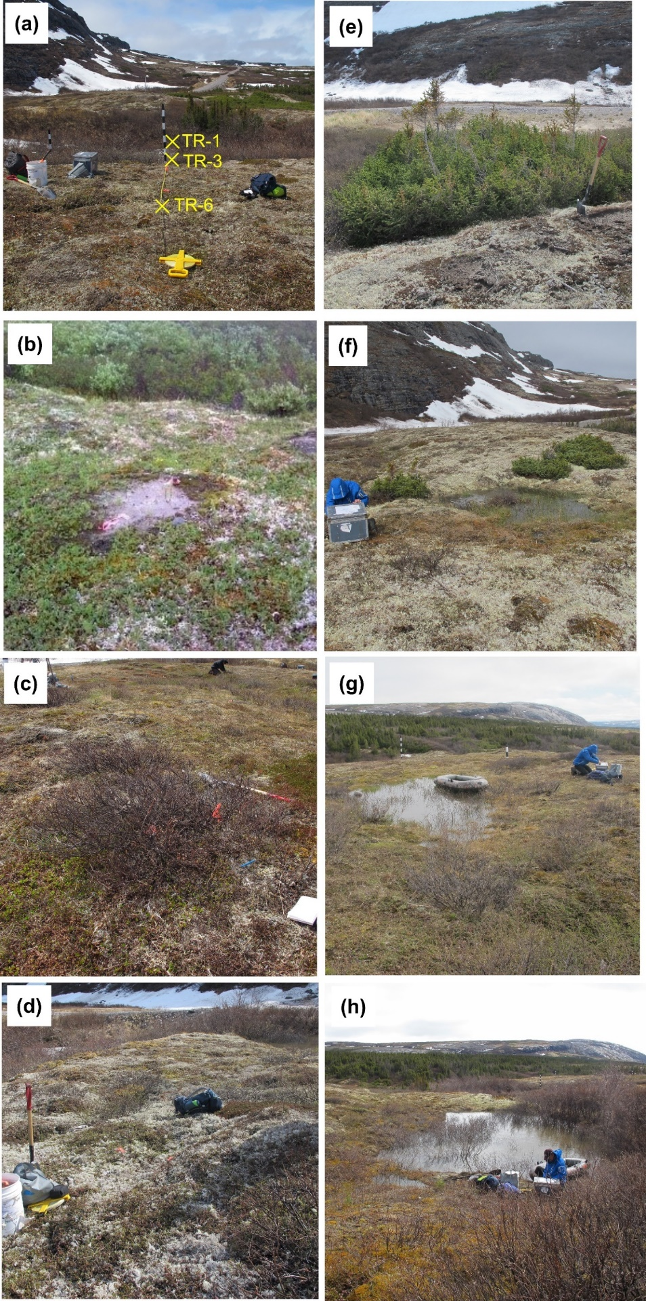
Figure SM4. Temperature probe sites (a) TR-1, TR-3 and TR-6, (b) OS-2, (c) AN-2, (d) DP-2, (e) EN-2, (f) MT-1, (g) MT-2, and (h) MT-3. See Table 1 for the description of ground surface conditions and temperatures for these sites.
Figure SM5. (a) Time series of hourly air and ground surface temperatures of a frost boil measured at probe site OS-2 for the period from July 2018 to July 2019. (b) Mean daily surface temperature (MDST) measured at probe site OS-2 as a function of mean daily air temperature (MDAT) for the same period. Simple linear regressions through the origin (0, 0), used in the numerical modelling, are also provided. Location of temperature probe OS-2 is shown in Figure SM3. See Table 1 for the statistics on air and ground surface temperatures.

Figure SM6. (a) Time series of hourly air and ground surface temperatures under (low) shrub coverage measured at probe site AN-2 for the period from July 2018 to July 2019. (b) Mean daily surface temperature (MDST) measured at probe site AN-2 as a function of mean daily air temperature (MDAT) for the same period. Simple linear regressions through the origin (0, 0), used in the numerical modelling, are also provided. Location of temperature probe AN-2 is shown in Figure SM3. See Table 1 for the statistics on air and ground surface temperatures.

Figure SM7. (a) Time series of hourly air and ground surface temperatures of a topographic depression measured at probe site DP-2 for the period from July 2018 to July 2019. (b) Mean daily surface temperature (MDST) measured at probe site DP-2 as a function of mean daily air temperature (MDAT) for the same period. Simple linear regressions through the origin (0, 0), used in the numerical modelling, are also provided. Location of temperature probe DP-2 is shown in Figure SM2. See Table 1 for the statistics on air and ground surface temperatures.

Figure SM8. (a) Time series of hourly air and ground surface temperatures under black spruce cover measured at probe site EN-2 for the period from July 2018 to July 2019. (b) Mean daily surface temperature (MDST) measured at probe site EN-2 as a function of mean daily air temperature (MDAT) for the same period. Simple linear regressions through the origin (0, 0), used in the numerical modelling, are also provided. Location of temperature probe EN-2 is shown in Figure SM3. See Table 1 for the statistics on air and ground surface temperatures.

Figure SM9. (a) Time series of hourly air and ground surface temperatures at the bottom of a thermokarst pond measured at probe site MT-2 for the period from July 2018 to July 2019. (b) Mean daily surface temperature (MDST) measured at probe site MT-2 as a function of mean daily air temperature (MDAT) for the same period. Simple linear regressions through the origin (0, 0), used in the numerical modelling, are also provided. Location of temperature probe MT-2 is shown in Figure SM3. See Table 1 for the statistics on air and ground surface temperatures.

Figure SM10. (a) Time series of hourly air and ground surface temperatures measured at probe site TR-3 for the period from July 2018 to July 2019. (b) Mean daily surface temperature (MDST) measured at probe site TR-3 as a function of mean daily air temperature (MDAT) for the same period. Simple linear regressions through the origin (0, 0), used in the numerical modelling, are also provided. Location of temperature probe TR-3 is shown in Figures 1 and SM3. See Table 1 for the statistics on air and ground surface temperatures.

Figure SM11. Differences in ground temperature ΔT (°C) in the 2D model between the reference case scenario S1 (slight climate warming of 0.23°C from 2020 to 2100 with no change in ground surface conditions; see Table 2) and the corresponding simulated ground temperatures in 2019 (see Figure 9a and 9b), in January and August. The 0°C isotherm in 2019 is identified by the white dashed line, while that of scenario S1 is identified by the solid white line.

