Table S1. Survival number and number of days from hatching to the second zoeae stage of the red snow crab *Chionoecetes japonicus* reared at eight constant temperatures in four trials.

|  |  |  |  |  |  |  |
| --- | --- | --- | --- | --- | --- | --- |
| Trial | Temperature (˚C) | Survival Number | |  | Number of days | |
| Mean ± SD | Observed value |  | Mean ± SD | Range |
| 1 | 1.04 | 0.00 | 0, 0, 0 |  |  |  |
|  | 3.15 | 2.67 ± 0.94 | 2 , 2, 4 |  | 85.08 ± 2.44 | 80 − 95 |
|  | 4.91 | 14.33 ± 0.94 | 13, 15, 15 |  | 59.33 ± 0.80 | 51 − 77 |
|  | 8.04 | 23 ± 1.41 | 21, 21, 24 |  | 35.06 ± 0.87 | 29 − 59 |
|  | 11.08 | 16.33 ± 1.70 | 14, 17, 18 |  | 24.13 ± 0.41 | 21 − 32 |
|  | 13.82 | 16 ± 1.41 | 15, 15, 18 |  | 17.92 ± 0.42 | 16 − 30 |
|  | 15.66 | 9.67 ± 2.36 | 8, 8, 13 |  | 15.51 ± 0.02 | 14 − 18 |
|  | 18.07 | 0.00 | 0, 0, 0 |  |  |  |
| 2 | 1.04 | 0.00 | 0, 0, 0 |  |  |  |
|  | 3.16 | 4 ± 1.63 | 2, 4, 6 |  | 82.00 ± 0.82 | 75 − 90 |
|  | 4.91 | 18 ± 0.82 | 17, 18 19 |  | 58.93 ± 0.54 | 53 − 75 |
|  | 8.04 | 20.67 ± 1.25 | 19, 21, 22 |  | 34.52 ± 0.35 | 28 − 56 |
|  | 11.07 | 16.67 ± 3.68 | 12, 17, 21 |  | 24.06 ± 0.44 | 20 − 38 |
|  | 13.84 | 14.33 ± 2.05 | 12, 14, 17 |  | 18.62 ± 0.76 | 15 − 28 |
|  | 15.69 | 9.67 ± 0.94 | 9, 9, 11 |  | 15.58 ± 0.04 | 14 − 20 |
|  | 17.94 | 0.00 | 0, 0, 0 |  |  |  |
| 3 | 1.05 | 0.00 | 0, 0, 0 |  |  |  |
|  | 3.12 | 14.33 ± 2.62 | 12, 13, 18 |  | 84.31 ± 2.60 | 68 − 101 |
|  | 4.90 | 22.67 ± 1.25 | 21, 23, 24 |  | 60.80 ± 1.49 | 51 − 74 |
|  | 8.05 | 26.33 ± 0.94 | 25, 27, 27 |  | 34.62 ± 0.47 | 30 − 46 |
|  | 11.12 | 27 ± 0.00 | 27, 27, 27 |  | 22.63 ± 0.28 | 20 − 27 |
|  | 13.84 | 25.67 ± 1.25 | 24, 26, 27 |  | 17.08 ± 0.27 | 16 − 21 |
|  | 15.77 | 24.67 ± 0.47 | 24, 25, 25 |  | 15.09 ± 0.04 | 14 − 17 |
|  | 18.06 | 1.33 ± 0.47 | 1, 1, 2 |  | 15.67 ± 0.47 | 14 − 16 |
| 4 | 1.03 | 0.00 | 0, 0, 0 |  |  |  |
|  | 3.10 | 6.67 ± 2.49 | 4, 6, 10 |  | 87.06 ± 6.50 | 70 − 105 |
|  | 4.89 | 21.33 ± 3.40 | 18, 20, 26 |  | 63.29 ± 1.42 | 52 − 82 |
|  | 8.04 | 28.67 ± 1.25 | 27, 29, 30 |  | 36.96 ± 0.69 | 31 − 48 |
|  | 11.12 | 28.67 ± 0.47 | 28, 29, 29 |  | 23.26 ± 0.25 | 20 − 30 |
|  | 13.78 | 24 ± 1.41 | 23, 23, 26 |  | 17.17 ± 0.19 | 15 − 29 |
|  | 15.77 | 21 ± 1.41 | 20, 20, 23 |  | 15.91 ± 0.80 | 10 − 24 |
|  | 18.11 | 3.67 ± 0.94 | 3, 3, 5 |  | 14.33 ± 0.94 | 12 − 20 |

Table S2. Survival number and number of days from hatching to the megalopae stage and carapace width of megalopae of the red snow crab *Chionoecetes japonicus* reared at eight constant temperatures in four trials.

|  |  |  |  |  |  |  |  |  |  |
| --- | --- | --- | --- | --- | --- | --- | --- | --- | --- |
| Trial | Temperature (˚C) | Survival Number | |  | Number of days | |  | Carapace width (mm) | |
| Mean ± SD | Observed value |  | Mean ± SD | Range |  | Mean ± SD | Range |
| 1 | 1.04 | 0.00 | 0, 0, 0 |  |  |  |  |  |  |
|  | 3.15 | 0.00 | 0, 0, 0 |  |  |  |  |  |  |
|  | 4.91 | 8.67 ± 1.89 | 6, 10, 10 |  | 117.17 ± 0.68 | 114 − 122 |  | 2.14 ± 0.03 | 2.11 − 2.17 |
|  | 8.04 | 19.33 ± 1.70 | 17, 20, 21 |  | 74.58 ± 0.91 | 67 − 96 |  | 2.17 ± 0.01 | 2.16 − 2.19 |
|  | 11.08 | 13.33 ± 0.47 | 13, 13, 14 |  | 51.8 ± 1.32 | 47 − 67 |  | 2.15 ± 0.03 | 2.11 − 2.18 |
|  | 13.82 | 10.00 ± 0.82 | 9, 10, 11 |  | 40.96 ± 0.71 | 37 − 50 |  | 2.06 ± 0.04 | 2.03 − 2.11 |
|  | 15.66 | 6.67 ± 1.70 | 5, 6, 9 |  | 37.10 ± 1.37 | 32 − 49 |  | 2.04 ± 0.02 | 2.01 − 2.07 |
|  | 18.07 | 0.00 | 0, 0, 0 |  |  |  |  |  |  |
| 2 | 1.04 | 0.00 | 0, 0, 0 |  |  |  |  |  |  |
|  | 3.16 | 0.00 | 0, 0, 0 |  |  |  |  |  |  |
|  | 4.91 | 12.33 ± 3.86 | 7, 14, 16 |  | 116.49 ± 1.1 | 111 − 124 |  | 2.14 ± 0.02 | 2.11 − 2.16 |
|  | 8.04 | 19.33 ± 0.94 | 18, 20, 20 |  | 73.44 ± 0.56 | 66 − 89 |  | 2.22 ± 0.02 | 2.19 − 2.25 |
|  | 11.07 | 13.67 ± 3.30 | 10, 13, 18 |  | 51.02 ± 0.89 | 47 − 59 |  | 2.17 ± 0.03 | 2.13 − 2.20 |
|  | 13.84 | 11.33 ± 2.62 | 9, 10, 15 |  | 40.9 ± 0.32 | 35 − 51 |  | 2.07 ± 0.04 | 2.02 − 2.11 |
|  | 15.69 | 5.67 ± 1.70 | 4, 5, 8 |  | 36.02 ± 0.53 | 32 − 40 |  | 2.04 ± 0.02 | 2.01 − 2.07 |
|  | 17.94 | 0.00 | 0, 0, 0 |  |  |  |  |  |  |
| 3 | 1.05 | 0.00 | 0, 0, 0 |  |  |  |  |  |  |
|  | 3.12 | 0.00 | 0, 0, 0 |  |  |  |  |  |  |
|  | 4.90 | 16.33 ± 1.70 | 14, 17, 18 |  | 119.53 ± 0.95 | 109 − 133 |  | 2.13 ± 0.01 | 2.12 − 2.14 |
|  | 8.05 | 22.67 ± 1.89 | 20, 24, 24 |  | 72.17 ± 1.00 | 67 − 82 |  | 2.19 ± 0.01 | 2.17 − 2.20 |
|  | 11.12 | 22.33 ± 1.25 | 21, 22, 24 |  | 49.71 ± 0.17 | 47 − 56 |  | 2.22 ± 0.02 | 2.2 − 2.24 |
|  | 13.84 | 12.67 ± 1.89 | 10, 10, 14 |  | 37.71 ± 0.41 | 35 − 45 |  | 2.1 ± 0.01 | 2.09 − 2.11 |
|  | 15.77 | 12.33 ± 2.87 | 9, 12, 16 |  | 35.3 ± 0.33 | 30 − 41 |  | 2.08 ± 0.01 | 2.06 − 2.09 |
|  | 18.06 | 0.00 | 0, 0, 0 |  |  |  |  |  |  |
| 4 | 1.03 | 0.00 | 0, 0, 0 |  |  |  |  |  |  |
|  | 3.10 | 0.00 | 0, 0, 0 |  |  |  |  |  |  |
|  | 4.89 | 5.00 ± 4.97 | 1, 2, 12 |  | 115.44 ± 1.06 | 109 − 124 |  | 2.14 ± 0.05 | 2.09 − 2.20 |
|  | 8.04 | 26.67 ± 2.62 | 23, 28, 29 |  | 72.79 ± 0.44 | 65 − 83 |  | 2.17 ± 0.01 | 2.16 − 2.19 |
|  | 11.12 | 21.67 ± 0.47 | 21, 22, 22 |  | 49.82 ± 0.34 | 45 − 58 |  | 2.21 ± 0.01 | 2.2 − 2.23 |
|  | 13.78 | 15.67 ± 3.40 | 11, 17, 19 |  | 38.06 ± 1.24 | 34 − 49 |  | 2.11 ± 0.02 | 2.09 − 2.13 |
|  | 15.77 | 11.67 ± 1.25 | 10, 12, 13 |  | 34.99 ± 0.75 | 32 − 41 |  | 2.07 ± 0.01 | 2.06 − 2.08 |
|  | 18.11 | 0.00 | 0, 0, 0 |  |  |  |  |  |  |

Table S3. Survival number and number of days from the megalopae stage to first-stage crabs and carapace width of first-stage crabs in the red snow crab *Chionoecetes japonicus* reared at eight constant temperatures.

|  |  |  |  |  |  |  |  |  |  |
| --- | --- | --- | --- | --- | --- | --- | --- | --- | --- |
| Temperature (˚C) | Survival Number | | |  | Number of days | |  | Carapace width (mm) | |
| Normal moult | Abnormal moult | Total |  | Mean ± SD | Range |  | Mean ± SD | Range |
| 0.98 | 0 | 0 | 0 |  |  |  |  |  |  |
| 2.98 | 1 | 5 | 6 |  | 117.50 ± 7.09 | 110 − 130 |  | 3.02 |  |
| 4.84 | 13 | 6 | 19 |  | 92.47 ± 5.99 | 83 − 106 |  | 2.99 ± 0.09 | 2.84 − 3.14 |
| 8.00 | 14 | 10 | 24 |  | 65.46 ± 4.87 | 56 − 76 |  | 3.17 ± 0.16 | 2.87 − 3.40 |
| 11.13 | 0 | 7 | 7 |  | 51.86 ± 5.03 | 46 − 63 |  |  |  |
| 13.84 | 2 | 3 | 5 |  | 41.4 ± 2.80 | 38 − 46 |  | 3.05 | 2.96 − 3.14 |
| 15.90 | 2 | 0 | 2 |  | 39.00 | 38 − 40 |  | 3.00 | 2.88 − 3.13 |
| 18.08 | 0 | 0 | 0 |  |  |  |  |  |  |

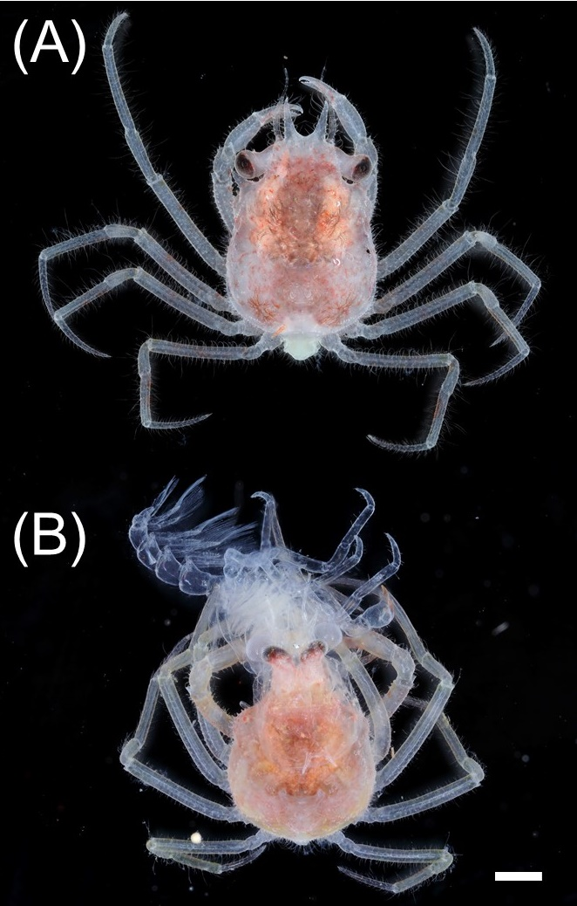

Figure S1. Photographs of morphologically normal (A) and abnormal (B) individuals of the first-stage crab of the red snow crab, *Chionoecetes japonicus*. The horizontal white line represents a scale of 1 mm.



Figure S2. Seasonal and vertical distribution of the red snow crab *Chionoecetes japonicus* larvae. Data were from the Tottori Prefectural Fisheries Experimental Station (1979, 1980, 1981). The number of larvae individuals were divided by the number of sampling occurrences. The blank figures indicate that surveys were conducted but no larvae were collected.



Figure S3. Seasonal and vertical distribution of the water temperatures where red snow crab *Chionoecetes japonicus* larvae were caught: March (A), April (B), May (D), and June (D). Data were from the Tottori Prefectural Fisheries Experimental Station (1979, 1980, 1981). The solid curves and shadows indicate the mean temperatures and their SDs, respectively.



Figure S4. Interspecific comparison of total zoeal (A) and megalopal (B) survival related to temperature between the red snow crab *Chionoecetes japonicus* (black line) and the snow crab *C. opilio* (grey line). The curves were drawn based on a logistic model (Logit(*p*) = *a* + *bT* + *cT*2). The survival data of the snow crab were obtained from Yamamoto et al. (2014). The parameters for the snow crab were *a* = −6.7173, *b* = 1.8256, *c* = −0.0901 in the zoeal stage and *a* = −2.7194, *b* = 1.3718, *c* = −0.0741 in the megalopal stage.



Figure S5. Interspecific comparison of total zoeal (solid line) and megalopal (dashed line) development durations related to temperature between the red snow crab *Chionoecetes japonicus* (black line) and the snow crab *C. opilio* (grey line). The curves were drawn based on heat summation theory equations. The parameters for the snow crab were obtained from Yamamoto et al (2014).