Coastal Management
Supporting Information for
Monitoring Ocean Acidification within State Borders: Lessons from Washington State (USA)
S. Fisher Gonski^{1+*}, Micah J. Horwith^{1*}, Skip Albertson¹, Julia Bos¹, Allison S. Brownlee^{1€}, Natalie Coleman¹, Carol Falkenhayn Maloy^{1¥}, Mya Keyzers¹, Christopher Krembs¹, Greg Pelletier¹, Elisa Rauschl¹, Holly R. Young¹, and Wei-Jun Cai²
¹Washington State Department of Ecology, PO Box 47600, Olympia, WA, 98504-7600, USA
²University of Delaware, School of Marine Science and Policy, 111 Robinson Hall, Newark, DE 19176, USA
⁺Present Address: University of Delaware, School of Marine Science and Policy, 111 Robinson Hall, Newark, DE 19716, USA
€Present Address: Washington State Department of Natural Resources, 1111 Washington St SE. MS47027. Olympia, WA 98504-7027, USA.
¥Present Address: Pierce County, 2702 S. 42nd St, Tacoma, WA 98409, USA
*Corresponding authors: S. Fisher Gonski (sfgonski@udel.edu); Micah J. Horwith (mhor461@ecy.wa.gov).

Contents of this file
Text S1 to S2
Table S1 to S7
Figure S1 to S2
Text S1.

Quality Control of DIC and TA Data: DIC and TA data are reviewed using three quality control levels. Level 1 encompasses deviations from the field collection methods discussed in section 2.3. When such deviations take place, they are recorded by staff in the field. If recorded deviations are judged likely to have only a minimal impact on sample quality, then resulting DIC and TA data are flagged with ‘JM,’ denoting ‘method modification.’ Such deviations have included:
- Sample was drawn from the Niskin bottle after other samples were already collected.
- Sample bottle contained small amount of headspace.
- Sample bottle was not transported in cooler.
- Sample was fixed with HgCl₂ outside of the laboratory.
If recorded deviations are judged likely to have a serious impact on sample quality, then resulting DIC and TA data are flagged with ‘R,’ denoting ‘rejected.’ Such deviations have included:
- Sample depth of collection was unknown or uncertain.
- Sample bottle was cracked, missing rubber bands and clips, or missing Apiezon L-grease.
- Sample was not filtered.
- Sample was spilled.
- Sample bottle contained excessive headspace.
- Sample was not poisoned with HgCl₂.
- Sample was collected by hand.
Finally, if a sample is held for longer than 6 months before analysis, then resulting DIC and TA data are flagged with ‘JH,’ denoting ‘holding time exceedance.’
Level 2 encompasses measurement quality in the laboratory. As discussed in section 2.4, PMEL analyzes CRMs with known values of DIC and TA to check laboratory performance. When measured and certified CRM values differ by >0.25%, DIC or TA data from that day are rejected (following Gonski et al., 2019). To date, however, no CRM analyses have yielded values that have exceeded this >0.25% threshold as shown in Table 4. PMEL analysts may also note deviations from laboratory methods or observed evidence of deviations from field collection methods. If noted deviations are judged likely to have only a minimal impact on data quality, then resulting DIC or TA data are flagged with ‘JM.’ Such deviations have included:
- Sample had little grease on bottle stopper.
- Sample spilled during hook up to analytical equipment.
- Sample DIC and/or TA results appeared inconsistent with surrounding samples.
- Sample head space appeared inconsistent with surrounding samples.
If noted deviations are judged likely to have a serious impact on data quality, then resulting DIC and/or TA data flagged with ‘R.’ Such deviations have included:
- Sample had no grease on bottle stopper.
- Sample had no rubber band over bottle stopper.
- Sample DIC and/or TA results suffered from analytical equipment failure.
Finally, if equipment failure prevents sample analysis entirely, then resulting data gaps are flagged with ‘M,’ denoting ‘missing result.’
Level 3 encompasses small-scale spatiotemporal variation and the representativeness of data. Ecology collects field replicate samples at selected stations and depths. When DIC and/or TA values from field replicates differ by more than 0.5%, and there were no deviations from field or laboratory SOPs, this is a likely indication that field conditions were highly dynamic at the time of collection. DIC and TA data from such samples are flagged with a ‘1,’ denoting ‘sensor/equipment performance.’
Quality control systems for DIC and TA data should be revisited, amended, and expanded as datasets grow. For example, Ecology OA data will one day span multiple years, and it may be appropriate to begin comparing monthly values at each station to historic means to identify trends, transient extremes, or potential errors, similar to the review process for other data collected by Ecology (Bos et al., 2015).
Bushnell et al. (2019), Dickson et al. (2007), Pearlman et al. (2019), Riebesell et al. (2011), and Sastri et al. (2019) (and the references therein) describe community-standard practices for quality control of OA datasets that can inform monitoring undertaken by regulatory agencies in other jurisdictions.
Text S2.
Approach to Marine CO₂ System Calculations: Ecology uses DIC and TA data together with in situ temperature and salinity, hydrostatic pressure, and inorganic nutrient concentrations to constrain the marine CO₂ system using the ‘Seacarb’ package (3.2.13) (Gattuso et al., 2020) in R (4.0.2). The ‘carb’ function is used to calculate pCO₂, pH (on the total scale, pH_{T}), Ω_{Ar} and Ω_{Ca}. In these calculations, inorganic carbon dissociation constants (K1 and K2) from Lueker et al. (2000) were used for all water samples with temperatures between 2 and 35ºC and salinities between 19 and 33 while water samples with temperatures and salinities outside of these ranges used those from Waters et al., (2014). It is important to note that K1 and K2 from Waters et al. (2014) are based on those discussed in Millero (2010) specifically for estuarine waters but recalculated for use with the free pH scale (pH_{F}). The equilibrium constant of hydrogen fluoride (K_{f}) from Perez and Fraga (1974) was used for water samples with temperatures between 9 and 33ºC and salinities between 10 and 40 while K_{f} from Dickson and Goyet (1994) was used samples with temperatures and/or salinities outside of those ranges. The borate-to-salinity ratio from Uppstrom (1974) and the dissociation constant for bisulfate from Dickson (1990) were also used in these calculations.
When DIC and TA are measured but coincident measurements of $\left[{PO}_{4}^{3-}\right]$ and $\left[{SiO}_{4}\right]$ are missing, site- and depth-specific seasonal estimates of $\left[{PO}_{4}^{3-}\right]$ and $\left[{SiO}_{4}\right]$ are used for marine CO₂ system calculations. For example, $\left[{PO}_{4}^{3-}\right]$ was not measured on 19 February 2020 at SAR003 at 0 m, so the mean of all $\left[{PO}_{4}^{3-}\right]$ measurements taken at SAR003 at 0 m during January, February, and March 2020 was used as an estimate for the $\left[{PO}_{4}^{3-}\right]$ to constrain the remainder of the marine CO₂ system for that station and depth on that day.
References
Bos, J., Keyzers, M., Hermanson, L., Krembs, C., and Albertson, S. (2015). Quality Assurance Monitoring Plan: Long-Term Marine Waters Monitoring, Water Column Program. Publication No. 15-03-101. Washington State Department of Ecology, Olympia. https://fortress.wa.gov/ecy/publications/SummaryPages/1503101.html

Bushnell, M., Waldmann, C., Seitz, S., Buckley, E., Tamburri, M., Hermes, J., Hemslop, E., and Lara-Lopez, A. (2019). Quality Assurance of Oceanographic Observations: Standards and Guidance Adopted by an International Partnership. Frontiers in Marine Science, 6, 706.

Dickson, A. G. (1990). Standard potential of the reaction: AgCl (s) + 1/2 H₂ (g) = Ag (s) + HCl (aq), and the standard acidity constant of the ion HSO₄⁻ in synthetic sea water from 273.15 to 318.15 K. The Journal of Chemical Thermodynamics, 22(2), 113-127.

Dickson, A. G., & Goyet, C. (1994). Handbook of methods for the analysis of the various parameters of the carbon dioxide system in sea water. Version 2 (No. ORNL/CDIAC-74). Oak Ridge National Lab., TN (United States).

Dickson, A. G., Sabine, C. L., and Christian, J. R. (2007). Guide to best practices for ocean CO₂ measurements. North Pacific Marine Science Organization.

Gattuso, J.-P., Epitalon, J.-P., Lavigne, H., and Orr, J. (2020). Seacarb Seawater Carbonate Chemistry. Package 3.2.13. https://cran.r-project.org/web/packages/seacarb/index.html.

Gonski, S., Krembs, C., and Pelletier, G. (2019). Quality Assurance Project Plan: Ocean Acidification Monitoring at Ecology’s Greater Puget Sound Stations. Publication No. 19-03-102. Washington State Department of Ecology, Olympia. https://fortress.wa.gov/ecy/publications/SummaryPages/1903102.html.

Lueker, T. J., Dickson, A. G., & Keeling, C. D. 2000. Ocean pCO₂ calculated from dissolved inorganic carbon, alkalinity, and equations for K₁ and K₂: validation based on laboratory measurements of CO₂ in gas and seawater at equilibrium. Marine Chemistry, 70(1-3), 105-119.

Pearlman, J. S., Bushnell, M., Coppola, L., Buttigieg, P. L., Pearlman, F., Simpson, P., et al. (2019). Evolving and sustaining ocean best practices and standards for the next decade. Frontiers in Marine Science, 6, 277.

Perez, F. F., and Fraga, F. (1987). Association constant of fluoride and hydrogen ions in seawater. Marine Chemistry, 21(2), 161-168.

Riebesell, U., Fabry, V. J., Hansson, L., and Gattuso, J.-P. (2011). Guide to best practices for ocean acidification research and data reporting. Office for Official Publications of the European Communities.

Sastri, A., Christian, J. R., Achterberg, E. P., Atamanchuk, D., Buck, J. J. H., Bresnahan, P. J., et al. (2019). Perspectives on in situ sensors for ocean acidification research. Frontiers in Marine Science, 6, 653.

Uppstrom, L. R., The boron/chlorinity ratio of deep-sea water from the Pacific Ocean. 1974. Deep Sea Research and Oceanographic Abstracts, 21(2), 161–162.

Waters, J., Millero, F. J., and Woosley, R. J. (2014). Corrigendum to “The free proton concentration scale for seawater pH”,[MARCHE: 149 (2013) 8-22]. Marine Chemistry, 165, 66-67.

Table S1. Summary statistics of data for temperature, salinity, and marine CO₂ system variables for discrete water samples collected in Admiralty Inlet.
Admiralty Inlet
Month Range (depth) | Variable (units) | Mean | Standard Deviation | Coefficient of Variation (%) | Minimum | Maximum
October-February (0 m) | Temperature (ºC) | 10.07 | 1.60 | 15.91 | 7.12 | 12.32
 | Salinity (PSU) | 29.23 | 3.05 | 10.42 | 19.48 | 31.32
 | DIC (µmol kg⁻¹) | 1980.63 | 170.27 | 8.60 | 1442.00 | 2106.00
 | TA (µmol kg⁻¹) | 2023.42 | 175.25 | 8.66 | 1461.90 | 2139.70
 | pH_{T} | 7.71 | 0.06 | 0.76 | 7.61 | 7.79
 | pCO₂ (µatm) | 858.50 | 154.51 | 18.00 | 550.00 | 1133.00
 | Ω_{Ar} | 0.81 | 0.14 | 16.96 | 0.47 | 1.02
 | Ω_{Ca} | 1.29 | 0.21 | 16.25 | 0.78 | 1.62
October-February (30 m) | Temperature (ºC) | 9.82 | 1.42 | 14.51 | 8.10 | 12.54
 | Salinity (PSU) | 30.88 | 0.84 | 2.73 | 29.30 | 32.30
 | DIC (µmol kg⁻¹) | 2066.55 | 50.89 | 2.46 | 1981.60 | 2157.60
 | TA (µmol kg⁻¹) | 2109.18 | 42.97 | 2.04 | 2028.20 | 2181.20
 | pH_{T} | 7.69 | 0.06 | 0.77 | 7.61 | 7.78
 | pCO₂ (µatm) | 917.38 | 142.45 | 15.53 | 717.00 | 1137.00
 | Ω_{Ar} | 0.83 | 0.07 | 8.97 | 0.73 | 0.93
 | Ω_{Ca} | 1.31 | 0.12 | 9.07 | 1.15 | 1.48
March-September (0 m) | Temperature (ºC) | 11.04 | 2.17 | 19.69 | 7.80 | 14.74
 | Salinity (PSU) | 30.08 | 1.33 | 4.43 | 26.39 | 31.66
 | DIC (µmol kg⁻¹) | 1971.66 | 114.68 | 5.82 | 1634.00 | 2096.50
 | TA (µmol kg⁻¹) | 2077.47 | 68.20 | 3.28 | 1885.80 | 2153.60
 | pH_{T} | 7.90 | 0.15 | 1.90 | 7.72 | 8.33
 | pCO₂ (µatm) | 581.79 | 177.38 | 30.49 | 162.00 | 885.00
 | Ω_{Ar} | 1.34 | 0.47 | 34.83 | 0.86 | 2.71
 | Ω_{Ca} | 2.12 | 0.75 | 35.18 | 1.37 | 4.34
March-September (30 m) | Temperature (ºC) | 10.28 | 1.78 | 17.29 | 8.05 | 14.44
 | Salinity (PSU) | 30.84 | 0.82 | 2.67 | 29.70 | 32.17
 | DIC (µmol kg⁻¹) | 2039.72 | 51.06 | 2.50 | 1963.50 | 2132.10
 | TA (µmol kg⁻¹) | 2115.75 | 39.06 | 1.85 | 2058.90 | 2180.30
 | pH_{T} | 7.81 | 0.06 | 0.83 | 7.69 | 7.90
 | pCO₂ (µatm) | 702.86 | 123.51 | 17.57 | 541.00 | 939.00
 | Ω_{Ar} | 1.07 | 0.14 | 12.83 | 0.88 | 1.28
 | Ω_{Ca} | 1.70 | 0.22 | 12.79 | 1.40 | 2.03
Table S2. Summary statistics of data for temperature, salinity, and marine CO₂ system variables for discrete water samples collected in Bellingham Bay.
Bellingham Bay
Time Period (depth) | Variable (units) | Mean | Standard Deviation | Coefficient of Variation (%) | Minimum | Maximum
October-February (0 m) | Temperature (ºC) | 8.35 | 1.74 | 20.88 | 5.84 | 10.97
 | Salinity (PSU) | 28.35 | 1.64 | 5.80 | 24.30 | 29.98
 | DIC (µmol kg⁻¹) | 1951.05 | 93.48 | 4.79 | 1709.10 | 2022.50
 | TA (µmol kg⁻¹) | 1996.51 | 107.27 | 5.37 | 1718.30 | 2067.10
 | pH_{T} | 7.76 | 0.06 | 0.80 | 7.63 | 7.82
 | pCO₂ (µatm) | 751.88 | 93.50 | 12.44 | 642.00 | 921.00
 | Ω_{Ar} | 0.81 | 0.15 | 19.00 | 0.50 | 1.00
 | Ω_{Ca} | 1.30 | 0.24 | 18.55 | 0.82 | 1.60
March-September (0 m) | Temperature (ºC) | 11.60 | 2.93 | 25.24 | 7.00 | 15.85
 | Salinity (PSU) | 29.00 | 1.14 | 3.92 | 26.94 | 30.26
 | DIC (µmol kg⁻¹) | 1880.93 | 99.52 | 5.29 | 1746.90 | 2018.50
 | TA (µmol kg⁻¹) | 2044.90 | 51.16 | 2.50 | 1949.60 | 2104.20
 | pH_{T} | 8.06 | 0.19 | 2.30 | 7.81 | 8.30
 | pCO₂ (µatm) | 397.83 | 188.48 | 47.38 | 184.00 | 693.00
 | Ω_{Ar} | 1.89 | 0.78 | 41.13 | 1.03 | 3.19
 | Ω_{Ca} | 3.00 | 1.22 | 40.80 | 1.64 | 5.04

Table S3. Summary statistics of data for temperature, salinity, and marine CO₂ system variables for discrete water samples collected in Hood Canal.
Hood Canal
Time Period (depth) | Variable (units) | Mean | Standard Deviation | Coefficient of Variation (%) | Minimum | Maximum
October-February (0 m) | Temperature (ºC) | 10.04 | 2.84 | 28.28 | 6.68 | 13.14
 | Salinity (PSU) | 25.36 | 3.39 | 13.35 | 19.66 | 28.46
 | DIC (µmol kg⁻¹) | 1818.45 | 147.66 | 8.12 | 1578.10 | 1979.60
 | TA (µmol kg⁻¹) | 1875.65 | 162.94 | 8.69 | 1598.20 | 2016.60
 | pH_{T} | 7.82 | 0.12 | 1.50 | 7.65 | 7.98
 | pCO₂ (µatm) | 655.00 | 207.78 | 31.72 | 420.00 | 990.00
 | Ω_{Ar} | 0.88 | 0.25 | 28.99 | 0.51 | 1.16
 | Ω_{Ca} | 1.42 | 0.40 | 28.22 | 0.85 | 1.88
October-February (30 m) | Temperature (ºC) | 11.05 | 0.41 | 3.67 | 10.39 | 11.46
 | Salinity (PSU) | 30.39 | 0.23 | 0.75 | 29.94 | 30.62
 | DIC (µmol kg⁻¹) | 2125.69 | 18.04 | 0.85 | 2100.20 | 2146.60
 | TA (µmol kg⁻¹) | 2093.82 | 10.94 | 0.52 | 2072.00 | 2106.50
 | pH_{T} | 7.41 | 0.04 | 0.54 | 7.35 | 7.47
 | pCO₂ (µatm) | 1829.78 | 178.36 | 9.75 | 1583.00 | 2094.00
 | Ω_{Ar} | 0.45 | 0.04 | 9.01 | 0.40 | 0.53
 | Ω_{Ca} | 0.72 | 0.06 | 9.01 | 0.63 | 0.83
March-September (0 m) | Temperature (ºC) | 15.68 | 3.09 | 19.68 | 11.14 | 20.10
 | Salinity (PSU) | 26.81 | 1.95 | 7.28 | 22.22 | 28.32
 | DIC (µmol kg⁻¹) | 1805.37 | 65.46 | 3.63 | 1652.70 | 1863.10
 | TA (µmol kg⁻¹) | 1921.07 | 65.12 | 3.39 | 1770.90 | 1974.00
 | pH_{T} | 7.93 | 0.09 | 1.08 | 7.85 | 8.10
 | pCO₂ (µatm) | 500.14 | 104.72 | 20.94 | 304.00 | 606.00
 | Ω_{Ar} | 1.41 | 0.14 | 10.02 | 1.27 | 1.70
 | Ω_{Ca} | 2.25 | 0.22 | 9.78 | 2.01 | 2.70
March-September (30 m) | Temperature (ºC) | 10.36 | 0.12 | 1.17 | 10.22 | 10.54
 | Salinity (PSU) | 30.16 | 0.13 | 0.42 | 29.99 | 30.41
 | DIC (µmol kg⁻¹) | 2142.95 | 20.71 | 0.97 | 2118.80 | 2181.90
 | TA (µmol kg⁻¹) | 2087.01 | 7.69 | 0.37 | 2072.20 | 2096.50
 | pH_{T} | 7.34 | 0.06 | 0.79 | 7.23 | 7.41
 | pCO₂ (µatm) | 2160.50 | 309.02 | 14.30 | 1809.00 | 2764.00
 | Ω_{Ar} | 0.38 | 0.05 | 12.87 | 0.29 | 0.44
 | Ω_{Ca} | 0.60 | 0.08 | 12.82 | 0.46 | 0.70
Table S4. Summary statistics of data for temperature, salinity, and marine CO₂ system variables for discrete water samples collected in Puget Sound Main Basin.
Puget Sound Main Basin
Time Period (depth) | Variable (units) | Mean | Standard Deviation | Coefficient of Variation (%) | Minimum | Maximum
October-February (0 m) | Temperature (ºC) | 11.79 | 1.42 | 12.09 | 9.29 | 13.18
 | Salinity (PSU) | 29.48 | 0.82 | 2.79 | 27.59 | 30.68
 | DIC (µmol kg⁻¹) | 2011.17 | 28.87 | 1.44 | 1926.70 | 2057.00
 | TA (µmol kg⁻¹) | 2053.76 | 36.27 | 1.77 | 1959.20 | 2113.30
 | pH_{T} | 7.68 | 0.02 | 0.24 | 7.65 | 7.71
 | pCO₂ (µatm) | 930.85 | 34.66 | 3.72 | 886.00 | 996.00
 | Ω_{Ar} | 0.82 | 0.08 | 10.02 | 0.66 | 0.94
 | Ω_{Ca} | 1.31 | 0.13 | 9.62 | 1.06 | 1.49
October-February (30 m) | Temperature (ºC) | 11.75 | 1.14 | 9.74 | 9.61 | 12.98
 | Salinity (PSU) | 30.45 | 0.29 | 0.97 | 29.86 | 30.82
 | DIC (µmol kg⁻¹) | 2048.97 | 11.52 | 0.56 | 2027.50 | 2065.60
 | TA (µmol kg⁻¹) | 2094.05 | 17.96 | 0.86 | 2062.40 | 2117.00
 | pH_{T} | 7.68 | 0.02 | 0.22 | 7.64 | 7.73
 | pCO₂ (µatm) | 946.47 | 35.92 | 3.79 | 856.00 | 1031.00
 | Ω_{Ar} | 0.85 | 0.07 | 8.09 | 0.74 | 0.99
 | Ω_{Ca} | 1.34 | 0.10 | 7.83 | 1.17 | 1.57
March-September (0 m) | Temperature (ºC) | 11.78 | 2.12 | 18.04 | 8.30 | 14.97
 | Salinity (PSU) | 28.90 | 1.25 | 4.34 | 24.20 | 30.48
 | DIC (µmol kg⁻¹) | 1914.71 | 83.05 | 4.34 | 1666.10 | 2025.70
 | TA (µmol kg⁻¹) | 2031.91 | 51.80 | 2.55 | 1871.80 | 2101.40
 | pH_{T} | 7.93 | 0.17 | 2.15 | 7.73 | 8.27
 | pCO₂ (µatm) | 534.11 | 205.13 | 38.41 | 195.00 | 849.00
 | Ω_{Ar} | 1.44 | 0.51 | 35.81 | 0.81 | 2.50
 | Ω_{Ca} | 2.29 | 0.82 | 35.90 | 1.29 | 3.97
March-September (30 m) | Temperature (ºC) | 10.72 | 1.91 | 17.83 | 8.16 | 13.53
 | Salinity (PSU) | 29.82 | 0.36 | 1.21 | 29.29 | 30.54
 | DIC (µmol kg⁻¹) | 1985.61 | 30.09 | 1.52 | 1910.20 | 2034.30
 | TA (µmol kg⁻¹) | 2067.05 | 18.17 | 0.88 | 2040.40 | 2099.70
 | pH_{T} | 7.83 | 0.08 | 1.01 | 7.72 | 8.03
 | pCO₂ (µatm) | 654.22 | 123.34 | 18.85 | 384.00 | 853.00
 | Ω_{Ar} | 1.11 | 0.21 | 18.61 | 0.80 | 1.67
 | Ω_{Ca} | 1.76 | 0.33 | 18.52 | 1.27 | 2.65
Table S5. Summary statistics of data for temperature, salinity, and marine CO₂ system variables for discrete water samples collected in South Puget Sound Basin.
South Puget Sound
Time Period (depth) | Variable (units) | Mean | Standard Deviation | Coefficient of Variation (%) | Minimum | Maximum
October-February (0 m) | Temperature (ºC) | 11.09 | 2.43 | 21.87 | 6.70 | 14.71
 | Salinity (PSU) | 28.79 | 1.90 | 6.59 | 22.50 | 30.42
 | DIC (µmol kg⁻¹) | 1973.46 | 83.19 | 4.22 | 1696.20 | 2063.00
 | TA (µmol kg⁻¹) | 2021.35 | 92.86 | 4.59 | 1691.30 | 2096.90
 | pH_{T} | 7.71 | 0.09 | 1.19 | 7.60 | 8.02
 | pCO₂ (µatm) | 865.65 | 165.26 | 19.09 | 406.00 | 1093.00
 | Ω_{Ar} | 0.86 | 0.28 | 32.54 | 0.41 | 1.81
 | Ω_{Ca} | 1.37 | 0.44 | 31.86 | 0.67 | 2.85
October-February (30 m) | Temperature (ºC) | 11.26 | 1.88 | 16.68 | 7.90 | 13.87
 | Salinity (PSU) | 29.93 | 0.48 | 1.59 | 28.76 | 30.51
 | DIC (µmol kg⁻¹) | 2025.28 | 25.43 | 1.26 | 1975.70 | 2062.90
 | TA (µmol kg⁻¹) | 2071.01 | 24.65 | 1.19 | 2016.60 | 2100.50
 | pH_{T} | 7.69 | 0.06 | 0.80 | 7.63 | 7.88
 | pCO₂ (µatm) | 914.56 | 123.68 | 13.52 | 582.00 | 1067.00
 | Ω_{Ar} | 0.85 | 0.17 | 20.26 | 0.68 | 1.38
 | Ω_{Ca} | 1.34 | 0.27 | 19.91 | 1.09 | 2.18
March-September (0 m) | Temperature (ºC) | 13.16 | 3.02 | 22.94 | 8.31 | 18.17
 | Salinity (PSU) | 28.57 | 1.33 | 4.67 | 25.20 | 30.21
 | DIC (µmol kg⁻¹) | 1877.42 | 72.92 | 3.88 | 1711.80 | 2025.40
 | TA (µmol kg⁻¹) | 2015.68 | 63.00 | 3.13 | 1859.00 | 2093.30
 | pH_{T} | 7.99 | 0.13 | 1.63 | 7.72 | 8.25
 | pCO₂ (µatm) | 451.38 | 152.64 | 33.82 | 205.00 | 873.00
 | Ω_{Ar} | 1.62 | 0.42 | 25.86 | 1.00 | 2.83
 | Ω_{Ca} | 2.57 | 0.66 | 25.70 | 1.58 | 4.46
March-September (30 m) | Temperature (ºC) | 11.27 | 2.36 | 20.96 | 7.94 | 15.88
 | Salinity (PSU) | 29.36 | 0.40 | 1.35 | 28.60 | 30.08
 | DIC (µmol kg⁻¹) | 1959.44 | 25.50 | 1.30 | 1900.70 | 2000.00
 | TA (µmol kg⁻¹) | 2050.34 | 20.27 | 0.99 | 2017.40 | 2096.60
 | pH_{T} | 7.86 | 0.05 | 0.66 | 7.75 | 7.97
 | pCO₂ (µatm) | 596.92 | 77.54 | 12.99 | 447.00 | 768.00
 | Ω_{Ar} | 1.18 | 0.17 | 14.61 | 0.80 | 1.46
 | Ω_{Ca} | 1.87 | 0.27 | 14.27 | 1.28 | 2.31
Table S6. Summary statistics of data for temperature, salinity, and marine CO₂ system variables for discrete water samples collected in The Straits.
The Straits
Time Period (depth) | Variable (units) | Mean | Standard Deviation | Coefficient of Variation (%) | Minimum | Maximum
October-February (0 m) | Temperature (ºC) | 9.43 | 1.30 | 13.74 | 7.44 | 12.09
 | Salinity (PSU) | 29.47 | 1.95 | 6.60 | 24.67 | 31.68
 | DIC (µmol kg⁻¹) | 1995.87 | 97.18 | 4.87 | 1763.30 | 2111.80
 | TA (µmol kg⁻¹) | 2040.75 | 97.40 | 4.77 | 1801.00 | 2148.10
 | pH_{T} | 7.73 | 0.06 | 0.72 | 7.64 | 7.84
 | pCO₂ (µatm) | 827.33 | 123.81 | 14.96 | 601.00 | 1030.00
 | Ω_{Ar} | 0.82 | 0.11 | 13.19 | 0.62 | 1.04
 | Ω_{Ca} | 1.31 | 0.17 | 12.92 | 1.01 | 1.65
October-February (30 m) | Temperature (ºC) | 9.14 | 0.91 | 9.91 | 8.04 | 10.85
 | Salinity (PSU) | 30.68 | 0.82 | 2.69 | 29.42 | 32.29
 | DIC (µmol kg⁻¹) | 2063.24 | 44.38 | 2.15 | 1991.10 | 2156.30
 | TA (µmol kg⁻¹) | 2102.85 | 40.58 | 1.93 | 2047.60 | 2185.70
 | pH_{T} | 7.70 | 0.06 | 0.78 | 7.60 | 7.80
 | pCO₂ (µatm) | 910.37 | 136.53 | 15.00 | 701.00 | 1136.00
 | Ω_{Ar} | 0.80 | 0.08 | 9.89 | 0.65 | 1.00
 | Ω_{Ca} | 1.27 | 0.13 | 9.99 | 1.03 | 1.59
March-September (0 m) | Temperature (ºC) | 10.45 | 2.43 | 23.23 | 7.42 | 15.99
 | Salinity (PSU) | 29.15 | 2.37 | 8.13 | 21.76 | 31.12
 | DIC (µmol kg⁻¹) | 1940.59 | 126.69 | 6.53 | 1610.80 | 2076.00
 | TA (µmol kg⁻¹) | 2044.88 | 99.31 | 4.86 | 1729.40 | 2129.60
 | pH_{T} | 7.92 | 0.13 | 1.70 | 7.71 | 8.23
 | pCO₂ (µatm) | 538.10 | 181.44 | 33.72 | 219.00 | 892.00
 | Ω_{Ar} | 1.31 | 0.34 | 26.02 | 0.92 | 2.30
 | Ω_{Ca} | 2.09 | 0.55 | 26.44 | 1.45 | 3.70
March-September (30 m) | Temperature (ºC) | 9.98 | 1.19 | 11.90 | 7.46 | 11.65
 | Salinity (PSU) | 30.63 | 0.75 | 2.45 | 29.26 | 31.83
 | DIC (µmol kg⁻¹) | 2032.84 | 48.48 | 2.39 | 1912.30 | 2108.10
 | TA (µmol kg⁻¹) | 2108.16 | 34.62 | 1.64 | 2053.40 | 2166.10
 | pH_{T} | 7.81 | 0.08 | 1.07 | 7.72 | 8.04
 | pCO₂ (µatm) | 698.42 | 133.70 | 19.14 | 377.00 | 880.00
 | Ω_{Ar} | 1.06 | 0.18 | 17.14 | 0.91 | 1.63
 | Ω_{Ca} | 1.69 | 0.29 | 17.30 | 1.46 | 2.59
Table S7. Summary statistics of data for temperature, salinity, and marine CO₂ system variables for discrete water samples collected in Whidbey Basin.
Whidbey Basin
Time Period (depth) | Variable (units) | Mean | Standard Deviation | Coefficient of Variation (%) | Minimum | Maximum
October-February (0 m) | Temperature (ºC) | 8.94 | 2.52 | 28.13 | 6.17 | 12.83
 | Salinity (PSU) | 18.76 | 7.33 | 39.06 | 3.88 | 28.31
 | DIC (µmol kg⁻¹) | 1441.23 | 398.16 | 27.63 | 557.60 | 1947.00
 | TA (µmol kg⁻¹) | 1450.22 | 425.58 | 29.35 | 506.60 | 1987.30
 | pH_{T} | 7.65 | 0.17 | 2.22 | 7.18 | 7.83
 | pCO₂ (µatm) | 753.85 | 210.11 | 27.87 | 454.00 | 1226.00
 | Ω_{Ar} | 0.46 | 0.27 | 58.99 | 0.02 | 1.11
 | Ω_{Ca} | 0.75 | 0.42 | 56.51 | 0.03 | 1.76
October-February (30 m) | Temperature (ºC) | 10.63 | 1.72 | 16.13 | 6.90 | 12.44
 | Salinity (PSU) | 30.10 | 0.54 | 1.78 | 28.71 | 30.58
 | DIC (µmol kg⁻¹) | 2037.06 | 41.97 | 2.06 | 1961.30 | 2083.70
 | TA (µmol kg⁻¹) | 2065.79 | 34.32 | 1.66 | 2001.00 | 2102.00
 | pH_{T} | 7.64 | 0.07 | 0.90 | 7.55 | 7.74
 | pCO₂ (µatm) | 1040.79 | 190.08 | 18.26 | 778.00 | 1311.00
 | Ω_{Ar} | 0.73 | 0.07 | 9.59 | 0.64 | 0.88
 | Ω_{Ca} | 1.16 | 0.11 | 9.66 | 1.01 | 1.38
March-September (0 m) | Temperature (ºC) | 13.00 | 3.09 | 23.74 | 7.72 | 17.91
 | Salinity (PSU) | 23.37 | 3.33 | 14.25 | 16.15 | 27.69
 | DIC (µmol kg⁻¹) | 1600.76 | 168.91 | 10.55 | 1266.90 | 1863.80
 | TA (µmol kg⁻¹) | 1731.34 | 182.47 | 10.54 | 1302.90 | 1953.50
 | pH_{T} | 8.04 | 0.26 | 3.20 | 7.60 | 8.54
 | pCO₂ (µatm) | 395.82 | 223.36 | 56.43 | 85.00 | 898.00
 | Ω_{Ar} | 1.54 | 0.82 | 53.15 | 0.40 | 3.19
 | Ω_{Ca} | 2.49 | 1.32 | 52.88 | 0.67 | 5.22
March-September (30 m) | Temperature (ºC) | 10.42 | 1.98 | 19.01 | 8.55 | 16.42
 | Salinity (PSU) | 29.78 | 0.36 | 1.22 | 29.14 | 30.53
 | DIC (µmol kg⁻¹) | 2023.54 | 31.48 | 1.56 | 1971.50 | 2087.70
 | TA (µmol kg⁻¹) | 2060.08 | 14.68 | 0.71 | 2040.50 | 2093.30
 | pH_{T} | 7.67 | 0.09 | 1.18 | 7.51 | 7.86
 | pCO₂ (µatm) | 961.29 | 218.33 | 22.71 | 600.00 | 1421.00
 | Ω_{Ar} | 0.78 | 0.14 | 18.46 | 0.58 | 1.08
 | Ω_{Ca} | 1.24 | 0.23 | 18.42 | 0.91 | 1.72
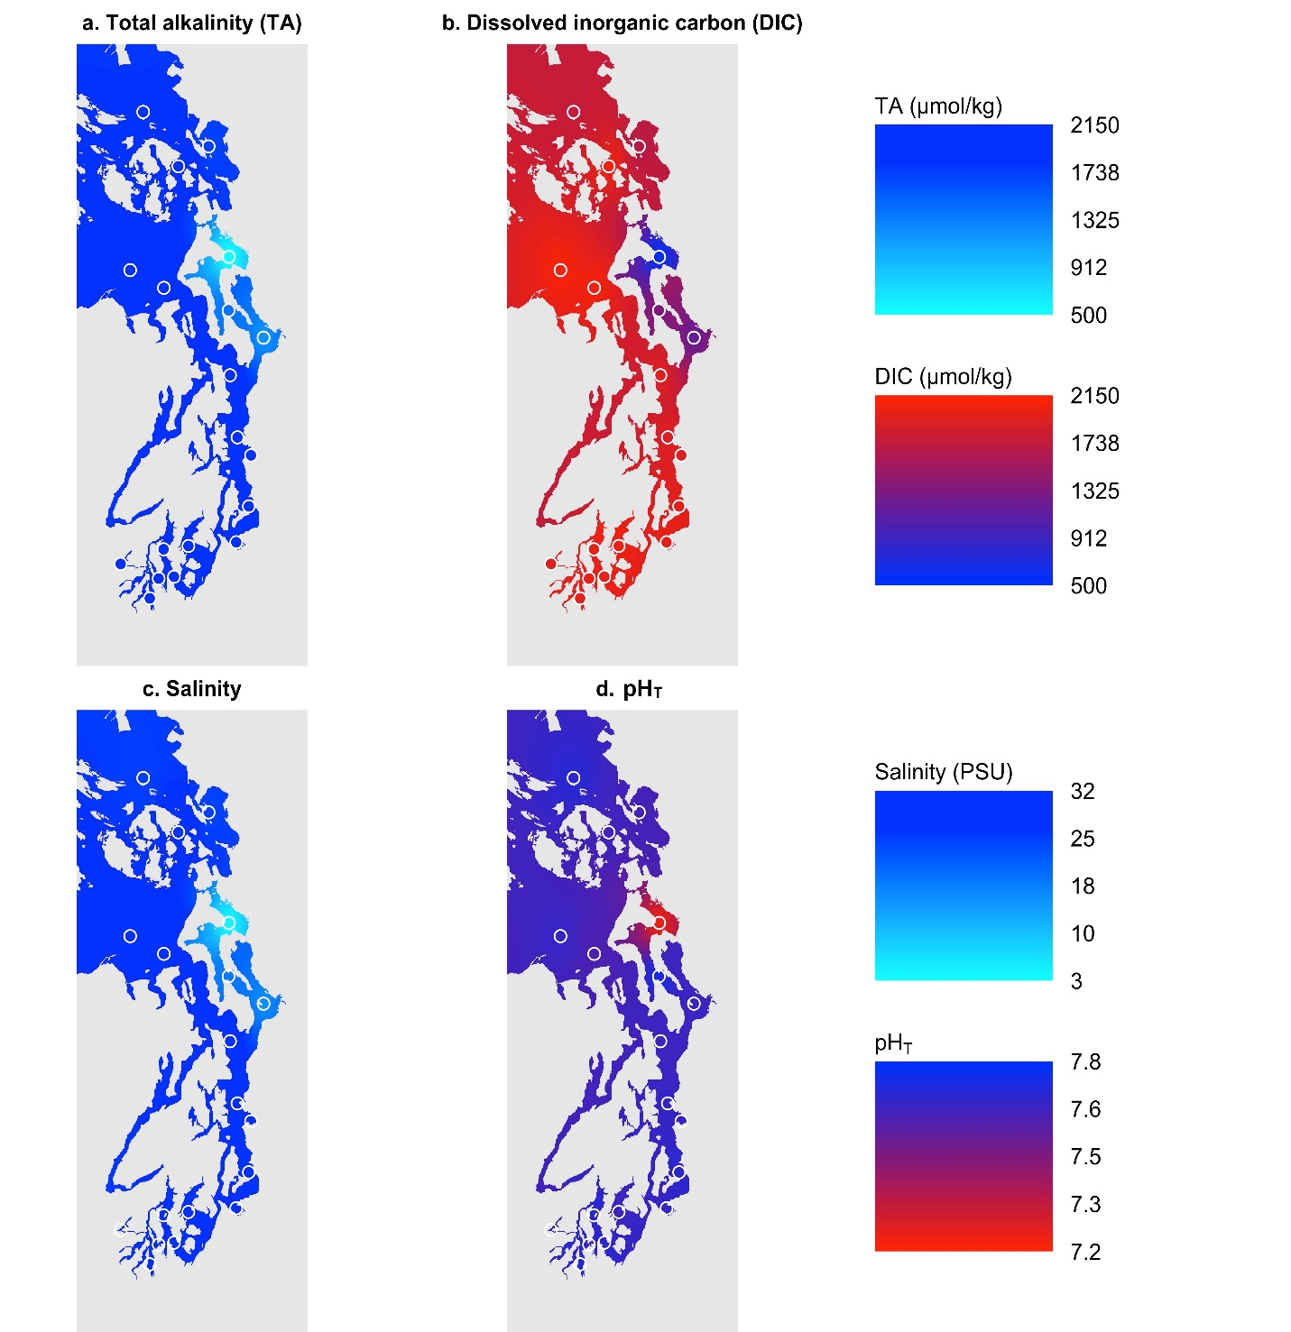
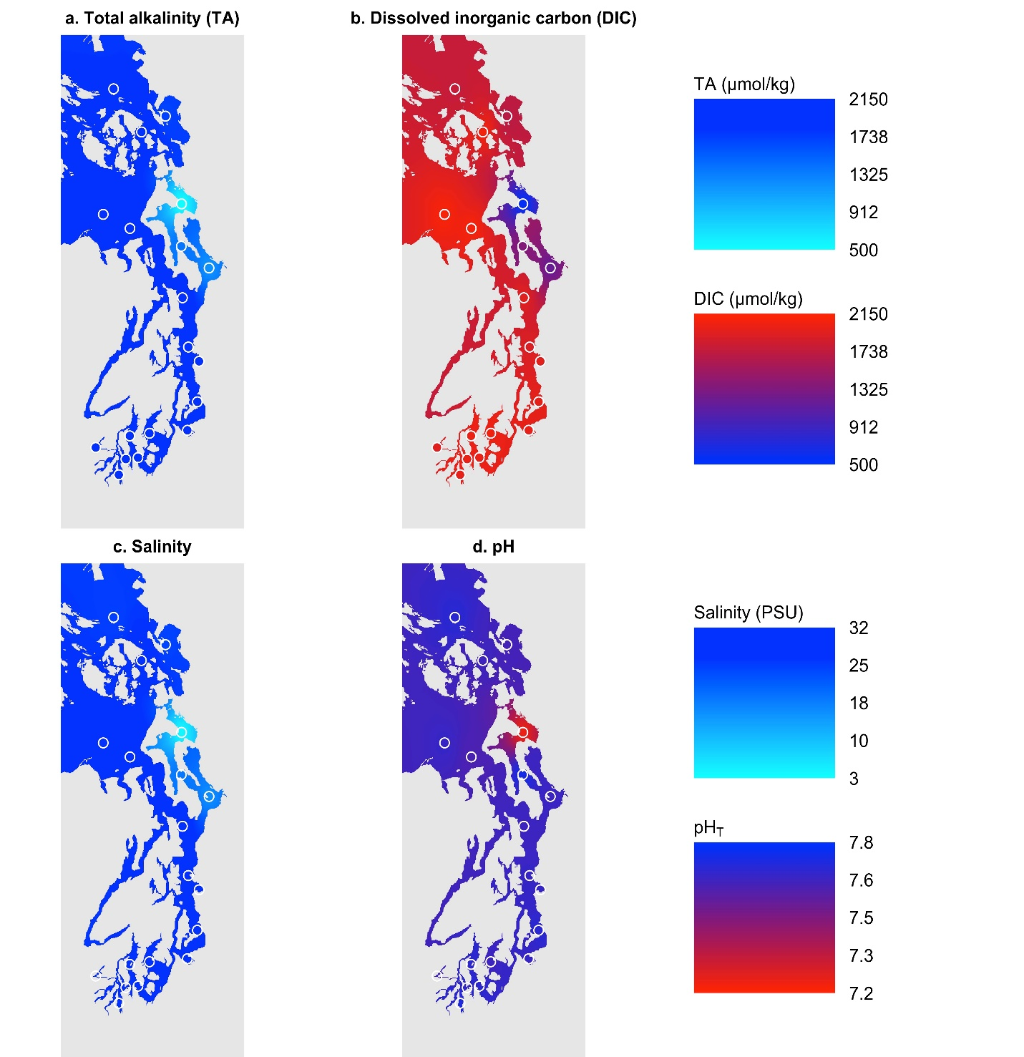
November 2018

Figure S1. Regional distributions of interpolated sea surface (a) TA, (b) DIC, (c) Salinity, and (d) pH_{T} in State waters of Puget Sound and the Salish Sea in November 2018. Open circles indicate sampling stations from which georeferenced data were used. Please note the different color bars and scales for each panel.

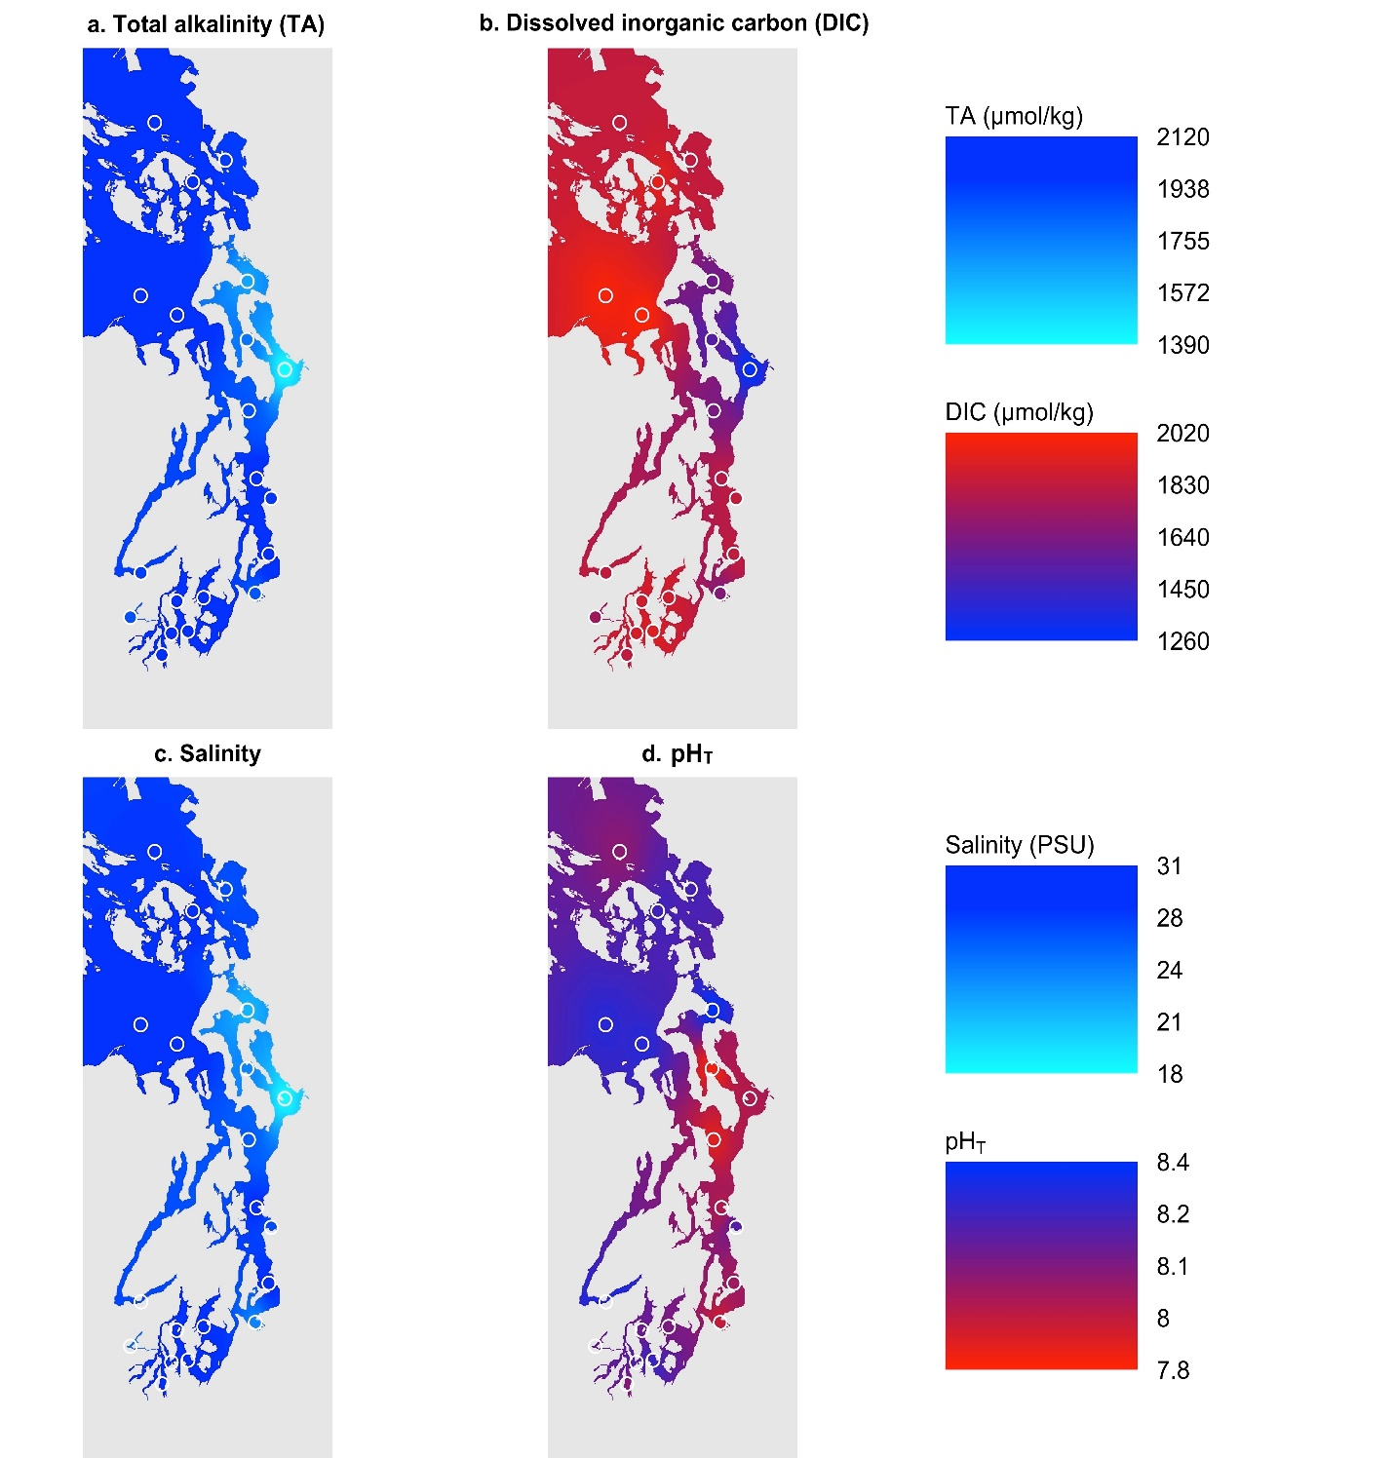
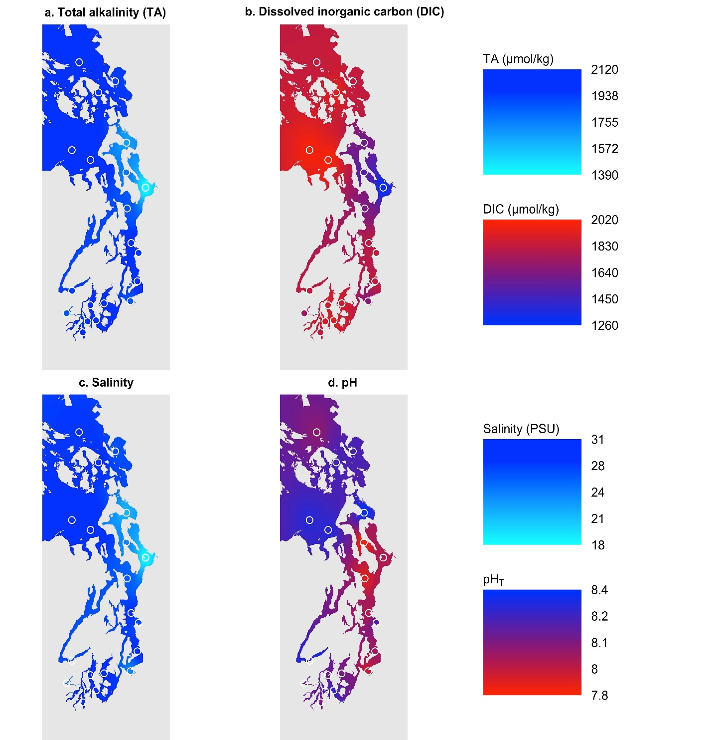
May 2019

Figure S2. Regional distributions of interpolated sea surface (a) TA, (b) DIC, (c) Salinity, and (d) pH_{T} in State waters of Puget Sound and the Salish Sea in May 2019. Open circles indicate sampling stations from which georeferenced data were used. Please note the different color bars and scales for each panel.

