SUPPORTING INFORMATION
Quick-fix Agarose Beads Impregnated with Hydrous Ferric Oxide for As(III) Species Removal from Pharmaceutical Wastewater
Dhanang Edy Pratamaª, Chia-Ling Yangª, Yu-Ying Chen^{b}, Chun-Chou Lin^{b}, Yufang Hu^{b}, and Tu Lee^{a,}⁎
ª Department of Chemical and Materials Engineering, National Central University,
300 Zhongda Road, Zhongli District, Taoyuan City 32001, Taiwan, R.O.C.
^{b} TTY Biopharm Co. Ltd., Pharmaceutical Development Center,
3F., No. 124, Xingshan Road, Neihu District, Taipei City 11469, Taiwan, R.O.C.

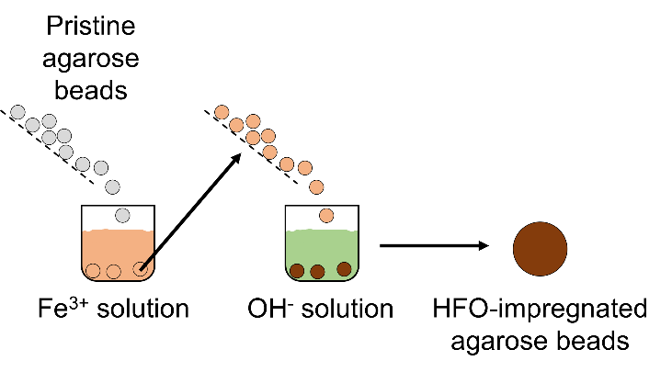
Figure S1. Schematic diagram of in-situ precipitation technique.

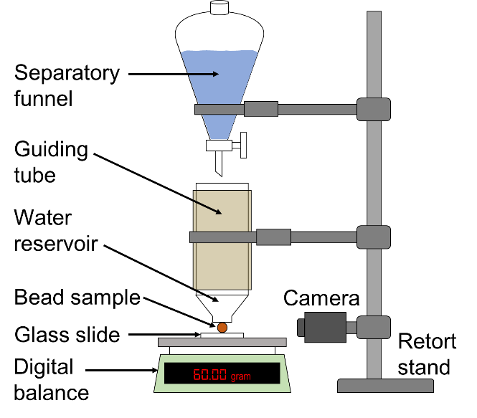
Figure S2. Compression test apparatus setup.

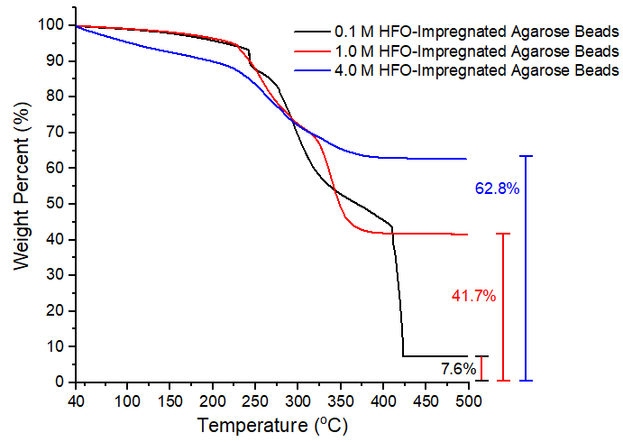
Figure S3. TGA scans of 0.1, 1.0, and 4.0 M HFO-impregnated agarose beads. Scans were performed under air flow.

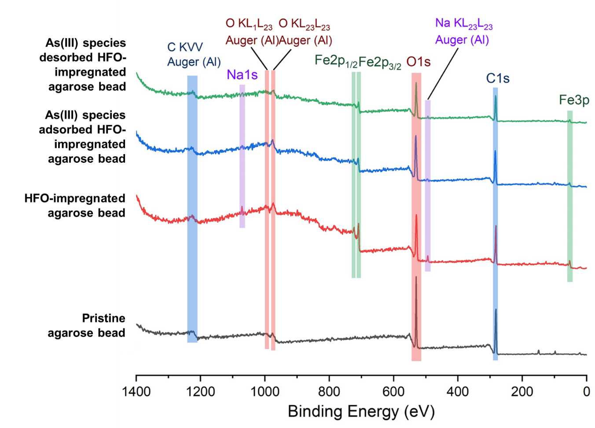
Figure S4. XPS survey spectra of pristine agarose bead and 1.0 M HFO-impregnated agarose beads before and after As(III) adsorption and desorption.
Table S1. Experimental results of As(III) species adsorption and desorption.
Desorption Experiments | Initial As(III) Species Concentration,  C₀ (mg/L) | Amount of As(III) Species Adsorbed  (mg adsorbate / g adsorbent) | Amount of As(III) Species Retained  After Desorption  (mg adsorbate / g adsorbent) | Percent Desorbed (%) | Average Percent Desorbed (%)
0.05 M NaOH | 20 | 18.5 | 9.3 | 50 | 66
 | 40 | 35.8 | 11.7 | 67
 | 60 | 50.3 | 16.7 | 67
 | 80 | 59.4 | 16.6 | 72
 | 100 | 66.1 | 16.4 | 75
0.1 M NaOH | 20 | 18.7 | 8.7 | 53 | 69
 | 40 | 35.6 | 10.9 | 69
 | 60 | 50.0 | 15.7 | 69
 | 80 | 60.3 | 14.8 | 75
 | 100 | 64.2 | 14.4 | 78
0.5 M NaOH | 20 | 18.3 | 7.5 | 59 | 70
 | 40 | 36.7 | 11.0 | 70
 | 60 | 50.0 | 14.7 | 71
 | 80 | 57.2 | 14.1 | 75
 | 100 | 66.6 | 16.8 | 75
1.0 M NaOH | 20 | 18.9 | 9.1 | 52 | 70
 | 40 | 36.3 | 12.9 | 64
 | 60 | 46.4 | 10.9 | 76
 | 80 | 55.1 | 14.5 | 74
 | 100 | 65.2 | 10.8 | 83
3.0 M NaOH | 20 | 18.3 | 6.6 | 64 | 69
 | 40 | 36.1 | 12.9 | 64
 | 60 | 49.9 | 14.4 | 71
 | 80 | 55.2 | 15.2 | 72
 | 100 | 67.0 | 18.1 | 73

Equation S1
 | $$Compressive strain= \frac{Bead height before loading-Bead height after loading}{Bead height before loading}$$ | (S1)

Equation S2 and S3
 | $$E=\frac{3\left(1-v^{2}\right)F}{4h^{3/2}r^{1/2}}$$ | (S2)
 | $$E=6C_{x}RT$$ | (S3)
where:
E = Young’s modulus (Pa)
v = Poisson’s ratio (~0.5 for agarose gel)³³
F = force of indenting ball against gel surface (N)
h = depth of penetration of the indenting ball (m)
r = radius of the ball (m)
C_{x} = crosslink density (mol of crosslink / m³)
R = gas constant (8.314 m³.Pa.K⁻¹.mol⁻¹)
T = temperature (K)

⁎ Corresponding Author. Tel: +886-3-4227151 ext. 34204. Fax: +886-3-4252296. E-mail: tulee@cc.ncu.edu.tw.

