SUPPLEMENTAL RESULTS

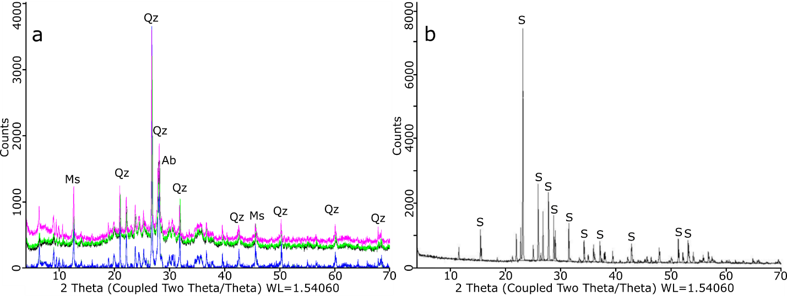
Supplemental Figure 1. Diffractograms of sediments samples (201 to 205). (a) Compiled diffractograms showing identical peaks between them 201 (black), 202 (dark green), 203 (blue), 204 (green) and 205 (pink). (b) Diffraction profile from precipitates obtained in culture enrichments (204 sample). Ab: Albite, Ms: Muscovite, Qz: Quartz, S: Sulfur.

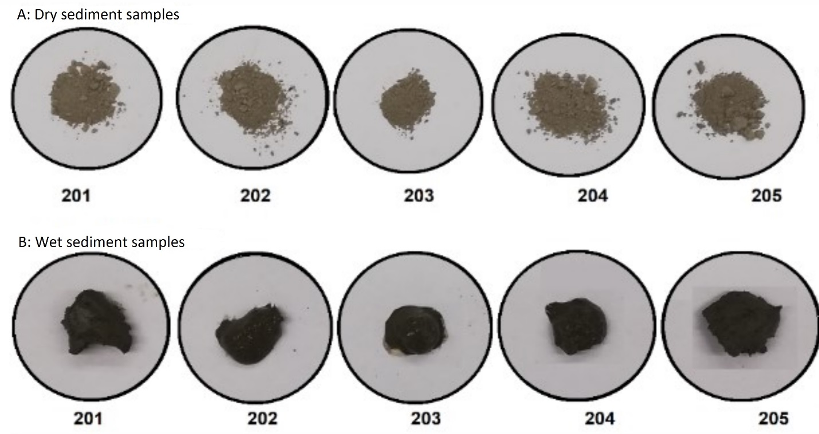
Supplemental Figure 2. Picture of dry (A) and wet (B) sediments from different stations in the Orca Seamount area.

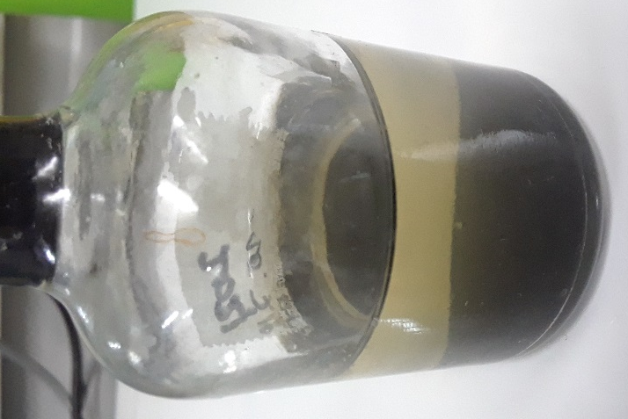
Supplemental Figure 3. Insoluble, black iron sulfide precipitates corresponding mainly to marcasite (FeS₂), produced during microbial growth under S° reducing conditions.

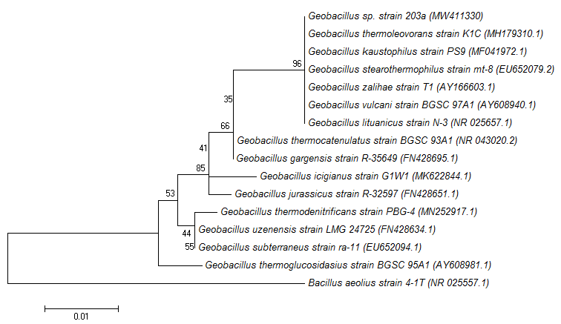
Supplemental Figure 4. Neighbor-joining phylogenetic tree based on 16S rRNA gene sequences of species from the Geobacillus genus. The percentage of replicate trees in which the associated taxa clustered together in the bootstrap test (1000 replicates) are shown next to the branches. The 16S rRNA gene sequence of Bacillus aeolius strain 4-1^{T} was used as an out-group. GenBank accession numbers are given in parentheses. Bar, 1 nucleotide substitutions per 100 nucleotides.

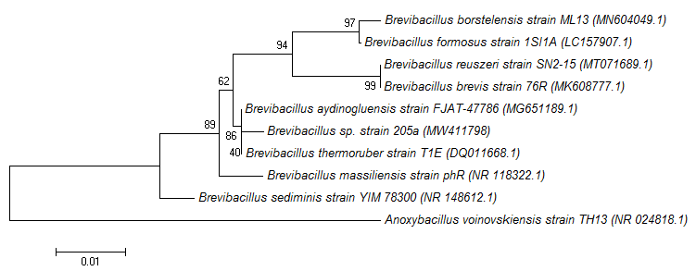
Supplemental Figure 5. Neighbor-joining phylogenetic tree based on 16S rRNA gene sequences of species from the Brevibacillus genus. The percentage of replicate trees in which the associated taxa clustered together in the bootstrap test (1000 replicates) are shown next to the branches. The 16S rRNA gene sequence of Anoxybacillus voinovskiensis strain TH13 was used as an out-group. GenBank accession numbers are given in parentheses. Bar, 1 nucleotide substitutions per 100 nucleotides.

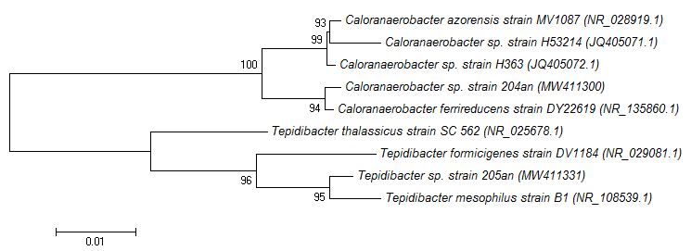
Supplemental Figure 6. Neighbor-joining phylogenetic tree based on 16S rRNA gene sequences of species from the Caloranaerobacter and Tepidibacter genus. The percentage of replicate trees in which the associated taxa clustered together in the bootstrap test (1000 replicates) are shown next to the branches. GenBank accession numbers are given in parentheses. Bar, 1 nucleotide substitutions per 100 nucleotides.

