Figure S1. Effect of chloroquine during OGD_{reox} and effects of PLAT/tPA on autophagy flux under normoxic conditions and dose effects during OGD_{reox}. (A) Representative immunostaining of neurons transduced with GFP-LC3 lentivirus then stain with anti-GFP antibody (yellow), and subjected or not to OGD_{reox} with or without 300 nM PLAT. RBFOX3/NeuN staining appears in cyan. (B) Corresponding percentage of area with GFP-LC3-positive dots compared to total area of neuron (mean±S.E.M. n=7 for Ctrl; n=9 for OGD_{reox}; n=9 for OGD_{reox} + PLAT; from 4 independent experiments; ###: p<0.001 compared to Ctrl; *: p<0.05 compared between OGD_{reox}; Mann–Whitney test). (C) Neuronal death of pure cortical neurons assessed by LDH release after OGD_{reox} in the presence or not of 50, 100 or 200 µM of Chloroquine (mean±S.E.M. n=25 from 6 independent experiments; ***: p<0.001 and *: p<0.05 compared between OGD_{reox}; Mann–Whitney test; dose/response correlation, Pearson r=0.9801 and *: p<0.05). (D) Representative western blots of LC3-II, SQSTM1/p62 and actin in cortical neurons in the presence or not of PLAT (300 nM). Densitometric quantification of LC3-II (E), or SQSTM1/p62 (F) normalized to actin (mean±S.E.M. n=6 independent experiments; ns: not significant; Mann–Whitney test). (G) Representative western blots of LC3-II, SQSTM1 and actin in neurons subjected or not to OGD_{reox} in the presence of PLAT 0 to 300nM. Densitometric quantification of LC3-II (H) and SQSTM1 (I) normalized to ACTB/actin (mean±S.E.M. n=5 independent experiments; ##: p<0.01 and #: p<0.05 compared to Ctrl; **: p<0.01 and *: p<0.05 compared between OGD_{reox}; Mann–Whitney test).

Figure S2. PLAT prevents hypoxic/excitotoxic-induced MTOR dephosphorylation. PLAT (300 nM) treatment prevents KaHx-induced decrease in MTOR phosphorylation (at Ser2448) as shown by (A) representative immunoblots and (B) the corresponding quantifications of the ratio p-MTOR:MTOR (Ct: 2.1 ± 0.2%, Ct+PLAT: 2.2 ± 0.3, KaHx: 1 ± 0.1%, KaHx: 1.9 ± 0.2%) PLAT (300 nM). Values are mean ± SEM. n = 8 or 9 from 3 independent experiments. ## p< 0.01 compared to untreated control neurons, *p< 0.05, **p< 0.01. Tukey's multiple comparisons tests.

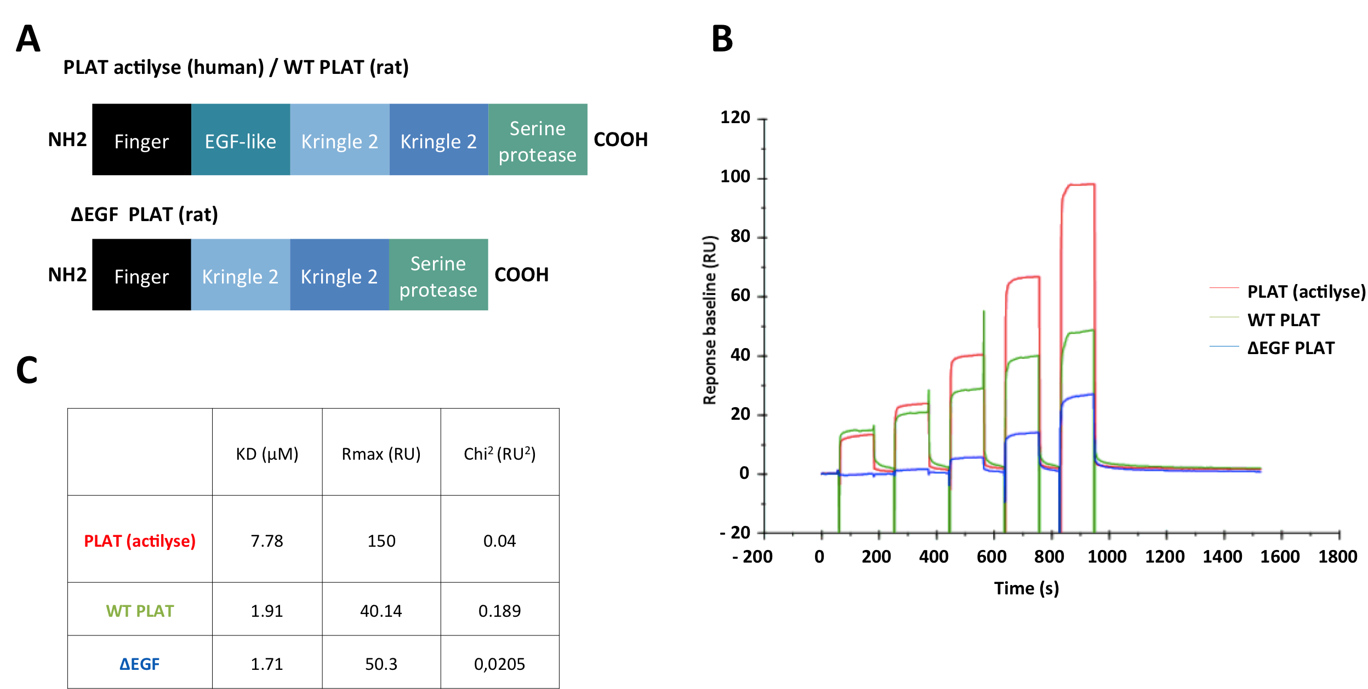
Figure S3. PLAT does not mediate a biological effect by a direct interaction to IGF1R. (A) Schematic representation of PLAT actilyse, wild-type PLAT (WT PLAT) and ΔEGF PLAT. PLAT (actilyse), WT PLAT and ΔEGF PLAT binding on IGF1R was measured by surface plasmon resonance (SPR) (B) Sensorgrams of the response (RU) versus time of the single-cycle kinetics assay performed by injecting five increasing concentrations (10, 5, 2.5, 1.25 and 0.625 μM) of PLAT (actilyse; red), PLAT WT (green) or PLAT ΔEGF (blue) on human recombinant IGF1R. (C) The equilibrium dissociation constant (KD), the analyte binding capacity (Rmax) and the Chi² (the sum of squared differences between the experimental data and reference data at each point values) reported in the table were obtained by fitting data with the langmuir 1:1 binding model and with the steady state model.

