**Supporting Information**

**Pollution profile of waterborne bacterial and fungal community in urban rivers of Pearl River Estuary: Microbial safety assessment**

**Qiyan Gua, Wanjun Wanga,b*, Guiying Lia,b, Yan Liua, Po Keung Wonga,b, Taicheng Ana,b**

*a Guangdong Key Laboratory of Environmental Catalysis and Health Risk Control, Guangdong Hong Kong-Macao Joint Laboratory for Contaminants Exposure and Health, Institute of Environmental Health and Pollution Control, Guangdong University of Technology, Guangzhou 510006, China.*

*b**Guangzhou Key Laboratory Environmental Catalysis and Pollution Control, Key Laboratory of City Cluster Environmental Safety and Green development, School of Environmental Science and Engineering, Guangdong University of Technology, Guangzhou 510006, China.*

Corresponding author

____________________________________________________________________

Tel: +86 20 3932 2298, Fax: +86 20 3932 2298, E-mail: wanjun@gdut.edu.cn (W.J. Wang);

Pages: 11

Contents: Experimental details; Seven Figures (Figure S1-S7);

Two Tables (Table S1-S2)

**DNA extraction and quality control**

High-quality DNA was extracted from the filter membranes by a modified method according to the previous study (Liang et al., 2020). Briefly, the membranes were cut into small pieces in a clean bench with sterilized scissors, forceps, and filter funnels. The remaining steps were performed according to the standard procedure of MP FastDNA SPIN Kit for Soil (MP Biomedicals, USA). The yield and quality of the extracted DNA were verified by gel electrophoresis and a spectrophotometer analysis (Nanodrop ND-1000). The obtained DNA extracts with the OD260/280 value between 1.8 and 2.0 were stored at -80°C for further analysis.

**Fungal community analyses**

The primer pair ITS3F: 5'-GCATCGATGAAGAACGCAGC-3' and ITS4R: 5'-TCCTCCGCTTATTGATATGC-3' were used for amplifying the fungal internal transcribed spacer of nuclear ribosomal RNA gene sequences. Raw sequence data were processed using QIIME 1.9.1 software according to the references (Zhang et al., 2016). Briefly, the sequence libraries were split and denoised to avoid diversity overestimation caused by sequencing errors. Operational taxonomic units (OTUs) were clustered with a 97 % similarity cutoff using UPARSE (Edgar, 2013), and chimeric sequences were identified and removed using UCHIME (Edgar et al., 2011). Sequences representing the OTUs were subjected to BLASTn search in UNITE 8.0 (https://unite.ut.ee/) to determine their taxonomic affiliation.

**Table S1.** Physical and chemical properties of different surface water samples. DO, dissolved oxygen; COD, chemical oxygen demand; TP, total phosphorus; TN, total nitrogen; TOC, total organic carbon.

|  |  |  |  |  |  |  |  |  |  |  |  |
| --- | --- | --- | --- | --- | --- | --- | --- | --- | --- | --- | --- |
| Sample | R4U | R4M | R4D | R8U | R8M | R8D | R16U | R16M | R16D | R19M | R19D |
| Location | 22.72° N 113.55° E | 22.71° N  113.54° E | 22.70° N 113.52° E | 22.70° N  113.58° E | 22.69° N  113.57° E | 22.67° N  113.55° E | 22.64° N  113.64° E | 22.63° N  113.63° E | 22.62° N  113.61° E | 22.60° N  113.65° E | 22.58° N  113.63° E |
| Temperature (℃) | 31.80 | 31.30 | 29.50 | 32.30 | 31.60 | 28.40 | 31.60 | 31.20 | 31.00 | 29.60 | 30.40 |
| PH | 7.91 | 7.97 | 7.83 | 8.11 | 7.86 | 8.02 | 8.25 | 8.23 | 8.10 | 8.21 | 8.30 |
| DO (mg/L) | 3.70 | 4.51 | 5.17 | 6.27 | 4.65 | 5.03 | 7.08 | 6.01 | 3.95 | 5.26 | 5.81 |
| COD (mg/L) | 113.20 | 60.20 | 59.20 | 147.20 | 66.20 | 25.20 | 32.20 | 41.20 | 69.20 | 73.20 | 66.20 |
| TP (mg/L) | 1.98 | 1.78 | 1.53 | 0.76 | 1.06 | 1.56 | 0.89 | 0.81 | 1.16 | 1.46 | 0.99 |
| UV254 | 0.07 | 0.05 | 0.05 | 0.08 | 0.07 | 0.05 | 0.08 | 0.07 | 0.06 | 0.08 | 0.12 |
| TOC (mg/L) | 3.87 | 2.16 | 1.75 | 4.60 | 3.80 | 3.00 | 3.39 | 3.69 | 2.75 | 3.14 | 3.74 |
| Nitrite (mg/L) | 0.28 | 0.10 | 0.14 | 0.25 | 0.26 | 0.15 | 0.43 | 0.28 | 0.19 | 0.13 | 0.18 |
| Nitrate (mg/L) | 18.16 | 13.38 | 21.28 | 7.06 | 17.37 | 37.73 | 43.07 | 25.79 | 45.90 | 37.14 | 36.83 |

|  |  |  |  |  |  |  |  |  |  |  |
| --- | --- | --- | --- | --- | --- | --- | --- | --- | --- | --- |
|  |  | T | pH | DO | COD | TP | UV254 | TOC | NO2-N | NO3-N |
| **bacteria** | RDA1 | -0.9774 | -0.4656 | 0.1351 | -0.8496 | 0.5146 | -0.4896 | -0.8143 | -0.9995 | 0.6815 |
| RDA2 | 0.2113 | 0.885 | 0.9908 | 0.5274 | -0.8574 | 0.872 | 0.5805 | 0.033 | -0.7318 |
| r2 | 0.5794 | 0.0237 | 0.2143 | 0.2688 | 0.4397 | 0.2282 | 0.6611 | 0.2111 | 0.1991 |
| p_values | 0.027* | 0.899 | 0.374 | 0.248 | 0.111 | 0.326 | 0.014* | 0.391 | 0.392 |
| **fungi** | RDA1 | -0.4833 | -0.9981 | -0.948 | 0.4241 | 0.9052 | -0.6416 | -0.4993 | -0.9308 | -0.6561 |
| RDA2 | 0.8754 | -0.0615 | -0.3181 | 0.9056 | -0.425 | 0.7671 | 0.8664 | 0.3654 | -0.7547 |
| r2 | 0.7667 | 0.4822 | 0.3841 | 0.2881 | 0.44 | 0.353 | 0.423 | 0.5356 | 0.1967 |
| p_values | 0.006** | 0.09 | 0.152 | 0.251 | 0.123 | 0.189 | 0.109 | 0.039* | 0.411 |

**Table S2.** The interpretation weight ratio and correlation data of each dimension in the RDA biplot.

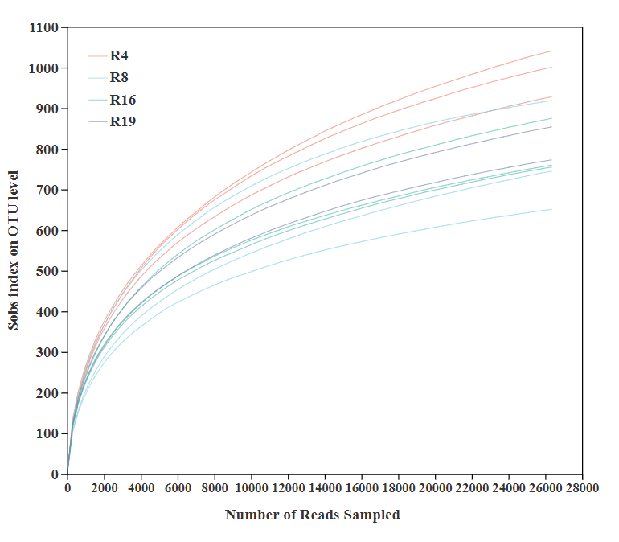

**(a)**

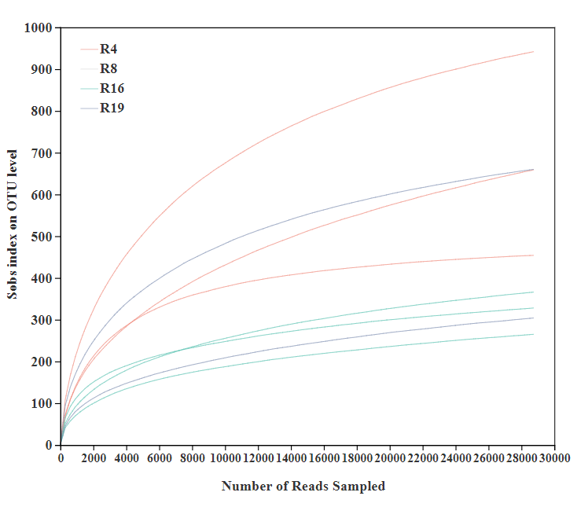

**(b)**

**Figure S1.** Rarefaction curves of (a) bacterial and (b) fungi from different rivers.

**(b)**

**(a)**

**Figure S2.** Venn diagram of bacteria on OTU level at four different urban rivers.

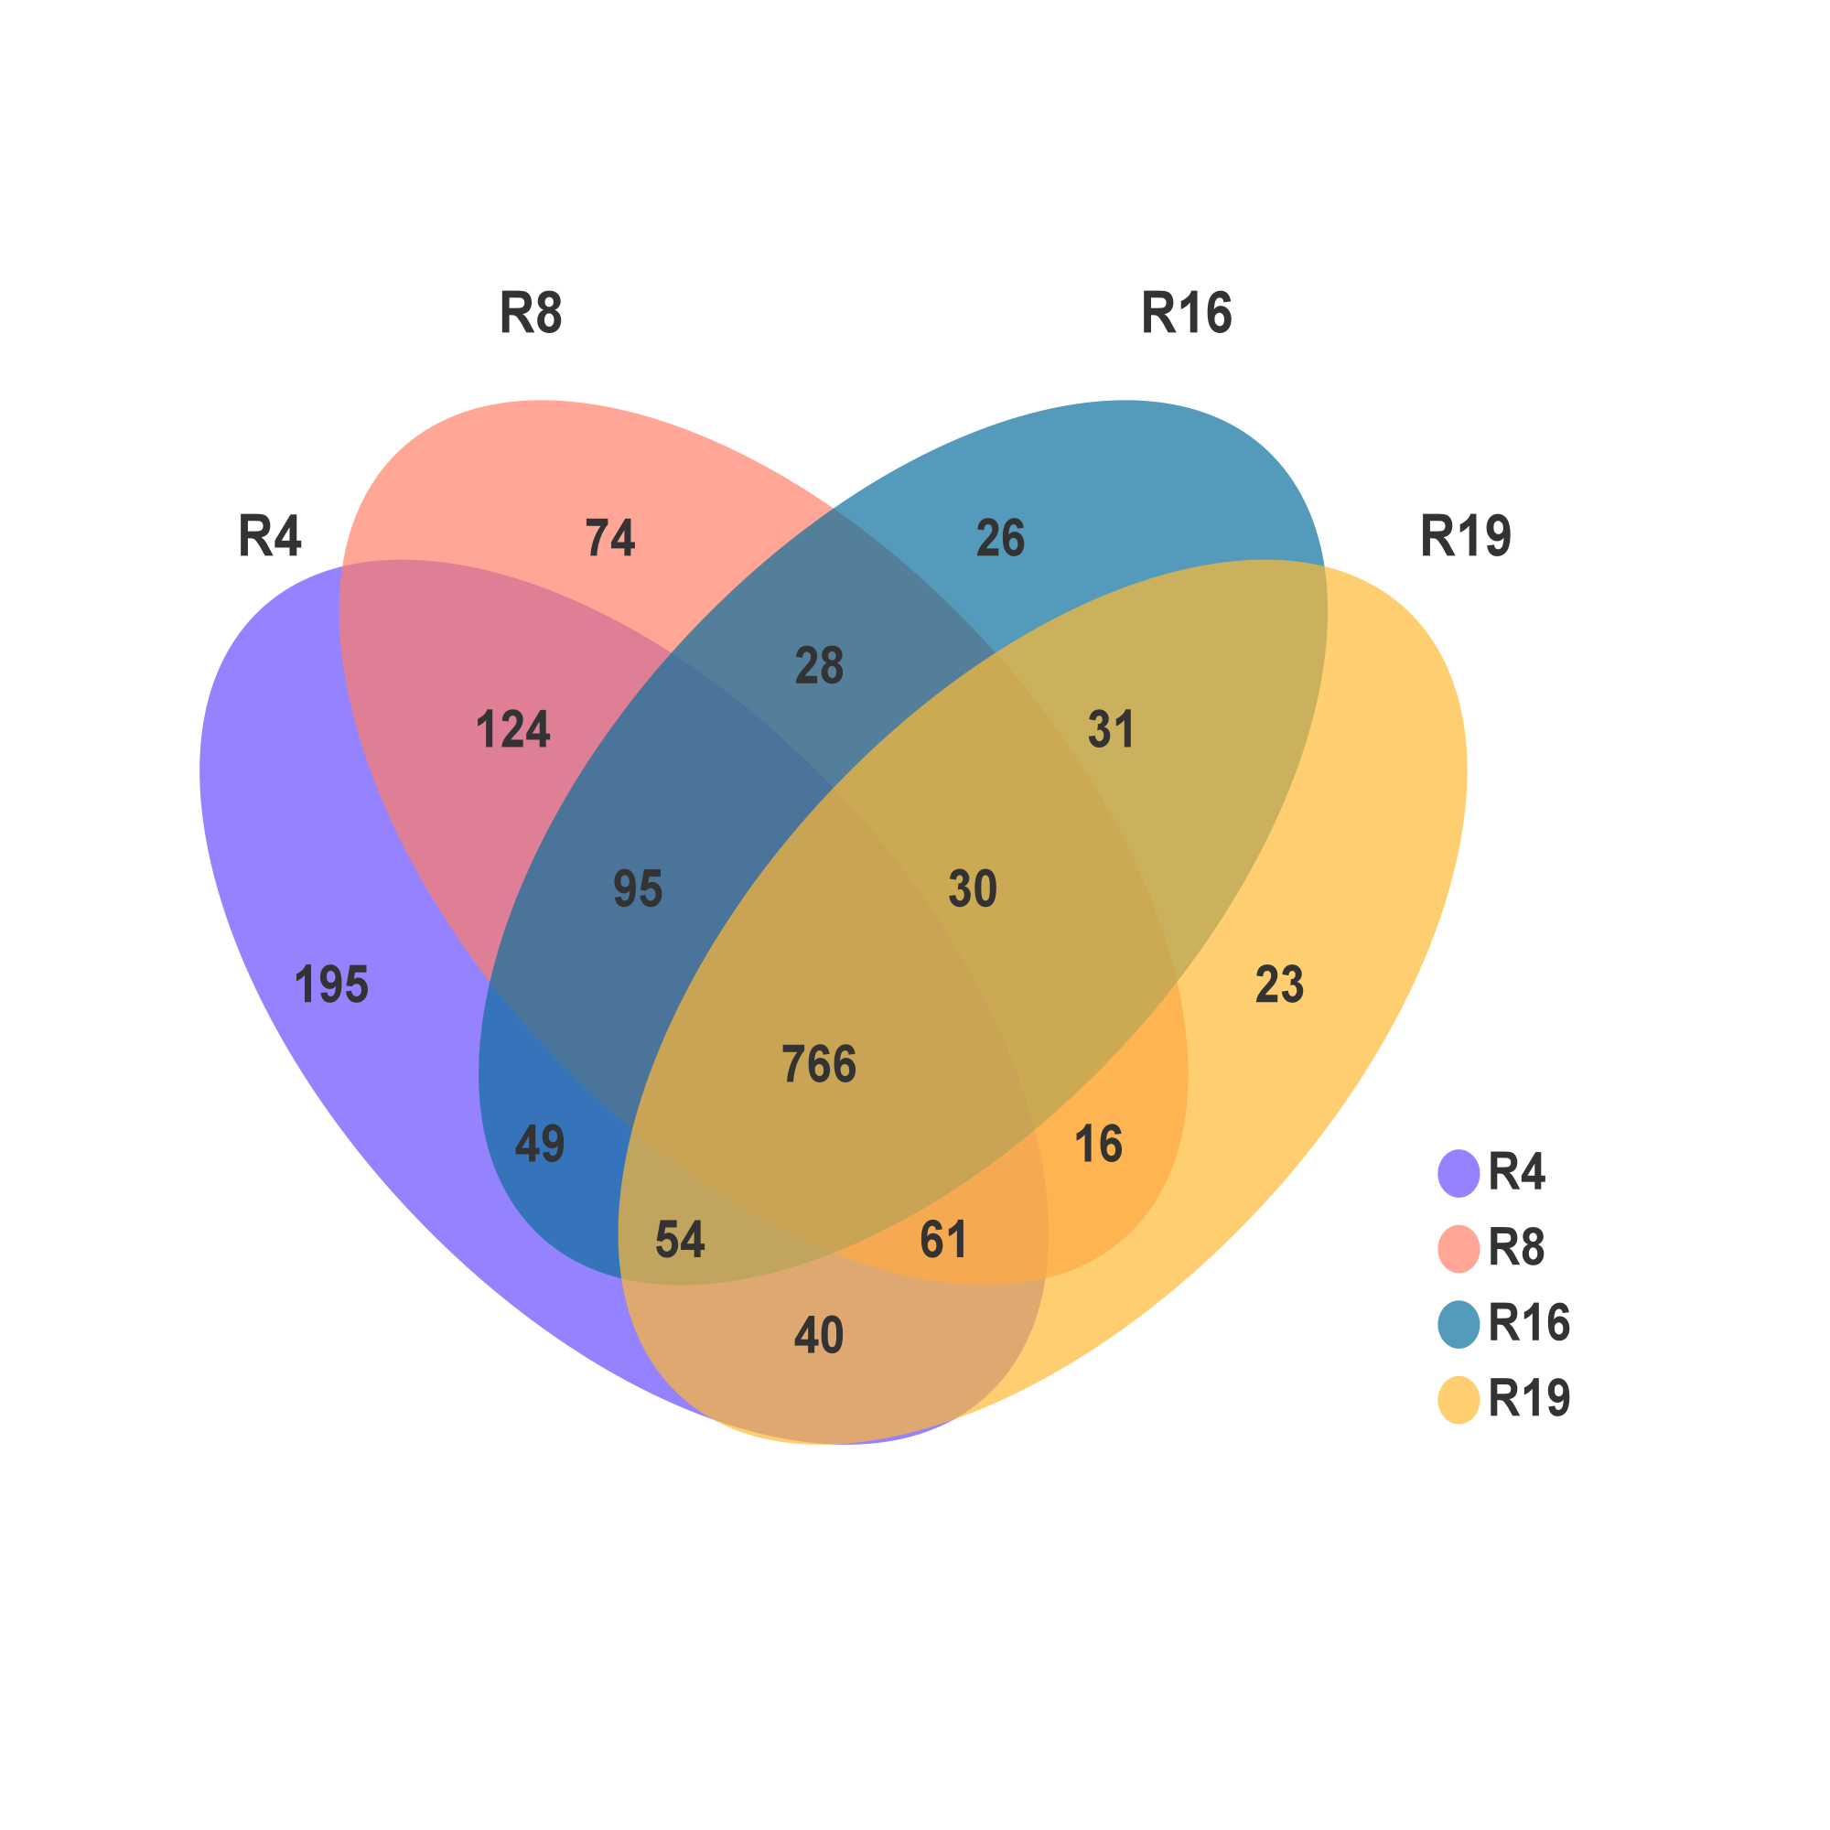



**(a)**



**(b)**

**Figure S3.** Different taxonomic numbers of sequence and derived OTU in (a) bacteria and (b) fungi.



**Figure S4.** Spearman correlations between physicochemical factors and the top 30 waterborne pathogenic bacteria at the genus level.

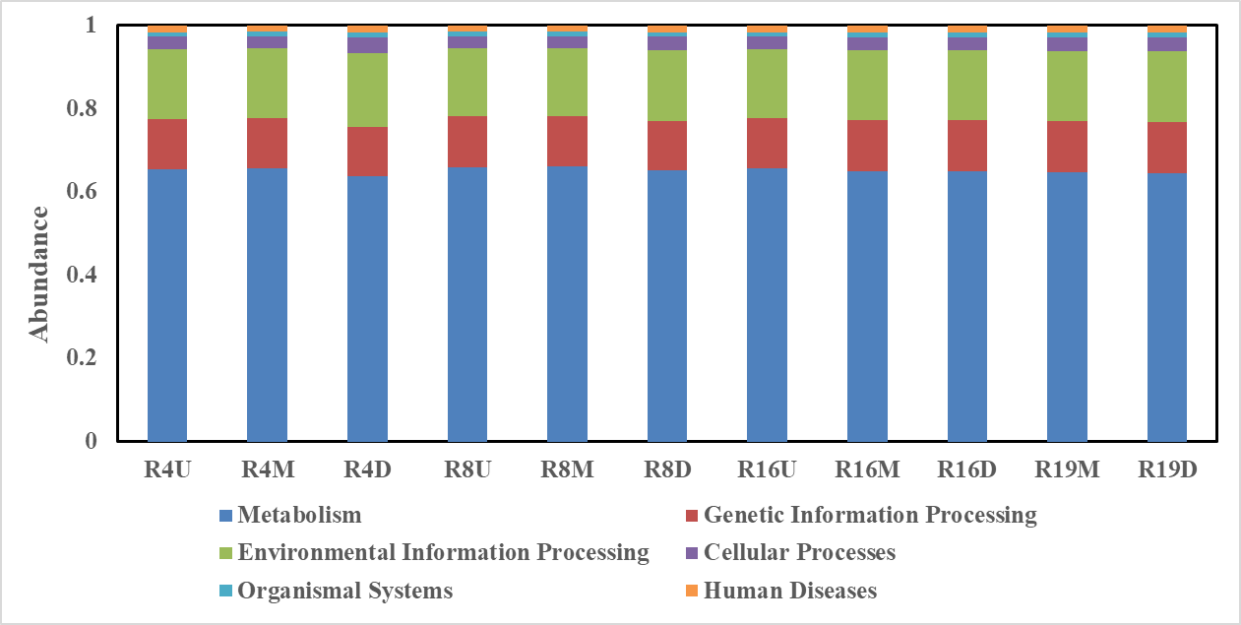

**(a)**

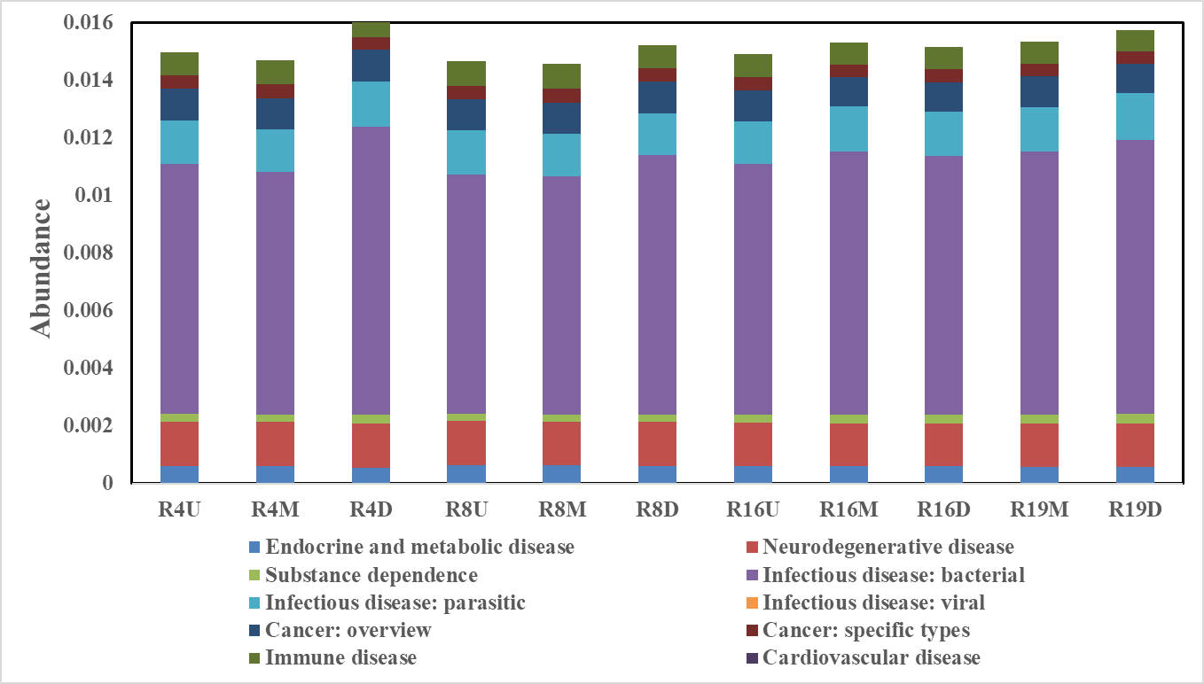

**(b)**

**Figure S5.** Relative abundance of KEGG (a) level 1 pathways and (b) level 2 pathways associated with human disease.



**Figure S6.** Levels of the maximum fluorescence intensities (FImax) of the PARAFAC-components in the water samples.



**Figure S7.** The community compositions of waterborne pathogenic bacteria at the genus level.

**References:**

Edgar, R C, 2013. UPARSE: highly accurate OTU sequences from microbial amplicon reads. Nature Methods 10:996-998.

Edgar, R C, Haas, B J, Clemente, J C, Quince, C, Knight, R, 2011. UCHIME improves sensitivity and speed of chimera detection. Bioinformatics 27:2194-2200.

Liang, Z, Yu, Y, Ye, Z, Li, G, Wang, W, An, T, 2020. Pollution profiles of antibiotic resistance genes associated with airborne opportunistic pathogens from typical area, Pearl River Estuary and their exposure risk to human. Environment International 143:105934.

Zhang, T, Wang, N F, Zhang, Y Q, Liu, H Y, Yu, L Y, 2016. Diversity and Distribution of Aquatic Fungal Communities in the Ny-Alesund Region, Svalbard (High Arctic): Aquatic Fungi in the Arctic. Microbial Ecology 71:543-554.