Supplementary Material

Starting Dates Associated to the Selected Countries

Country | First Report of Daily Test | First Reported Case | First Reported Death | First Reported ICU Patient
Canada | 12-Mar | 26-Jan | 9-Mar | 13-Mar
USA | 1-Mar | 24-Jan | Feb-29 | 26-Mar
UK | 31-Mar | 31-Jan | 6-Mar | 2-Apr
Italy | 25-Feb | 31-Jan | 21-Feb | 24-Feb
Belgium | 1-Mar | 4-Feb | 11-Mar | 15-Mar
Ireland | 19-Mar | Feb-29 | 11-Mar | 27-Mar
South Africa | 14-Feb | 5-Mar | 27-Mar | -
Colombia | 8-Mar | 6-Mar | 22-Mar | -
Table S.1: Selected countries and their starting dates for the four considered parameters (All dates were in 2020)

Data Cleaning
After collecting data, we dealt with gaps, outliers, and negative values based on the scenarios and actions listed in Table S.2. Table S.3 reports the number of cleaned pieces of data and their percentages to the total number of considered pieces of data. The percentages are low, and they range from 0.088% to 0.677%. By performing the data cleaning actions, the dataset became ready to perform the required analysis. It is important to note that the cleaning actions potentially did not affect the analysis results because these actions were performed to negligible percentages of data.
ID | Case | Action
1 | Gaps in daily number of cases | If the gap was only for one day and the cumulative number of cases increased during this gap, we calculated the difference between cumulative cases before and after the gap in data to get the daily number of cases.
 |  | If the gap was for multiple days and the cumulative number of cases increased during this gap, we calculated the difference between cumulative cases before and after the gap in data to know the number of cases for multiple days, then we estimated the number of cases relative to the number of tests announced during these days.
 |  | If the cumulative number of cases was missing, linear interpolation was performed based on the number of daily cases, the number of daily tests for the closest dates before and after the considered date, and the number of tests for the considered date.
2 | Gaps in daily number of tests | If the gap was only for one day and the cumulative number of tests increased during this gap, we calculated the difference between cumulative tests before and after the gap in data to get the daily number of tests.
 |  | If the gap was for multiple days and the cumulative number of tests increased during this gap, we calculated the difference between cumulative tests before and after the gap in data to know the number of tests for multiple days, then we estimated the number of tests relative to the number of cases announced during these days.
 |  | If the cumulative number of tests was missing, linear interpolation was performed based on the number of daily tests, the number of cases for the closest dates before and after the considered date, and the number of cases for the considered date.
3 | Gaps, outliers, or negative values in daily death or ICU patient numbers | We set the value based on the average number of deaths or ICU patients for the closest dates before and after the considered date.
4 | Outliers or negative values in daily number of cases | Linear interpolation was performed based on the number of daily tests and number of cases for the closest dates before and after the considered date and the number of tests for the considered date.
5 | Outliers or negative values in daily number of tests | Linear interpolation was performed based on the number of daily tests and number of cases for the closest dates before and after the considered date and the number of cases for the considered date.
Table S.2: Actions to deal with cases of gaps, outliers, and negative values
Country | Cleaned Pieces of Data
Canada | 7 (0.592%)
USA | 2 (0.168%)
United Kingdom | 1 (0.088%)
Italy | 5 (0.407%)
Belgium | 8 (0.677%)
Ireland | 7 (0.621%)
South Africa | 5 (0.590%)
Colombia | 4 (0.467%)
Table S.3: Number and percentage of cleaned pieces of data

The change in APR and 7-day averages for daily tests, cases, deaths, and ICU patients over time

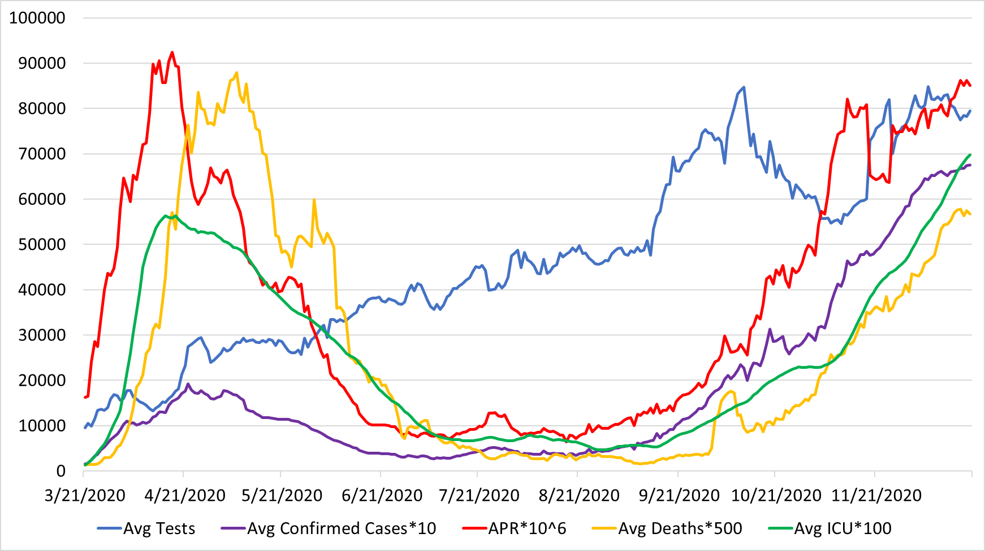
Figure S.1: The change in APR and 7-day averages for daily tests, cases, deaths, and ICU patients over time during the pandemic in Canada
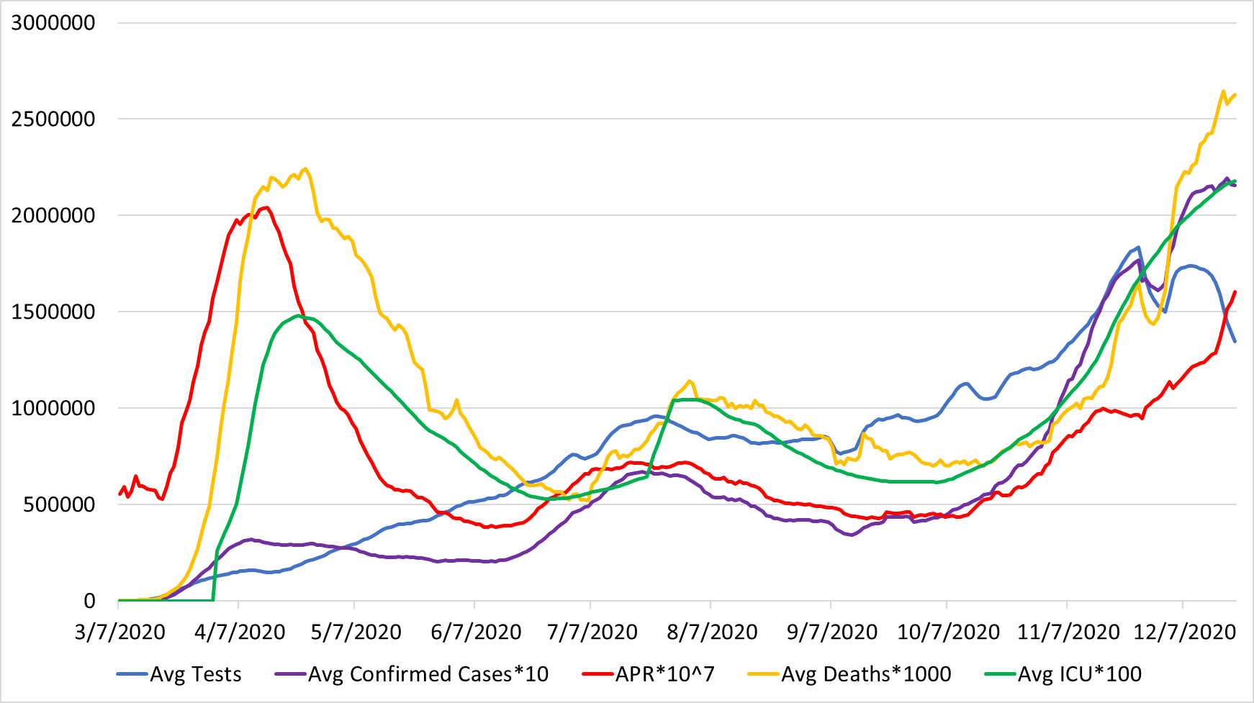
Figure S.2: The change in APR and 7-day averages for daily tests, cases, deaths, and ICU patients over time during the pandemic in the USA

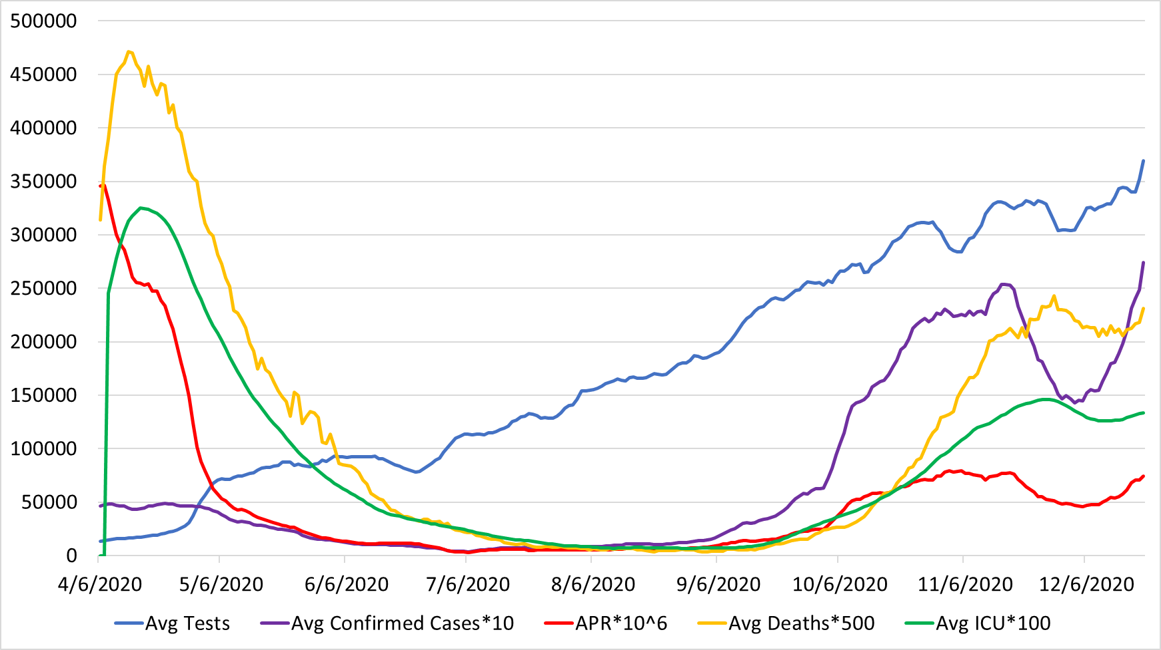
Figure S.3: The change in APR and 7-day averages for daily tests, cases, deaths, and ICU patients over time during the pandemic in the UK
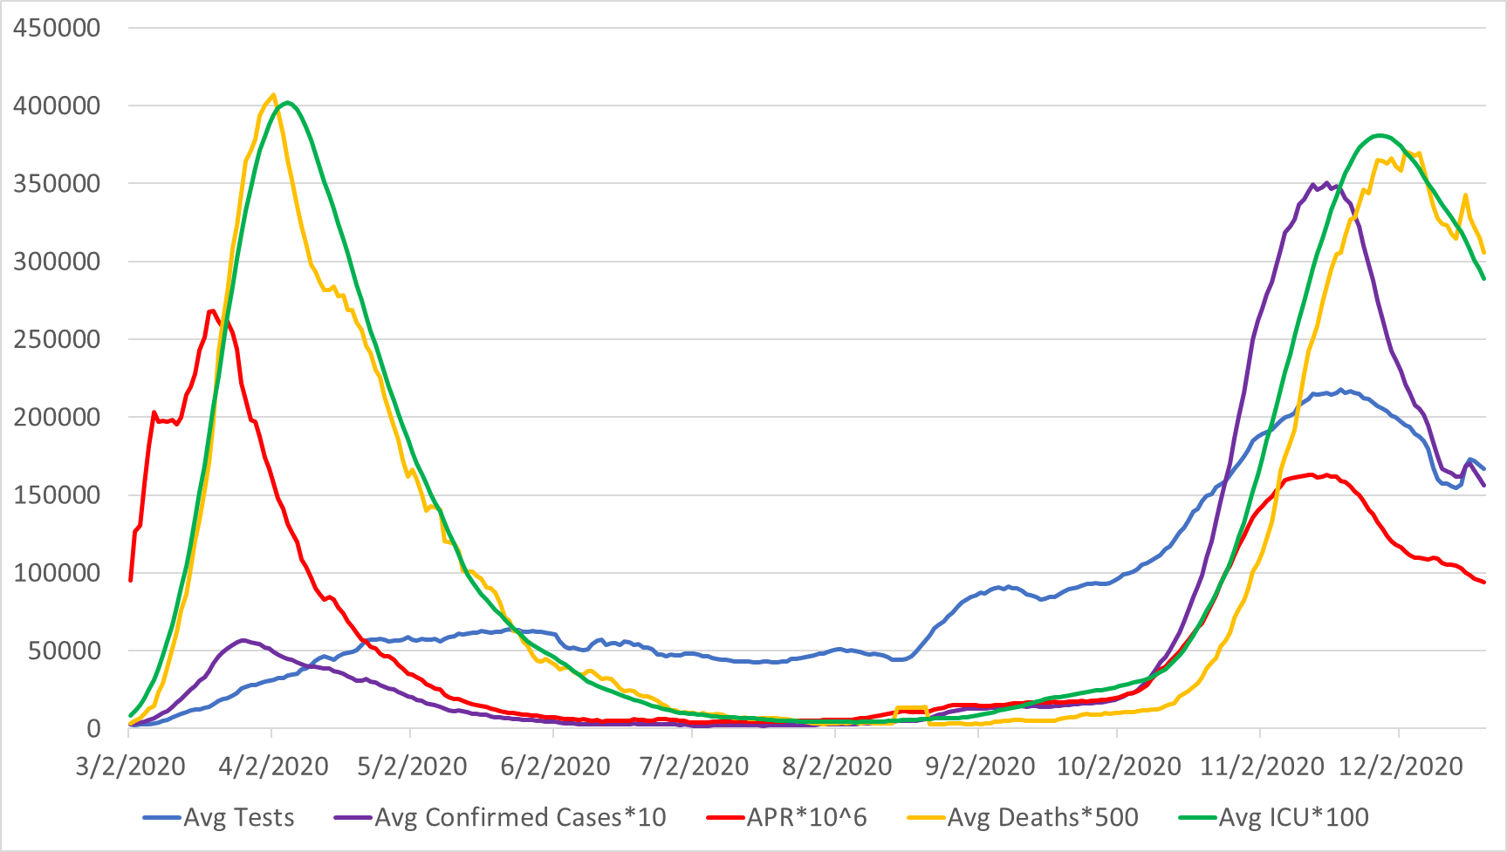
Figure S.4: The change in APR and 7-day averages for daily tests, cases, deaths, and ICU patients over time during the pandemic in Italy

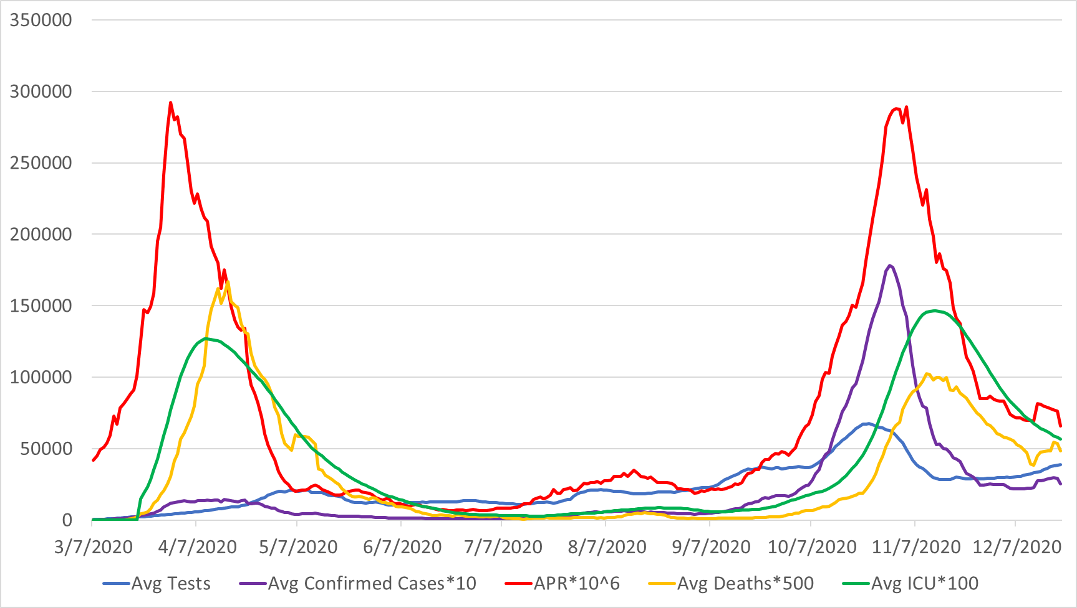
Figure S.5: The change in APR and 7-day averages for daily tests, cases, deaths, and ICU patients over time during the pandemic in Belgium
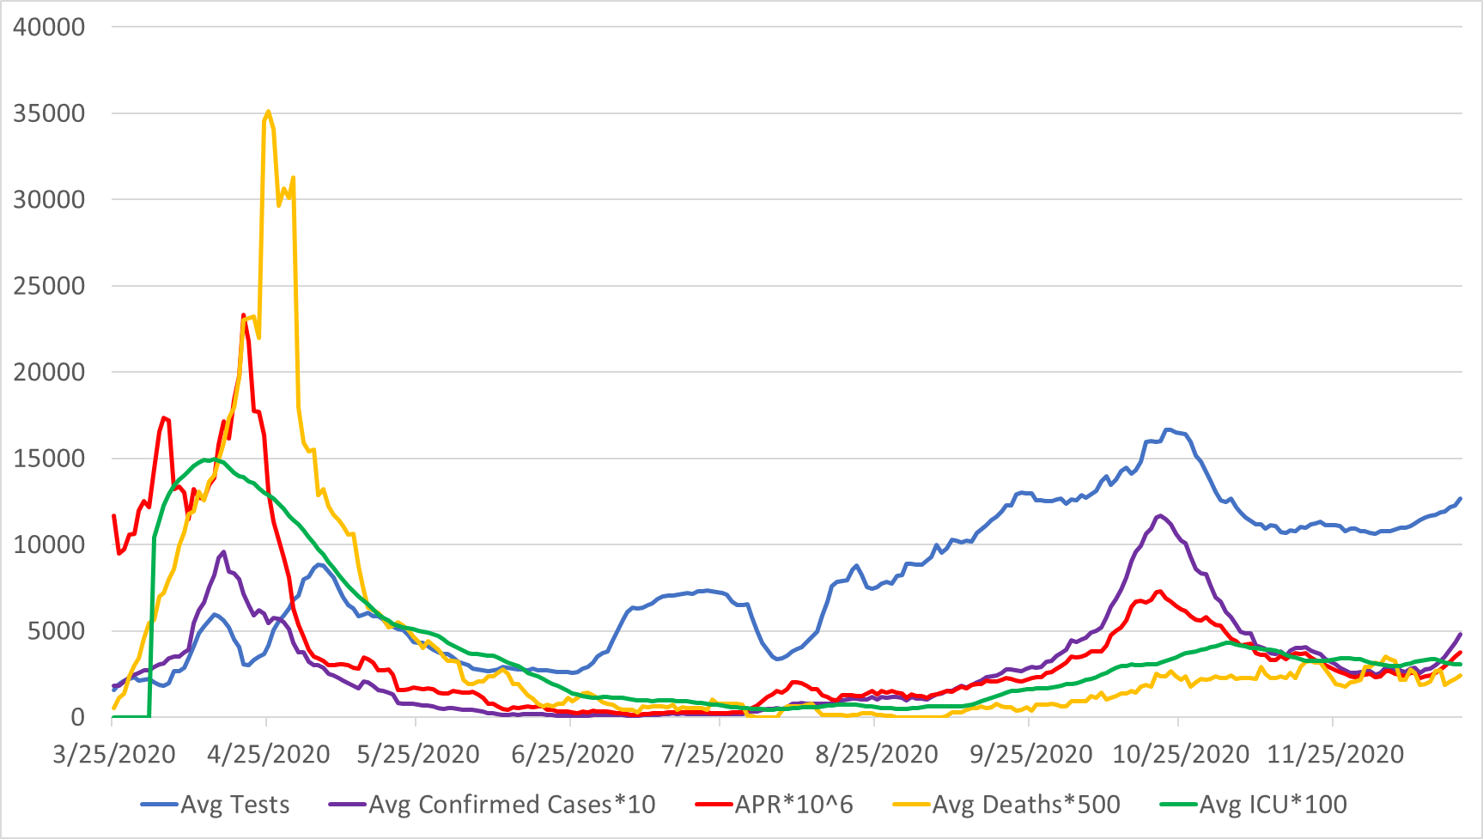
Figure S.6: The change in APR and 7-day averages for daily tests, cases, deaths, and ICU patients over time during the pandemic in Ireland

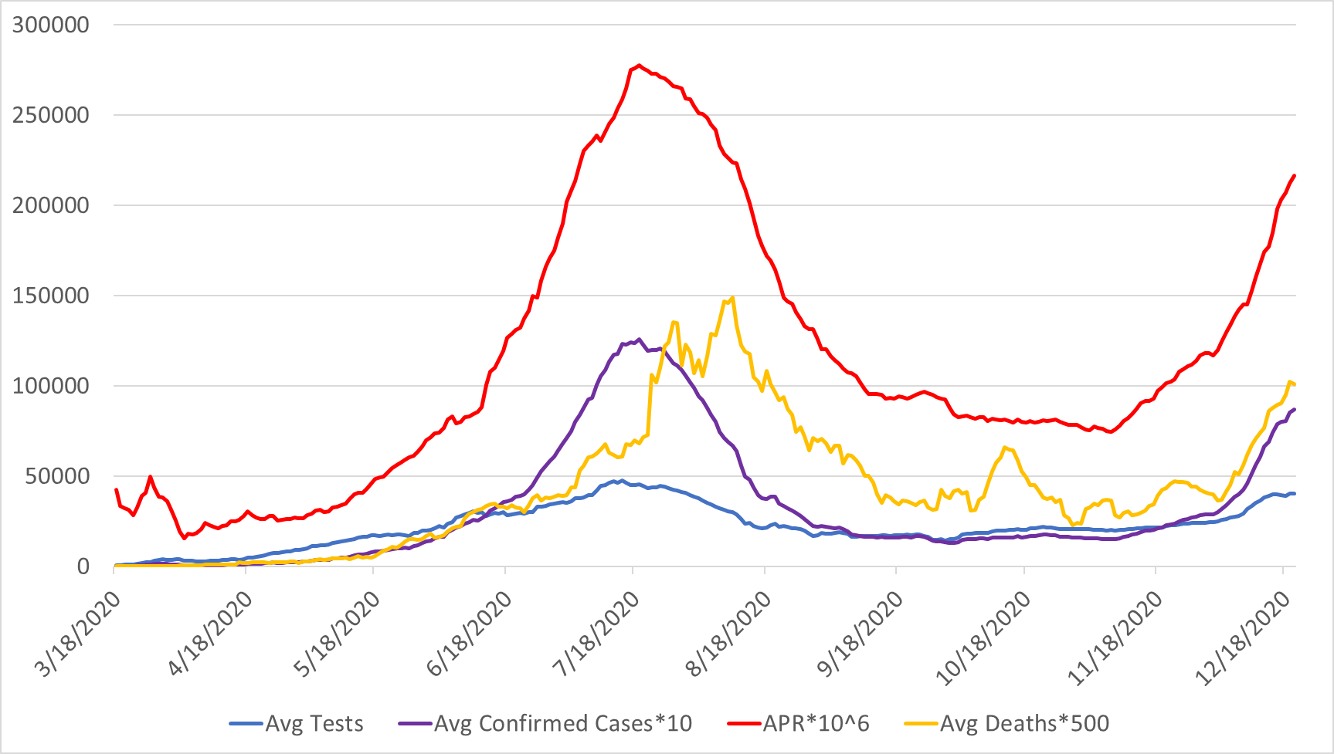

Figure S.7: The change in APR and 7-day averages for daily tests, cases, and deaths over time during the pandemic in South Africa

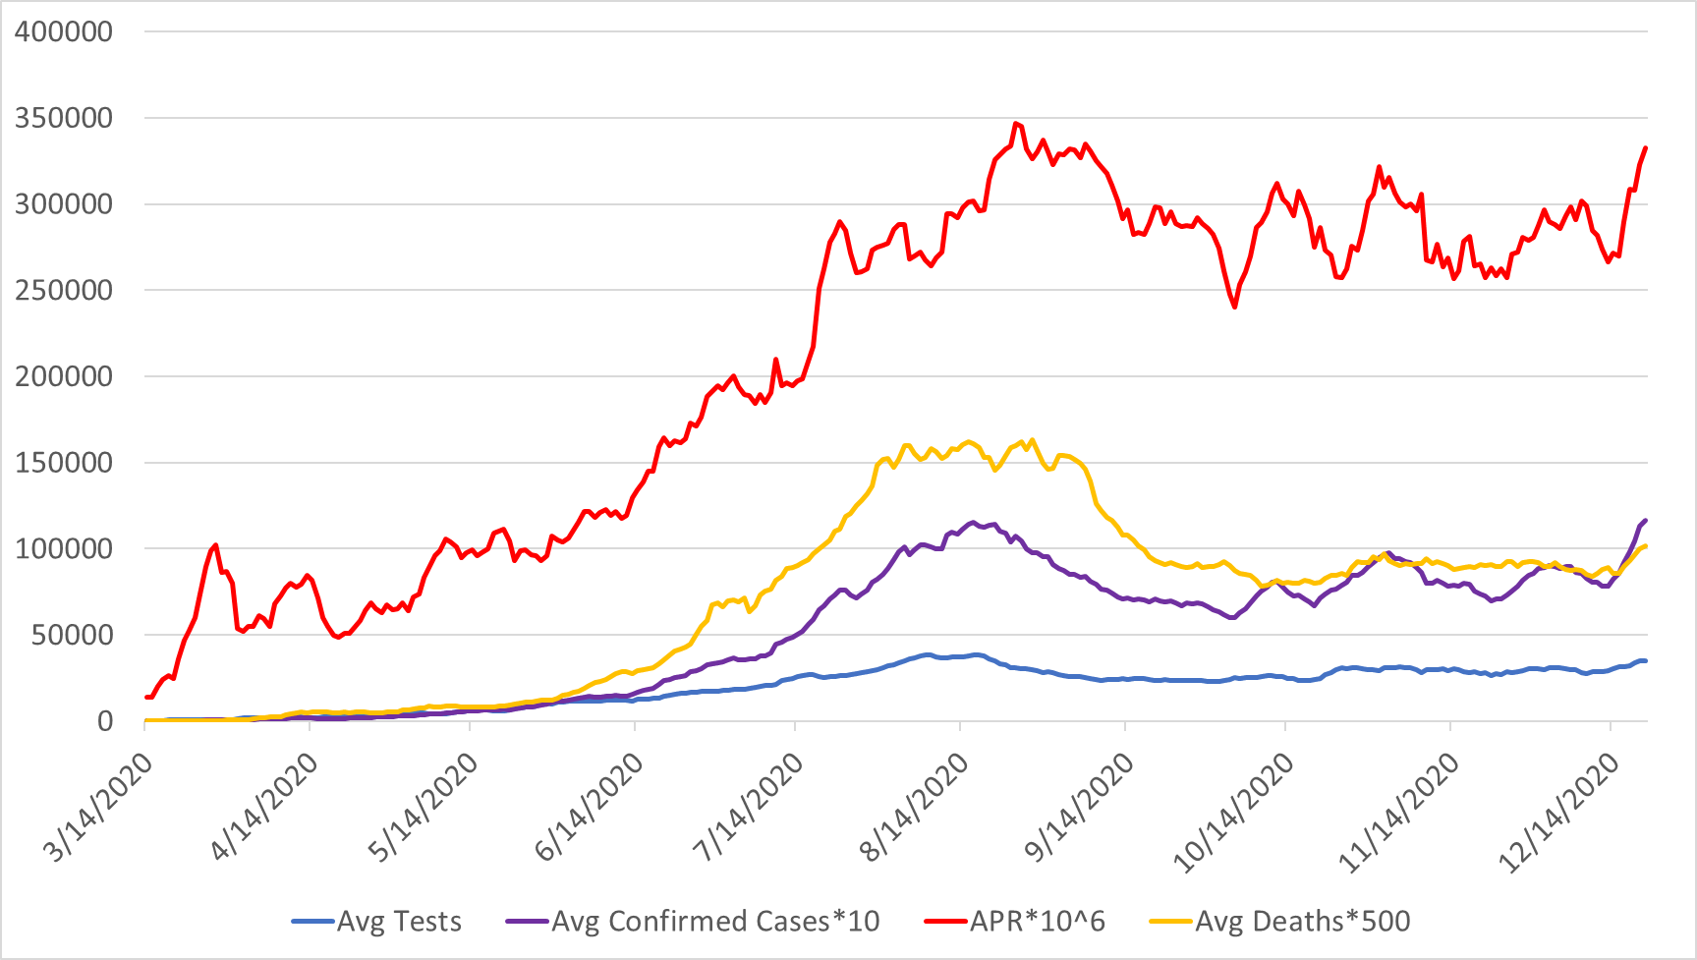
Figure S.8: The change in APR and 7-day averages for daily tests, cases, and deaths over time during the pandemic in Colombia

The change in the coefficient for the correlation between each of the four considered scenarios and deaths

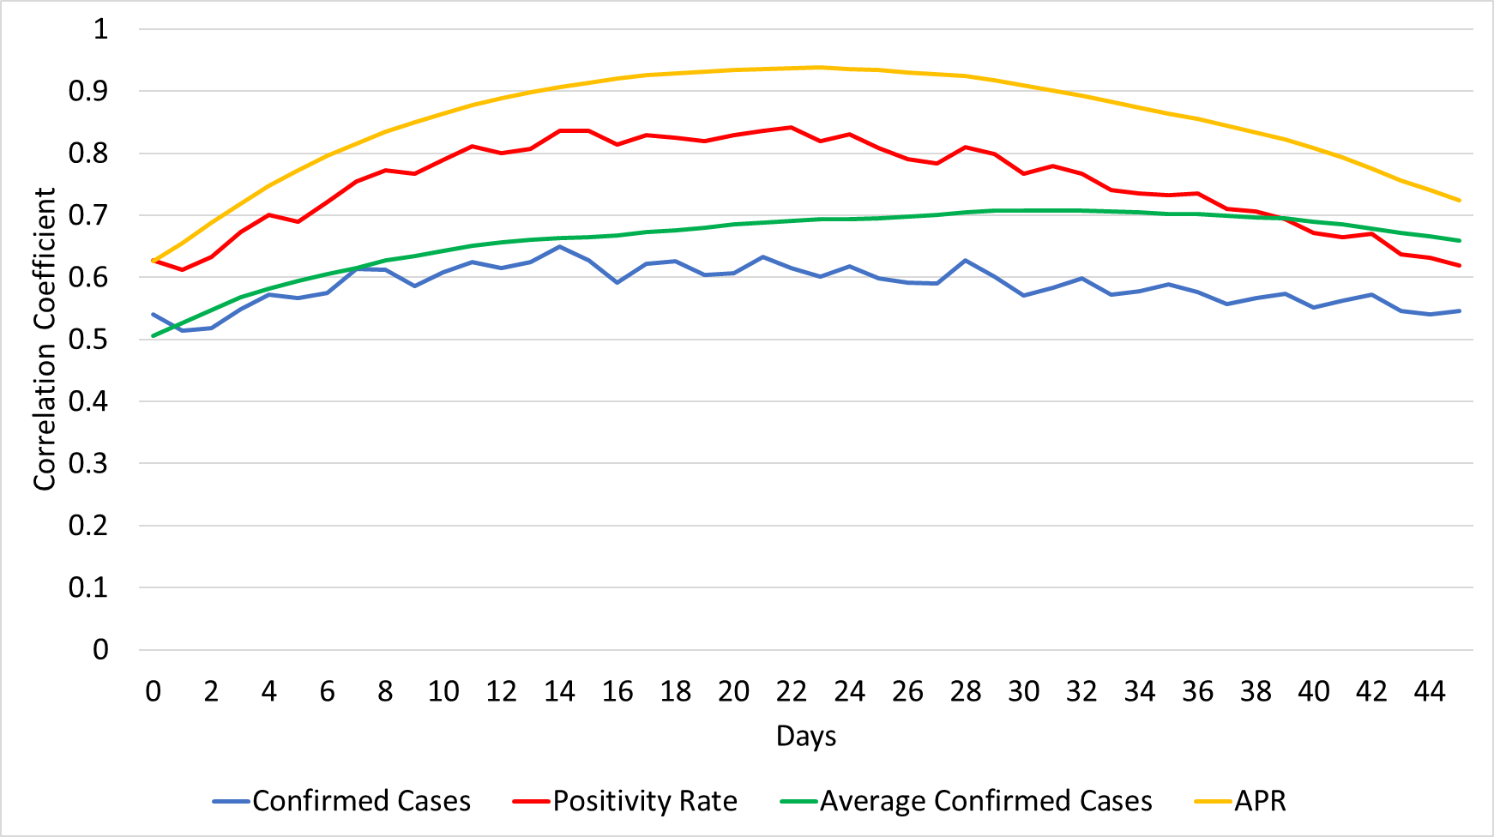
Figure S.9: The change in the coefficient for the correlation between each of the four considered scenarios and deaths reported after x days, where x ranges from 0 to 45, for Canada.
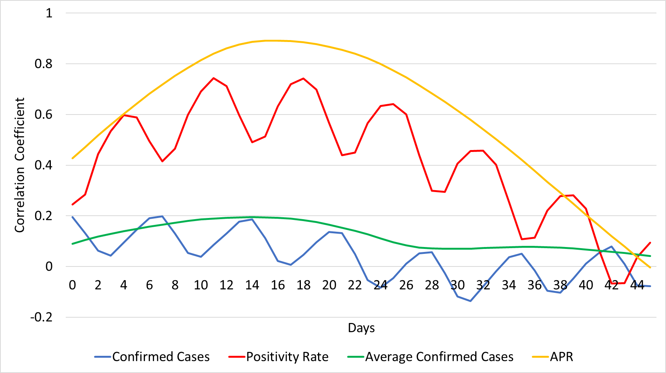
Figure S.10: The change in the coefficient for the correlation between each of the four considered scenarios and deaths reported after x days, where x ranges from 0 to 45, for the USA.

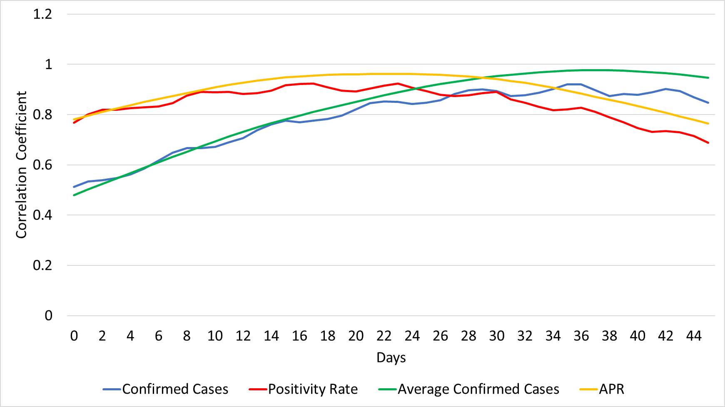
Figure S.11: The change in the coefficient for the correlation between each of the four considered scenarios and deaths reported after x days, where x ranges from 0 to 45, for the UK.

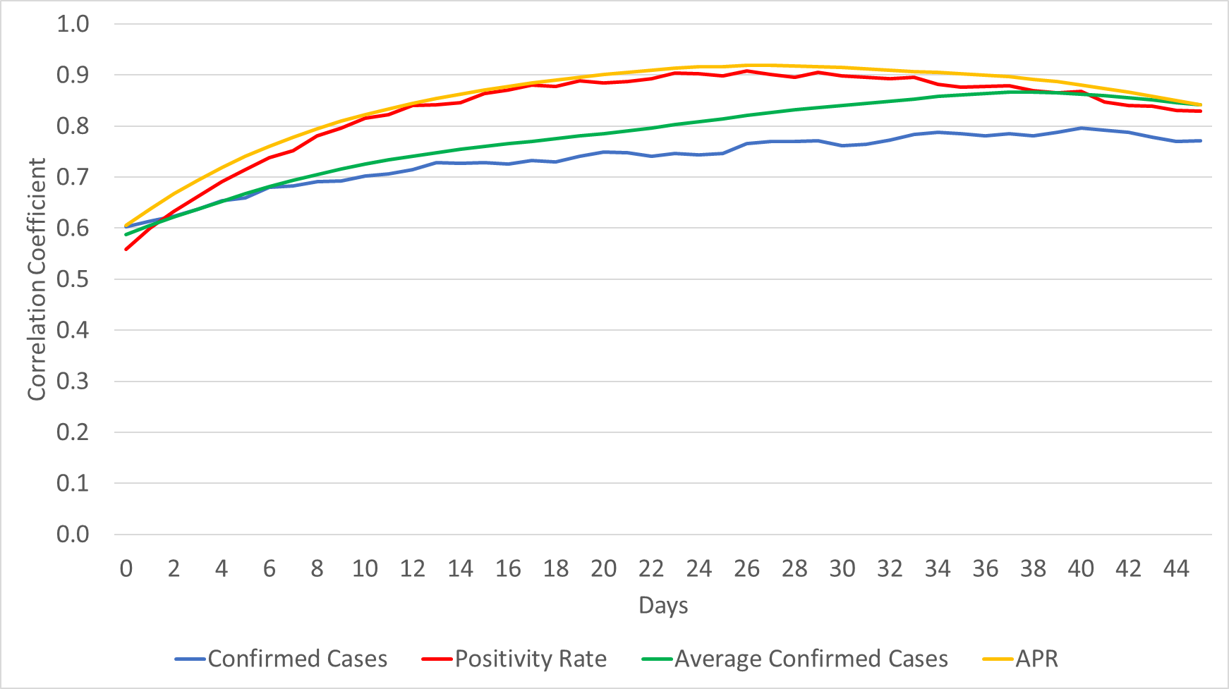
Figure S.12: The change in the coefficient for the correlation between each of the four considered scenarios and deaths reported after x days, where x ranges from 0 to 45, for Italy.
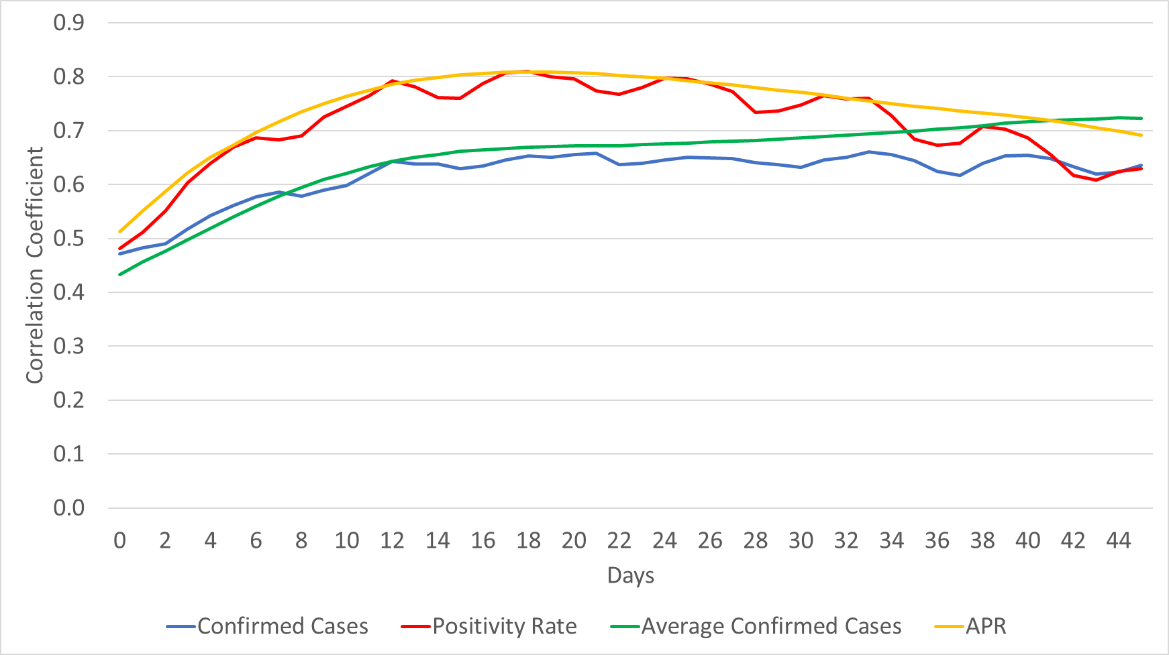
Figure S.13: The change in the coefficient for the correlation between each of the four considered scenarios and deaths reported after x days, where x ranges from 0 to 45, for Belgium.
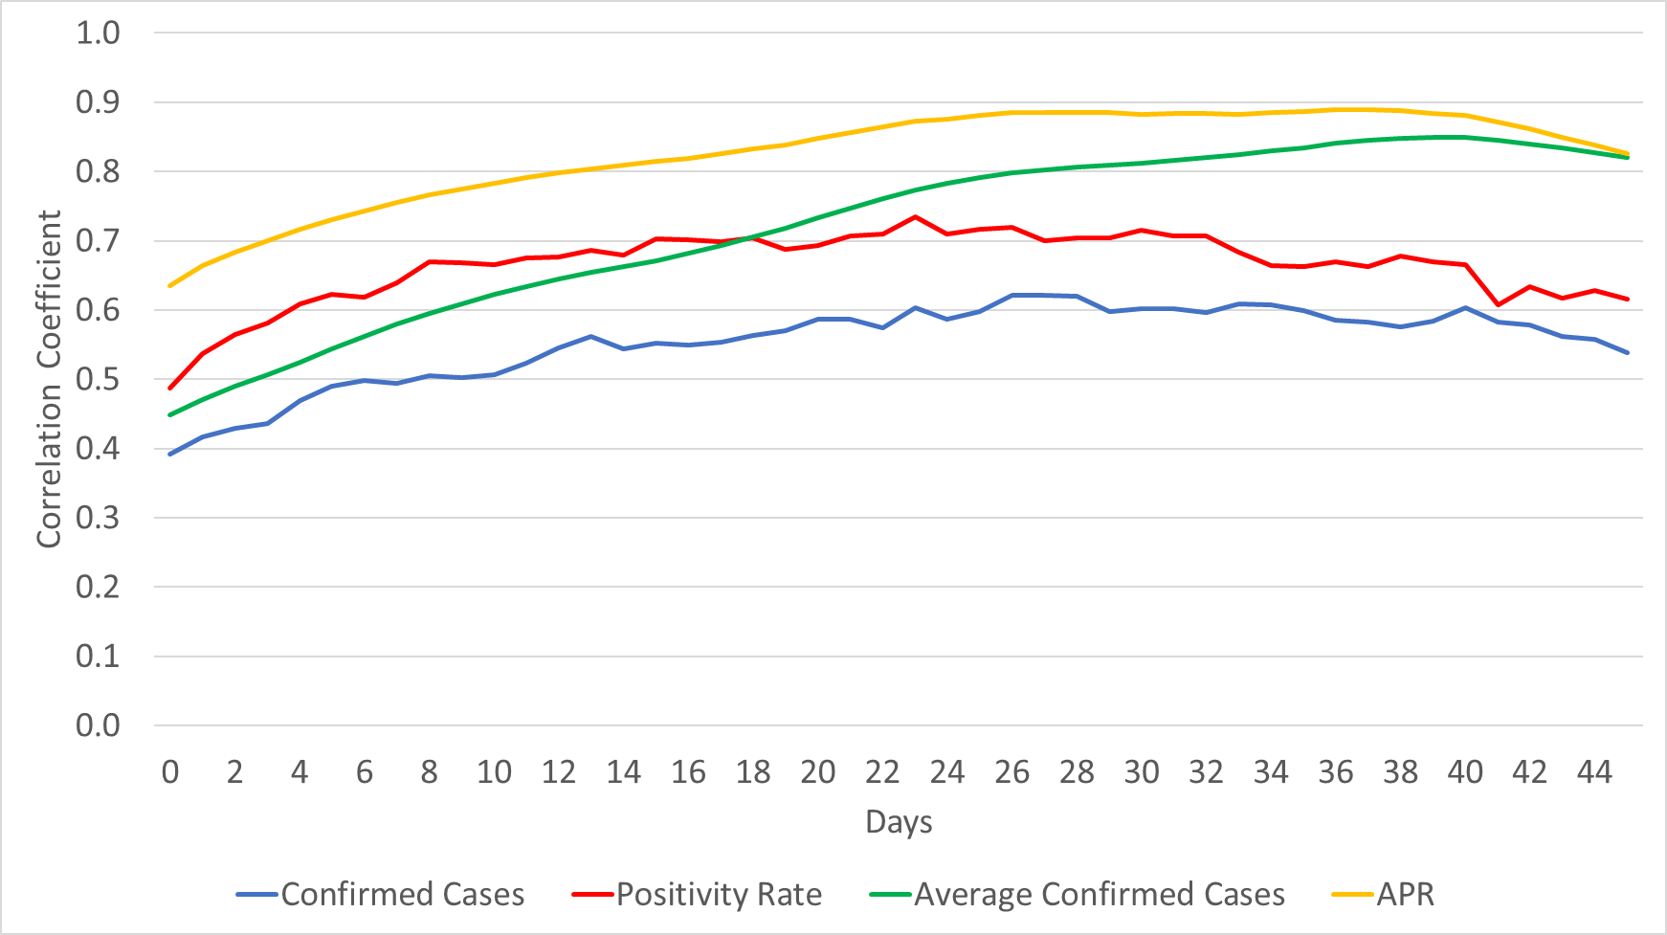
Figure S.14: The change in the coefficient for the correlation between each of the four considered scenarios and deaths reported after x days, where x ranges from 0 to 45, for Ireland.

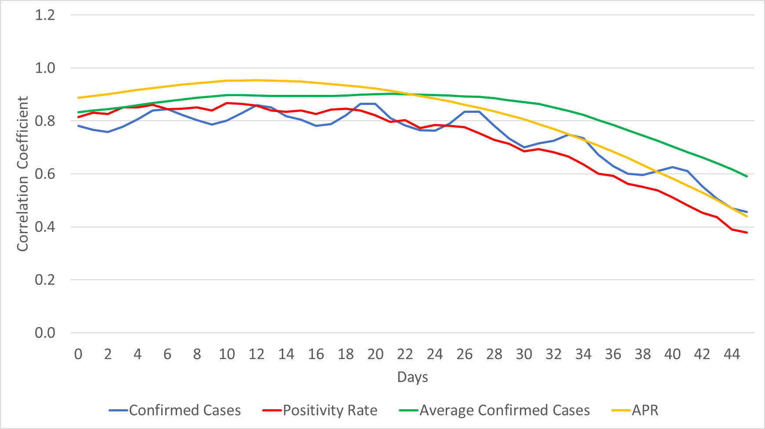
Figure S.15: The change in the coefficient for the correlation between each of the four considered scenarios and deaths reported after x days, where x ranges from 0 to 45, for South Africa.
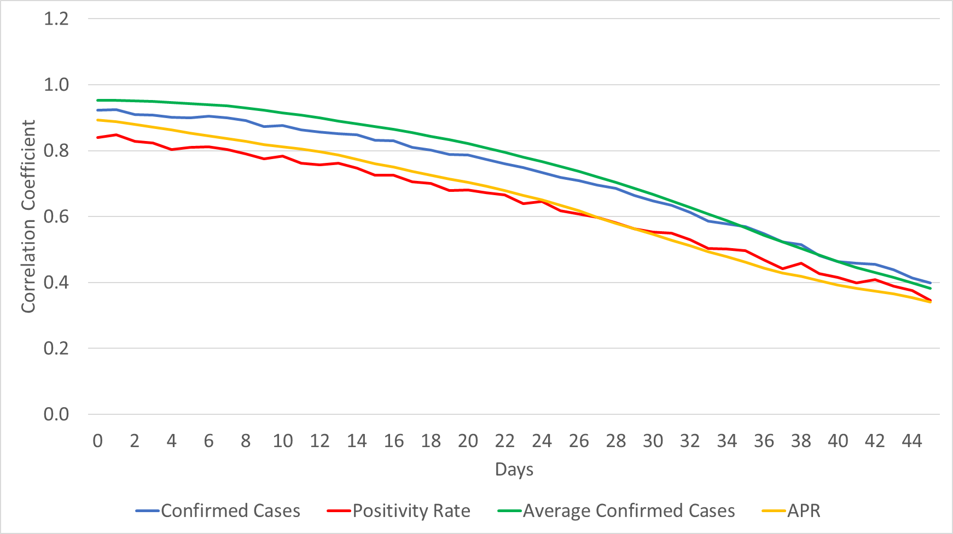
Figure S.16: The change in the coefficient for the correlation between each of the four considered scenarios and deaths reported after x days, where x ranges from 0 to 45, for Colombia.

The change in the coefficient for the correlation between each of the four considered scenarios and ICU patients

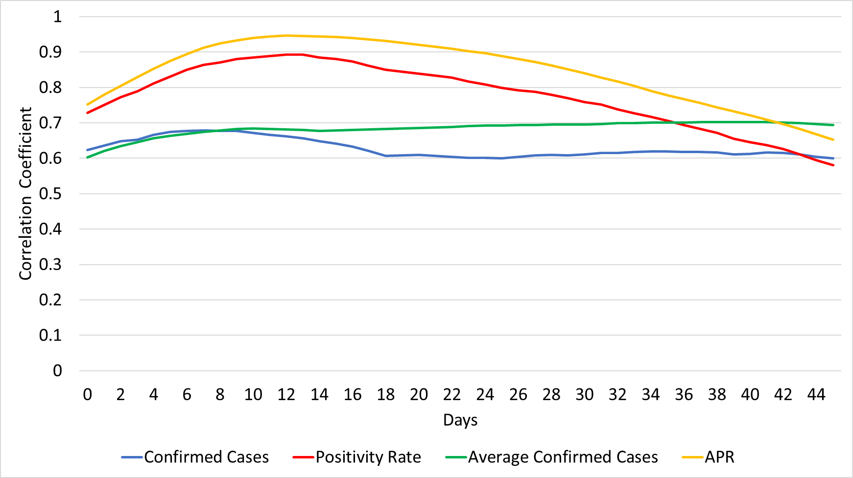
Figure S.17: The change in the coefficient for the correlation between each of the four considered scenarios and ICU patients reported after x days, where x ranges from 0 to 45, for Canada.
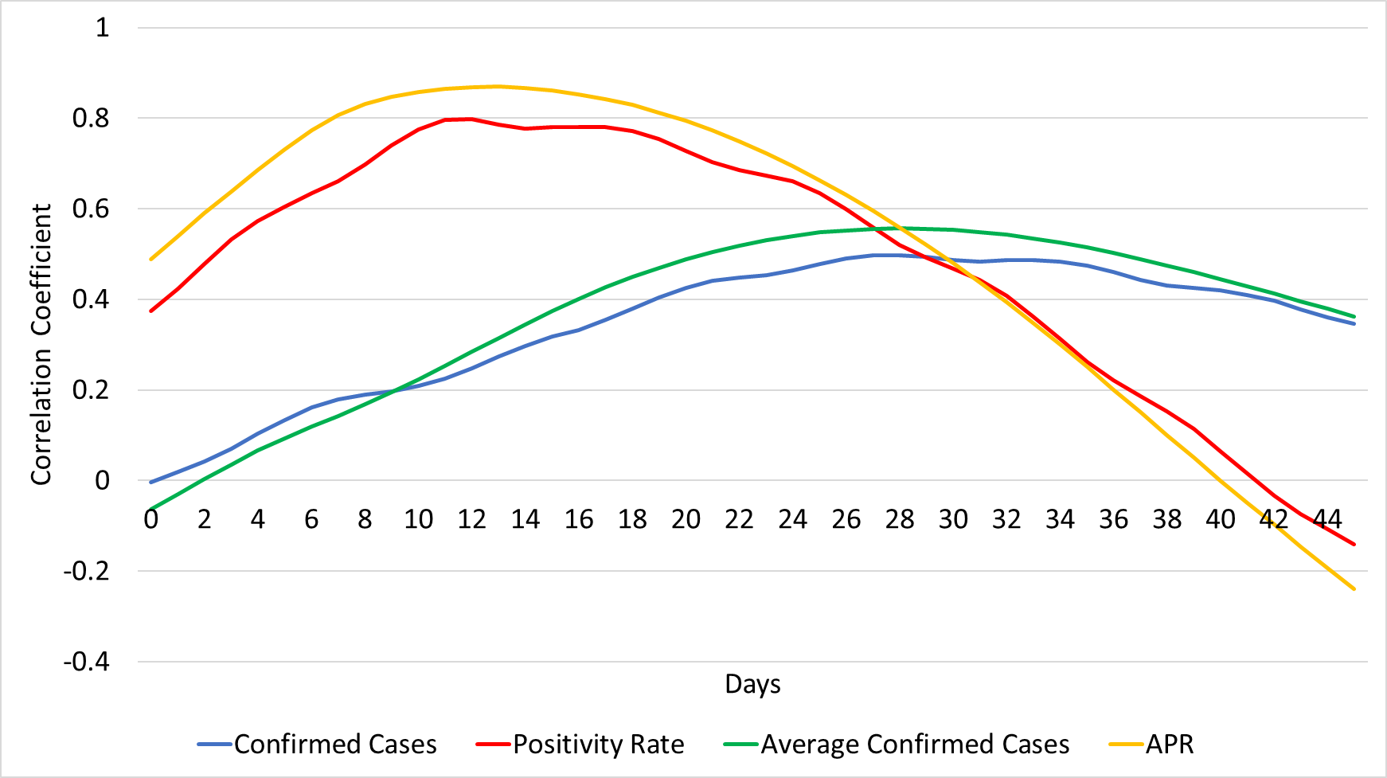
Figure S.18: The change in the coefficient for the correlation between each of the four considered scenarios and ICU patients reported after x days, where x ranges from 0 to 45, for the USA.

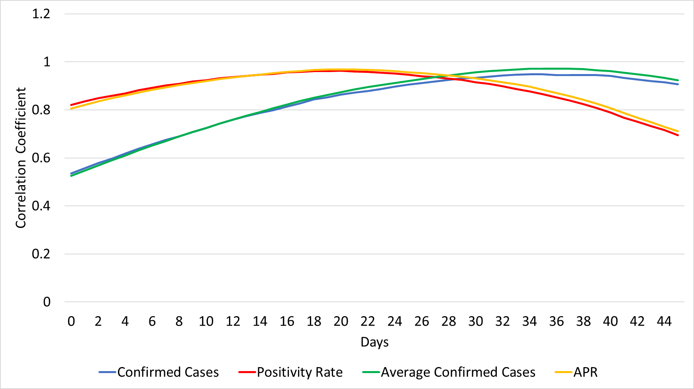
Figure S.19: The change in the coefficient for the correlation between each of the four considered scenarios and ICU patients reported after x days, where x ranges from 0 to 45, for the UK.

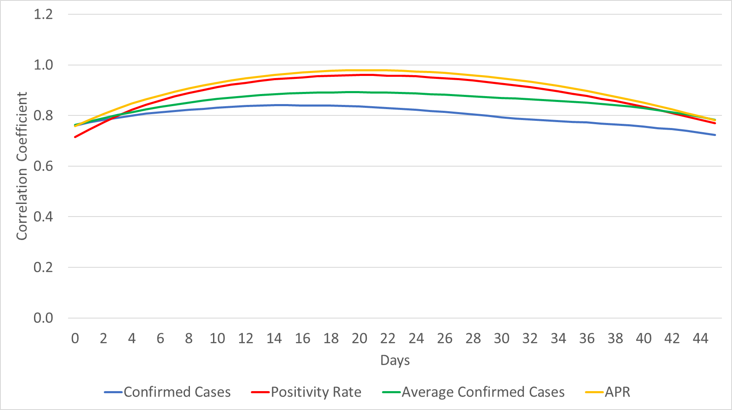
Figure S.20: The change in the coefficient for the correlation between each of the four considered scenarios and ICU patients reported after x days, where x ranges from 0 to 45, for Italy.
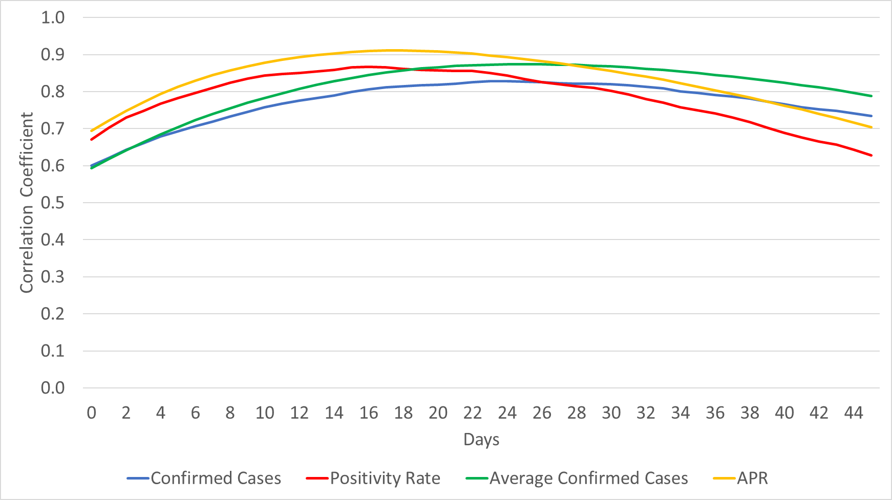
Figure S.21: The change in the coefficient for the correlation between each of the four considered scenarios and ICU patients reported after x days, where x ranges from 0 to 45, for Belgium.

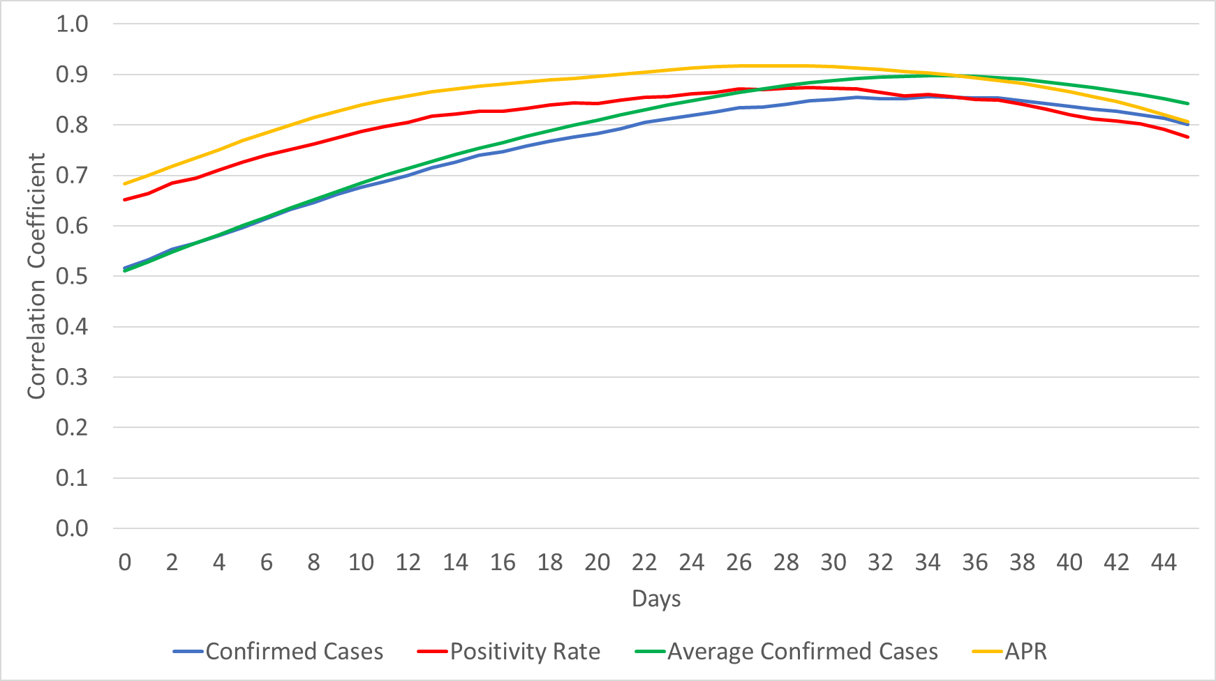
Figure S.22: The change in the coefficient for the correlation between each of the four considered scenarios and ICU patients reported after x days, where x ranges from 0 to 45, for Ireland.

The change in R_{e} values over time

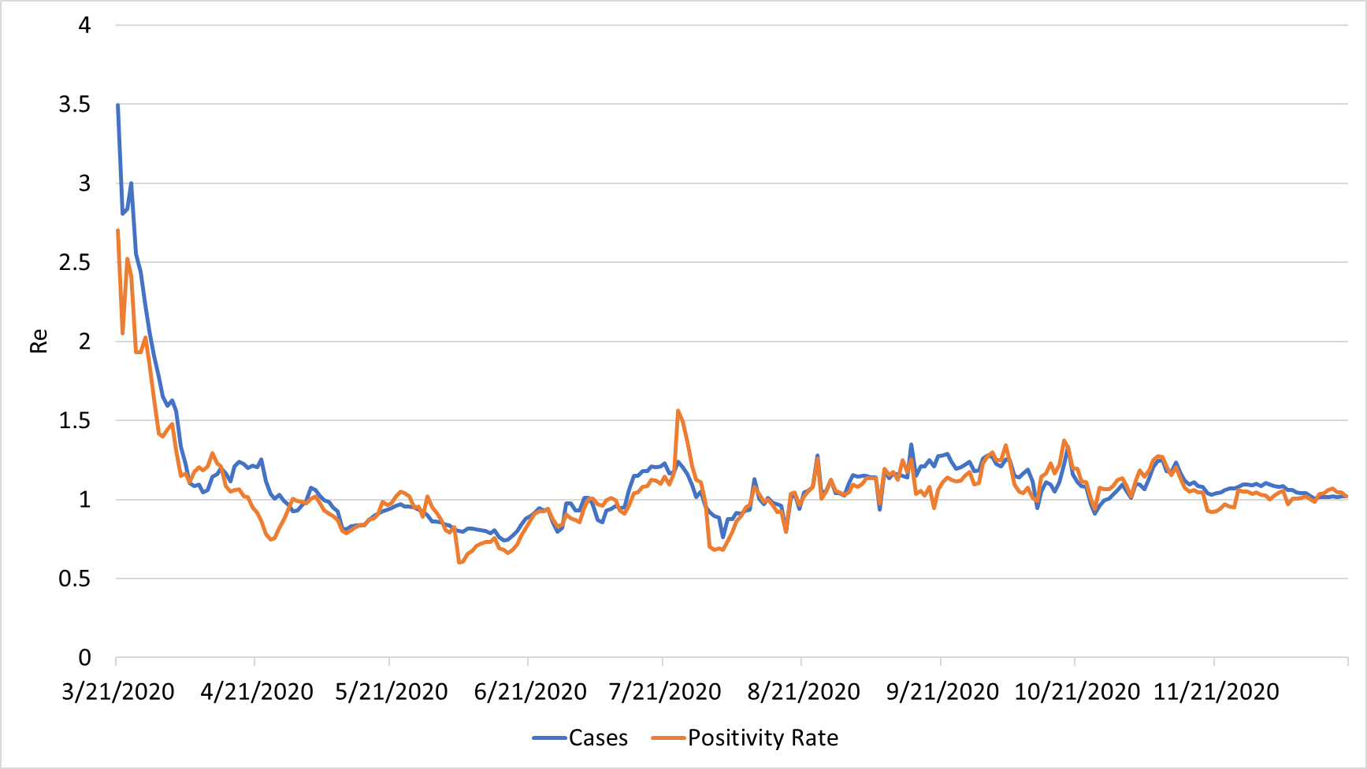
Figure S.23: The change in R_{e} values over time for Canada

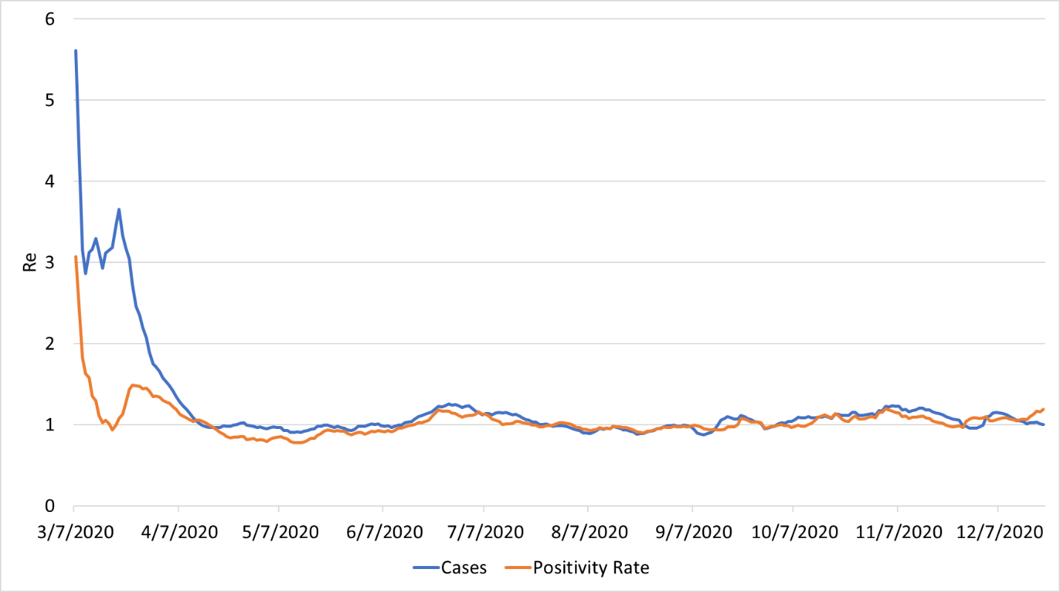
Figure S.24: The change in R_{e} values over time for the USA

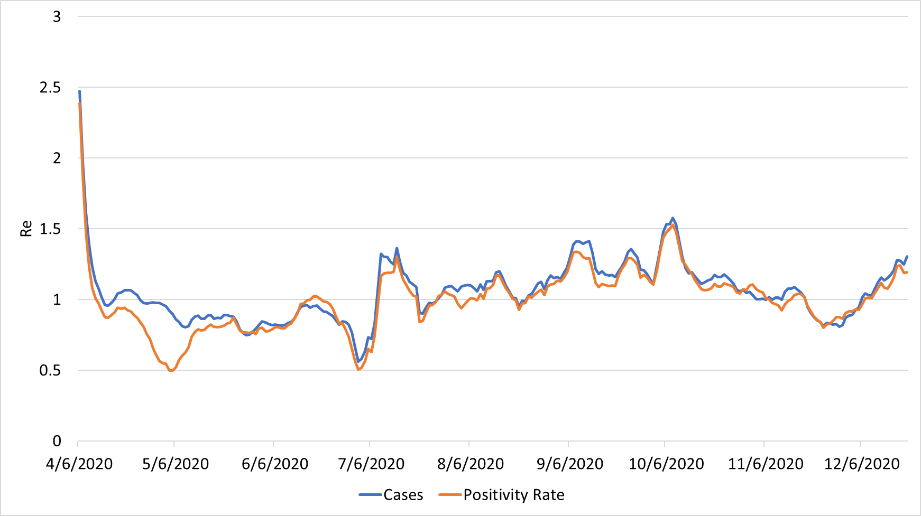
Figure S.25: The change in R_{e} values over time for the UK

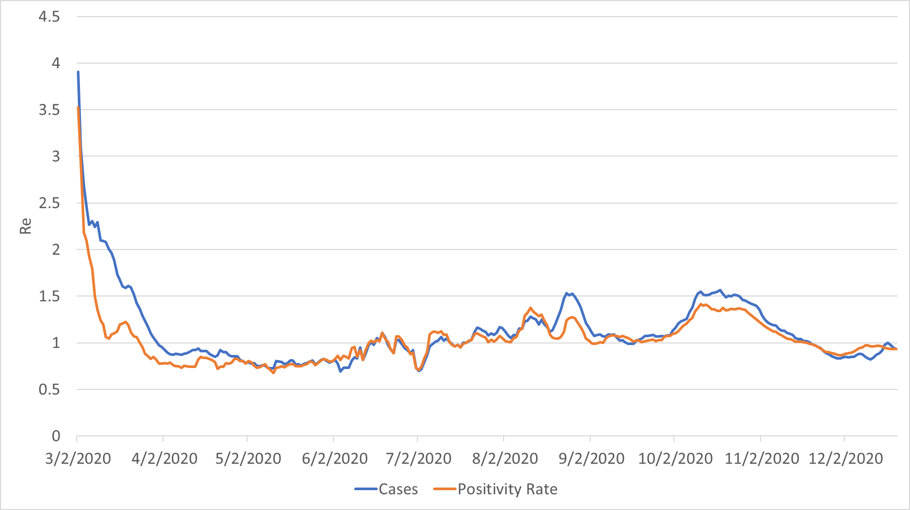
Figure S.26: The change in R_{e} values over time for Italy

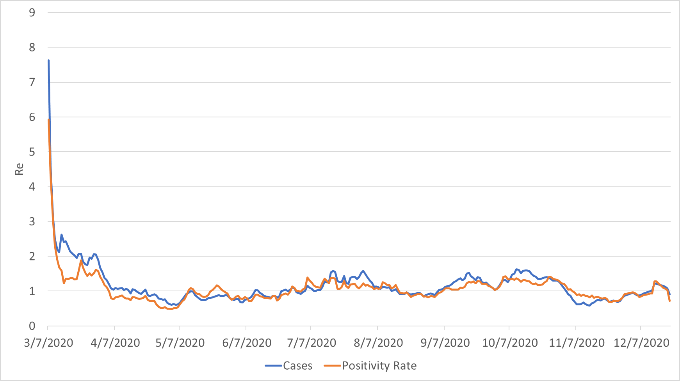
Figure S.27: The change in R_{e} values over time for Belgium

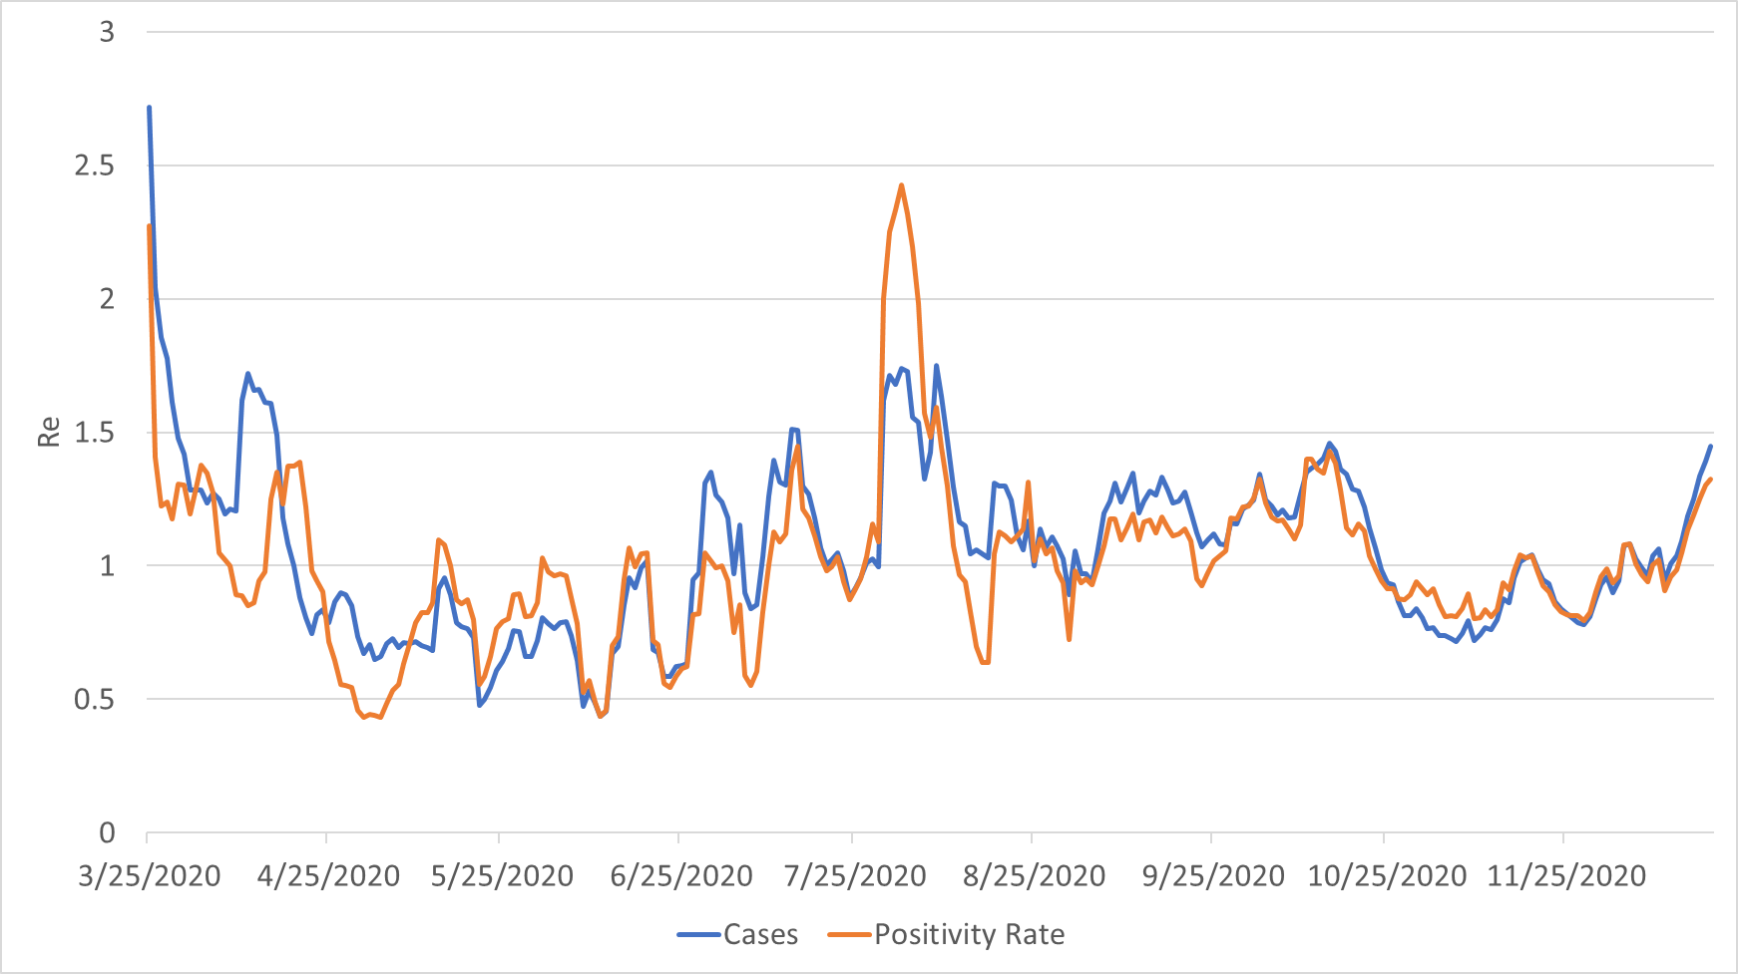
Figure S.28: The change in R_{e} values over time for Ireland

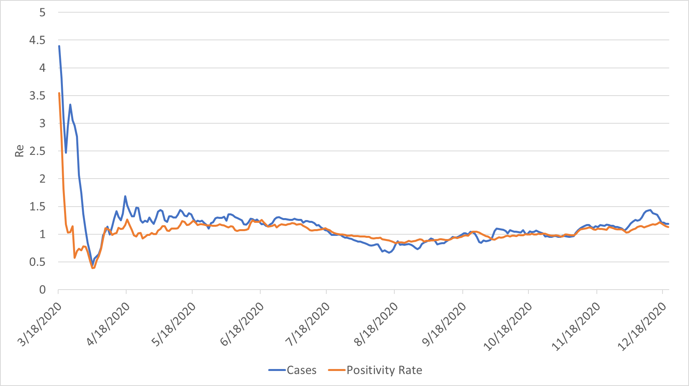
Figure S.29: The change in R_{e} values over time for South Africa

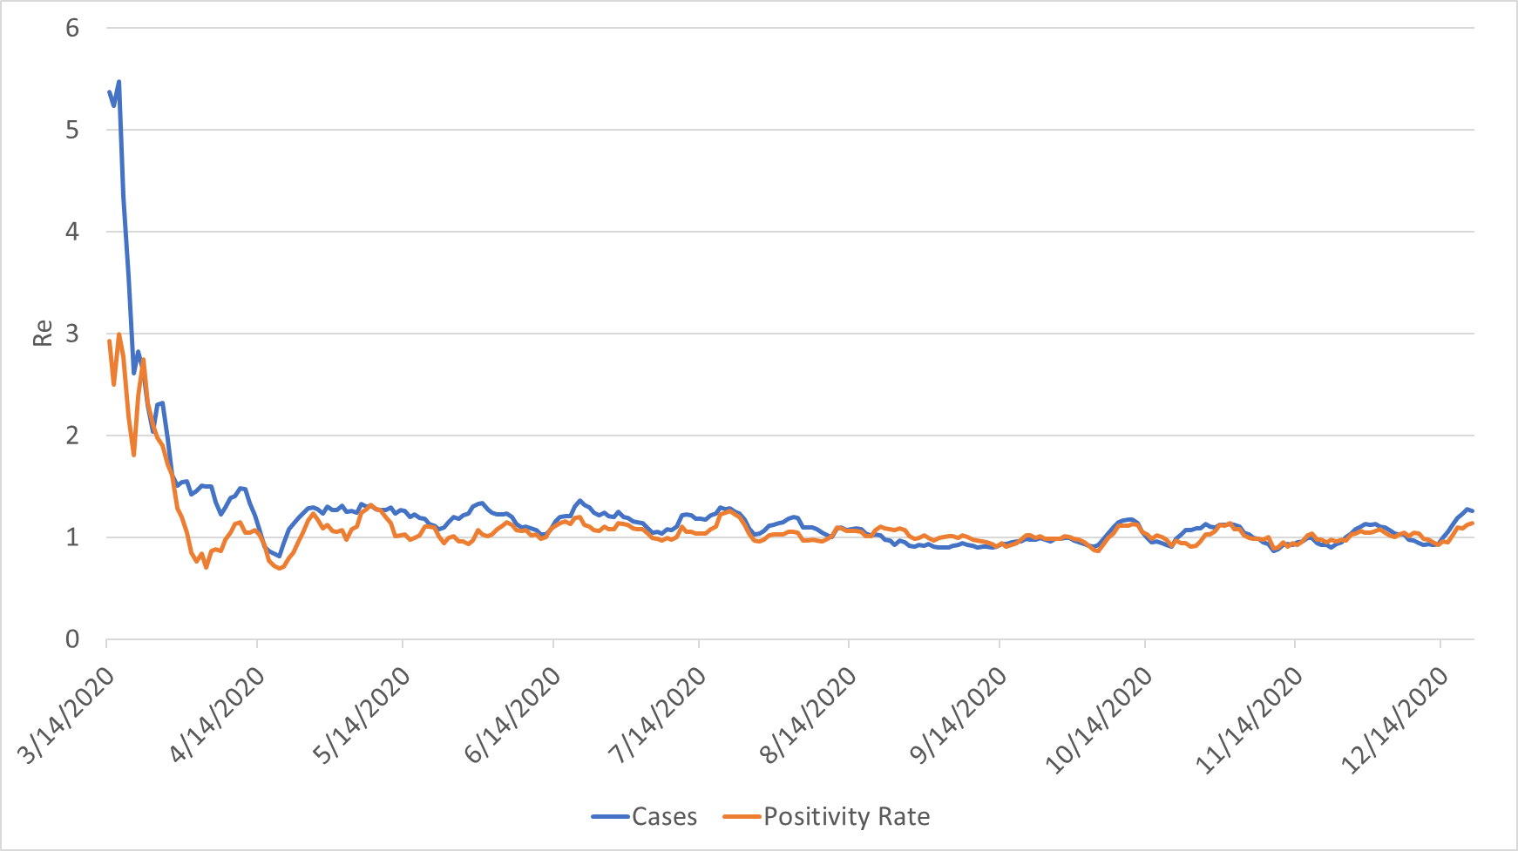
Figure S.30: The change in R_{e} values over time for Colombia

