Folding-Induced In-plane Birefringence in Homeotropically Aligned Graphene-Oxide Liquid Crystal Films Formed by Solution Shear
Le Gia Trung, Subhangi Subedi, Avinash Kumar Rella, Vineet Kumar, and Shin-Woong Kang*
Department of Nano Convergence Engineering, Jeonbuk National University, Jeonju, Republic of Korea, 54896.
*Corresponding author: (E-mail) swkang@jbnu.ac.kr

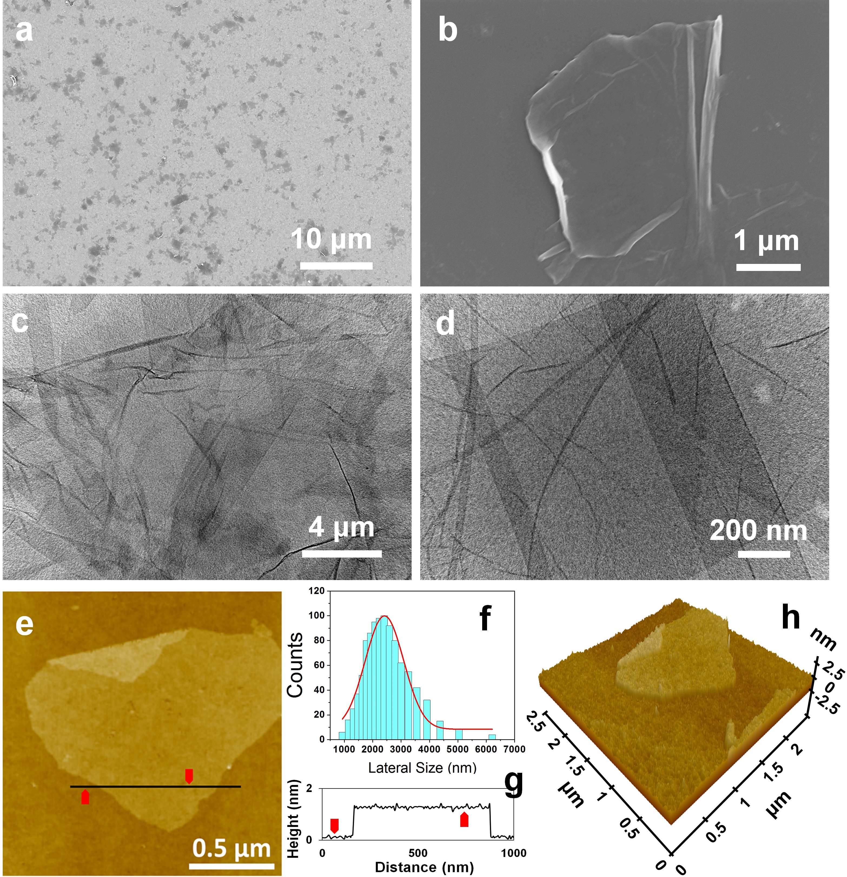
Figure S1. (a),(b) SEM images of GO flakes prepared by spin-coating dilute aqueous GO dispersions on silicon substrates. (c),(d) TEM images of multilayer/monolayer GO flakes obtained via dropping on a copper TEM grid. (e) AFM image of a GO flake. (f) Histogram of the size distribution of GO flakes measured from a Particle size analyzer. (g),(h) Height profile and AMF 3D-image of a GO flake, corresponding to the AFM image in (e), respectively.

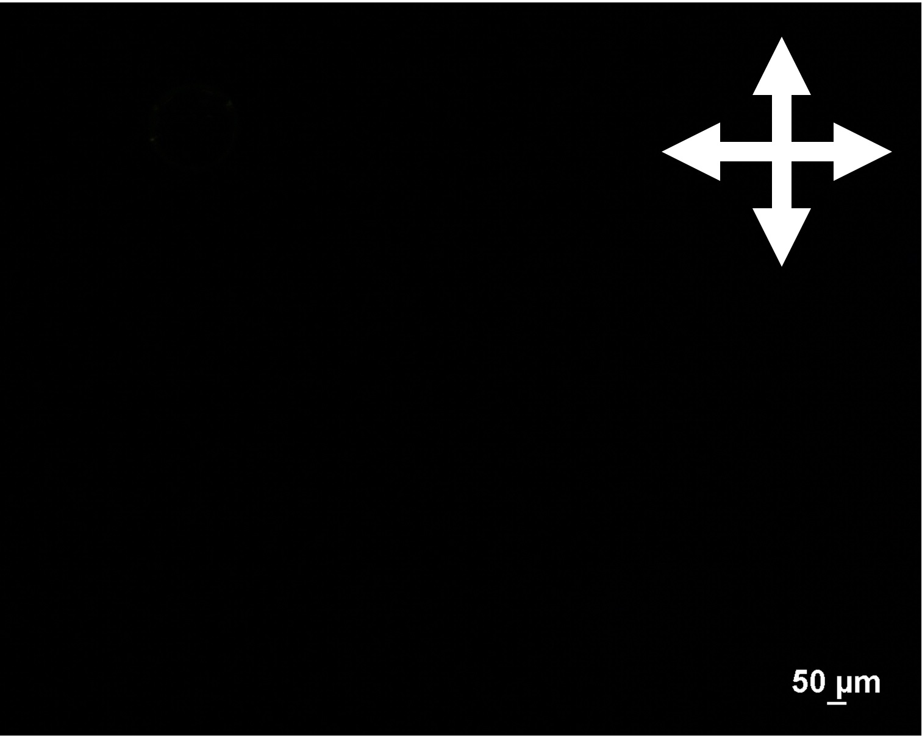
Figure S2. POM image of ~0.15 wt% GO dispersion in water on a flat glass slide. The crossed white arrows specify the polarizer and analyzer directions.

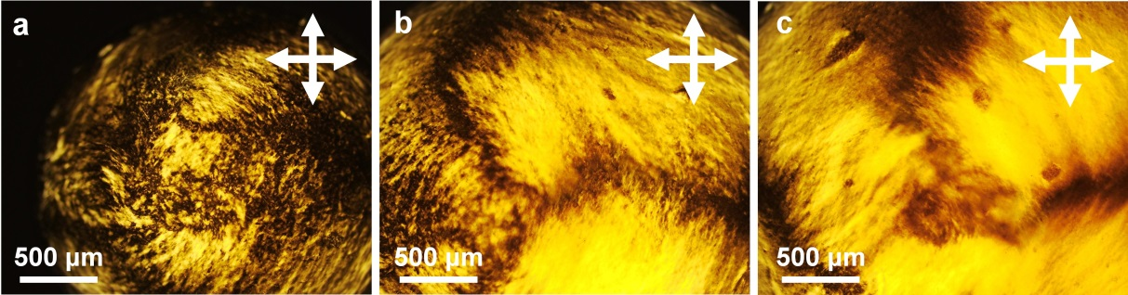
Figure S3. POM images of (a) 0.3, (b) 0.4, and (c) 0.5 wt% GO dispersion droplets on a flat glass substrate, respectively. The crossed arrows denote the polarizer and analyzer directions.
In Figure S2, Complete extinction of the ~ 0.15 wt% GO dispersion at any azimuthal rotation confirms an optically isotropic phase of the GO-dispersion. Figure S3 shows POM images of GO-LC dispersions at different dispersion rates. The yellowish light textures indicate optical birefringence with the uniaxial optic axis lying in the plane of a substrate. The dark brushes in the textures correspond to the regions where the in-plane optic axis is parallel or perpendicular to the polarizers. The lightest state was observed if the optic axis aligned at 45 degree to the crossed polarizers

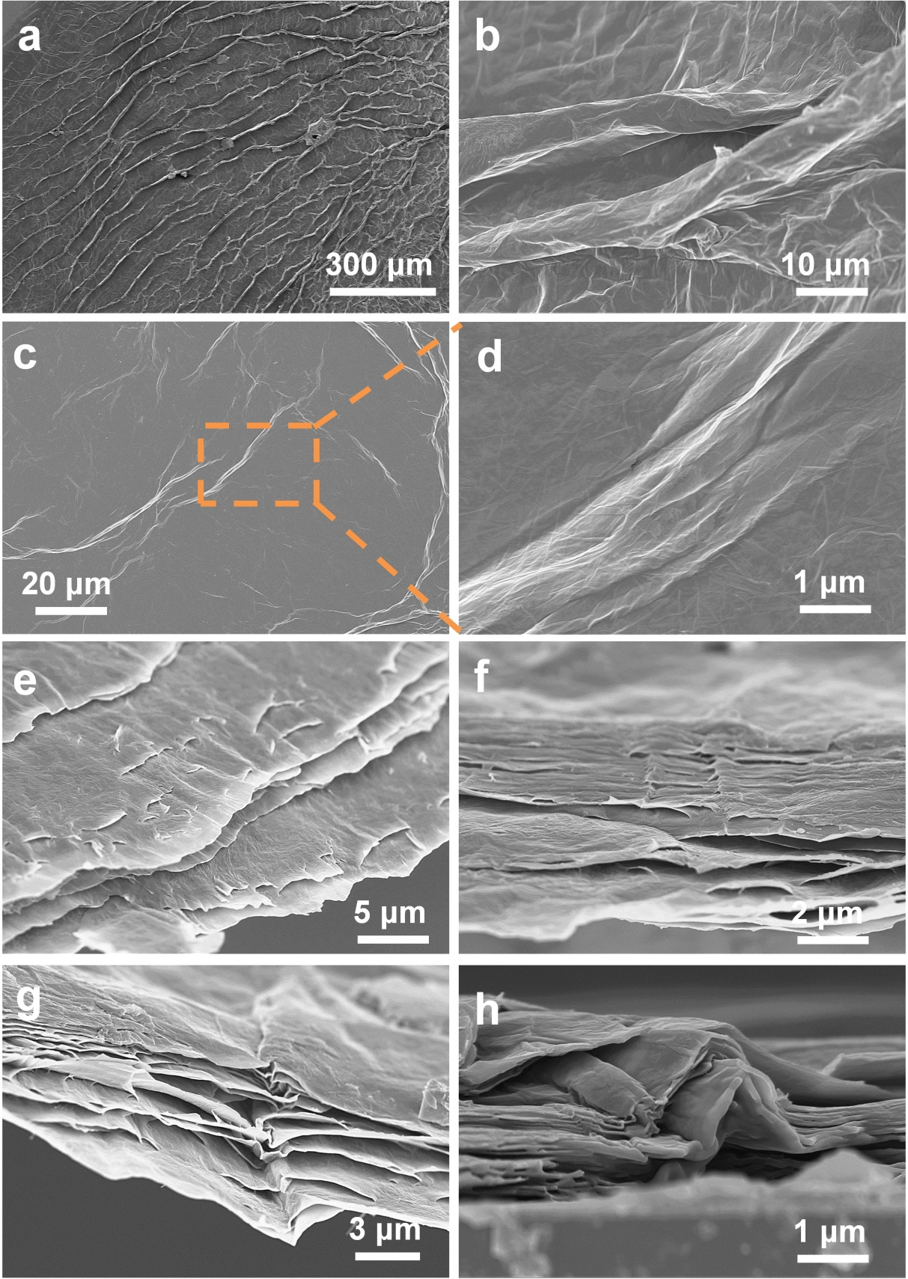
Figure S4. SEM images of the dried drop-cast GO film obtained from 1.1 wt% GO-LC dispersion, dropped on a flat-glass substrate and completely dried: (a)-(d) Top views, (e)/(f) tilted views from substrate normal, (g)/(h) cross-sectional views near the edge. The images (b) and (c) correspond to the more and less deformed regions. The image (d) is a magnified view of the dotted region.
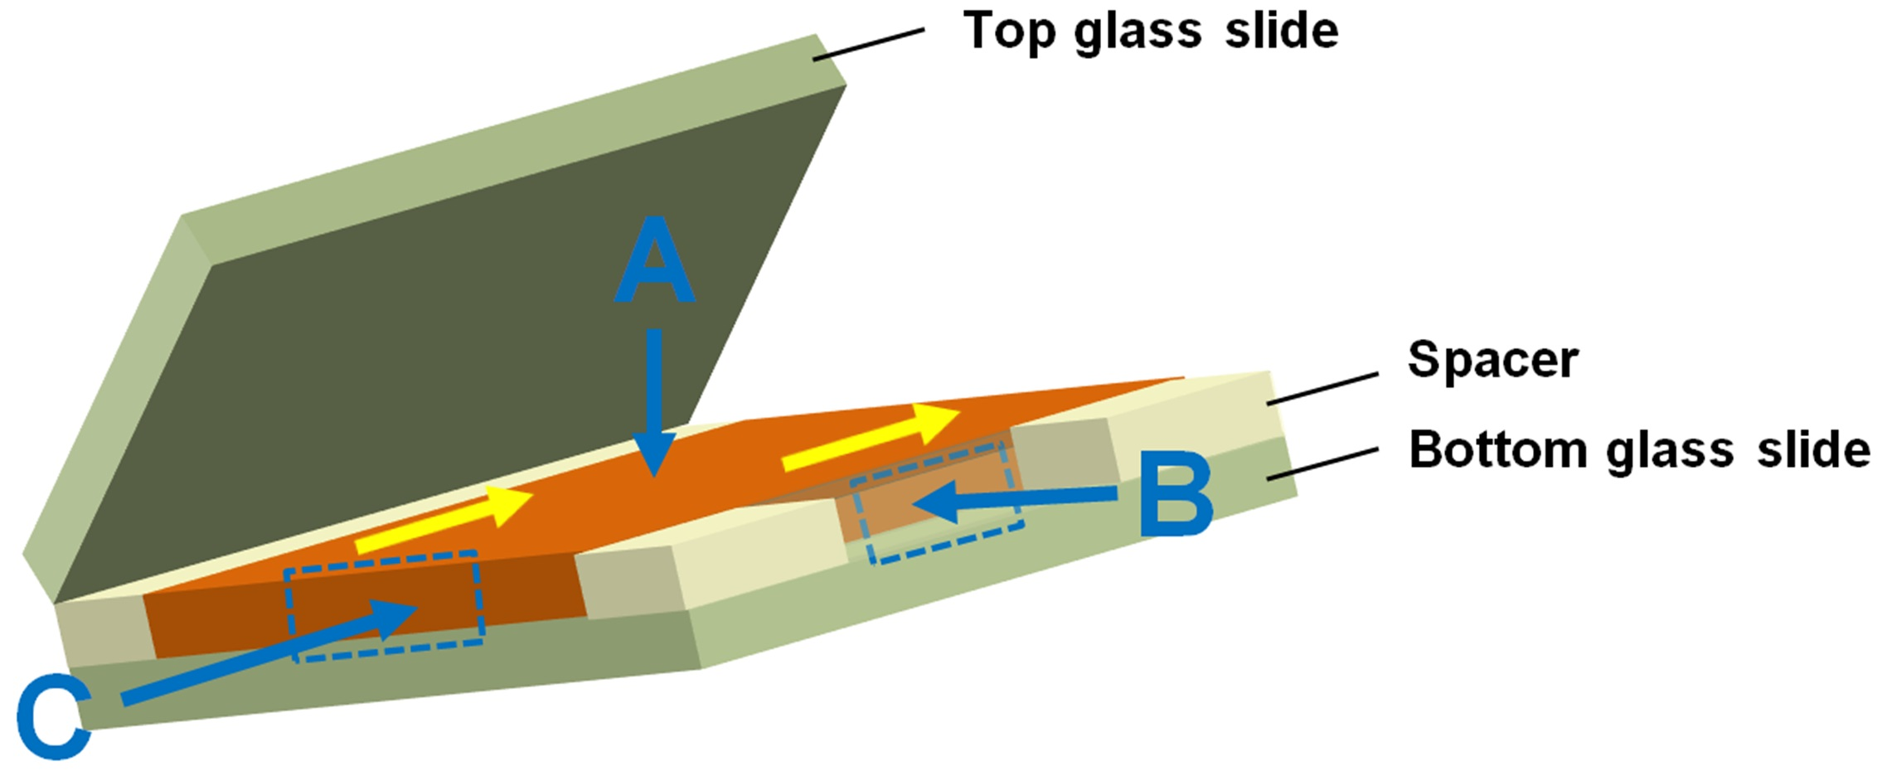
Figure S5. Illustration of the GO-LC cell, consisted of two flat substrates and spacers, and directions for SEM characterizations. The thickness of the GO-LC film (orange) was ~300 μm. The yellow arrow denotes the shear direction. The arrows in blue indicate the directions of SEM investigations.
For a solution shear, the top glass-plate was uniaxially translated back and forth by a finger. The shear alignment was completed by 5-cycles of back-and-forth translation within approximately 10 seconds. The solution-shear method features the laminar flow in a thin liquid-layer (see Figure S5, S6), which imposes mass-transport limitations during the coating process. The mass-transport limitations are not unique to a solution-shear method but are commonly observed in other fast coating methods as well. This kind of hydraulic coating method for morphologically anisotropic fluids had been reported in previously (Nature Mater. 2013, 12, 665).
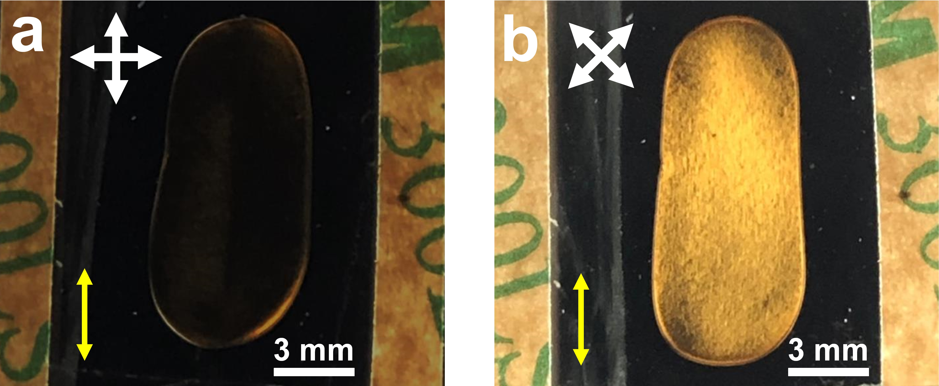
Figure S6. Macroscopic polarized optical images of the shear-aligned GO-LC cell, containing 1.1 wt% GO-LC dispersion. The yellow arrow denotes the shear direction. The crossed arrows represent a polarizer and analyzer.
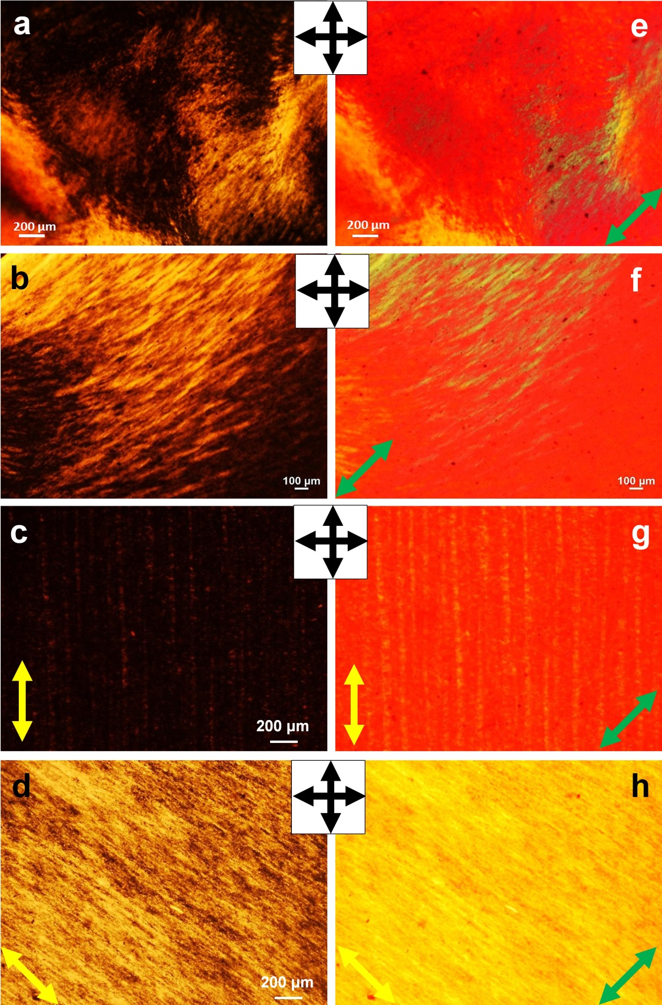
Figure S7. POM images of the 1.1 wt% GO-LC dispersion: (a) unaligned droplet on a flat glass plate, (b) sandwiched by placing a coverslip on a droplet in (a), (c)/(d) shear-aligned GO-LC cell (thickness of ~300 μm) as shown in Figure S5. The images (e)-(h) were acquired by addition of the red plate to the corresponding images (a)-(d). The yellow and green arrows denote the shear direction and slow axis of the red plate (Δn > 0). The polarizer directions are indicated in the inset boxes.

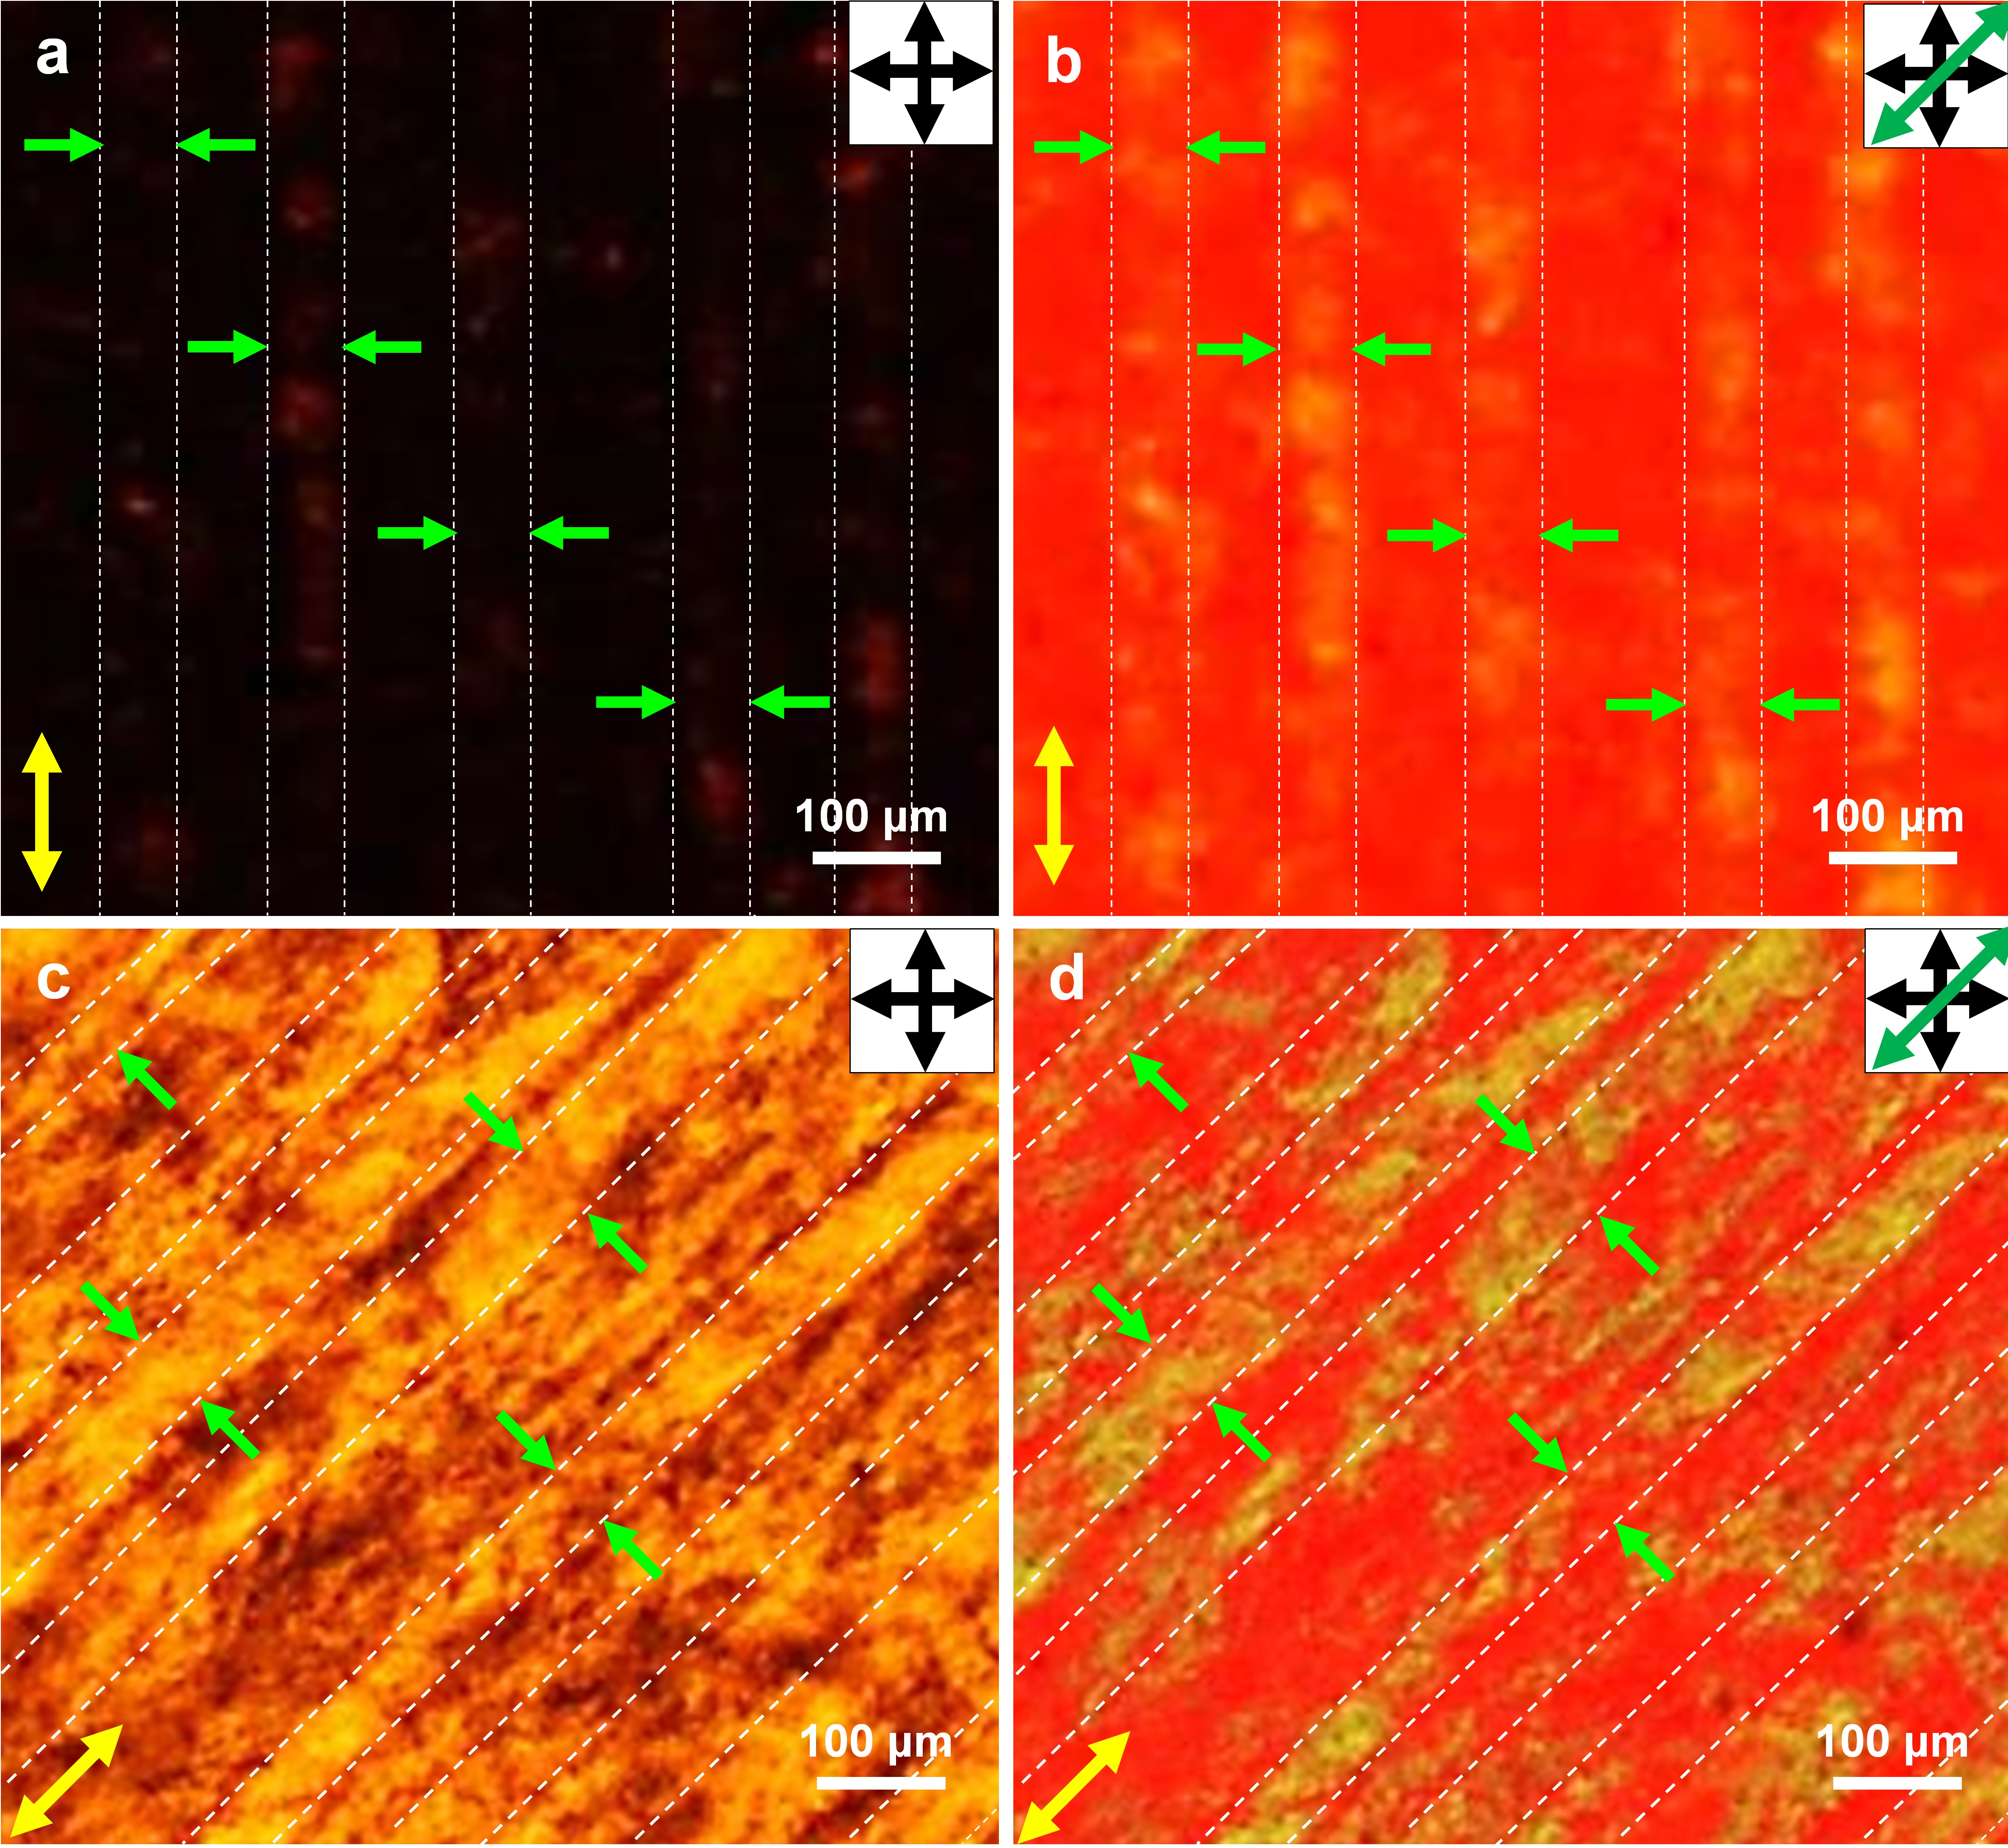
Figure S8. POM images of the 1.1 wt% shear-aligned GO-LC dispersion, sandwiched by two flat-glass slides (gap of ~300 μm): (a,c) without and (b,d) with the insertion of λ-plate at different orientations. Single-ended green arrows indicate approximate width of the bands with different optical retardations.
The images (d)/(h) in Figure S7 aligned at 45° orientation indicate subtraction of optical retardation (also see Figure 3), identifying that the optic axis of the negative crystal is perpendicular to the shear direction in the substrate plane. The width of stripes/bands with in-plane birefringence in a wet-aligned film was approximately ~ 50 μm on average.
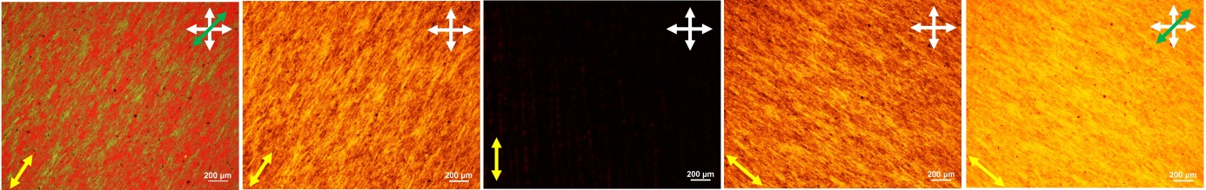
Figure S9. POM images of the 1.1 wt% shear-aligned GO-LC cell, used for the freeze-dried GO-LC foam. Note that the 1st and 5th images were obtained with the insertion of the red plate. The yellow and green arrows denote the shear direction and slow axis of the red plate (Δn > 0). The crossed arrows represent the polarizer directions. The 1st (greenish) and 5th (yellowish) regions correspond to the addition and subtraction of the optical retardation, respectively.
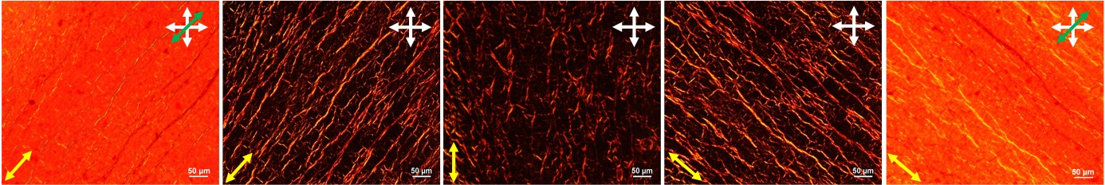
Figure S10. POM images of the dried GO-film, prepared by drying the shear-aligned GO-LC dispersion (used for Figure 3b and Figure 5). The aligned GO-LC film was immersed into acetone prior to drying at room temperature. The yellow and green arrows denote the shear direction and slow axis of the red plate (Δn > 0). The crossed arrows specify the polarizer and analyzer directions. Scale bars correspond to 50 μm.
The 1st (greenish lines) and 5th (yellowish lines) images correspond to the addition and subtraction of the optical retardation, respectively. This identifies that the optic axis of bundles is perpendicular to the shear direction in the plane of a substrate. It was similar to the case in Figure 3a, Figure 4b (aligned wet GO-LC film).
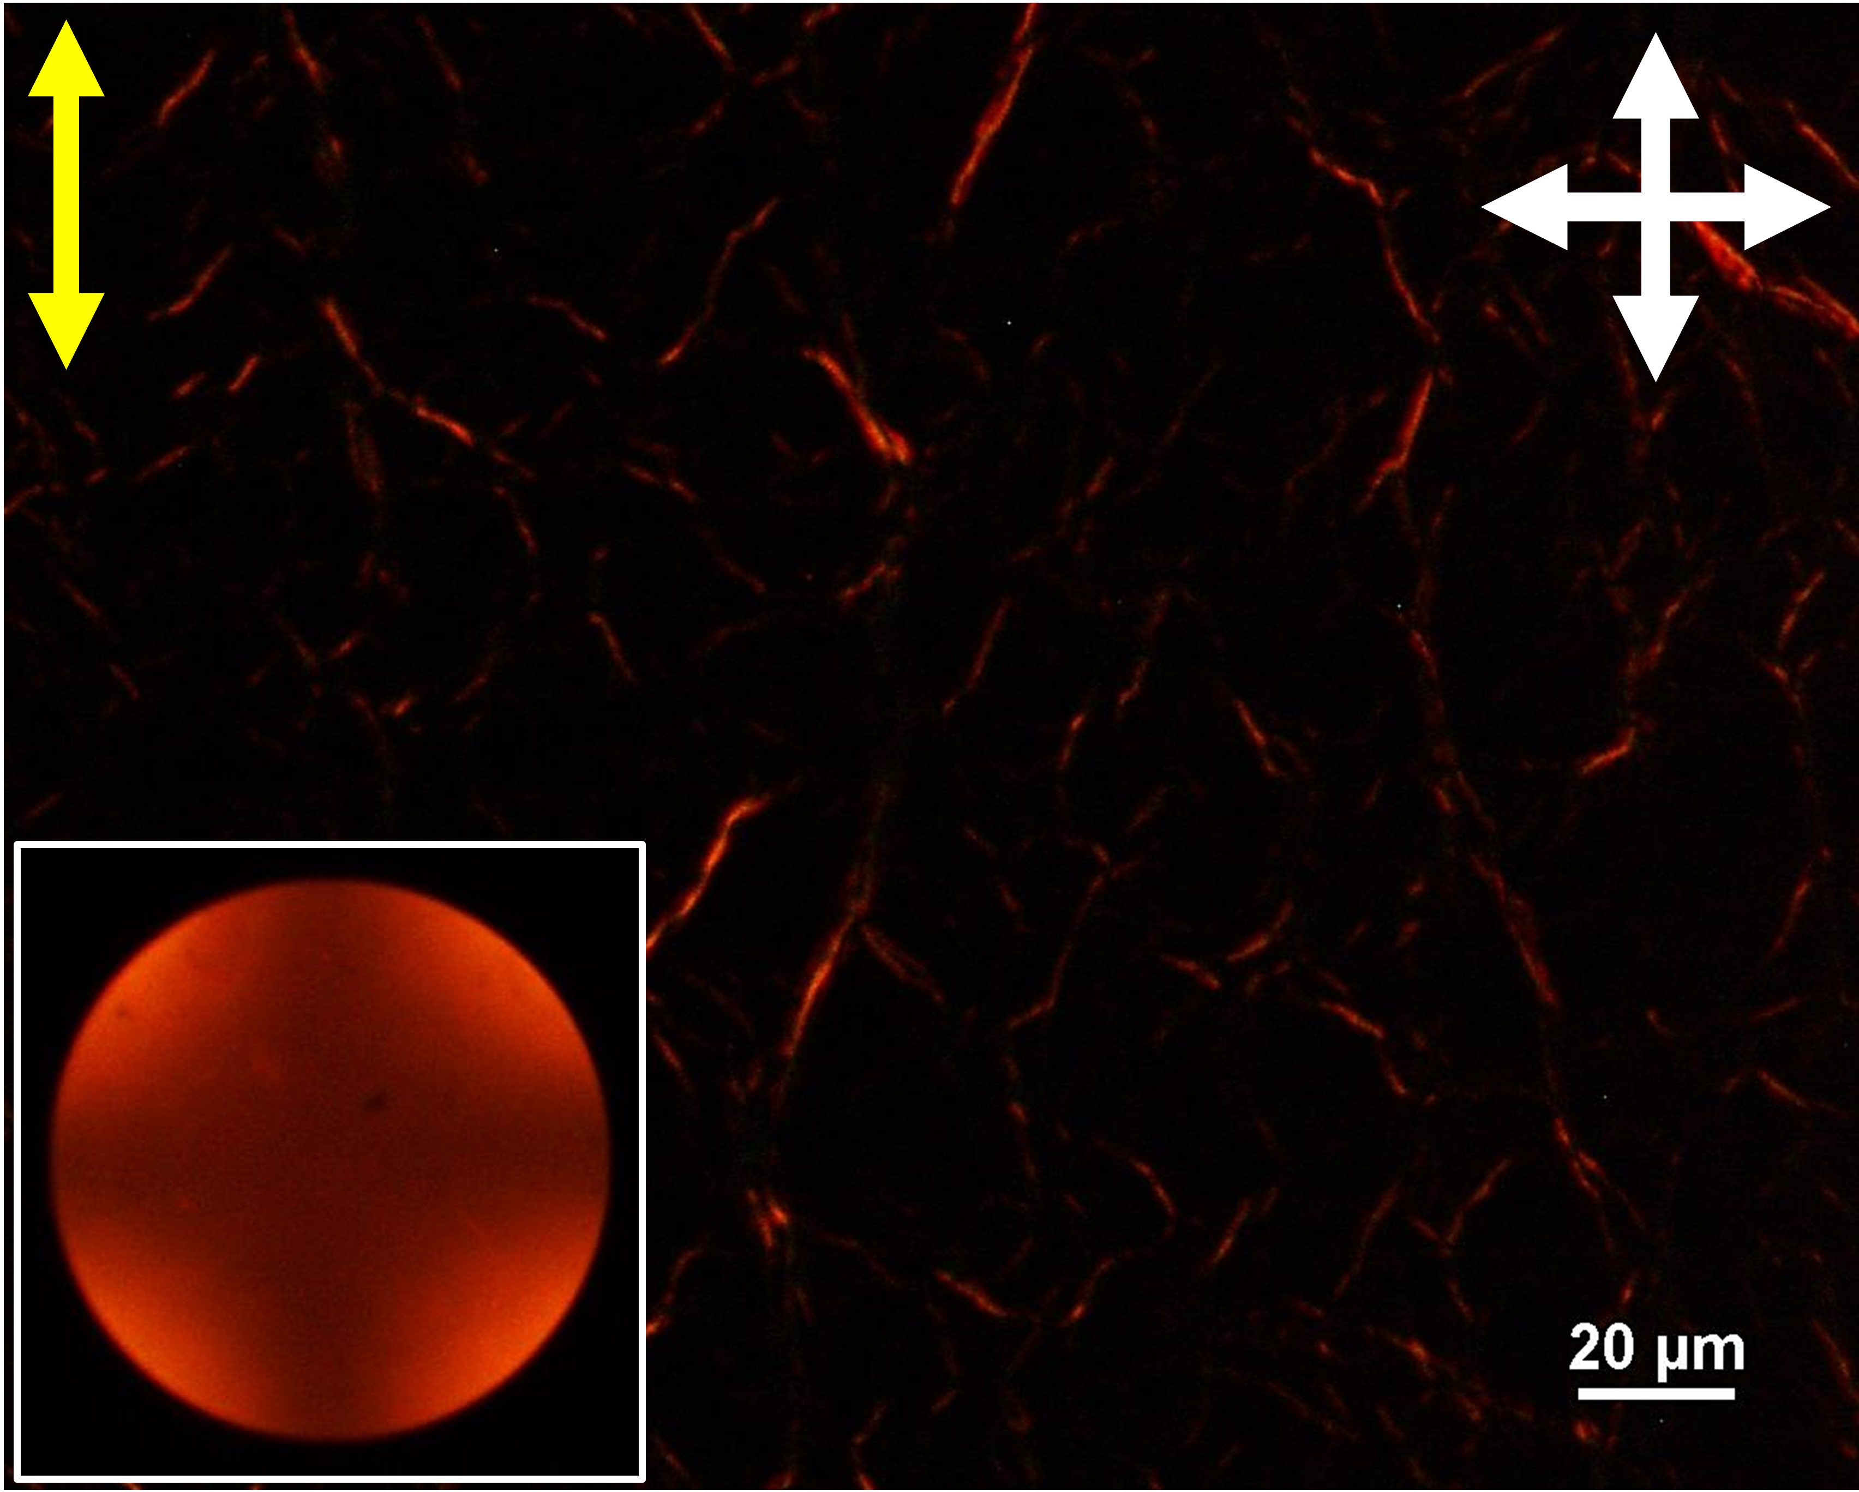
Figure S11. POM image of the dried GO-LC film, prepared using 1.1 wt% GO dispersion. The same cell was used for Figure 5 and Figure S10, S13-S15. The POM image corresponds to the shear-aligned region with relatively smaller birefringence. The inset shows a conoscopic figure for the same region, indicating homeotropic orientation of the optic axis. The yellow and white arrows represent the shear direction and polarizer directions.
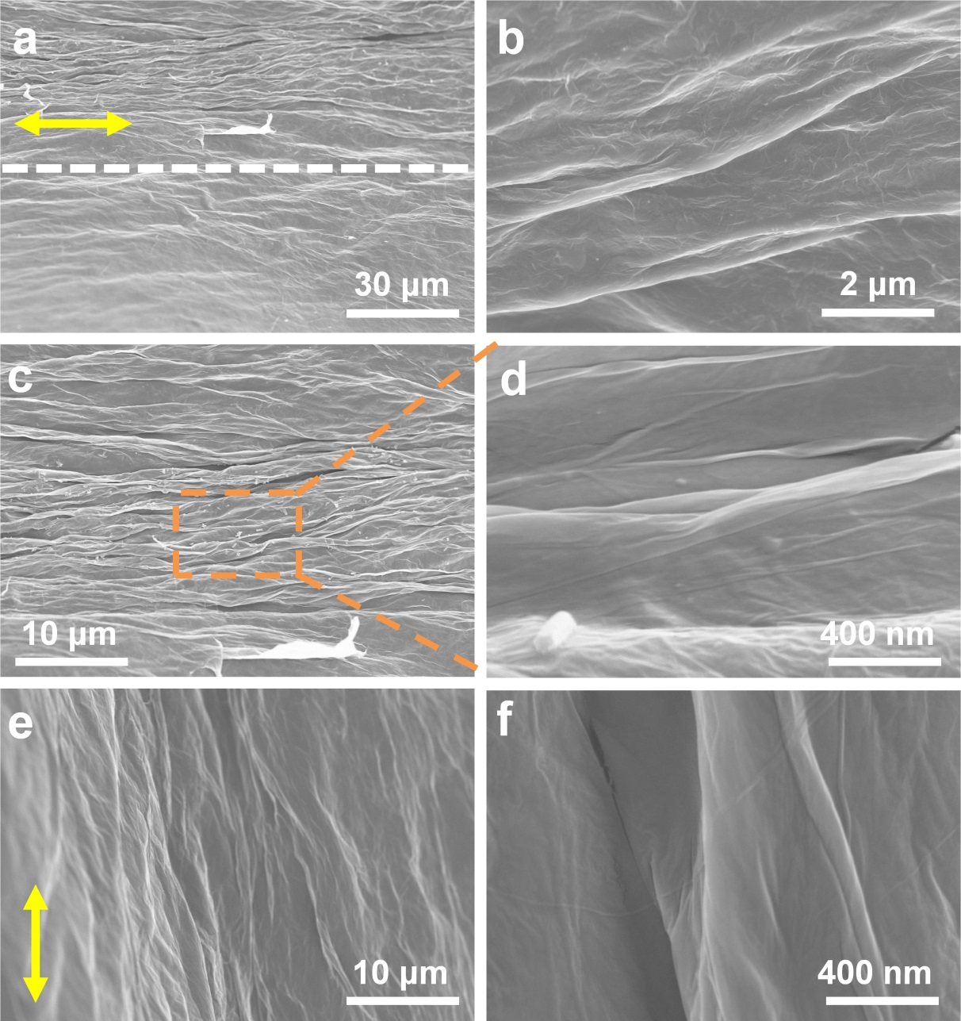
Figure S12. SEM images, observed from substrate normal (top view), of the dried GO-LC film. The shear-aligned GO-LC film was prepared using 1.1 wt% GO dispersion. The wet film, in the sandwiched GO-LC cell, was dried at an ambient condition. The GO-LC cell was opened after complete drying. The images (b) and (c) correspond to the magnified views for lower and upper parts in (a). The images (d)/(f) are magnified views of (c)/(e), respectively. The yellow arrow denotes the shear direction.

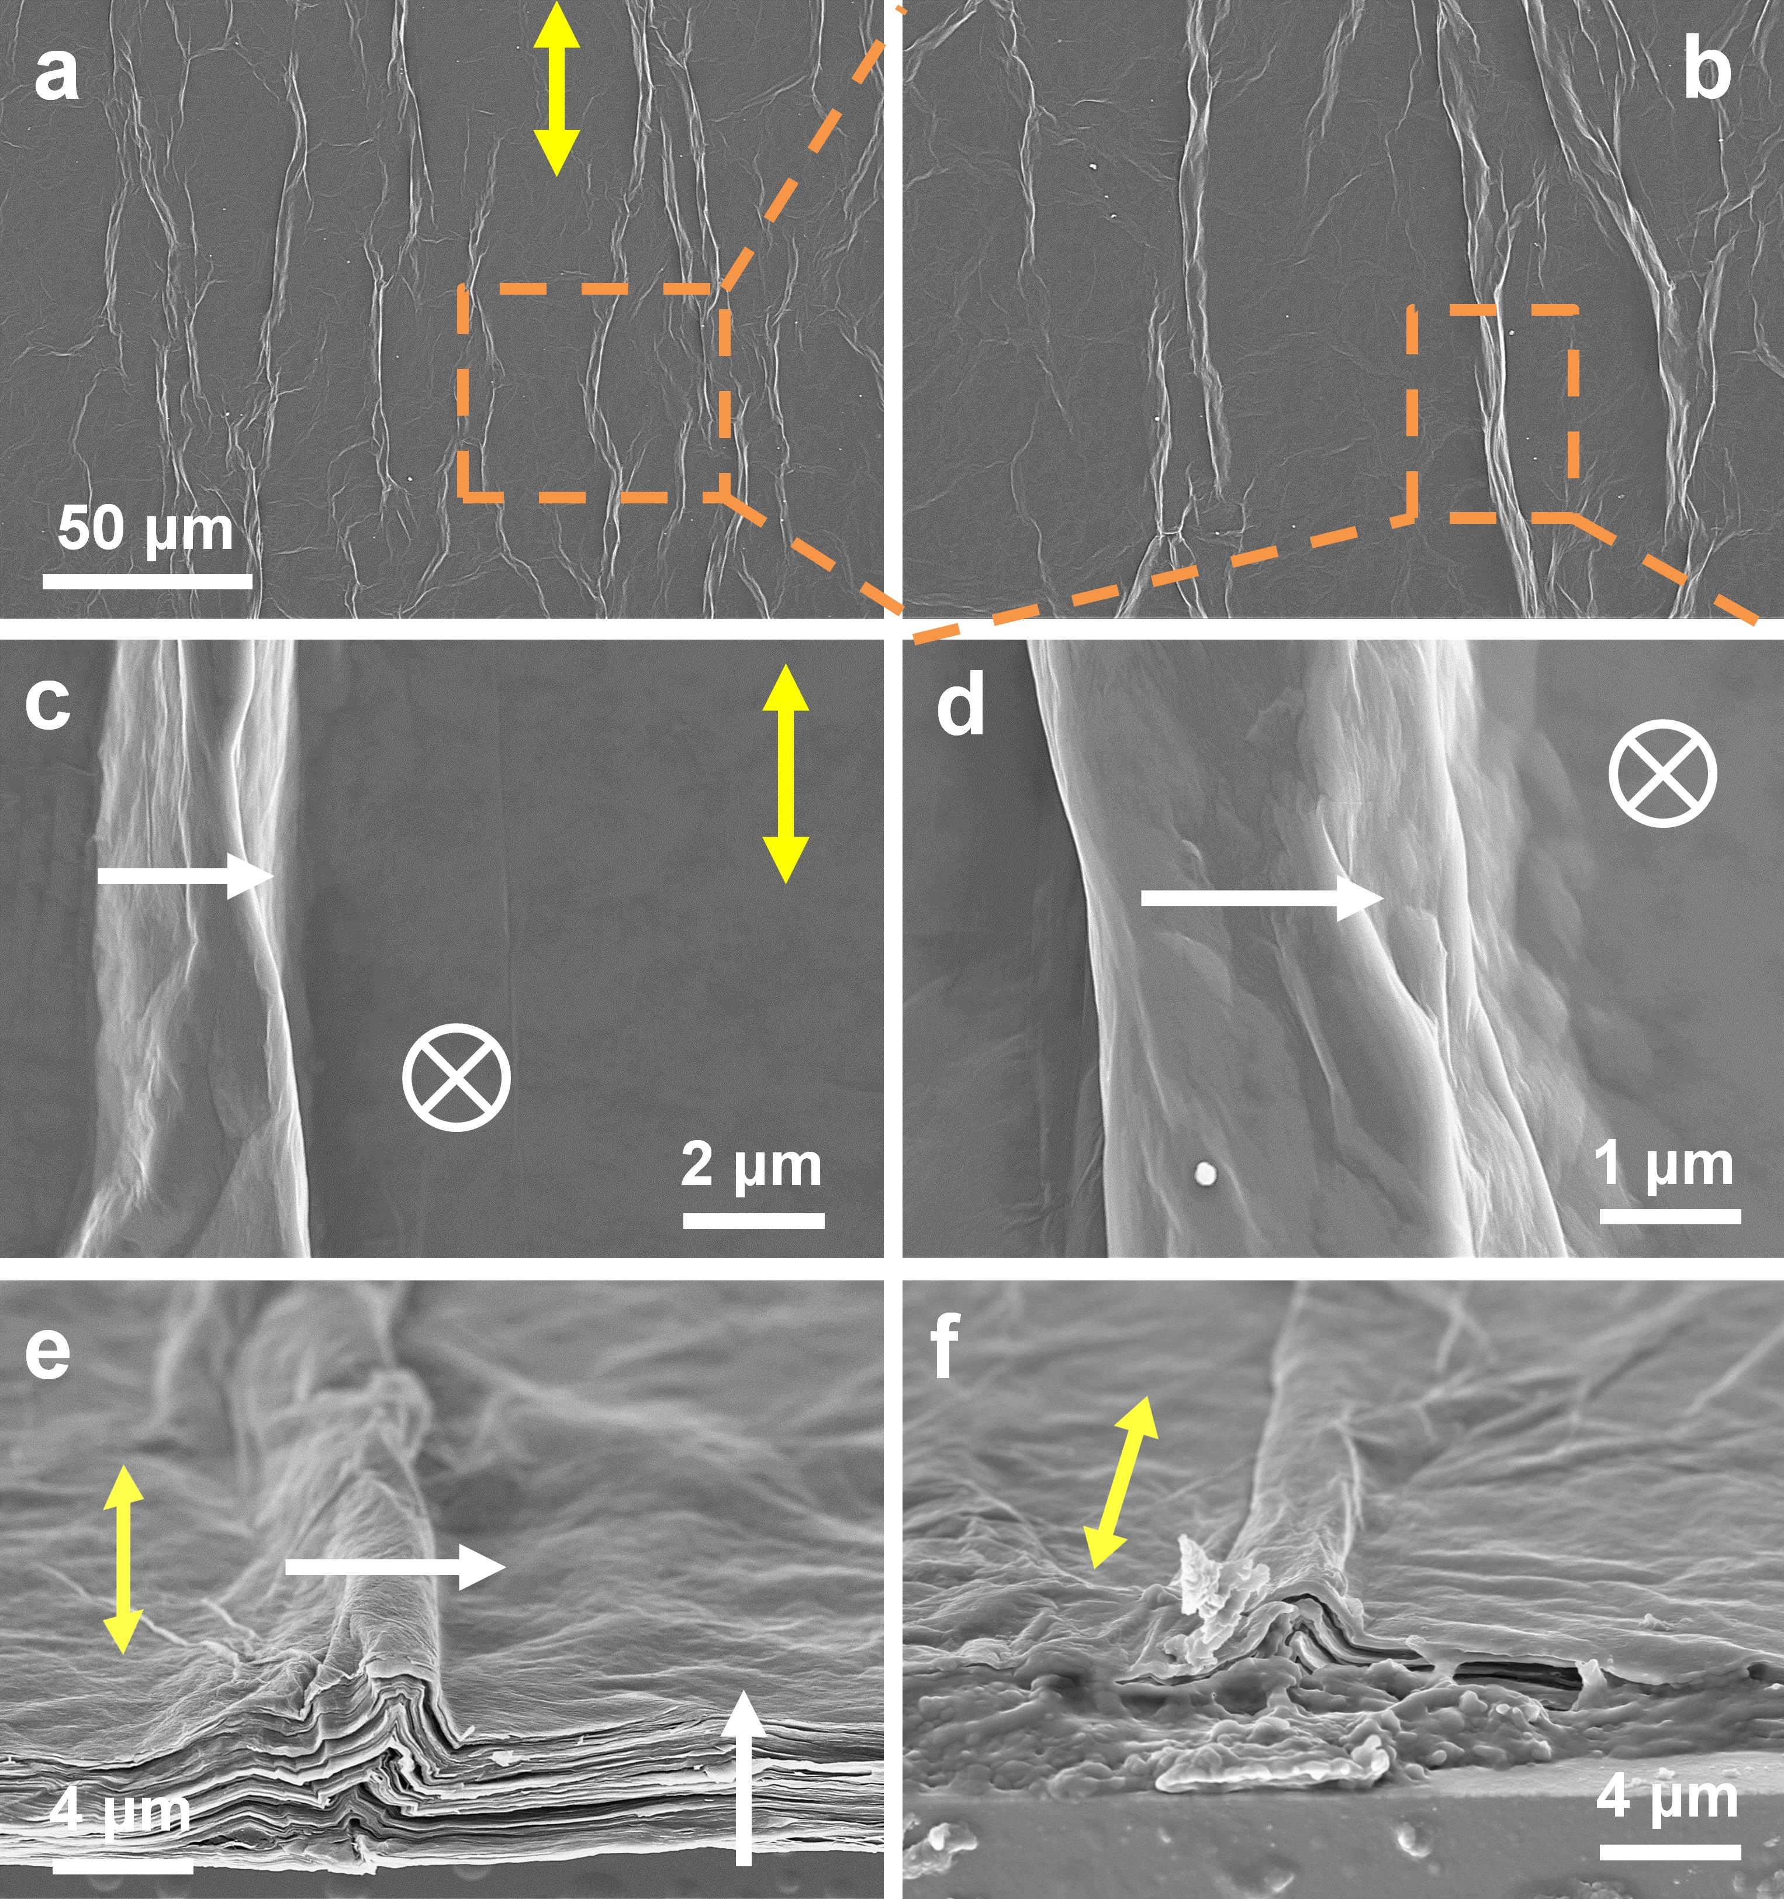
Figure S13. SEM images, observed from the A-direction (see Figure S5), of the dried GO-LC film. The same cell was used for Figure 5 and Figure S10, S14-S15. The shear-aligned GO-LC film was prepared using 1.1 wt% GO dispersion. The wet film, shear-aligned on the bottom substrate, was dried at an ambient condition. The GO-LC cell was opened prior to the drying. (a)-(d) Top view from a substrate normal, (e)/(f) the corresponding tilted views toward the C-direction. (b)/(c)/(d) shows magnified views of the marked region in (a). The single-ended white arrow designates a local director (i.e., local optic axis). The yellow arrow represents the shear direction. The dotted square marks the magnified region.

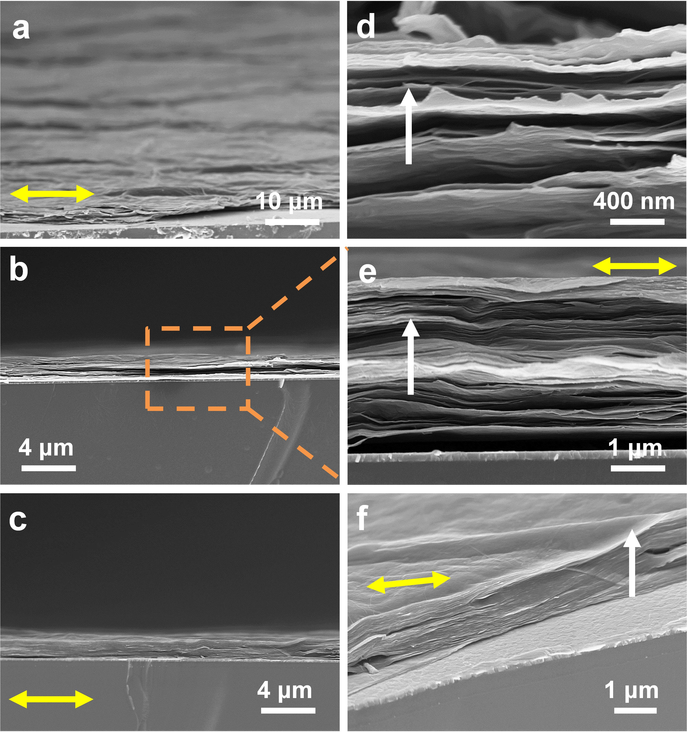
Figure S14. SEM images, observed from the B-side (see Figure S5), of the dried GO-LC film. The same sample, used for Figure S13, was inspected from a different direction B. The single-ended white arrow designates a local director (i.e., local optic axis). Other symbols and marks are analogous to those in Figure S13.
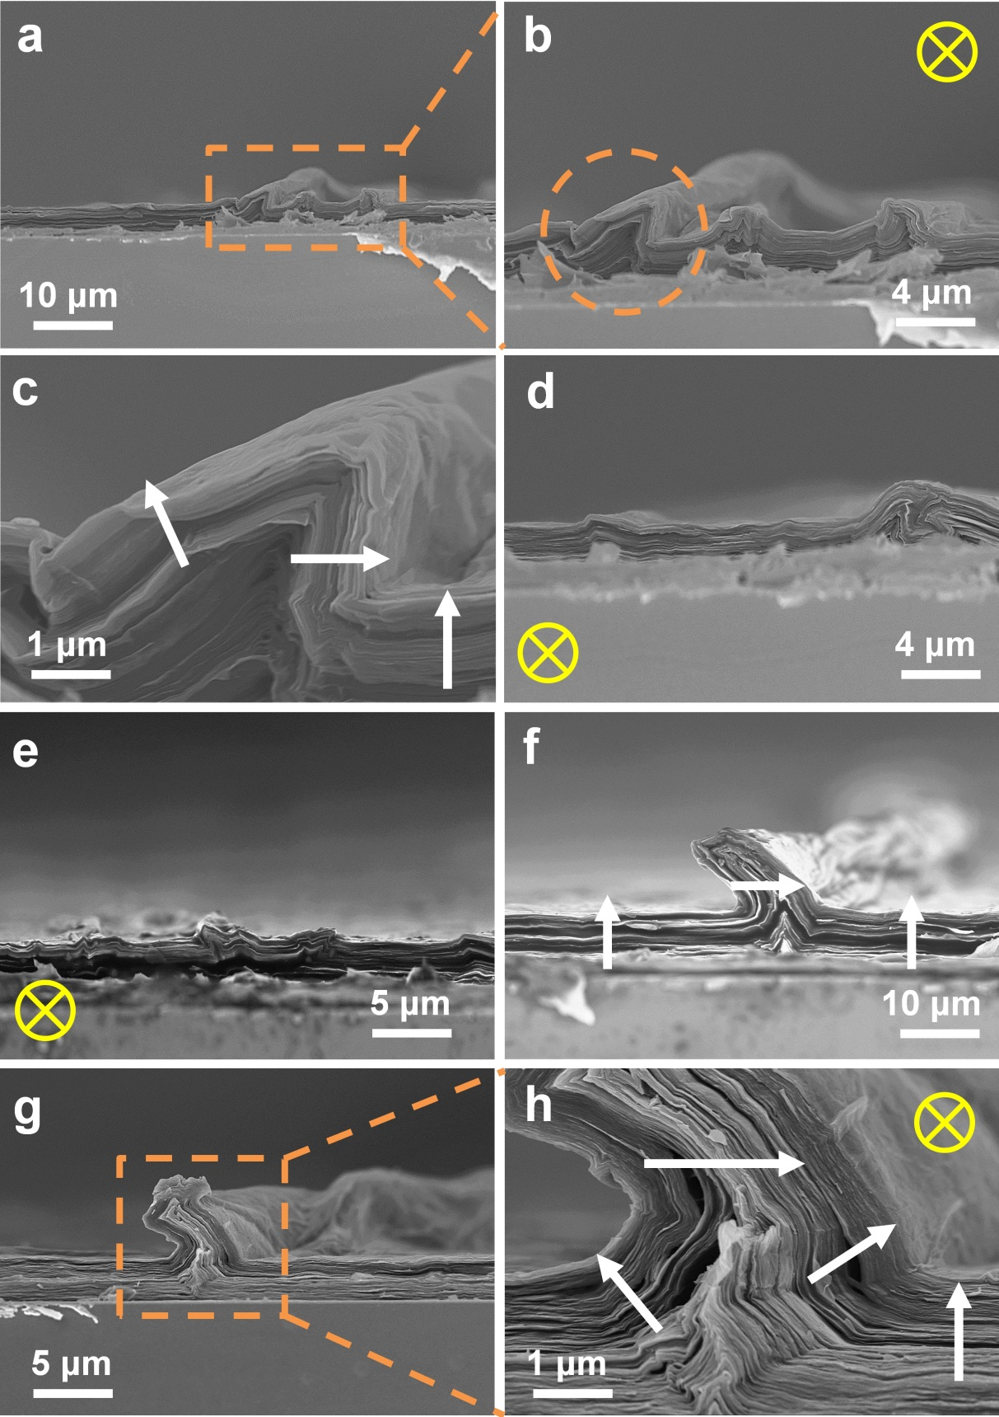
Figure S15. SEM images, observed from the C-direction (see Figure S5), of the dried GO-LC film. The same sample, used for Figure S13 and S14, was inspected from a different direction C. The single-ended white arrow designates a local director (i.e., local optic axis). Other symbols and marks are analogous to those in Figure S13. Note that the shear-direction (a tail of arrow in yellow) points into the page.
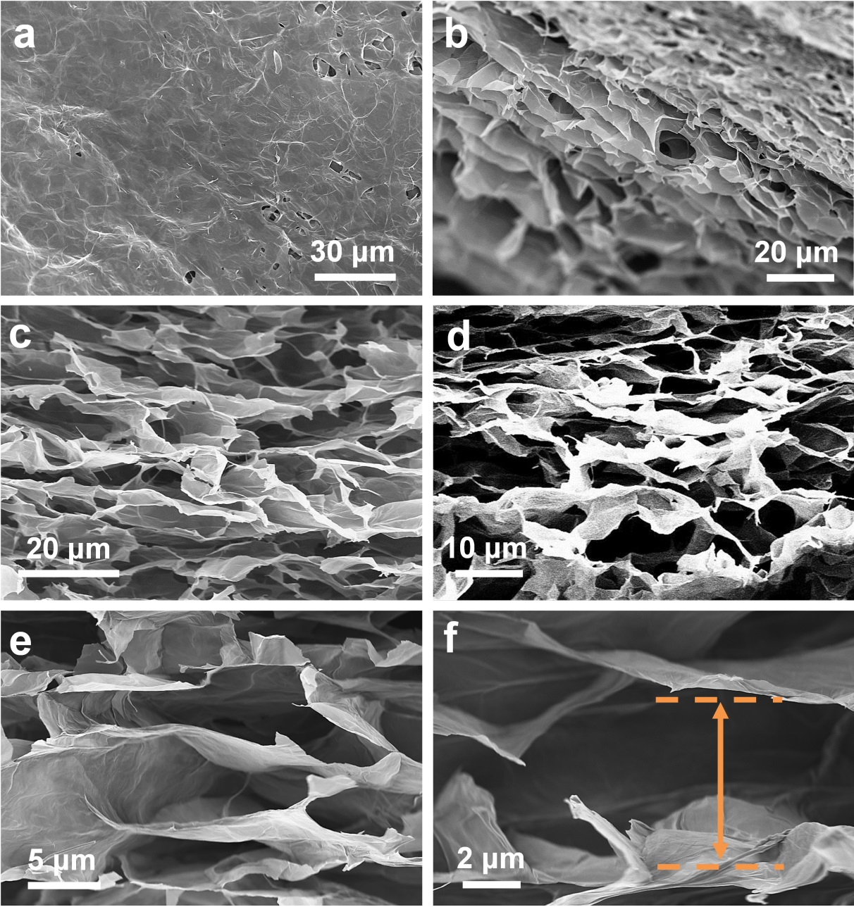
Figure S16. SEM images of the freeze-dried GO-LC foam, prepared via shear-aligned GO-LC dispersions in the prototype cell (Figure S5). The same cell was used for Figure 5k and Figure S9. (a)/(b) the top views from A-direction, (b) near the edge of cross-sectional cut, (c)-(f) cross-sectional views from the C-direction with different magnifications. Note the degree of deformation and interlayer spacing (~ a few μm), compared to those in films, dried in an ambient condition. Refer to Figure S5 for A- and C-direction.

