Where do people want to become entrepreneurs? Mapping entrepreneurship potential across Great Britain

Supplementary Information
We used Actor-based Clustering (Brenner, 2017) to explore the spatial distribution of entrepreneurial potential across Great Britain. Actor-based Clustering represents a spatial-smoothing technique that considers not only the observations residing in locality i to calculate a certain metric (e.g., the share of potential entrepreneurs) but also those living in localities j. by using spatial weights. Accordingly, close observations (e.g., those that can reach i within a driving distance of 10 minutes) will receive greater weights than those further away (e.g., those that require several hours to reach i). To receive these spatial weights, we calculated the travel time distance (driving time) between all possible pairs of spatial entities and employed a log-logistic distance decay function that is given by:
$$f\left(d\right)= \frac{1}{1+ {\left(\frac{d}{r}\right)}^{s}}$$
where d denotes the distance. The parameter r denotes the distance at which the decay function reaches a value of ½ and s determines the slope of the decay with distance.
We employed two different distance decay functions (see Figure S1). First, we aimed at depicting regional differences within Great Britain. To do so, we calculated travel time matrix between all 9,271 postcode sectors. We then created a map that represents the interaction radius that is available for a person on a daily basis (Ahmed & Stopher, 2014). Therefore, we set parameter r = 30 minutes such that observations within a travel time distance of 20 minutes receive a weight of nearly 1, observations within 30 minutes a weight of 0.5, and observations exceeding a distance of 50 minutes receive a weight of nearly zero. Results remained unchanged when using different thresholds such as r = 45 minutes. Second, we aimed at depicting local differences within the three largest cities London, Birmingham, and Manchester. To do so, we specified the distance decay function with the aim to capture a person’s immediate interaction space. We therefore set the parameter r = 10 minutes.

The final values generated with Actor-Based Clustering indicate the share of potential entrepreneurs among the population that resides within a given distance (as specified by the corresponding distance decay function) around a postcode sector.

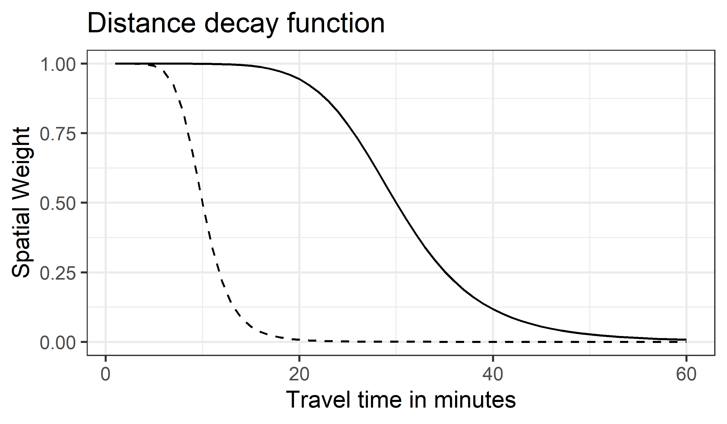
Figure S1: Spatial weights of the two distance decay functions based on r = 30 minutes (solid line) r = 10 minutes (dashed line).

To highlight the strengths of our mapping approach, we contrasted our map from the main text using Actor-Based Clustering with a conventional map based on disaggregation at the NUTS-2 level (i.e., grouping all individuals from the sample into their corresponding NUTS-2 region). The two maps are displayed in Figure S2 revealing that Actor-Based Clustering (panel A) produces a fine-grained map showing detailed differences in potential entrepreneurship that are hidden when individuals are grouped into higher level spatial units such as the commonly used level of NUTS-2 regions (panel B). For example, while the disaggregated map indicates that 13,4% of the population in West Wales (NUTS-2 = UKL1) are potential entrepreneurs, the map generated with Actor-Based clustering reveals that the regional share varies considerably from 10,5% in Llandudno to 17.5% in Swansea. Hence, Actor-Based clustering provides an alternative to conventional mapping techniques (e.g., disaggregation at high-order spatial units) once researchers are interested in detecting geographic patterns at the lowest spatial scale available to them.

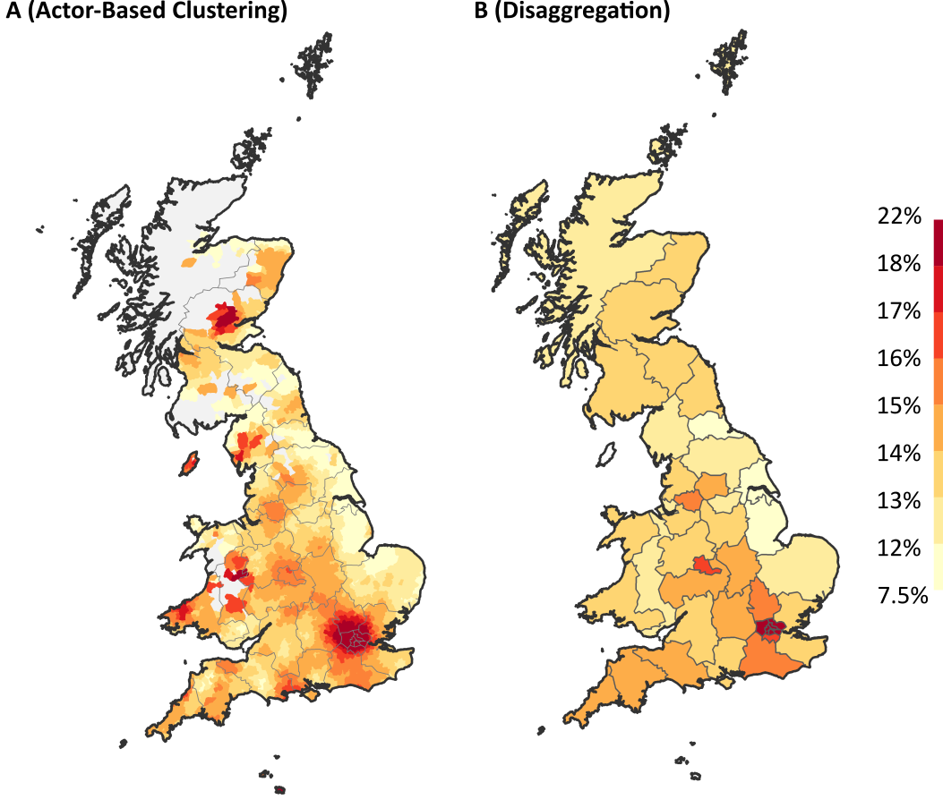

Figure S2: The share of potential entrepreneurs generated with Actor-Based Clustering at the level of postcode sectors (A) and based on disaggregation at the NUTS-2 level (B). Data was too scarce to produce reliable estimates in postcode sectors colored in grey in panel A.

References

Ahmed, A., & Stopher, P. (2014). Seventy Minutes Plus or Minus 10—A Review of Travel Time Budget Studies. Transport Reviews, 34(5), 607–625. https://doi.org/10.1080/01441647.2014.946460
Brenner, T. (2017). Identification of clusters: An actor-based approach. Working Papers on Innovation and Space, 2(17).

