Supplementary Material - Table A

Types of Conceptual Reasoning Associated with the Items on the Thermodynamics Conceptual Reasoning Inventory

Types of Conceptual Reasoning | Number of Items*
First Law Reasoning | 8
Equation-of-State Reasoning | 6
Calorific Equation-of-State Reasoning | 12
Graphical Reasoning | 7
Distinguishing among Processes | 11
* Item pairs are treated as one item for this categorization; some item pairs have more than one associated type of conceptual reasoning.

Supplemental Material - Table B

Additional Concepts Associated with the Items on the Thermodynamics Conceptual Reasoning Inventory

Additional Concepts | Number of Items*
Moving Boundary (Expansion/Compression) Work
Definition of Work | 11
Relation of Work to Process | 12
Direction (In/Out) of Work | 10
Heat Interaction
Relation of Heat to Process | 8
Direction (In/Out) of Heat | 9
Other
Heat/Temperature Confusion | 3
Isothermal vs. Adiabatic | 4
State Function vs. Path Function | 2
* Item pairs are treated as one item for this categorization; some item pairs have more than one associated concept.

Supplementary Material - Thermodynamics Conceptual Reasoning Inventory (TCRI)
NOTE: Online Qualtrics version of the TCRI is available for sharing upon request (email: cfiretto@asu.edu); printer-friendly version is available below. Item pairs/pages should be randomized for implementation.

Thermodynamics Conceptual Reasoning Inventory (TCRI)

GENERAL INSTRUCTIONS
Participation takes approximately 1 hour, but individual times may vary. You must complete the entire survey in a single sitting. Do not begin unless you are ready, and please take your time.
Do not use textbooks, notes, or the Internet to search for answers—the purpose of the TCRI is to understand more about what you already know about these concepts.

NOTE: All of the following questions relate to a fixed-mass system (i.e. closed) for an ideal gas. Assume all processes are quasi-equilibrium, with uniform properties inside of the system at any given time.

Which of the following processes result in work done by the system on the surroundings?
- a constant-pressure compression process
- a constant-temperature expansion process
- a constant-temperature compression process
- a constant-volume process with heat crossing the boundary from the surroundings to the system

Justify your selection by selecting the most appropriate justification from the following:
- Work is caused by a change in volume. If the volume of the system increases then work is done by the system on the surroundings.
- In order to keep the volume constant while heat is flowing into the system, the system must do work to push it back out.
- Work is caused by a change in volume. If the volume of the system decreases then work is done by the system on the surroundings.
- Any change in volume results in work being done.

Which of the following processes result in work done by the surroundings on the system?
- a constant-pressure expansion process
- a constant-temperature expansion process
- a constant-temperature compression process
- a constant-volume process with heat crossing the boundary from the system to the surroundings

Justify your selection by selecting the most appropriate justification from the following:
- Positive work means the surroundings do work on the system.
- Work is always done on a system unless it is adiabatic.
- The surroundings must do work on the system in order for the system to expand without a temperature change.
- Because the volume is decreasing, work is done by the surroundings on the system.

Which of the following processes result in zero work being done on or by the system?
- a constant-pressure expansion process
- a constant-temperature expansion process
- a constant-temperature compression process
- a constant-volume process with heat crossing the boundary from the surroundings to the system

Justify your selection by selecting the most appropriate justification from the following:
- Work is the integral of PdV, so no change in volume results in no work done on or by the system.
- Any time heat crosses the boundary, no work is done.
- No work is done with constant temperature. With constant volume or constant pressure, work would equal P(V2-V1) or V(P2-P1).
- Constant pressure expansion means average collisions with the walls of the system is the same, so if the volume is greater, the speed of the particles must be greater, i.e. having more energy, so work must be done on the system to add this energy.

Select the correct statement.
- No heat crosses the boundary of the system in a constant-pressure expansion process.
- No heat crosses the boundary of the system in a constant-temperature expansion process.
- Heat crosses the boundary from the surroundings to the system in both constant-pressure and constant-temperature expansion processes.
- Heat crosses the boundary from the system to the surroundings in both constant-pressure and constant-temperature expansion processes.

Justify your selection by selecting the most appropriate justification from the following:
- There must be heat in because there is work out and the internal energy change is either positive or zero.
- Constant-temperature and constant-pressure expansion indicates negative work, or heat going into the surroundings.
- Heat only crosses the boundary when there is a difference in temperatures, not constant temperatures.
- In a constant-pressure expansion, the work out equals the internal energy change.

Which of the following processes results in zero internal energy change ΔU?
- a constant-pressure expansion process
- a constant-temperature expansion process
- a constant-pressure compression process
- a constant-volume process with heat crossing the boundary from the system to the surroundings

Justify your selection by selecting the most appropriate justification from the following:
- For an ideal gas, internal energy is a function of temperature only. If there is no change in temperature then there is no change in internal energy
- If pressure is constant, and the work out of the system is equal to the heat into the system, then change in internal energy is zero.
- Internal energy is dependent on heat transfer, and this is the only process where the heat remains constant.
- There is no work done during a constant-volume process; therefore, the internal energy change is zero.

Which of the following processes results in a positive internal energy change ΔU, i.e., the internal energy of the system increased as a result of the process?
- a constant-pressure expansion process
- a constant-temperature expansion process
- a constant-temperature compression process
- a constant-volume process with heat crossing the boundary from the system to the surroundings

Justify your selection by selecting the most appropriate justification from the following:
- Compression of a system causes the volume to decrease and increases internal energy.
- The temperature increases as the volume increases at constant pressure.
- A positive amount of work will correlate with a positive internal energy change.
- No work is done on the system and the heat interaction is positive.

Which of the following processes results in a negative internal energy change ΔU, i.e., the internal energy of the system decreased as a result of the process?
- a constant-pressure expansion process
- a constant-pressure compression process
- a constant-temperature compression process
- a constant-volume process with heat crossing the boundary from the surroundings to the system

Justify your selection by selecting the most appropriate justification from the following:
- For a constant-pressure compression process, the volume is decreased, which would increase the pressure, but since it is constant pressure, the temperature (and thus internal energy) must decrease.
- H = U + PV, so for internal energy to change, pressure must change. As internal energy goes down, compression must happen to make pressure constant.
- Compression means the system gets smaller, so the internal energy decreases.
- Constant-pressure compression with the final volume being less than the initial turns the minus sign in the isobaric internal energy equation into a plus. The larger final volume also make the natural log negative for constant temperature.
- For a constant-volume process, energy is entering the system via heat transfer and there is no work, so the internal energy must decrease.

Consider an ideal gas contained in a piston-cylinder assembly that undergoes a quasi-equilibrium process. During the process, the gas expands causing the piston to move. The final temperature exceeds the value of that for the initial state. The work interaction for this process is
- zero.
- from the surroundings to the system.
- from the system to the surroundings.
- indeterminate.

Justify your selection by selecting the most appropriate justification from the following:
- To increase the temperature, work from the surrounding to the system is required.
- Because the process is neither isothermal nor isobaric, the direction of the work cannot be determined.
- The gas expands so the work is done by the system on the surroundings.
- The heat transfer equals the internal energy change.

Consider an ideal gas contained in a piston-cylinder assembly that undergoes a quasi-equilibrium process. During the process, the gas expands causing the piston to move. The final temperature exceeds the value of that for the initial state. The heat interaction for this process is
- zero.
- from the surroundings to the system.
- from the system to the surroundings.
- indeterminate.

Justify your selection by selecting the most appropriate justification from the following:
- Work is separate from a heat interaction, so the heat interaction cannot be determined.
- If work is from the system to the surroundings, then heat must be from the surroundings to the system in accordance with the first law of thermodynamics.
- Because the process is isothermal, only work is done.
- If work is from the system to the surroundings, then heat also must be from the system to the surroundings in accordance with the first law of thermodynamics.

Select the best choice. An ideal gas undergoes a quasi-equilibrium compression process during which the temperature is constant. To accomplish the compression, work is done on the gas by the surroundings. How is it possible that the gas temperature is constant even though work is done on the gas?
- Heat is transferred out of the system.
- Heat is transferred into the system.
- The process is quasi-equilibrium so the temperature remains constant.
- The gas is ideal so the pressure change and temperature changes offset each other.

Justify your selection by selecting the most appropriate justification from the following:
- In a quasi-equilibrium process, the process is done so slowly that the temperature appears to remain constant during the compression.
- Because the internal energy change is zero, the heat out must equal the work in.
- Heat must be transferred out to lower the energy to keep the process quasi-equilibrium.
- Work can be done while heat remains constant in a quasi-equilibrium process.

Select the best choice. Consider a (closed) ideal-gas thermodynamic system undergoing a quasi-equilibrium isothermal process. During the process, work is done by the system on the surroundings. For this process:
- There is no heat interaction.
- Heat crosses the boundary from the system to the surroundings.
- Heat crosses the boundary from the surroundings to the system.
- None of the other options.

Justify your selection by selecting the most appropriate justification from the following:
- Because the process is isothermal, only work is done.
- Isothermal does not mean adiabatic; therefore, the heat interaction cannot be determined from the given information.
- The internal energy change is zero; therefore, the heat from the surroundings to the system must equal the work done by the system on the surroundings.
- The internal energy change is zero; therefore, the heat from the system to the surroundings must equal the work done by the system on the surroundings.

Select the best choice. Consider a (closed) ideal-gas thermodynamic system undergoing a quasi-equilibrium adiabatic expansion process from state 1 to state 2. For this process:
- T₂ < T₁
- T₂ = T₁
- T₂ > T₁
- There is not enough information to determine the relative magnitudes of T₂ and T₁.

Justify your selection by selecting the most appropriate justification from the following:
- In an expansion process the volume increases; because the volume is proportional to the temperature, the temperature must increase.
- The internal energy change and, therefore, the temperature change must be negative because the work is from the system to the surroundings.
- Because the process is adiabatic, there is no heat interaction; therefore, the temperature remains constant.
- To determine the temperature, additional property information is required.

A fixed mass of an ideal gas undergoes a quasi-equilibrium process along process path A, which takes the system from state 1 to state 2. An identical fixed mass of the same ideal gas undergoes a different quasi-equilibrium process along process path B, which also takes this system from state 1 to state 2. The two processes are illustrated in the pressure-volume plot below.
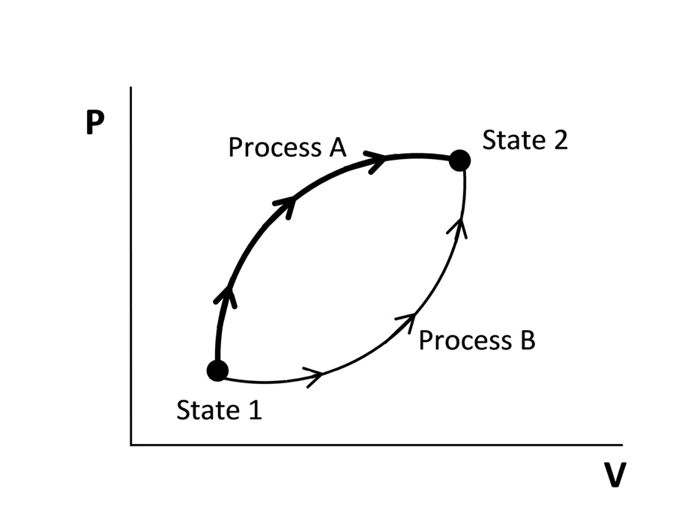

Select the best choice. The work for process A
- is greater than the work for process B.
- is less than the work for process B.
- is equal to the work for process B.
- cannot be compared to process B. More information is required to estimate the relative magnitudes of the work for the two processes.

Justify your selection by selecting the most appropriate justification from the following:
- Work is area under the P-V curve. Therefore, from state 1 to state 2, the work is greater for process A because the integral (area under the curve) is greater for A than for B.
- Since the process undergoes a reversible transformation, the conservation of energy makes sure that work is independent of the path. So work is equal regardless of the path.
- The work for the two processes is equal. The constant-volume specific heat for each path is the same because it is the same gas. The change in volume is the same as well because they have the same end points.
- Work is the area to the left of the P-V curve, so process B has more work.

Select the plot that represents a constant-temperature expansion. The numbers represent state points; 1 is the initial state and 2 is the final state.
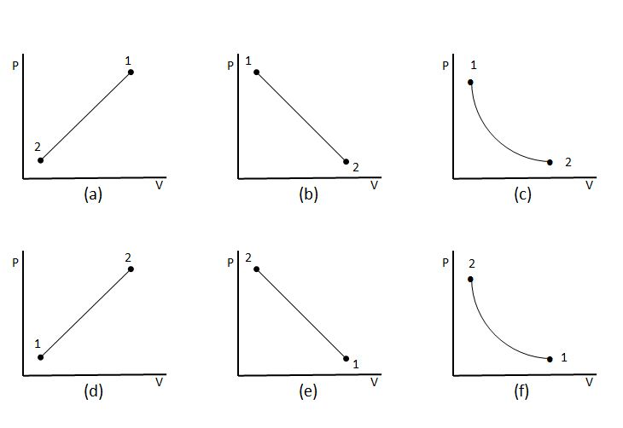

- (a)
- (b)
- (c)
- (d)
- (e)
- (f)

Justify your selection by selecting the most appropriate justification from the following:
- With constant T, P is inversely related to v. It is an expansion, so state 2 should be at a larger volume than state 1.
- Pressure, temperature and volume are directly related. So the graph is linear. The system expands, so the volume increases, and so does the pressure, proportionately. The line starts in the lower left and expands to upper right.
- The constant temperature line is positive and linear. With expansion, pressure will go down.
- Pressure, temperature, and volume are all related by the ideal gas law. So the graph is linear. Because the system expands, the slope of the line must be negative with V2 > V1.

Select the pressure-volume plot that represents the following sequences of processes. The numbers 1, 2, and 3 represent state points.
1 - 2: constant-pressure expansion process
2 - 3: constant-volume process with heat from the system to the surroundings
3 - 1: constant-temperature compression to the initial state
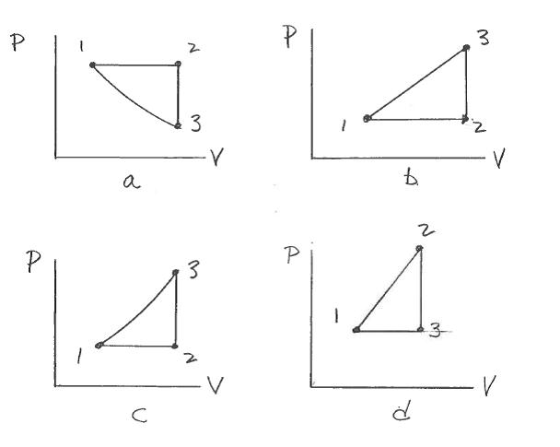
- a
- b
- c
- d

Select the temperature-volume plot that represents the following sequences of processes. The numbers 1, 2, and 3 represent state points.
1 - 2: constant-volume process with heat from the surroundings to the system
2 - 3: constant-temperature expansion
3 - 1: constant-pressure compression process to the initial state

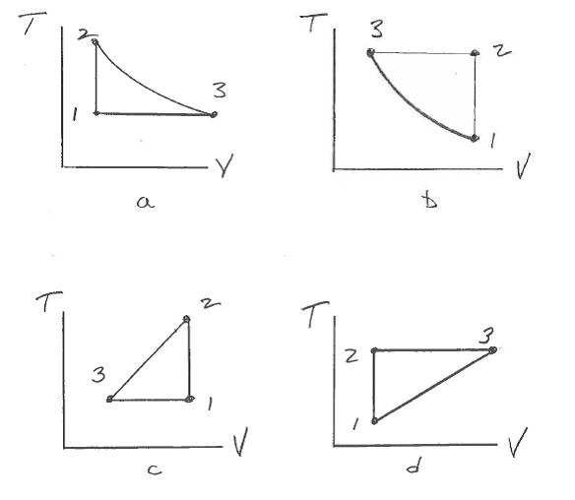

- a
- b
- c
- d

Select the plot that represents a constant-pressure compression process. The numbers represent state points; 1 is the initial state and 2 is the final state.
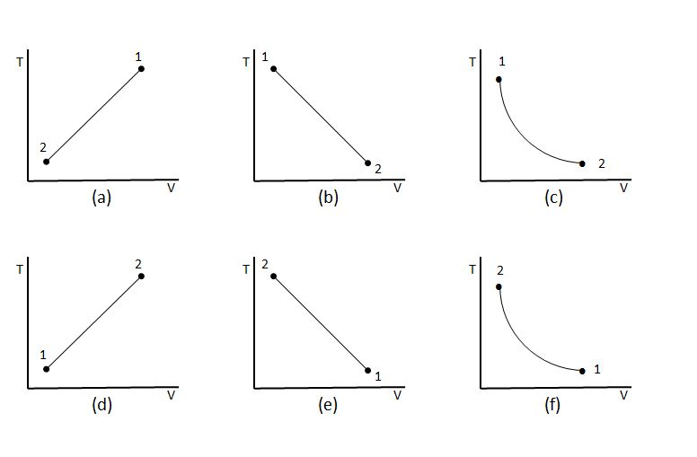
- (a)
- (b)
- (c)
- (d)
- (e)
- (f)

Justify your selection by selecting the most appropriate justification from the following:
- A constant-pressure process follows a line extending from the origin and compression is from right to left.
- When temperature increases and volume decreases, pressure increases.
- The line for this process must be curved due to the ideal gas law; temperature must also increase.
- Pressure is the slope of T and V and temperature must increase.
- The temperature will increase and the volume will decrease when compressed, and the relation between T and V is linear for an ideal gas.
- The process is represented by a curved line, and the volume at state 2 is smaller than at state 1.

Please note that these are pressure-temperature (P-T) plots. Select the plot that represents a constant-volume process with heat transfer from the surroundings to the system. The numbers represent state points; 1 is the initial state and 2 is the final state.
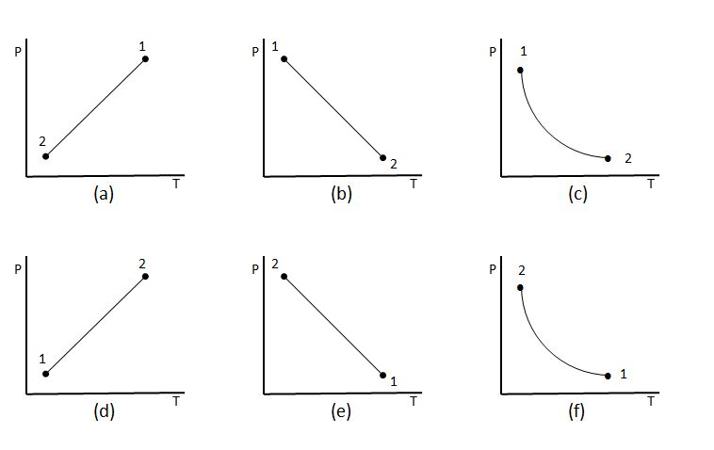
- (a)
- (b)
- (c)
- (d)
- (e)
- (f)

Justify your selection by selecting the most appropriate justification from the following:
- The pressure and temperature are related linearly, with pressure increasing as temperature increases.
- The pressure and temperature are related linearly, with pressure decreasing as temperature increases.
- The curve must be hyperbolic and temperature must decrease in going from state 1 to state 2.
- The curve must be hyperbolic and temperature must increase in going from state 1 to state 2.

A fixed mass of an ideal gas undergoes a quasi-equilibrium process along process path A, which takes the system from state 1 to state 2. An identical fixed mass of the same ideal gas undergoes a different quasi-equilibrium process along process path B, which also takes this system from state 1 to state 2. The two processes are illustrated in the pressure-volume plot below.
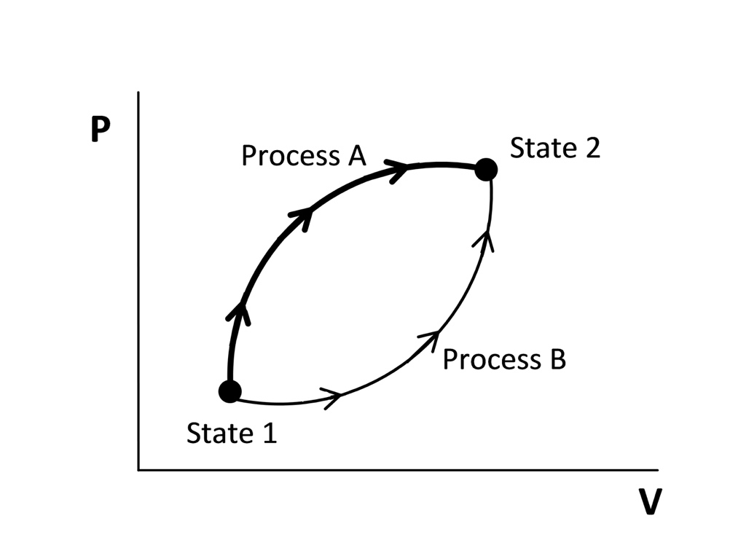
Select the best choice. The internal energy change for process A
- is greater than the internal energy change for process B.
- is less than the internal energy change for process B.
- is equal to the internal energy change for process B.
- cannot be compared to process A. More information is required to estimate the relative magnitudes of the internal energy change for the two processes.

Justify your selection by selecting the most appropriate justification from the following:
- The area under the curve for process A is greater than the area for process B, indicating a greater internal energy change for process A.
- Because the work for process A is greater than the work for process B, the internal energy change for process B must be greater than for process A.
- Because there is no information provided about the enthalpy change, the relative magnitudes of the internal energy change for the process cannot be determined.
- Internal energy is not a path function.

