Supplementary Information

Contents Page no.

- Energy minimisation of the crystal structure of 3CL^{pro} 02
- Binding pose and binding affinity of library molecules for 3CL^{pro} 03
- In-house library of antiviral compounds from tropical mangrove plants 13
Structure | Evaluation Tools
R | Pro Check |  |  |  |  |  |  | ERRAT  quality  factor  (%) | Verify_3D  (%)
 | Ramachandran Plot statistics G-Factors
 | Most  favoured  (%) | Additionally  allowed  (%) | Generously  Allowed  (%) | Disallowed  (%) | Dihedral  angles | Covalent  geometry | Overall  average
Initial State  (PDB ID: 6LU7) | 89.4 | 9.5 | 0.4 | 0.8 | 0.4 | 0.36 | 0.17 | 98.25 | 95.72
Minimised State  (PDB ID: 6LU7) | 89 | 9.9 | 0.8 | 0.4 | -0.05 | 0.42 | 0.15 | 99.63 | 96.52
Table 1: Model evaluation of the minimised state of 3CL^{pro}

Table 2: 3D interaction diagrams, estimated binding affinity and estimated inhibition constant of in-house library molecules against 3CL^{pro}
S. No | Molecule Name | 3D Ligand interaction diagram | Estimated Binding Affinity  (kcal/mol) | Estimated Inhibition constant  (µM)
1 | Krishnolide A |  | -6.6 | 14.52
2 | Krishnolide B |  | -6.4 | 20.35
3 | Krishnolide C | 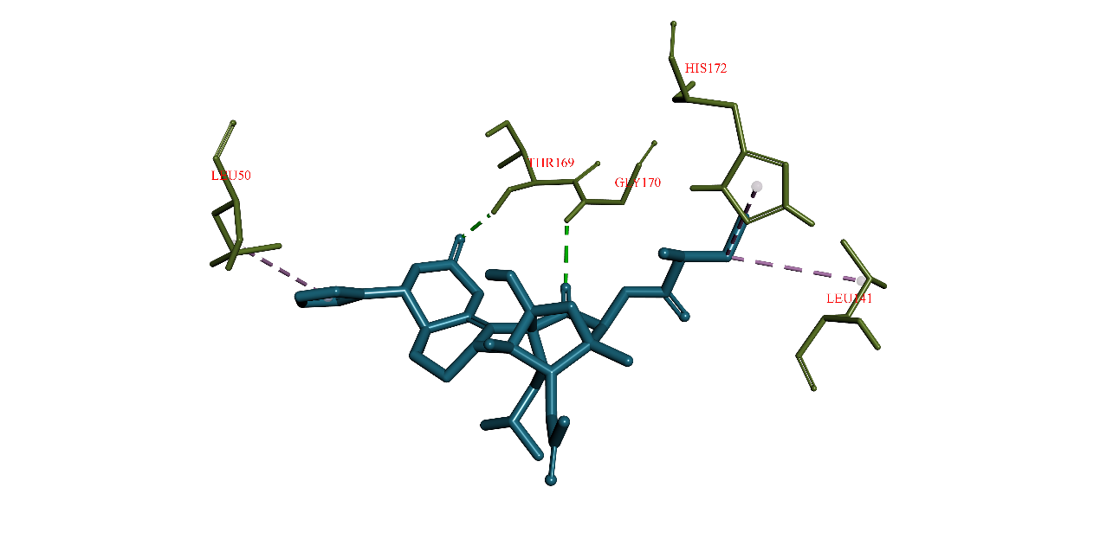 | -6.4 | 20.35
4 | Krishnolide D |  | -6.3 | 24.1
5 | Sundarbanxylogranin A | 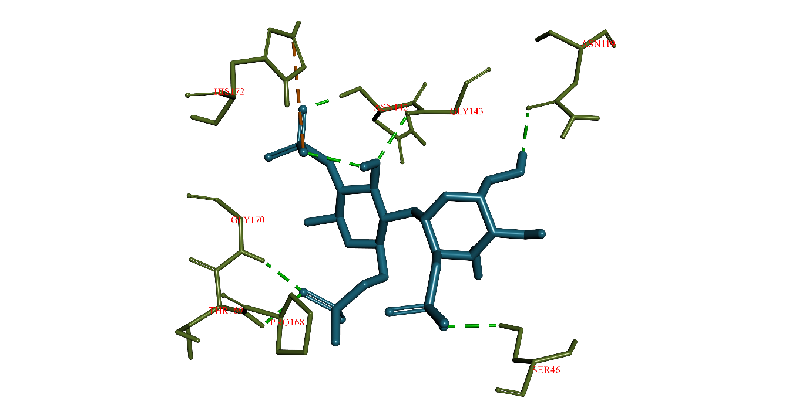 | -6.6 | 14.52
6 | Sundarbanxylogranin B |  | -6.6 | 14.52
7 | Sundarbanxylogranin C | 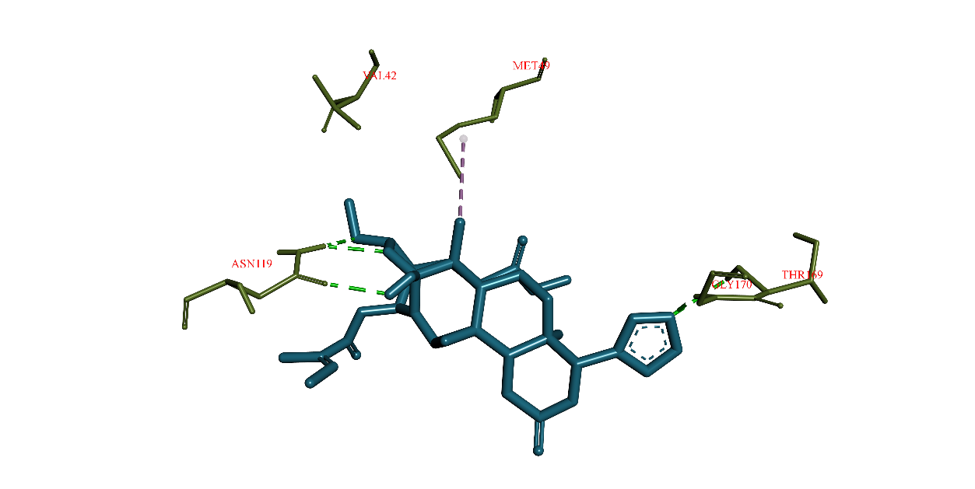 | -6.5 | 17.19
8 | Sundarbanxylogranin D | 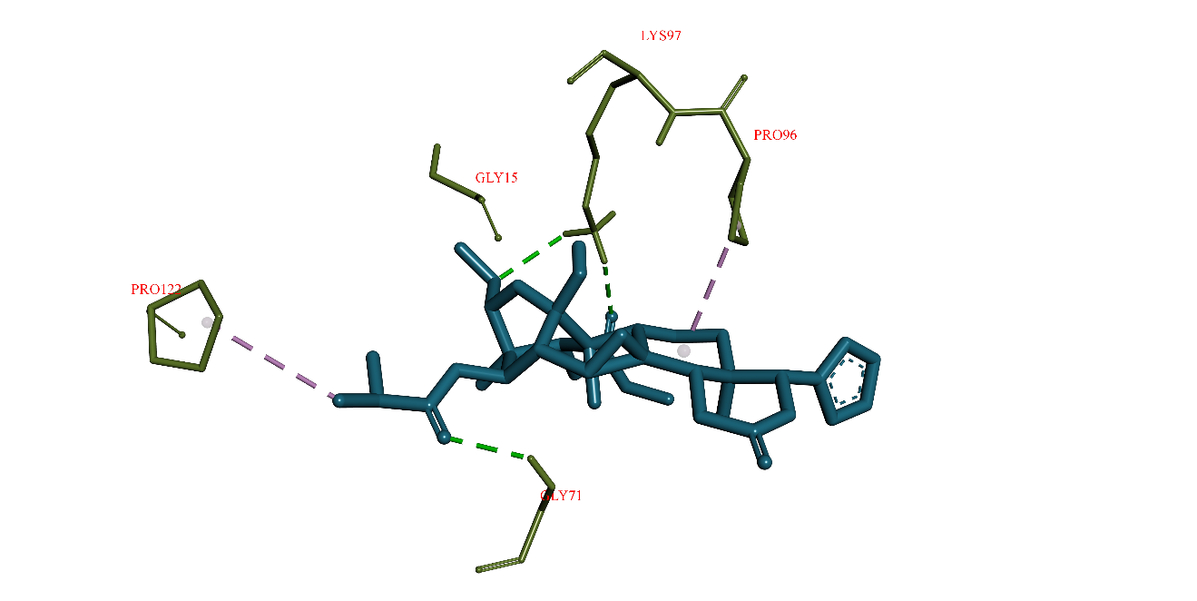 | -6.6 | 14.52
9 | Sundarbanxylogranin E |  | -6.5 | 17.19
10 | Khayanolide I |  | -6.5 | 17.19
11 | Khayanolide K | 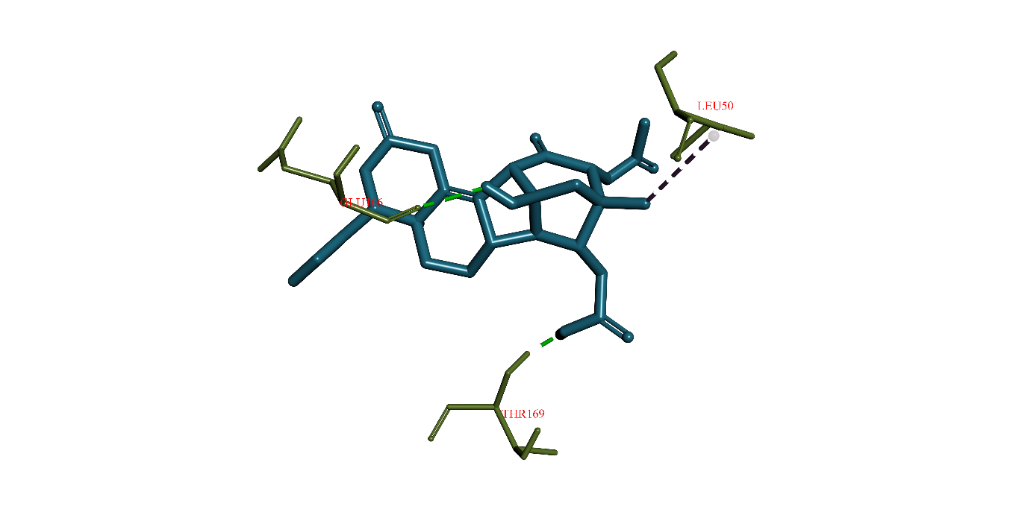 | -6.6 | 14.52
12 | Khayanolide M | 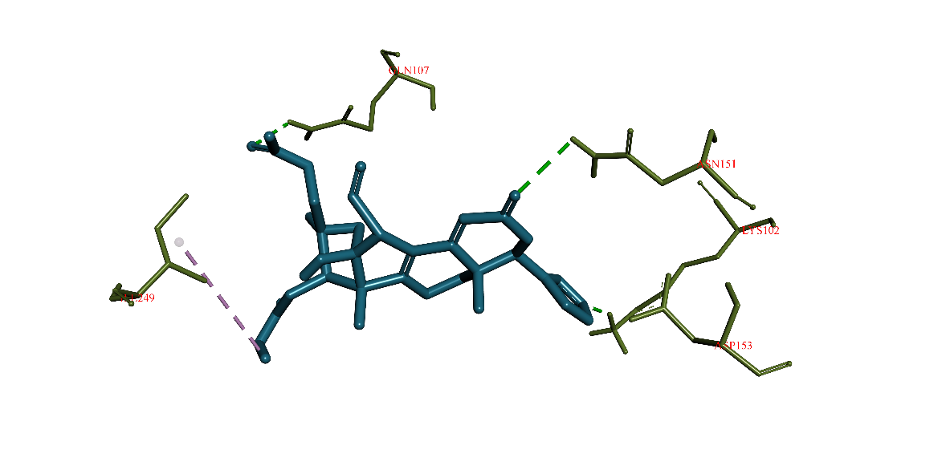 | -6.5 | 17.19
13 | 2,5-Didehydroxy-6-methylembelin |  | -5.4 | 110.01
14 | Embelin |  | -5.4 | 110.01
15 | 5-O-Ethylembelin | 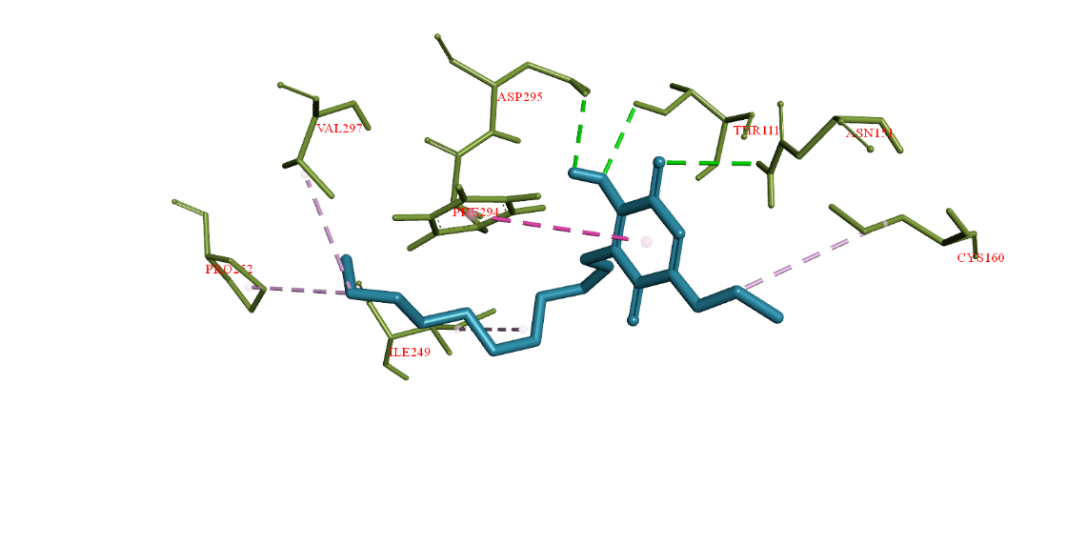 | -5.9 | 47.33
16 | 5-O-Methylembelin |  | -5.5. | 92.97
17 | 5-O-Methyl-2-acetoxyembelin |  | -5.3 | 130.29
18 | Quinazarin |  | -6.3 | 24.1
19 | Lupeol |  | -6.6 | 14.52
20 | Butelin |  | -6.3 | 24.1
21 | β-Sitosterol |  | -6.2 | 28.53
22 | Velutin |  | -6.2 | 28.53
23 | Rutin | 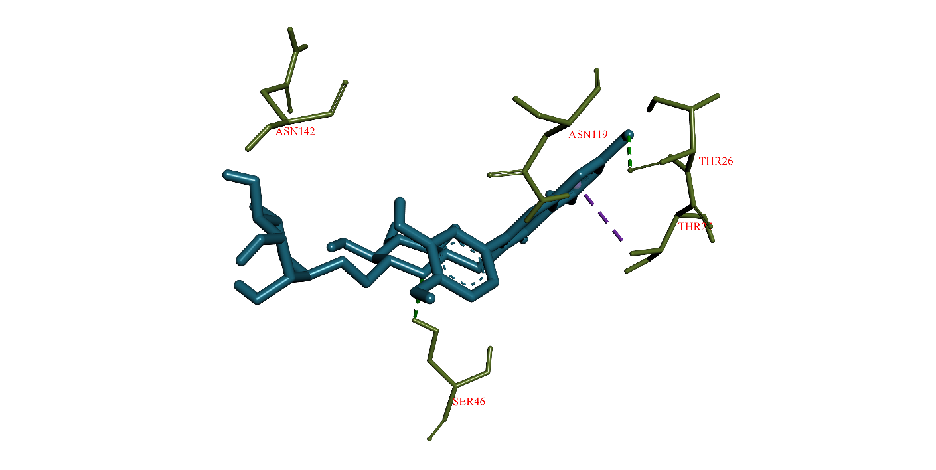 | -6.7 | 12.27
24 | Chrysin |  | -6.4 | 20.35
25* | Gallic acid |  | -5.3 | 130.29
31 | Mucic acid |  | -4.7 | 358.8
32 | Mucic acid analogue |  | -4.7 | 358.8
33. | Sulfated polysaccharide | 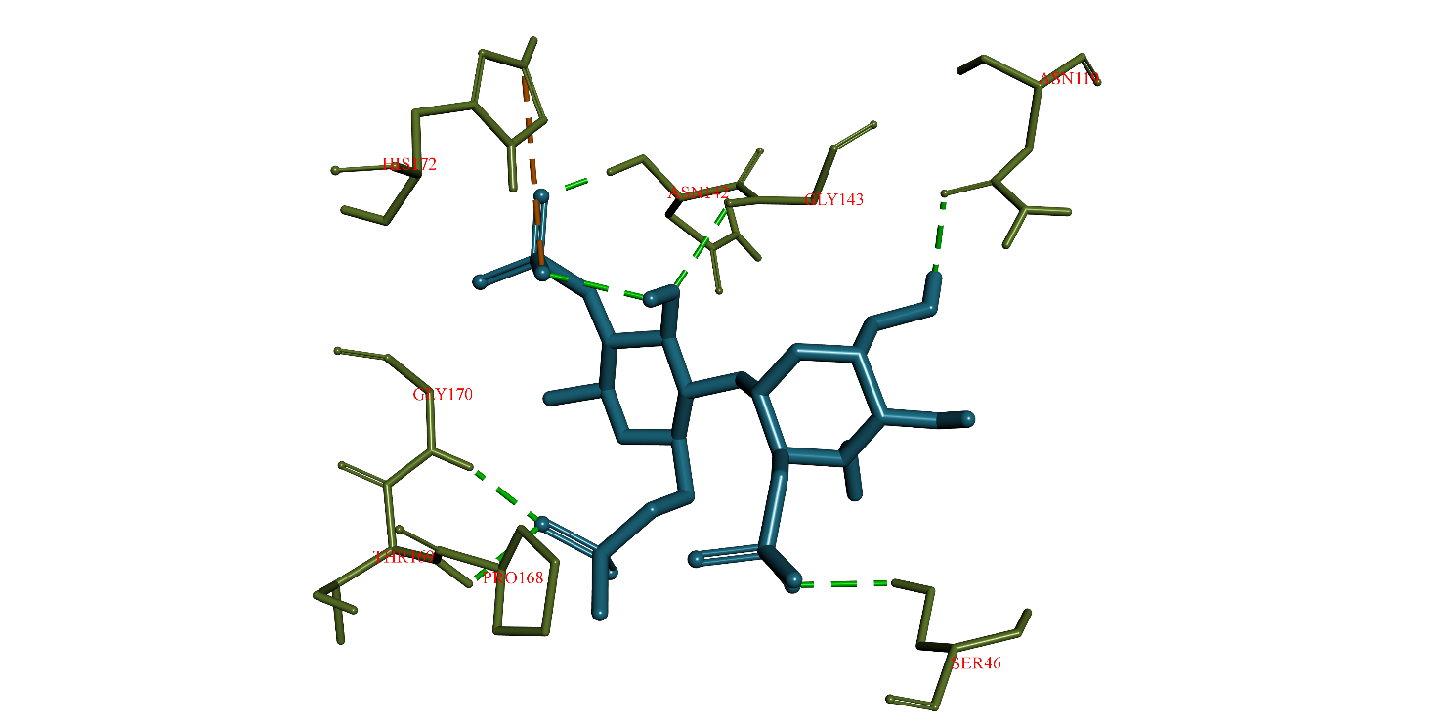 | -5.9 | 47.33
*2D/3D interaction diagram, binding affinity and inhibition constant for molecules 26 to 30 were already provided in the main-text
Table 3: In-house library of antiviral compounds from tropical mangrove plants

S.No | Compound Name | Compound Structure | Antiviral activity | Description | Reference
1 | Krishnolide A |  | Anti-HIV activity | Source: X. moluccensis  Chemical Formula: C₃₆H₄₆O₁₁  Molecular Weight: 654.75 | Zhang et al., 2017
2 | Krishnolide B |  | Anti-HIV activity | Source: X. moluccensis  Chemical Formula:  C₃₆H₄₄O₁₀  Molecular Weight:  636.74 | Zhang et al., 2017
3 | Krishnolide C |  | Anti-HIV activity | Source: X. moluccensis  Chemical Formula:  C₃₆H₄₆O₁₀  Molecular Weight:  638.75 | Zhang et al., 2017
4 | Krishnolide D |  | Anti-HIV activity | Source: X. moluccensis  Chemical Formula:  C₃₆H₄₆O₁₀  Molecular Weight:  638.75 | Zhang et al., 2017
5 | Sundarbanxylogranin A |  | Anti-HIV activity | Source: X. granatum  Chemical Formula:  C₃₂H₄₀O₈  Molecular Weight: 552.66 | Dai et al., 2017
6 | Sundarbanxylogranin B |  | Anti-HIV activity | Source: X. granatum  Chemical Formula:  C₂₉H₃₆O₉  Molecular Weight:  528.60 | Dai et al., 2017
7 | Sundarbanxylogranin C |  | Anti-HIV activity | Source: X. granatum  Chemical Formula:  C₃₃H₄₂O₁₁  Molecular Weight:  614.69 | Dai et al., 2017
8 | Sundarbanxylogranin D |  | Anti-HIV activity | Source: X. granatum  Chemical Formula:  C₃₂H₄₂O₁₁  Molecular Weight:  602.68 | Dai et al., 2017
9 | Sundarbanxylogranin E |  | Anti-HIV activity | Source: X. granatum  Chemical Formula:  C₃₂H₄₂O₁₀  Molecular Weight:  586.68 | Dai et al., 2017
10 | Khayanolide I |  | Influenza A virus (subtype H1N1) activity | Source: X. moluccensis  Chemical Formula: C₂₉H₃₄O₁₀  Molecular Weight: 542.58 | Li et al. 2015
11 | Khayanolide K |  | Influenza A virus (subtype H1N1) activity | Source: X. moluccensis  Chemical Formula: C₂₉H₃₄O₉  Molecular Weight: 526.58 | Li et al. 2015
12 | Khayanolide M |  | Influenza A virus (subtype H1N1) activity | Source: X. moluccensis  Chemical Formula: C₂₉H₃₂O₉  Molecular Weight: 524.57 | Li et al. 2015
13 | 2,5-Didehydroxy-6-methylembelin |  | Anti- hepatitis B virus (HBV) activity. | Source: A.corniculatum  Chemical Formula: C₁₈H₂₈O₂  Molecular Weight: 276.42 | (Thota et al., 2016; Parvez et al. 2019)
14 | Embelin |  | Anti- hepatitis B virus (HBV) activity. | Source: A.corniculatum and R. apiculata  Chemical Formula: C₁₇H₂₆O₄  Molecular Weight: 294.39 | (Thota et al., 2016; Parvez et al. 2019)
15 | 5-O-Ethylembelin |  | Anti- hepatitis B virus (HBV) activity. | Source: A.corniculatum  Chemical Formula: C₁₉H₃₀O₄  Molecular Weight: 322.44 | (Thota et al., 2016; Parvez et al. 2019)
16 | 5-O-Methylembelin |  | Anti- hepatitis B virus (HBV) activity. | Source: A.corniculatum  Chemical Formula: C₁₈H₂₈O₄  Molecular Weight: 308.42 | (Thota et al., 2016; Parvez et al. 2019)
17 | 5-O-Methyl-2-acetoxyembelin |  | Anti- hepatitis B virus (HBV) activity. | Source: A.corniculatum  Chemical Formula: C₂₀H₃₀O₅  Molecular Weight: 350.45 | (Thota et al., 2016; Parvez et al. 2019)
18 | Quinazarin |  | Anti- hepatitis B virus (HBV) activity. | Source: A.corniculatum  Chemical Formula: C₁₄H₈O₄  Molecular Weight: 240.21 | (Thota et al., 2016; Parvez et al. 2019)
19 | Lupeol |  | Anti- hepatitis B virus (HBV) activity | Source: A.ofﬁcinalis, R. mucronata, C. tagal, and Avicennia alba  Chemical Formula: C₃₀H₅₀O  Molecular Weight: 426.73 | (Lakshmi etal. 2017; Ramanjaneyulu et al. 2017; Parvez et al. 2019)
20 | Butelin |  | Anti- hepatitis B virus (HBV) activity | Source: A.ofﬁcinalis, R. mucronata, C. tagal, and Avicennia alba  Chemical Formula: C₃₀H₅₀O₃  Molecular Weight: 458.73 | (Lakshmi etal. 2017; Ramanjaneyulu et al. 2017; Parvez et al. 2019)
21 | β-Sitosterol |  | Anti- hepatitis B virus (HBV) activity | Source: R. mucronata,A.ilicifolius and A. officinalis  Chemical Formula: C₂₉H₅₀O  Molecular Weight: 414.72 | (Rao et al., 2005; Parvez et al. 2019)
22 | Velutin |  | Anti- hepatitis B virus (HBV) activity | Source: A. officinalis, E. agallocha and A. rotundifolia  Chemical Formula: C₁₇H₁₄O₆  Molecular Weight: 314.29 | (Kaliamurthi and Selvaraj, 2016; Ghosh et al., 2019; Parvez et al. 2019).
23 | Kaempferol |  | Anti- hepatitis B virus (HBV) activity | Source: A. officinalis, E. agallocha and A. rotundifolia  Chemical Formula: C₁₅H₁₀O₆  Molecular Weight: 286.24 | (Kaliamurthi and Selvaraj, 2016; Ghosh et al., 2019; Parvez et al. 2019).
24 | Luteolin |  | Anti- hepatitis B virus (HBV) activity | Source: A. officinalis, E. agallocha and A. rotundifolia  Chemical Formula: C₁₅H₁₀O₆  Molecular Weight: 286.24 | (Kaliamurthi and Selvaraj, 2016; Ghosh et al., 2019; Parvez et al. 2019).
25 | Rutin |  | Anti- hepatitis B virus (HBV) activity | Source: A. officinalis, E. agallocha and A. rotundifolia  Chemical Formula: C₂₇H₃₀O₁₆  Molecular Weight: 610.52 | (Kaliamurthi and Selvaraj, 2016; Ghosh et al., 2019; Parvez et al. 2019).
26 | Chrysoeriol |  | Anti- hepatitis B virus (HBV) activity | Source: A. officinalis, E. agallocha and A. rotundifolia  Chemical Formula: C₁₆H₁₂O₆  Molecular Weight: 300.27 | (Kaliamurthi and Selvaraj, 2016; Ghosh et al., 2019; Parvez et al. 2019).
27 | Catechin |  | Anti- hepatitis B virus (HBV) activity | Source: A. officinalis, E. agallocha and A. rotundifolia  Chemical Formula: C₁₅H₁₄O₆  Molecular Weight: 290.27 | (Kaliamurthi and Selvaraj, 2016; Ghosh et al., 2019; Parvez et al. 2019).
28 | Chrysin |  | Anti- hepatitis B virus (HBV) activity | Source: A. officinalis, E. agallocha and A. rotundifolia  Chemical Formula: C₁₅H₁₀O₄  Molecular Weight: 254.24 | (Kaliamurthi and Selvaraj, 2016; Ghosh et al., 2019; Parvez et al. 2019).
29 | Diosmetin |  | Anti- hepatitis B virus (HBV) activity | Source: A. officinalis, E. agallocha and A. rotundifolia  Chemical Formula: C₁₆H₁₂O₆  Molecular Weight: 300.27 | (Kaliamurthi and Selvaraj, 2016; Ghosh et al., 2019; Parvez et al. 2019).
30 | Gallic acid |  | Anti- hepatitis B virus (HBV) activity | Source: A. officinalis, E. agallocha and A. rotundifolia  Chemical Formula: C₇H₆O₅  Molecular Weight: 170.12 | (Kaliamurthi and Selvaraj, 2016; Ghosh et al., 2019; Parvez et al. 2019).
31 | Mucic acid |  | Anti- hepatitis B virus (HBV) activity | Source: R. apiculata  Chemical Formula: ⁻ C₆H₁₀O₈  Molecular Weight: 210.14 | (Kaliamurthi and Selvaraj, 2016; Parthiban et al, 2020)
32 | Mucic acid analogue |  | Anti- hepatitis B virus (HBV) activity | Source: R. apiculata  Chemical Formula: C₇H₇K₅O₈  Molecular Weight: 414.62 | (Kaliamurthiand Selvaraj, 2016; Parthiban et al, 2020)
33. | Sulfated polysaccharide |  | Anti- SARS-CoV-2 activity | Source: R. mangle and A. aureum  Chemical Formula: C₁₄H₂₃O₁₉S₃³⁻  Molecular Weight: 591.50 | (Kwon et al, 2020; Aquino et al, 2011)

References
- Zhang, Q., Satyanandamurty, T., Shen, L., Jun Wu, J. (2017). Krishnolides A–D: New 2-Ketokhayanolides from the Krishna Mangrove, Xylocarpusmoluccensis. Mar. Drugs. 15, 333.
- Li, W., Jiang, Z., Shen, Li., Pedpradab, P., Bruhn, T., Wu, J., Bringmann, G. (2015). Antiviral Limonoids Including Khayanolides from the Trang Mangrove Plant Xylocarpusmoluccensis. J. Nat. Prod. 78, 7, 1570-1578.
- Thota, S. P. R., Sarma, N., Murthy, Y. L. M., Kantamreddi, V. S. S. N., Wright, C. W. (2016). A New embelin from the mangrove Aegicerascorniculatum. Indian J. Chem. 55B, 123-127.
- Parvez MK, TabishRehman M, Alam P, Al-Dosari MS, Alqasoumi SI, Alajmi MF. Plant-derived antiviral drugs as novel hepatitis B virus inhibitors: Cell culture and molecular docking study. Saudi Pharm J. 2019;27(3):389-400.
- Lakshmi, V., Mahdi, A. A., Agarwal, S.K., Kumar, R. (2017). Isolation and Characterization of Bioactive Terpenoids from the Leaves of Ceriopstagal Linn. Herbal Medicine: Open Acces ISSN :2472-0151.
- Ramanjaneyulu, M. V. V., Venkateswara, R. B., Ramanjaneyulu, K., Suvarna, R. P. (2015). Phytochemical analysis of Avicenniaofficinalisof Krishna Estuary. J. Pharm. Drug. 3, 176–180.
- Rao, B. V., Rao, C. V., Subrahmanyam. C., Jairaj, M. A. (2005). Chemical constituents of Rhizophoramucronata of Andaman and Nicobar Islands. J. Indian Chem. Soc. 82, 155-157.
- Kaliamurthi, S and Selvaraj, G. (2016). Insight on Excoecariaagallocha: An Overview. Nat. Prod. Chem. Res. 4(2), 1-2.
- Ghosh, D., Sumanta Mondal, S., Ramakrishna,. K. (2019). Spectroscopic characterization of phytoconstituents isolated from a rare mangrove aegialitis rotundifolia roxb., leaves and evaluation of antimicrobial activity of the crude extract. Asian J. Pharm. Res. 9(12), 220-224.
- Sachithanandam, V., Parthiban, A., Lalitha, P., Muthukumaran, J., Dhanasekar, E., Kamalraja, J., R. Sridhar, Purvaja, R., Ramesh R. (2020). Biological evaluation of gallic acid and quercetin derived from Ceriopstagal: insights from extensive in vitro and in silico studies. J. Biomol. Struct. Dyn. DOI: 10.1080/07391102.2020.1828173.

- Parthiban, A., Sachithanandam V., Lalitha, P., Baskaran, S., Misra, R; Sridhar., R; Purvaja., R; Ramesh, R. (2020). Isolation and characterization of novel potassium salts of 2-methoxy mucic acid from leaves of Rhizophoraapiculata: in vitro and in silico studies on its potential anticancer and antioxidant activities (unpublished work).
- Kwon, P. S., Oh, H., Kwon, S. J., Jin, W., Zhang, F., Fraser, K., Hong, J. J., Linhardt, R. J., & Dordick, J. S. (2020). Sulfated polysaccharides effectively inhibit SARS-CoV-2 in vitro. Cell discovery, 6, 50.
- Aquino, R. S., Grativol, C., & Mourão, P. A. (2011). Rising from the sea: correlations between sulfated polysaccharides and salinity in plants. PloS one, 6(4), e18862.

