Supplemental material
Table S1. Annual and four seasonal average concentrations of PM_{2.5} (Mean ± SD) in the 194 cities: 2015-2019.
 | PM_{2.5}(μg/m³)
 | Yearly | Spring | Summer | Autumn | Winter
2015 | 53 ± 44 | 48 ± 28 | 36 ± 23 | 50 ± 42 | 79 ± 60
2016 | 48 ± 41 | 47 ± 29 | 30 ± 18 | 46 ± 35 | 72 ± 57
2017 | 47 ± 39 | 44 ± 28 | 29 ± 17 | 42 ± 32 | 72 ± 54
2018 | 40 ± 32 | 43 ± 26 | 26 ± 13 | 37 ± 29 | 62 ± 47
2019 | 39 ± 33 | 36 ± 24 | 22 ± 12 | 35 ± 22 | 62 ± 48
Note：SD is standard deviation.
Table S2. Non-attainment condition of PM_{2.5} concentrations in 194 cities during year of 2015 to 2019.
Year | Non-attainment cities  Number (%) | Daily average non-attainment rate
 |  | Mean ± SD | Range | Median (IQR)
2015 | 159(81.96%) | 23.94% ± 17.23% | 0.00%-68.22% | 21.51%(9.32%-30.96%)
2016 | 145(74.74%) | 20.20% ± 14.73% | 0.00%-58.63% | 17.81%(8.70%-29.59%)
2017 | 144(74.23%) | 20.25% ± 14.56% | 0.00%-58.24% | 16.07%(9.27%-32.35%)
2018 | 120(61.86%) | 15.78% ± 12.68% | 0.00%-45.45% | 12.73%(5.08%-26.44%)
2019 | 110(56.70%) | 11.42% ± 9.32% | 0.00%-28.49% | 10.27%(3.01%-19.25%)
Note：SD is standard deviation; IQR is interquartile range.

Figure S1. Sample sites of 194 prefecture-level and above cities in China.
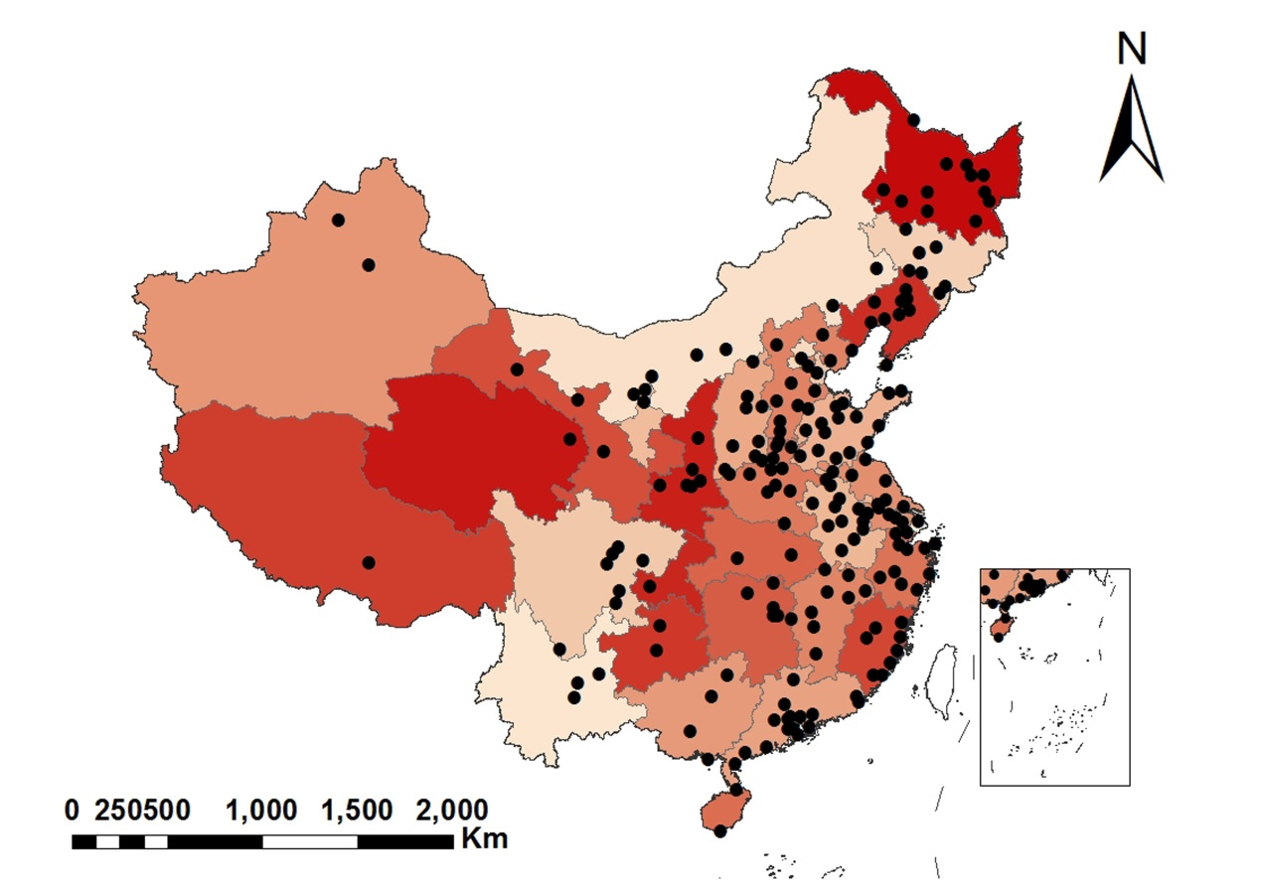

Figure S2. Temporal distributions of PM_{2.5} concentrations of 194 cities in China: 2015-2019. (a) Monthly distribution of PM_{2.5}. (b) Total days distribution of different pollution levels of PM_{2.5}.

Figure S3. Spatial distribution maps of daily average non-attainment rate of PM_{2.5}, 2015-2019.
