Piperazine-Grafted Magnetic Reduced Graphene Oxide (Fe₃O₄@rGO-NH) as a Reusable Heterogeneous Catalyst for Gewald Three-Component Reaction
Esmail Rezaei-Seresht*, Morteza Bakhshi-Noroozi, Behrooz Maleki
Department of Chemistry, School of Sciences, Hakim Sabzevari University, Sabzevar, Iran
*Corresponding author. Tel.: ++98-51-44013267; Fax: ++98-51-44013365; E-mail: e.rezaei@hsu.ac.ir

Supporting Information

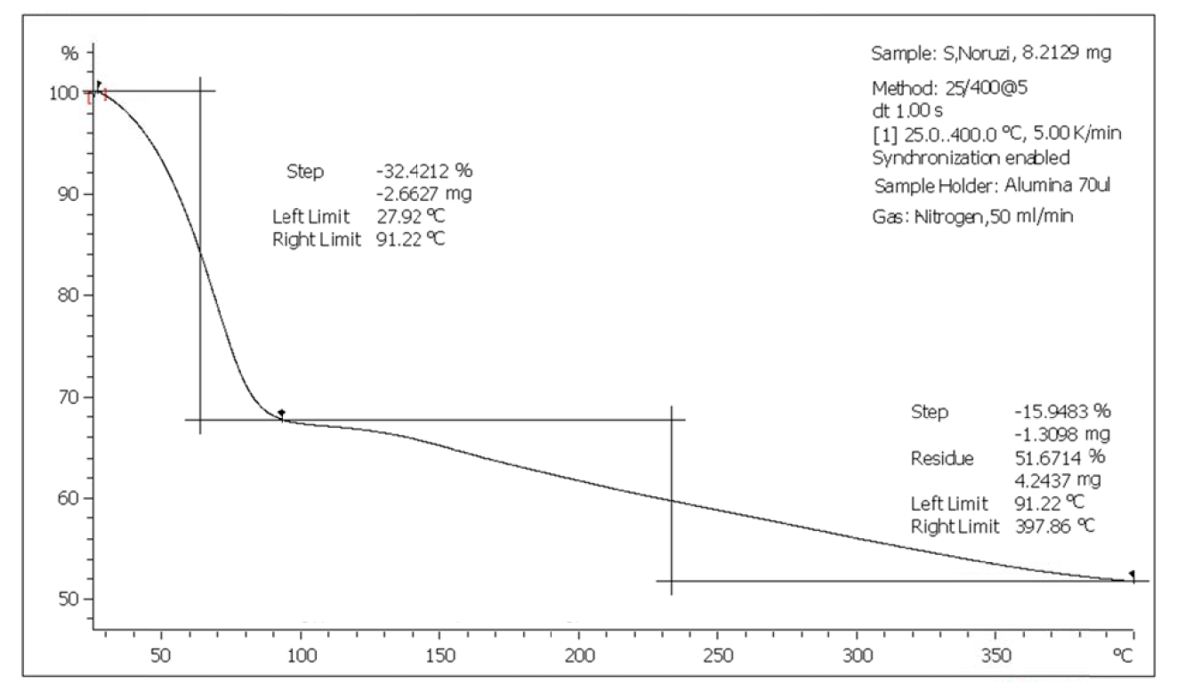
Figure S1. TGA curve of catalyst Fe₃O₄@rGO-NH

Figure S2. FT-IR spectrum of catalyst Fe₃O₄@rGO-NH

