Supplementary Figures

A
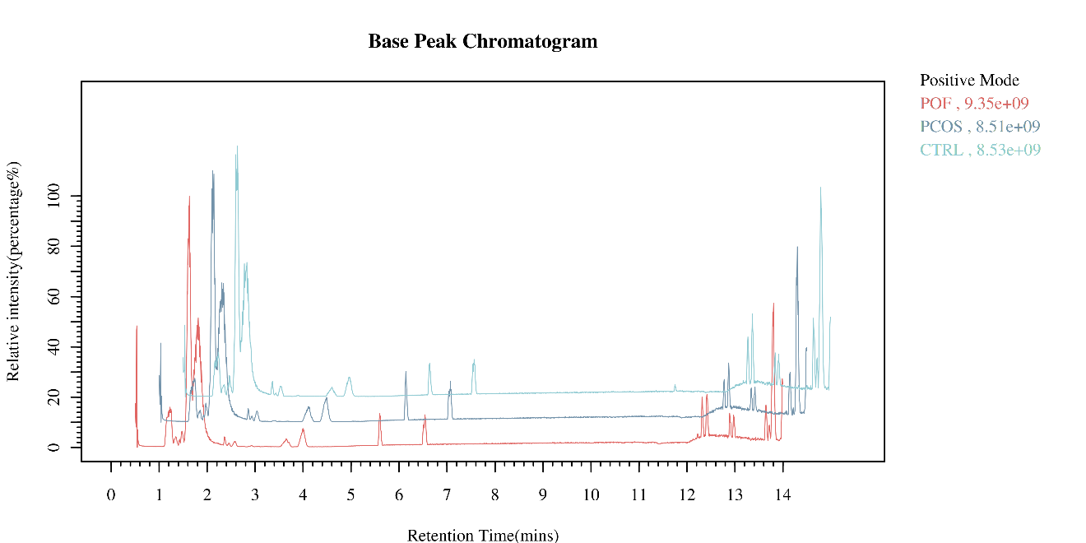
B
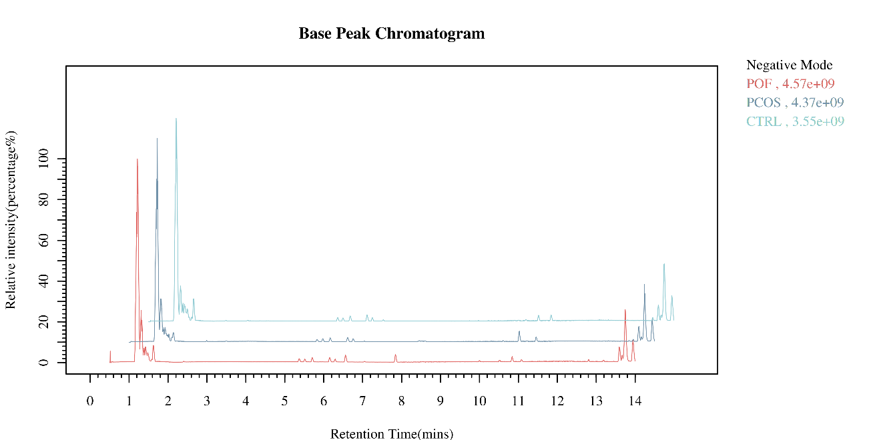
Figure S1. Base peak chromatogram analyzed the ion ESI+ and ESI- specific intensity of three groups. (ESI⁺), and ESI⁻(negative modes)

A C
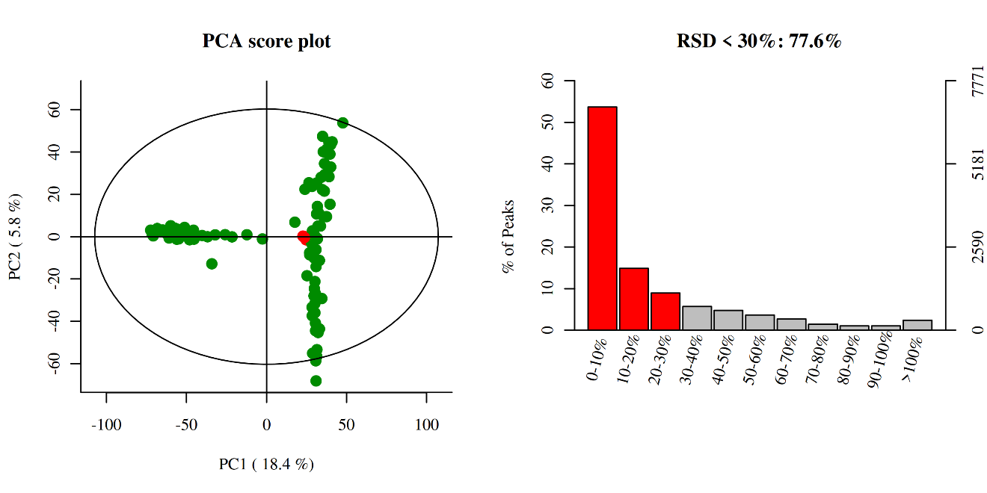
B D
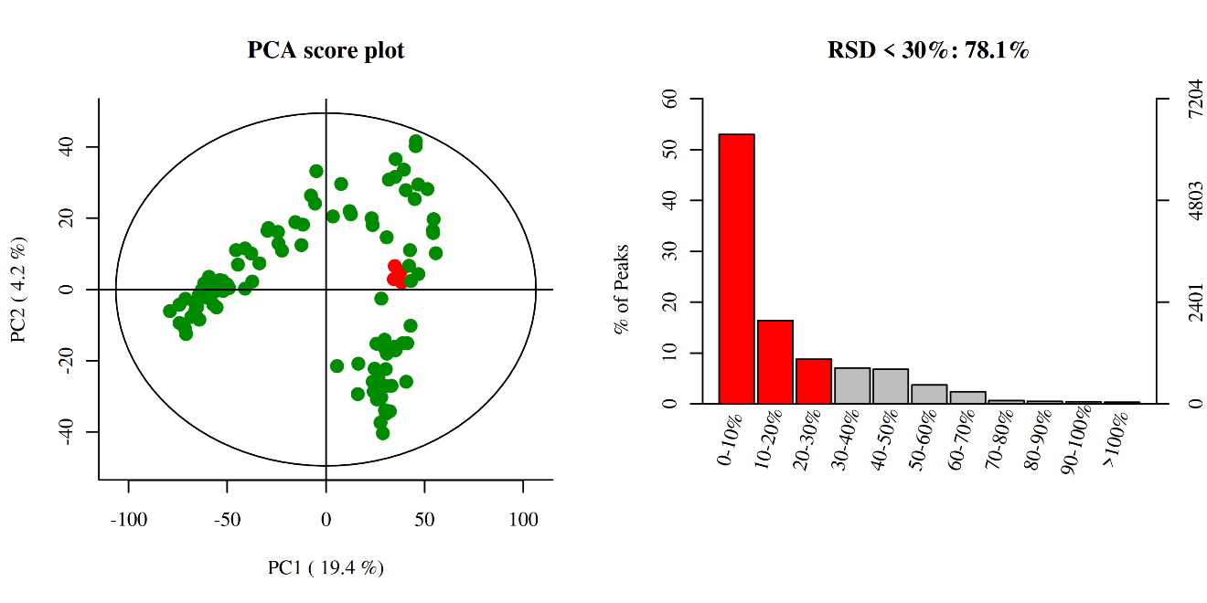
Figure S2. Quality check and quality assurance were assessed before metabolomics. (A,B) Principal component analysis of positive and negative modes. (C,D) Relative standard deviation tops at a coefficient of variation by histogram.

A B
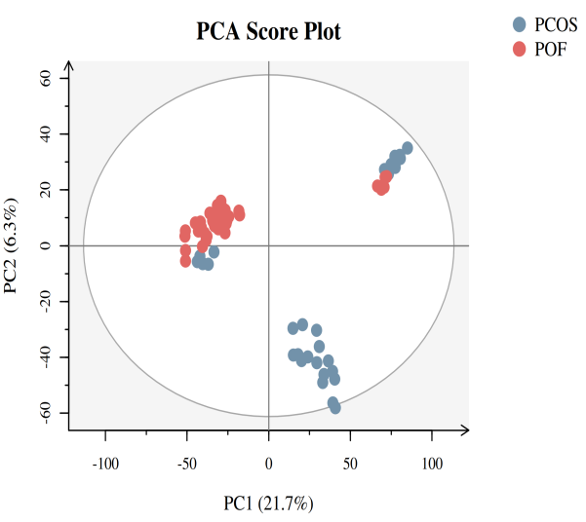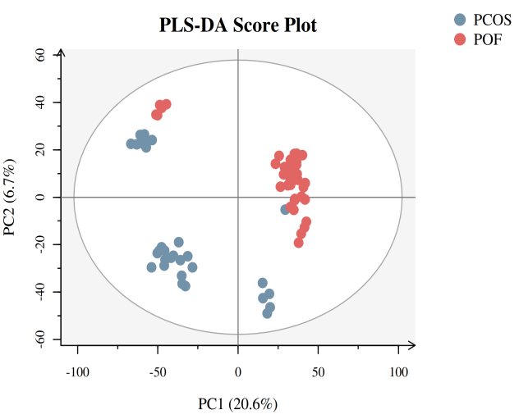
C D
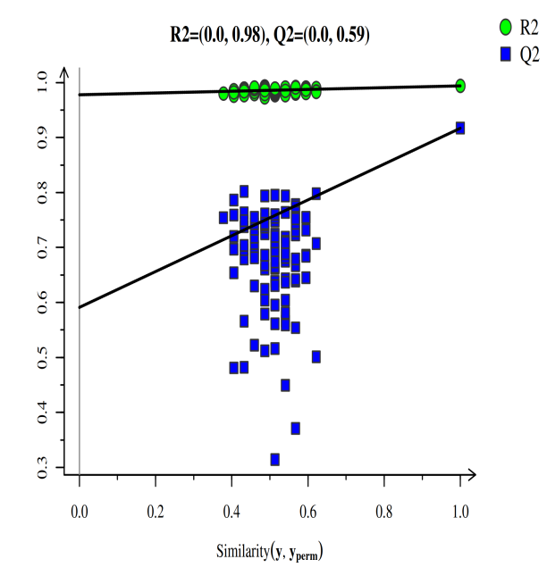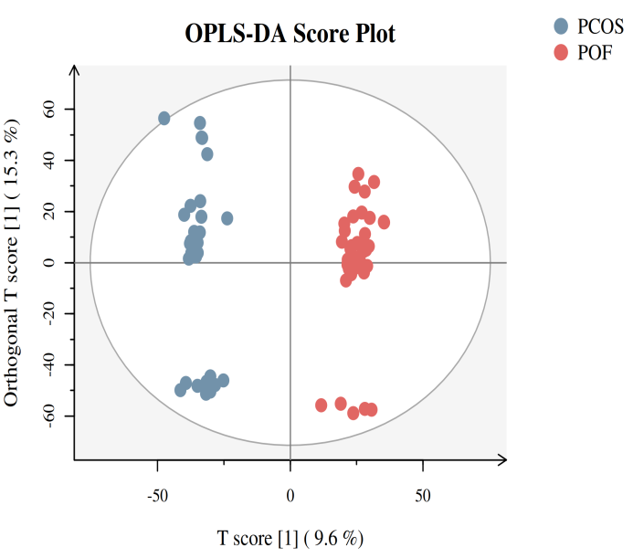

Figure S3. Score plots of three different analyses based on ESI- mode in PCOS and POF. (A) Principal component analysis (PCA), (B,C) Partial least discriminant analysis (PLS-DA) (D) Orthogonal partial least square discriminant analysis (OPLS-DA) was used for displaying PCOS and POF subjects.

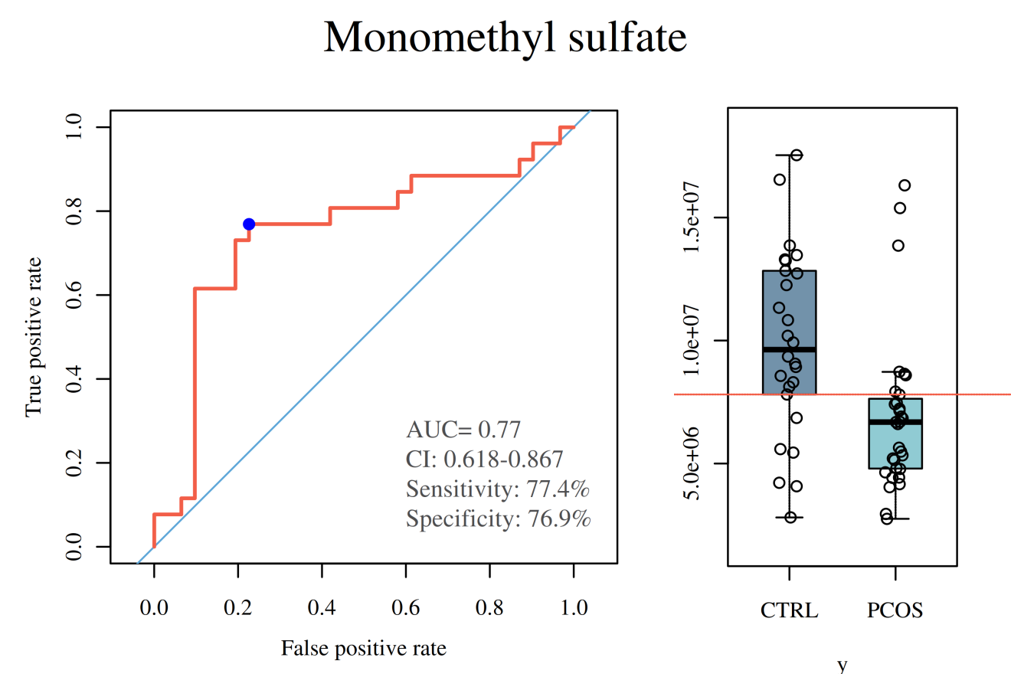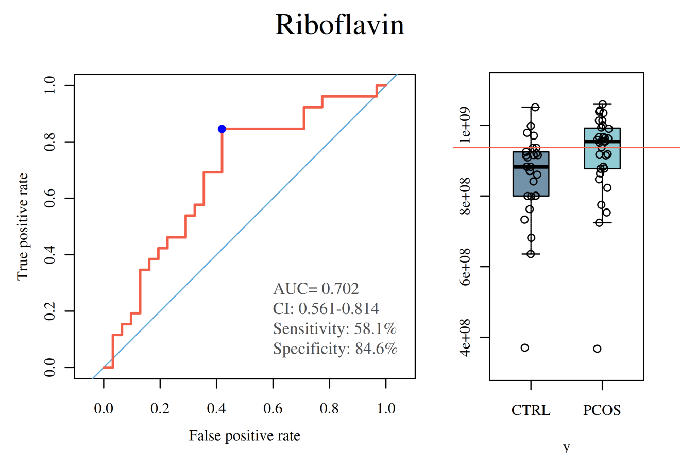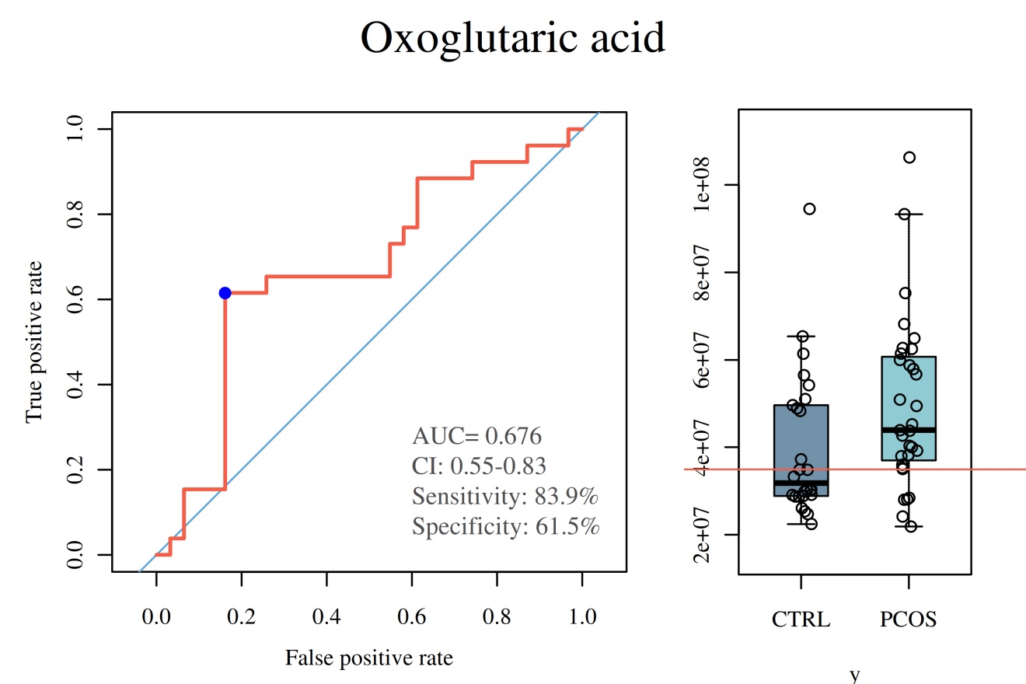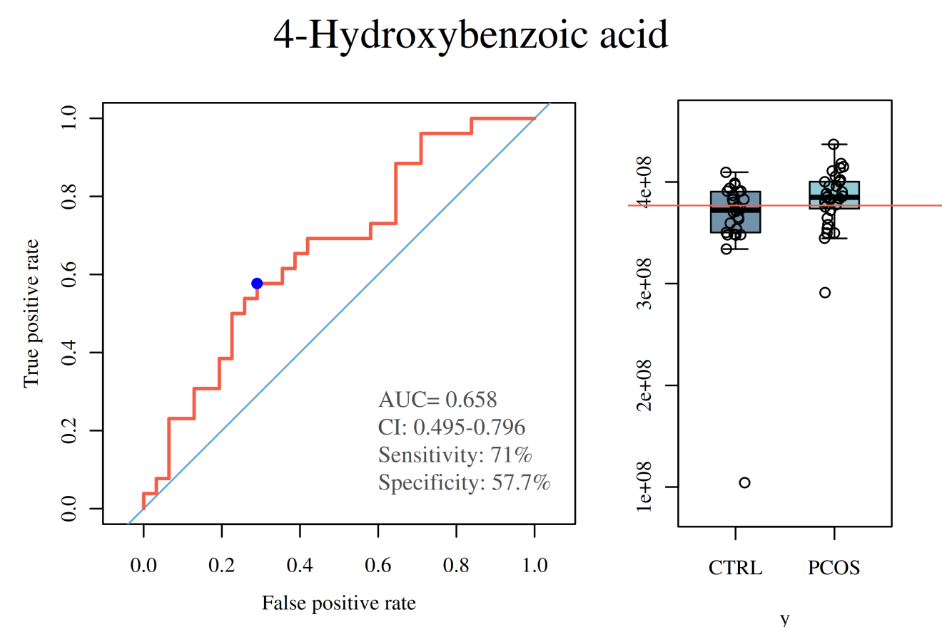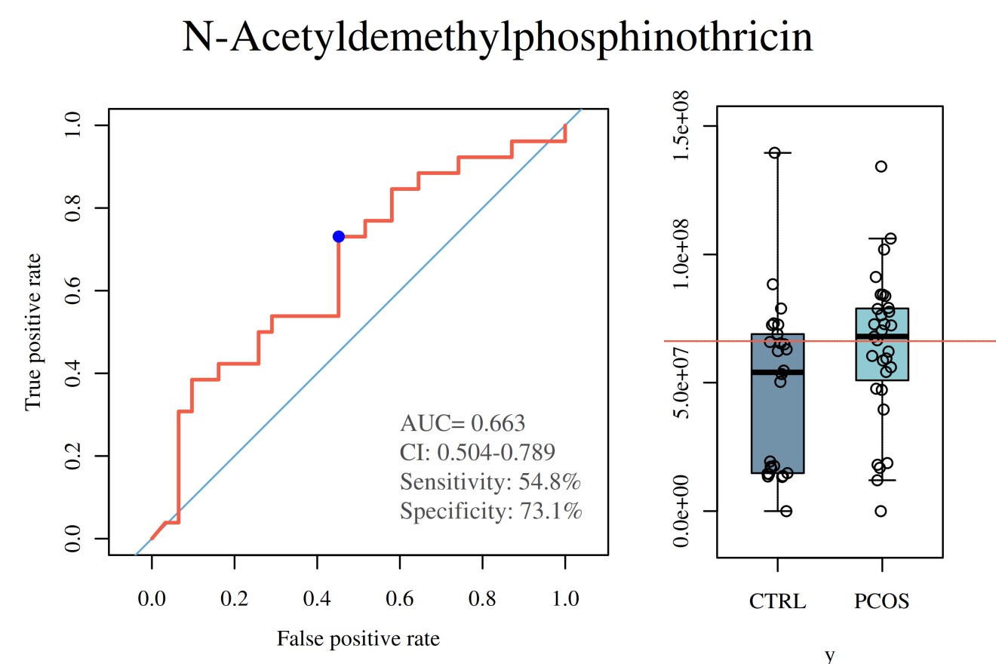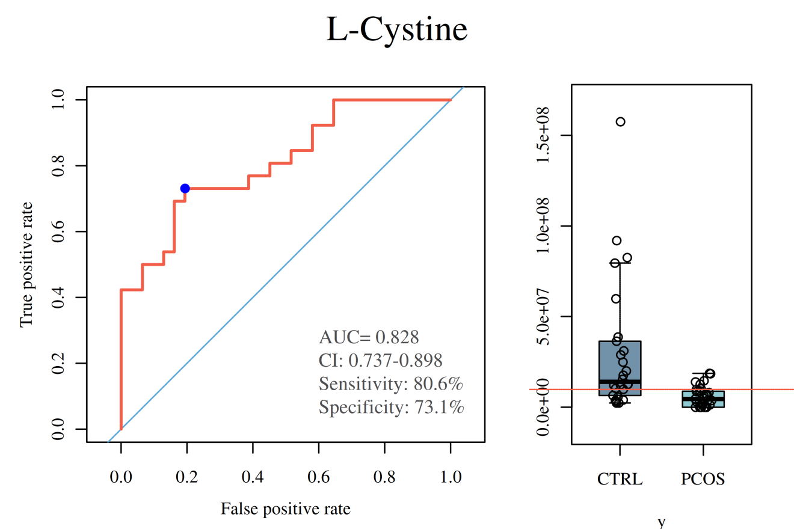

Figure S4. ROC curves of six metabolites in PCOS vs CTRL group.
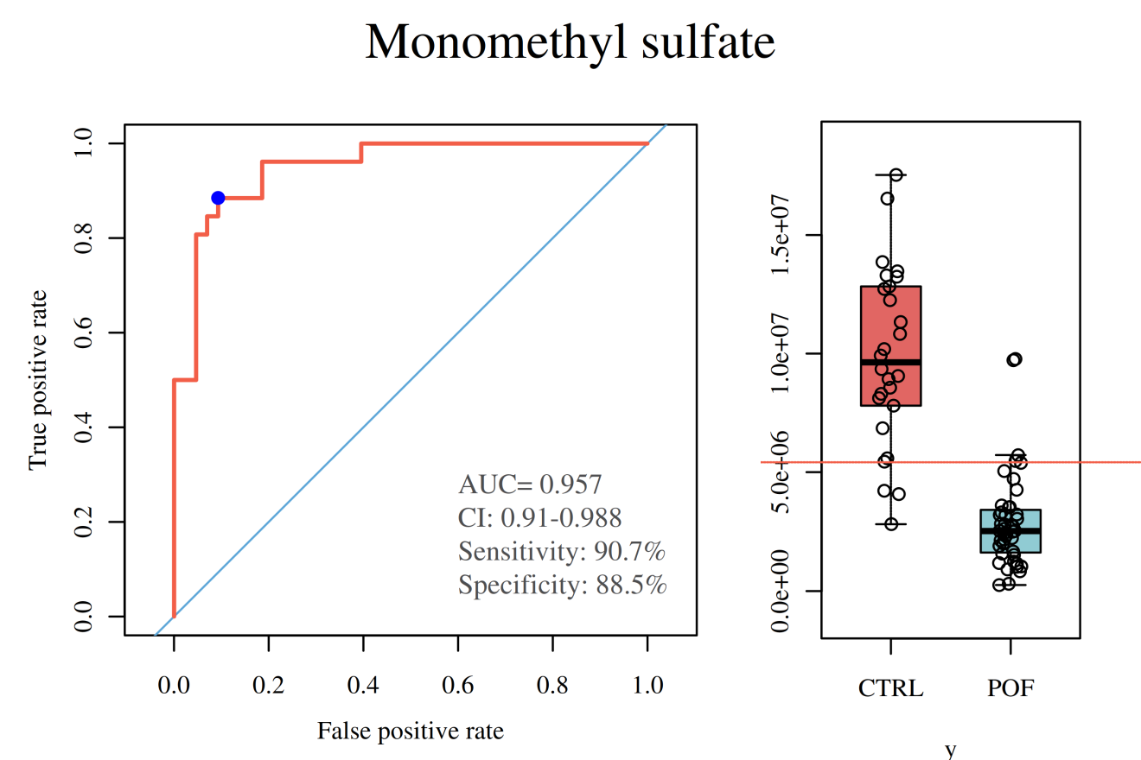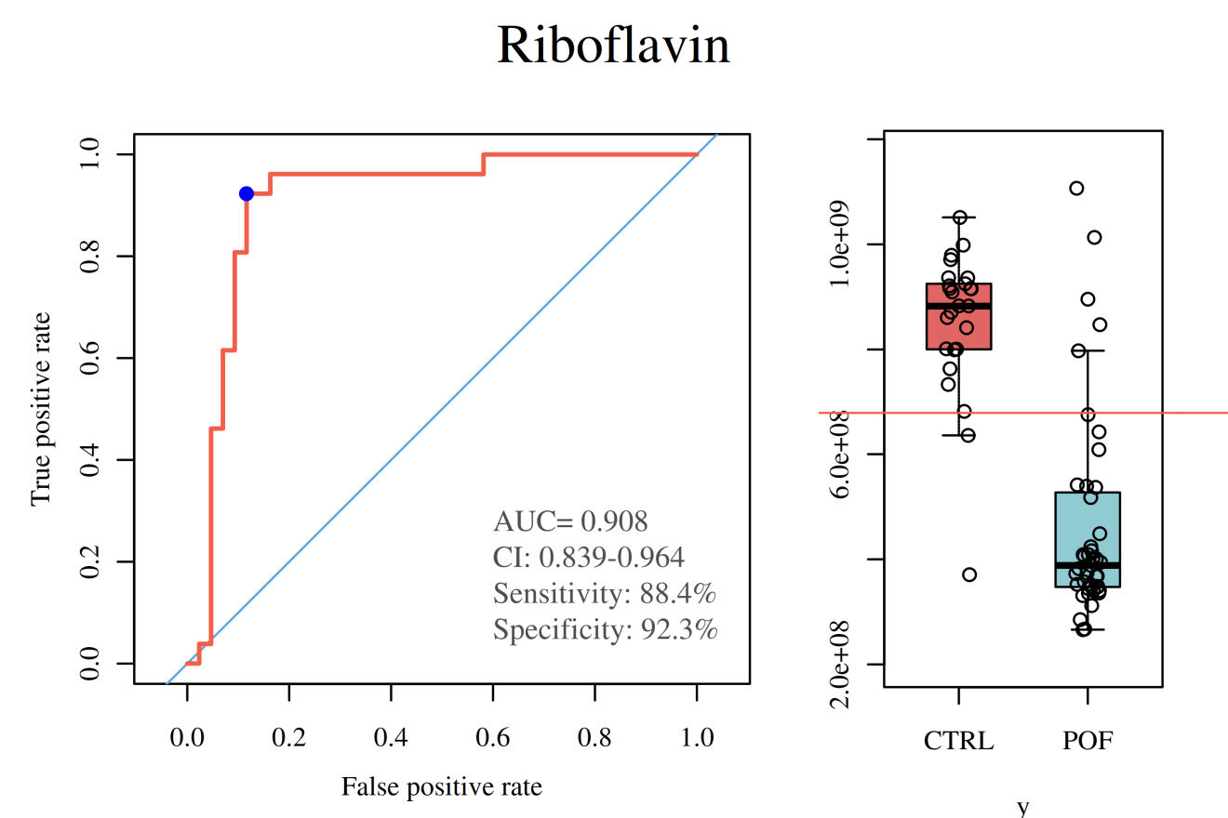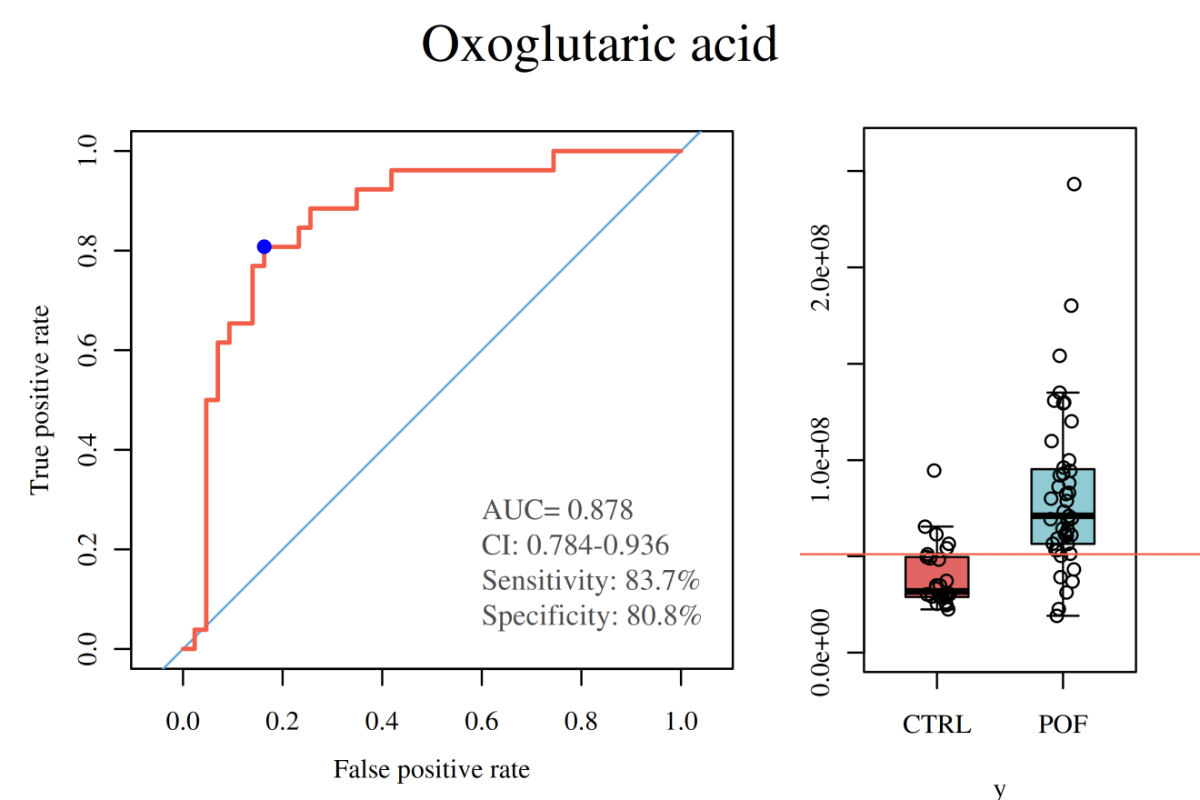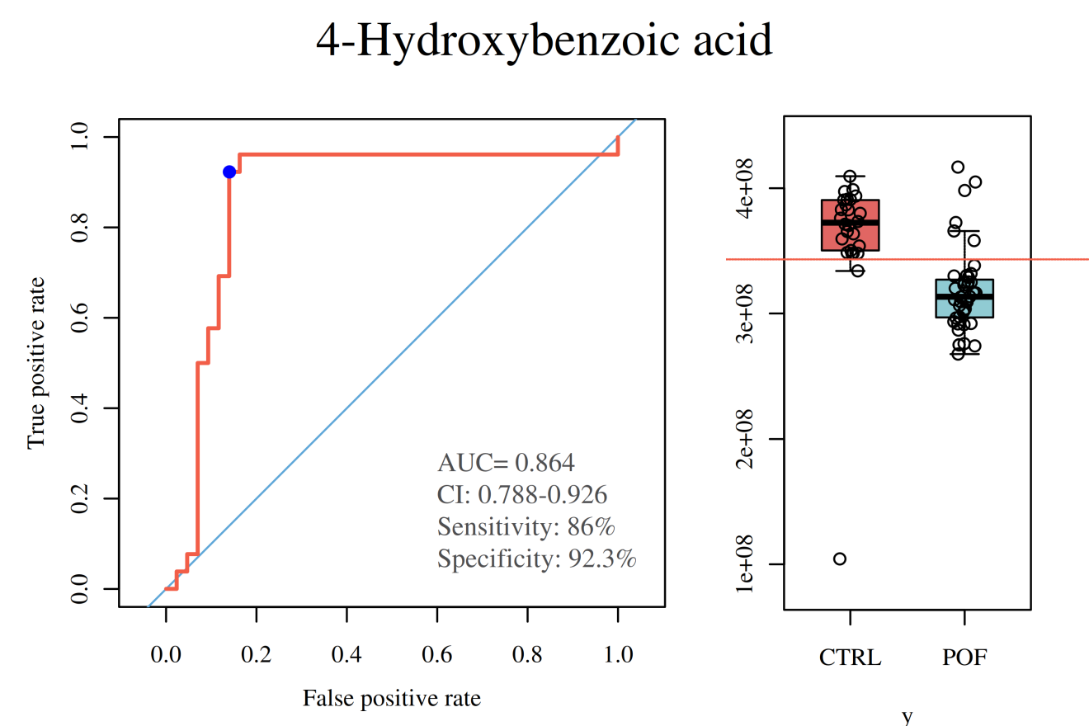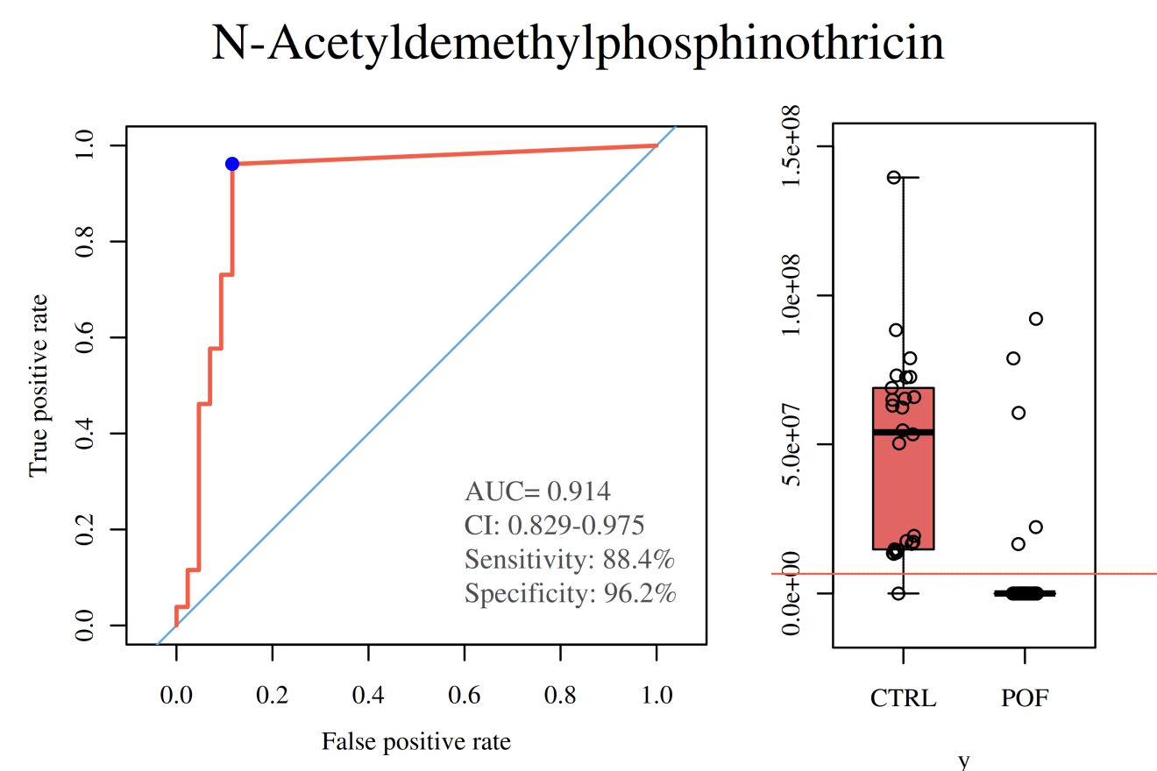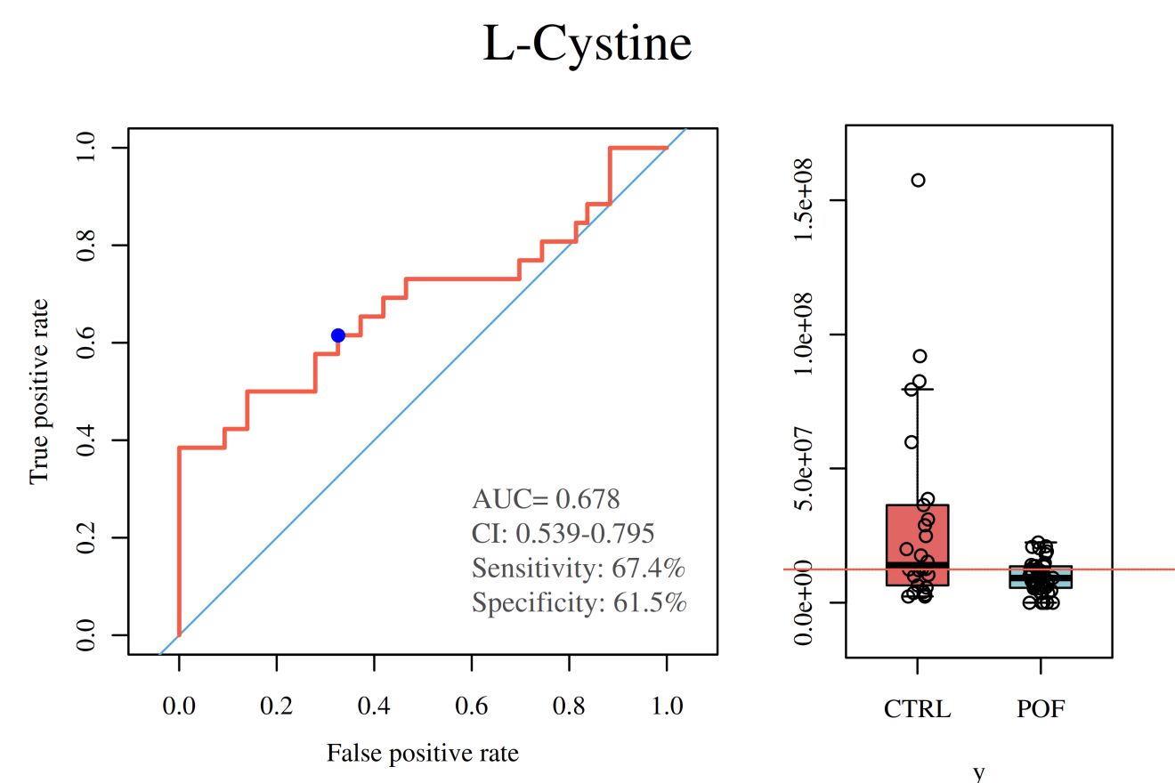

Figure S5. ROC curves of six metabolites in POF vs CTRL group.

