Electronic supplementary material Wimalasiri et al.

Spatial patterns and key drivers of zooplankton in the north central Indian Ocean
Wimalasiri, H.B.U.G.M. ¹, Weerakoon, W.R.W.M.A.P.¹, Jayasinghe R.P.P.K.¹, Dalpadado, P. ^{2*}
¹ National Aquatic Resources Research and Development Agency (NARA), Crow Island, Colombo 15, Sri Lanka
²Institute of Marine Research (IMR), P O Box 1870 Nordnes, N-5817 Bergen, Norway
*Corresponding author: padmini.dalpadado@hi.no; https://orcid.org/0000-0003-38264856

Table SI. Zooplankton biomass (g dry wt. m⁻²; g dry wt. m⁻³) for the three-depth intervals (~ 30 m, ~ 100 m, ~ 200 m)
sampled during 24th June – 16th July 2018. Running station numbers used in Figure 1 and Figure 11 are given in parenthesis.
Station | Year | Month | Day | Time (GMT) | Lat.  (°N) | Lon.  (°E) | Bottom depth (m) | Sampling | g dry wt. m⁻² | g dry wt. m⁻³ | Polygon name
 |  |  |  |  |  |  |  | depth (m)
463 (1) | 2018 | 6 | 26 | 528 | 10.281 | 80.715 | 986 | 30 | 0.218 | 0.007 | NE_deep
466 (2) | 2018 | 6 | 26 | 1125 | 10.194 | 80.475 | 95 | 30 | 0.16 | 0.005 | NE_shelf
468 (3) | 2018 | 6 | 26 | 1510 | 10.134 | 80.336 | 30 | 30 | 1.072 | 0.036 | NE_shelf
485 (4) | 2018 | 6 | 28 | 1450 | 9.35 | 81.075 | 1060 | 30 | 0.11 | 0.004 | CE_deep
487 (5) | 2018 | 6 | 28 | 1740 | 9.329 | 81.014 | 101 | 30 | 0.297 | 0.01 | CE_shelf
488 (6) | 2018 | 6 | 28 | 2050 | 9.295 | 80.922 | 31 | 30 | 0.705 | 0.023 | CE_shelf
498 (7) | 2018 | 6 | 30 | 557 | 8.468 | 81.542 | 1001 | 30 | 0.378 | 0.013 | CE_deep
499 (8) | 2018 | 6 | 30 | 812 | 8.449 | 81.506 | 76 | 30 | 0.648 | 0.022 | CE_shelf
500 (9) | 2018 | 6 | 30 | 1050 | 8.414 | 81.441 | 27 | 20 | 0.499 | 0.025 | CE_shelf
511 (10) | 2018 | 7 | 1 | 2030 | 7.551 | 82.007 | 1029 | 30 | 0.165 | 0.005 | SE_deep
513 (11) | 2018 | 7 | 2 | 20 | 7.531 | 81.898 | 148 | 30 | 0.542 | 0.018 | SE_shelf
514 (12) | 2018 | 7 | 2 | 200 | 7.524 | 81.855 | 31 | 30 | 0.821 | 0.027 | SE_shelf
524 (13) | 2018 | 7 | 3 | 1345 | 6.563 | 82.007 | 998 | 30 | 0.578 | 0.019 | SE_deep
525 (14) | 2018 | 7 | 3 | 1555 | 6.582 | 81.956 | 94 | 30 | 0.915 | 0.031 | SE_shelf
527 (15) | 2018 | 7 | 3 | 1755 | 6.604 | 81.862 | 36 | 30 | 1.507 | 0.05 | SE_shelf
537 (16) | 2018 | 7 | 5 | 415 | 5.802 | 81.212 | 1002 | 30 | 1.388 | 0.046 | S_deep
540 (17) | 2018 | 7 | 5 | 835 | 5.901 | 81.175 | 163 | 30 | 1.528 | 0.051 | S_shelf
542 (18) | 2018 | 7 | 5 | 1200 | 6.081 | 81.075 | 30 | 25 | 1.15 | 0.046 | S_shelf
552 (19) | 2018 | 7 | 6 | 2000 | 5.781 | 80.118 | 1102 | 30 | 1.478 | 0.049 | SW_deep
554 (20) | 2018 | 7 | 6 | 2300 | 5.829 | 80.141 | 111 | 30 | 1.474 | 0.049 | SW_shelf
556 (21) | 2018 | 7 | 7 | 450 | 5.986 | 80.253 | 38 | 30 | 1.772 | 0.059 | SW_shelf
564 (22) | 2018 | 7 | 9 | 435 | 6.654 | 79.689 | 1103 | 30 | 2.052 | 0.068 | SW_deep
566 (23) | 2018 | 7 | 9 | 800 | 6.648 | 79.731 | 159 | 30 | 1.262 | 0.042 | SW_shelf
568 (24) | 2018 | 7 | 9 | 1425 | 6.653 | 79.853 | 30 | 28 | 2.634 | 0.094 | SW_shelf
574 (26) | 2018 | 7 | 11 | 335 | 7.678 | 79.577 | 1056 | 30 | 0.917 | 0.031 | NW_deep
576 (27) | 2018 | 7 | 11 | 640 | 7.67 | 79.624 | 38 | 30 | 0.856 | 0.029 | NW_shelf
578 (28) | 2018 | 7 | 12 | 1640 | 8.833 | 79.531 | 32 | 30 | 0.361 | 0.012 | NW_shelf
582 (29) | 2018 | 7 | 12 | 2058 | 8.637 | 79.346 | 1542 | 30 | 1.182 | 0.039 | NW_deep
586 (30) | 2018 | 7 | 13 | 510 | 8.249 | 78.937 | 1542 | 30 | 2.214 | 0.074 | NW_deep
589 (31) | 2018 | 7 | 13 | 1258 | 7.754 | 78.932 | 2184 | 30 | 2.075 | 0.069 | NW_deep
595 (25) | 2018 | 7 | 14 | 1035 | 6.672 | 78.931 | 2627 | 30 | 1.834 | 0.061 | SW_deep
463 | 2018 | 6 | 26 | 525 | 10.281 | 80.715 | 986 | 200 | 0.855 | 0.004 | NE_deep
466 | 2018 | 6 | 26 | 1130 | 10.194 | 80.475 | 95 | 90 | 1.202 | 0.013 | NE_shelf
487 | 2018 | 6 | 28 | 1745 | 9.329 | 81.014 | 101 | 100 | 1.213 | 0.012 | CE_shelf
498 | 2018 | 6 | 30 | 600 | 8.468 | 81.542 | 1001 | 200 | 1.435 | 0.007 | CE_deep
499 | 2018 | 6 | 30 | 815 | 8.449 | 81.506 | 76 | 70 | 1.043 | 0.015 | CE_shelf
511 | 2018 | 7 | 1 | 2035 | 7.551 | 82.007 | 1029 | 200 | 0.81 | 0.004 | SE_deep
513 | 2018 | 7 | 2 | 25 | 7.531 | 81.898 | 148 | 100 | 1.782 | 0.018 | SE_shelf
524 | 2018 | 7 | 3 | 1347 | 6.563 | 82.007 | 998 | 200 | 2.52 | 0.013 | SE_deep
525 | 2018 | 7 | 3 | 1605 | 6.582 | 81.956 | 94 | 94 | 2.624 | 0.028 | SE_shelf
537 | 2018 | 7 | 5 | 420 | 5.802 | 81.212 | 1002 | 200 | 4.302 | 0.342 | S_deep
540 | 2018 | 7 | 5 | 840 | 5.901 | 81.175 | 163 | 100 | 2.456 | 0.025 | S_shelf
552 | 2018 | 7 | 6 | 2010 | 5.781 | 80.118 | 1102 | 200 | 2.866 | 0.014 | SW_deep
554 | 2018 | 7 | 6 | 2310 | 5.829 | 80.141 | 111 | 100 | 1.928 | 0.019 | SW_shelf
564 | 2018 | 7 | 9 | 440 | 6.654 | 79.689 | 1103 | 200 | 3.32 | 0.017 | SW_deep
566 | 2018 | 7 | 9 | 805 | 6.648 | 79.731 | 159 | 100 | 2.571 | 0.026 | SW_shelf
574 | 2018 | 7 | 11 | 338 | 7.678 | 79.577 | 1056 | 200 | 2.336 | 0.012 | NW_deep
582 | 2018 | 7 | 12 | 2110 | 8.249 | 78.937 | 1542 | 200 | 1.998 | 0.01 | NW_deep
586 | 2018 | 7 | 13 | 515 | 8.249 | 78.937 | 1542 | 200 | 1.33 | 0.007 | NW_deep
589 | 2018 | 7 | 13 | 1300 | 7.754 | 78.932 | 2184 | 200 | 3.09 | 0.015 | NW_deep
595 | 2018 | 7 | 14 | 1040 | 6.672 | 78.931 | 2627 | 200 | 6.451 | 0.032 | SW_deep

Table SII. Zooplankton abundance (ind. m⁻³) and biomass (g dry wt. m⁻²) in the upper 30 m at different regions: NE=North East, CE= Central East, SE=South East, S=South, SW=South West, NW=North West. The total zooplankton biomass and the three size fractions, large (>2000µm), medium (1000-2000µm) and small (180-1000µm) are given.

Region | Abundance | SD | Total biomass | SD | >2000 µm | SD | 1000-2000 µm | SD | 180-1000 µm | SD
NE | 229 | 160.04 | 0.483 | 0.295 | 0.000 | 0.000 | 0.227 | 0.199 | 0.256 | 0.099
CE | 711 | 490.95 | 0.439 | 0.091 | 0.002 | 0.002 | 0.191 | 0.049 | 0.246 | 0.069
SE | 943 | 345.98 | 0.755 | 0.184 | 0.104 | 0.061 | 0.162 | 0.049 | 0.489 | 0.136
S | 1534 | 804.32 | 1.355 | 0.110 | 0.243 | 0.138 | 0.378 | 0.192 | 0.735 | 0.128
SW | 1895 | 856.25 | 1.787 | 0.173 | 0.124 | 0.070 | 0.347 | 0.058 | 1.316 | 0.232
NW | 1931 | 767.63 | 1.267 | 0.298 | 0.248 | 0.248 | 0.390 | 0.150 | 0.629 | 0.186

Figure S1. Images of dominant zooplankton groups observed in the upper 30 m in Sri Lankan waters, during 24th June – 16th July 2018. (a) Euchaeta spp. (b) Acrocalanus spp. (c) Pontellina plumata (d) Candacia spp. (e)Miracia spp. (f) Eucalanus spp. (g) Macrosetella spp. and (h) Krill. All images courtesy of Mr. M.I.G. Rathnasuriya.
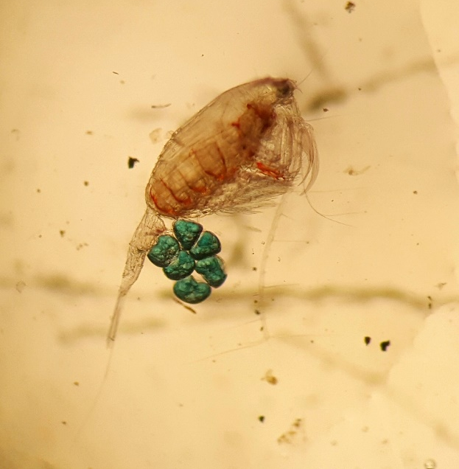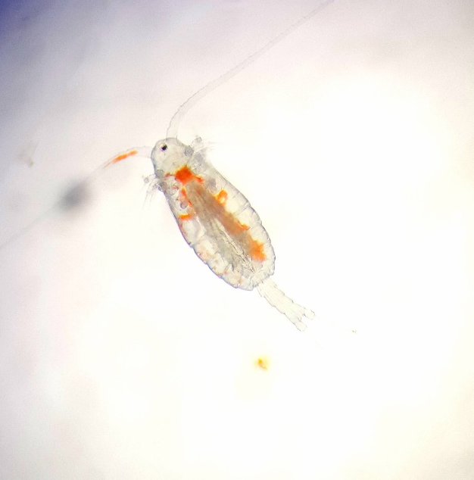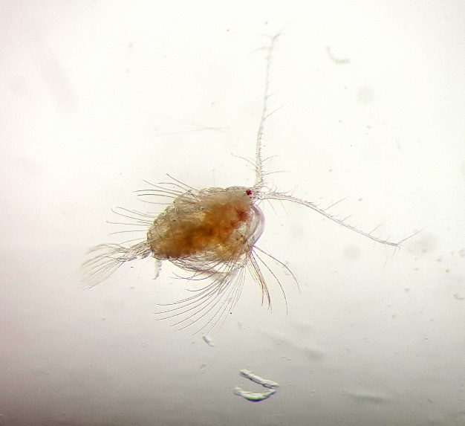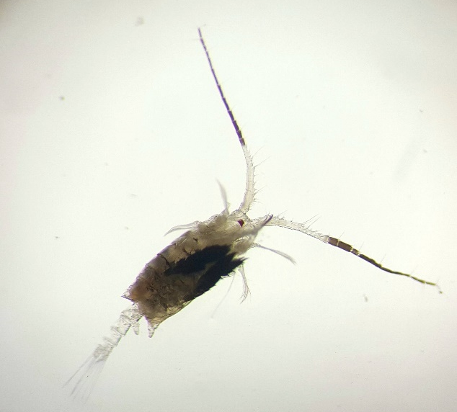
0.5 mm
0.5 mm
0.5 mm
0.5 mm
0.5 mm
0.5 mm
(f)
(e)
(d)
(c)
(b)
(a)
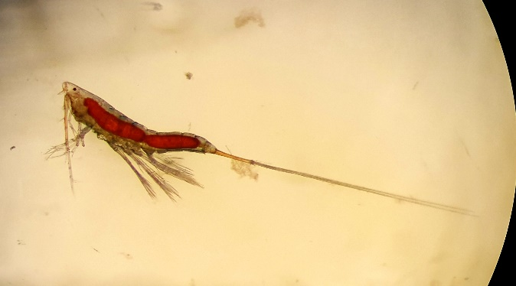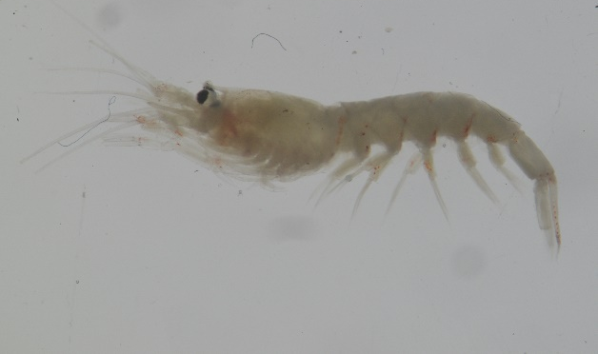
1 mm
0.3 mm
(g)
(h)

