Supplementary Information for

Fertilizer-derived nitrogen use of two varieties of single-crop paddy rice: A free-air carbon dioxide enrichment study using polymer-coated ¹⁵N-labeled urea

Kentaro Hayashi, Takeshi Tokida, Miwa Arai, Hidemitsu Sakai, Hirofumi Nakamura, Toshihiro Hasegawa

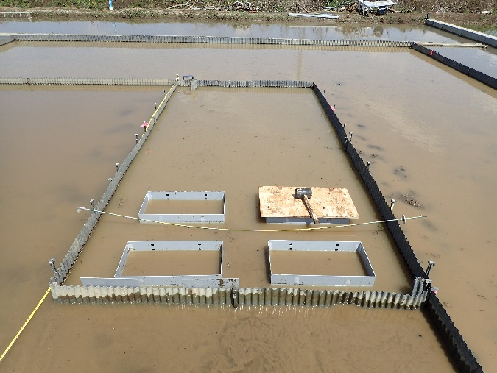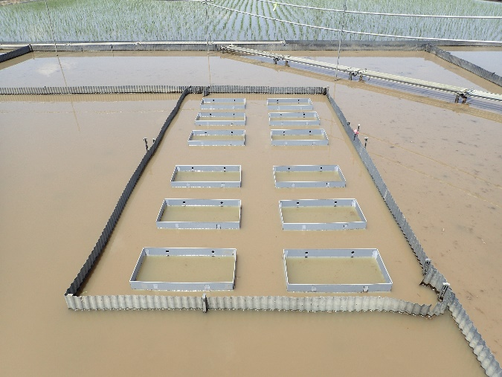
(a) (b)
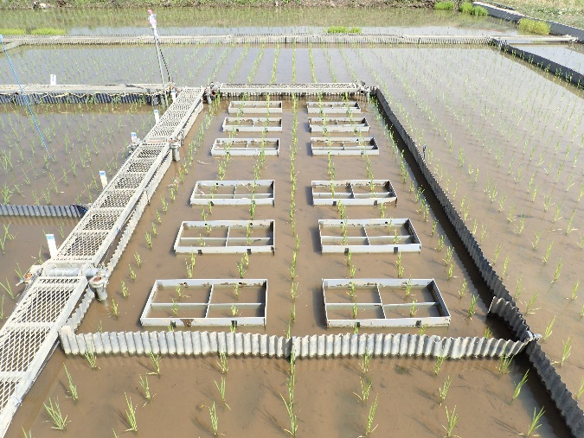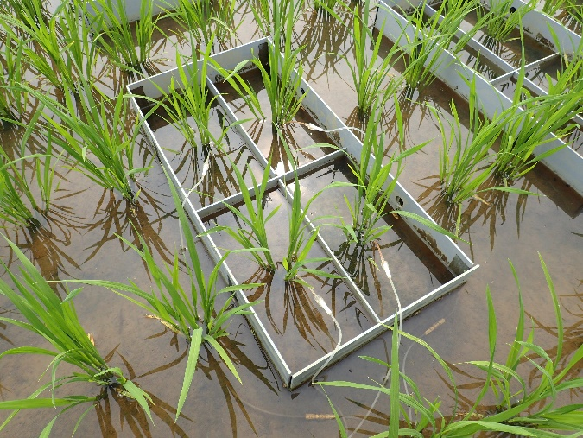
(c) (d)
Figure S1. Pictures of the experimental section in this study. (a) Setting enclosures on May 21, 2015, (b) The enclosures set up on May 21, 2015, (c) Shortly after starting the experiment on June 2, 2015, and (d) One enclosure for sampling at the maturing stage with rice seedlings (Oryza sativa cv. Takanari) and soil solution collection tubes on June 16, 2015.

Figure S2. Nitrogen (N) content of each part of paddy rice separating the fertilizer-derived N and N from other sources expressed as the difference between the total N content and the fertilizer-derived N content. PI, HD, and MT denote the panicle initiation, heading, and maturing stages, respectively. F, elevated carbon dioxide (CO₂) plot; A, ambient CO₂ plot; Koshihikari, paddy rice (cv. Koshihikari); and Takanari, paddy rice (cv. Takanari).

Figure S3. Fate of fertilizer-derived nitrogen (N) with an application rate of 80 kg N ha^{–1} at the maturing stage. Bars denote the standard deviation (n = 4 blocks). FACE, elevated carbon dioxide (CO₂) plot; Ambient, ambient CO₂ plot; Koshihikari, paddy rice (cv. Koshihikari); and Takanari, paddy rice (cv. Takanari). Lost to the environment was estimated as the balance between the application rate and the other fate.
Table S1. Rice plant biomass per unit area.

Growth | Part |  | Unit | Rice (cv. Koshihikari) |  |  |  | Rice (cv. Takanari)
stage |  |  |  | FACE |  | Ambient |  | FACE |  | Ambient
 |  |  |  | Mean | SD | Mean | SD | Mean | SD | Mean | SD
PI | Aboveground part |  | (Mg ha^{–1}) | 2.11 | (0.19) | 1.97 | (0.22) | 2.24 | (0.22) | 1.94 | (0.23)
 |  | Leaves | (Mg ha^{–1}) | 0.99 | (0.10) | 0.96 | (0.09) | 1.04 | (0.09) | 0.98 | (0.08)
 |  | Dead leaves | (Mg ha^{–1}) | 0.01 | (0.00) | 0.00 | (0.00) | 0.01 | (0.00) | 0.01 | (0.00)
 |  | Straw | (Mg ha^{–1}) | 1.11 | (0.09) | 1.01 | (0.13) | 1.19 | (0.14) | 0.96 | (0.15)
 | Root |  | (Mg ha^{–1}) | 0.55 | (0.05) | 0.49 | (0.14) | 0.83 | (0.03) | 0.75 | (0.14)
 | Total |  | (Mg ha^{–1}) | 2.66 | (0.21) | 2.46 | (0.33) | 3.07 | (0.20) | 2.69 | (0.31)
 | Shoot/root ratio |  | (–) | 3.86 | (0.39) | 4.15 | (0.76) | 2.70 | (0.34) | 2.65 | (0.48)
HD | Aboveground part |  | (Mg ha^{–1}) | 13.90 | (1.19) | 10.99 | (1.00) | 13.38 | (0.10) | 11.80 | (0.34)
 |  | Panicles | (Mg ha^{–1}) | 2.94 | (0.33) | 2.02 | (0.29) | 3.06 | (0.46) | 2.43 | (0.20)
 |  | Leaves | (Mg ha^{–1}) | 2.28 | (0.13) | 2.34 | (0.09) | 2.14 | (0.11) | 2.21 | (0.13)
 |  | Dead leaves | (Mg ha^{–1}) | 0.30 | (0.04) | 0.29 | (0.02) | 0.45 | (0.07) | 0.37 | (0.05)
 |  | Straw | (Mg ha^{–1}) | 7.94 | (0.61) | 6.49 | (0.75) | 7.30 | (0.39) | 6.59 | (0.29)
 | Root |  | (Mg ha^{–1}) | 1.21 | (0.26) | 0.85 | (0.21) | 1.59 | (0.16) | 1.56 | (0.20)
 | Total |  | (Mg ha^{–1}) | 14.67 | (1.03) | 11.99 | (1.24) | 14.54 | (0.80) | 13.16 | (0.38)
 | Shoot/root ratio |  | (–) | 11.47 | (2.21) | 13.47 | (2.32) | 8.25 | (1.29) | 7.58 | (1.37)
MT | Aboveground part |  | (Mg ha^{–1}) | 18.28 | (1.61) | 15.36 | (0.40) | 17.46 | (0.49) | 16.33 | (0.97)
 |  | Panicles | (Mg ha^{–1}) | 8.16 | (0.32) | 6.99 | (0.18) | 9.61 | (0.44) | 8.45 | (0.73)
 |  | Leaves | (Mg ha^{–1}) | 1.34 | (0.18) | 1.45 | (0.19) | 1.20 | (0.17) | 1.23 | (0.19)
 |  | Dead leaves | (Mg ha^{–1}) | 0.93 | (0.08) | 0.87 | (0.07) | 1.02 | (0.11) | 1.00 | (0.06)
 |  | Straw | (Mg ha^{–1}) | 7.31 | (0.99) | 6.13 | (0.29) | 5.47 | (0.17) | 5.04 | (0.34)
 | Root |  | (Mg ha^{–1}) | 1.20 | (0.17) | 0.90 | (0.18) | 1.79 | (0.30) | 1.58 | (0.26)
 | Total |  | (Mg ha^{–1}) | 18.95 | (1.60) | 16.34 | (0.62) | 19.09 | (0.84) | 17.31 | (1.15)
 | Shoot/root ratio |  | (–) | 14.84 | (0.88) | 17.55 | (3.02) | 9.85 | (1.47) | 10.16 | (1.55)
SD, standard deviation (n = 4); PI, panicle initiation stage; HD, heading stage; and MT, maturing stage.

Table S2. Total nitrogen (N) concentration and the ratio of fertilizer-derived N in the rice plants.

Growth | Part | Total N concentration (% w/w) |  |  |  |  |  |  |  | Ratio of fertilizer-derived N to total N (%)
stage |  | Rice (cv. Koshihikari) |  |  |  | Rice (cv. Takanari) |  |  |  | Rice (cv. Koshihikari) |  |  |  | Rice (cv. Takanari)
 |  | FACE |  | Ambient |  | FACE |  | Ambient |  | FACE |  | Ambient |  | FACE |  | Ambient
 |  | Mean | SD | Mean | SD | Mean | SD | Mean | SD | Mean | SD | Mean | SD | Mean | SD | Mean | SD
PI | Leaves | 3.56 | (0.13) | 3.70 | (0.23) | 3.15 | (0.25) | 3.59 | (0.21) | 47.1 | (3.3) | 45.5 | (4.7) | 49.8 | (7.9) | 47.3 | (4.1)
 | Dead leaves¹⁾ | – | – | – | – | – | – | – | – | – | – | – | – | – | – | – | –
 | Straw | 1.71 | (0.07) | 1.78 | (0.19) | 1.38 | (0.19) | 1.60 | (0.21) | 48.3 | (3.5) | 47.0 | (4.3) | 51.2 | (7.2) | 49.2 | (4.2)
 | Root | 1.10 | (0.07) | 1.14 | (0.09) | 1.10 | (0.11) | 1.15 | (0.04) | 36.1 | (7.4) | 41.8 | (3.7) | 36.8 | (6.7) | 36.1 | (6.1)
HD | Panicles | 0.97 | (0.01) | 1.03 | (0.02) | 1.00 | (0.02) | 1.00 | (0.01) | 45.0 | (3.0) | 47.5 | (3.8) | 46.5 | (3.3) | 45.9 | (2.9)
 | Leaves | 1.94 | (0.05) | 2.07 | (0.12) | 1.83 | (0.10) | 1.93 | (0.06) | 47.9 | (3.3) | 48.4 | (3.9) | 49.6 | (3.4) | 47.9 | (3.7)
 | Dead leaves | 0.59 | (0.04) | 0.60 | (0.05) | 0.51 | (0.03) | 0.51 | (0.02) | 41.2 | (5.6) | 39.8 | (4.7) | 41.6 | (2.8) | 36.8 | (3.4)
 | Straw | 0.45 | (0.02) | 0.49 | (0.05) | 0.47 | (0.03) | 0.49 | (0.02) | 44.6 | (2.7) | 46.5 | (3.2) | 45.8 | (3.0) | 45.2 | (3.4)
 | Root | 1.01 | (0.05) | 0.99 | (0.11) | 0.89 | (0.05) | 0.89 | (0.03) | 26.6 | (2.8) | 31.1 | (5.0) | 27.2 | (3.0) | 33.3 | (4.3)
MT | Panicles | 0.99 | (0.05) | 1.03 | (0.04) | 0.98 | (0.10) | 1.01 | (0.03) | 39.9 | (2.5) | 42.2 | (4.7) | 37.4 | (2.9) | 40.9 | (3.3)
 | Leaves | 1.11 | (0.13) | 1.20 | (0.13) | 1.05 | (0.19) | 1.05 | (0.04) | 44.0 | (2.3) | 45.6 | (5.4) | 42.7 | (3.2) | 45.1 | (4.2)
 | Dead leaves | 0.51 | (0.06) | 0.53 | (0.05) | 0.45 | (0.07) | 0.46 | (0.03) | 38.8 | (3.3) | 39.1 | (3.9) | 36.2 | (4.3) | 36.3 | (1.6)
 | Straw | 0.39 | (0.05) | 0.40 | (0.04) | 0.36 | (0.06) | 0.35 | (0.02) | 38.1 | (1.9) | 40.2 | (4.4) | 35.1 | (3.0) | 38.7 | (3.7)
 | Root | 0.96 | (0.08) | 0.91 | (0.04) | 0.74 | (0.04) | 0.77 | (0.03) | 30.2 | (6.0) | 32.3 | (4.3) | 27.8 | (6.0) | 23.8 | (3.8)
SD, standard deviation (n = 4); PI, panicle initiation stage; HD, heading stage; and MT, maturing stage.
1) Not determined due to the small sample amounts.

Table S3. Total nitrogen (N) content in the rice plants per unit area.

Growth | Part |  | Unit | Rice (cv. Koshihikari) |  |  |  | Rice (cv. Takanari)
stage |  |  |  | FACE |  | Ambient |  | FACE |  | Ambient
 |  |  |  | Mean | SD | Mean | SD | Mean | SD | Mean | SD
PI | Aboveground part |  | (kg N ha^{–1}) | 54.8 | (6.6) | 53.3 | (4.1) | 49.4 | (5.3) | 50.3 | (1.4)
 |  | Leaves | (kg N ha^{–1}) | 35.5 | (4.5) | 35.4 | (2.6) | 32.9 | (3.7) | 35.0 | (0.8)
 |  | Dead leaves¹⁾ | (kg N ha^{–1}) | 0.3 | (0.1) | 0.2 | (0.0) | 0.2 | (0.1) | 0.2 | (0.1)
 |  | Straw | (kg N ha^{–1}) | 19.0 | (2.1) | 17.7 | (1.4) | 16.3 | (1.5) | 15.1 | (0.6)
 | Root |  | (kg N ha^{–1}) | 6.0 | (0.7) | 5.6 | (1.4) | 9.1 | (0.6) | 8.7 | (1.8)
 | Total |  | (kg N ha^{–1}) | 60.8 | (7.2) | 58.9 | (4.0) | 58.6 | (5.5) | 58.9 | (2.3)
 | Shoot/root ratio |  | (–) | 9.06 | (0.47) | 10.03 | (2.53) | 5.42 | (0.61) | 6.03 | (1.50)
HD | Aboveground part |  | (kg N ha^{–1}) | 109.9 | (8.3) | 102.1 | (5.0) | 106.4 | (11.5) | 101.2 | (6.0)
 |  | Panicles | (kg N ha^{–1}) | 28.5 | (3.1) | 20.7 | (2.6) | 30.4 | (4.6) | 24.3 | (2.2)
 |  | Leaves | (kg N ha^{–1}) | 44.3 | (3.1) | 48.3 | (3.4) | 39.3 | (4.1) | 42.8 | (3.5)
 |  | Dead leaves | (kg N ha^{–1}) | 1.8 | (0.2) | 1.7 | (0.1) | 2.3 | (0.5) | 1.9 | (0.2)
 |  | Straw | (kg N ha^{–1}) | 35.4 | (3.5) | 31.3 | (1.4) | 34.4 | (3.3) | 32.2 | (1.5)
 | Root |  | (kg N ha^{–1}) | 12.2 | (2.2) | 8.6 | (2.9) | 14.2 | (1.8) | 13.9 | (2.0)
 | Total |  | (kg N ha^{–1}) | 122.1 | (7.2) | 110.6 | (6.2) | 120.6 | (9.8) | 115.1 | (5.6)
 | Shoot/root ratio |  | (–) | 9.30 | (1.93) | 12.94 | (4.21) | 7.63 | (1.62) | 7.38 | (1.24)
MT | Aboveground part |  | (kg N ha^{–1}) | 129.0 | (9.8) | 118.2 | (7.2) | 131.3 | (18.9) | 120.2 | (6.5)
 |  | Panicles | (kg N ha^{–1}) | 80.9 | (2.1) | 71.7 | (1.1) | 94.3 | (11.2) | 85.2 | (6.0)
 |  | Leaves | (kg N ha^{–1}) | 15.0 | (2.9) | 17.6 | (4.2) | 12.7 | (3.9) | 13.0 | (2.4)
 |  | Dead leaves | (kg N ha^{–1}) | 4.7 | (0.5) | 4.6 | (0.2) | 4.5 | (0.7) | 4.6 | (0.1)
 |  | Straw | (kg N ha^{–1}) | 28.5 | (5.3) | 24.4 | (2.0) | 19.8 | (3.4) | 17.5 | (0.9)
 | Root |  | (kg N ha^{–1}) | 11.6 | (2.5) | 8.3 | (1.8) | 13.3 | (2.6) | 12.0 | (1.4)
 | Total |  | (kg N ha^{–1}) | 140.7 | (11.7) | 126.4 | (6.8) | 144.6 | (21.4) | 132.2 | (6.9)
 | Shoot/root ratio |  | (–) | 11.38 | (2.00) | 14.93 | (3.74) | 9.96 | (0.81) | 10.12 | (1.29)
SD, standard deviation (n = 4); PI, panicle initiation stage; HD, heading stage; and MT, maturing stage.
1) Determined using the N concentrations in leaves instead of dead leaves due to the small sample amounts.

Table S4. Fertilizer-derived nitrogen (N) content in the rice plants per unit area.

Growth | Part |  | Unit | Rice (cv. Koshihikari) |  |  |  | Rice (cv. Takanari)
stage |  |  |  | FACE |  | Ambient |  | FACE |  | Ambient
 |  |  |  | Mean | SD | Mean | SD | Mean | SD | Mean | SD
PI | Aboveground part |  | (kg N ha^{–1}) | 25.9 | (2.0) | 24.6 | (3.4) | 24.6 | (2.3) | 24.0 | (1.6)
 |  | Leaves | (kg N ha^{–1}) | 16.6 | (1.4) | 16.1 | (2.2) | 16.2 | (1.7) | 16.5 | (1.2)
 |  | Dead leaves¹⁾ | (kg N ha^{–1}) | 0.1 | (0.0) | 0.1 | (0.0) | 0.1 | (0.0) | 0.1 | (0.0)
 |  | Straw | (kg N ha^{–1}) | 9.1 | (0.7) | 8.4 | (1.2) | 8.3 | (0.7) | 7.4 | (0.5)
 | Root |  | (kg N ha^{–1}) | 2.1 | (0.2) | 2.3 | (0.4) | 3.4 | (0.6) | 3.2 | (1.0)
 | Total |  | (kg N ha^{–1}) | 28.0 | (1.8) | 26.9 | (3.6) | 27.9 | (1.9) | 27.2 | (2.5)
 | Shoot/root ratio |  | (–) | 12.22 | (2.10) | 10.84 | (1.65) | 7.59 | (1.99) | 8.18 | (2.72)
HD | Aboveground part |  | (kg N ha^{–1}) | 50.6 | (5.9) | 48.4 | (3.9) | 50.2 | (4.2) | 46.7 | (1.5)
 |  | Panicles | (kg N ha^{–1}) | 12.9 | (2.2) | 9.8 | (1.6) | 14.1 | (1.7) | 11.1 | (0.9)
 |  | Leaves | (kg N ha^{–1}) | 21.2 | (1.9) | 23.4 | (2.1) | 19.4 | (1.7) | 20.4 | (0.6)
 |  | Dead leaves | (kg N ha^{–1}) | 0.7 | (0.1) | 0.7 | (0.1) | 0.9 | (0.2) | 0.7 | (0.1)
 |  | Straw | (kg N ha^{–1}) | 15.8 | (2.0) | 14.6 | (1.0) | 15.7 | (1.3) | 14.5 | (0.9)
 | Root |  | (kg N ha^{–1}) | 3.2 | (0.7) | 2.6 | (0.6) | 3.9 | (0.8) | 4.7 | (1.2)
 | Total |  | (kg N ha^{–1}) | 53.8 | (5.6) | 51.0 | (4.5) | 54.1 | (3.5) | 51.4 | (1.3)
 | Shoot/root ratio |  | (–) | 16.35 | (4.83) | 19.27 | (2.86) | 13.51 | (3.90) | 10.58 | (3.32)
MT | Aboveground part |  | (kg N ha^{–1}) | 51.5 | (3.4) | 49.7 | (3.4) | 48.9 | (4.4) | 49.1 | (3.9)
 |  | Panicles | (kg N ha^{–1}) | 32.3 | (1.8) | 30.2 | (3.0) | 35.1 | (2.4) | 34.8 | (2.3)
 |  | Leaves | (kg N ha^{–1}) | 6.6 | (1.1) | 7.9 | (1.0) | 5.3 | (1.3) | 5.9 | (1.5)
 |  | Dead leaves | (kg N ha^{–1}) | 1.8 | (0.2) | 1.8 | (0.2) | 1.6 | (0.2) | 1.7 | (0.1)
 |  | Straw | (kg N ha^{–1}) | 10.8 | (2.0) | 9.8 | (0.6) | 6.9 | (0.8) | 6.8 | (0.7)
 | Root |  | (kg N ha^{–1}) | 3.5 | (1.1) | 2.7 | (0.7) | 3.6 | (0.5) | 2.8 | (0.1)
 | Total |  | (kg N ha^{–1}) | 55.0 | (4.0) | 52.3 | (4.1) | 52.5 | (4.2) | 51.9 | (3.8)
 | Shoot/root ratio |  | (–) | 15.50 | (4.22) | 19.35 | (3.72) | 13.80 | (2.44) | 17.43 | (1.65)
SD, standard deviation (n = 4); PI, panicle initiation stage; HD, heading stage; and MT, maturing stage.
1) Determined using the N concentrations in leaves instead of dead leaves due to the small sample amounts.

Table S5. Bulk density, total nitrogen (N) concentration, the ratio of fertilizer-derived N to the total N, total N content, and fertilizer-derived N content remained in soil at the maturing stage.

Item | Soil layer | Unit | Rice (cv. Koshihikari) |  |  |  | Rice (cv. Takanari)
 |  |  | FACE |  | Ambient |  | FACE |  | Ambient
 |  |  | Mean | SD | Mean | SD | Mean | SD | Mean | SD
Bulk density
 | 0–5 cm depth | (Mg m^{–3}) | 0.747 | (0.050) | 0.820 | (0.044) | 0.795 | (0.049) | 0.802 | (0.050)
 | 5 – 10 cm depth | (Mg m^{–3}) | 0.925 | (0.089) | 0.951 | (0.041) | 0.902 | (0.057) | 0.956 | (0.080)
 | 10–15 cm depth | (Mg m^{–3}) | 1.079 | (0.127) | 1.052 | (0.160) | 1.117 | (0.056) | 1.089 | (0.064)
Total N concentration
 | 0–5 cm depth | (% w/w) | 0.182 | (0.019) | 0.160 | (0.018) | 0.177 | (0.027) | 0.162 | (0.020)
 | 5 – 10 cm depth | (% w/w) | 0.176 | (0.025) | 0.158 | (0.017) | 0.166 | (0.013) | 0.158 | (0.018)
 | 10–15 cm depth | (% w/w) | 0.161 | (0.031) | 0.139 | (0.028) | 0.168 | (0.028) | 0.150 | (0.022)
Ratio of fertilizer-derived N to total N
 | 0–5 cm depth | (%) | 1.81 | (0.21) | 1.24 | (0.36) | 1.27 | (0.35) | 1.27 | (0.67)
 | 5 – 10 cm depth | (%) | 0.53 | (0.39) | 0.44 | (0.35) | 0.51 | (0.28) | 0.30 | (0.21)
 | 10–15 cm depth | (%) | 0.34 | (0.39) | 0.28 | (0.16) | 0.21 | (0.13) | 0.14 | (0.05)
Total N content
 | 0–5 cm depth | (kg N ha^{–1}) | 677.3 | (49.9) | 658.6 | (90.6) | 701.0 | (76.6) | 648.6 | (83.4)
 | 5 – 10 cm depth | (kg N ha^{–1}) | 807.9 | (48.6) | 748.6 | (59.1) | 747.9 | (89.5) | 752.2 | (48.9)
 | 10–15 cm depth | (kg N ha^{–1}) | 853.6 | (84.9) | 772.0 | (135.1) | 870.5 | (55.6) | 814.2 | (90.6)
 | 0–15 cm total | (kg N ha^{–1}) | 2338.8 | (167.0) | 2179.2 | (265.3) | 2319.5 | (182.7) | 2214.9 | (214.0)
Fertilizer-derived N content
 | 0–5 cm depth | (kg N ha^{–1}) | 12.3 | (2.1) | 8.2 | (3.0) | 8.8 | (1.8) | 8.0 | (3.7)
 | 5 – 10 cm depth | (kg N ha^{–1}) | 4.4 | (3.3) | 3.2 | (2.4) | 3.8 | (2.1) | 2.3 | (1.7)
 | 10–15 cm depth | (kg N ha^{–1}) | 3.0 | (3.5) | 2.2 | (1.3) | 1.8 | (1.1) | 1.1 | (0.4)
 | 0–15 cm total | (kg N ha^{–1}) | 19.6 | (7.1) | 13.6 | (1.6) | 14.4 | (3.2) | 11.4 | (5.2)

