Supplementary figure

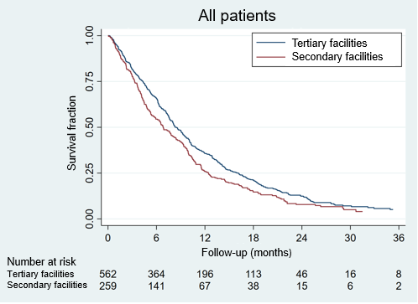
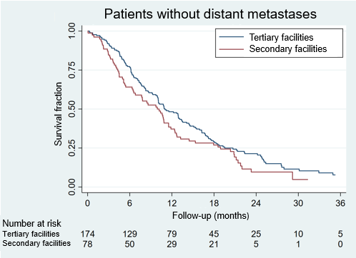

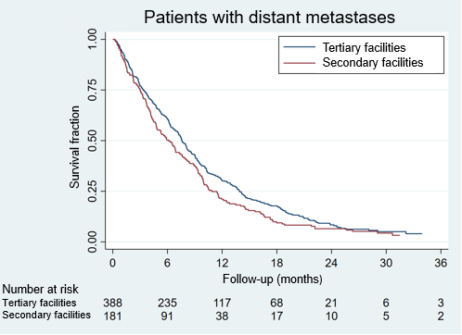
Supplementary Figure. Results of survival analysis
according to facility type for the last two years of the
inclusion period (2017-2018) for all patients (P=0.01),
for patients without distant metastases (P=0.10),
and for patients with distant metastases (P=0.04).

Reporting checklist for cohort study.
Based on the STROBE cohort guidelines.

 |  | Reporting Item | Page Number
Title and abstract
Title | #1a | Indicate the study’s design with a commonly used term in the title or the abstract | 1
Abstract | #1b | Provide in the abstract an informative and balanced summary of what was done and what was found | 2
Introduction
Background / rationale | #2 | Explain the scientific background and rationale for the investigation being reported | 3
Objectives | #3 | State specific objectives, including any prespecified hypotheses | 3
Methods
Study design | #4 | Present key elements of study design early in the paper | 3
Setting | #5 | Describe the setting, locations, and relevant dates, including periods of recruitment, exposure, follow-up, and data collection | 4
Eligibility criteria | #6a | Give the eligibility criteria, and the sources and methods of selection of participants. Describe methods of follow-up. | 4
Eligibility criteria | #6b | For matched studies, give matching criteria and number of exposed and unexposed | n/a
Variables | #7 | Clearly define all outcomes, exposures, predictors, potential confounders, and effect modifiers. Give diagnostic criteria, if applicable | 4
Data sources / measurement | #8 | For each variable of interest give sources of data and details of methods of assessment (measurement). Describe comparability of assessment methods if there is more than one group. Give information separately for for exposed and unexposed groups if applicable. | 4-5
Bias | #9 | Describe any efforts to address potential sources of bias | 4-5
Study size | #10 | Explain how the study size was arrived at | 3-4
Quantitative variables | #11 | Explain how quantitative variables were handled in the analyses. If applicable, describe which groupings were chosen, and why | 5
Statistical methods | #12a | Describe all statistical methods, including those used to control for confounding
5
Statistical methods | #12b | Describe any methods used to examine subgroups and interactions | 5
Statistical methods | #12c | Explain how missing data were addressed | 4
Statistical methods | #12d | If applicable, explain how loss to follow-up was addressed | 4-5
Statistical methods | #12e | Describe any sensitivity analyses
5
Results
Participants | #13a | Report numbers of individuals at each stage of study—eg numbers potentially eligible, examined for eligibility, confirmed eligible, included in the study, completing follow-up, and analysed. Give information separately for for exposed and unexposed groups if applicable. | 5-6
Participants | #13b | Give reasons for non-participation at each stage | 3
Participants | #13c | Consider use of a flow diagram
n/a
Descriptive data | #14a | Give characteristics of study participants (eg demographic, clinical, social) and information on exposures and potential confounders. Give information separately for exposed and unexposed groups if applicable. | 5-6
Descriptive data | #14b | Indicate number of participants with missing data for each variable of interest
5-6
Descriptive data | #14c | Summarise follow-up time (eg, average and total amount)
5-6
Outcome data | #15 | Report numbers of outcome events or summary measures over time. Give information separately for exposed and unexposed groups if applicable.
5-6
Main results | #16a | Give unadjusted estimates and, if applicable, confounder-adjusted estimates and their precision (eg, 95% confidence interval). Make clear which confounders were adjusted for and why they were included | 5-7
Main results | #16b | Report category boundaries when continuous variables were categorized | 5-7
Main results | #16c | If relevant, consider translating estimates of relative risk into absolute risk for a meaningful time period
n/a
Other analyses | #17 | Report other analyses done—eg analyses of subgroups and interactions, and sensitivity analyses | 5-7
Discussion
Key results | #18 | Summarise key results with reference to study objectives | 7
Limitations | #19 | Discuss limitations of the study, taking into account sources of potential bias or imprecision. Discuss both direction and magnitude of any potential bias. | 8-9
Interpretation | #20 | Give a cautious overall interpretation considering objectives, limitations, multiplicity of analyses, results from similar studies, and other relevant evidence. | 7-9
Generalisability | #21 | Discuss the generalisability (external validity) of the study results | 7-9
Other Information
Funding | #22 | Give the source of funding and the role of the funders for the present study and, if applicable, for the original study on which the present article is based | 9
The STROBE checklist is distributed under the terms of the Creative Commons Attribution License CC-BY. This checklist was completed on 23. November 2021 using https://www.goodreports.org/, a tool made by the EQUATOR Network in collaboration with Penelope.ai

