**Supplemental data**

**Video S1.** Autophagosome formation in H2O2-activated human platelets by three-dimensional reconstructed video. Washed platelets treated with 100 μM H2O2 for 60 min and then fixed. The LC3 (green fluorescence) and lysosomes (red fluorescence) were stained with anti-LC3 and anti-LAMP1 antibodies, respectively. This video shows 3-dimensional autophagosome-lysosome fusion in H2O2-treated platelets from different angles.

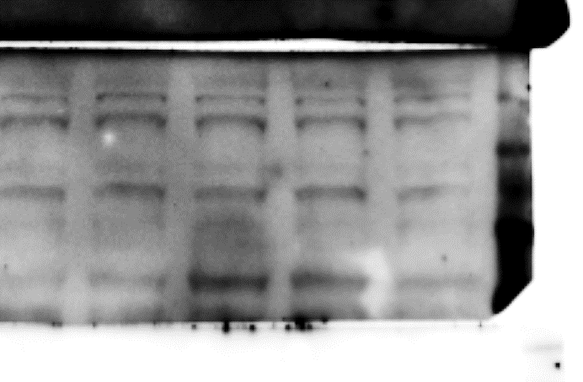F:\cynthia\TMUH WORK\LEE platelet ROS\autophagy\R1\ros platelet WB\ULK\n8 ULK 20201209 2 platelet ROS ULK 11.tif

|  |  |  |  |
| --- | --- | --- | --- |
| **H2O2** | **** | **** | **** |
| **compound C** | **** | **** | **** |

**Figure S1.** Regulatory effects of AMPK-MTOR on ULK1 in response to H2O2 in platelets. Washed platelets treated with 100 μM H2O2 for 60 min in the presence or absence of compound C (10 μM). Specific antibodies were used to detect p-ULK (Ser777 [Sigma Aldrich, ABC213] and Ser757 [Cell Signaling Technology, 14202]) by western blotting. Data are presented as the means ± S.E.M. (*n =* 3). \*\**P <* 0.01 and \*\*\**P <* 0.001, compared with the control platelets; #*P <* 0.05 and ###*P <* 0.001, compared with the H2O2-treated platelets.

|  |  |  |  |
| --- | --- | --- | --- |
| **H2O2** | **** | **** | **** |
| **compound C** | **** | **** | **** |

**p-ULK(S777)**

**p-ULK(S757)**



**ULK**

**ULK**



|  |  |
| --- | --- |
| ***Atg5f/f*** | ***atg5-/-*** |

|  |  |
| --- | --- |
| ***Atg5f/f*** | ***atg5-/-*** |

**Figure S2.** Effects of platelet autophagy in platelet activation in platelet-specific *atg5*−/− mice. Washed platelets from *Atg5*f/f or platelet-specific *atg5*−/− mice stimulated with 0.02 U/mL α thrombin to trigger platelet activation. After fixation, PE-SELP/P-selectin (BioLegend, 148306) and FITC-CD40LG (CD40 ligand; BioLegend, 157006) antibodies were added to detect SELP and CD40LG by flow cytometry. The fold change between activated and resting platelets are shown. Data are presented as the means ± S.E.M. (*n =* 4).

A

p-PRKAA(T172)

PRKAA



SM 16:0

SM 24:0

SM 18:0

50

10

0

50

10

0

50

10

0

(μM)



B



p-PRKAA(T172)

PRKAA



|  |  |  |  |
| --- | --- | --- | --- |
| **H2O2** | **** | ** ** | ** ** |
| **GW4869** | **** | ** ** | ** ** |

**Figure S3.** Effects of sphingolipids on PRKAA in platelets. (**A**) Washed platelets treated with 10 and 50 μM sphingomyelin SM (16:0, 18:0, and 24:0; [Avanti Polar Lipid, 860061, 860586, 860592]) for 60 min. (**B**) Washed platelets treated with 100 μM H2O2 for 60 min in the presence or absence of GW4869 (5 μM, Cayman Chemical, 13127). Specific antibodies were used to detect p-PRKAA by western blotting. Data (**B**) are presented as the means ± S.E.M. (*n =* 3). \**P <* 0.05, compared with the control platelets; #*P <* 0.05, compared with the H2O2-treated platelets.

H2O2 0 M

H2O2 100 M

Sample 1

Sample 2

Sample 3

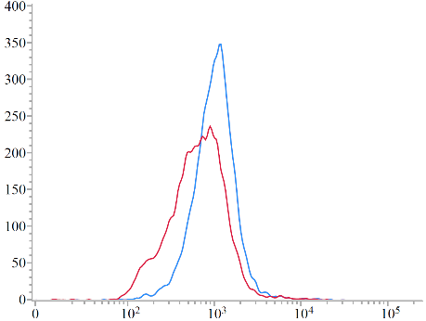

400

300

200

100

0

0 102 103 104  105

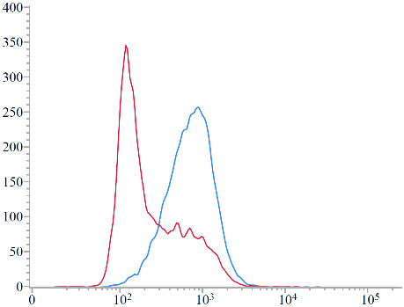

400

300

200

100

0

0 102 103 104  105

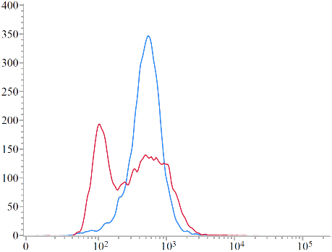

400

300

200

100

0

0 102 103 104  105

Count

DiOC6

A



**Figure S4.** Effects of H2O2 on the mitochondrial function in platelets. (**A**) Washed platelets (1 × 106/mL) treated with 100 μM H2O2 for 60 min and stained with DiOC6 (Enzo Life Science, ENZ-52303) for the detection of mitochondrial potential through a flow cytometry. Three independent experiments were performed (*n* = 3). (**B**) Washed platelets (1 × 107/mL) treated with 50 and 100 μM H2O2 for 60 min. ATP content was then determined by a ATP assay kit (Sigma Aldrich, MAK135). Data (**B**) are presented as the means ± S.E.M. (*n =* 4). \*\*\**P <* 0.001, compared with the control platelets. RLU, relative light units.

B

H2O2





103 104 105  106  107

NAO

0 100 200 300

H2O2 0 M

H2O2 50 M

H2O2 100 M

A





102 103 104  105

MitoTracker Red

0 100 200 300

H2O2 0 M

H2O2 50 M

H2O2 100 M

B

C

**Figure S5.** Effects of H2O2 on the mitochondrial mass in platelets. Washed platelets (1 × 106/mL) treated with 50 and 100 μM H2O2 for 60 min and stained with NAO (Thermo Fisher Scientific, A1372) or MitoTracker Red (Thermo Fisher Scientific, M7512) for detecting the loss of mitochondrial content through a flow cytometry. The P3 marker indicates cells with reduced fluorescence of NAO (**A**) and MitoTracker Red (**B**). Data are presented as the means ± S.E.M. (*n =* 4). \**P <* 0.05, and \*\**P <* 0.01, compared with the control platelets.(**C**) Washed platelets treated with 100 μM H2O2 for 60 min in the presence or absence of compound C (10 μM). Specific antibodies were used to detect p-ULK (Ser555; Cell Signaling Technology, 5869) by western blotting. Data are presented as the means ± S.E.M. (*n =* 3). \*\**P <* 0.01, compared with the control platelets; #*P <* 0.05, compared with the H2O2-treated platelets.

|  |  |  |  |
| --- | --- | --- | --- |
| **H2O2** | **** | **** | **** |
| **compound C** | **** | **** | **** |

|  |  |  |  |
| --- | --- | --- | --- |
| **H2O2** | **** | **** | **** |
| **compound C** | **** | **** | **** |

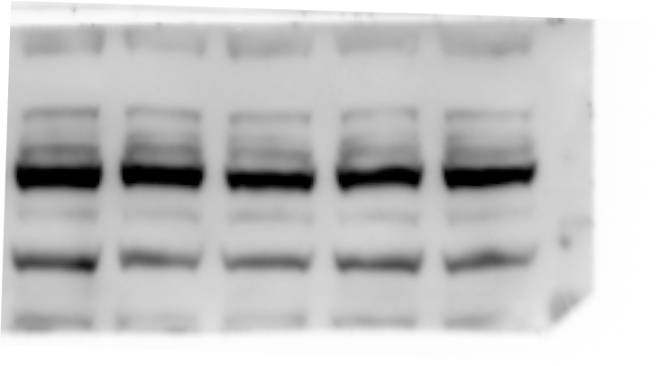

**ULK**

**p-ULK(S555)**

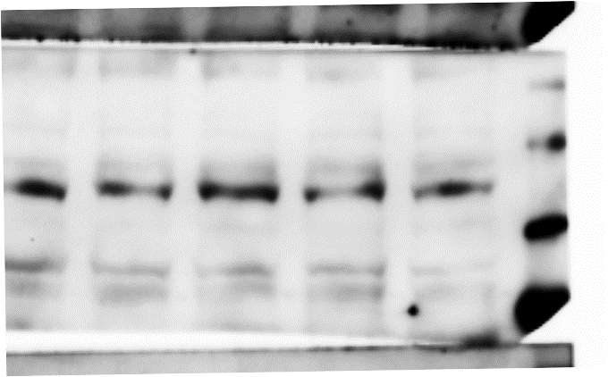

H2O2

H2O2

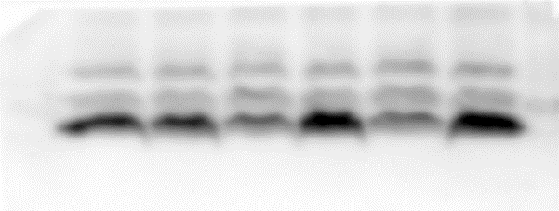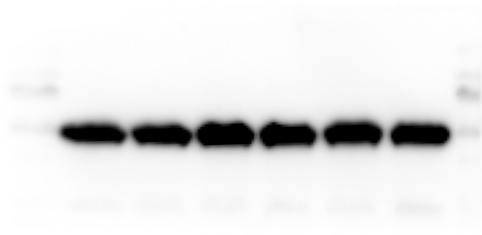

LC3-I

TUBA

H2O2

R

COL

TH

UX

ADP

LC3-II

**Figure S6.** Effect of various agonists on LC3-II expression in human platelets. Washed platelets treated with different agonists, such as 1 g/mL collagen (COL), 0.02 U/mL thrombin (TH; Chrono-Log Corporation, P/N 386), 20 M ADP, 1 M U46619 (UX; Sigma Aldrich, D8174), and 100 M H2O2 for 60 min.