Public Perceptions of Bats

Understanding your opinions and perspectives
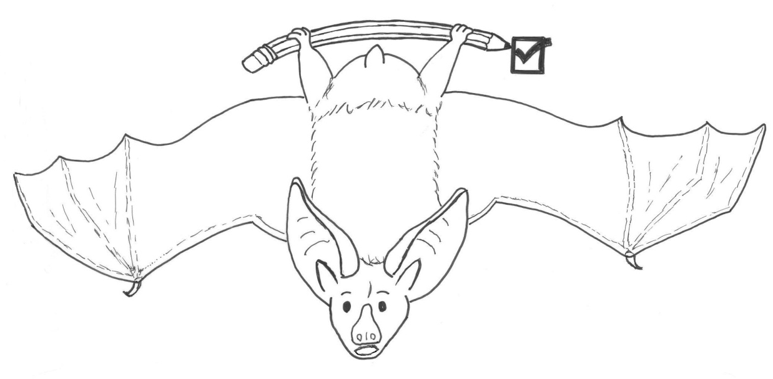

ID#:

Instructions: Please answer all of the questions to the best of your ability.
Section I. Knowledge of Bats
This section is designed to learn what you know about bats within and outside Kachina Village and where you would get information about bats. Depending on your personal experience with bats, some of these questions may not fully apply to you. Thus, please read all the directions for each question thoroughly.
- Prior to this survey, were you aware that there are bats in Kachina Village? (check one)
Yes No Unsure
- How would you classify your knowledge of bats in general?

No knowledge
Below average (minimal)
Average
Above average
A great deal of knowledge
Unsure
- Do you know what a bat roost is? (check one)
Yes No Unsure

- Do you know how to identify a bat roost? (check one)

Yes No Unsure

1
38. What is your highest level of formal education? (check one)
Attended elementary school
Attended high school
High school degree or GED
Vocational or trade school
Some college but no degree
Associates degree
Bachelors degree
Masters or doctorate degree (professional degree)
39. Is there anything else you would like to tell us about bats?
- Please check this box if you would like to participate in an educational program about Arizona bats and bats in Kachina Village.
- Please check this box if you would be willing to show a researcher where bats are on your property (or allow a researcher to examine bats on your property)

THANK YOU FOR YOUR VALUABLE CONTRIBUTION!
Please fold and return the questionnaire to Northern Arizona University in the postage-paid return envelope.

14
Section IV. Background information
This is the last section of the survey. Thank you for making it this far! We’d like to ask you a few questions about your background to better understand your responses to the rest of the survey. Just a reminder, your responses, as well as any personal information, such as name or address will not be linked and will be kept confidential.

- Are you an Arizona resident? (check one)
Yes If yes, for how many years? years
No
- How many months/years have you lived in Kachina Village?
months/years (circle which)
- Do you own the property where you live? (check one)

Yes No
- Are you male or female? (check one)
- What is your age? years
- Do you have any pets? (If yes, please list the number and type of any in your home [e.g., 1 dog, 2 cats])

Yes if yes, number and type of animal(s):
No
- How many children under the age of 12 currently reside in your home? (if none, please write “0”)
Children younger than age 12

13
- If you wanted to increase your knowledge of bats, which of the following sources of information would you be most likely to use? (check all that apply)
Local or state newspapers
Family members/friends/neighbors
TV news or wildlife shows
Internet websites or videos
AZ Game and Fish Department (AZGFD) publications
AZGFD meetings
Radio
Popular magazines (e.g., National Geographic, Nature)
Science literature (e.g., academic journals)
Zoos, local or state parks, environmental centers, etc.
Library
Other
I have no interest in learning more about bats
- From the sources of information listed in question #5, which would you choose first to get information about bats? (circle one in question #5)
- Which of the following do you think bats eat? (check all that apply)
Insects
Nectar
Leaves
Bark
Seeds
Fruit
Blood
Birds
Amphibians (frogs, toads and salamanders)
Reptiles (lizards, snakes and turtles)
Small mammals (mice, rats, voles, etc)
Other bats
Other (please specify) 2
Section II. Experiences with Bats
This next section asks about any experiences you may have had with bats.

- Have you ever had any encounters with bats in Kachina Village? (check one)

Yes No
If yes, please describe the encounter(s) and how you felt during the encounter(s).

Describe encounter(s):

How did you feel during the encounter(s): (check one)

Positive (interested, curious, appreciative)
Negative (threatened, frightened, uneasy)
Neutral
No opinion
- How often do you see bats in Kachina Village? (check one)
Daily
Weekly
Monthly
Yearly

I have never seen bats in Kachina Village skip to question #12 c.

3

- The final question in this section is designed to further understand how you would react in several plausible scenarios with bats. For each hypothetical encounter, please choose the response that best fits how you would react in that situation. (check one for each situation)
Hypothetical Encounter with Bats | I would watch with interest | I would do nothing | I would ask someone what I should do | I would remove myself from the situation | I would contact someone to remove the bat(s) | I would safely remove the bat(s) myself | I would kill the bat(s) | Unsure
You see a bat while walking in your neighborhood.
You see bat(s) flying around your property.
You see bat(s) roosting on your property.
You see a live, but injured bat on the ground.
A bat flies into your home.
A bat bites a family member or friend.
A slow and low-flying bat approaches you.

12
- During the time you have lived in Kachina Village, do you think that the bat population in your neighborhood has: (check one and explain)
Increased Why?

Decreased Why?

Remained the sameWhy?

Unsure Why?
- Would you prefer an increase, decrease or no change in the current population of bats in Kachina Village? (check one and explain)
Increase Why?

Decrease Why?

Remain the sameWhy?

Unsure Why?
- How important is it to you that a potential change in the current bat population in Kachina Village matches your response to question #28? (check one)
Very important
Important
Somewhat important
Neither important nor unimportant
Somewhat unimportant
Unimportant
Very unimportant
11

- During what time(s) of day do you most often see bats within Kachina Village? (if selecting more than one, please numerically [1, 2, 3, etc] rank your choices in order of most common to least common times of day [1=most common])
Dawn (sunrise)
Morning
Afternoon
Dusk (sunset)
Evening
- Where do you most often see bats within Kachina Village? (if selecting more than one location, please rank your choices in order of most common to least common location [1=most common and highest number =least common])
In the air
In trees
Near Kachina Wetlands (or other sources of water)
On the ground
On a building (e.g., house, barn, shed)
- Have you ever seen bats on your property?
Yes No (skip to question #12 c) Unsure (skip to question #12 c)
- If yes, have bats ever flown into your home? (check one)
Yes No Unsure
4
- Do bats roost (rest or sleep) on your property? (check one)

Yes If yes, estimate the number of roosting bats on your property:
No
Unsure

- Would you prefer that the number of bats (even if there are none) roosting on your property be increased, decreased, or remain the same? (check one)
Increased
Decreased
Remain the same
Unsure
- Are you aware of how to remove a bat roost from your property or who to contact to do so? If yes, who or what organization would you contact to do so? (check one)
Yes Person(s)/organization(s) to contact
No
Unsure
- Would you be willing to set up an artificial bat roost on your property to house bats? (check one)

Yes No Unsure
- How would you feel about having bats on your property and why? (check one)

Like why?

Dislike why?

Unsure why?
5
- Do you feel the bat population in Kachina Village should be managed by local wildlife organizations such as Arizona Game and Fish Department? Why or why not? (check one and explain)
Yes Why?

No Why?

Unsure Why?
- Do you feel there is a risk in having bats in Kachina village? (check one and explain)
Yes Why?

No Why?

Unsure Why?
- How strongly do you support or oppose protection of bats? (check one)
Strongly support
Moderately support
Somewhat support
Neither support nor oppose
Somewhat oppose
Moderately oppose
Strongly oppose

10
- Please indicate how strongly you agree or disagree with each of the following statements. (check one for each statement)
Statements about Bats | Strongly agree | Somewhat agree | Neither agree nor disagree | Somewhat disagree | Strongly disagree | Unsure
Bats are important for a healthy ecosystem.
Bats are free to live wherever they occur naturally.
I enjoy seeing bats near my home
It is best to avoid contact with a bat under all circumstances.
Bat presence near my home increases my overall quality of life.
Bats are blind rats with wings that carry diseases and drink blood.
Bats are an unacceptable threat to my family’s and personal well-being.
Bats help reduce insect numbers.
Knowing there are bats in my neighborhood reduces my overall quality of life.

9

- Do your neighbors have bats roosting on their property? (check one)

Yes No Unsure

- How would you feel about having bats on your neighbor’s property and why? (check one)
Like why?

Dislike why?

Unsure why?
- Have you ever had any encounters with bats outside of Kachina Village? (check one)

Yes No Unsure
If yes, please describe the encounter(s) and how you felt during the encounter(s).

Describe encounter(s):

How did you feel during the encounter(s): (check one)

Positive (interested, curious, appreciative)
Negative (threatened, frightened, uneasy)
Neutral
No opinion
6
Section III. Perceptions of and Attitudes Towards Bats
Understanding public perceptions of wildlife allows managers to make more effective decisions that can benefit both people and wildlife. We’d like to find out how you feel about bats and how they should be managed.
- In your own words (5 or less) please describe what you think of when someone mentions bats.
- How likely do you think you are to encounter a bat in Kachina Village? (check one)
Highly likely
Moderately likely
Possible
Moderately unlikely
Highly unlikely
Unsure
- How safe or afraid would you feel if you encountered a bat…(check one for each location)
In the wild? In your neighborhood?
Very safe Very safe
Somewhat safe Somewhat safe
Neither safe nor unsafe Neither safe nor unsafe
Somewhat unsafe Somewhat unsafe
Very unsafe Very unsafe
Unsure Unsure

7

- If you have or had children, how safe or unsafe would you feel if your child or children came in close contact with a bat… (check one for each location)
In the wild? In your neighborhood?
Very safe Very safe
Somewhat safe Somewhat safe
Neither safe nor unsafe Neither safe nor unsafe
Somewhat unsafe Somewhat unsafe
Very unsafe Very unsafe
Unsure Unsure
- If you have or had pets, how safe or unsafe would you feel if your pet(s) came in close contact with a bat…(check one for each location)
In the wild? In your neighborhood?
Very safe Very safe
Somewhat safe Somewhat safe
Neither safe nor unsafe Neither safe nor unsafe
Somewhat unsafe Somewhat unsafe
Very unsafe Very unsafe
Unsure Unsure
- Based solely on their appearance, in your opinion bats are: (check one)
Beautiful
Cute/adorable
Nondescript
Ugly
Terrifying to look at
Other (please specify)
Unsure
8

