# Appendix 1

Interview guide that was used for interviewing eight experts from different Chemelot companies.

|  |  |
| --- | --- |
| **Theme** | **Interview questions** |
| **Introduction** | - Name, affiliation and position in the organisation  - How long have you been working for this organisation/ in this position?  - What are the main products that your company is producing? |
| **Envisioning the future** | - How do you envision your company in the future (say after 2030)? and the Chemelot cluster?  - What is the climate target of your organisation?  - What are the key climate neutrality options for your companies?  - What are the main climate neutrality options for the Chemelot cluster?  - Do you see any conflict/inconsistency between the climate neutrality plans of your company and the Chemelot cluster? |
| **Cluster effects** | - How do you characterise your company’s inter-organisational relationship/cooperation within the Chemelot cluster towards reaching climate neutrality goals?  - What are the advantages of being in a cluster to attain the climate neutrality goals?  Sensitising topics  1. Symbiosis (use streams that would otherwise end up as waste)  2. Gain access to resources  3. Risk and cost sharing (sharing the risk and cost of a climate neutral business endeavour)  4. Learning and sharing knowledge  5. Economies of scale (finding partners to expand production volume to lower high fixed costs)  6. (re)gain access to a foreign market (e.g. partnering with an (local) international company based in the cluster to gain access to a foreign market)  7. Product and/or service development (partners pool their skills to develop new products and/or services)  8. Speed to market (e.g. firms with complementary skills, such as one firm that is technologically strong and another that has strong market access, partner to increase speed to market in hopes of capturing first-mover advantages)  9. Flexibility (e.g. providing alternative to markets and hierarchies, and being subject to fewer regulatory concerns than acquisitions)  10. Collective lobbying  11. Neutralising or blocking competitors (gaining the competencies and market power that is needed to neutralize or block the moves of a competitor)  - What are the disadvantages of being in a cluster to attain the climate neutrality goals?  Sensitising topics  12. Loss of proprietary information (Proprietary information can be lost to a partner who is already a competitor or will eventually become one)  13. Management complexities (combined effort of two or more firms are often difficult to manage that may lead to frustrations and costly delays)  14. Financial and organisational risks (e.g. potential opportunistic behaviour)  15. Risk becoming dependent on a partner (e.g. lock-in, resource dependence, power imbalance)  16. Partial loss of decision autonomy (Joint planning and decision making may result in a loss of decision autonomy)  17. Loss of organisational flexibility (e.g. foreclosing the possibility of establishing a partnership with another firm) |

# Appendix 2

Graphical presentation on the system dynamics model building process.

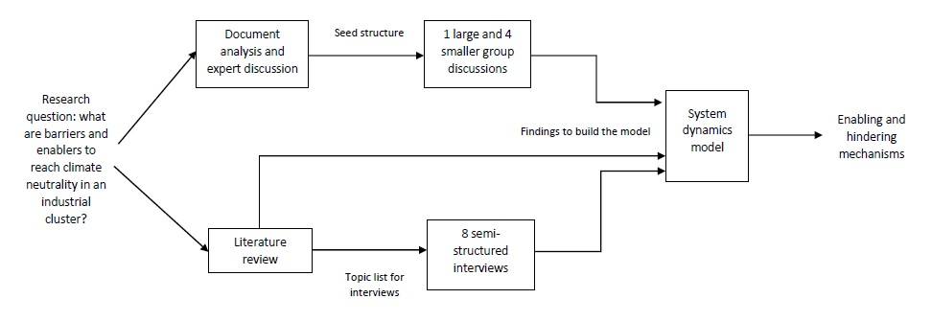

# Appendix 3

Illustrative examples of intermediate stock and flow models that emerged from words-and-arrows diagramming









