Supplemental materials (SM) for “Satellite mapping of air temperature under polar night conditions”
The error analysis included the following stages:
- assessment of the quality of the satellite data used for mapping;
- analysis of air temperature mapping uncertainty;
- estimation of the air temperature mapping errors based on independent measurements (direct validation).
- Aassessment of the quality of the satellite data used for mapping
In the Arctic region, collecting a large amount of high-quality satellite scenes is a challenging task due to a high percentage of cloudy days. Satellite observations are not carried out unless specially ordered; archived satellite images are in a very short supply. In winter, high-quality satellite imagery is possible only in a clear and, accordingly, frosty weather. Such weather periods are short-lived; unsteady thermal regime prevails in the near-surface atmosphere. As a result, the hoarfrost occurs in the near-surface atmosphere. Depending on its density, the transparency of the atmosphere varies (this is especially true of the thermal IR wavelength range). Because of heat release accompanying the formation of hoarfrost, “warm” semitransparent patterns can be observed in the IR satellite images.
In the first stage, 16 scenes with a satisfactory level of quality out of the 25 Landsat 7 and 8 scenes available from the satellite data archives were selected according to the expert assessment results
These 16 scenes were arranged in Table MP.1 according to the Sun elevation at the shooting moment and subdivided into two datasets with 6° as the borderline, the so-called “Night” and “Day”.
Analysis of the regressions constructed on the basis of the satellite imagery collected in the absence of solar radiation (“Night” dataset) and immediately after the end of the polar night at small Sun elevation (“Day” dataset) (Fig. SM.1) showed that:
- the parameters of the regressions constructed on the basis of the dataset obtained in the presence (“Day” dataset) and absence (“Night” dataset) of solar radiation are different (Figure SM.1);
- the regression errors for the “Day” dataset are noticeably higher (Figure SM.1).
Legend: 1 – “Night” dataset, regression equation: T_{a}(x_{WMO},y_{WMO},τ ) =1.01T_{S}(x_{WMO}, y_{WMO}, τ )+8.61; 2 – “Day” dataset, regression equation: T_{a}(x_{WMO}, y_{WM}, τ ) =1.03T_{S}(x_{WMO}, y_{WMO}, τ )+6.37.
Figure SM.1 – Plots of T_{a}(x_{WMO}, y_{WMO},τ) as the outcome variable of predictor T_{S}(x_{WMO},y_{WMO},τ).

For analyzing the air temperature mapping errors in relation to the different numbers of the scenes involved in implementation of the technique presented in the main part of the research, the following procedure was applied. The initial set of 6 scenes (scenes 1–6 in Table MP.1) was formed, and scenes 7–16 (Table MP.1) were sequentially added. On this basis, the histograms of distribution of the air temperatures differences, obtained using the set of 6 scenes, and of the extended sets of scenes, were compiled (Figure SM.2 A).
As seen from Figure SM.2 A, the addition of the scenes from “Day” dataset (though at small Sun elevation) caused a shift towards higher temperature, leading to a systematic error. The regression errors increased simultaneously (see Figure SM.2 B).
The solution steadiness and quality of the satellite data were assessed the cross-validation procedure (Figure SM.3). The base solution, obtained on the basis the first six scenes from Table MP1, was compared successively with the solution which was derived using only five of the first six scenes from Table MP1.
Removal of one of the scenes led to an insignificant (up to 0.4°С) change in the mode (systematic error), whose sign changed from scene to scene. The distribution range (0.05–0.95%) for the solution difference, in general, did not exceed 1.2°С, reaching 2.1°С in one case. The increase in the distribution range in case 5 (February 3, 2019, was eliminated) was caused by the presence of “warm” and almost transparent patterns in this scene.

- Histograms of distribution of the air temperature differences between the base solution (scenes 1–6 in Table MP1) and the solution obtained using other sets of the scenes: 1. 1–8; 2. 1–10; 3. 1–12; 4. 1–16 in Table МP.1, respectively.
(B) Histograms of distribution of the air temperature regression errors for some scene sets used: 1. 1–6; 2. 1–8; 3. 1–10; 4. 1–12; 5. 1–16 in Table MP1, respectively.
Figure SM.2 – Comparison of the solutions based on different sets of scenes.

Legend: Histograms of distribution of the air temperature differences between the base solution (scenes 1–6 in Table MP.1) and the shortened set without one of the following scenes: 1. 05.01.2020; 2. 02.03.2019; 3. 24.04.2019; 4. 31.01.2017; 4. 31.01.2017; 5. 03.02.2019; 6. 06.02.2019.
Figure SM.3. Solution steadiness and satellite data quality assessment/Assessment of the solution steadiness and satellite data quality. Comparison of the base solution obtained using the first six scenes from Table MP.2 with the solution calculated using the shortened set without one scene from the base set of scenes.

2. Analysis of the air temperature mapping uncertainty
The error of regression MP.3 was estimated as the upper limit (with probability 0.9) of RMSE (Bol’shev and Smirnov 1983) for T_{a}(x_{WMO},y_{WMO},τ )=-20°С as follows:
T_{a}(x,y,τ) = F(x,y)*T_{a}(x_{WMO},y_{WMO},τ )+G(x,y) (MP.3)
Regression errors maps were compiled for the solution obtained on the basis of the scenes with Sun elevation <10^{о} at the moment of shooting (the first eight scenes in Table 2; see Fig. SM.4A), and those for the extended range with Sun elevation <16° (see Figure SM.4B). The maps compiled were used for estimating the dependence of the errors on some factors affecting the surface air temperature (see Figures SM.4 and SM.5).
- Legend: 1. Lakes; 2. Artificial water bodies; 3. Tailing dumps; 4. Mask of mountain areas (elevation >320 m). Histograms of RE distribution are corresponding with Fig. SM2B.
Map compiled on the basis of 8 scenes (numbers 1-8 in Table MP.1).

(B) Map compiled on the basis of 16 scenes (“Day” datasets).
Figure SM.4 – Maps of the T_{a}(x,y,τ ) = F(x,y)*T_{a}(x_{WMO},y_{WMO},τ )+G(x,y) regression errors for T_{a}(x_{WMO},y_{WMO},τ )=-20°C.
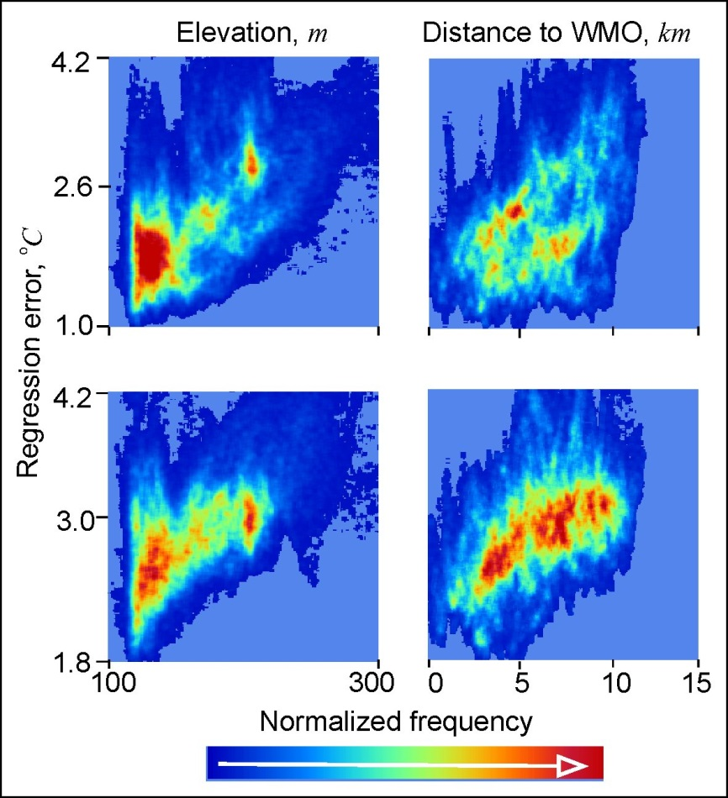
Legend: Top row: maps compiled on the basis of scenes 1–8 from Table MP.1. Bottom row: maps compiled on the basis of scenes 1–16 from the extended “Day” dataset from Table MP.1.
Figure SM. 5 – Two-dimensional histograms of distribution of the regression errors as dependent on: - surface relief elevation; - distance to the weather station.

Figures SM.4 and SM.5 show the relationship between the errors and the relief elevation and the distance to WMO22213 weather station located in the lakeside lowland.
3. Estimation of the air temperature mapping errors based on independent measurements (direct validation)
For independent assessment of the air temperature mapping errors the direct validation procedure was applied. It consisted of comparing T_{a}(x,y,τ ), the satellite-derived surface air temperature (Figure MP.8), which was calculated for all the periods of “dead calm” and for those during which the wind speeds did not exceed 2 m/s, with Ta(x_{j},y_{j},τ ), the air temperature recorded by the loggers at the same moment (j is the logger number). A rectangular matrix of errors ΔT_{a}(x_{j},y_{j},τ ) was compiled, including the data recorded at each observation time by each logger. This was followed by estimation of the systematic error as the mean deviation from the data measured by the loggers and of σ, the root mean square error (RMSE), using the well-known formulas (see Table SM.1).

Table SM.1 Errors estimated from the results of independent measurements of the air temperatures by the loggers
“Night”, dead calm |  |  |  | Extended period, wind speed <2 m/s
Number of scenes | Number of control measurements | Systematic error,  °C | σ,°C | Number of scenes | Number of control measurements | Systematic error,  °C | σ,°C
6 | 145 | 1.0 | 1.5 | 12 | 300 | 1.8 | 2.28
8 | 145 | 1.5 | 1.5 | 16 | 300 | 2.0 | 2.3

