Supporting Information
LSD1 inhibitors from the roots of Pueraria lobata
Meng-Ru Tian^{a#}, Kun Du^{ab#}*, Yan-Le Zhiª, Gui-Min Xueª, Zhen-Zhu Zhaoª, Ying-Ying Siª, Hui Chenª, Yan-Jun Sunª, Wei-Sheng Fengª, Jin-Lian Ma^{c}*
ªSchool of Pharmacy, Henan University of Chinese Medicine, Zhengzhou 450046, China
^{b}The First Affiliated Hospital of Henan University of Chinese Medicine, Zhengzhou 450000, China
^{c}Academy of Chinese Medical Sciences, Henan University of Chinese Medicine, Zhengzhou, 450046, China

*Corresponding author:
Dr. Kun Du, E-mail: qqninenine@hotmail.com
Dr. Jin-Lian Ma, E-mail: lianzi556@163.com
# co-first author

Table of content
Figure S1. ¹H NMR spectrum of compound 1 in DMSO-d₆·······························3 Figure S2. ¹³C NMR spectrum of compound 1 in DMSO-d₆·······························3
Figure S3. DEPT135 spectrum of compound 1 in DMSO-d₆······························4
Figure S4. ¹H-¹H COSY spectrum of compound 1 in DMSO-d₆··························4
Figure S5. HSQC spectrum of compound 1 in DMSO-d₆··································5
Figure S6. HMBC spectrum of compound 1 in DMSO-d₆·································5
Figure S7. HRESIMS of compound 1·························································6 Figure S8. ¹H NMR spectrum of compound 7 in DMSO-d₆·······························6
Figure S9. ¹³C NMR spectrum of compound 7 in DMSO-d₆·······························7
Figure S10. DEPT135 spectrum of compound 7 in DMSO-d₆·····························7
Figure S11. ¹H-¹H COSY spectrum of compound 7 in DMSO-d₆························8
Figure S12. HSQC spectrum of compound 7 in DMSO-d₆································8
Figure S13. HMBC spectrum of compound 7 in DMSO-d₆································9
Figure S14. NOESY spectrum of compound 7 in DMSO-d₆·······························9
Figure S15. HRESIMS of compound 7······················································10
Figure S16. Calculated ECD spectra of 6aS,11aR,11bR-7 and 6aR,11aS,11bS-7······10
Figure S17. Calculated ECD spectra of 6aR,11aS,11bR-7 and 6aS,11aR,11bS-7······11
Figure S18. Calculated ECD spectra of 6aR,11aS,11bR-7 and 6aR,11aR,11bS-7······11

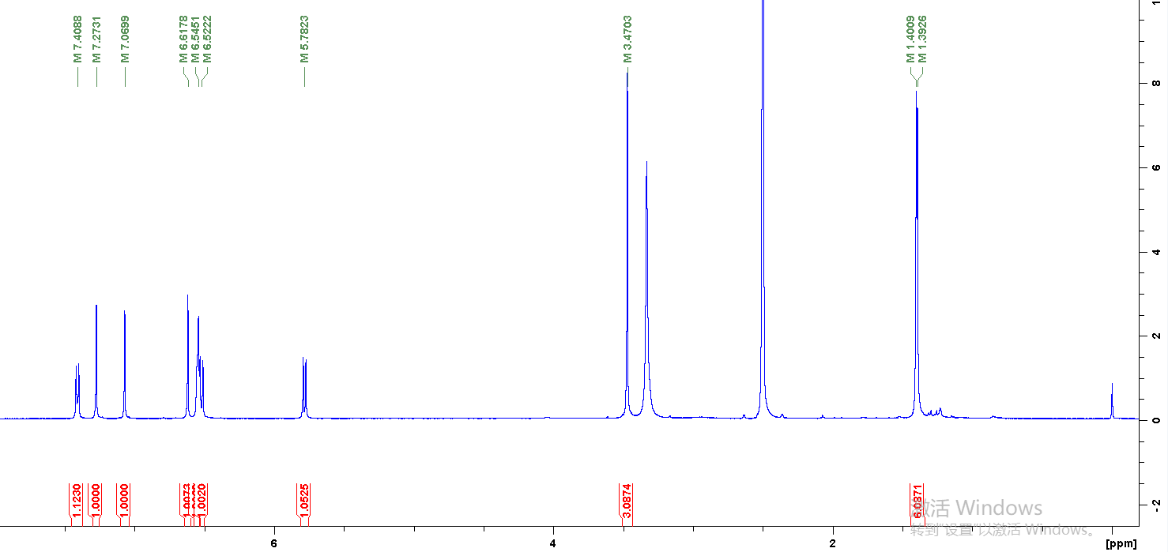
Figure S1. ¹H NMR spectrum of compound 1 in DMSO-d₆

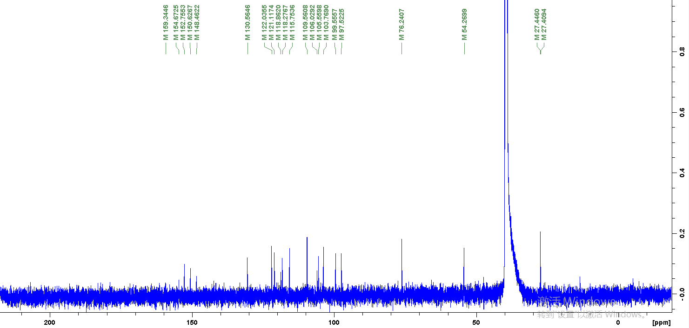
Figure S2. ¹³C NMR spectrum of compound 1 in DMSO-d₆

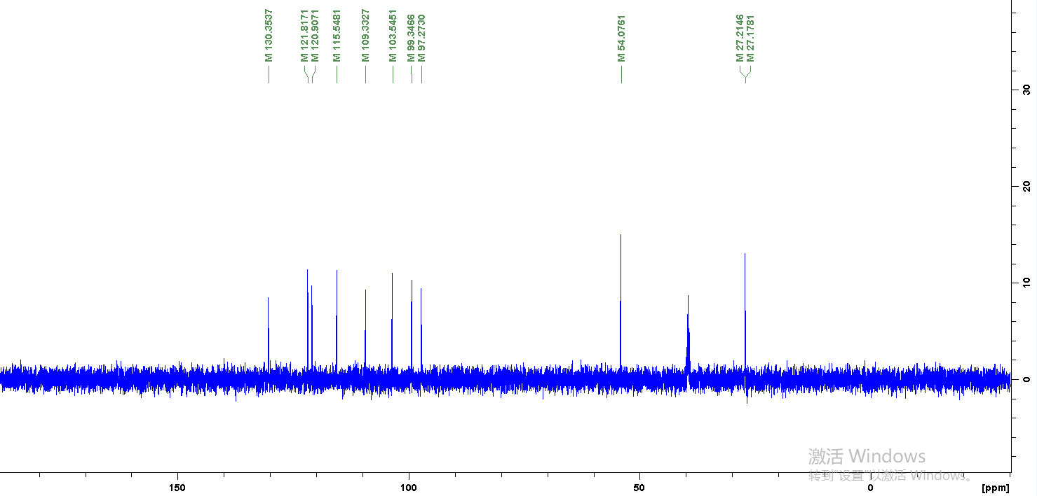
Figure S3. DEPT135 spectrum of compound 1 in DMSO-d₆

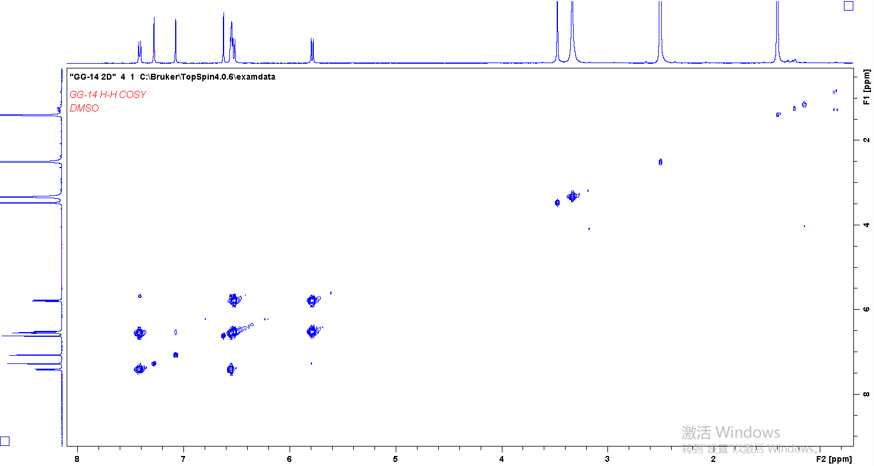
Figure S4. ¹H-¹H COSY spectrum of compound 1 in DMSO-d₆
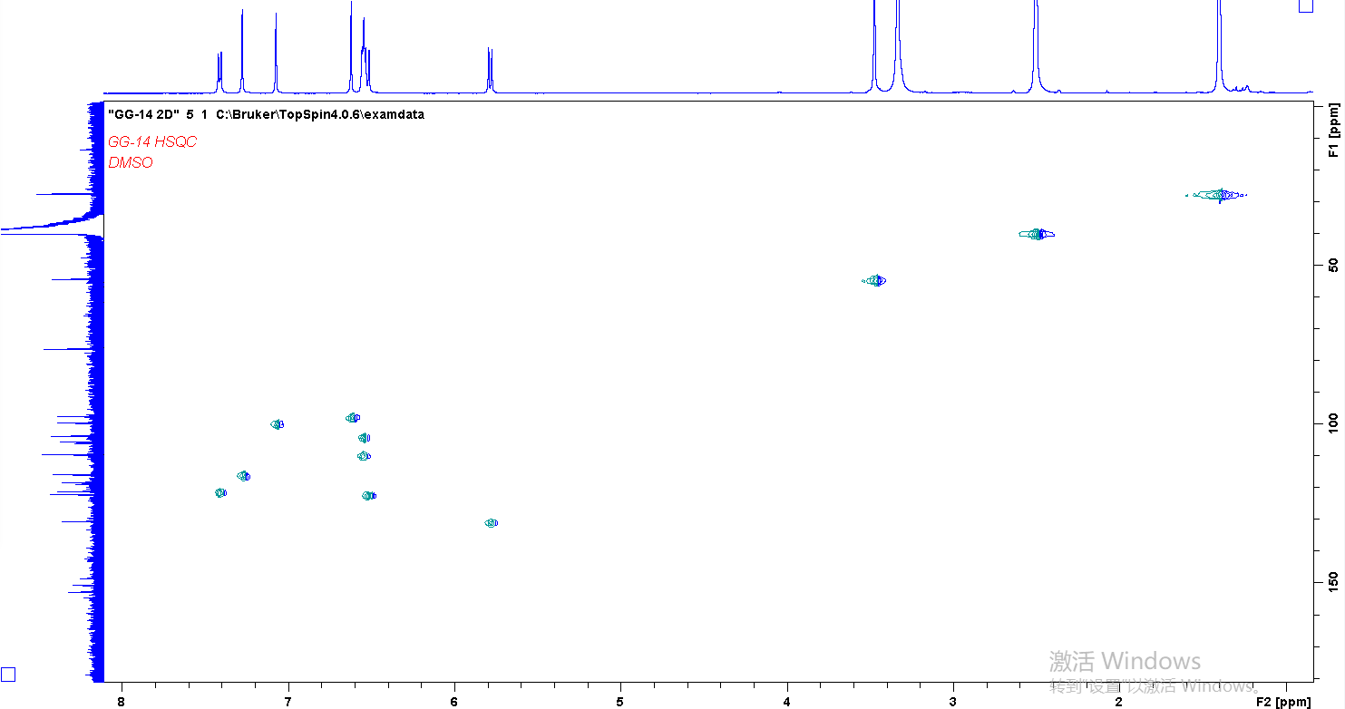
Figure S5. HSQC spectrum of compound 1 in DMSO-d₆

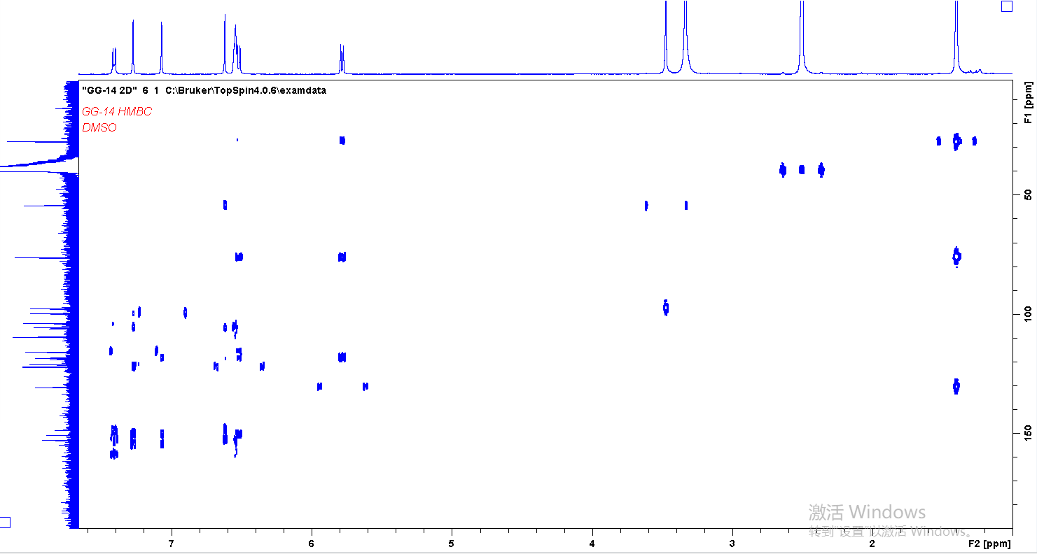
Figure S6. HMBC spectrum of compound 1 in DMSO-d₆

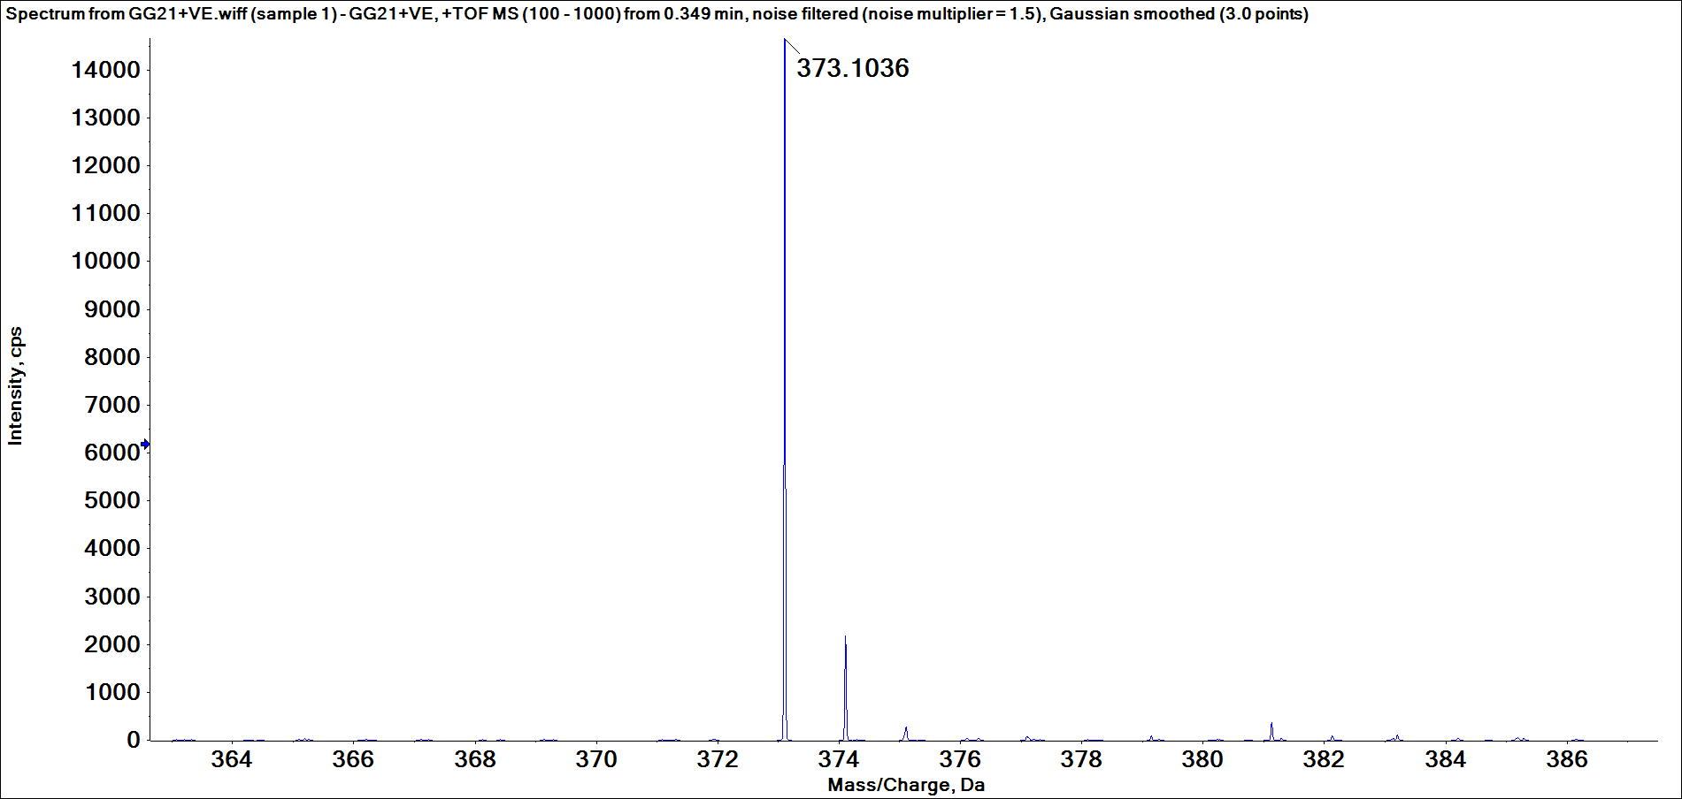
Figure S7. HRESIMS of compound 1

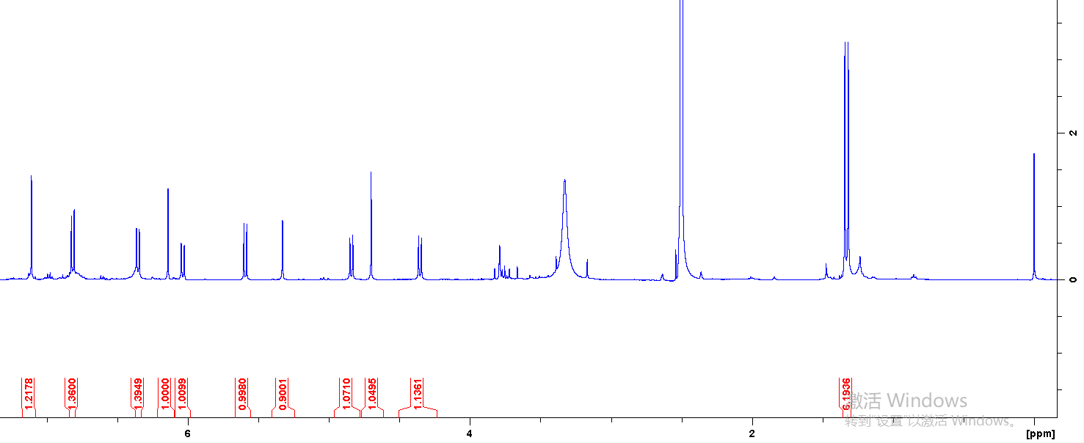
Figure S8. ¹H NMR spectrum of compound 7 in DMSO-d₆

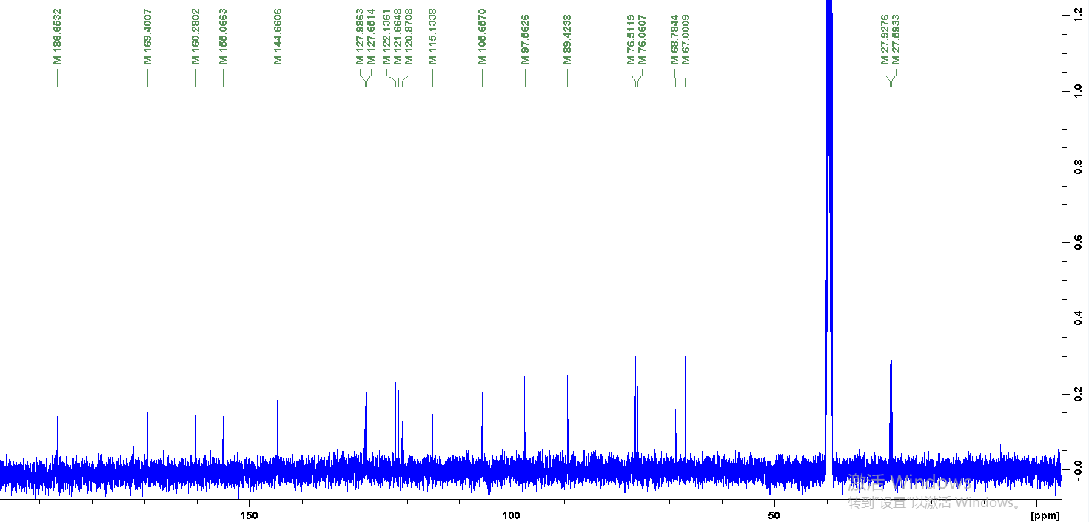
Figure S9. ¹³C NMR spectrum of compound 7 in DMSO-d₆

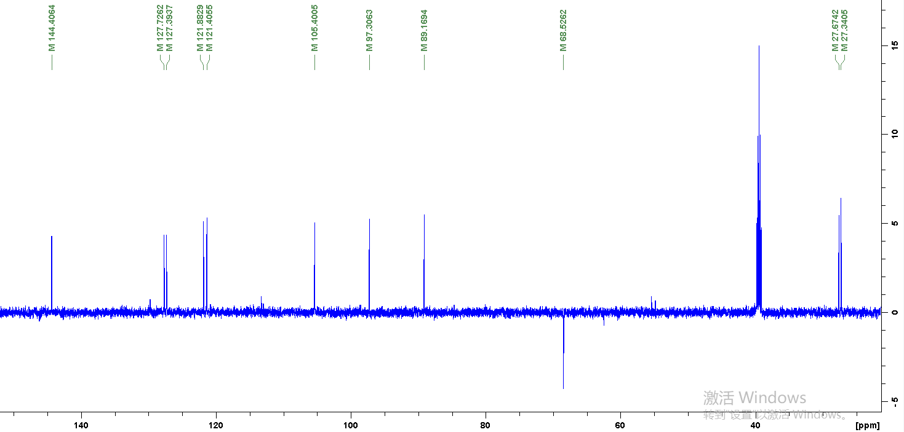
Figure S10. DEPT135 spectrum of compound 7 in DMSO-d₆
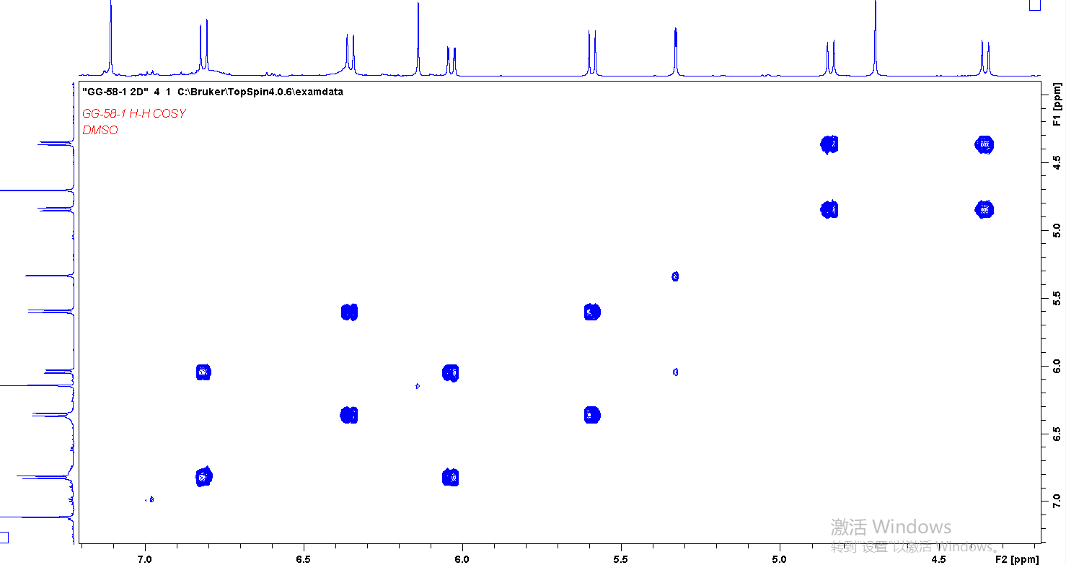
Figure S11. ¹H-¹H COSY spectrum of compound 7 in DMSO-d₆
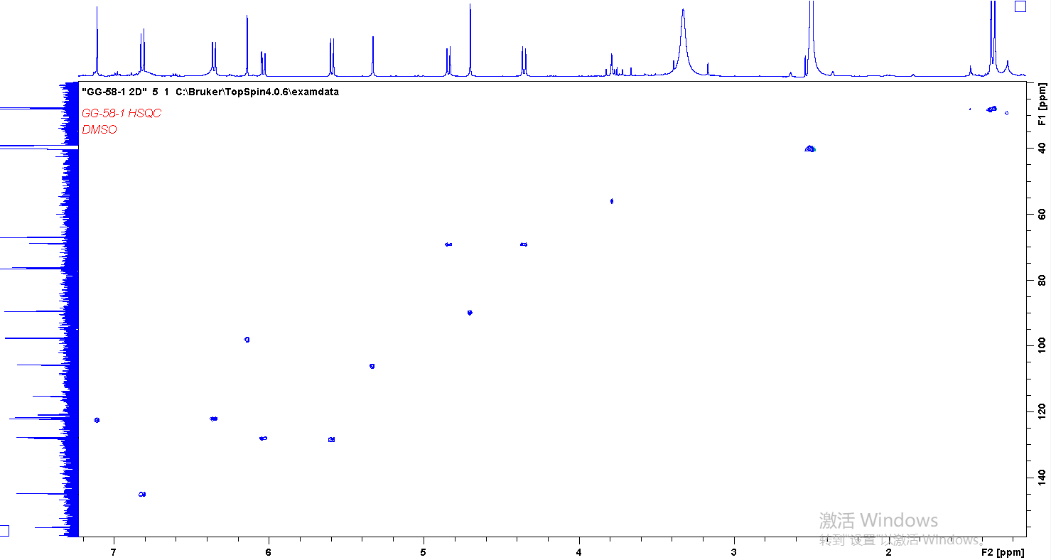
Figure S12. HSQC spectrum of compound 7 in DMSO-d₆
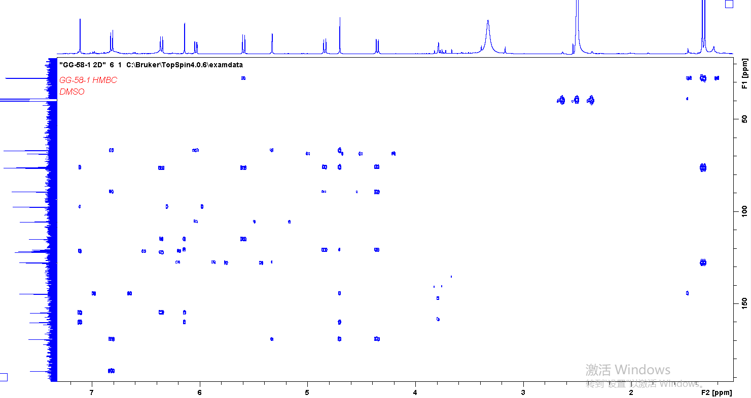
Figure S13. HMBC spectrum of compound 7 in DMSO-d₆
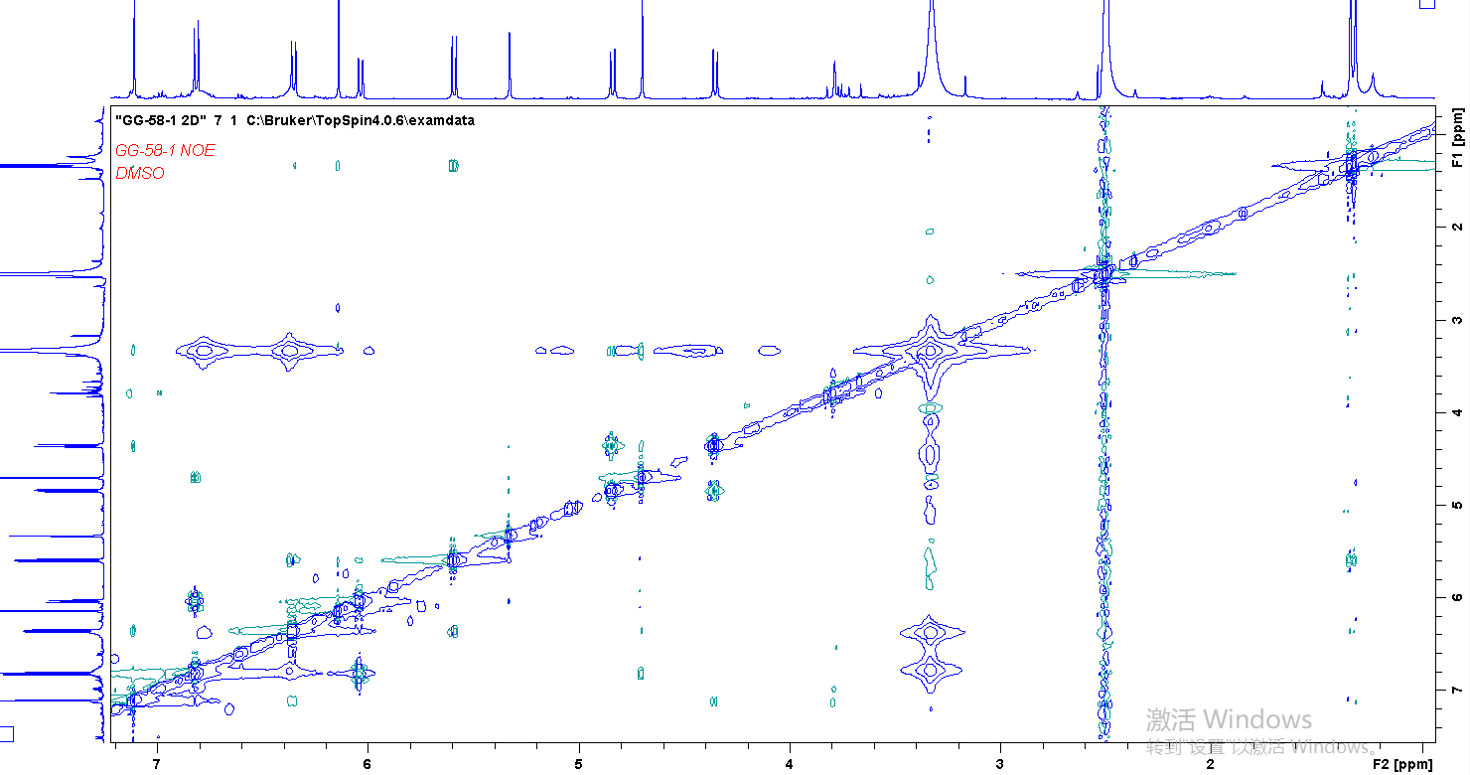
Figure S14. NOESY spectrum of compound 7 in DMSO-d₆

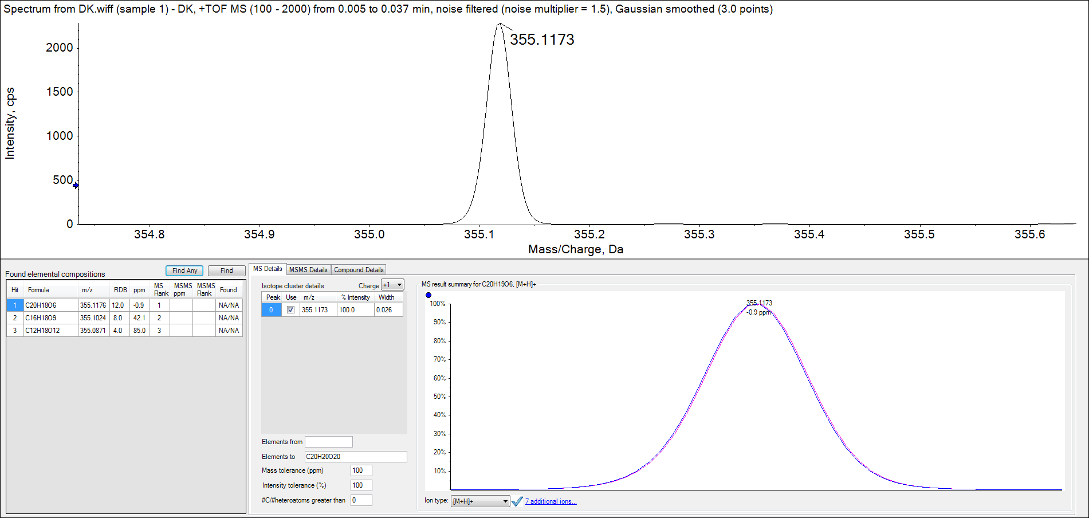
Figure S15. HRESIMS of compound 7

Figure S16. Calculated ECD spectra of 6aS,11aR,11bR-7 and 6aR,11aS,11bS-7

Figure S17. Calculated ECD spectra of 6aR,11aS,11bR-7 and 6aS,11aR,11bS-7

Figure S18. Calculated ECD spectra of 6aR,11aS,11bR-7 and 6aR,11aR,11bS-7

