Supplementary - Retrieval of Svalbard ice flow velocities using Sentinel 1A/1B three-pass Differential SAR Interferometry

In this document, we provide additional details on our results and discussions (Figures S1-S5).
Figure S1 demonstrates the spatial patterns of coherence images generated in 1995 and 2017 year over the region of the Eidembreen glacier, Svalbard and its surrounding areas (ice-free areas/locations). Furthermore, the coherence and interferogram images of the Eidembreen glacier are extracted and illustrated in Figure S2 and Figure S3, respectively. The mean coherence values with 6 days Sentinel 1A/1B acquisitons over the glacier are reasonably good and approximately greater than 0.5 (Table 2). The coherence value of the ERS-1/2 tandem pair (29 and 30 October 1995) is higher (0.78) among all the pairs (Figure S2 a).
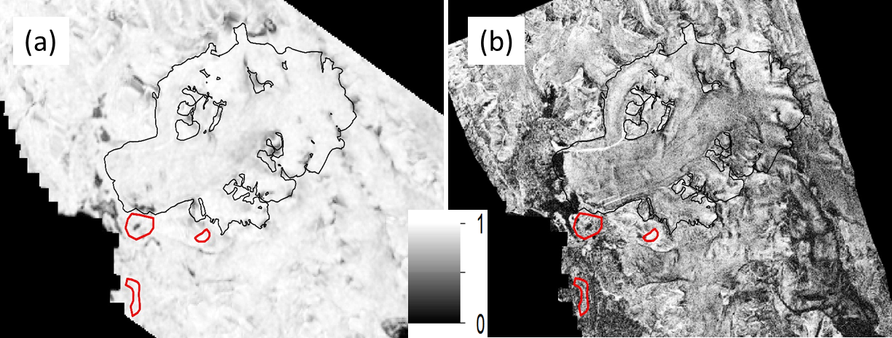
Figure S1. Interferometry coherence images formed from the combination of (a) 29 October to 30 October 1995 and (b) 01 November 2017 to 07 November. The three ice-free regions (red colour polygons) are selected as non-glaciated (ice-free) regions to estimate the atmospheric uncertainties.
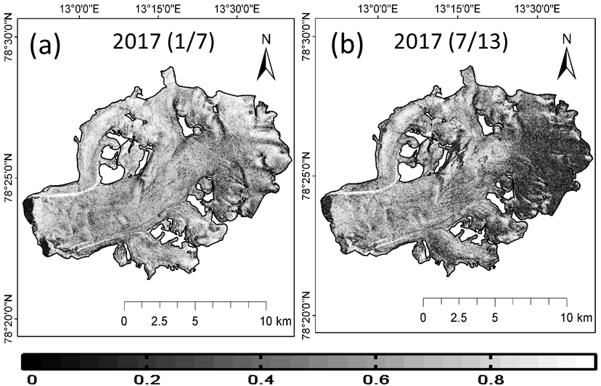
Figure S2. Interferometry coherence images are formed from the pairs of (a) 01 and 07 November 2017, and (b) 07 and 13 November 2017 (listed in the Table 2).
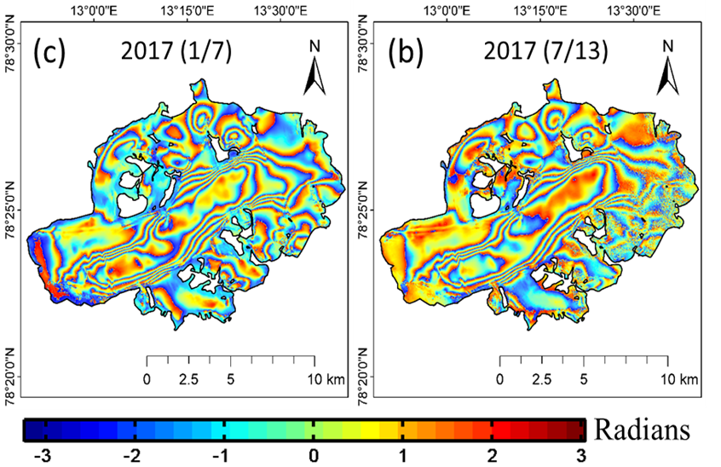
Figure S3. Interferogram images are formed from the pairs of (a) 01 and 07 November 2017, and (b) 07 and 13 November 2017 (listed in the Table 2).

Reason for selecting all the images in October/November month:
Glacier velocity changes seasonally. So, the different in months/seasons may introduce seasonal velocity change uncertainties. It is always preferable to show the DInSAR based ice flow velocities of a complete basin/archipelago during the same period. Hence, we considered the same month (October/November) of images to show the complete velocity map of a Svalbard archipelago.
Coherence is a quality parameter to check the decorrelation effect of the interferometry pair. Here, we used this coherence parameter to select the best/suitable pair of images to infer glacier ice flow velocity. In the coherence images (Figure S4), we observed that pre-and post- ablation seasons are giving high coherence, which is useful to measure glacier velocity with the interferometry technique. Melting season could be the reason for decorrelation in the months of April to September and the melting of glaciers slows down in September. Melting of the glaciers makes infeasible to measure the velocities of summer seasons using the interferometry technique. The October/November months are post-ablation period in the Svalbard region. The optimum coherence is observed in early spring (February/March) and early winter (October) to continue the DInSAR process. However, in the month of March, the complete study area did not reach the coherence threshold value. So, we selected October/November image pairs for our study.

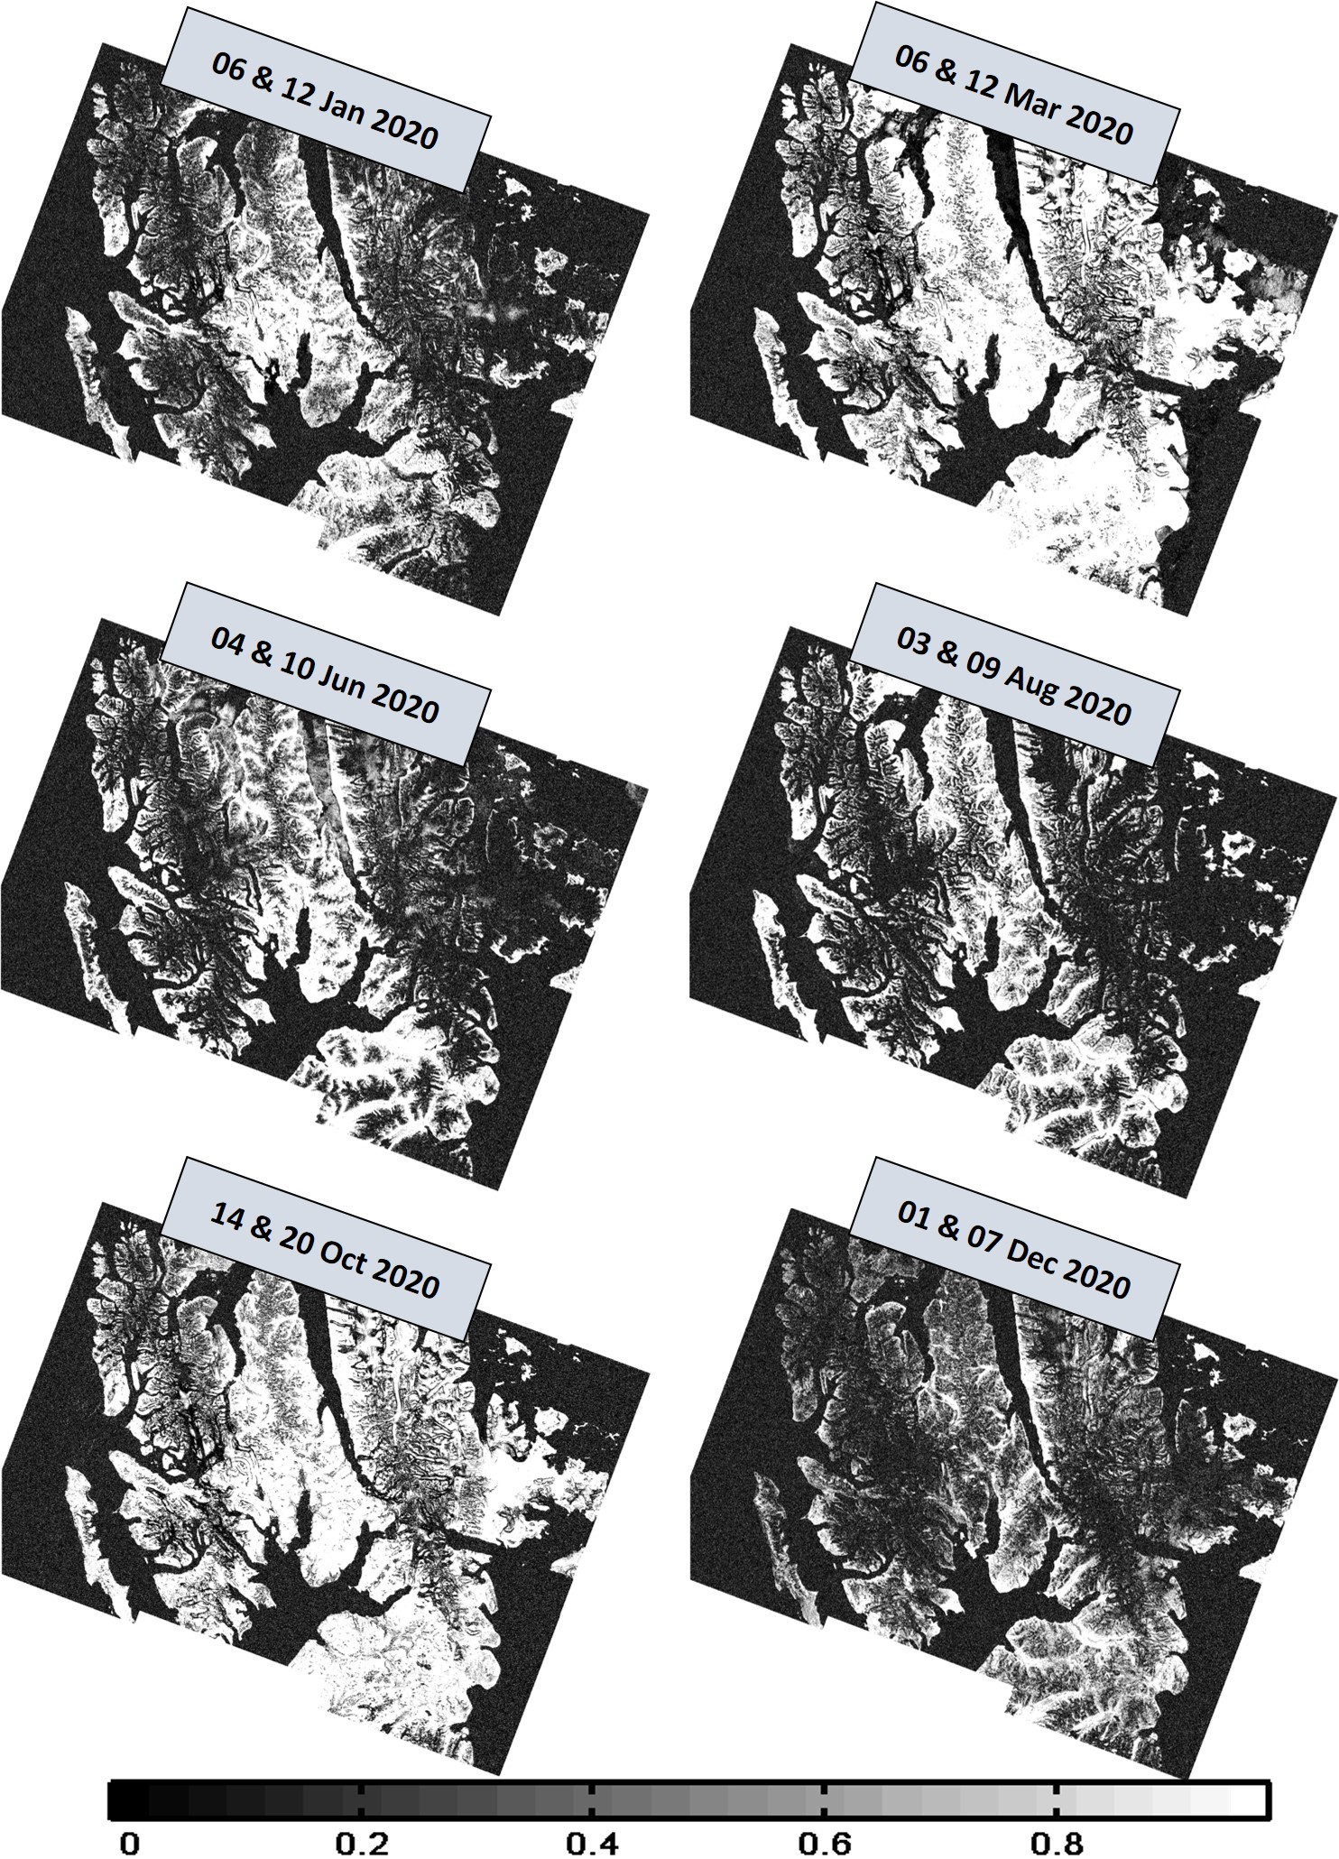
Figure S4. Coherence changes and decorrelation effect of SAR interferometry pairs of Sentinel-1A/1B with 6 days temporal baseline, generated in different months of 2020 year.
Effect of different resolutions DEM (used in the topographic phase removal process) on 2-pass DInSAR glacier movement
We generated LOS velocity maps with different resolutions of ArcticDEM. For this we selected 15m, 30m 60m and 90m resampled DEMs and used to remove topography phase from the interferomgram. The Eidembreen glacier is selected for this analysis. The mean difference of all these DEMs are less than 0.5 m (50 cm). So, the LOS velocity with these different resolutions DEMs is same.

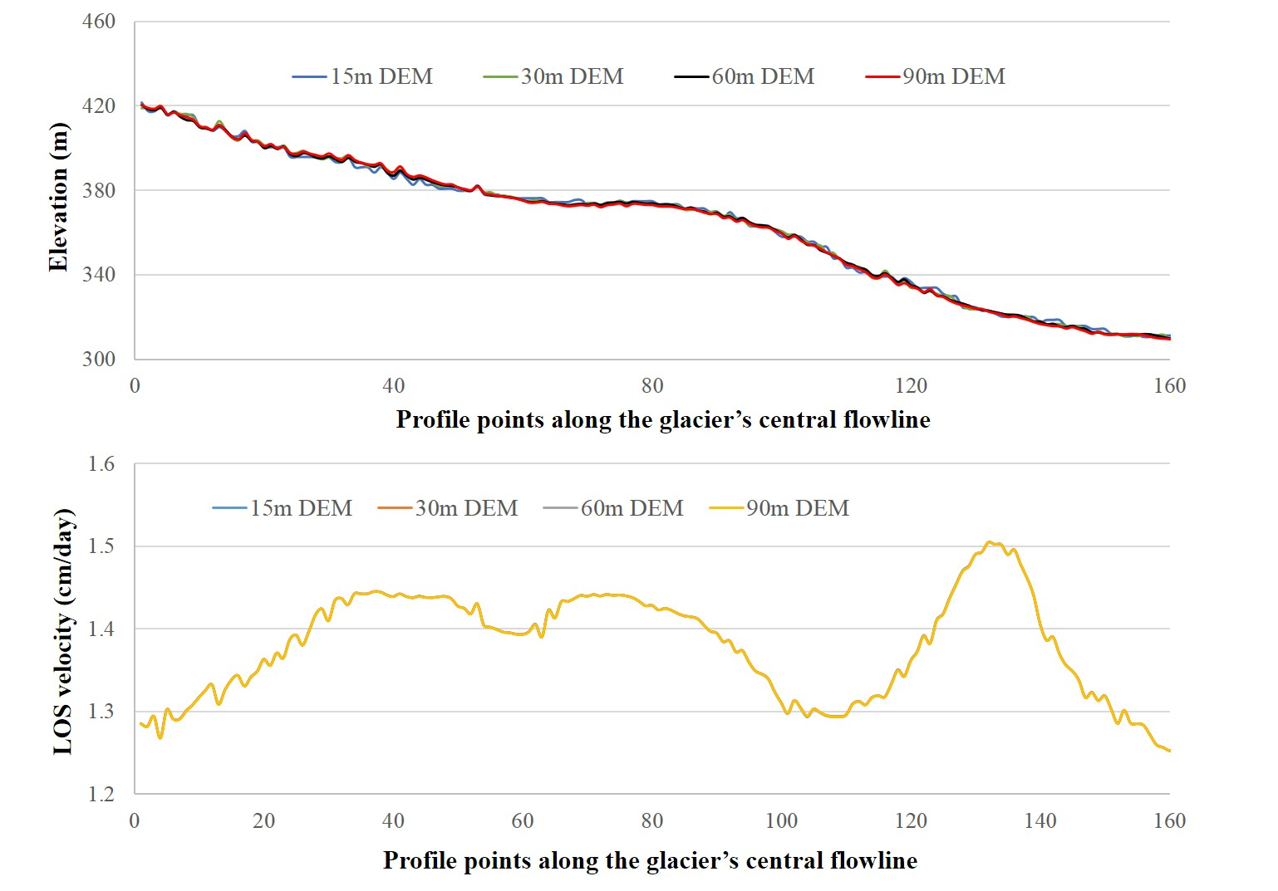
Figure S5. Different resolutions (15m, 30m, 60m and 90m) ArcticDEM topographic phase effect on 2-pass DInSAR glacier movement.

