ArcWaT: a model-based cell-by-cell GIS toolbox for estimating wave transformation during storm surge events

Supplementary Material.
Validation of Total Water Levels and Significant Wave Heights:
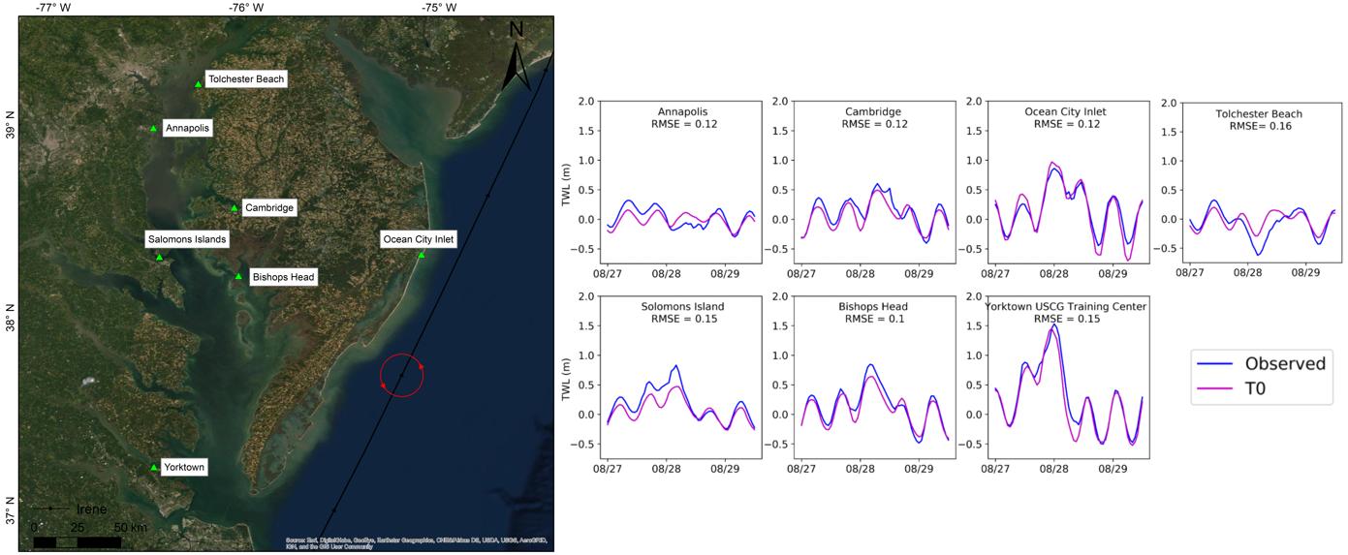
Figure 1. Validation of Total Water Levels (TWL) during Hurricane Irene.

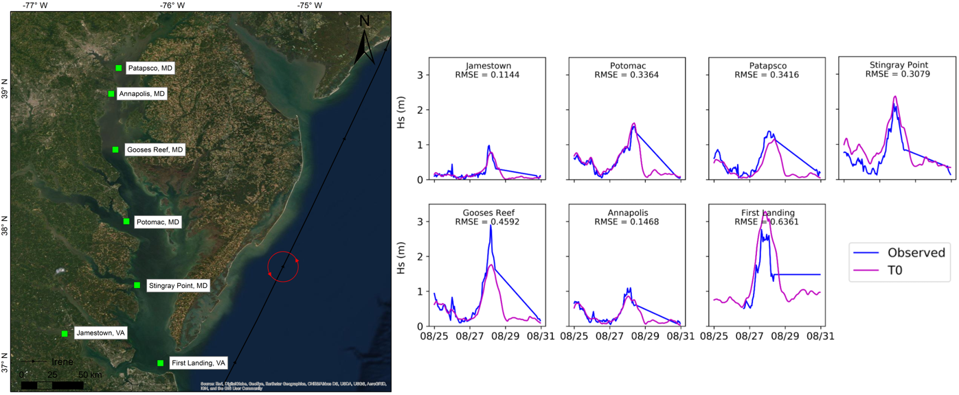
Figure 2. Validation of Significant Wave Heights (Hs) during Hurricane Irene.

