Supplementary data

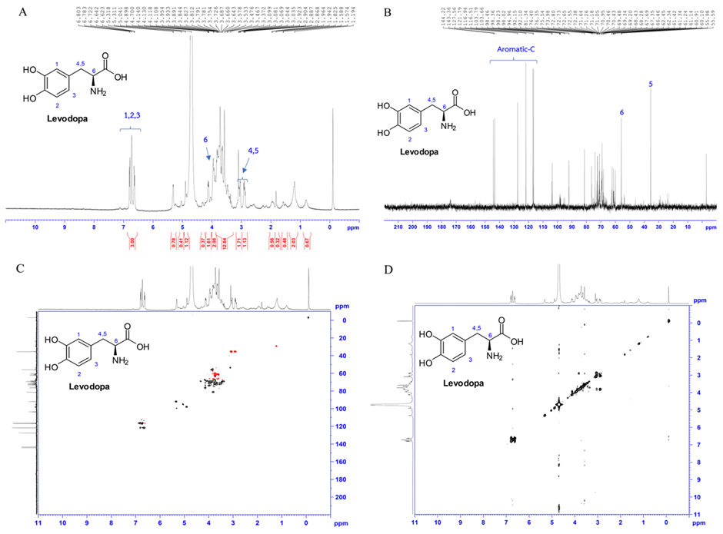

Supplementary Fig. 1. Showing nuclear magnetic resonance (NMR) spectrometry of levodopa (L-DOPA) detected in the crude extract of T-MP, demonstrated by ¹H-NMR (A), ¹³C-NMR (B), ¹H-¹³C HSQC-NMR (C), and ¹H-¹H COSY-NMR (D), respectively.

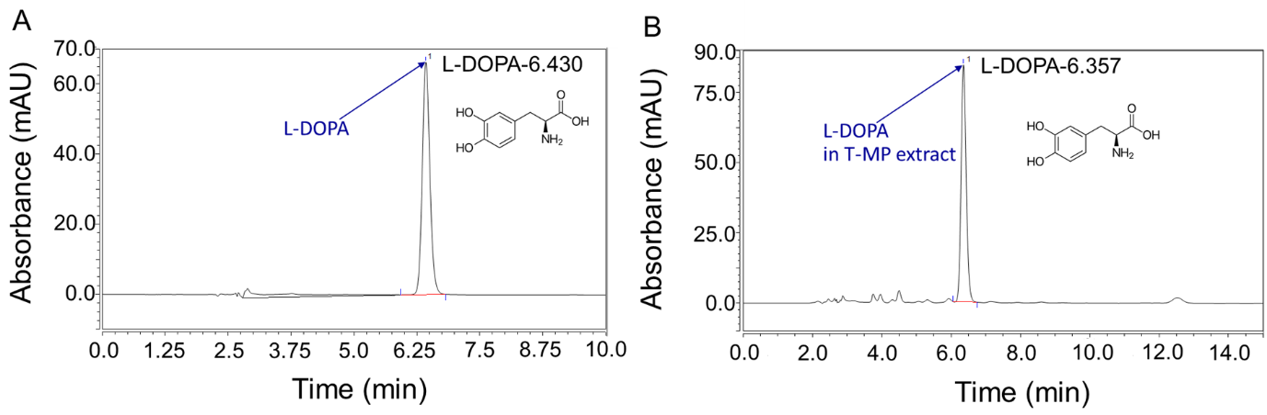
Supplementary Fig. 2 A peak of (A) purified standard levodopa (L-DOPA) and found in (B) T-MP seed extract revealed by high-performance liquid chromatography (HPLC). L-DOPA: Levodopa T-MP: Thai Mucuna pruriens.

