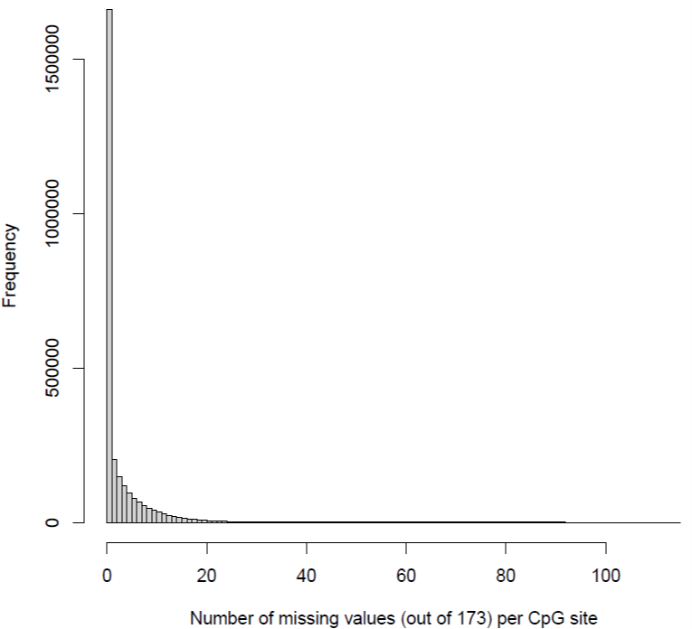
Supplementary Figure 1: A histogram of the number of missing (coverage = 0) values per CpG site out of a total number of 173 samples. A small fraction (2.6 %) of the CpG sites had more than 20 missing values. This histogram was created for the approx. 2.7 million CpG sites that remained after quality control and coverage filtering steps (i.e. those CpG sites that are part of the differential methylation analysis).
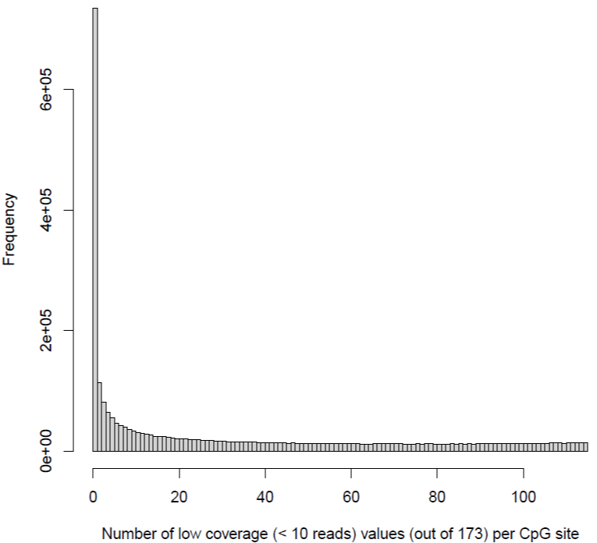
Supplementary Figure 2: A histogram of the number of low-coverage (coverage < 10 reads) values per CpG site out of a total number of 173 samples. This histogram was created for the approx. 2.7 million CpG sites that remained after quality control and coverage filtering steps (i.e. those CpG sites that are part of the differential methylation analysis).
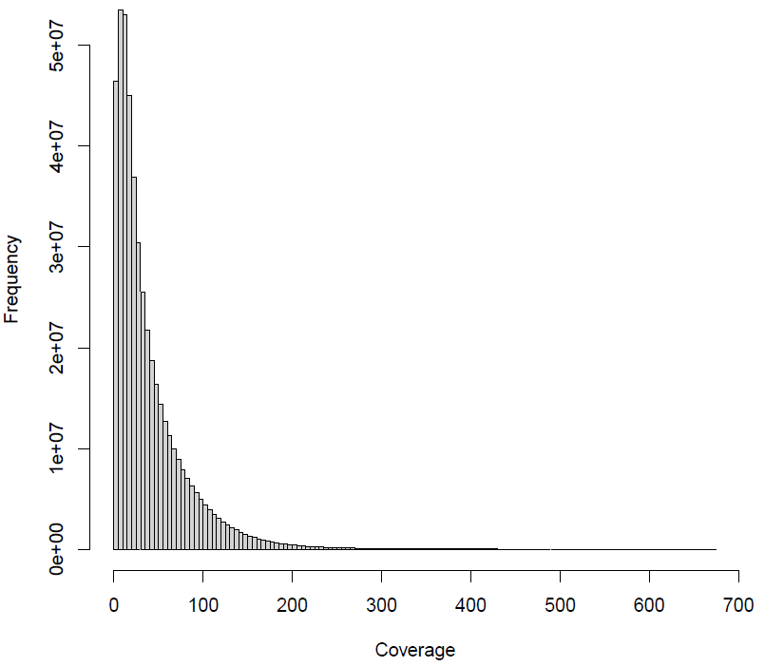
Supplementary Figure 3: The coverage distribution across the whole set of measurements that were part of the analysis (173 samples × approx. 2.7 million CpG sites that remained after quality control and coverage filtering steps)
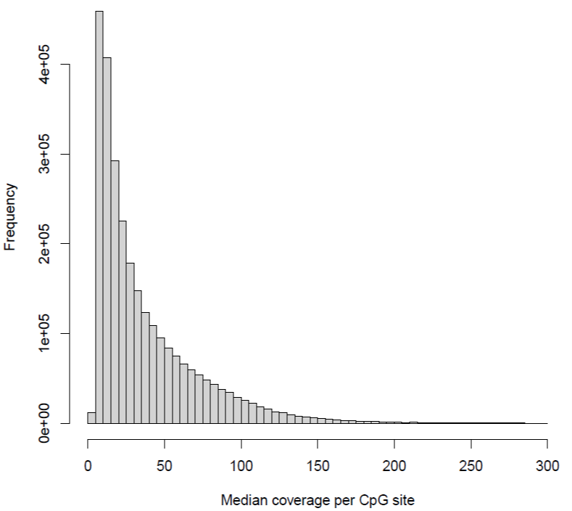
Supplementary Figure 4: A histogram of the median coverage of each CpG site. This histogram was created for the approx. 2.7 million CpG sites that remained after quality control and coverage filtering steps (i.e. those CpG sites that are part of the differential methylation analysis).

