Supplementary material

Table S1. Parameters for the automatic classifier for White-chinned Petrel (Procellaria aequinoctialis) vocalizations built in Kaleidoscope Pro v5 (Wildlife Acoustics Inc.).
Signal parameters
Frequency (Hz) | 800-9000
Duration (s) | 2-11
Inter-syllable gap (s) | .1
Cluster parameters
Max distance | 1.3
FFT Window (ms) | 10.67
Max States | 8
Max Distance to Cluster | .5
Max Cluster | 50

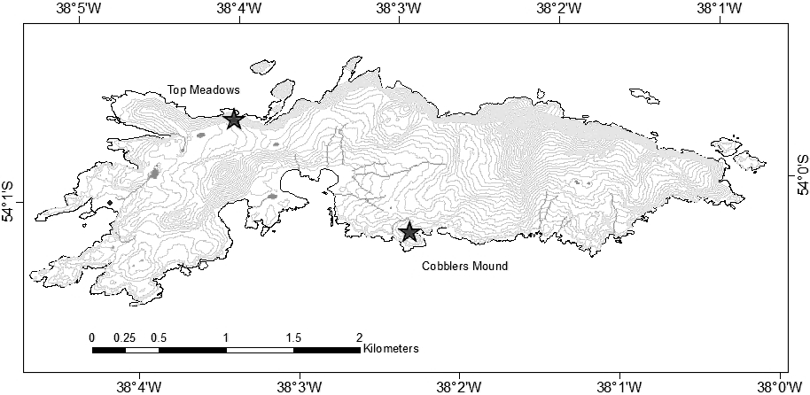
Figure S1. Location of acoustic recording devices on Bird Island, South Georgia, indicated by stars.

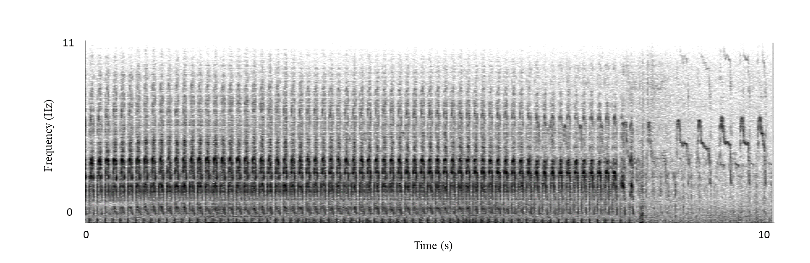
Figure S2. Spectrogram of White-chinned Petrel rattle call, showing the broadband, long call pattern, making manual and automatic detection challenging.

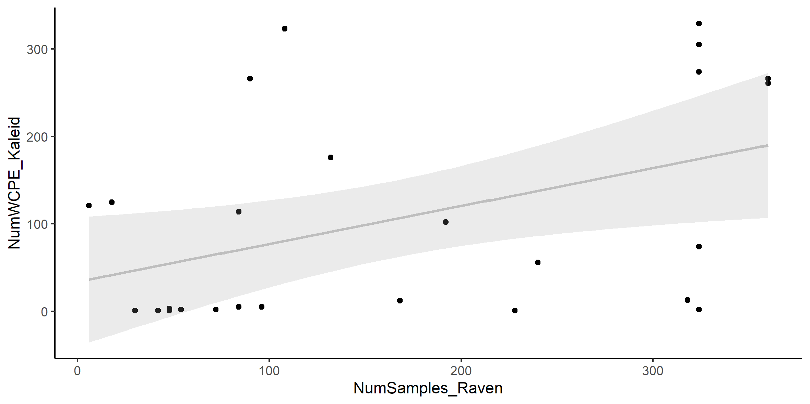
Figure S3. Relationship between the manual detections of White-chinned Petrel calls and the detections made with Kaleidoscope Pro. R²=0.19 (i.e., the relationship was weak).

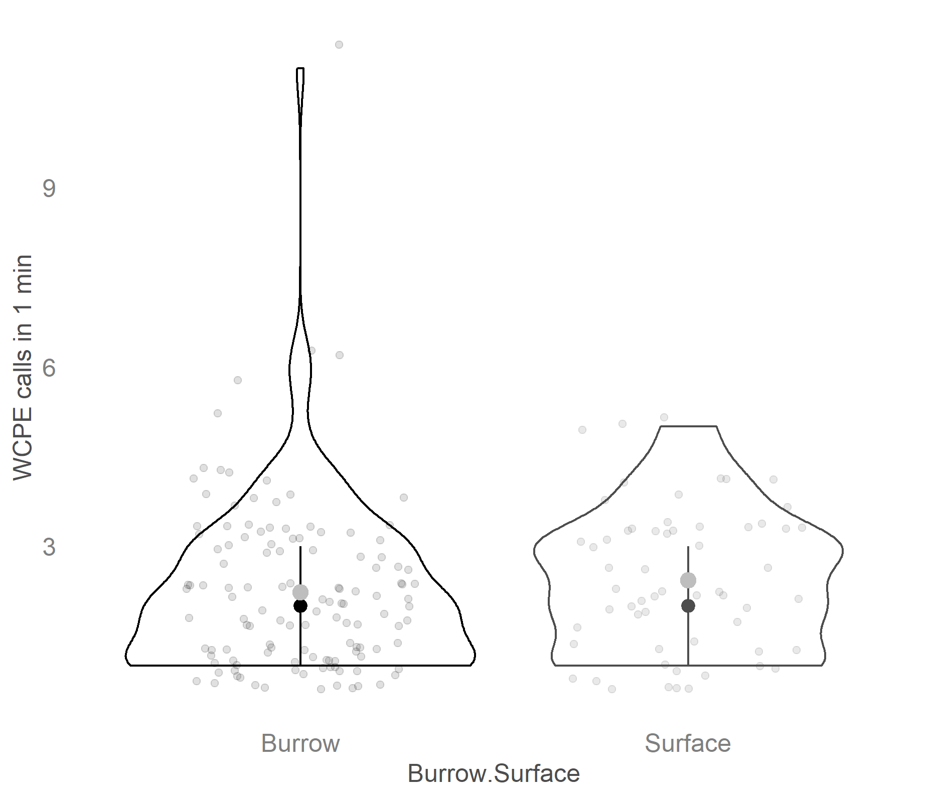

Figure S4. The number of times that White-chinned Petrels vocalize per minute from burrows and on the surface, recorded over nine nights at two sites (Cobblers Mound and Top Meadows) on Bird Island, South Georgia (mean= grey dot, median=black dot).

Figure S5. Importance of covariates in random forest models indicated by the percentage increase in mean squared error (MSE): (a) the occurrence of a White-chinned Petrel vocalization in a 2 min recording clip, (b) the number of 10 sec clips in a 2 min clip containing a White-chinned Petrel vocalization. Greater MSE indicates a larger loss of predictive accuracy when covariates are permuted and thus a higher influence in the model. Results are shown for acoustic index covariates, ordered by MSE. See Table 1 for a description of the acoustic indices.

“Procedure for measuring the SNR,

We measured the in-band power (dB) from 43 calls used to train the Kaleidoscope classifier and calculated the SNR as described in the methods section. We compared SNR to 59 (34 Cobblers Mound, 25 Top Meadows) random calls belonging to the test data we used to evaluate the classifier.

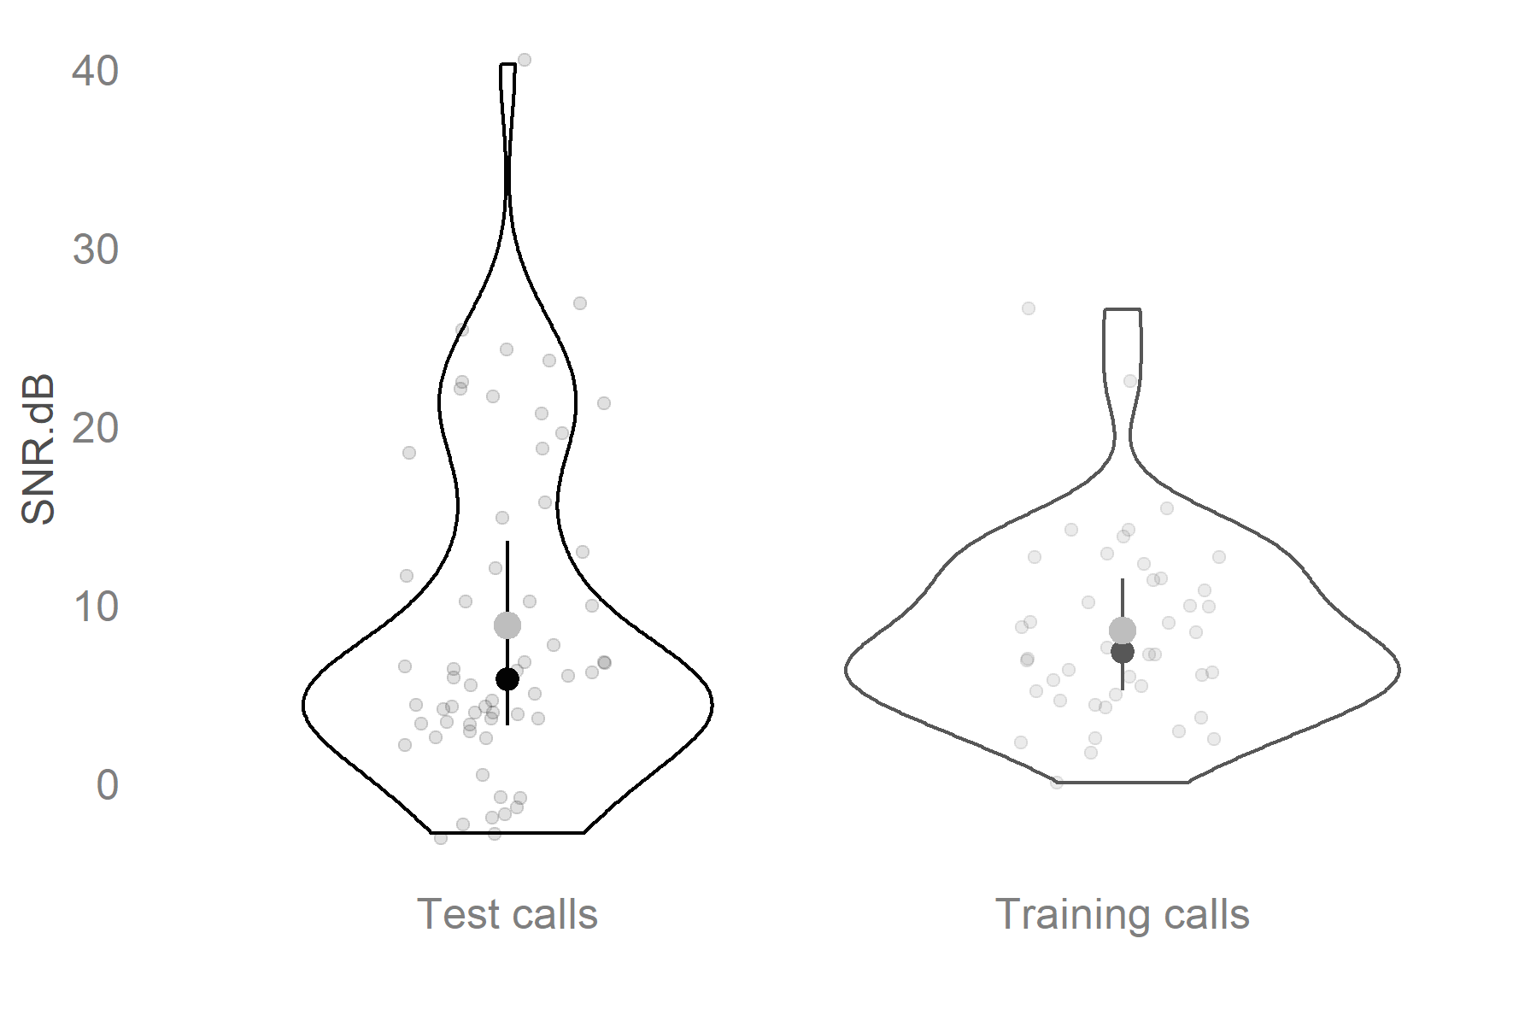

Figure S6. Comparison between White-chinned Petrel rattle calls from the training data (n=43) set and calls from the test data used to explore the efficacy of the classifier (n=59). The mean indicated by the grey dot and the median by the black dot.

