Methodological Appendix
Below we provide the syntax, model diagnostics, and ARIMA output in SPSS to explain the modeling decisions made for each of the key outcomes examined.

Line Graphs of Individual Crime Types

Simple and Aggravated Assaults, by Week
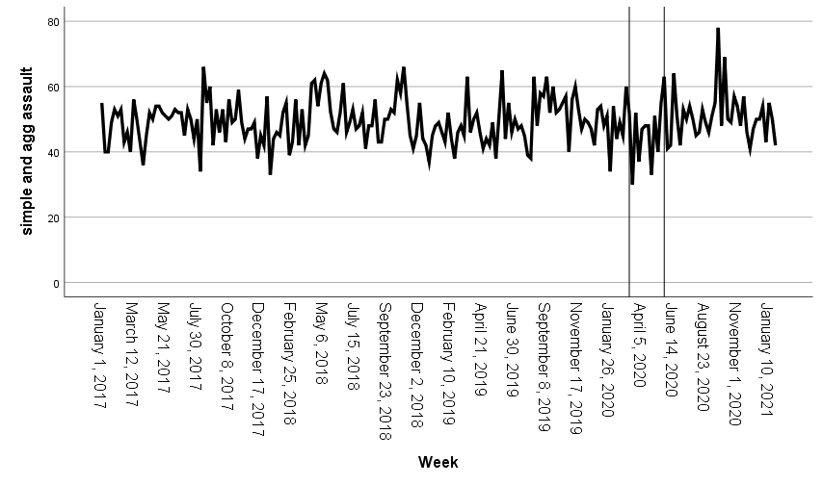

Robbery by Week
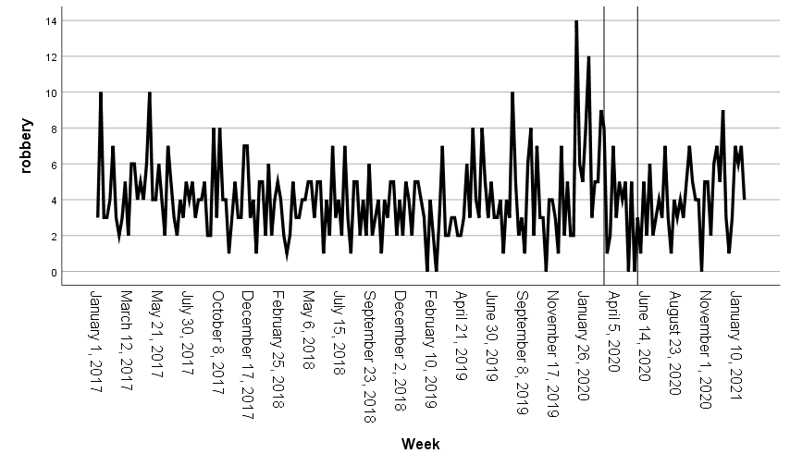

Burglary by Week
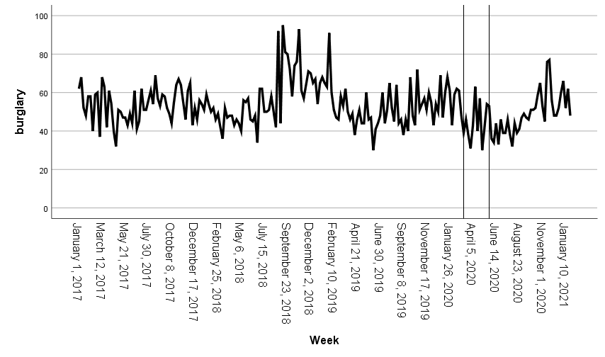

Domestic Violence by Week
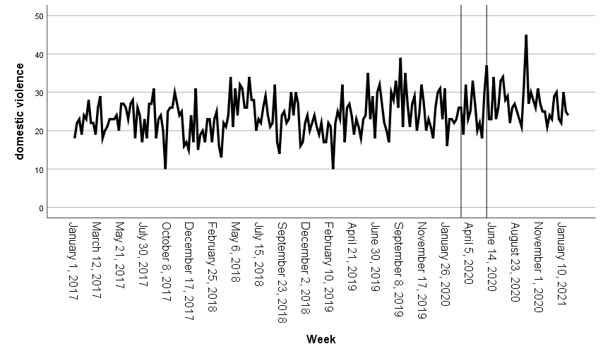

Citizen-Initiated Activity

The first phase of model identification is to review the ACF and PACF for trend (i.e., autoregressive or moving average). The syntax and graphs of the ACF and PACF are below. The slow decaying ACF and spiking PACF indicate an autoregressive trend.

ACF VARIABLES=Citizen
/NOLOG
/MXAUTO 16
/SERROR=IND
/PACF.

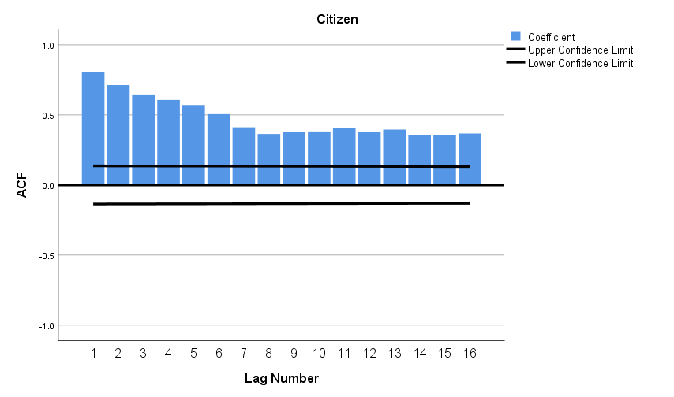
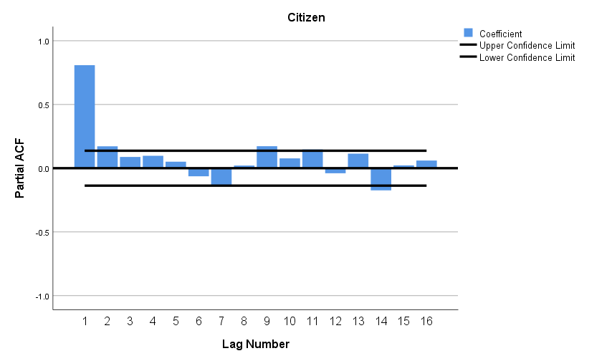

The next step is to confirm selection of the best-fitting model. The output below is for a model (1,0,0). The autoregressive model component is statistically significant, and the residuals are not significant.

PREDICT THRU END.
* Time Series Modeler.
TSMODEL
/MODELSUMMARY PRINT=[MODELFIT]
/MODELSTATISTICS DISPLAY=YES MODELFIT=[ SRSQUARE]
/MODELDETAILS PRINT=[ PARAMETERS RESIDACF RESIDPACF] PLOT=[ RESIDACF RESIDPACF]
/SERIESPLOT OBSERVED FORECAST
/OUTPUTFILTER DISPLAY=ALLMODELS
/AUXILIARY CILEVEL=95 MAXACFLAGS=24
/MISSING USERMISSING=EXCLUDE
/MODEL DEPENDENT=Citizen
PREFIX='Model'
/ARIMA AR=[1] DIFF=0 MA=[0] ARSEASONAL=[0] DIFFSEASONAL=0 MASEASONAL=[0]
TRANSFORM=NONE CONSTANT=YES
/AUTOOUTLIER DETECT=OFF.

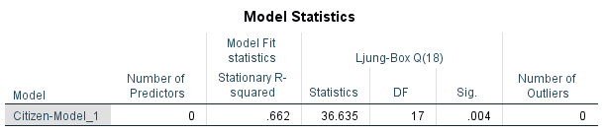
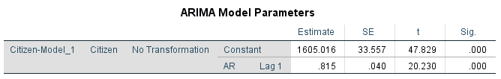
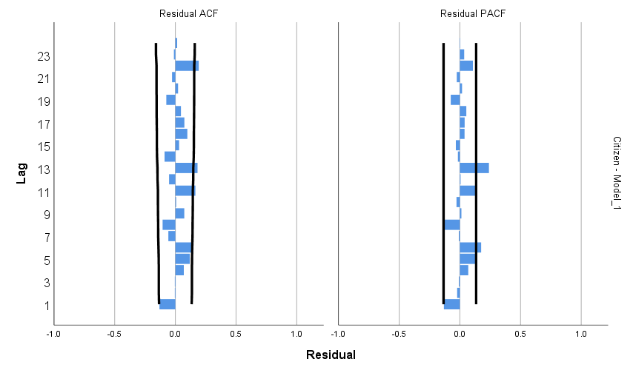

The final step is to add the intervention to the model. First, we test the impact of the COVID-19 pandemic. We hypothesize an immediate impact, starting the week of March 8, 2020. The best-fitting model below confirms the immediate statistically significant decline which lasted through the end of the study period.

PREDICT THRU END.
* Time Series Modeler.
TSMODEL
/MODELSUMMARY PRINT=[MODELFIT]
/MODELSTATISTICS DISPLAY=YES MODELFIT=[ SRSQUARE]
/MODELDETAILS PRINT=[ PARAMETERS RESIDACF RESIDPACF] PLOT=[ RESIDACF RESIDPACF]
/SERIESPLOT OBSERVED FORECAST
/OUTPUTFILTER DISPLAY=ALLMODELS
/AUXILIARY CILEVEL=95 MAXACFLAGS=24
/MISSING USERMISSING=EXCLUDE
/MODEL DEPENDENT=Citizen INDEPENDENT=pandemic
PREFIX='Model'
/ARIMA AR=[1] DIFF=0 MA=[0] ARSEASONAL=[0] DIFFSEASONAL=0 MASEASONAL=[0]
TRANSFORM=NONE CONSTANT=YES
/AUTOOUTLIER DETECT=OFF.
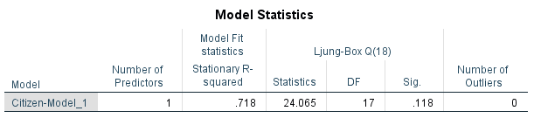
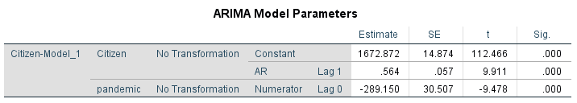
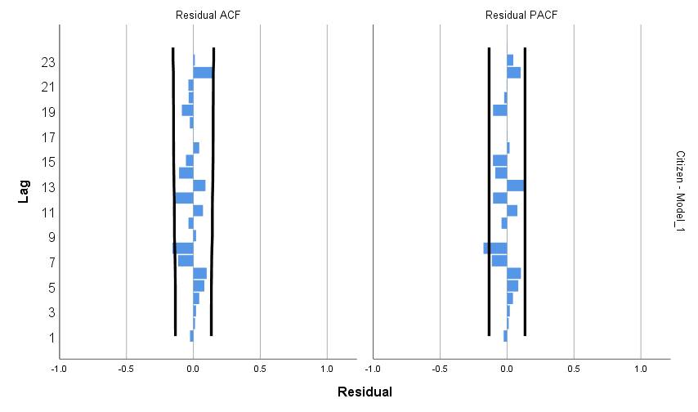
Second, we test the impact of the defund/reform movement. We hypothesize an immediate impact, starting the week of May 24, 2020. The best-fitting model below confirms a near-immediate statistically significant decline starting the week of May 31, 2020 and lasting through the end of the study period.

PREDICT THRU END.
* Time Series Modeler.
TSMODEL
/MODELSUMMARY PRINT=[MODELFIT]
/MODELSTATISTICS DISPLAY=YES MODELFIT=[ SRSQUARE]
/MODELDETAILS PRINT=[ PARAMETERS RESIDACF RESIDPACF] PLOT=[ RESIDACF RESIDPACF]
/SERIESPLOT OBSERVED FORECAST
/OUTPUTFILTER DISPLAY=ALLMODELS
/AUXILIARY CILEVEL=95 MAXACFLAGS=24
/MISSING USERMISSING=EXCLUDE
/MODEL DEPENDENT=Citizen INDEPENDENT=pandemicreform
PREFIX='Model'
/ARIMA AR=[1] DIFF=0 MA=[0] ARSEASONAL=[0] DIFFSEASONAL=0 MASEASONAL=[0]
TRANSFORM=NONE CONSTANT=YES
/AUTOOUTLIER DETECT=OFF.

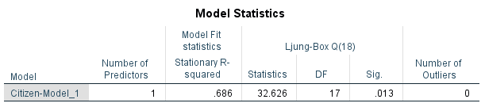
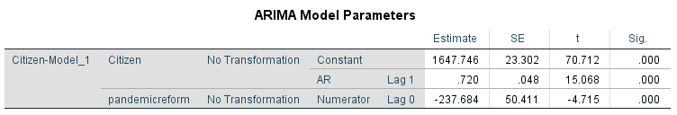
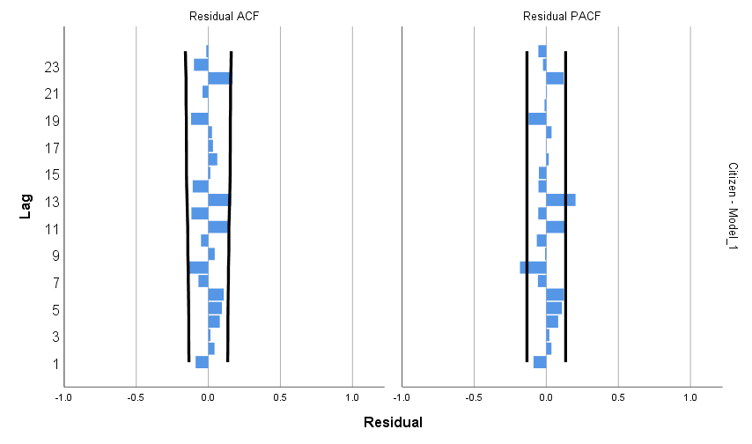

Total Crime

The first phase of model identification is to review the ACF and PACF for trend (i.e., autoregressive or moving average). The syntax and graphs of the ACF and PACF are below. The slow decaying ACF and spiking PACF indicate an autoregressive trend.

DATASET ACTIVATE DataSet1.
ACF VARIABLES=ReportedCrime
/NOLOG
/MXAUTO 16
/SERROR=IND
/PACF.
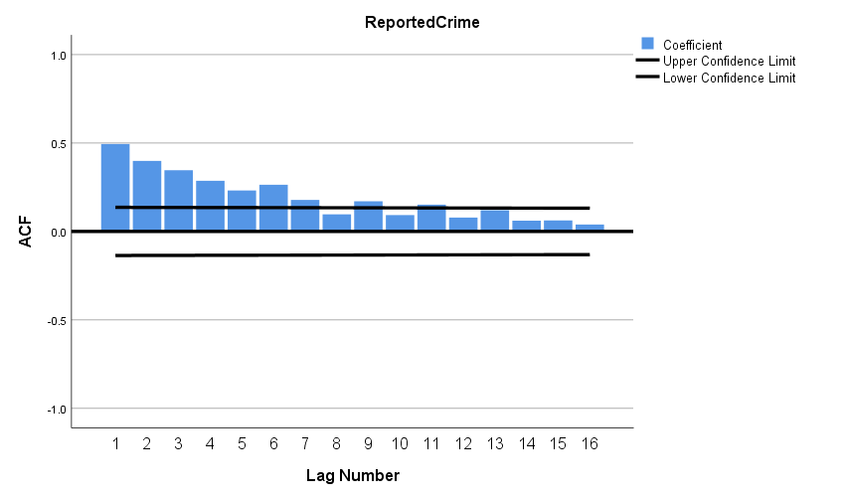

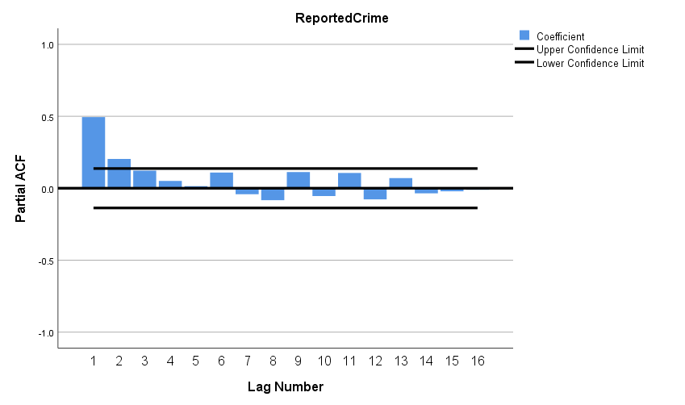

The next step is to confirm selection of the best-fitting model. The output below is for a model (1,0,0). The autoregressive model component is statistically significant, and the residuals are not significant.

PREDICT THRU END.
* Time Series Modeler.
TSMODEL
/MODELSUMMARY PRINT=[MODELFIT]
/MODELSTATISTICS DISPLAY=YES MODELFIT=[ SRSQUARE]
/MODELDETAILS PRINT=[ PARAMETERS RESIDACF RESIDPACF] PLOT=[ RESIDACF RESIDPACF]
/SERIESPLOT OBSERVED FORECAST
/OUTPUTFILTER DISPLAY=ALLMODELS
/AUXILIARY CILEVEL=95 MAXACFLAGS=24
/MISSING USERMISSING=EXCLUDE
/MODEL DEPENDENT=ReportedCrime
PREFIX='Model'
/ARIMA AR=[1] DIFF=0 MA=[0] ARSEASONAL=[0] DIFFSEASONAL=0 MASEASONAL=[0]
TRANSFORM=NONE CONSTANT=YES
/AUTOOUTLIER DETECT=OFF.

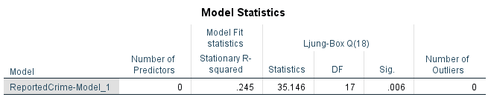
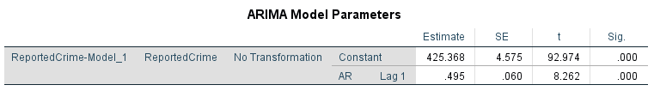
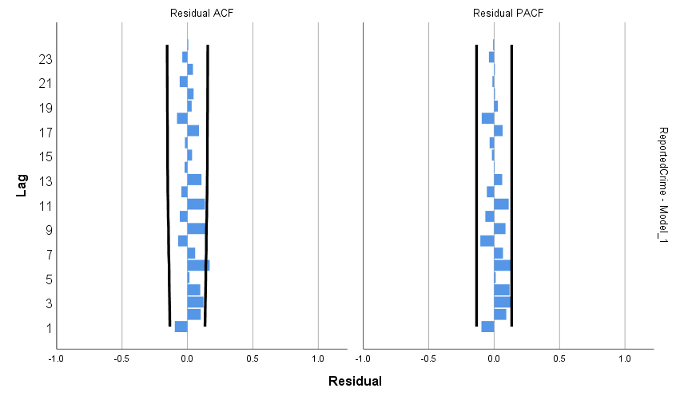
The final step is to add the intervention to the model. First, we test the impact of the COVID-19 pandemic. We hypothesize an immediate impact, starting the week of March 8, 2020. The best-fitting model below confirms the immediate statistically significant decline which lasted until the week of August 16, 2020.

PREDICT THRU END.
* Time Series Modeler.
TSMODEL
/MODELSUMMARY PRINT=[MODELFIT]
/MODELSTATISTICS DISPLAY=YES MODELFIT=[ SRSQUARE]
/MODELDETAILS PRINT=[ PARAMETERS RESIDACF RESIDPACF] PLOT=[ RESIDACF RESIDPACF]
/SERIESPLOT OBSERVED FORECAST
/OUTPUTFILTER DISPLAY=ALLMODELS
/AUXILIARY CILEVEL=95 MAXACFLAGS=24
/MISSING USERMISSING=EXCLUDE
/MODEL DEPENDENT=ReportedCrime INDEPENDENT=pandemic
PREFIX='Model'
/ARIMA AR=[1] DIFF=0 MA=[0] ARSEASONAL=[0] DIFFSEASONAL=0 MASEASONAL=[0]
TRANSFORM=NONE CONSTANT=YES
/AUTOOUTLIER DETECT=OFF.

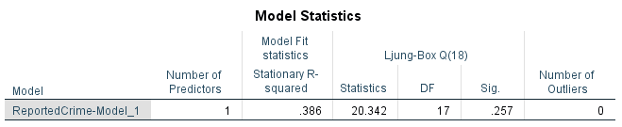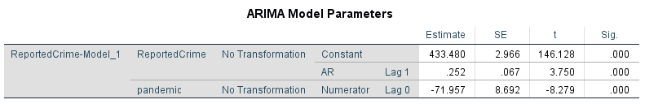
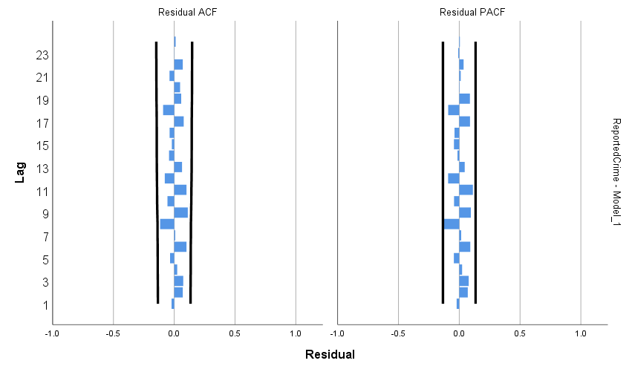

Second, we test the impact of the defund/reform movement. We hypothesize an immediate impact, starting the week of May 24, 2020. The best-fitting model below confirms the immediate statistically significant decline which lasted until the week of August 16, 2020.
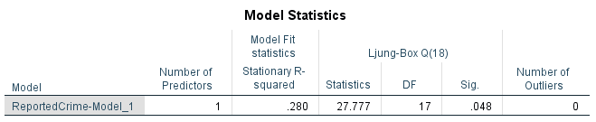
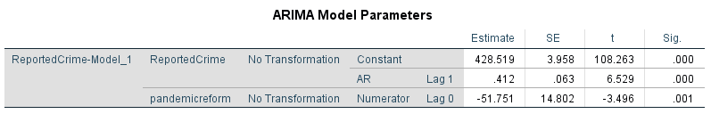
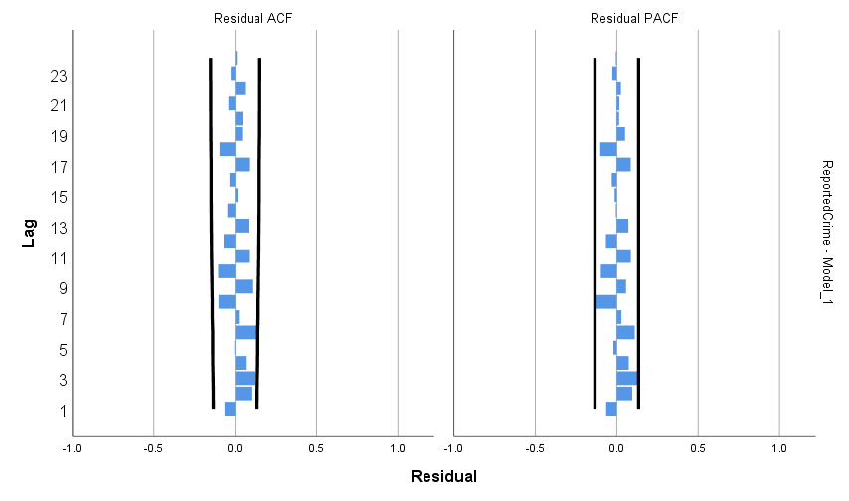
Serious Person Crimes

The first phase of model identification is to review the ACF and PACF for trend (i.e., autoregressive or moving average). The syntax and graphs of the ACF and PACF are below. The spiking ACF and slowly decaying PACF indicate a moving average trend.

ACF VARIABLES=personcrimes
/NOLOG
/DIFF=1
/MXAUTO 16
/SERROR=IND
/PACF.
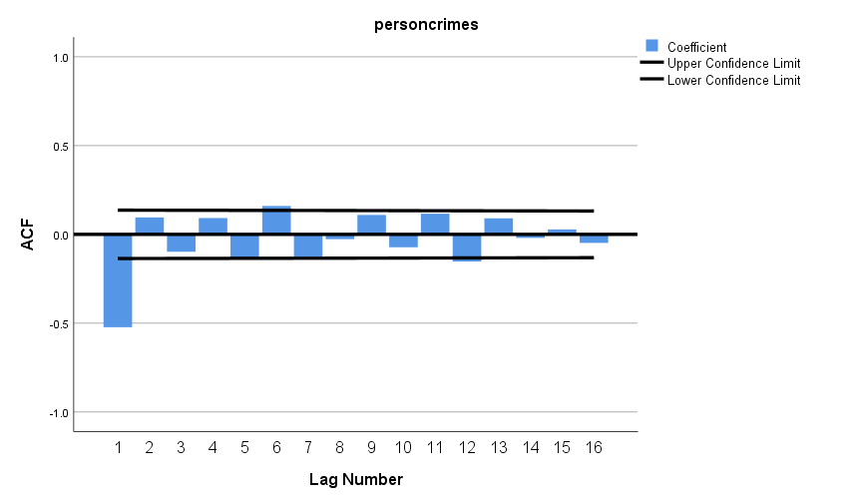

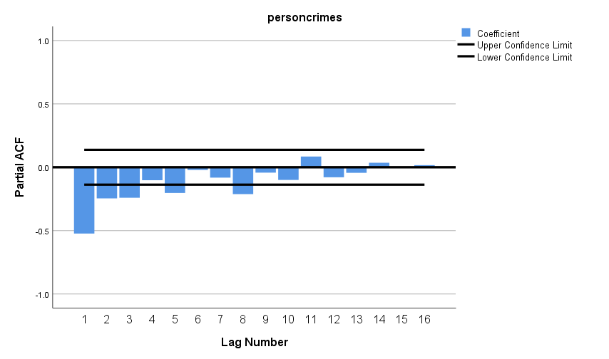
The next step is to confirm selection of the best-fitting model. The output below is for a model (0,1,1). The moving average model component is statistically significant, and the residuals are not significant.

PREDICT THRU END.
* Time Series Modeler.
TSMODEL
/MODELSUMMARY PRINT=[MODELFIT]
/MODELSTATISTICS DISPLAY=YES MODELFIT=[ SRSQUARE]
/MODELDETAILS PRINT=[ PARAMETERS RESIDACF RESIDPACF] PLOT=[ RESIDACF RESIDPACF]
/SERIESPLOT OBSERVED FORECAST
/OUTPUTFILTER DISPLAY=ALLMODELS
/AUXILIARY CILEVEL=95 MAXACFLAGS=24
/MISSING USERMISSING=EXCLUDE
/MODEL DEPENDENT=personcrimes
PREFIX='Model'
/ARIMA AR=[0] DIFF=1 MA=[1] ARSEASONAL=[0] DIFFSEASONAL=0 MASEASONAL=[0]
TRANSFORM=NONE CONSTANT=NO
/AUTOOUTLIER DETECT=OFF.

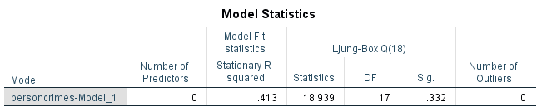
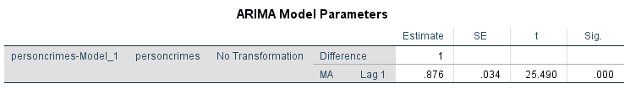
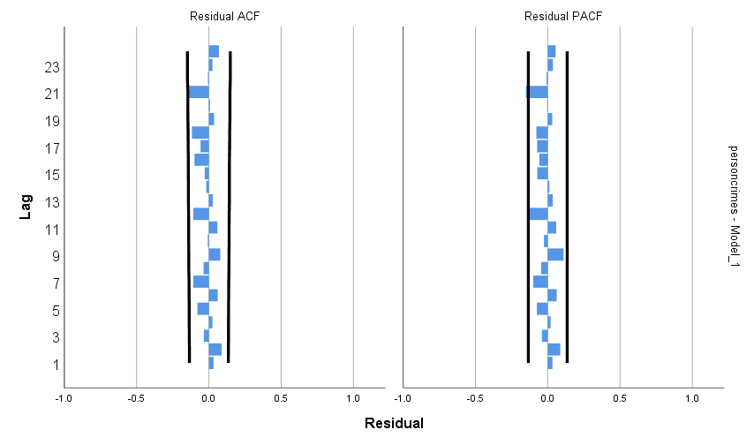
The final step is to add the intervention to the model. First, we test the impact of the COVID-19 pandemic. We hypothesize an immediate impact, starting the week of March 8, 2020. This hypothesis is rejected. There was no statistically significant change in crimes against persons associated with the COVID-19 pandemic (abrupt, permanent impact shown).

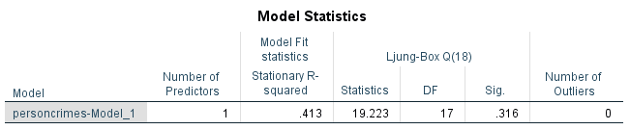
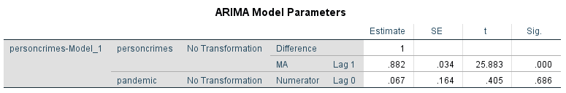

Second, we test the impact of the reform/defund movement. We hypothesize an immediate impact, starting the week of May 24, 2020. This hypothesis is rejected. There was no statistically significant change in crimes against persons associated with the reform/defund movement (abrupt, permanent impact shown).
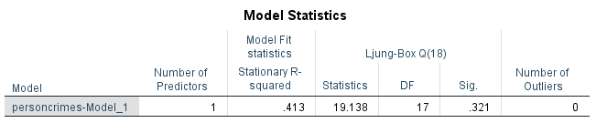
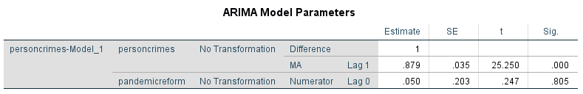

Assaults (Simple and Aggravated)
The first phase of model identification is to review the ACF and PACF for trend (i.e., autoregressive or moving average). The syntax and graphs of the ACF and PACF are below. The spiking ACF and decaying PACF indicate a moving average trend.

ACF VARIABLES=simpleaggassault
/NOLOG
/DIFF=1
/MXAUTO 16
/SERROR=IND
/PACF.
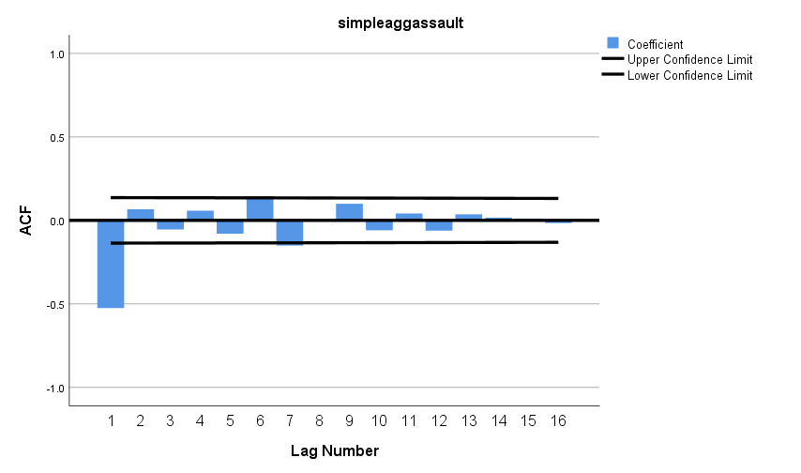
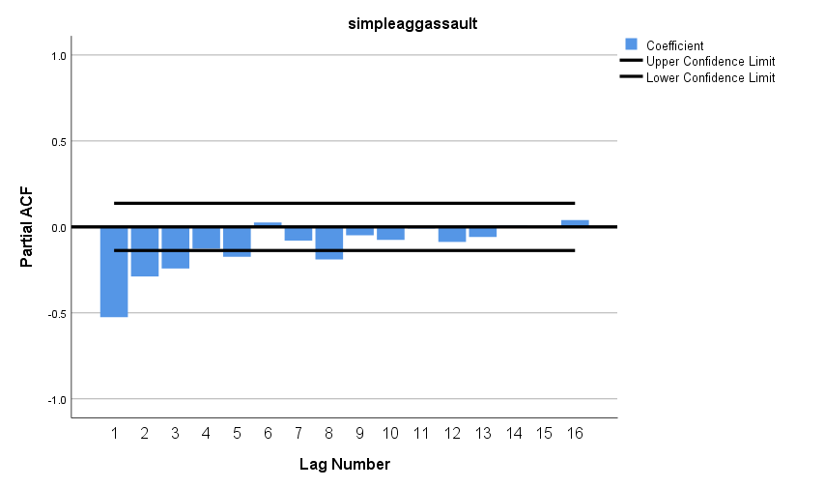

The next step is to confirm selection of the best-fitting model. The output below is for a model (0,1,1)(0,0,1). The moving average model (regular and seasonal) components are statistically significant, and the residuals are not significant.

PREDICT THRU END.
* Time Series Modeler.
TSMODEL
/MODELSUMMARY PRINT=[MODELFIT]
/MODELSTATISTICS DISPLAY=YES MODELFIT=[ SRSQUARE]
/MODELDETAILS PRINT=[ PARAMETERS RESIDACF RESIDPACF] PLOT=[ RESIDACF RESIDPACF]
/SERIESPLOT OBSERVED FORECAST
/OUTPUTFILTER DISPLAY=ALLMODELS
/AUXILIARY CILEVEL=95 MAXACFLAGS=24
/MISSING USERMISSING=EXCLUDE
/MODEL DEPENDENT=simpleaggassault
PREFIX='Model'
/ARIMA AR=[0] DIFF=1 MA=[1] ARSEASONAL=[0] DIFFSEASONAL=0 MASEASONAL=[1]
TRANSFORM=NONE CONSTANT=NO
/AUTOOUTLIER DETECT=OFF.
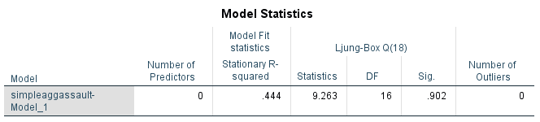
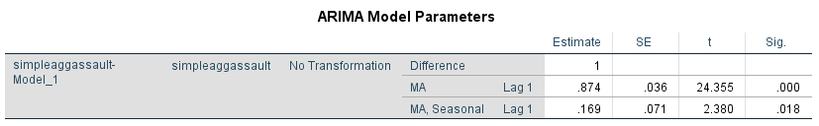
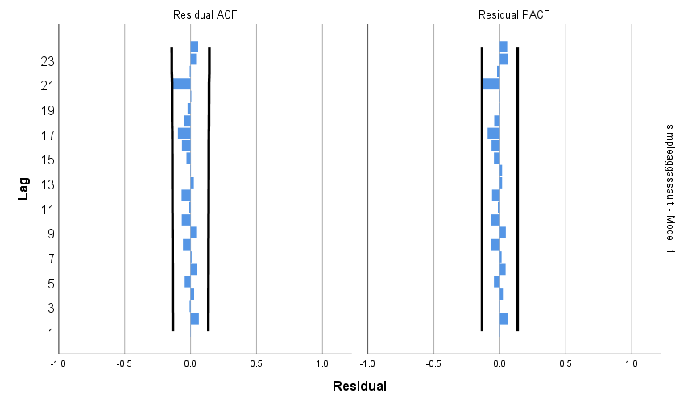

The final step is to add the intervention to the model. First, we test the impact of the COVID-19 pandemic. We hypothesize an immediate impact, starting the week of March 8, 2020. This hypothesis is rejected. There was no statistically significant change in assaults associated with the COVID-19 pandemic (abrupt, permanent impact shown).

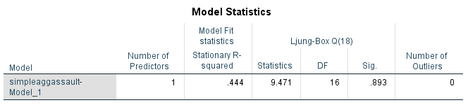
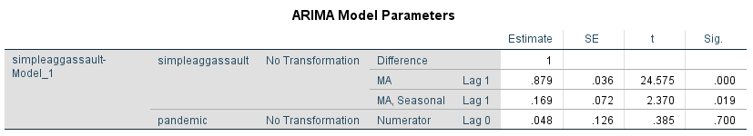

Second, we test the impact of the reform/defund movement. We hypothesize an immediate impact, starting the week of May 24, 2020. This hypothesis is rejected. There was no statistically significant change in assaults associated with the reform/defund movement (abrupt, permanent impact shown).

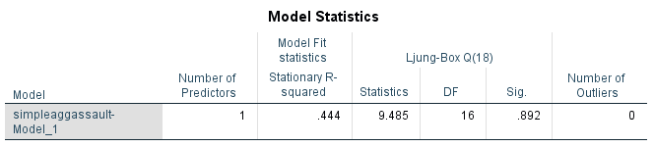
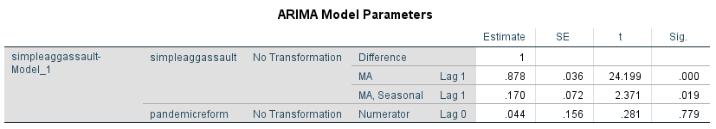

Property Crimes
The first phase of model identification is to review the ACF and PACF for trend (i.e., autoregressive or moving average). The syntax and graphs of the ACF and PACF are below. The spiking ACF and decaying PACF indicate a moving average trend.

ACF VARIABLES=propertycrimes
/NOLOG
/DIFF=1
/MXAUTO 16
/SERROR=IND
/PACF.
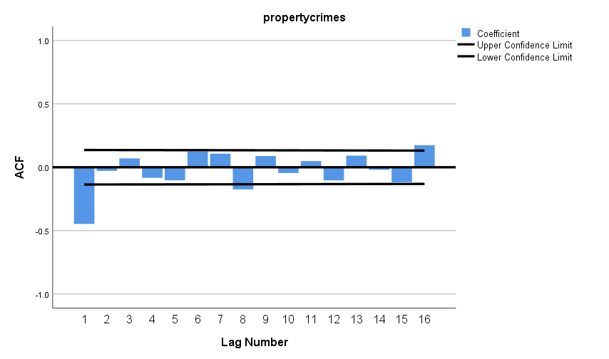
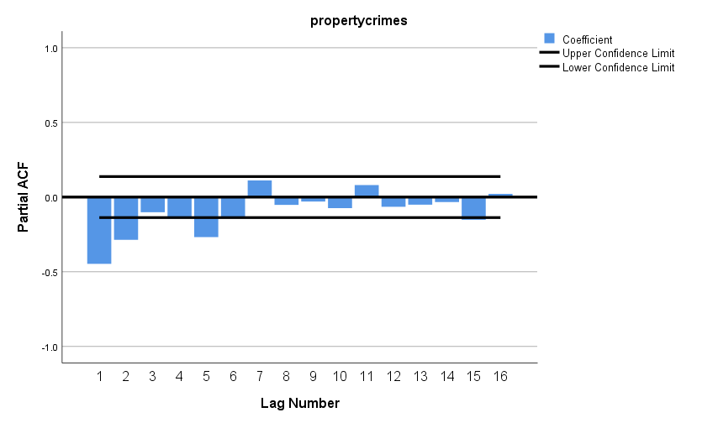
The next step is to confirm selection of the best-fitting model. The output below is for a model (0,1,1). The moving average model component is statistically significant, and the residuals are not significant.

PREDICT THRU END.
* Time Series Modeler.
TSMODEL
/MODELSUMMARY PRINT=[MODELFIT]
/MODELSTATISTICS DISPLAY=YES MODELFIT=[ SRSQUARE]
/MODELDETAILS PRINT=[ PARAMETERS RESIDACF RESIDPACF] PLOT=[ RESIDACF RESIDPACF]
/SERIESPLOT OBSERVED FORECAST
/OUTPUTFILTER DISPLAY=ALLMODELS
/AUXILIARY CILEVEL=95 MAXACFLAGS=24
/MISSING USERMISSING=EXCLUDE
/MODEL DEPENDENT=propertycrimes
PREFIX='Model'
/ARIMA AR=[0] DIFF=1 MA=[1] ARSEASONAL=[0] DIFFSEASONAL=0 MASEASONAL=[0]
TRANSFORM=NONE CONSTANT=NO
/AUTOOUTLIER DETECT=OFF.

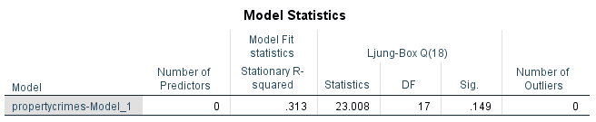
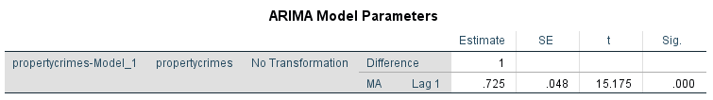
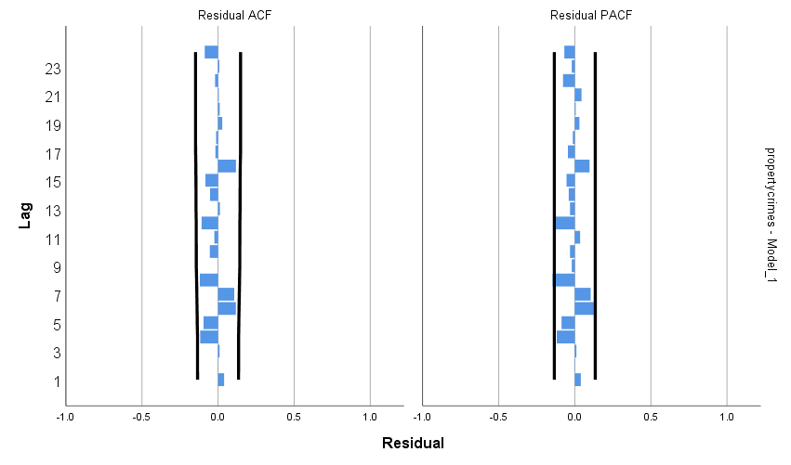

The final step is to add the intervention to the model. First, we test the impact of the COVID-19 pandemic. We hypothesize an immediate impact, starting the week of March 8, 2020. The best-fitting model below confirms the immediate statistically significant decline which lasted two weeks (ending week of March 15, 2020).

PREDICT THRU END.
* Time Series Modeler.
TSMODEL
/MODELSUMMARY PRINT=[MODELFIT]
/MODELSTATISTICS DISPLAY=YES MODELFIT=[ SRSQUARE]
/MODELDETAILS PRINT=[ PARAMETERS RESIDACF RESIDPACF] PLOT=[ RESIDACF RESIDPACF]
/SERIESPLOT OBSERVED FORECAST
/OUTPUTFILTER DISPLAY=ALLMODELS
/AUXILIARY CILEVEL=95 MAXACFLAGS=24
/MISSING USERMISSING=EXCLUDE
/MODEL DEPENDENT=propertycrimes INDEPENDENT=pandemic
PREFIX='Model'
/ARIMA AR=[0] DIFF=1 MA=[1]
TRANSFORM=NONE CONSTANT=NO
/AUTOOUTLIER DETECT=OFF.
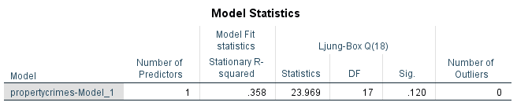
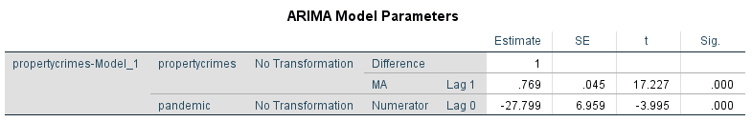
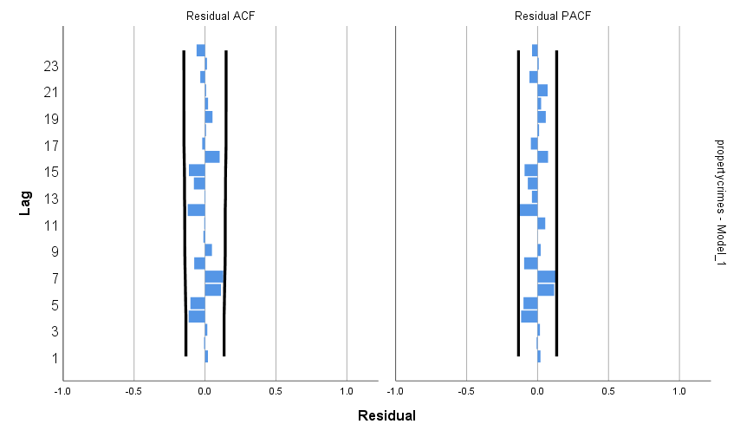
Second, we test the impact of the defund/reform movement. We hypothesize an immediate impact, starting the week of May 24, 2020. This hypothesis is rejected. There was no statistically significant change in crimes against property associated with the reform/defund movement (abrupt, permanent impact shown).

PREDICT THRU END.
* Time Series Modeler.
TSMODEL
/MODELSUMMARY PRINT=[MODELFIT]
/MODELSTATISTICS DISPLAY=YES MODELFIT=[ SRSQUARE]
/MODELDETAILS PRINT=[ PARAMETERS RESIDACF RESIDPACF] PLOT=[ RESIDACF RESIDPACF]
/SERIESPLOT OBSERVED FORECAST
/OUTPUTFILTER DISPLAY=ALLMODELS
/AUXILIARY CILEVEL=95 MAXACFLAGS=24
/MISSING USERMISSING=EXCLUDE
/MODEL DEPENDENT=propertycrimes INDEPENDENT=pandemicreform
PREFIX='Model'
/ARIMA AR=[0] DIFF=1 MA=[1]
TRANSFORM=NONE CONSTANT=NO
/AUTOOUTLIER DETECT=OFF.
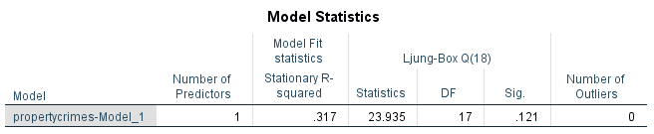
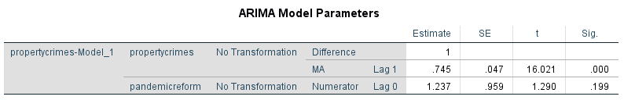

Robbery
The first phase of model identification is to review the ACF and PACF for trend (i.e., autoregressive or moving average). The syntax and graphs of the ACF and PACF are below. The spiking ACF and decaying PACF indicate a moving average trend.

ACF VARIABLES=robbery
/NOLOG
/DIFF=1
/MXAUTO 16
/SERROR=IND
/PACF.

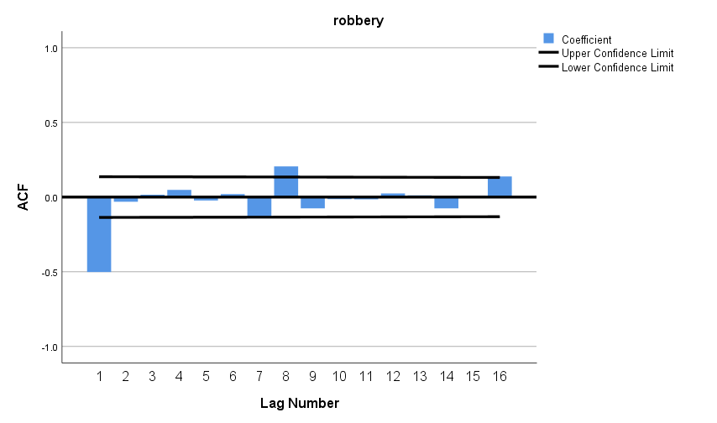
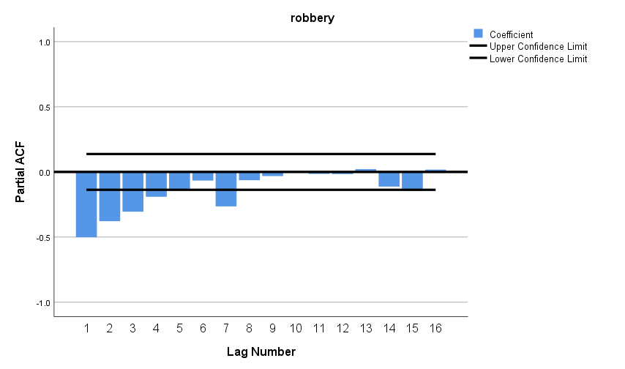

The next step is to confirm selection of the best-fitting model. The output below is for a model (0,1,1). The moving average model component is statistically significant, and the residuals are not significant.

PREDICT THRU END.
* Time Series Modeler.
TSMODEL
/MODELSUMMARY PRINT=[MODELFIT]
/MODELSTATISTICS DISPLAY=YES MODELFIT=[ SRSQUARE]
/MODELDETAILS PRINT=[ PARAMETERS RESIDACF RESIDPACF] PLOT=[ RESIDACF RESIDPACF]
/SERIESPLOT OBSERVED FORECAST
/OUTPUTFILTER DISPLAY=ALLMODELS
/AUXILIARY CILEVEL=95 MAXACFLAGS=24
/MISSING USERMISSING=EXCLUDE
/MODEL DEPENDENT=robbery
PREFIX='Model'
/ARIMA AR=[0] DIFF=1 MA=[1] ARSEASONAL=[0] DIFFSEASONAL=0 MASEASONAL=[0]
TRANSFORM=NONE CONSTANT=NO
/AUTOOUTLIER DETECT=OFF.
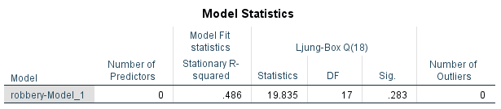
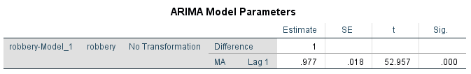
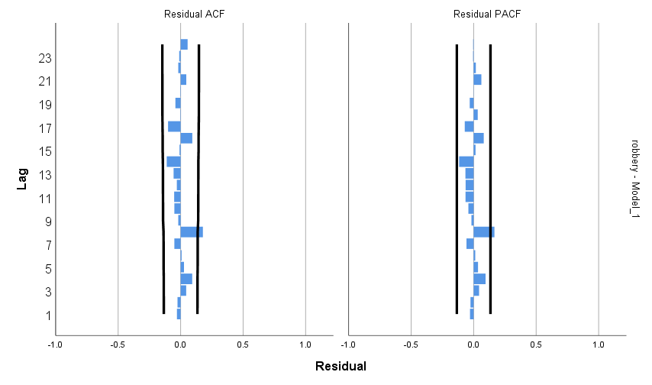
The final step is to add the intervention to the model. First, we test the impact of the COVID-19 pandemic. We hypothesize an immediate impact, starting the week of March 8, 2020. This hypothesis is rejected. There was no statistically significant change in robbery associated with the COVID-19 pandemic (abrupt, permanent impact shown).

PREDICT THRU END.
* Time Series Modeler.
TSMODEL
/MODELSUMMARY PRINT=[MODELFIT]
/MODELSTATISTICS DISPLAY=YES MODELFIT=[ SRSQUARE]
/MODELDETAILS PRINT=[ PARAMETERS RESIDACF RESIDPACF] PLOT=[ RESIDACF RESIDPACF]
/SERIESPLOT OBSERVED FORECAST
/OUTPUTFILTER DISPLAY=ALLMODELS
/AUXILIARY CILEVEL=95 MAXACFLAGS=24
/MISSING USERMISSING=EXCLUDE
/MODEL DEPENDENT=robbery INDEPENDENT=pandemic
PREFIX='Model'
/ARIMA AR=[0] DIFF=1 MA=[1] ARSEASONAL=[0] DIFFSEASONAL=0 MASEASONAL=[0]
TRANSFORM=NONE CONSTANT=NO
/AUTOOUTLIER DETECT=OFF.

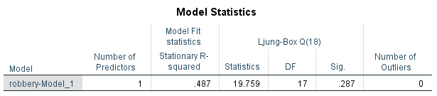
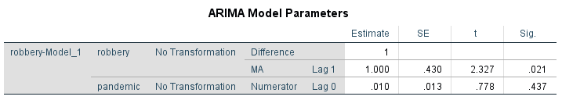
Second, we test the impact of the defund/reform movement. We hypothesize an immediate impact, starting the week of May 24, 2020. This hypothesis is rejected. There was no statistically significant change in robbery associated with the reform/defund movement (abrupt, permanent impact shown).

PREDICT THRU END.
* Time Series Modeler.
TSMODEL
/MODELSUMMARY PRINT=[MODELFIT]
/MODELSTATISTICS DISPLAY=YES MODELFIT=[ SRSQUARE]
/MODELDETAILS PRINT=[ PARAMETERS RESIDACF RESIDPACF] PLOT=[ RESIDACF RESIDPACF]
/SERIESPLOT OBSERVED FORECAST
/OUTPUTFILTER DISPLAY=ALLMODELS
/AUXILIARY CILEVEL=95 MAXACFLAGS=24
/MISSING USERMISSING=EXCLUDE
/MODEL DEPENDENT=robbery INDEPENDENT=pandemicreform
PREFIX='Model'
/ARIMA AR=[0] DIFF=1 MA=[1] ARSEASONAL=[0] DIFFSEASONAL=0 MASEASONAL=[0]
TRANSFORM=NONE CONSTANT=NO
/AUTOOUTLIER DETECT=OFF.

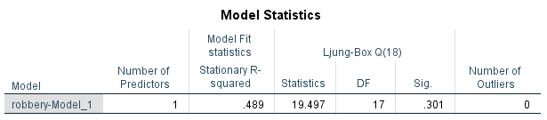
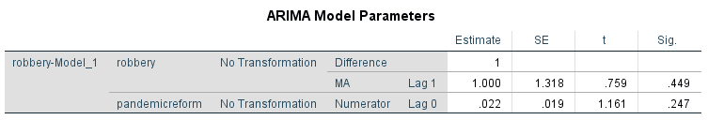
Burglary
The first phase of model identification is to review the ACF and PACF for trend (i.e., autoregressive or moving average). The syntax and graphs of the ACF and PACF are below. The spiking ACF and decaying PACF indicate a moving average trend.

ACF VARIABLES=burglary
/NOLOG
/DIFF=1
/MXAUTO 16
/SERROR=IND
/PACF.
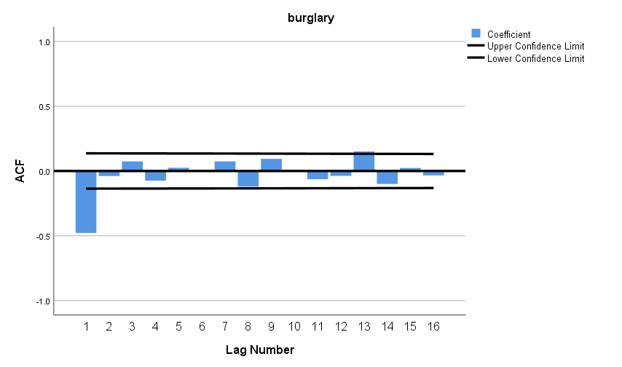
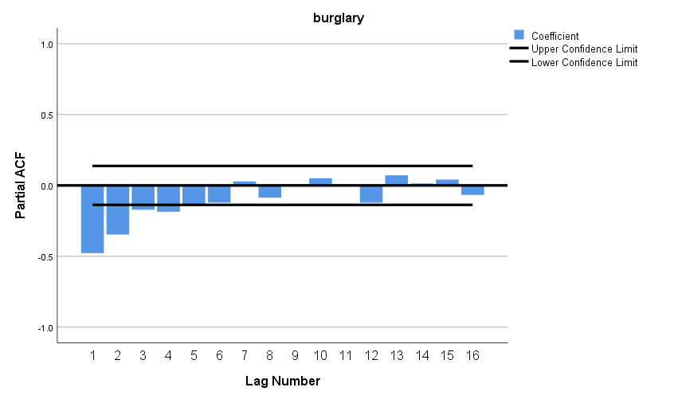

The next step is to confirm selection of the best-fitting model. The output below is for a model (0,1,1). The moving average model component is statistically significant, and the residuals are not significant.
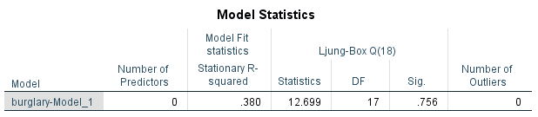
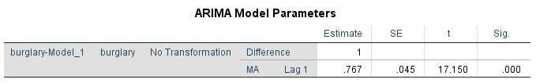
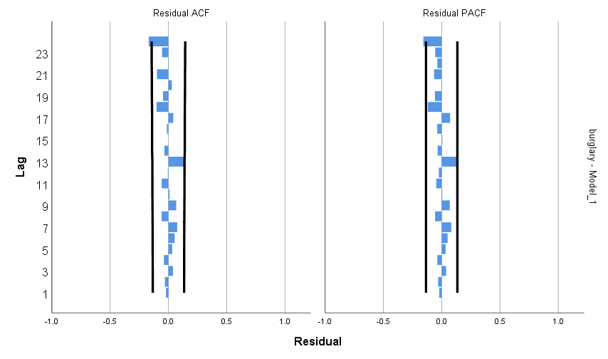

The final step is to add the intervention to the model. First, we test the impact of the COVID-19 pandemic. We hypothesize an immediate impact, starting the week of March 8, 2020. The best-fitting model below confirms the immediate statistically significant decline that lasted just one week.

PREDICT THRU END.
* Time Series Modeler.
TSMODEL
/MODELSUMMARY PRINT=[MODELFIT]
/MODELSTATISTICS DISPLAY=YES MODELFIT=[ SRSQUARE]
/MODELDETAILS PRINT=[ PARAMETERS RESIDACF RESIDPACF] PLOT=[ RESIDACF RESIDPACF]
/SERIESPLOT OBSERVED FORECAST
/OUTPUTFILTER DISPLAY=ALLMODELS
/AUXILIARY CILEVEL=95 MAXACFLAGS=24
/MISSING USERMISSING=EXCLUDE
/MODEL DEPENDENT=burglary INDEPENDENT=pandemic
PREFIX='Model'
/ARIMA AR=[0] DIFF=1 MA=[1] ARSEASONAL=[0] DIFFSEASONAL=0 MASEASONAL=[0]
TRANSFORM=NONE CONSTANT=NO
/AUTOOUTLIER DETECT=OFF.
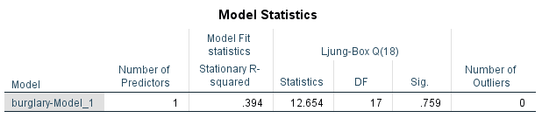
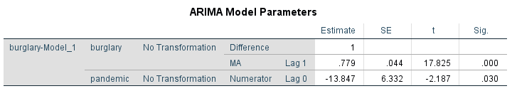
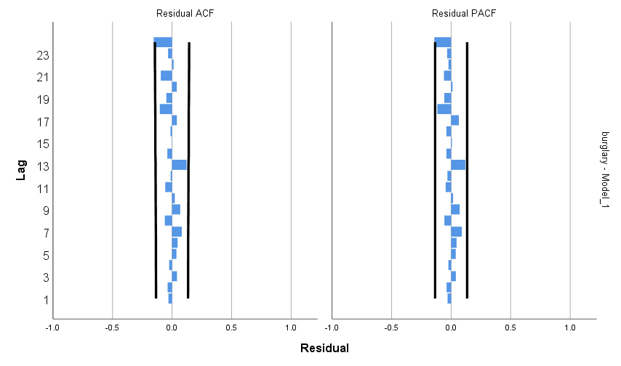
Second, we test the impact of the defund/reform movement. We hypothesize an immediate impact, starting the week of May 24, 2020. This hypothesis is rejected. There was no statistically significant change in burglary associated with the reform/defund movement (abrupt, permanent impact shown).

PREDICT THRU END.
* Time Series Modeler.
TSMODEL
/MODELSUMMARY PRINT=[MODELFIT]
/MODELSTATISTICS DISPLAY=YES MODELFIT=[ SRSQUARE]
/MODELDETAILS PRINT=[ PARAMETERS RESIDACF RESIDPACF] PLOT=[ RESIDACF RESIDPACF]
/SERIESPLOT OBSERVED FORECAST
/OUTPUTFILTER DISPLAY=ALLMODELS
/AUXILIARY CILEVEL=95 MAXACFLAGS=24
/MISSING USERMISSING=EXCLUDE
/MODEL DEPENDENT=burglary INDEPENDENT=pandemicreform
PREFIX='Model'
/ARIMA AR=[0] DIFF=1 MA=[1] ARSEASONAL=[0] DIFFSEASONAL=0 MASEASONAL=[0]
TRANSFORM=NONE CONSTANT=NO
/AUTOOUTLIER DETECT=OFF.
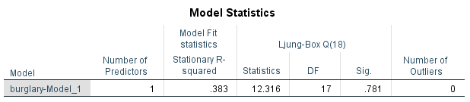
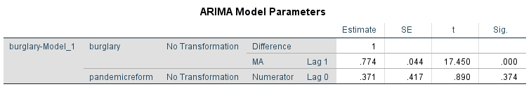

Crimes Against Society
The first phase of model identification is to review the ACF and PACF for trend (i.e., autoregressive or moving average). The syntax and graphs of the ACF and PACF are below. The spiking ACF and decaying PACF indicate a moving average trend.

ACF VARIABLES=societycrimes
/NOLOG
/MXAUTO 16
/SERROR=IND
/PACF.
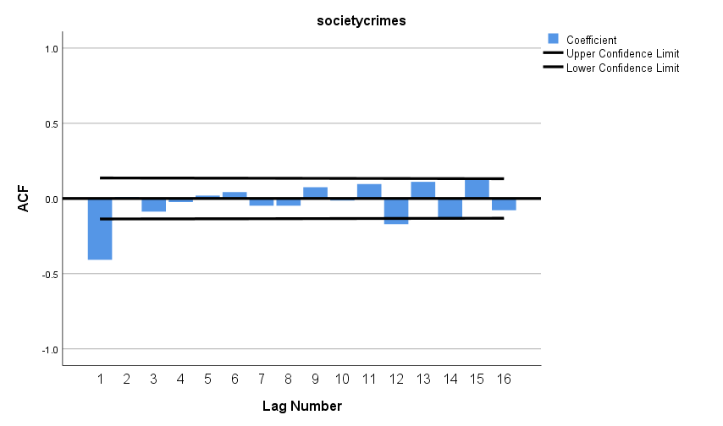
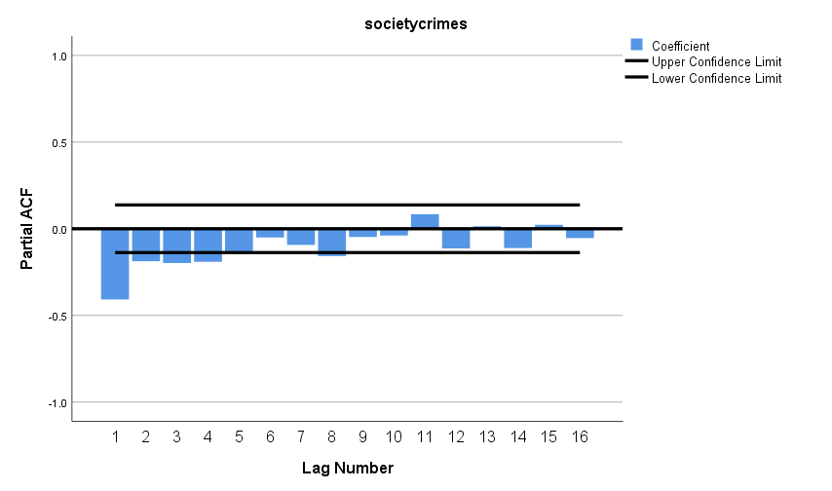

The next step is to confirm selection of the best-fitting model. The output below is for a model (0,1,1). The moving average model component is statistically significant, and the residuals are not significant.

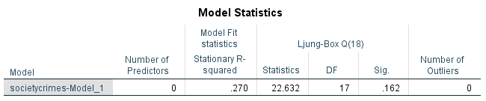
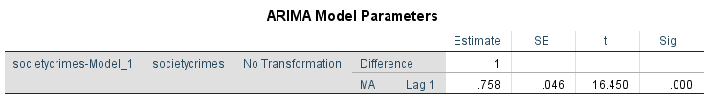
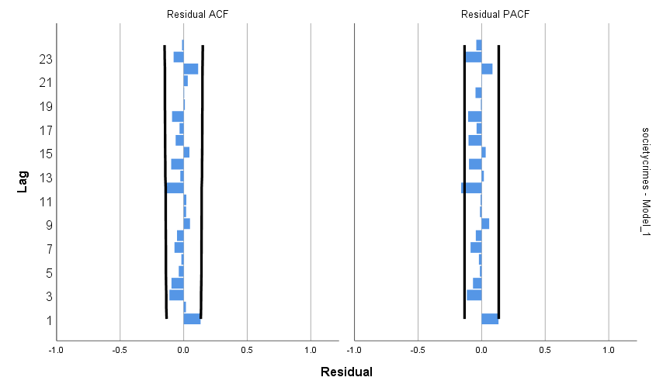
The final step is to add the intervention to the model. First, we test the impact of the COVID-19 pandemic. We hypothesize an immediate impact, starting the week of March 8, 2020. The best-fitting model below confirms the immediate statistically significant decline beginning the week of March 8, 2020 and lasting three weeks (through the week of March 22, 2020).

PREDICT THRU END.
* Time Series Modeler.
TSMODEL
/MODELSUMMARY PRINT=[MODELFIT]
/MODELSTATISTICS DISPLAY=YES MODELFIT=[ SRSQUARE]
/MODELDETAILS PRINT=[ PARAMETERS RESIDACF RESIDPACF] PLOT=[ RESIDACF RESIDPACF]
/SERIESPLOT OBSERVED FORECAST
/OUTPUTFILTER DISPLAY=ALLMODELS
/AUXILIARY CILEVEL=95 MAXACFLAGS=24
/MISSING USERMISSING=EXCLUDE
/MODEL DEPENDENT=societycrimes INDEPENDENT=pandemic
PREFIX='Model'
/ARIMA AR=[0] DIFF=1 MA=[1] ARSEASONAL=[0] DIFFSEASONAL=0 MASEASONAL=[0]
TRANSFORM=NONE CONSTANT=NO
/AUTOOUTLIER DETECT=OFF.
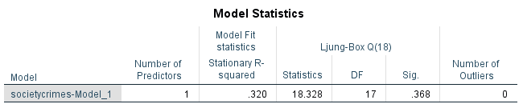
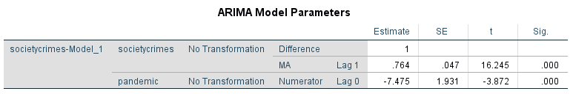
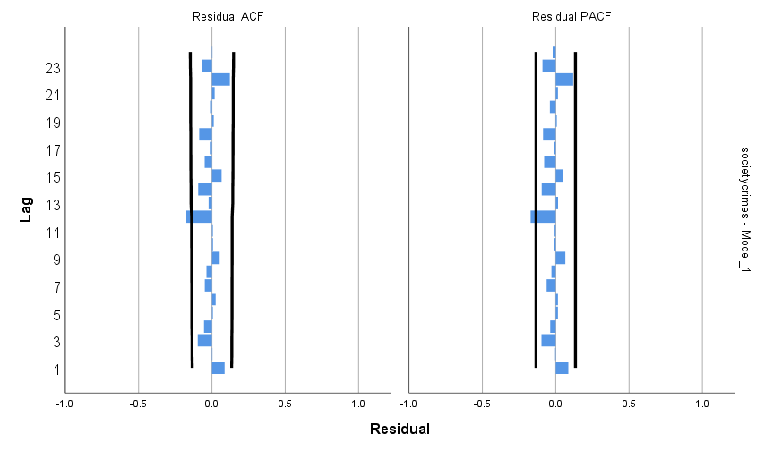
Second, we test the impact of the defund/reform movement. We hypothesize an immediate impact, starting the week of May 24, 2020. This hypothesis is rejected. There was no statistically significant change in crimes against society associated with the reform/defund movement (abrupt, permanent impact shown).

PREDICT THRU END.
* Time Series Modeler.
TSMODEL
/MODELSUMMARY PRINT=[MODELFIT]
/MODELSTATISTICS DISPLAY=YES MODELFIT=[ SRSQUARE]
/MODELDETAILS PRINT=[ PARAMETERS RESIDACF RESIDPACF] PLOT=[ RESIDACF RESIDPACF]
/SERIESPLOT OBSERVED FORECAST
/OUTPUTFILTER DISPLAY=ALLMODELS
/AUXILIARY CILEVEL=95 MAXACFLAGS=24
/MISSING USERMISSING=EXCLUDE
/MODEL DEPENDENT=societycrimes INDEPENDENT=pandemicreform
PREFIX='Model'
/ARIMA AR=[0] DIFF=1 MA=[1] ARSEASONAL=[0] DIFFSEASONAL=0 MASEASONAL=[0]
TRANSFORM=NONE CONSTANT=NO
/AUTOOUTLIER DETECT=OFF.

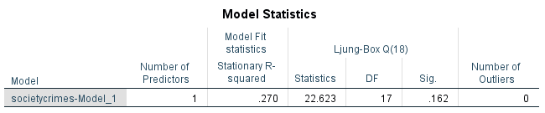
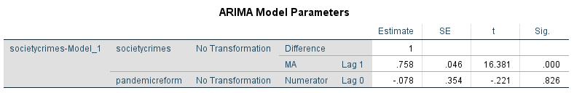

Domestic Violence
The first phase of model identification is to review the ACF and PACF for trend (i.e., autoregressive or moving average). The syntax and graphs of the ACF and PACF are below. The spiking ACF and decaying PACF indicate a moving average trend.

DATASET ACTIVATE DataSet1.
ACF VARIABLES=DVTOTAL
/NOLOG
/DIFF=1
/MXAUTO 16
/SERROR=IND
/PACF.

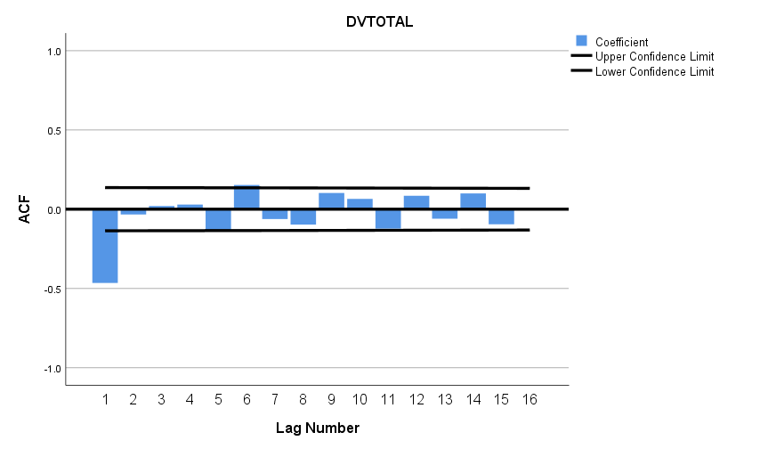
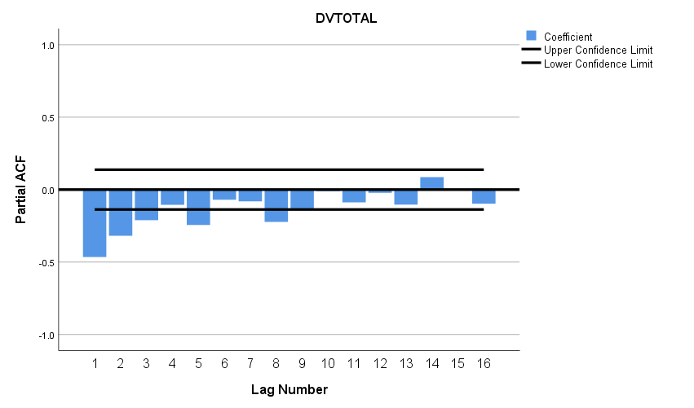

The next step is to confirm selection of the best-fitting model. The output below is for a model (0,1,1). The moving average model component is statistically significant, and the residuals are not significant.
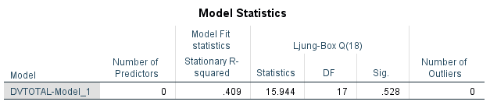
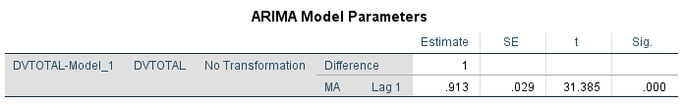
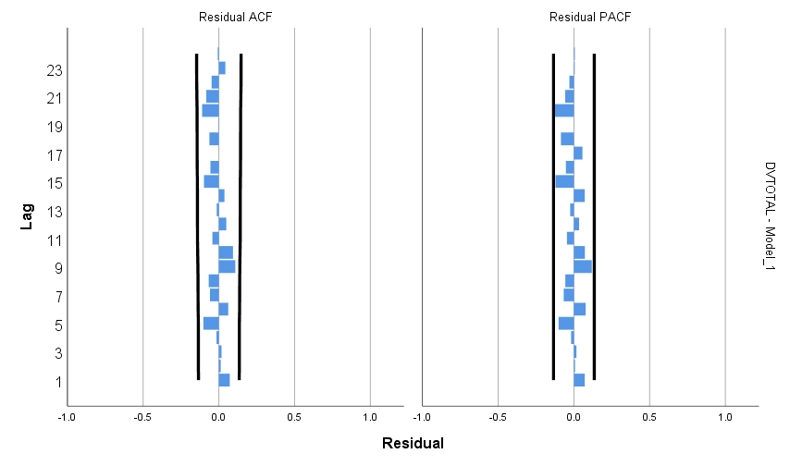

The final step is to add the intervention to the model. First, we test the impact of the COVID-19 pandemic. We hypothesize an immediate impact, starting the week of March 8, 2020. This hypothesis is rejected. There was no statistically significant change in domestic violence associated with the COVID-19 pandemic (abrupt, permanent impact shown).

PREDICT THRU END.
* Time Series Modeler.
TSMODEL
/MODELSUMMARY PRINT=[MODELFIT]
/MODELSTATISTICS DISPLAY=YES MODELFIT=[ SRSQUARE]
/MODELDETAILS PRINT=[ PARAMETERS RESIDACF RESIDPACF] PLOT=[ RESIDACF RESIDPACF]
/SERIESPLOT OBSERVED FORECAST
/OUTPUTFILTER DISPLAY=ALLMODELS
/AUXILIARY CILEVEL=95 MAXACFLAGS=24
/MISSING USERMISSING=EXCLUDE
/MODEL DEPENDENT=DVTOTAL INDEPENDENT=pandemic
PREFIX='Model'
/ARIMA AR=[0] DIFF=1 MA=[1] ARSEASONAL=[0] DIFFSEASONAL=0 MASEASONAL=[0]
TRANSFORM=NONE CONSTANT=NO
/AUTOOUTLIER DETECT=OFF.

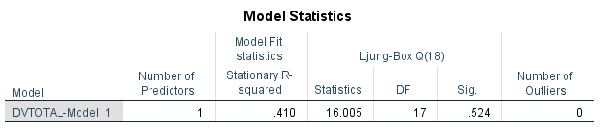
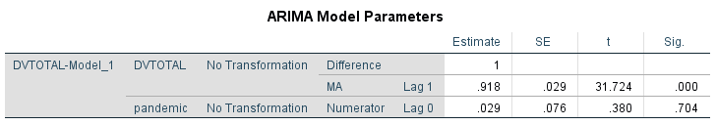

Second, we test the impact of the defund/reform movement. We hypothesize an immediate impact, starting the week of May 24, 2020. This hypothesis is rejected. There was no statistically significant change in domestic violence associated with the reform/defund (abrupt, permanent impact shown).

PREDICT THRU END.
* Time Series Modeler.
TSMODEL
/MODELSUMMARY PRINT=[MODELFIT]
/MODELSTATISTICS DISPLAY=YES MODELFIT=[ SRSQUARE]
/MODELDETAILS PRINT=[ PARAMETERS RESIDACF RESIDPACF] PLOT=[ RESIDACF RESIDPACF]
/SERIESPLOT OBSERVED FORECAST
/OUTPUTFILTER DISPLAY=ALLMODELS
/AUXILIARY CILEVEL=95 MAXACFLAGS=24
/MISSING USERMISSING=EXCLUDE
/MODEL DEPENDENT=DVTOTAL INDEPENDENT=pandemicreform
PREFIX='Model'
/ARIMA AR=[0] DIFF=1 MA=[1] ARSEASONAL=[0] DIFFSEASONAL=0 MASEASONAL=[0]
TRANSFORM=NONE CONSTANT=NO
/AUTOOUTLIER DETECT=OFF.

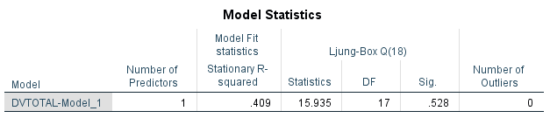
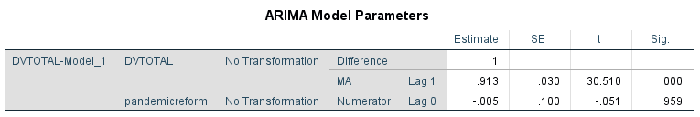
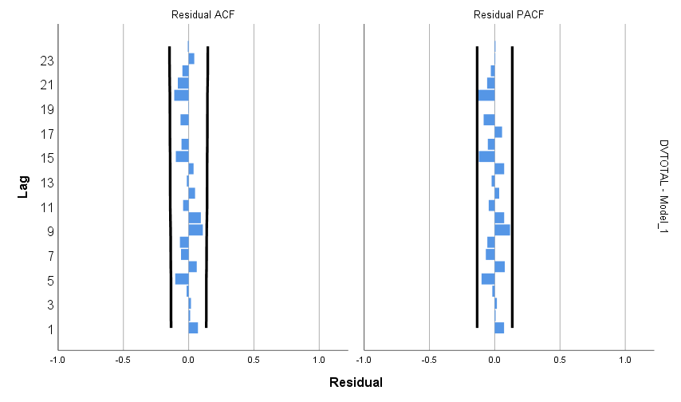

Officer-Initiated Activity
The first phase of model identification is to review the ACF and PACF for trend (i.e., autoregressive or moving average). The syntax and graphs of the ACF and PACF below. The slow decaying ACF and spiking PACF indicate an autoregressive trend.

ACF VARIABLES=Officer
/NOLOG
/MXAUTO 16
/SERROR=IND
/PACF.
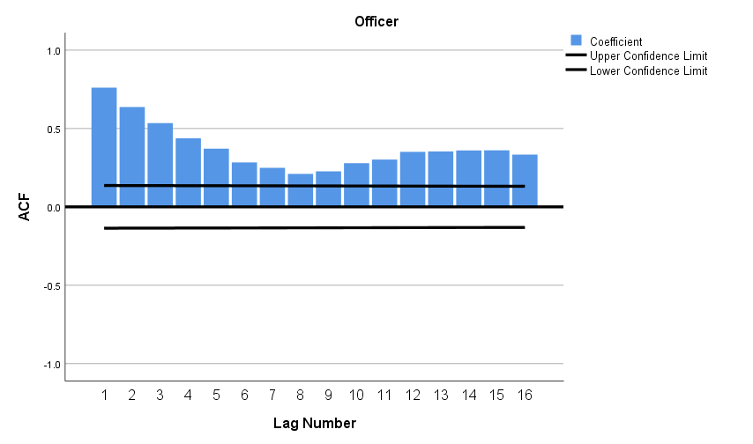
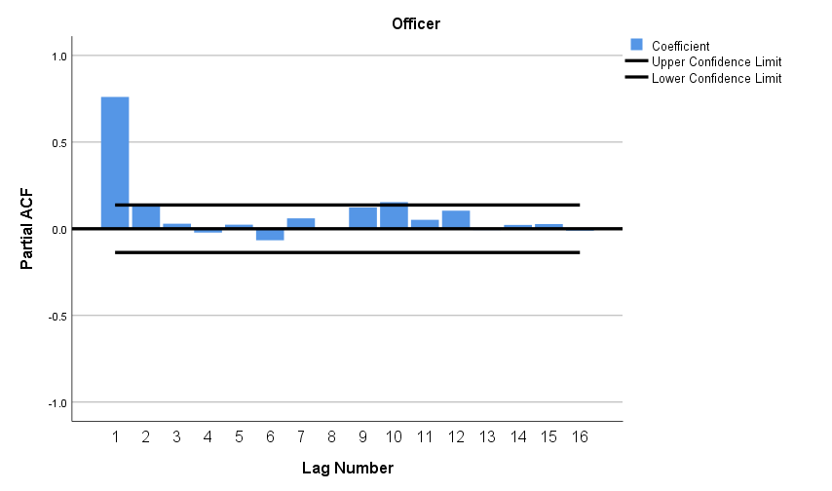

The next step is to confirm selection of the best-fitting model. The output below is for a model (1,0,0). The autoregressive model component is statistically significant, and the residuals are not significant.

PREDICT THRU END.
* Time Series Modeler.
TSMODEL
/MODELSUMMARY PRINT=[MODELFIT]
/MODELSTATISTICS DISPLAY=YES MODELFIT=[ SRSQUARE]
/MODELDETAILS PRINT=[ PARAMETERS RESIDACF RESIDPACF] PLOT=[ RESIDACF RESIDPACF]
/SERIESPLOT OBSERVED FORECAST
/OUTPUTFILTER DISPLAY=ALLMODELS
/AUXILIARY CILEVEL=95 MAXACFLAGS=24
/MISSING USERMISSING=EXCLUDE
/MODEL DEPENDENT=Officer
PREFIX='Model'
/ARIMA AR=[1] DIFF=0 MA=[0] ARSEASONAL=[0] DIFFSEASONAL=0 MASEASONAL=[0]
TRANSFORM=NONE CONSTANT=YES
/AUTOOUTLIER DETECT=OFF.

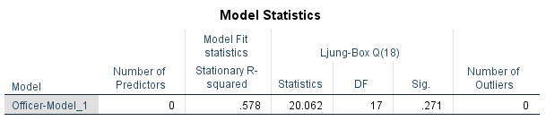
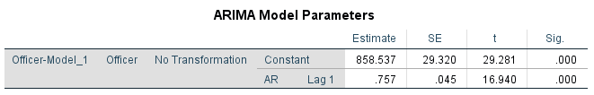
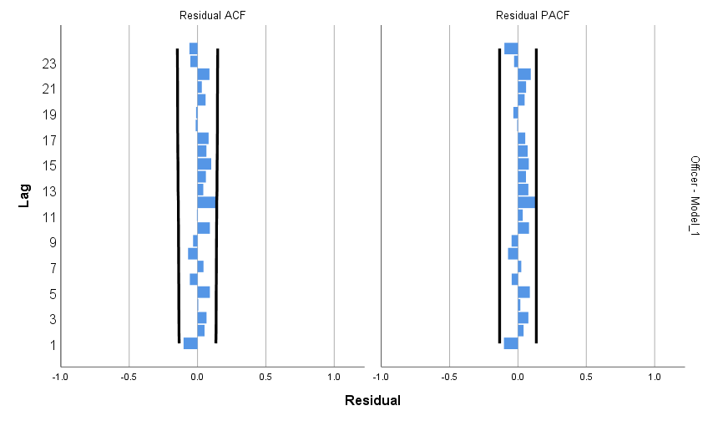

The final step is to add the intervention to the model. First, we test the impact of the COVID-19 pandemic. We hypothesize an immediate impact, starting the week of March 8, 2020. The best-fitting model below confirms the immediate statistically significant decline which lasted until the week of November 1, 2020.

PREDICT THRU END.
* Time Series Modeler.
TSMODEL
/MODELSUMMARY PRINT=[MODELFIT]
/MODELSTATISTICS DISPLAY=YES MODELFIT=[ SRSQUARE]
/MODELDETAILS PRINT=[ PARAMETERS RESIDACF RESIDPACF] PLOT=[ RESIDACF RESIDPACF]
/SERIESPLOT OBSERVED FORECAST
/OUTPUTFILTER DISPLAY=ALLMODELS
/AUXILIARY CILEVEL=95 MAXACFLAGS=24
/MISSING USERMISSING=EXCLUDE
/MODEL DEPENDENT=Officer INDEPENDENT=pandemic
PREFIX='Model'
/ARIMA AR=[1] DIFF=0 MA=[0] ARSEASONAL=[0] DIFFSEASONAL=0 MASEASONAL=[0]
TRANSFORM=NONE CONSTANT=YES
/AUTOOUTLIER DETECT=OFF.

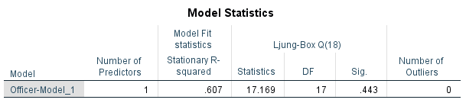
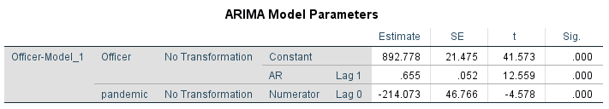
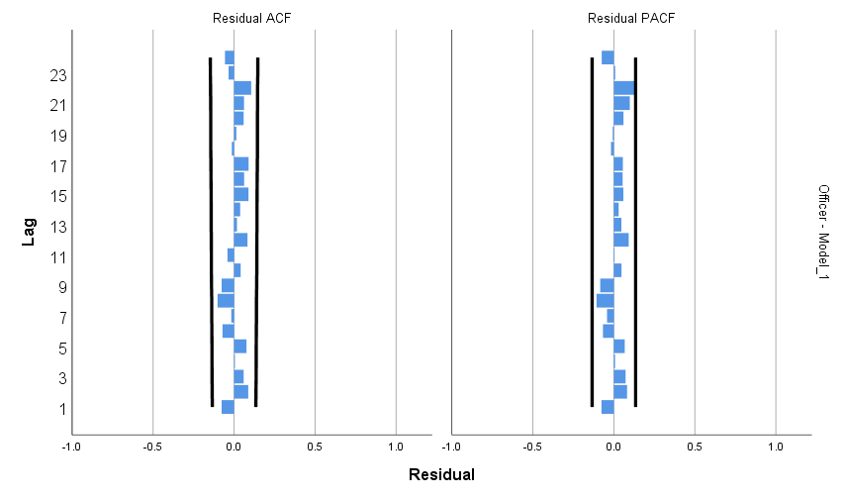

Second, we test the impact of the defund/reform movement. We hypothesize an immediate impact, starting the week of May 24, 2020. The best-fitting model below confirms the immediate statistically significant decline which lasted until the week of November 1, 2020.

PREDICT THRU END.
* Time Series Modeler.
TSMODEL
/MODELSUMMARY PRINT=[MODELFIT]
/MODELSTATISTICS DISPLAY=YES MODELFIT=[ SRSQUARE]
/MODELDETAILS PRINT=[ PARAMETERS RESIDACF RESIDPACF] PLOT=[ RESIDACF RESIDPACF]
/SERIESPLOT OBSERVED FORECAST
/OUTPUTFILTER DISPLAY=ALLMODELS
/AUXILIARY CILEVEL=95 MAXACFLAGS=24
/MISSING USERMISSING=EXCLUDE
/MODEL DEPENDENT=Officer INDEPENDENT=pandemicreform
PREFIX='Model'
/ARIMA AR=[1] DIFF=0 MA=[0] ARSEASONAL=[0] DIFFSEASONAL=0 MASEASONAL=[0]
TRANSFORM=NONE CONSTANT=YES
/AUTOOUTLIER DETECT=OFF.

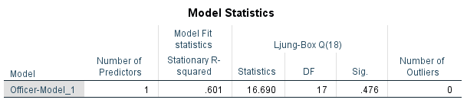
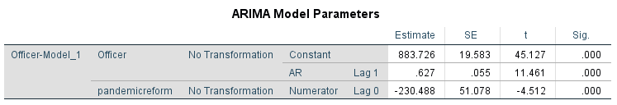
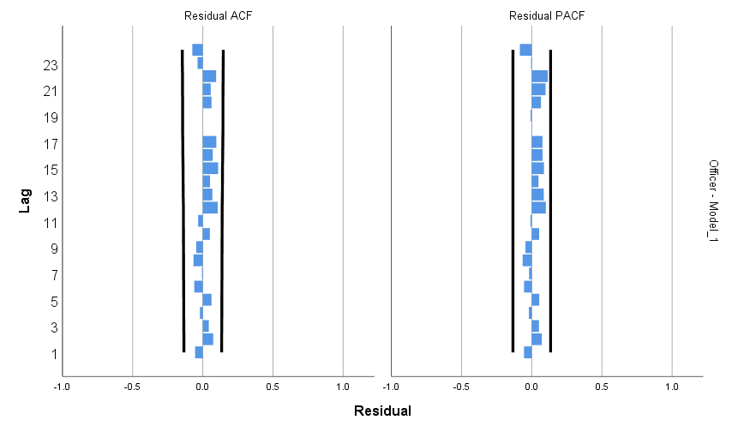

Use of Force
The first phase of model identification is to review the ACF and PACF for trend (i.e., autoregressive or moving average). The syntax and graphs of the ACF and PACF are below. The spiking ACF and decaying PACF indicate a moving average trend.

ACF VARIABLES=force
/NOLOG
/DIFF=1
/MXAUTO 16
/SERROR=IND
/PACF.
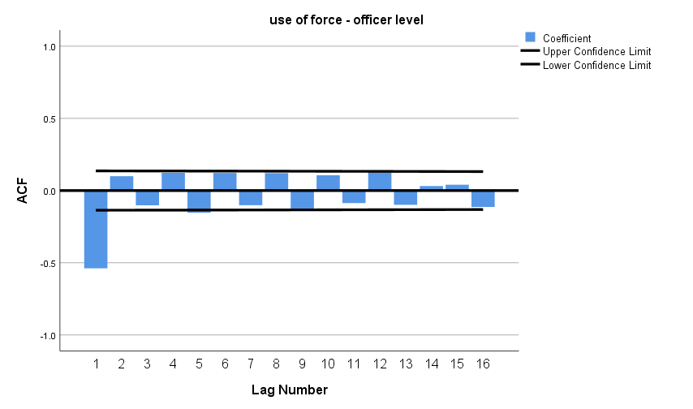
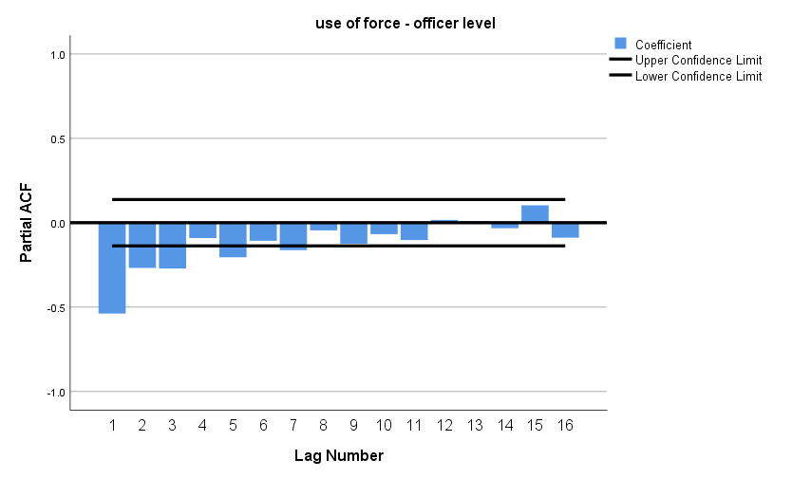
The next step is to confirm selection of the best-fitting model. The output below is for a model (0,1,1). The moving average model component is statistically significant, and the residuals are not significant.

PREDICT THRU END.
* Time Series Modeler.
TSMODEL
/MODELSUMMARY PRINT=[MODELFIT]
/MODELSTATISTICS DISPLAY=YES MODELFIT=[ SRSQUARE]
/MODELDETAILS PRINT=[ PARAMETERS RESIDACF RESIDPACF] PLOT=[ RESIDACF RESIDPACF]
/SERIESPLOT OBSERVED FORECAST
/OUTPUTFILTER DISPLAY=ALLMODELS
/AUXILIARY CILEVEL=95 MAXACFLAGS=24
/MISSING USERMISSING=EXCLUDE
/MODEL DEPENDENT=force
PREFIX='Model'
/ARIMA AR=[0] DIFF=1 MA=[1] ARSEASONAL=[0] DIFFSEASONAL=0 MASEASONAL=[0]
TRANSFORM=NONE CONSTANT=NO
/AUTOOUTLIER DETECT=OFF.

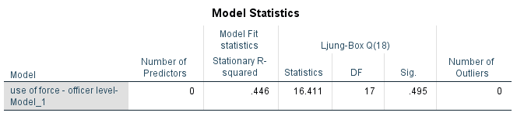
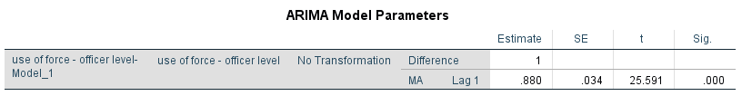
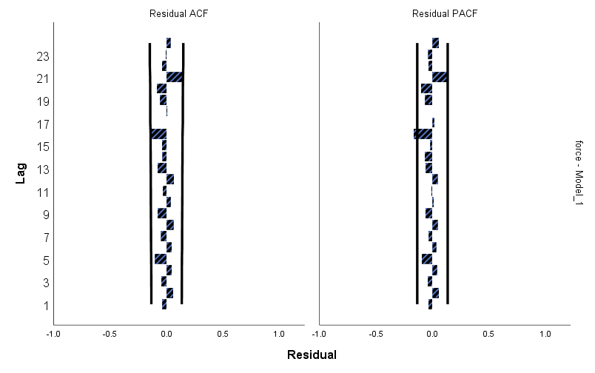

The final step is to add the intervention to the model. First, we test the impact of the COVID-19 pandemic. We hypothesize an immediate impact, starting the week of March 8, 2020. The best-fitting model below confirms an immediate statistically significant increase which lasted until the end of the study period.
PREDICT THRU END.
* Time Series Modeler.
TSMODEL
/MODELSUMMARY PRINT=[MODELFIT]
/MODELSTATISTICS DISPLAY=YES MODELFIT=[ SRSQUARE]
/MODELDETAILS PRINT=[ PARAMETERS RESIDACF RESIDPACF] PLOT=[ RESIDACF RESIDPACF]
/SERIESPLOT OBSERVED FORECAST
/OUTPUTFILTER DISPLAY=ALLMODELS
/AUXILIARY CILEVEL=95 MAXACFLAGS=24
/MISSING USERMISSING=EXCLUDE
/MODEL DEPENDENT=force INDEPENDENT=pandemic
PREFIX='Model'
/ARIMA AR=[0] DIFF=1 MA=[1] ARSEASONAL=[0] DIFFSEASONAL=0 MASEASONAL=[0]
TRANSFORM=NONE CONSTANT=NO
/AUTOOUTLIER DETECT=OFF.

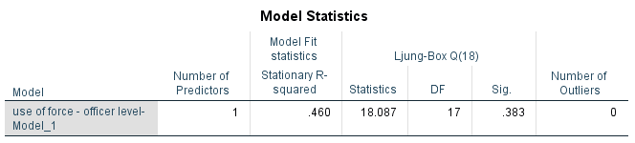
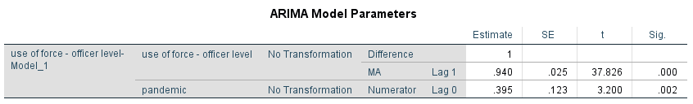
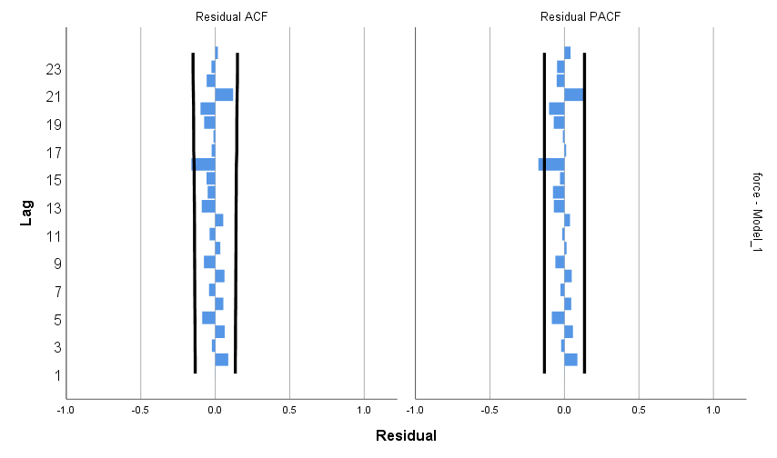
Second, we test the impact of the defund/reform movement. We hypothesize an immediate impact, starting the week of May 24, 2020. The best-fitting model below shows a gradual statistically significant increase starting the week of July 19, 2020 and lasting through the end of the study period.

PREDICT THRU END.
* Time Series Modeler.
TSMODEL
/MODELSUMMARY PRINT=[MODELFIT]
/MODELSTATISTICS DISPLAY=YES MODELFIT=[ SRSQUARE]
/MODELDETAILS PRINT=[ PARAMETERS RESIDACF RESIDPACF] PLOT=[ RESIDACF RESIDPACF]
/SERIESPLOT OBSERVED FORECAST
/OUTPUTFILTER DISPLAY=ALLMODELS
/AUXILIARY CILEVEL=95 MAXACFLAGS=24
/MISSING USERMISSING=EXCLUDE
/MODEL DEPENDENT=force INDEPENDENT=pandemicreform
PREFIX='Model'
/ARIMA AR=[0] DIFF=1 MA=[1] ARSEASONAL=[0] DIFFSEASONAL=0 MASEASONAL=[0]
TRANSFORM=NONE CONSTANT=NO
/AUTOOUTLIER DETECT=OFF.

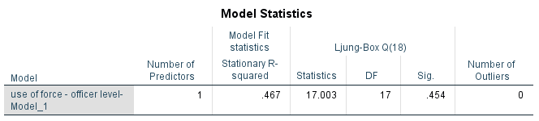
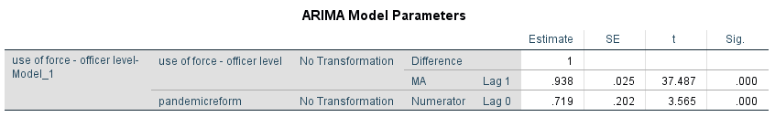

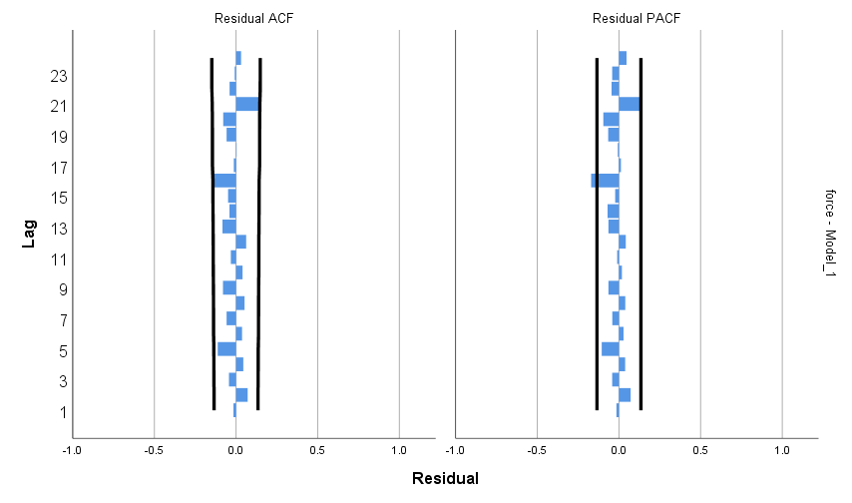
Arrests
The first phase of model identification is to review the ACF and PACF for trend (i.e., autoregressive or moving average). The syntax and graphs of the ACF and PACF are below. The slow decaying ACF and spiking PACF indicate an autoregressive trend.

DATASET ACTIVATE DataSet2.
ACF VARIABLES=Arrests
/NOLOG
/MXAUTO 16
/SERROR=IND
/PACF.
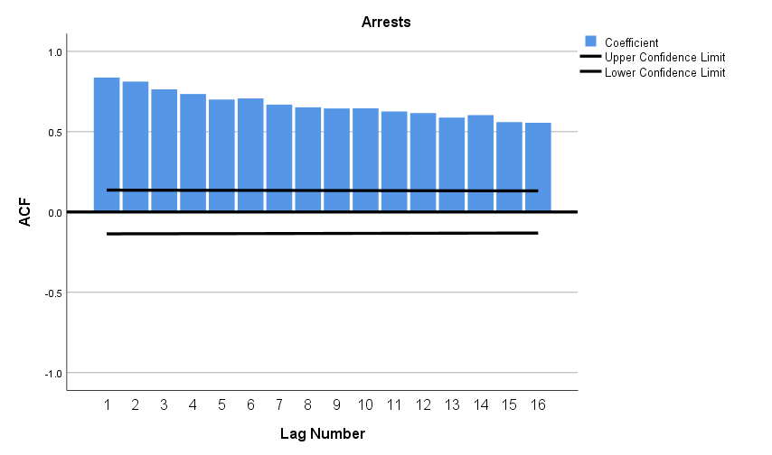
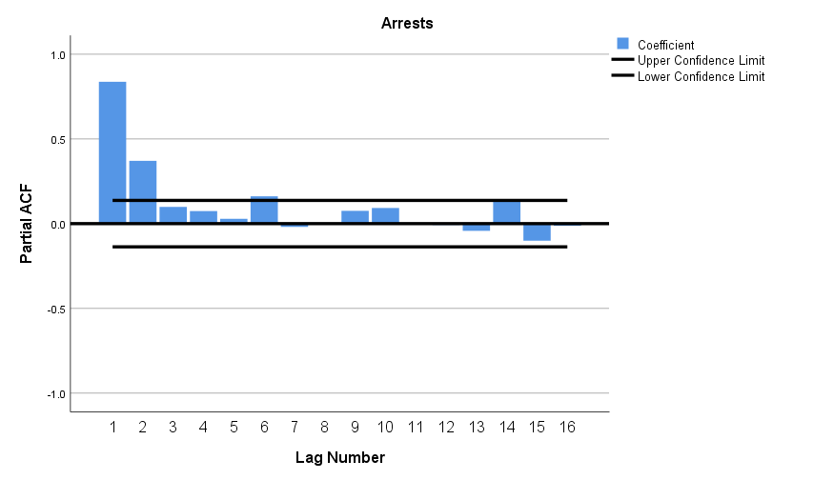

The next step is to confirm selection of the best-fitting model. The output below is for a model (1,1,0). The autoregressive model component is statistically significant, and the residuals are not significant.

PREDICT THRU END.
* Time Series Modeler.
TSMODEL
/MODELSUMMARY PRINT=[MODELFIT]
/MODELSTATISTICS DISPLAY=YES MODELFIT=[ SRSQUARE]
/MODELDETAILS PRINT=[ PARAMETERS RESIDACF RESIDPACF] PLOT=[ RESIDACF RESIDPACF]
/SERIESPLOT OBSERVED FORECAST
/OUTPUTFILTER DISPLAY=ALLMODELS
/AUXILIARY CILEVEL=95 MAXACFLAGS=24
/MISSING USERMISSING=EXCLUDE
/MODEL DEPENDENT=Arrests
PREFIX='Model'
/ARIMA AR=[1] DIFF=1 MA=[0] ARSEASONAL=[0] DIFFSEASONAL=0 MASEASONAL=[0]
TRANSFORM=NONE CONSTANT=NO
/AUTOOUTLIER DETECT=OFF.

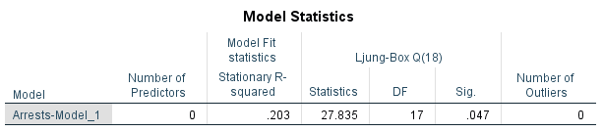

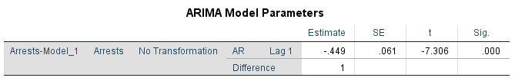

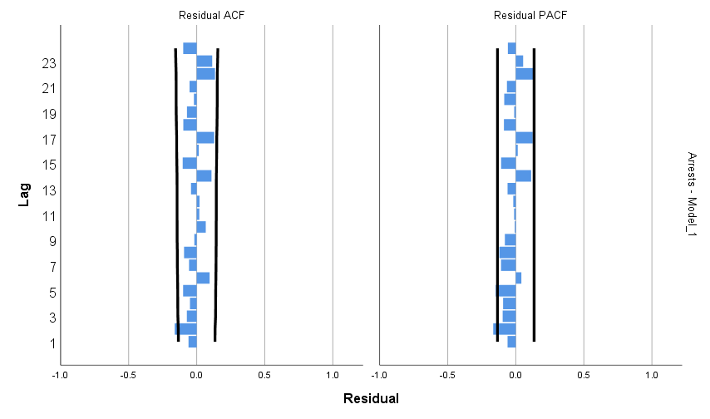

The final step is to add the intervention to the model. First, we test the impact of the COVID-19 pandemic. We hypothesize an immediate impact, starting the week of March 8, 2020. The best-fitting model below confirms the immediate statistically significant decrease which lasted for 3 weeks until the week of March 22, 2020.

PREDICT THRU END.
* Time Series Modeler.
TSMODEL
/MODELSUMMARY PRINT=[MODELFIT]
/MODELSTATISTICS DISPLAY=YES MODELFIT=[ SRSQUARE]
/MODELDETAILS PRINT=[ PARAMETERS RESIDACF RESIDPACF] PLOT=[ RESIDACF RESIDPACF]
/SERIESPLOT OBSERVED FORECAST
/OUTPUTFILTER DISPLAY=ALLMODELS
/AUXILIARY CILEVEL=95 MAXACFLAGS=24
/MISSING USERMISSING=EXCLUDE
/MODEL DEPENDENT=Arrests INDEPENDENT=pandemic
PREFIX='Model'
/ARIMA AR=[1] DIFF=1 MA=[0] ARSEASONAL=[0] DIFFSEASONAL=0 MASEASONAL=[0]
TRANSFORM=NONE CONSTANT=NO
/AUTOOUTLIER DETECT=OFF.

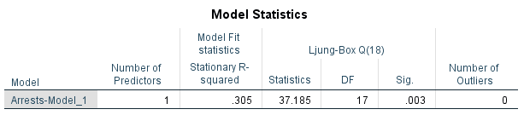

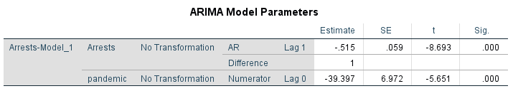
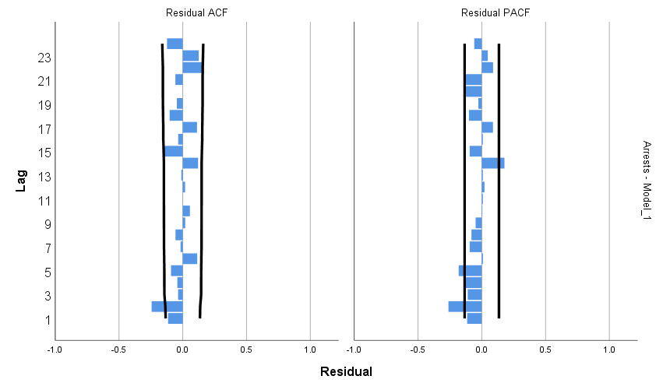

Second, we test the impact of the reform/defund movement. We hypothesize an immediate impact, starting the week of May 24, 2020. This hypothesis is rejected. There was no statistically significant change in arrests associated with the reform/defund movement (abrupt, permanent impact shown).

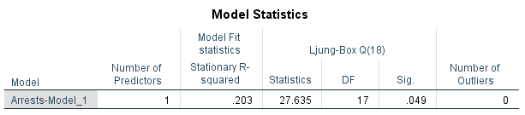
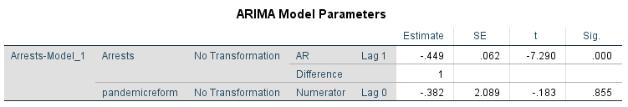

Accidents
The first phase of model identification is to review the ACF and PACF for trend (i.e., autoregressive or moving average). The syntax and graphs of the ACF and PACF are below. The slow decaying ACF and spiking PACF indicate an autoregressive trend.

ACF VARIABLES=Accidents
/NOLOG
/MXAUTO 16
/SERROR=IND
/PACF.
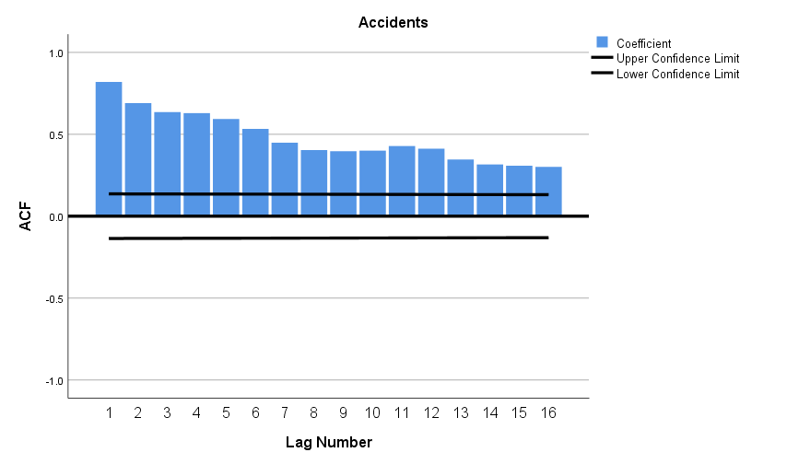
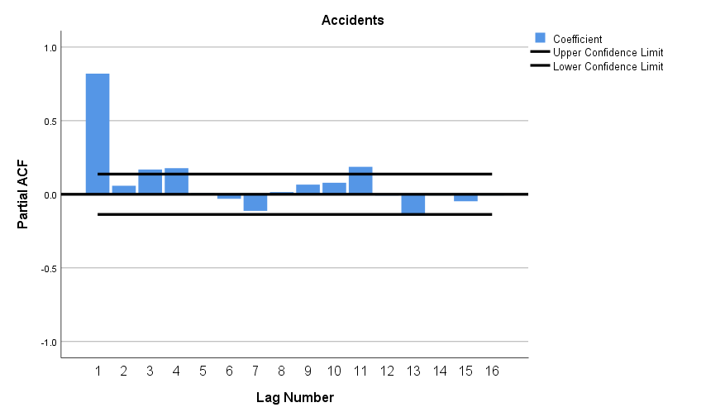
The next step is to confirm selection of the best-fitting model. The output below is for a model (1,0,0). The autoregressive model component is statistically significant, and the residuals are not significant.

PREDICT THRU END.
* Time Series Modeler.
TSMODEL
/MODELSUMMARY PRINT=[MODELFIT]
/MODELSTATISTICS DISPLAY=YES MODELFIT=[ SRSQUARE]
/MODELDETAILS PRINT=[ PARAMETERS RESIDACF RESIDPACF] PLOT=[ RESIDACF RESIDPACF]
/SERIESPLOT OBSERVED FORECAST
/OUTPUTFILTER DISPLAY=ALLMODELS
/AUXILIARY CILEVEL=95 MAXACFLAGS=24
/MISSING USERMISSING=EXCLUDE
/MODEL DEPENDENT=Accidents
PREFIX='Model'
/ARIMA AR=[1] DIFF=0 MA=[0] ARSEASONAL=[0] DIFFSEASONAL=0 MASEASONAL=[0]
TRANSFORM=NONE CONSTANT=YES
/AUTOOUTLIER DETECT=OFF.
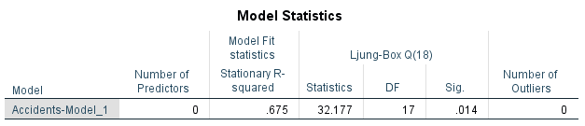
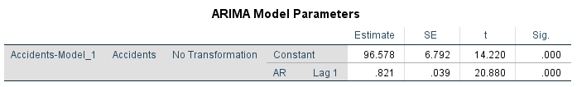
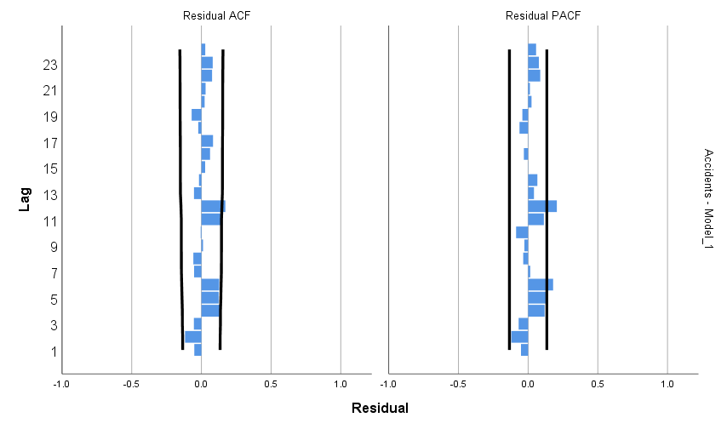
The final step is to add the intervention to the model. First, we test the impact of the COVID-19 pandemic. We hypothesize an immediate impact, starting the week of March 8, 2020. The best-fitting model below confirms a near-immediate statistically significant decline starting the week of March 22, 2020 and lasting through the end of the study period.

PREDICT THRU END.
* Time Series Modeler.
TSMODEL
/MODELSUMMARY PRINT=[MODELFIT]
/MODELSTATISTICS DISPLAY=YES MODELFIT=[ SRSQUARE]
/MODELDETAILS PRINT=[ PARAMETERS RESIDACF RESIDPACF] PLOT=[ RESIDACF RESIDPACF]
/SERIESPLOT OBSERVED FORECAST
/OUTPUTFILTER DISPLAY=ALLMODELS
/AUXILIARY CILEVEL=95 MAXACFLAGS=24
/MISSING USERMISSING=EXCLUDE
/MODEL DEPENDENT=Accidents INDEPENDENT=pandemic
PREFIX='Model'
/ARIMA AR=[1] DIFF=0 MA=[0] ARSEASONAL=[0] DIFFSEASONAL=0 MASEASONAL=[0]
TRANSFORM=NONE CONSTANT=YES
/AUTOOUTLIER DETECT=OFF.

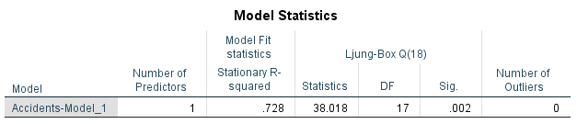
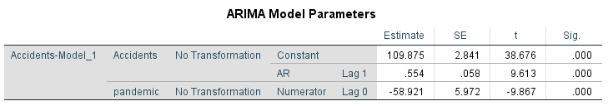
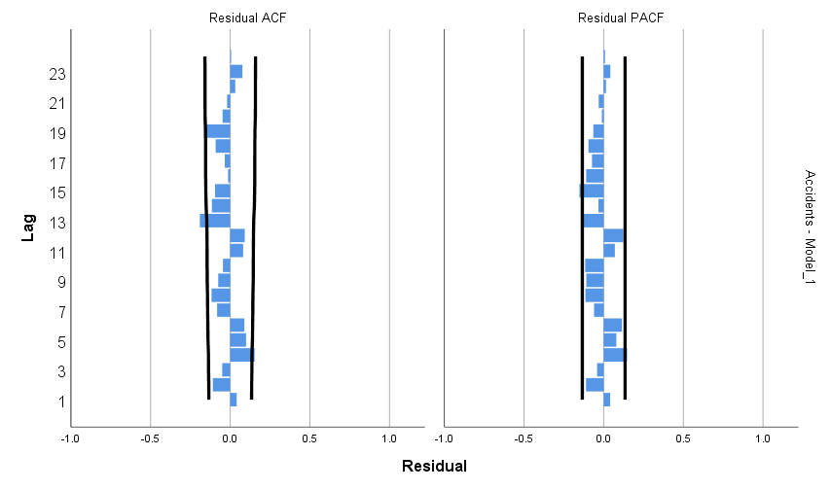
Second, we test the impact of the defund/reform movement. We hypothesize an immediate impact, starting the week of May 24, 2020. The model below shows a near-immediate statistically significant decline starting the week of June 7, 2020 and lasting through the end of the study period.

