Supplemental Materials
Supplementary Figure 1
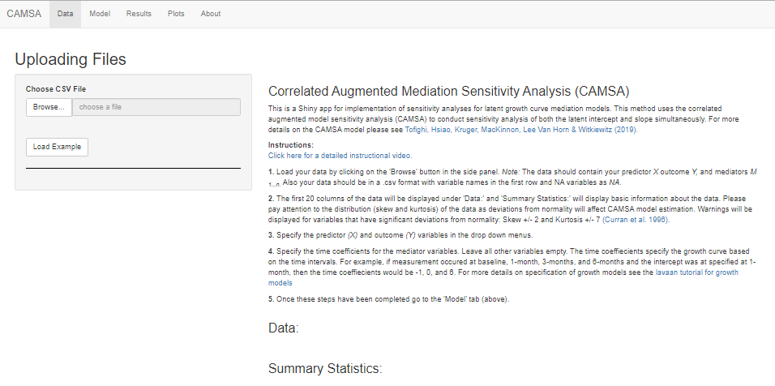

Supplementary Figure 2
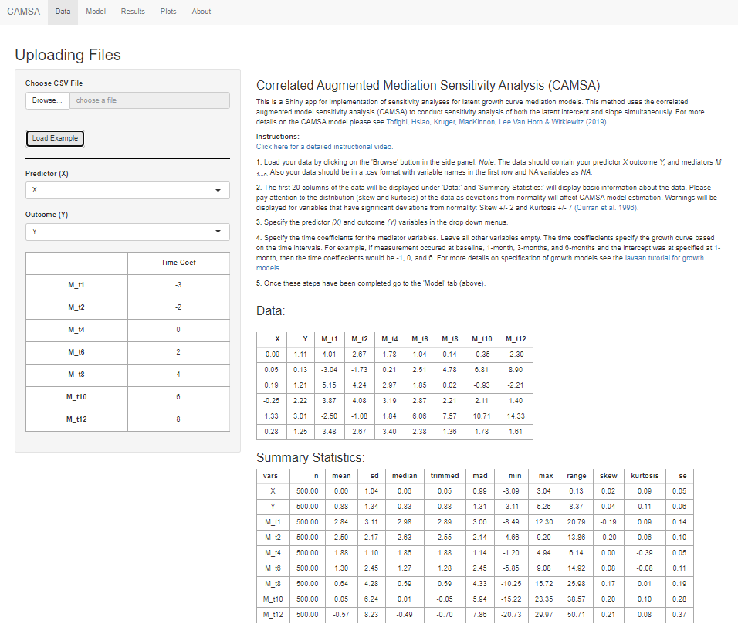

Supplementary Figure 3
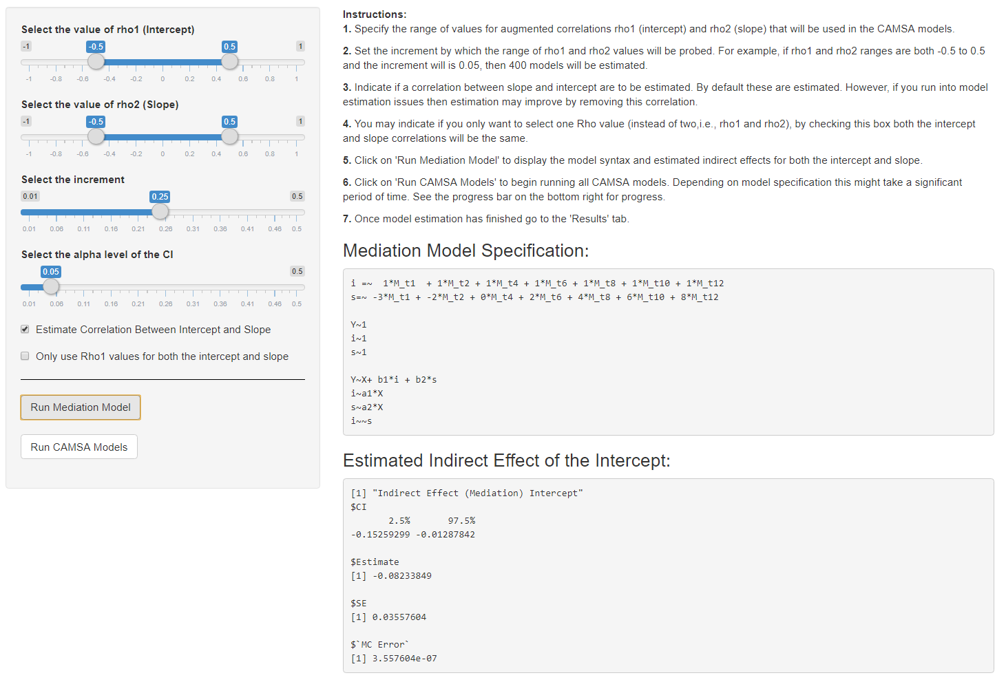

Supplementary Figure 4
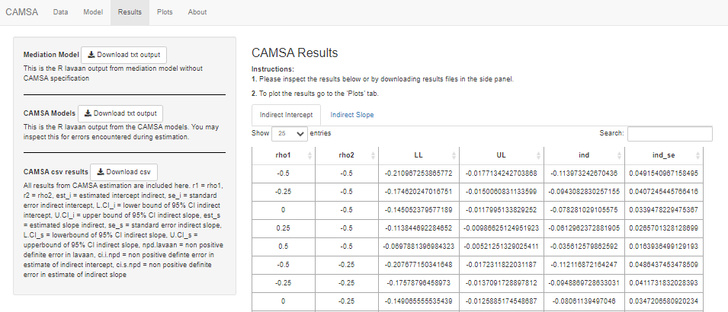

Supplementary Table 1
CAMSA Results.csv variable definitions
Column | Definition
Unnamed Column | *Model Iteration #
r1 | *Intercept confounding correlation value
r2 | *Slope confounding correlation value
est_i | Indirect intercept estimate
se_i | Indirect intercept standard error
L.CI_i | Lower bound of the 95% of the indirect intercept
U.CI_i | Upper bound of the 95% of the indirect intercept
est_s | Indirect slope estimate
se_s | Indirect slope standard error
L.CI_s | Lower bound of the 95% of the indirect slope
U.CI_s | Upper bound of the 95% of the indirect slope
npd.lavaan | Non positive definite covariance matrices in lavaan estimation; TRUE = non positive definite matrices
ci.i.npd | Non positive definite covariance matrices in RMediation estimation for the indirect intercept path 95% confidence interval; TRUE = non positive definite matrices
ci.s.npd | Non positive definite covariance matrices in RMediation estimation for the indirect slope path 95% confidence interval; TRUE = non positive definite matrices
*The values for model iteration #0 corresponding to the first row of data is the results from the latent growth mediation model without confounding correlations specified.
Note. If there are no values for a given combination that confounding correlation (r1 and r2 values) then a model estimation error occurred (e.g., non-convergence, non-positive definite matrices, or negative variances)

