Supplementary material: Reproducibility of the Infinium MethylationEPIC BeadChip assay using low DNA amounts
Steffan Noe Christiansen¹, Jeppe Dyrberg Andersen¹, Marie-Louise Kampmann¹, Jing Liu^{1.2}, Mikkel Meyer Andersen³, Jacob Tfelt-Hansen^{1,4}, Niels Morling¹

¹ Section of Forensic Genetics, Department of Forensic Medicine, Faculty of Health and Medical Sciences, University of Copenhagen, Denmark
² Institute of Forensic Medicine, West China School of Basic Medical Sciences & Forensic Medicine, Sichuan University, Chengdu 610041, China
³ Department of Mathematical Sciences, Aalborg University, Denmark
⁴ The Department of Cardiology, The Heart Centre, Copenhagen University Hospital, Rigshospitalet, Copenhagen, Denmark

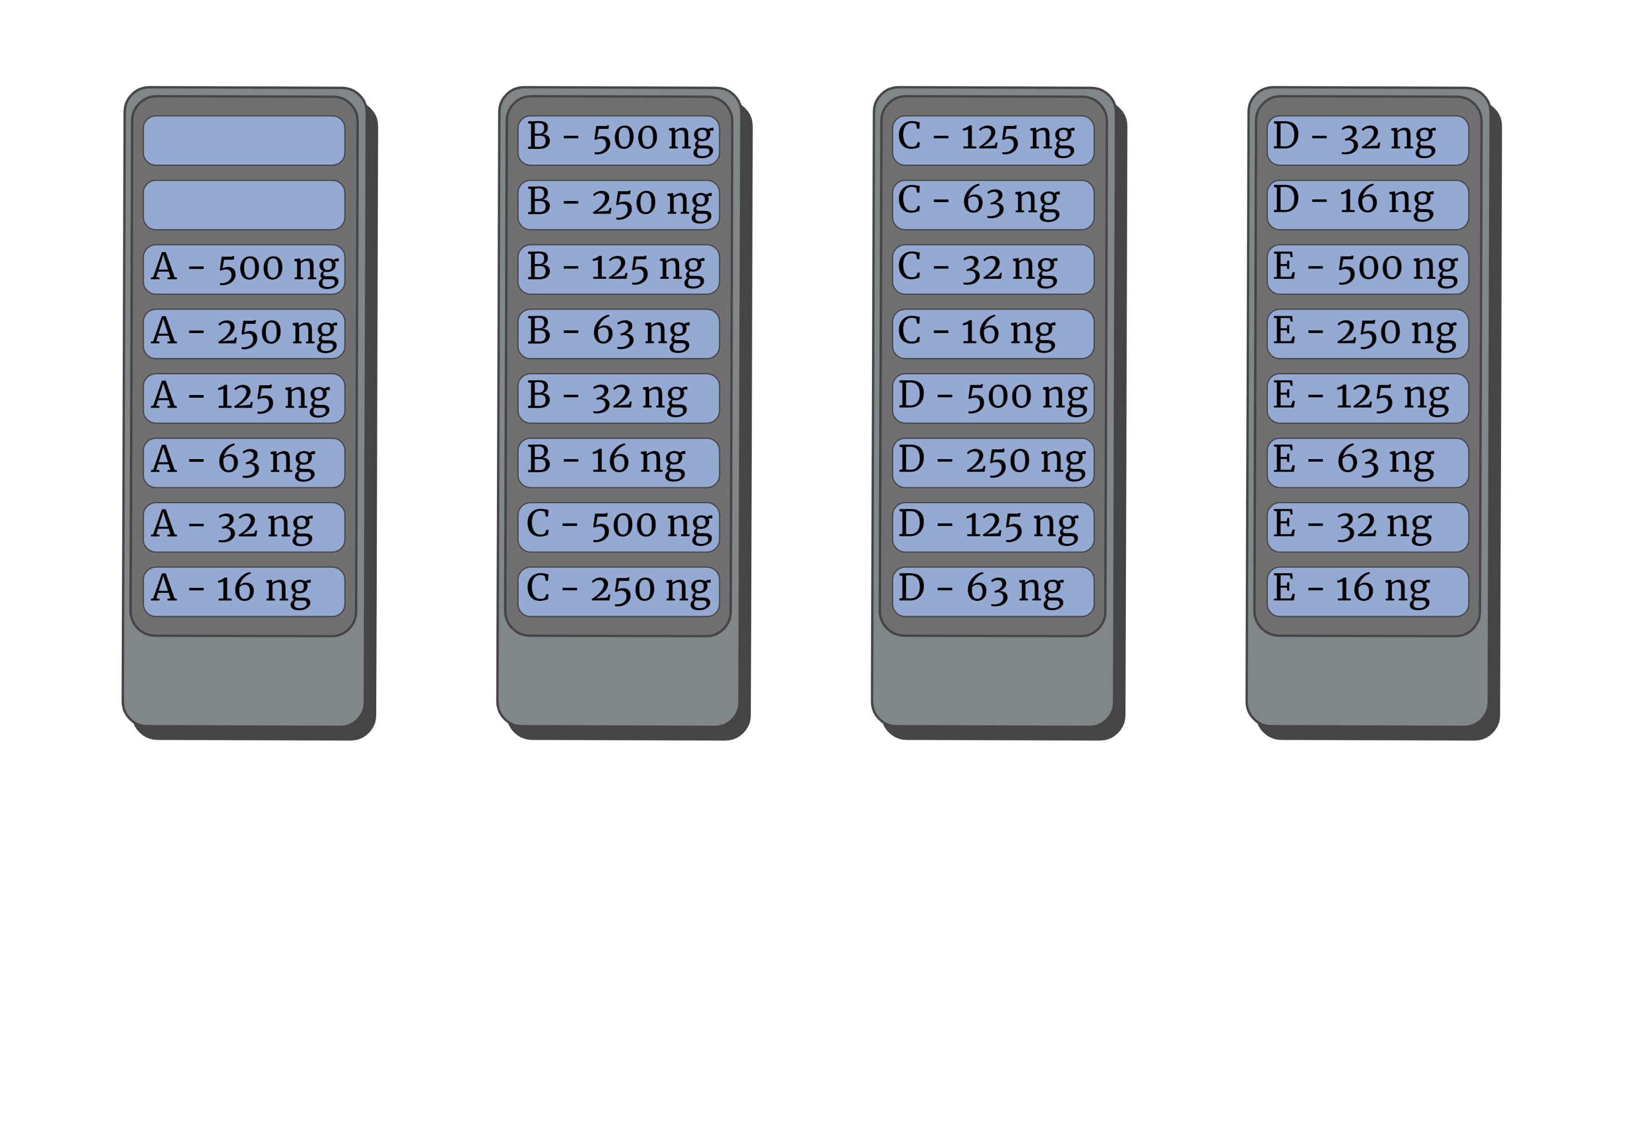
Supplementary Figure 1. Sample distribution on the slides. The samples from the five individuals (A-E) and six DNA amounts were distributed in the same way on both investigation days. The blank positions were used for samples unrelated to this study.

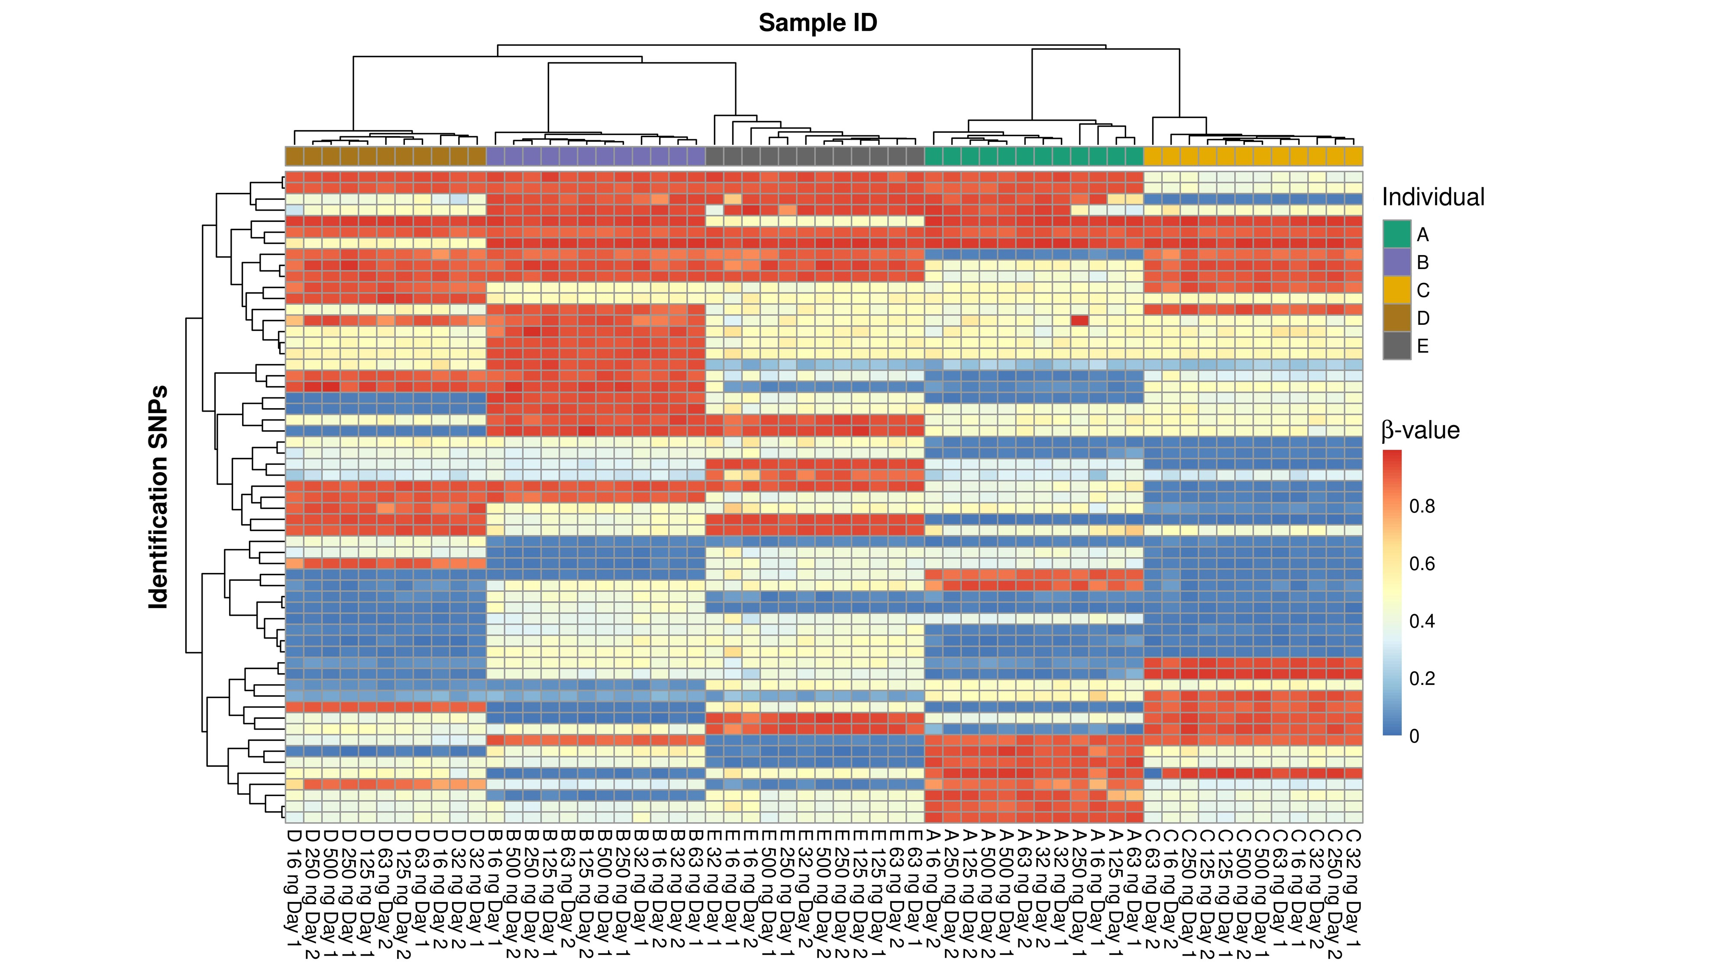
Supplementary Figure 2. Sample identification using the identification SNPs in the Illumina Infinium MethylationEPIC BeadChip Kit. Two-dimensional dendrogram with a heatmap of the β-values of the SNP typing results of six samples from each of five individuals investigated twice (except sample D6) on two different days. Each row represents an SNP, and each column represents a sample. The colours and their intensities illustrate the β-values of the 59 identification SNPs. The β-values generally grouped into three clusters around 0, 0.5, and 1 corresponding to homozygous, heterozygous, and opposite homozygous SNP typing results, respectively. SNP: Single nucleotide polymorphism.

Supplementary Figure 3. Density plots of signal intensities with various amounts of DNA with the Infinium MethylationEPIC BeadChip Kit. Signal intensities of 866,091 methylation positions in five individuals investigated twice on different days. The density estimates were based on a Gaussian kernel of the combined data from the five individuals.

Supplementary Figure 4. Associations between the signal intensities and the β-values for 250 ng and 16 ng DNA. Combined data of the β-values of DNA methylation sites in five individuals investigated twice on different days. 500 ng DNA failed to have data from both investigation days. Thus, the experiment with 250 ng was used since it was the second-highest DNA amount. For the calculation of the β-values, the α-value was set to either 0 (A-B) or 100 (C-D). Notice the absence of data points in the upper left corner when the α-value was set to 100 compared with 0.

Supplementary Figure 5. Between-days correlations of β-values of individual B. Scatter plots of the β-values obtained on two different days with 500 ng (A), 250 ng (B), 125 ng (C), 63 ng (D), 32 ng (E), and 16 ng (F) DNA.

Supplementary Figure 6. Between-days correlations of β-values of individual C. Scatter plots of the β-values obtained on two different days with 500 ng (A), 250 ng (B), 125 ng (C), 63 ng (D), 32 ng (E), and 16 ng (F) DNA.

Supplementary Figure 7. Between-days correlations of β-values of individual D. Scatter plots of the β-values obtained on two different days with 250 ng (A), 125 ng (B), 63 ng (C), 32 ng (D), and 16 ng (E) DNA. The experiment with 500 ng DNA failed to have two data sets to compare.

Supplementary Figure 8. Between-days correlations of β-values of individual E. Scatter plots of the β-values obtained on two different days with 500 ng (A), 250 ng (B), 125 ng (C), 63 ng (D), 32 ng (E), and 16 ng (F) DNA.

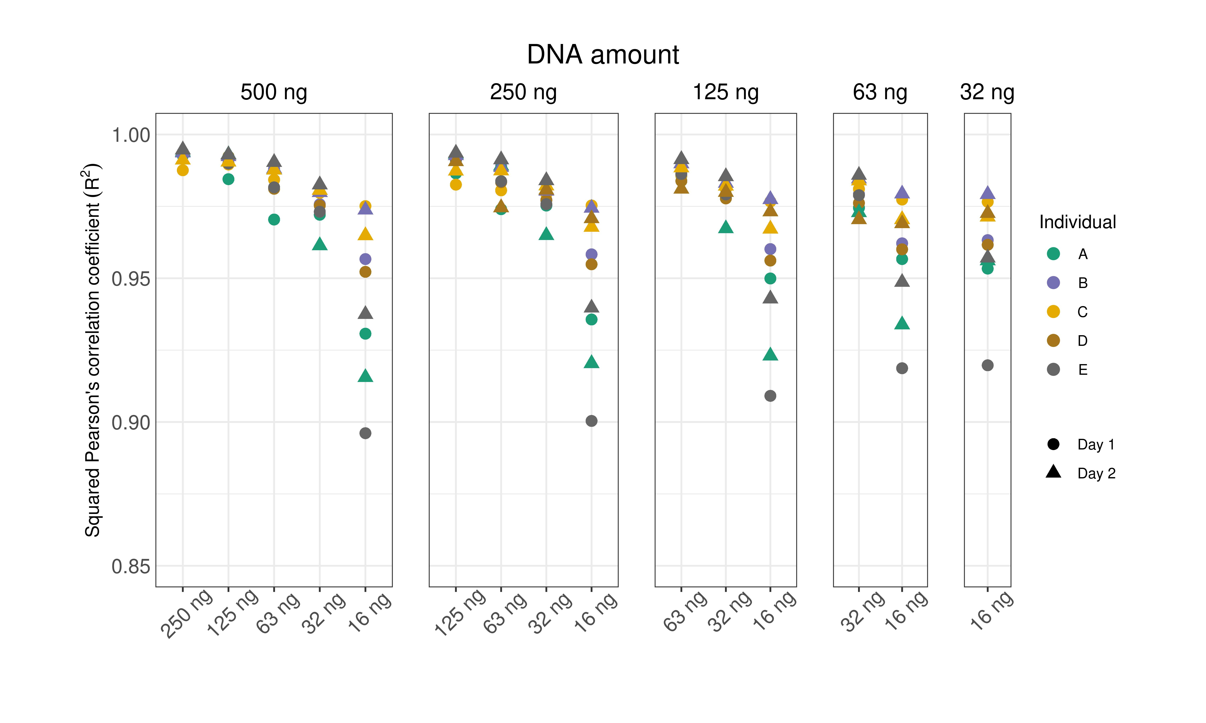
Supplementary Figure 9. Correlations between β-values obtained with various DNA amounts in five individuals. Squared Pearson’s correlation coefficients of the β-values among the various DNA amounts. The correlations were only investigated within each day. Hence, the correlation between e.g., 500 ng (Day 1) and 250 ng (Day 2) was not calculated.

Supplementary Table 1. Median squared Pearson’s correlation coefficients of the β-values between various amounts of DNA from five individuals.

Compared DNA amounts | Squared Pearson’s correlation coefficients ordered by median
250 ng vs 500 ng | 0.994
125 ng vs 250 ng | 0.991
125 ng vs 500 ng | 0.991
63 ng vs 500 ng | 0.988
63 ng vs 125 ng | 0.987
63 ng vs 250 ng | 0.985
32 ng vs 125 ng | 0.979
32 ng vs 63 ng | 0.979
32 ng vs 250 ng | 0.978
32 ng vs 500 ng | 0.976
16 ng vs 32 ng | 0.962
16 ng vs 63 ng | 0.961
16 ng vs 125 ng | 0.958
16 ng vs 250 ng | 0.957
16 ng vs 500 ng | 0.952

Supplementary Table 2. Median standard deviations of the between-days variability.

DNA amount
β-value interval | 500 ng | 250 ng | 125 ng | 63 ng | 32 ng | 16 ng
0.0-0.1 | 0.005 | 0.005 | 0.006 | 0.006 | 0.006 | 0.006
0.1-0.2 | 0.010 | 0.010 | 0.012 | 0.015 | 0.017 | 0.023
0.2-0.3 | 0.012 | 0.012 | 0.014 | 0.018 | 0.022 | 0.033
0.3-0.4 | 0.012 | 0.014 | 0.014 | 0.018 | 0.022 | 0.034
0.4-0.5 | 0.013 | 0.016 | 0.015 | 0.019 | 0.023 | 0.035
0.5-0.6 | 0.013 | 0.016 | 0.016 | 0.020 | 0.024 | 0.037
0.6-0.7 | 0.014 | 0.017 | 0.017 | 0.021 | 0.026 | 0.039
0.7-0.8 | 0.014 | 0.017 | 0.017 | 0.020 | 0.026 | 0.037
0.8-0.9 | 0.014 | 0.017 | 0.015 | 0.018 | 0.021 | 0.027
0.9-1.0 | 0.009 | 0.011 | 0.010 | 0.011 | 0.012 | 0.013

Supplementary Table 3. Median coefficients of variation of the between-days variability.
DNA amount
β-value interval | 500 ng | 250 ng | 125 ng | 63 ng | 32 ng | 16 ng
0.0-0.1 | 0.135 | 0.137 | 0.145 | 0.156 | 0.151 | 0.166
0.1-0.2 | 0.068 | 0.072 | 0.085 | 0.108 | 0.123 | 0.167
0.2-0.3 | 0.047 | 0.050 | 0.056 | 0.074 | 0.089 | 0.134
0.3-0.4 | 0.035 | 0.040 | 0.040 | 0.052 | 0.063 | 0.097
0.4-0.5 | 0.029 | 0.035 | 0.034 | 0.041 | 0.050 | 0.078
0.5-0.6 | 0.024 | 0.029 | 0.029 | 0.036 | 0.043 | 0.068
0.6-0.7 | 0.021 | 0.025 | 0.026 | 0.032 | 0.039 | 0.060
0.7-0.8 | 0.019 | 0.022 | 0.022 | 0.027 | 0.034 | 0.049
0.8-0.9 | 0.017 | 0.020 | 0.018 | 0.021 | 0.025 | 0.032
0.9-1.0 | 0.010 | 0.011 | 0.011 | 0.012 | 0.013 | 0.014

A

