Journal of Vertebrate Paleontology
Postcrania and paleobiology of Patriofelis ulta (Mammalia, Oxyaenodonta) of the Bridgerian (Early-Middle Eocene) of North America
ANNE E. KORT, ^{*,1} HEATHER AHRENS,² P. DAVID POLLY, ³ and MICHAEL MORLO⁴
¹Department of Earth and Atmospheric Sciences, Indiana University Bloomington, Bloomington, Indiana 47408 U.S.A., aekort@iu.edu;
²Department of Biology, High Point University, High Point, North Carolina 27268 U.S.A., hahrens@highpoint.edu;
³Department of Earth and Atmospheric Sciences, Indiana University Bloomington, Bloomington, Indiana 47408 U.S.A., pdpolly@indiana.edu;
⁴Forschungsinstitut Senckenberg, Abt. Messelforschung und Mammalogie, Senckenberganlage 25, D - 60325 Frankfurt am Main, Germany, Michael.Morlo@senckenberg.de
RH: KORT ET AL.—PALEOBIOLOGY OF PATRIOFELIS
*Corresponding author

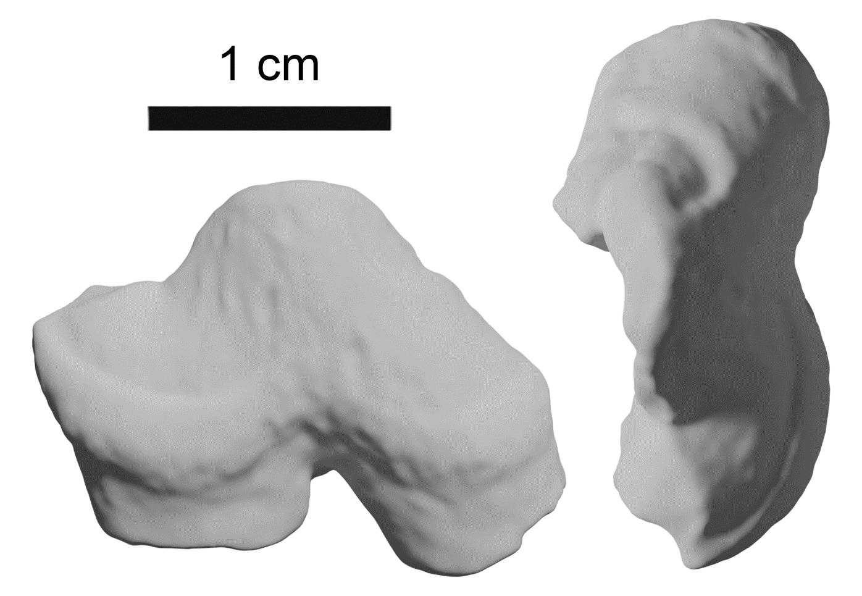
FIGURE S1. Lower right p4 from CM 87673 in A, labial and B, occlusal views. The posterolingual face of the tooth has broken off. Scale bar equals 1 centimeter.
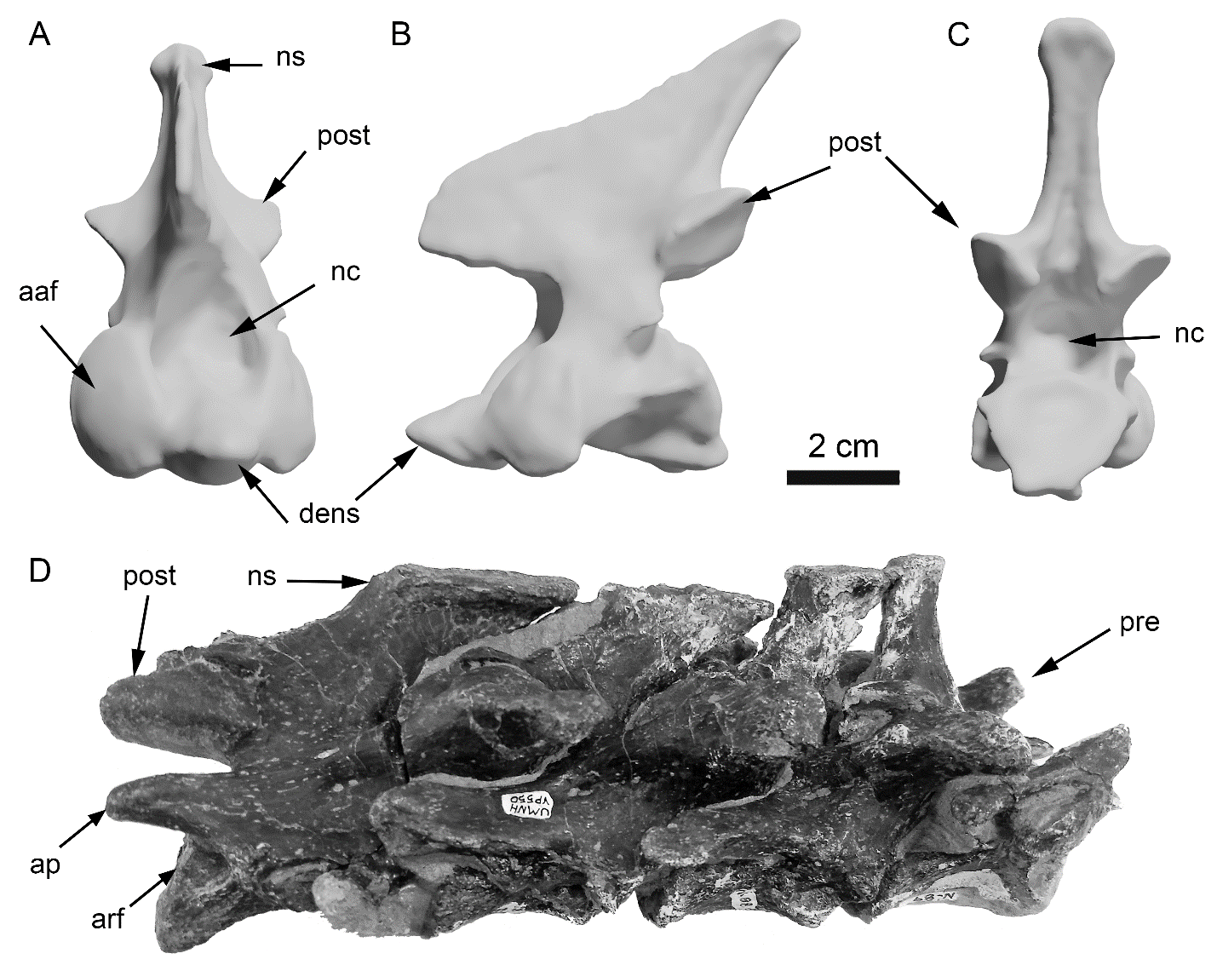
FIGURE S2. Atlas from UMNH VP 550 in A, anterior, B, lateral and C, posterior views; D, articulated posterior dorsal vertebrae from UMNH VP 550 in right lateral view. Anterior is to the right. Abbreviations: aaf, anterior articular facet; arf, anterior rib facet; ap, anapophysis; dens, dens; nc, neural canal; ns, neural spine; pre, prezygapophysis; post, postzygapophyses. Scale bar equals 2 cm.

TABLE S1. List of scanned elements from CM 87673 and UMNH VP 550 available on Morphosource.org. Each ARK identifier can be accessed by navigating to http://n2t.net/ark... in a web browser e.g. http://n2t.net/ark:/87602/m4/374804
Data Type | Specimen | Element(s) | ARK Identifier
CT Image Series | UMNH VP 550 | Metatarsal; Caudal Vertebrae; Carpal; Phalange; Pelvis; Rib; Clavicle; Cranium; Tarsal; Metacarpal; Mandible | ark:/87602/m4/374808
CT Image Series | UMNH VP 550 | Tibia; Femur; Humerus; Fibula; Thoracic Vertebrae; Cervical Vertebrae; Caudal Vertebrae; Lumbar Vertebrae | ark:/87602/m4/374811
Mesh | UMNH VP 550 | Astragalus | ark:/87602/m4/374863
Mesh | UMNH VP 550 | Axis | ark:/87602/m4/375033
Mesh | UMNH VP 550 | Basicranium | ark:/87602/m4/374866
Mesh | UMNH VP 550 | Calcaneum | ark:/87602/m4/375037
Mesh | UMNH VP 550 | Caudal Vertebrae | ark:/87602/m4/374895
Mesh | UMNH VP 550 | Caudal Vertebrae | ark:/87602/m4/374883
Mesh | UMNH VP 550 | Caudal Vertebrae | ark:/87602/m4/374878
Mesh | UMNH VP 550 | Caudal Vertebrae | ark:/87602/m4/374873
Mesh | UMNH VP 550 | Cervical Vertebrae | ark:/87602/m4/375040
Mesh | UMNH VP 550 | Clavicle | ark:/87602/m4/374898
Mesh | UMNH VP 550 | Cranium | ark:/87602/m4/374905
Mesh | UMNH VP 550 | Femur | ark:/87602/m4/375051
Mesh | UMNH VP 550 | Fibula | ark:/87602/m4/375072
Mesh | UMNH VP 550 | Humerus | ark:/87602/m4/375054
Mesh | UMNH VP 550 | Lumbar Vertebrae | ark:/87602/m4/375065
Mesh | UMNH VP 550 | Lumbar Vertebrae | ark:/87602/m4/375059
Mesh | UMNH VP 550 | Mandible | ark:/87602/m4/374927
Mesh | UMNH VP 550 | Pelvis | ark:/87602/m4/374923
Mesh | UMNH VP 550 | Radius | ark:/87602/m4/375048
Mesh | UMNH VP 550 | Rib | ark:/87602/m4/375023
Mesh | UMNH VP 550 | Rib | ark:/87602/m4/375019
Mesh | UMNH VP 550 | Rib | ark:/87602/m4/375015
Mesh | UMNH VP 550 | Rib | ark:/87602/m4/375012
Mesh | UMNH VP 550 | Rib | ark:/87602/m4/375009
Mesh | UMNH VP 550 | Rib | ark:/87602/m4/375006
Mesh | UMNH VP 550 | Rib | ark:/87602/m4/375000
Mesh | UMNH VP 550 | Rib | ark:/87602/m4/374990
Mesh | UMNH VP 550 | Rib | ark:/87602/m4/374981
Mesh | UMNH VP 550 | Rib | ark:/87602/m4/374973
Mesh | UMNH VP 550 | Rib | ark:/87602/m4/374961
Mesh | UMNH VP 550 | Rib | ark:/87602/m4/374955
Mesh | UMNH VP 550 | Rib | ark:/87602/m4/374948
Mesh | UMNH VP 550 | Rib | ark:/87602/m4/374939
Mesh | UMNH VP 550 | Thoracic Vertebrae | ark:/87602/m4/375064
Mesh | UMNH VP 550 | Thoracic Vertebrae | ark:/87602/m4/375044
Mesh | UMNH VP 550 | Thoracic Vertebrae | ark:/87602/m4/375027
Mesh | UMNH VP 550 | Tibia | ark:/87602/m4/375069
Mesh | UMNH VP 550 | Tibia | ark:/87602/m4/375058
Mesh | CM 87733 | Astragalus | ark:/87602/m4/374171
Mesh | CM 87732 | Astragalus | ark:/87602/m4/374181
Mesh | CM 87731 | Calcaneum | ark:/87602/m4/374185
Mesh | CM 87730 | Calcaneum | ark:/87602/m4/374189
Mesh | CM 87729 | Capitulum | ark:/87602/m4/374193
Mesh | CM 87728 | Caudal Vertebrae | ark:/87602/m4/374203
Mesh | CM 87727 | Caudal Vertebrae | ark:/87602/m4/374215
Mesh | CM 87726 | Caudal Vertebrae | ark:/87602/m4/374221
Mesh | CM 87725 | Caudal Vertebrae | ark:/87602/m4/374225
Mesh | CM 87724 | Caudal Vertebrae | ark:/87602/m4/374229
Mesh | CM 87723 | Caudal Vertebrae | ark:/87602/m4/374234
Mesh | CM 87722 | Caudal Vertebrae | ark:/87602/m4/374238
Mesh | CM 87721 | Caudal Vertebrae | ark:/87602/m4/374242
Mesh | CM 87720 | Caudal Vertebrae | ark:/87602/m4/374246
Mesh | CM 87719 | Caudal Vertebrae | ark:/87602/m4/374250
Mesh | CM 87718 | Distal Femur | ark:/87602/m4/374254
Mesh | CM 87717 | Distal Femur | ark:/87602/m4/374258
Mesh | CM 87716 | Femoral head | ark:/87602/m4/374262
Mesh | CM 87715 | Fibula | ark:/87602/m4/374266
Mesh | CM 87714 | Hamate | ark:/87602/m4/374270
Mesh | CM 87713 | Metacarpal II | ark:/87602/m4/374274
Mesh | CM 87712 | Metatarsal 2 | ark:/87602/m4/374278
Mesh | CM 87711 | Metatarsal 3 | ark:/87602/m4/374282
Mesh | CM 87710 | Metatarsal 4 | ark:/87602/m4/374286
Mesh | CM 87709 | Metatarsal 5 | ark:/87602/m4/374292
Mesh | CM 87708 | Tibia | ark:/87602/m4/374300
Mesh | CM 87707 | Ulna | ark:/87602/m4/374304
Mesh | CM 87706 | Ulna | ark:/87602/m4/374312
Mesh | CM 87705 | Ulna | ark:/87602/m4/374317
Mesh | CM 87704 | Ulna | ark:/87602/m4/374324
Mesh | CM 87703 | Lunate | ark:/87602/m4/374330
Mesh | CM 87702 | Mandible Coronoid | ark:/87602/m4/374335
Mesh | CM 87701 | Mandible Condyle | ark:/87602/m4/374340
Mesh | CM 87700 | Mandible Condyle | ark:/87602/m4/374348
Mesh | CM 87699 | Medial Cuneiform | ark:/87602/m4/374352
Mesh | CM 87698 | Lower p4 | ark:/87602/m4/374357
Mesh | CM 87697 | Patella | ark:/87602/m4/374361
Mesh | CM 87696 | Patella | ark:/87602/m4/374366
Mesh | CM 87695 | Radius | ark:/87602/m4/374371
Mesh | CM 87694 | Radius | ark:/87602/m4/374375
Mesh | CM 87693 | Radius | ark:/87602/m4/374380
Mesh | CM 87692 | Radius | ark:/87602/m4/374387
Mesh | CM 87691 | Cuboid | ark:/87602/m4/374678
Mesh | CM 87690 | Lateral Cuneiform | ark:/87602/m4/374683
Mesh | CM 87689 | Metatarsal 1 | ark:/87602/m4/374688
Mesh | CM 87688 | Metatarsal 1 | ark:/87602/m4/374695
Mesh | CM 87687 | Metatarsal 2 | ark:/87602/m4/374705
Mesh | CM 87686 | Metatarsal 2 | ark:/87602/m4/374714
Mesh | CM 87685 | Metatarsal 3 | ark:/87602/m4/374719
Mesh | CM 87684 | Metatarsal 4 | ark:/87602/m4/374734
Mesh | CM 87683 | Metatarsal 4 | ark:/87602/m4/374739
Mesh | CM 87682 | Metatarsal 5 | ark:/87602/m4/374750
Mesh | CM 87681 | Metatarsal 5 | ark:/87602/m4/374755
Mesh | CM 87680 | Tibia | ark:/87602/m4/374766
Mesh | CM 87679 | Tibia | ark:/87602/m4/374775
Mesh | CM 87678 | Ulna | ark:/87602/m4/374781
Mesh | CM 87677 | Ulna | ark:/87602/m4/374786
Mesh | CM 87676 | Ulna | ark:/87602/m4/374790
Mesh | CM 87675 | Sagittal Crest | ark:/87602/m4/374795
Mesh | CM 87674 | Scaphoid | ark:/87602/m4/374800
Mesh | CM 87673 | Scapula | ark:/87602/m4/374804

TABLE S2. List of fossil specimens referenced for comparison to Patriofelis specimens described.
Species | Collection | Catalog number | Order | Subfamily
Palaeonictis sp. | YPM VP | 013001 | Oxyaenodonta | Ambloctoninae
Oxyaena gulo | AMNH FM | 15724 | Oxyaenodonta | Oxyaeninae
Oxyaena lupina | AMNH FM | 107 | Oxyaenodonta | Oxyaeninae
Patriofelis cf. ulta | AMNH FM | 17505 | Oxyaenodonta | Oxyaeninae
Patriofelis ferox | AMNH FM | 1507 | Oxyaenodonta | Oxyaeninae
Patriofelis ferox | YPM VP | 012864 | Oxyaenodonta | Oxyaeninae
Patriofelis ferox | YPM VP | 013093 | Oxyaenodonta | Oxyaeninae
Patriofelis sp. | YPM VP | 011089 | Oxyaenodonta | Oxyaeninae
Hyaenodon horridus | YPM VPPU | 010916 | Hyaenodonta | Hyaenodontinae
Hyaenodon horridus | YPM VPPU | 010995 | Hyaenodonta | Hyaenodontinae
Limnocyon potens | AMNH FM | 13138 | Hyaenodonta | Limnocyoninae
Limnocyon verus | AMNH FM | 12155 | Hyaenodonta | Limnocyoninae
Limnocyon verus | YPM VP | 013034 | Hyaenodonta | Limnocyoninae
Limnocyon verus | YPM VP | 013065 | Hyaenodonta | Limnocyoninae
Tritemnodon sp. | AMNH FM | 12636 | Hyaenodonta | Sinopinae

TABLE S3. Modern specimens used in geometric morphometric analysis from the WRAZL osteology collection.
Common Name | Species | Catalog Number | Order
Bison | Bison bison | 9810423 | Artiodactyla
Collared Peccary | Pecari tajacu | 9210299 | Artiodactyla
Domestic Goat | Capra hircus | 9710078 | Artiodactyla
White-tailed Deer | Odocoileus virginianus | 9910233 | Artiodactyla
American Badger | Taxidea taxus | 9010138 | Carnivora
Bobcat | Felis rufus | 0210001 | Carnivora
Common Raccoon | Procyon lotor | 9610344 | Carnivora
Cougar | Puma concolor | 0110164 | Carnivora
Grey Wolf | Canis lupus | 9910092 | Carnivora
Harbor Seal | Phoca vitulina | 9510001 | Carnivora
North American River Otter | Lontra canadensis | 9010009 | Carnivora
Polar Bear | Ursus maritimus | 9710081 | Carnivora
Wolverine | Gulo gulo | 9310464 | Carnivora
Nine-Banded Armadillo | Dasypus novemcinctus | 8610148 | Cingulata
Tasmanian Devil | Sarcophilus harris | 9310970 | Dasyuromorphia
Virginia Opossum | Didelphis virginianus | 9710249 | Didelphimorphia
Rock Hyrax | Procavia capensis | 0010011 | Hyracoidea
European Rabbit | Oryctolagus cuniculus | 8410118 | Lagomorpha
Domestic Horse | Equus caballus | 8810102 | Perissodactyla
American Beaver | Castor canadensis | H25 | Rodentia
Guinea Pig | Cavia porcellus | 9610245 | Rodentia
North American Porcupine | Erethizon dorsatum | T25 | Rodentia

