Supplementary Materials

Appendix A
Table 1: Demographic properties of the population under study. Please note that the better hearing ear is defined by the ear having a better PTA.
 | First-time users  n = 884 | Experienced users  n = 329
Mean age, years (±SD)  (range) | 67 (11)  (22-94) | 69 (11)  (19-100)
Gender, n (%)  Men | 509 (58) | 198 (60)
Mean PTA, dB HL (±SD)  Better hearing ear  Worst hearing ear | 33 (10)  39 (11) | 44 (13)  50 (13)
Mean WRS, percentage (±SD)  Better hearing ear  Worst hearing ear | 92 (12)  88 (16) | 85 (16)  82 (18)
Interaural asymmetry, n (%)  Symmetric | 738 (83) | 274 (83)
Tinnitus, n (%)  Present (THI > 16) | 184 (21) | 53 (16)
Mean motivation score (±SD)  Range (1–10) | 8 (2) | 9 (1)
HA type, n (%)  BTE (RITE)  BTE (molded earplug)  BTE (power)  BTE (thin tube)  ITC  CIC | 767 (87)  104 (12)  5  6  1  1 | 234 (71)  70 (22)  13 (4)  4 (1)  5 (1)  3 (1)
Acoustic Fitting type, n (%)  Open dome  Tulip dome (semi-open)  Double tulip dome (power)  Custom earmold  Closed dome | 548 (62)  59 (7)  9 (1)  174 (20)  94 (10) | 115 (35)  37 (11)  4 (1)  140(43)  33 (10)
Mean HA usage time, hours per day (±SD)  (range) | 8 (5)  (0-24) | 10 (5)  (0-24)

Appendix B
Self-reported Outcomes
The bar plot in Figure 1 shows the median, min, and max values for the IOI-HA Factor 1 and Factor 1 scores calculated after applying the utility weights to the individual IOI-HA item scores. The experienced users report a significantly higher mean Factor 1 score and lower mean Factor 2 score than first-time users in a paired t-test. The result in Figure 2 suggests that the first-time users reported significantly higher scores than experienced users in all three subscales of SSQ12. The mean scores for experienced users were 4.76, 6.3, and 6.15 for speech, spatial, and quality subscales. The speech, spatial, and quality domain scores for first-time users were 5.76, 6.9, and 6.7, respectively.
Figure 1: Whisker box plot for IOI-HA Factor 1 (Benefit) and IOI-HA Factor 2 (Residual Activity) scores. The scores were calculated after re-coding IOI-HA ordinal data to an interval scale using the numerical values suggested in Leijon et al, (2021). The *** indicates a p-value of ≤ 0.001, suggesting a significant difference between the mean scores of first-time and experienced users. A higher score indicates a better HA outcome. The box represents the 25% and 75% quartiles, and the error bar denotes a 95% confidence interval. The data points outside the 95% confidence intervals are shown as dots.

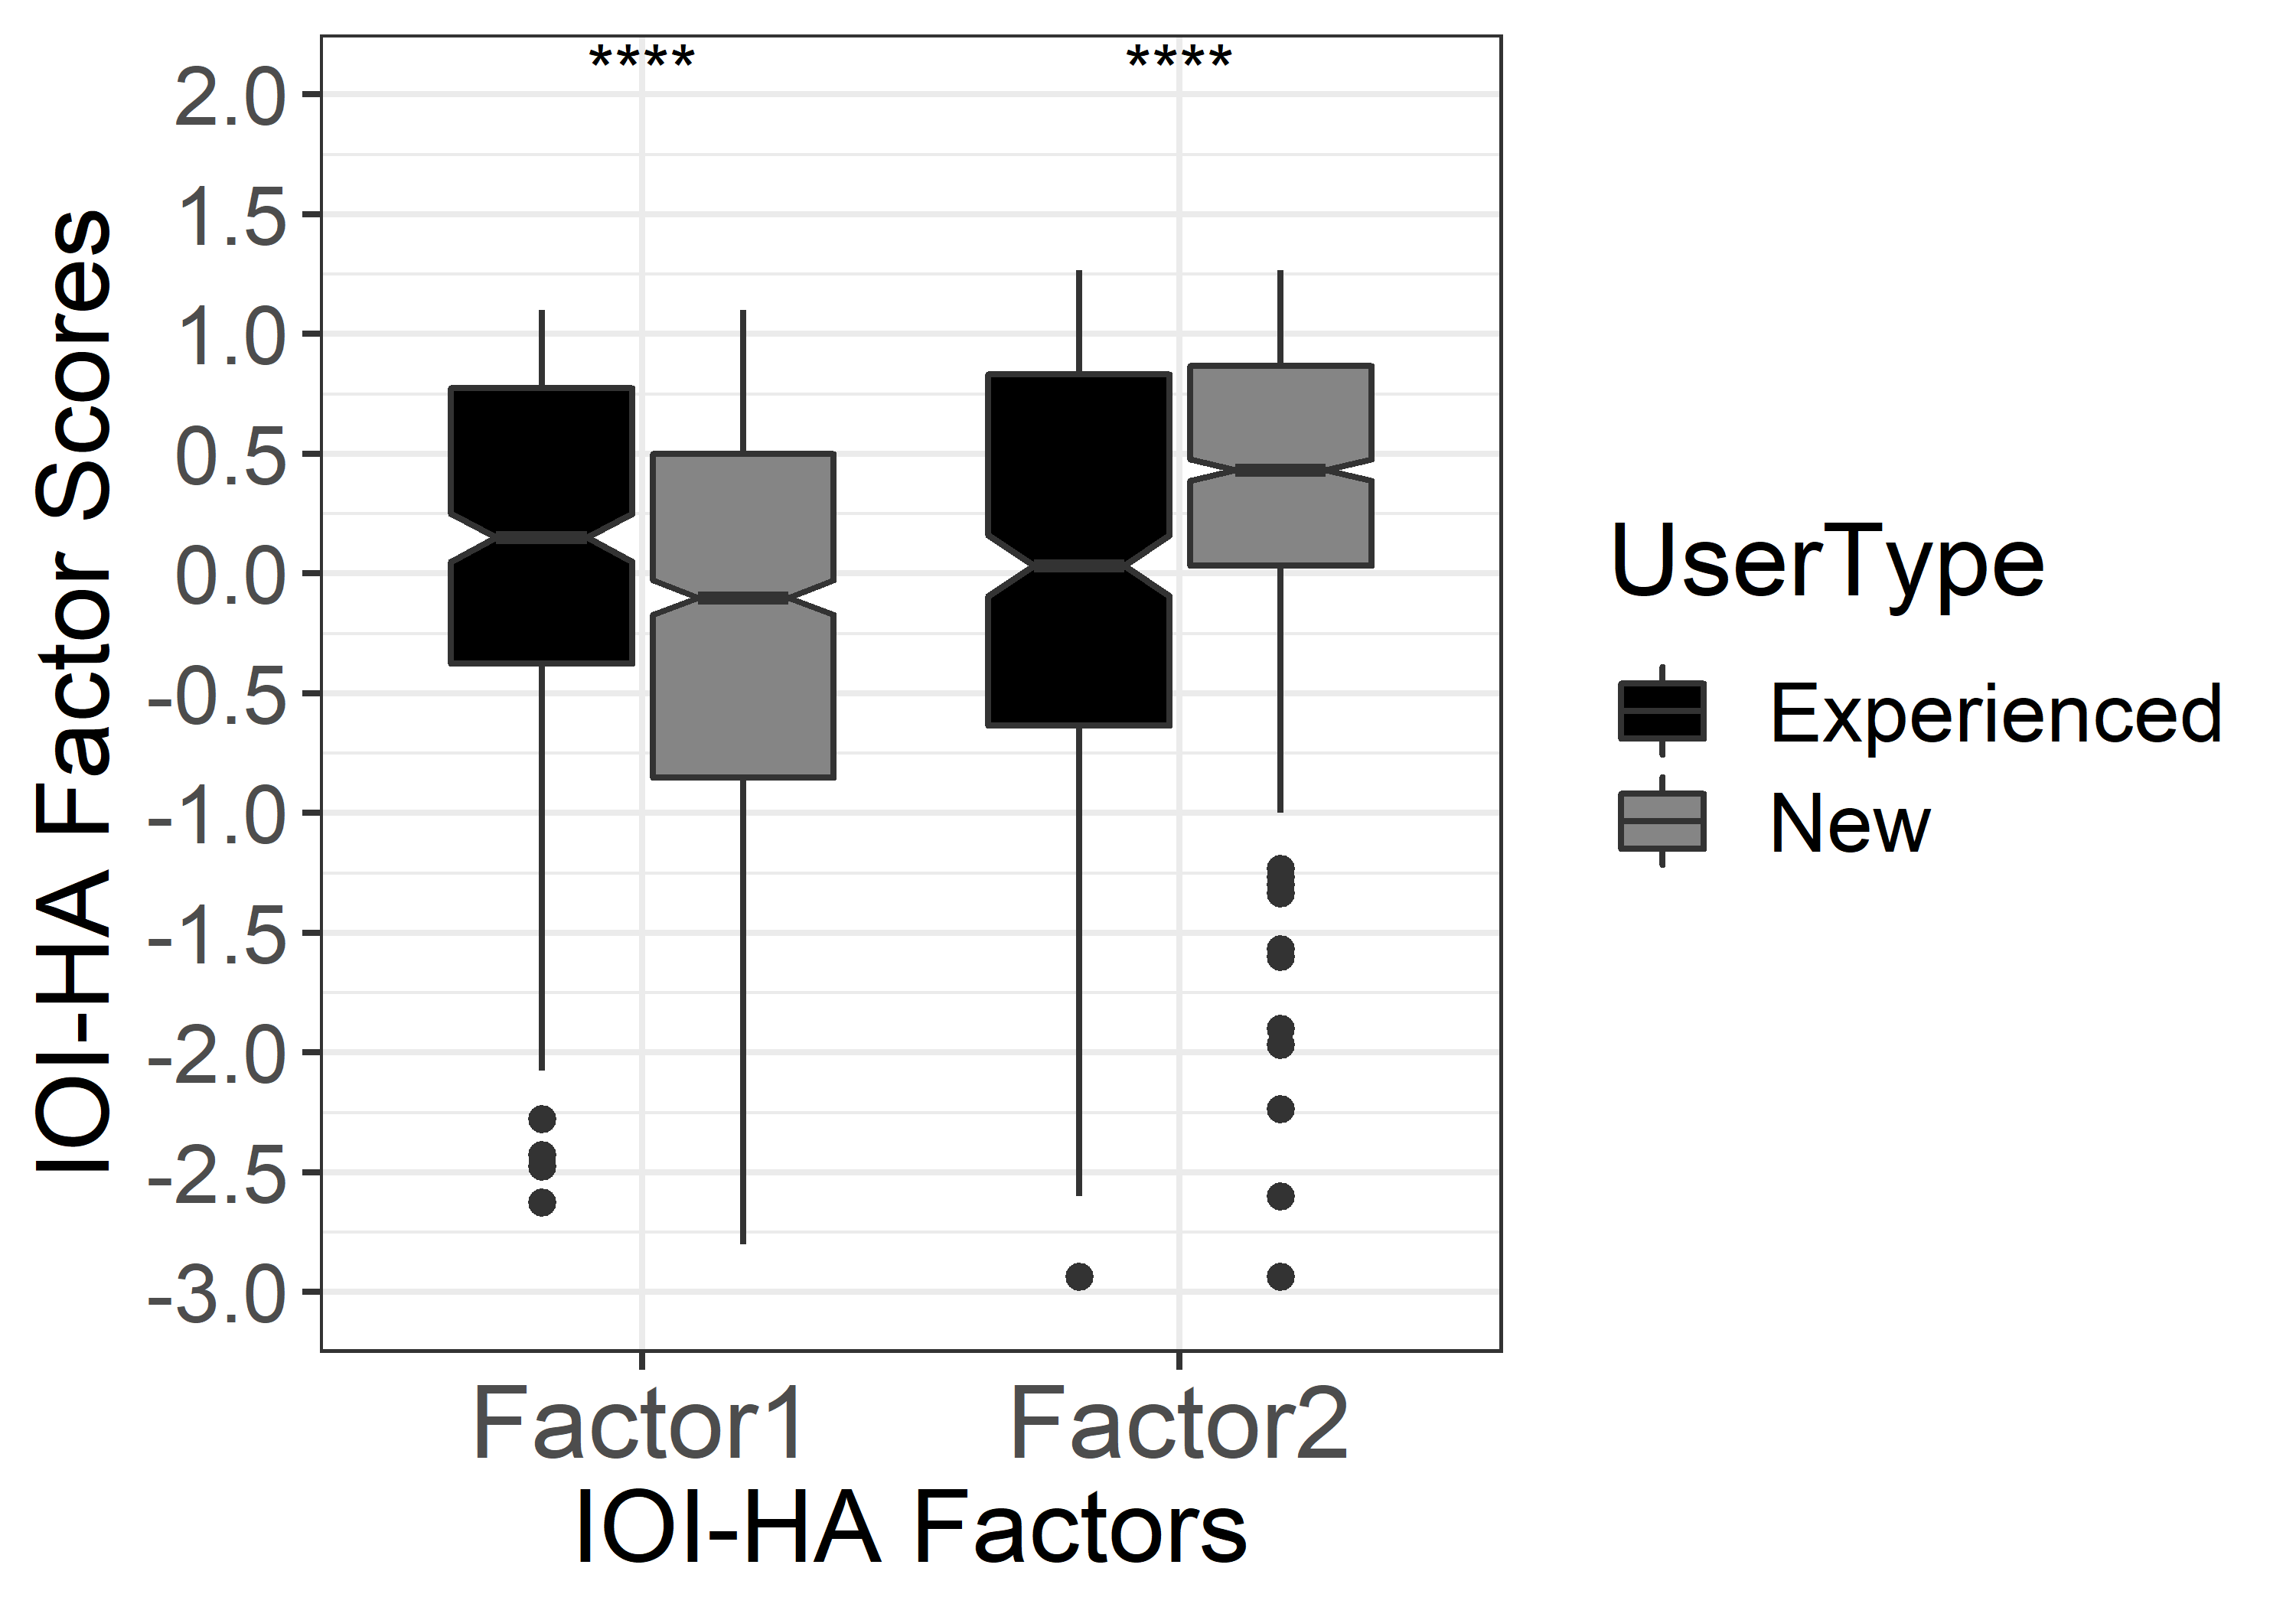
Figure 2: Whisker boxplot for three subscales of SSQ for the first-time and experienced user. The ***indicates a p-value of ≤ 0.001, suggesting a significant difference between the mean scores of first-time and experienced users. A higher score indicates a better HA outcome. The box represents the 25% and 75% quartiles, and the error bar denotes a 95% confidence interval. The data points outside the 95% confidence intervals are shown as dots.

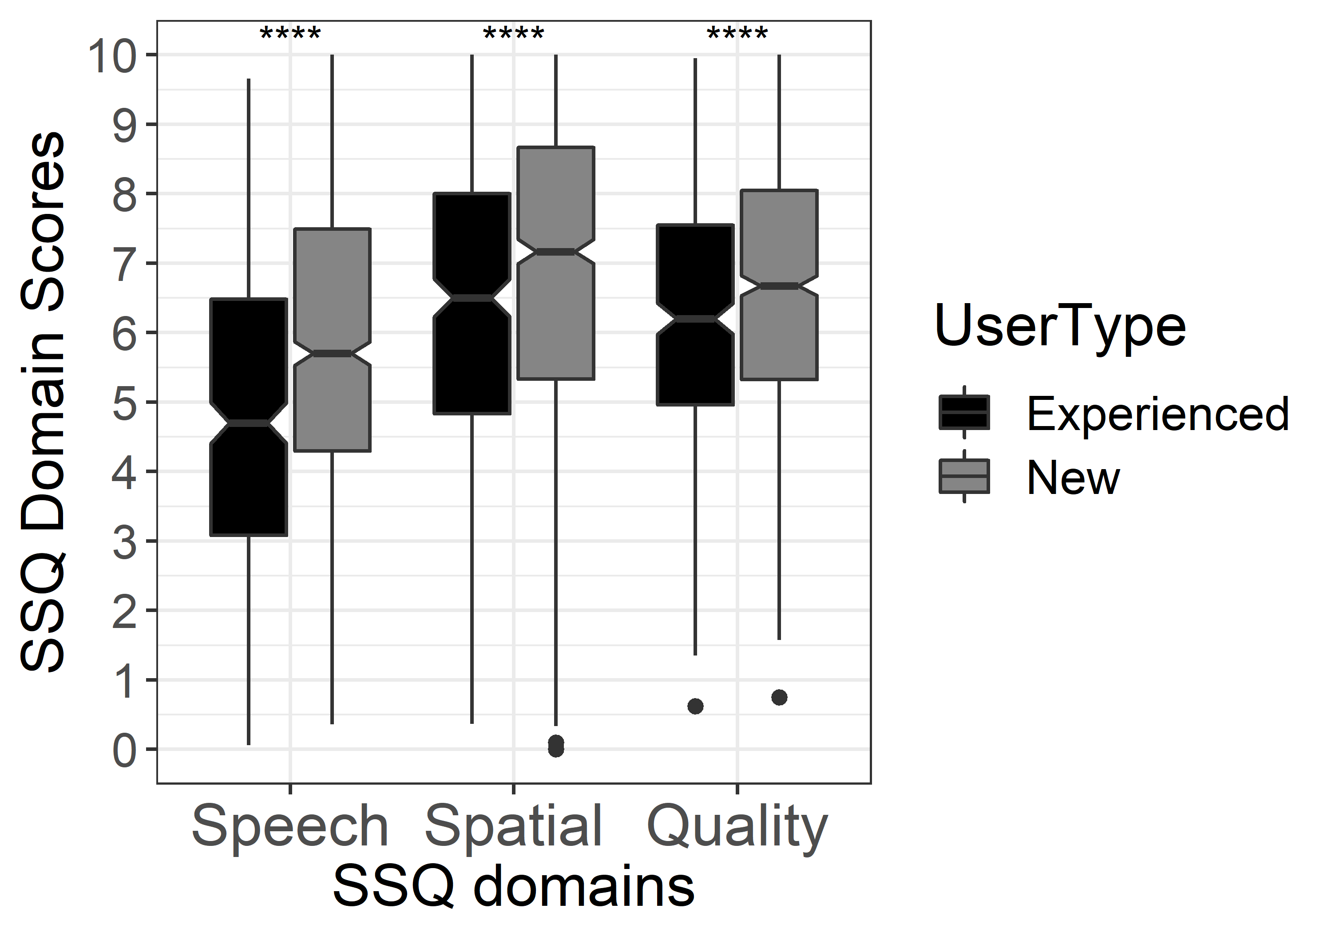

Appendix C
Table 2: Stepwise multiple linear regression analysis of two IOI-HA Factor 1 scores for first-time HA users without including motivation variable. The results are shown only for the model for the gain difference to NAL-NL2. ***p<0.001, **p<0.01, *p<0.05. NA means that the variable was not included in the model suggested by stepwise elimination.

 | First-time Users (n = 884)
 | IOI-HA Factor1
Adj. R² = 0.28,
Prob>F = 0.00
 | Coef. (95%CI)
HA usage time | 0.10 (0.09;0.11) ***
PTA (best ear) | 0.02 (0.01;0.02) ***
WRS (best ear) | NA
Gender (ref. Female) | -0.12 (-0.23; -0.02) *
Age | -0.01 (-0.02; -0.001) **
Asymmetric HL (ref. symmetric HL) | NA
Acoustic fitting (ref. Open)
Closed dome | -0.06 (-0.23;0.12)
Custom earmold | -0.21 (-0.36; -0.06) **
Double tulip dome (Power) | 0.34 (-0.17;0.85)
Tulip dome (semi-open) | -0.18 (-0.39;0.03)
Tinnitus (ref: no tinnitus) | 0.14 (0.01;0.28) *
Cluster 2 (ref. Cluster 1) | -0.08 (-0.21-0.06)
Cluster 3 (ref. Cluster 1) | -0.14 (-0.26; -0.01) *
Constant | -0.68 (-1.16; -0.32) **

