Figure A1. Different centrality measures calculated for actors within the EU migration policy system.

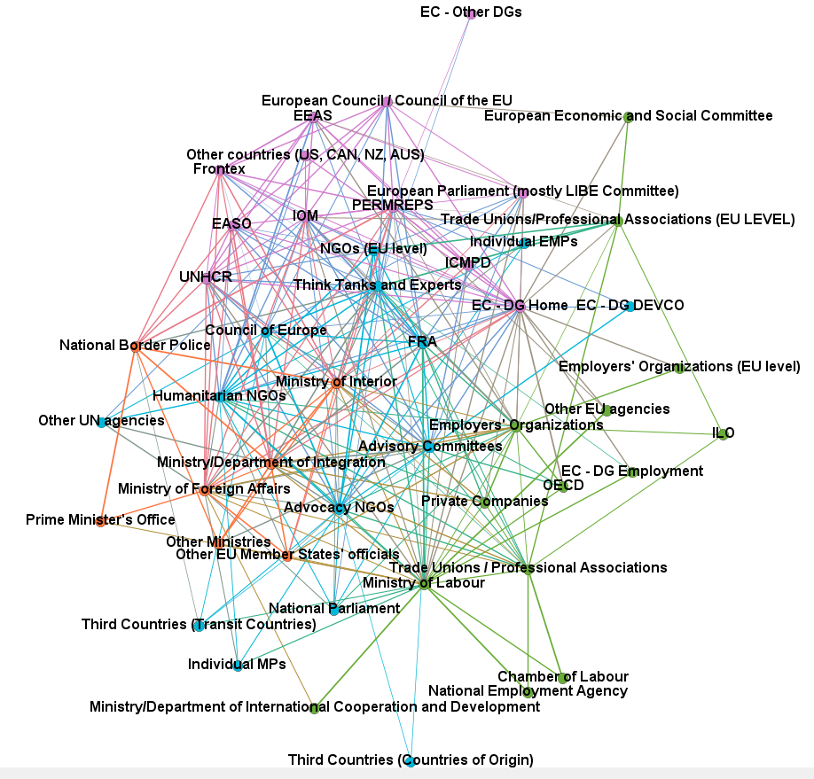
Figure A2. Network representing the degree of framing consonance among actors within the EU migration policy system. Edges represent discussions among actors. The weight of edges is proportional to their degree of framing consonance. Colours identify clusters of actors sharing more similar perspectives/views.

Table A1 –List of Interviewees.

TYPE OF ACTOR | MIGRATION-RELATED COMPONENTS/ PORTFOLIOS (if >1) | NUMBER OF INTERVIEWEES | EU COUNTRIES
Advisory Committees |  | 2 | UK, NED
Advocacy NGOs (national level) |  | 2 | NED, SPA
Council of Europe |  | 1
EC - DG Home | High-Skilled | 1
 | Externalisation | 1
 | Integration | 1
 | Border Management | 1
EEAS |  | 1
Employers' Organizations |  | 2 | AUT, GER
European Council / Council of the EU |  | 1
FRA |  | 1
Humanitarian NGOs (national level) |  | 3 | SP, NED, AUT
IOM |  | 1
Ministry/Department of International Cooperation and/or Development |  | 1
Ministry of Foreign Affairs |  | 2 | GER, ITA
Ministry of Interior | Migration/Asylum | 2 | GER, AUT
 | Border Control | 2 | NED, UK
Ministry of Labour |  | 4 | AUT; GER; SP; ITA
Ministry/Department of Integration/ Naturalisation |  | 2 | GER; NED
National Border Police |  | 1 | SPA
NGOs (EU level) |  | 1
PERMREP |  | 3 | UK, NED, AUT
Think Tanks and Experts (progressive) |  | 1
Trade Unions / Professional Associations (national level) |  | 2 | AUT; GER
Trade Unions/Professional Associations (EU level) |  | 1
UNHCR |  | 1
TOTAL |  | 41

Table A2. List of actors listed in the survey filled in by interviewees.

Advisory Committees; Advocacy NGOs (national level); Chamber of Labour; Council of Europe; EASO; EC (DG DEVCO); EC (DG Employment); EC (DG Home); EC (Other DGs); EEAS; Employers' Organizations (EU level); Employers' Organizations; European Council / Council of the EU; European Economic and Social Committee; European Parliament; FRA; Frontex; Humanitarian NGOs (national level); ICMPD; ICRC; ILO; Individual EMPs; Individual MPs; IOM; Ministry of Foreign Affairs; Ministry of Interior; Ministry of Labour; Ministry/Department of Integration/ Naturalisation; Ministry/Department of International Cooperation and/or Development; National Border Police; National Employment Agency; National Parliament; NGOs (EU level); OECD; Other EU agencies; Other EU Member States' officials; Other Ministries; Other UN agencies; PERMREP; Prime Minister's Office; Private Companies; Think Tanks and Experts; Third Countries (Countries of Origin); Third countries (EFTA Member States); Third Countries (Transit Countries); Third countries (US, CAN, NZ, AUS); Trade Unions / Professional Associations (national level); Trade Unions/Professional Associations (EU level); UNHCR.

