Supplementary material

Number of measurements needed for obtaining a reliable estimate of home blood pressure and hypertension status
Eline H. Groenland, MD, Michiel L. Bots, MD, PhD, Frank L.J. Visseren, MD, PhD, Richard J. McManus, MBBS, PhD, Wilko Spiering, MD, PhD

Corresponding author
Wilko Spiering, MD PhD; Department of Vascular Medicine; University Medical Center Utrecht; Utrecht University; P.O. Box 85500; 3508 GA Utrecht; The Netherlands; Phone: +31 (0)88 7571188; Email: W.Spiering@umcutrecht.nl

Supplementary File 1 – Linear mixed model for home blood pressure measurements

$$y_{ij}= β_{0} +{u_{0i}+βX_{ij}^{T}+ ε}_{ij}$$

$$Where:$$
$$- y_{ij}:j^{th} blood pressure measurement for i^{th} individual$$
$$- β_{0}:average home BP in population on day 7 (j=7)$$
$$- u_{0i}:random intercept for i^{th} individual with u_{0i}\sim N(0,σ_{between}^{2})$$
$$- β :\left(row\right) vector with fixed effects$$
$$- X_{ij} :\left(row\right) vector with explanatory covariates$$
$$(day after start HBPM, moment of measurement \left(morning or evening)\right) \\ - ε_{ij} :residual variance with ε_{i}∼N\left(0,Σ\right) for covariance matrix Σ$$

Such that $β_{0} +u_{0i}$ equals the true home BP for individual $i$, and $ε_{ij}$ equals the deviation of the measurement from the expected BP at the $j^{th}$ measurement.
With this model the average of $k$ BP measurements, ${\overline{y}}_{ik}=\frac{1}{k}\sum_{j=1}^{k}{y_{ij}}$, is normally distributed: ${\overline{y}}_{ik}∼N(β_{0}+u_{0i}+\frac{1}{k}\sum_{j=1}^{k}{βX_{ij}^{T}}, zΣ_{k}z^{T}$), where $Σ_{k}$ is the sub-matrix consisting of the first $k$ rows and columns of the covariance matrix $Σ and z=\left(\frac{1}{k},\frac{1}{k},…,\frac{1}{k}\right)$ is a row vector with $k$ elements. Thus, $zΣ_{k}z^{T}$ equals the sum of all elements of $Σ_{k}$ divided by $k^{2}.$
Supplementary Table 1 – Parameter estimates from model for systolic BP measurements

$$β_{0}$$ | 140.82
$$σ_{between}^{ }$$ | 15.89
$$β_{morning}$$ | -0.94
$$β_{evening}$$ | 0.94
$$β_{day 1}$$ | 5.51
$$β_{day 2}$$ | 3.33
$$β_{day 3}$$ | 2.34
$$β_{day 4}$$ | 1.59
$$β_{day 5}$$ | 1.10
$$β_{day 6}$$ | 0.96

Supplementary Table 2 – Parameter estimates from model for diastolic BP measurements

$$β_{0}$$ | 83.57
$$σ_{between}^{ }$$ | 9.36
$$β_{morning}$$ | 0.32
$$β_{evening}$$ | -0.32
$$β_{day 1}$$ | 2.22
$$β_{day 2}$$ | 1.18
$$β_{day 3}$$ | 0.67
$$β_{day 4}$$ | 0.43
$$β_{day 5}$$ | 0.15
$$β_{day 6}$$ | 0.20

Supplementary Table 3 – Covariance matrix $(Σ)$ estimate from model for systolic BP measurements

 | 1 | 2 | 3 | 4 | 5 | 6 | 7 | 8 | 9 | 10 | 11 | 12 | 13 | 14
1 | 86.95 | 3.46 | 29.84 | -8.72 | 18.92 | -11.12 | 9.19 | -8.28 | 5.99 | -5.97 | 3.85 | -3.94 | 2.59 | -2.64
2 | 3.46 | 129.55 | 3.46 | 44.46 | -8.72 | 28.20 | -11.12 | 13.69 | -8.28 | 8.92 | -5.97 | 5.73 | -3.94 | 3.86
3 | 29.84 | 3.46 | 86.95 | 3.46 | 29.84 | -8.72 | 18.92 | -11.12 | 9.19 | -8.28 | 5.99 | -5.97 | 3.85 | -3.94
4 | -8.72 | 44.46 | 3.46 | 129.55 | 3.46 | 44.46 | -8.72 | 28.20 | -11.12 | 13.69 | -8.28 | 8.92 | -5.97 | 5.73
5 | 18.92 | -8.72 | 29.84 | 3.46 | 86.95 | 3.46 | 29.84 | -8.72 | 18.92 | -11.12 | 9.19 | -8.28 | 5.99 | -5.97
6 | -11.12 | 28.20 | -8.72 | 44.46 | 3.46 | 129.55 | 3.46 | 44.46 | -8.72 | 28.20 | -11.12 | 13.69 | -8.28 | 8.92
7 | 9.19 | -11.12 | 18.92 | -8.72 | 29.84 | 3.46 | 86.95 | 3.46 | 29.84 | -8.72 | 18.92 | -11.12 | 9.19 | -8.28
8 | -8.28 | 13.69 | -11.12 | 28.20 | -8.72 | 44.46 | 3.46 | 129.55 | 3.46 | 44.46 | -8.72 | 28.20 | -11.12 | 13.69
9 | 5.99 | -8.28 | 9.19 | -11.12 | 18.92 | -8.72 | 29.84 | 3.46 | 86.95 | 3.46 | 29.84 | -8.72 | 18.92 | -11.12
10 | -5.97 | 8.92 | -8.28 | 13.69 | -11.12 | 28.20 | -8.72 | 44.46 | 3.46 | 129.55 | 3.46 | 44.46 | -8.72 | 28.20
11 | 3.85 | -5.97 | 5.99 | -8.28 | 9.19 | -11.12 | 18.92 | -8.72 | 29.84 | 3.46 | 86.95 | 3.46 | 29.84 | -8.72
12 | -3.94 | 5.73 | -5.97 | 8.92 | -8.28 | 13.69 | -11.12 | 28.20 | -8.72 | 44.46 | 3.46 | 129.55 | 3.46 | 44.46
13 | 2.59 | -3.94 | 3.85 | -5.97 | 5.99 | -8.28 | 9.19 | -11.12 | 18.92 | -8.72 | 29.84 | 3.46 | 86.95 | 3.46
14 | -2.64 | 3.86 | -3.94 | 5.73 | -5.97 | 8.92 | -8.28 | 13.69 | -11.12 | 28.20 | -8.72 | 44.46 | 3.46 | 129.55

Supplementary Table 4 – Covariance matrix (Σ) estimate from model for diastolic BP measurements

 | 1 | 2 | 3 | 4 | 5 | 6 | 7 | 8 | 9 | 10 | 11 | 12 | 13 | 14
1 | 27.04 | 0.91 | 9.35 | -2.21 | 6.47 | -3.52 | 3.11 | -2.61 | 2.10 | -2.03 | 1.38 | -1.36 | 0.96 | -0.95
2 | 0.91 | 36.37 | 0.91 | 12.57 | -2.21 | 8.70 | -3.52 | 4.18 | -2.61 | 2.82 | -2.03 | 1.85 | -1.36 | 1.29
3 | 9.35 | 0.91 | 27.04 | 0.91 | 9.35 | -2.21 | 6.47 | -3.52 | 3.11 | -2.61 | 2.10 | -2.03 | 1.38 | -1.36
4 | -2.21 | 12.57 | 0.91 | 36.37 | 0.91 | 12.57 | -2.21 | 8.70 | -3.52 | 4.18 | -2.61 | 2.82 | -2.03 | 1.85
5 | 6.47 | -2.21 | 9.35 | 0.91 | 27.04 | 0.91 | 9.35 | -2.21 | 6.47 | -3.52 | 3.11 | -2.61 | 2.10 | -2.03
6 | -3.52 | 8.70 | -2.21 | 12.57 | 0.91 | 36.37 | 0.91 | 12.57 | -2.21 | 8.70 | -3.52 | 4.18 | -2.61 | 2.82
7 | 3.11 | -3.52 | 6.47 | -2.21 | 9.35 | 0.91 | 27.04 | 0.91 | 9.35 | -2.21 | 6.47 | -3.52 | 3.11 | -2.61
8 | -2.61 | 4.18 | -3.52 | 8.70 | -2.21 | 12.57 | 0.91 | 36.37 | 0.91 | 12.57 | -2.21 | 8.70 | -3.52 | 4.18
9 | 2.10 | -2.61 | 3.11 | -3.52 | 6.47 | -2.21 | 9.35 | 0.91 | 27.04 | 0.91 | 9.35 | -2.21 | 6.47 | -3.52
10 | -2.03 | 2.82 | -2.61 | 4.18 | -3.52 | 8.70 | -2.21 | 12.57 | 0.91 | 36.37 | 0.91 | 12.57 | -2.21 | 8.70
11 | 1.38 | -2.03 | 2.10 | -2.61 | 3.11 | -3.52 | 6.47 | -2.21 | 9.35 | 0.91 | 27.04 | 0.91 | 9.35 | -2.21
12 | -1.36 | 1.85 | -2.03 | 2.82 | -2.61 | 4.18 | -3.52 | 8.70 | -2.21 | 12.57 | 0.91 | 36.37 | 0.91 | 12.57
13 | 0.96 | -1.36 | 1.38 | -2.03 | 2.10 | -2.61 | 3.11 | -3.52 | 6.47 | -2.21 | 9.35 | 0.91 | 27.04 | 0.91
14 | -0.95 | 1.29 | -1.36 | 1.85 | -2.03 | 2.82 | -2.61 | 4.18 | -3.52 | 8.70 | -2.21 | 12.57 | 0.91 | 36.37

Supplementary Figure 1 - Subgroup analyses for maximal deviation from home blood pressure for 95% of individuals
A
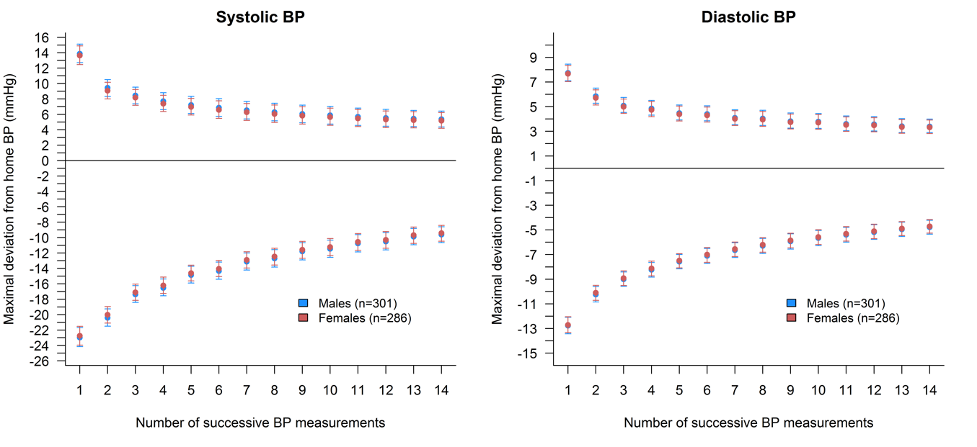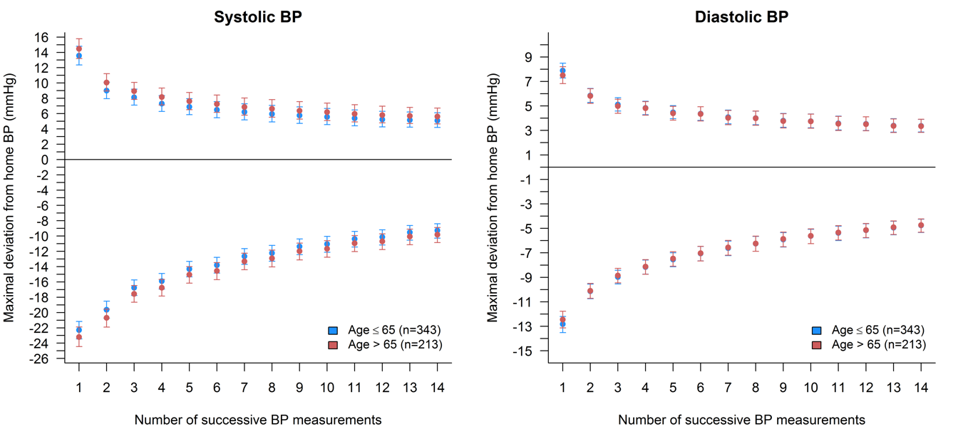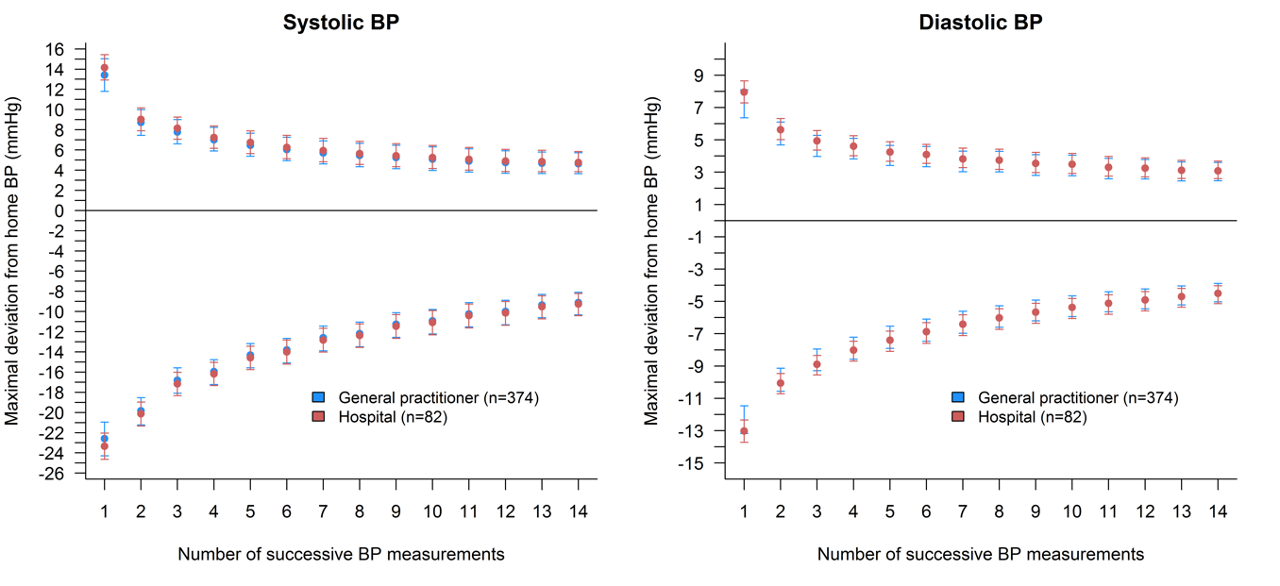
B
C
Maximal deviation from home systolic (left column) and diastolic (right column) blood pressure stratified according to sex (A), age (≤65 and >65) (B), and healthcare domain (C).
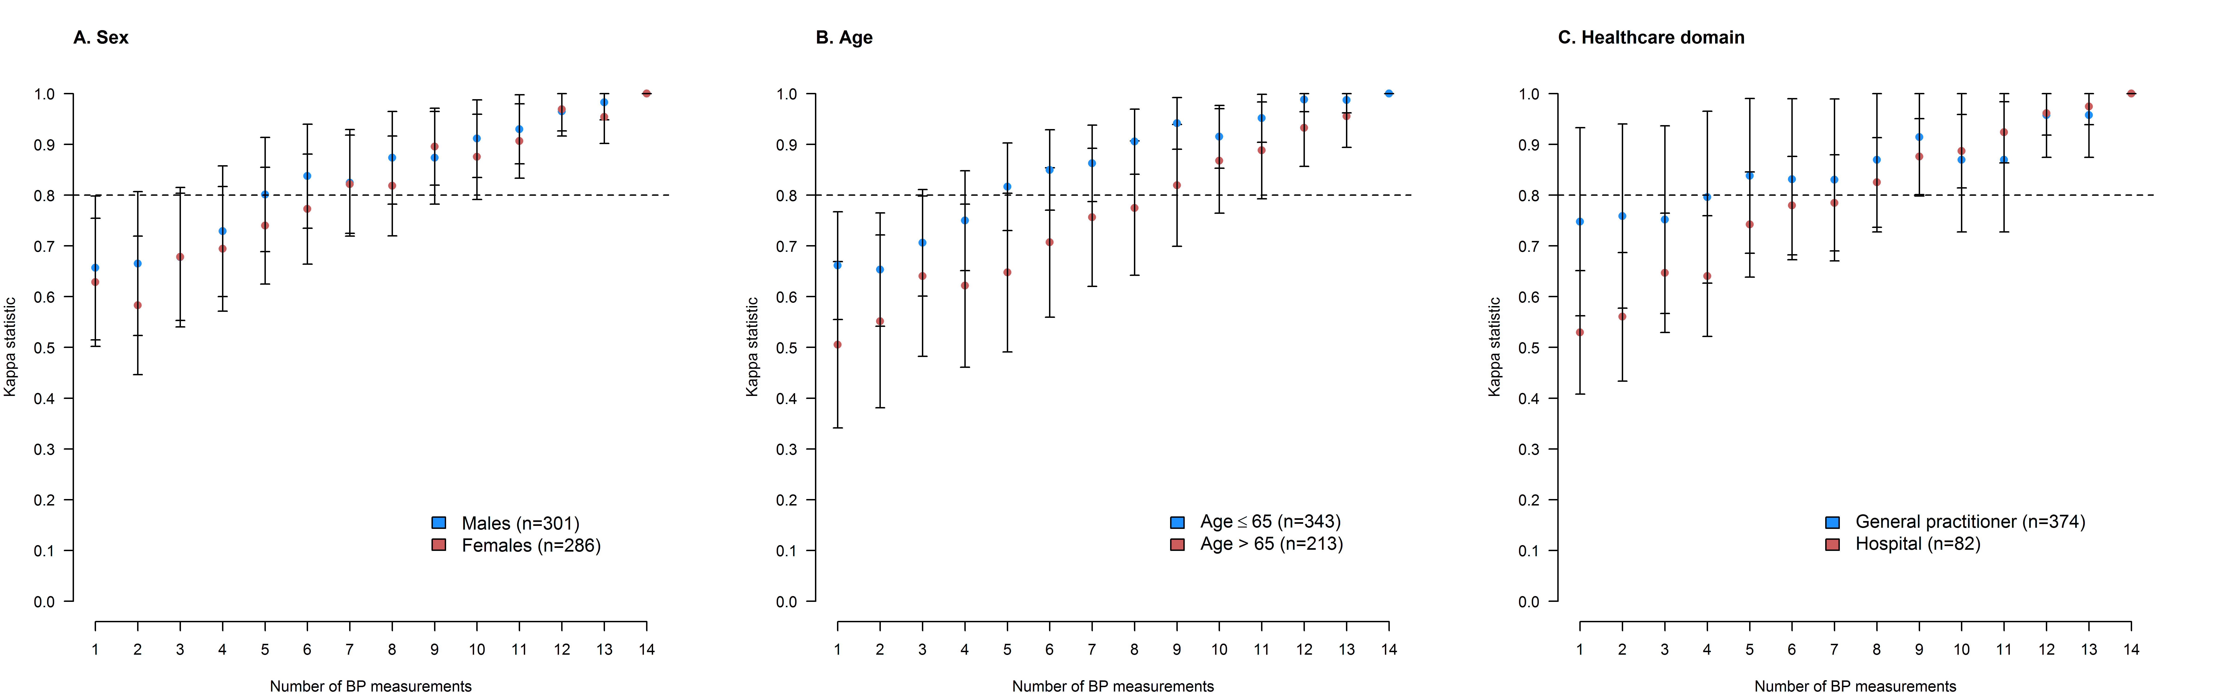
Supplementary Figure 2 – Subgroup analyses for agreement of home hypertension status determined with an increasing number of successive BP readings compared to the maximum of 14 BP readings.

Agreement (expressed by the ĸ statistic) of home hypertension status determined with an increasing number of successive BP readings stratified according to sex (A), age (≤65 and >65) (B), and healthcare domain (C).

