Supplementary Materials
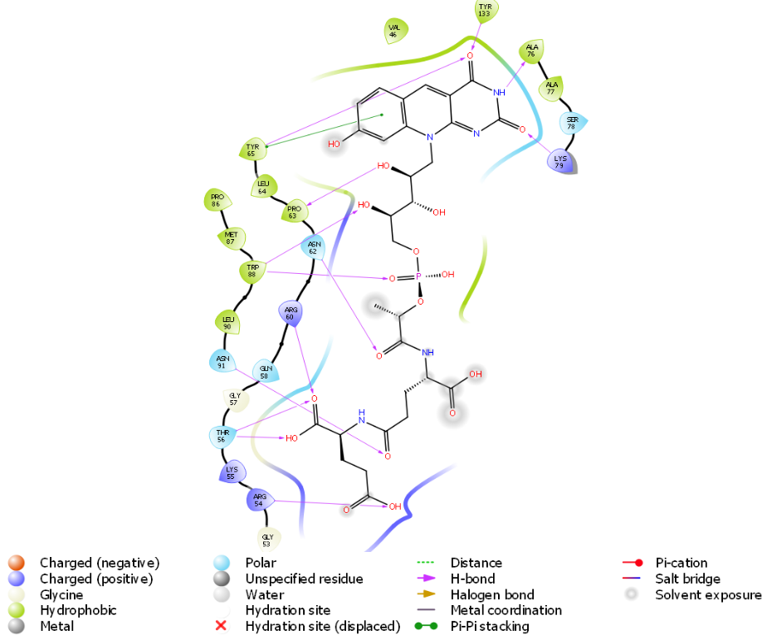

Figure S1: Analysis of the interactions between Ddn and F420H2.

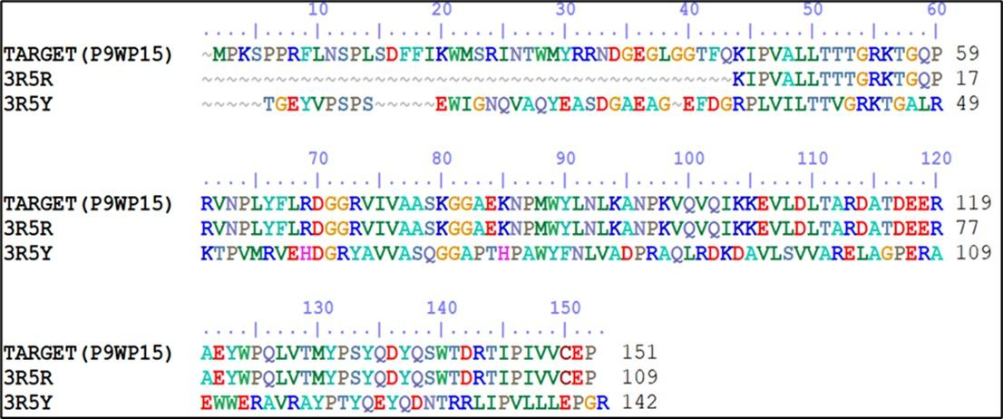

Figure S2 Alignment of query(P9WP15) with templates (3R5R & 3R5Y). The pink-colored boxes indicate ligand binding residues.
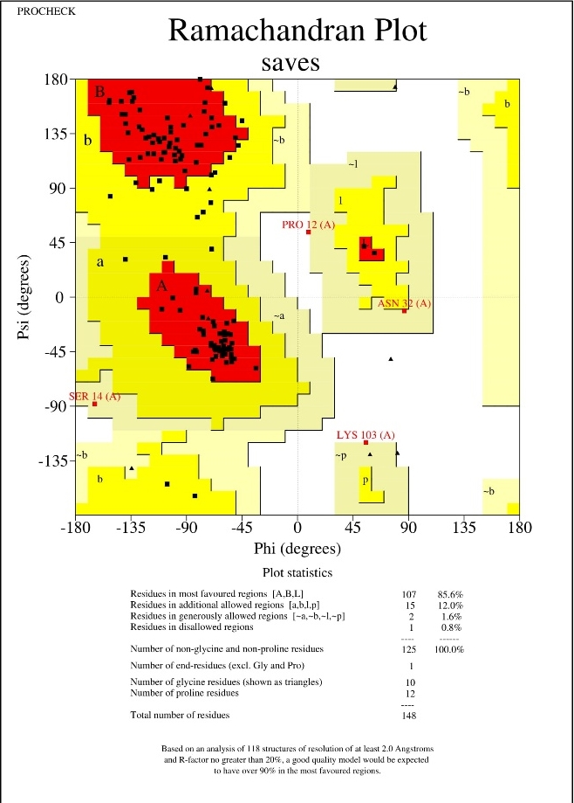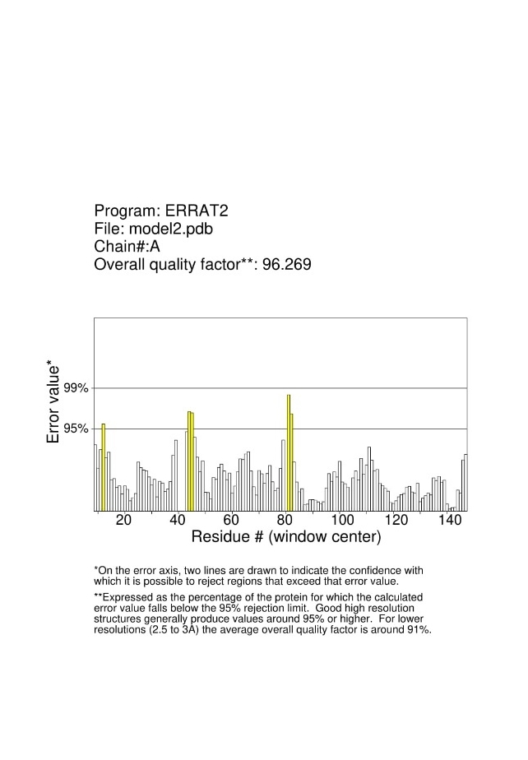
Figure S3: (A)Errat plot & (B)Ramachandran Plot of the homology modelling of Ddn protein
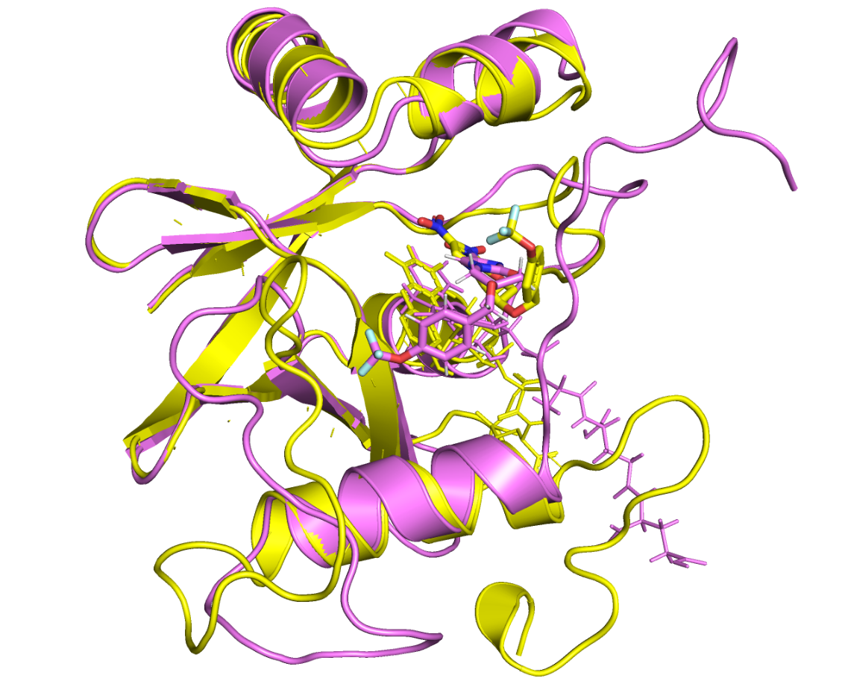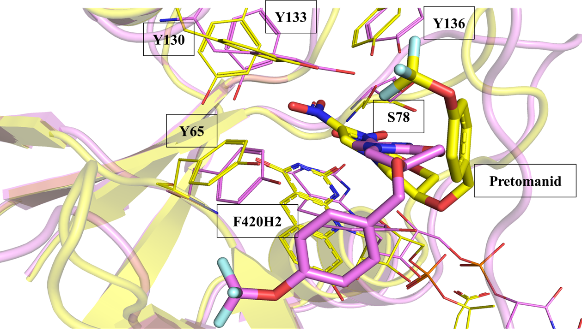
Figure S4: Pre-MD and post-MD visualisation of protein and ligand: (a) A superimposition of the pre-MD (Yellow) and post-MD (violet) snapshots of Ddn-F420-pretomanid complex. The cartoon represents the secondary structure of the protein chain; the wire and licorice-represented molecules correspond to F420 and pretomanid. (b) The change in position of pretomanid before and after MD simulation with respect to five crucial binding residues.
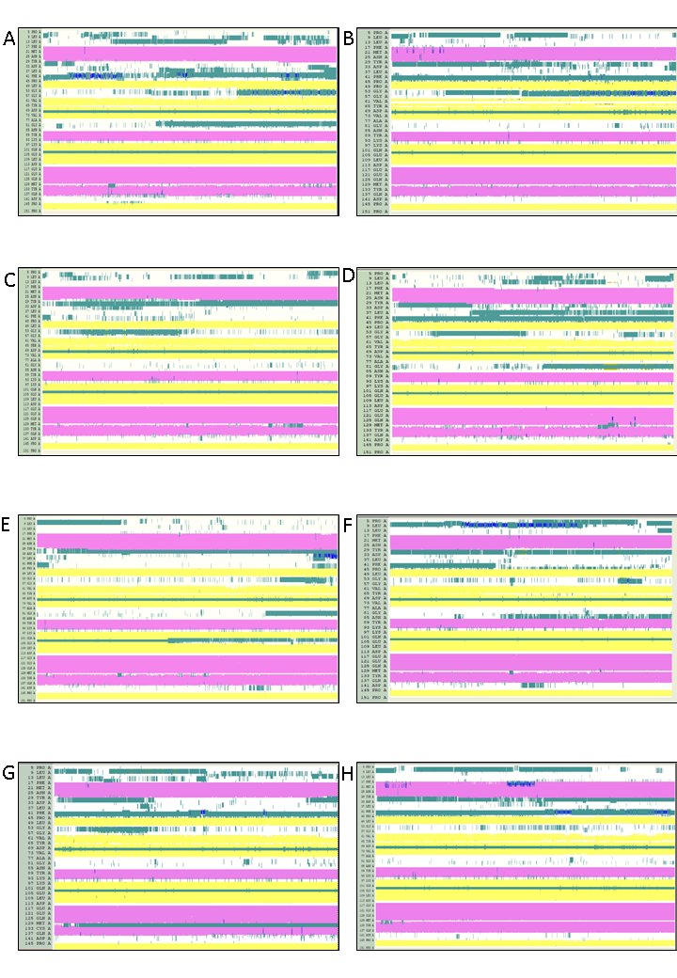
Figure S5. Secondary Structure elements and their change over the course of MD simulation during md simulation A)Ddn^{WT}, B)Ddn^{L49P}, C)Ddn^{Y65S}, D)Ddn^{S78Y}, E)Ddn^{K79Q},F)Ddn^{W88R}, G)Ddn^{Y133C}, H)Ddn^{Y136S}

Ddn^{L49P}
Ddn^{WT}
2.232Å
2.488Å
Ddn^{S78Y}
Ddn^{Y65S}
2.096Å

2.233Å

Ddn^{W88R}
Ddn^{K79Q}
1.944Å
1.841Å

Ddn^{Y136S}
Ddn^{Y133C}
1.862Å
2.383Å

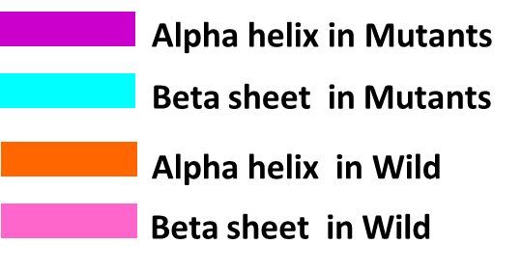
Figure S6. Structural superimposition of the top ranked cluster representative of WT and MT Ddn proteins obtained from MD. A)Ddn^{WT}, B) Ddn^{L49P},C) Ddn^{Y65S},D) Ddn^{S78Y},E) Ddn^{K79Q},F) Ddn^{W88R},G) Ddn^{Y133C},H) Ddn^{Y136S}

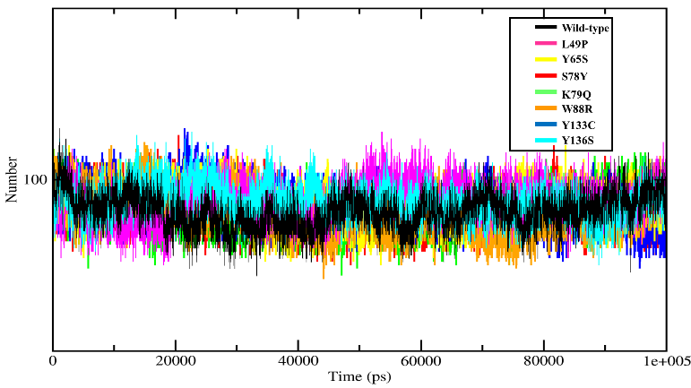
Figure S7 Analysis of intramolecular H-bonds of Ddn wild and mutant protein complexes at 100 ns. The x-axis indicates the time (ps), and the y-axis indicates the number of H-bonds. The Ddn^{WT}, Ddn^{L49P}, Ddn^{Y65S}, Ddn^{S78Y}, Ddn^{K79Q}, Ddn^{W88R}, Ddn^{Y133C}, Ddn^{Y136S} is indicated in black, red, green, blue, yellow, magenta, orange and cyan respectively.
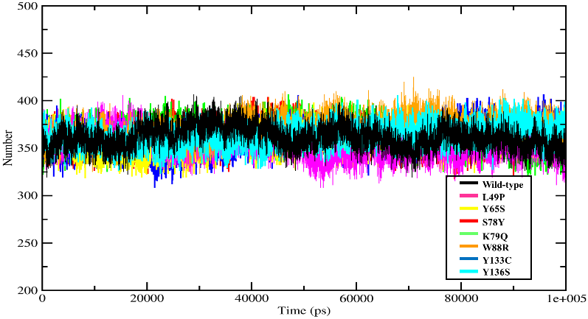
Figure S8: Analysis of inter-molecular H-bonds of Ddn wild and mutant protein complexes at 100 ns. The x-axis indicates the time (ps), and the y-axis indicates the number of H-bonds. The Ddn^{WT}, Ddn^{L49P}, Ddn^{Y65S}, Ddn^{S78Y}, Ddn^{K79Q}, Ddn^{W88R}, Ddn^{Y133C}, Ddn^{Y136S} is indicated in black, red, green, blue, yellow, magenta, orange and cyan respectively
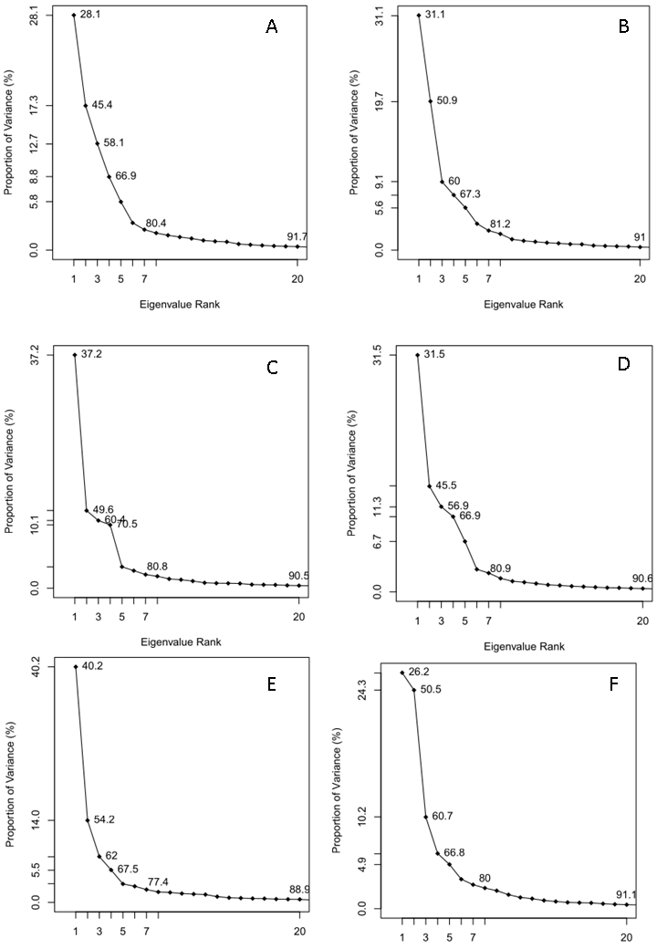
Figure S9: Shows first two eigenvectors PC1 and PC2. A)Ddn^{WT} B)Ddn^{L49P} C)Ddn^{Y65S} D)Ddn^{S78Y} E)Ddn^{K79Q} F)Ddn^{W88R} G)Ddn^{Y133C} H)Ddn^{Y136S}

System | Ddn^{WT} | Ddn^{L49P} | Ddn^{Y65S} | Ddn^{S78Y} | Ddn^{K79Q} | Ddn^{W88R} | Ddn^{Y133C} | Ddn^{Y136S}
R54 | 0.001 | 0.002 | 0 | 0 | 0.001 | 0 | 0 | 0
K55 | 0 | 0 | 0 | 0.001 | 0.052 | 0 | 0 | 0.001
T56 | 0 | 0 | 0 | 0.001 | 0.029 | 0.001 | 0 | 0
R60 | 0.123 | 0.037 | 0.072 | 0.332 | 0.359 | 0.043 | 0.008 | 0.065
N62 | 0.549 | 0.741 | 0.897 | 0.916 | 0.338 | 0.346 | 0.293 | 0.159
P63 | 0.913 | 0.887 | 0.908 | 0.889 | 0.650 | 0.184 | 0.709 | 0.535
Y65* | 0.972 | 0.902 | 1.132 | 0.962 | 0.976 | 0.866 | 0.844 | 0.979
A76 | 0.481 | 0.636 | 0.468 | 0.109 | 0.426 | 0.371 | 0.874 | 0.462
K79* | 0 | 0 | 0 | 0 | 0 | 0.049 | 0 | 0
M87 | 0.607 | 0.788 | 0.810 | 0.722 | 0.671 | 0.076 | 0 | 0.651
W88* | 1.266 | 0.789 | 1.035 | 0.962 | 0.936 | 0.390 | 0.874 | 0.613
N91 | 0 | 0.004 | 0 | 0.011 | 0.289 | 0 | 0.564 | 0.024
Y133* | 0.034 | 0.097 | 0.450 | 0.217 | 0.138 | 0.082 | 1.095 | 0.320

Table S1: Average number of hydrogen bonds formed by each residue interacting with the cofactor F420H ̄

