To be put in supplementary materials
Figure 1
Sample Screenshot of One Test Question for TSLCT
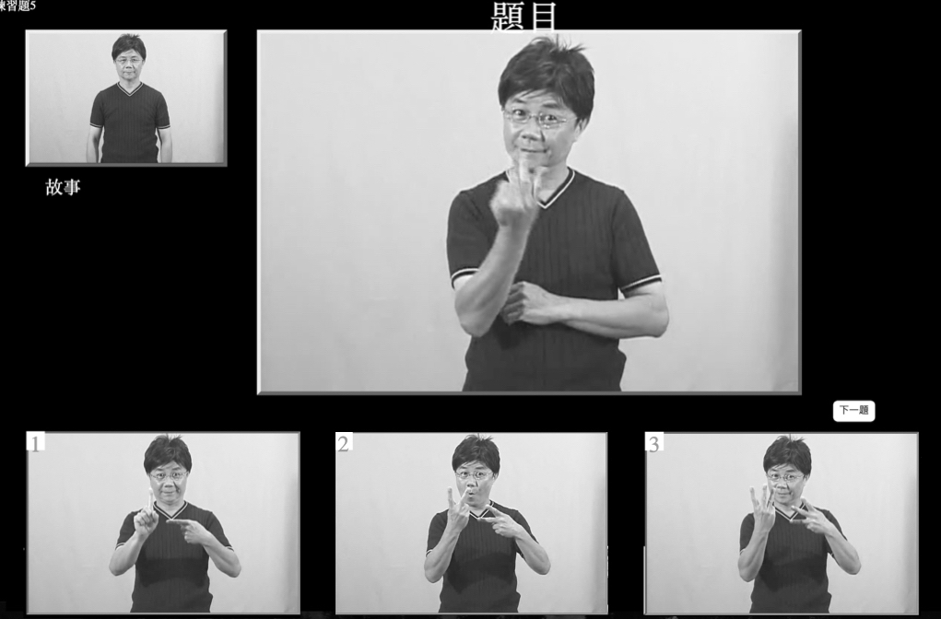
Note. The top left panel is a short story signed in TSL which participants will have already reviewed, but is available for review as participants make their answer. The next panel on top right is the question, HOW MANY(多少). The three panels on lower screen are the answer choices. (1) ONE (ㄧ); (2) TWO (二); (3) THREE (三). When the participant clicks on the correct answer, on screen then a check appears on the number. Written consent was obtained from individuals in this image.
Figure 1 Alt Text: Here are five screenshots, each of which shows the same male deaf adult signing Taiwanese Sign Language.

Figure 2
Sample Screenshot of One Test Question for TSL-RST
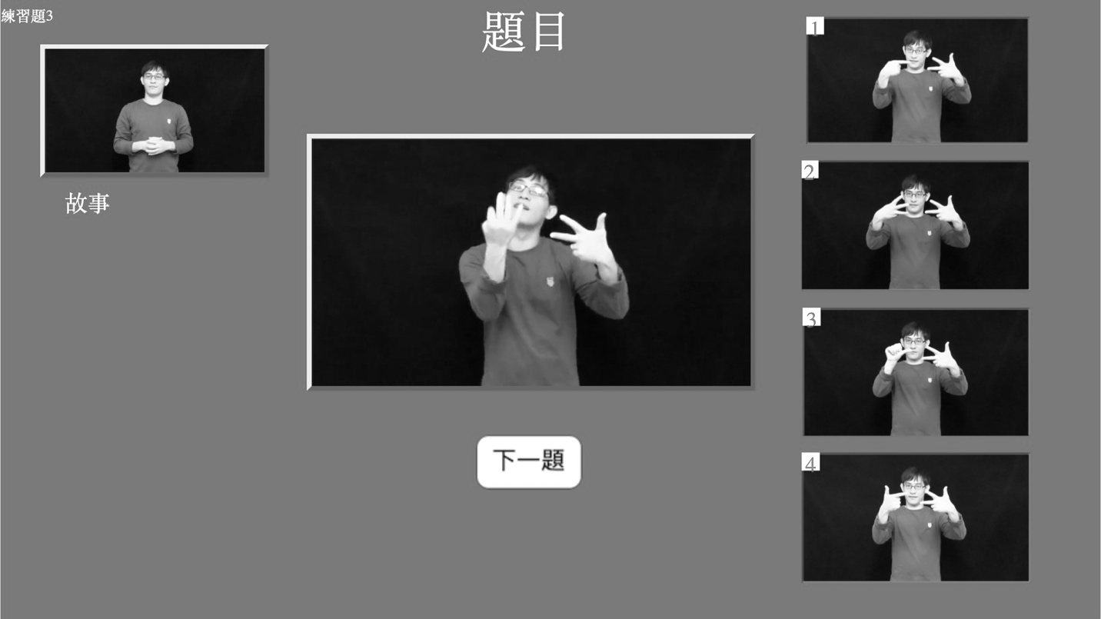
Note. The top left panel is a short narrative signed in TSL which participants will have already reviewed, but is available for review as participants make their answer. The mid panel is the question, WHAT DAY….? (星期幾). The four panels on right side screen are the answer choices. (1) MONDAY (星期一); (2) WEDNESDAY (星期三); (3) FRIDAY (星期五); (4) SATURDAY (星期六). When the participant clicks on the correct answer on the screen then a check appears on the number. Written consent was obtained from individuals in this image.
Figure 2 Alt Text: Here are six screenshots, each of which shows the same male deaf adult signing Taiwanese Sign Language.

Appendix A
Background Questionnaire

1. Name
2. Gender: Female______ Male________
3. Date of Birth
4. Mother: Deaf_____ Hearing_______
5. Father: Deaf______Hearing_______
6. Age when you first learned TSL___________
7. How many years have you been using TSL ____________
8. Age of onset of Deafness: Before Age 3________ After age 3__________
9. dB in Better ear:
55-69 dB________
70-90 dB________
91+ dB_________
10. Years living in Deaf School dormitory
0-3 yrs. ________
4-8 yrs. ________
9-12 yrs._______
11. Years attending Deaf school
1-4 yrs._______
5-8 yrs._______
9+ yrs.________
12. TSL ability (self-report)
Basic ________
Intermediate _______
Advanced __________
13. Teacher-Rating of Child TSL Skills
Basic ________
Intermediate _______
Advanced __________

Appendix B
Chinese (Mandarin) Reading Comprehension Test (Zhang & Yang, 2004): Sample Items Translated Into English
Total number of passages = 17
The content included four types of texts: 4 requiring interpretation (with 4 questions), 4 requiring proposition combination (with 4 questions), three requiring sentence comprehension (with 3 questions questions), and short essay reading (with 6 questions). The test had a total of 17 questions.
Four Samples are shown here:
- Interpretation
I forgot to bring an eraser. The classmate next to me has two piece. I can ______from her.
  - grab
  - sell
  - borrow
  - ask

- Proposition combination
At night, everyone was exhausted and soon fell into a sweet dream. What's are everyone doing?
- got sick
- walked into the hometown
- fell asleep
- had a nightmare

- Sentence comprehension
My mother and I went shopping for clothes, and my younger brother also followed.
- My mother and I went shopping for clothes
- Mom and my younger brother go shopping for clothes
- My mother, my younger brother and I went shopping together
- My older brother accompanies me and my mother to buy clothes

- Short essay reading
Dang! Dang! The bell rang after class and the children all ran out to play. Suddenly, John rushed out of the classroom and bumped into Bob in the hallway, and both of them fell. John lost one tooth, but the other had a nosebleed. The teacher saw it and told the two to go to the health center to find the nurse aunt.
Q: John lost one tooth, but the other has a nosebleed. Who is the other one referring to?
- teacher
- nurse’s aunt
- Bob
- John

This scale uses a rigorous test preparation process to draw research samples. The pre-sample is a first-year elementary school student, with a total of 286 students. In terms of norms, a total of 669 first-year pupils were selected. In terms of the reliability of this scale, the internal consistency a reliability coefficient is .86 and the test-retest reliability is .74, reaching a significant level of .01. After analyzing the above test, it can be seen that this scale has quite good reliability and validity.

