Supplementary Tables and Figures

Honeys derived from plants of the coastal sandplains of Western Australia: antibacterial and antioxidant activity, and other characteristics.

Kathryn J. Green^{1,2}, Md Khairul Islam^{1,3}, Ivan Lawag^{1,3}, Cornelia Locher^{1,3}, Katherine A. Hammer^{1,2}

¹ Cooperative Research Centre for Honey Bee Products Limited (CRC HBP), The University of Western Australia, Crawley, 6009, Australia
² School of Biomedical Sciences, The University of Western Australia, Crawley, 6009, Australia
³ Division of Pharmacy, School of Allied Health, The University of Western Australia, Crawley, 6009, Australia
Correspondence: katherine.hammer@uwa.edu.au

Supplementary Table 1. Typical HPTLC fingerprinting bands determined for four floral sources.
Supplementary Figure 1. Map of Western Australia indicating locations of bee hives within several bioregions.

Floral source | R254 | R366 (developed) | White light | R366 after derivitisation with vanillin
Agonis flexuosa | 0.22  0.32 (blue)  0.38 (major)  0.53 | 0.11 (yellow)  0.32 (bright blue)  0.42  0.50 | 0.10  0.23 (ash)  0.38 (blue)  0.47 (orange) | 0.22  0.3 (bright blue)  0.37 (brick red)  0.49 (bright red)
Banksia menziesii | 0.23  0.33  0.40 | 0.23 (light blue)  0.32 (very faint  light blue) | 0.23 (red-brown)  0.40 (brown) | 0.23 (beige)  0.40 (brown)  0.46  0.55
Banksia sessilis |  | 0.32 (light blue) | 0.42 (dark blue)  0.47 (light blue) | 0.42 (red-brown)  0.48 (red)  0.55
Calothamnus |  | 0.23 (light blue)*  0.32 (light blue) | 0.33*  0.42 (dark blue)  0.47 (light blue) | 0.31  0.35  0.42 (light green)*  0.48 (brick red)
Bold type indicates key identification bands. *Faint but important band

Supplementary Figure 2: Colour (A) and total phenolics content (B) of selected floral sources.
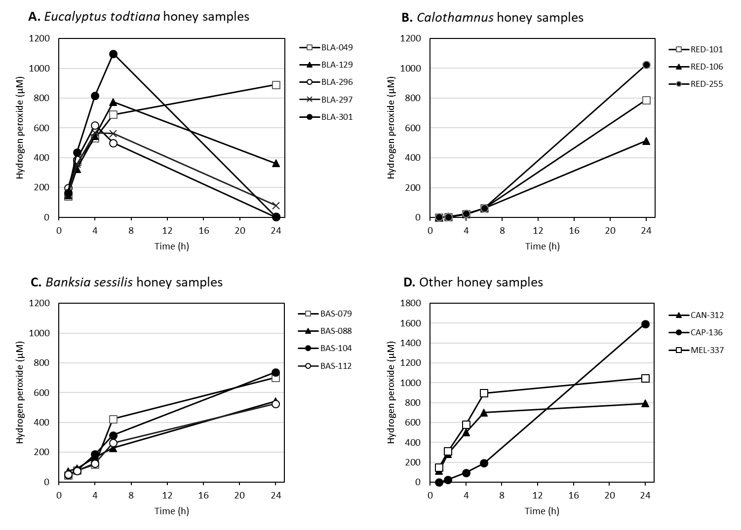
Supplementary Figure 3. Honey samples (n = 15) producing greater than 500 µM hydrogen peroxide at one or more time points.

Supplementary Figure 4. PCA proportion of variance

Supplementary Table 2. Loadings of PCA. Values greater than 0.5 or less than -0.5 are indicated in bold type.

Variable | PC1 | PC2
Mean MIC | -0.377 | 0.722
pH | -0.494 | -0.604
Refractive Index (nD20) | -0.379 | -0.451
Colour After Filtering | 0.821 | -0.247
Total Phenolics (GA eq.mg /100g) | 0.917 | -0.166
µmol TE/kg at 2 hrs | 0.904 | -0.225
HP 6h | -0.379 | -0.713
HP 24h | -0.145 | -0.623
Eigenvalue | 3.027 | 2.126
Percentage variance explained | 37.84% | 26.58%
Cumulative proportion of variance | 37.84% | 64.41%

Supplementary Table 3. Correlation matrix from PCA of 20 variables.
 | S. aureus MIC | E. coli MIC | E. faecalis MIC | P. aeruginosa MIC | Mean MIC | Antibacterial Value | Phenol Equivalence | pH | Refractive Index | Brix | Colour - Filtering | Colour + Filtering | Total Phenolics | Antioxidant (DPPH) | Antioxidant (FRAP) | Hydrogen peroxide 1h | Hydrogen peroxide 2h | Hydrogen peroxide 4h | Hydrogen peroxide 6h | Hydrogen peroxide 24h
- S. aureus MIC | 1.00
- E. coli MIC | 0.90 | 1.00
- E. faecalis MIC | 0.64 | 0.73 | 1.00
- P. aeruginosa MIC | 0.88 | 0.84 | 0.67 | 1.00
- Mean MIC | 0.96 | 0.96 | 0.78 | 0.93 | 1.00
- Antibacterial Value | -0.92 | -0.90 | -0.75 | -0.94 | -0.96 | 1.00
- Phenol equivalence | -0.74 | -0.78 | -0.68 | -0.75 | -0.80 | 0.79 | 1.00
- pH | -0.17 | -0.10 | -0.12 | -0.10 | -0.14 | 0.05 | 0.13 | 1.00
- Refractive Index | -0.24 | -0.16 | -0.02 | -0.14 | -0.18 | 0.14 | 0.15 | 0.44 | 1.00
- Brix | -0.24 | -0.17 | -0.03 | -0.15 | -0.18 | 0.14 | 0.15 | 0.44 | 1.00 | 1.00
- Colour - Filtering | -0.20 | -0.23 | -0.26 | -0.31 | -0.26 | 0.34 | 0.12 | -0.34 | -0.30 | -0.30 | 1.00
- Colour + Filtering | -0.33 | -0.34 | -0.31 | -0.43 | -0.38 | 0.43 | 0.16 | -0.14 | -0.18 | -0.18 | 0.91 | 1.00
- Total Phenolics | -0.29 | -0.41 | -0.25 | -0.38 | -0.36 | 0.38 | 0.19 | -0.32 | -0.23 | -0.23 | 0.72 | 0.75 | 1.00
- Antioxidants (DPPH) | -0.39 | -0.49 | -0.41 | -0.49 | -0.47 | 0.51 | 0.34 | -0.29 | -0.18 | -0.18 | 0.69 | 0.71 | 0.86 | 1.00
- Antioxidants (FRAP) | -0.42 | -0.52 | -0.44 | -0.54 | -0.51 | 0.54 | 0.35 | -0.20 | -0.12 | -0.11 | 0.70 | 0.74 | 0.85 | 0.95 | 1.00
- Hydrogen peroxide 1h | -0.35 | -0.27 | -0.32 | -0.31 | -0.34 | 0.30 | 0.51 | 0.48 | 0.19 | 0.19 | -0.35 | -0.26 | -0.40 | -0.32 | -0.29 | 1.00
- Hydrogen peroxide 2h | -0.34 | -0.28 | -0.40 | -0.33 | -0.36 | 0.32 | 0.51 | 0.44 | 0.15 | 0.15 | -0.27 | -0.19 | -0.33 | -0.27 | -0.25 | 0.92 | 1.00
- Hydrogen peroxide 4h | -0.36 | -0.31 | -0.47 | -0.35 | -0.39 | 0.34 | 0.50 | 0.48 | 0.16 | 0.16 | -0.23 | -0.14 | -0.28 | -0.21 | -0.20 | 0.86 | 0.97 | 1.00
- Hydrogen peroxide 6h | -0.35 | -0.31 | -0.42 | -0.31 | -0.37 | 0.31 | 0.45 | 0.49 | 0.19 | 0.19 | -0.24 | -0.15 | -0.25 | -0.20 | -0.20 | 0.78 | 0.91 | 0.96 | 1.00
- Hydrogen peroxide 24h | -0.21 | -0.21 | -0.12 | -0.16 | -0.20 | 0.13 | 0.15 | 0.29 | 0.16 | 0.16 | -0.02 | -0.01 | 0.03 | -0.02 | 0.00 | 0.18 | 0.25 | 0.31 | 0.44 | 1.00

