Supporting Information
A combination strategy of structure-based virtual screening, MM-GBSA, cross docking, molecular dynamics and metadynamics simulations used to investigate natural compounds as potent and specific inhibitors of tumor linked human carbonic anhydrase IX
Varun Chahal and Rita Kakkar*
Computational Chemistry Group, Department of Chemistry, University of Delhi,
Delhi-110007, India
*Corresponding Author: ritakakkar10@gmail.com, rkakkar@chemistry.du.ac.in
Table S1 Docking parameters and Gibbs energies of binding (kcal mol⁻¹) of the potent hCA IX inhibitors.
Z# | Title | DS | E_{vdW} | E_{coul} | Glide energy | E_{model} | hbond | lipo | ΔG¹_{bind}
1 | ZINC085488260 | -11.72 | -19.84 | -28.03 | -47.87 | -59.85 | -1.65 | -2.80 | -141.34
2 | ZINC020060085 | -10.52 | -30.25 | -12.66 | -42.91 | -63.34 | -1.49 | -3.74 | -134.66
3 | ZINC067911367 | -11.49 | -23.83 | -18.64 | -42.48 | -54.19 | -2.66 | -3.03 | -134.41
4 | ZINC077257402 | -11.19 | -18.96 | -18.82 | -37.77 | -48.49 | -3.02 | -2.37 | -131.03
5 | ZINC067911837 | -11.08 | -15.56 | -28.21 | -43.77 | -48.36 | -4.34 | -1.46 | -129.77
6 | ZINC008765165 | -10.91 | -12.39 | -26.12 | -38.52 | -32.98 | -2.25 | -1.32 | -129.76
7 | ZINC038139746 | -12.10 | -18.64 | -23.61 | -42.25 | -60.96 | -3.15 | -2.77 | -128.51
8 | ZINC085616853 | -10.45 | -26.19 | -18.11 | -44.30 | -56.94 | -1.73 | -1.56 | -125.67
9 | ZINC031163109 | -10.90 | -27.22 | -22.89 | -50.11 | -68.80 | -1.97 | -2.38 | -125.48
10 | ZINC012296578 | -11.42 | -28.38 | -24.89 | -53.26 | -67.83 | -1.48 | -2.99 | -125.00
11 | ZINC085488298 | -11.55 | -19.38 | -29.20 | -48.58 | -63.76 | -2.30 | -2.32 | -124.93
12 | ZINC095912669 | -11.26 | -16.41 | -18.14 | -34.55 | -19.30 | -1.98 | -2.14 | -124.79
13 | ZINC008762323 | -11.59 | -27.58 | -27.69 | -55.27 | -53.76 | -1.40 | -3.19 | -124.43
14 | ZINC085493046 | -11.08 | -21.21 | -22.86 | -44.08 | -59.94 | -1.44 | -2.81 | -124.38
15 | ZINC008765233 | -10.68 | -13.80 | -24.64 | -38.43 | -38.26 | -2.07 | -1.41 | -123.74
16 | ZINC002134575 | -10.40 | -27.80 | -18.74 | -46.54 | -59.32 | -1.08 | -2.71 | -123.54
17 | ZINC067911369 | -12.23 | -16.20 | -27.55 | -43.76 | -54.71 | -5.01 | -1.83 | -123.36
18 | ZINC039560146 | -11.20 | -25.07 | -17.84 | -42.91 | -47.56 | -2.31 | -3.16 | -122.60
19 | ZINC067911842 | -11.03 | -18.44 | -30.10 | -48.54 | -52.66 | -4.38 | -1.37 | -121.93
20 | ZINC085488296 | -10.91 | -21.96 | -26.96 | -48.91 | -51.78 | -1.82 | -2.18 | -121.30
21 | ZINC077257400 | -11.48 | -22.75 | -22.54 | -45.28 | -51.64 | -2.97 | .2.68 | -121.02
22 | ZINC031159406 | -11.13 | -23.62 | -18.81 | -42.43 | -53.37 | -1.31 | -2.95 | -120.59
23 | ZINC002093715 | -10.55 | -26.06 | -20.23 | -46.29 | -55.55 | -1.08 | -2.70 | -120.16
24 | ZINC009059034 | -10.61 | -24.42 | -21.53 | -45.95 | -64.47 | -1.75 | -2.60 | -118.86
25 | ZINC004090201 | -11.05 | -34.69 | -21.95 | -56.64 | -57.86 | -1.22 | -3.44 | -118.54
26 | ZINC040313318 | -10.82 | -29.94 | -17.21 | -47.15 | -63.57 | -0.87 | -3.43 | -117.74
27 | ZINC018041859 | -10.93 | -13.64 | -15.51 | -29.14 | -33.49 | -2.30 | -1.04 | -117.61
28 | ZINC008790425 | -10.61 | -25.86 | -22.14 | -48.00 | -56.78 | -1.90 | -2.39 | -116.88
29 | ZINC014610258 | -11.03 | -15.96 | -27.53 | -43.49 | -53.90 | -1.89 | -2.11 | -116.14
30 | ZINC039560148 | -11.81 | -26.13 | -21.22 | -47.35 | -54.78 | -2.55 | -3.28 | -115.79
31 | ZINC008738298 | -11.91 | -10.52 | -12.32 | -22.83 | -28.24 | -1.22 | -1.21 | -115.69
32 | ZINC004088879 | -10.72 | -27.55 | -23.55 | -51.11 | -65.76 | -1.64 | -2.57 | -115.36
33 | ZINC002117521 | -10.68 | -29.59 | -19.53 | -49.12 | -60.72 | -1.08 | -2.91 | -115.20
34 | ZINC525915261 | -10.09 | -19.16 | -24.05 | -43.21 | -45.82 | -1.92 | -2.09 | -115.13
35 | ZINC103395445 | -10.71 | -28.41 | -20.62 | -49.03 | -56.46 | -1.52 | -2.48 | -114.82
36 | ZINC005383079 | -10.85 | -17.75 | -32.32 | -50.07 | -57.30 | -1.95 | -0.90 | -114.20
37 | ZINC031159413 | -11.29 | -22.51 | -22.89 | -45.41 | -55.42 | -2.75 | -2.36 | -112.91
38 | ZINC000141570 | -11.11 | -10.00 | -27.03 | -37.03 | -41.98 | -1.36 | -1.45 | -112.83
39 | ZINC004090368 | -10.84 | -36.12 | -20.49 | -56.60 | -83.55 | -1.22 | -3.30 | -112.72
40 | ZINC000281479 | -10.63 | -9.27 | -17.93 | -27.20 | -33.64 | -2.14 | -1.64 | -112.39
41 | ZINC248265574 | -11.90 | -14.78 | -21.43 | -36.20 | -42.61 | -2.51 | -2.03 | -112.08
42 | ZINC170625764 | -10.47 | -27.25 | -19.67 | -46.92 | -56.66 | -1.22 | -2.49 | -112.04
43 | ZINC012888345 | -11.89 | -33.15 | -24.70 | -57.85 | -74.73 | -2.34 | -2.97 | -111.09
44 | ZINC085488294 | -11.56 | -16.65 | -32.33 | -48.98 | -60.65 | -2.35 | -2.24 | -110.10
45 | ZINC031168253 | -11.19 | -17.71 | -20.07 | -37.77 | -52.87 | -3.02 | -1.58 | -108.86
46 | ZINC015116100 | -11.49 | -10.45 | -12.99 | -23.44 | -21.28 | -1.26 | -1.04 | -108.11
47 | ZINC003644712 | -10.89 | -15.32 | -24.79 | -40.11 | -46.33 | -0.73 | -1.83 | -107.94
48 | ZINC685935975 | -11.71 | -26.62 | -15.61 | -42.22 | -56.80 | -3.21 | -2.80 | -107.73
49 | ZINC004023143 | -11.37 | -14.85 | -28.67 | -43.52 | -45.39 | -1.42 | -2.01 | -107.69
50 | ZINC106611510 | -10.34 | -17.61 | -25.12 | -42.73 | -46.86 | -2.94 | -1.19 | -107.39
51 | ZINC002116233 | -10.39 | -25.97 | -19.65 | -45.63 | -57.59 | -1.42 | -2.11 | -107.38
52 | ZINC014776978 | -12.66 | -14.78 | -24.18 | -38.96 | -60.56 | -4.15 | -1.57 | -106.47
53 | ZINC005681347 | -10.90 | -18.56 | -30.14 | -48.70 | -61.49 | -1.43 | -1.46 | -105.66
54 | ZINC004124883 | -10.68 | -14.69 | -25.82 | -40.51 | -42.19 | -0.75 | -1.62 | -104.57
55 | ZINC005761060 | -10.66 | -11.17 | -30.12 | -41.29 | -50.38 | -1.24 | -1.14 | -102.87
56 | ZINC014815682 | -11.25 | -18.27 | -23.72 | -42.00 | -56.53 | -2.64 | -2.42 | -102.54
57 | ZINC014720640 | -11.47 | -15.39 | -23.15 | -38.54 | -47.53 | -2.35 | -1.87 | -102.21
58 | ZINC049181838 | -10.58 | -16.84 | -18.50 | -35.34 | -41.68 | -2.50 | -1.98 | -100.25
59 | ZINC014696227 | -10.78 | -13.90 | -26.14 | -40.05 | -49.00 | -2.13 | -1.40 | -99.80
60 | ZINC000274151 | -11.19 | -9.37 | -23.21 | -32.58 | -29.48 | -1.54 | -1.92 | -99.56
61 | ZINC085224978 | -11.26 | -8.99 | -25.27 | -34.26 | -47.71 | -3.51 | -0.61 | -98.24
62 | ZINC085488311 | -11.47 | -23.49 | -26.97 | -50.46 | -60.51 | -1.48 | -2.79 | -97.51
63 | ZINC067913081 | -12.40 | -32.45 | -22.96 | -55.41 | -62.38 | -2.54 | -4.14 | -97.49
64 | ZINC000182882 | -10.72 | -18.77 | -24.78 | -43.55 | -56.64 | -3.05 | -1.15 | -97.47
65 | ZINC000490726 | -10.40 | -19.95 | -21.95 | -41.90 | -50.51 | -2.05 | -1.44 | -96.61
66 | ZINC012296371 | -10.66 | -34.51 | -18.88 | -53.39 | -61.75 | -0.66 | -3.55 | -96.35
67 | ZINC012869128 | -10.38 | -25.59 | -23.87 | -49.45 | -56.55 | -2.31 | -3.14 | -95.75
68 | ZINC002139855 | -10.37 | -23.18 | -28.08 | -51.25 | -65.65 | -2.31 | -1.69 | -94.10
69 | ZINC000374877 | -11.02 | -15.41 | -27.28 | -42.69 | -58.70 | -2.81 | -1.09 | -94.01
70 | ZINC039233635 | -11.59 | -8.34 | -27.50 | -35.84 | -45.35 | -3.10 | -1.17 | -93.37
71 | ZINC085488278 | -11.52 | -22.67 | -27.84 | -50.51 | -54.76 | -1.79 | -2.48 | -92.65
72 | ZINC085488293 | -11.84 | -21.54 | -31.03 | -52.56 | -67.15 | -2.51 | -2.45 | -91.57
73 | ZINC040312977 | -11.09 | -34.23 | -20.30 | -54.52 | -73.48 | -1.28 | -3.15 | -91.51
74 | ZINC004028166 | -11.11 | -30.56 | -22.06 | -52.62 | -67.94 | -1.41 | -2.96 | -91.46
75 | ZINC067911840 | -11.47 | -22.34 | -22.29 | -44.64 | -50.00 | -3.69 | -1.83 | -89.78
76 | ZINC070455351 | -11.03 | -19.71 | -26.89 | -46.60 | -54.66 | -1.85 | -2.15 | -88.94
77 | ZINC002510346 | -10.74 | -5.17 | -27.99 | -33.16 | -36.46 | -2.53 | -0.21 | -88.63
78 | ZINC004521131 | -12.16 | -17.48 | -28.18 | -45.66 | -53.06 | -2.45 | -2.11 | -88.54
79 | ZINC012297102 | -11.01 | -27.73 | -21.48 | -49.21 | -54.04 | -1.51 | -2.70 | -87.69
80 | ZINC018137170 | -10.36 | -8.21 | -22.54 | -30.75 | -29.48 | -1.15 | -1.61 | -87.48
81 | ZINC514287912 | -11.80 | -22.22 | -24.00 | -46.22 | -55.34 | -1.87 | -2.73 | -87.44
82 | ZINC196865227 | -12.01 | -25.29 | -20.75 | -46.04 | -56.49 | -2.03 | .3.54 | -85.25
83 | ZINC002120135 | -10.25 | -30.27 | -19.23 | -49.49 | -46.18 | -1.07 | -2.74 | -85.21
84 | ZINC514287910 | -11.75 | -22.79 | -24.02 | -46.81 | -56.36 | -1.66 | -2.89 | -84.70
85 | ZINC085491000 | -11.86 | -24.98 | -20.43 | -45.41 | -55.83 | -1.44 | -3.43 | -84.63
86 | ZINC008790685 | -10.71 | -25.04 | -21.70 | -46.74 | -57.71 | -1.73 | -2.70 | -84.33
87 | ZINC040312538 | -10.73 | -36.21 | -19.36 | -55.57 | -75.78 | -0.90 | -3.23 | -84.31
88 | ZINC001795975 | -10.51 | -31.40 | -18.92 | -50.32 | -61.93 | -0.73 | -3.12 | -83.46
89 | ZINC008791152 | -11.55 | -26.68 | -22.56 | -49.24 | -57.61 | -2.23 | -3.00 | -82.90
90 | ZINC229760253 | -11.84 | -22.81 | -19.65 | -42.46 | -51.65 | -1.62 | -3.35 | -82.69
91 | ZINC001678298 | -11.06 | -32.93 | -21.07 | -54.00 | -65.92 | -2.03 | -3.02 | -82.22
92 | ZINC077257399 | -11.80 | -23.63 | -22.18 | -45.81 | -50.11 | -1.67 | -3.08 | -81.62
93 | ZINC039560149 | -11.70 | -17.41 | -21.99 | -39.40 | -54.65 | -2.81 | -2.84 | -81.47
94 | ZINC002107535 | -10.42 | -34.53 | -19.38 | -53.91 | -63.03 | -0.84 | -2.97 | -81.44
95 | ZINC004085608 | -10.64 | -28.07 | -21.64 | -49.70 | -60.94 | -1.73 | -2.54 | -81.36
96 | ZINC514288028 | -11.78 | -24.35 | -23.25 | -47.60 | -53.24 | -1.66 | -2.97 | -80.61
97 | ZINC002116765 | -10.58 | -34.83 | -18.61 | -53.44 | -55.71 | -1.74 | -3.44 | -80.15
98 | ZINC002100435 | -11.05 | -32.89 | -19.12 | -52.01 | -58.76 | -1.53 | -2.92 | -79.96
99 | ZINC035466038 | -11.67 | -22.91 | -20.42 | -43.33 | -56.23 | -1.99 | -2.69 | -79.93
100 | ZINC002150586 | -10.99 | -29.46 | -18.18 | -47.63 | -61.57 | -1.63 | -2.88 | -79.52
101 | ZINC012296674 | -10.61 | -15.12 | -22.41 | -37.52 | -42.90 | -1.99 | -1.72 | -79.48
102 | ZINC002140328 | -10.85 | -31.59 | -20.25 | -51.84 | -60.81 | -1.25 | -2.83 | -79.24
103 | ZINC004074027 | -11.48 | -34.45 | -22.01 | -56.46 | -64.32 | -1.26 | -3.53 | -79.19
104 | ZINC229766139 | -12.60 | -24.15 | -23.75 | -47.90 | -55.18 | -2.47 | -2.95 | -79.08
105 | ZINC137430827 | -10.81 | -21.81 | -28.32 | -50.12 | -52.30 | -1.36 | -2.42 | -78.98
106 | ZINC070455348 | -11.38 | -24.80 | -27.35 | -52.15 | -59.82 | -1.91 | -2.45 | -78.96
107 | ZINC002158774 | -10.94 | -33.79 | -18.89 | -52.68 | -72.98 | -1.51 | -2.99 | -78.63
108 | ZINC070455465 | -11.16 | -24.46 | -21.27 | -45.74 | -58.89 | -1.52 | -3.01 | -78.55
109 | ZINC685935319 | -11.79 | -5.18 | -21.05 | -26.23 | 6.34 | -2.73 | -1.80 | -77.47
110 | ZINC001737611 | -10.73 | -26.01 | -29.19 | -55.20 | -61.45 | -0.66 | -3.03 | -77.18
111 | ZINC196864765 | -12.48 | -17.86 | -25.99 | -43.84 | -50.61 | -2.62 | -2.42 | -76.79
112 | ZINC031168242 | -11.66 | -19.70 | -23.36 | -43.06 | -61.30 | -3.12 | -1.71 | -75.75
113 | ZINC033832220 | -11.56 | -23.08 | -18.77 | -41.85 | -45.25 | -4.19 | -2.89 | -75.47
114 | ZINC008790788 | -10.53 | -28.51 | -21.27 | -49.78 | -62.80 | -1.72 | -2.51 | -75.43
115 | ZINC002120454 | -10.80 | -33.95 | -18.48 | -52.44 | -64.09 | -1.50 | -2.91 | -73.80
116 | ZINC002113292 | -10.29 | -28.83 | -20.29 | -49.12 | -58.74 | -1.26 | -2.54 | -72.90
117 | ZINC000167489 | -10.71 | -5.89 | -24.17 | -30.06 | -45.02 | -2.49 | -0.28 | -72.48
118 | ZINC033834007 | -11.32 | -15.93 | -25.74 | -41.67 | -52.75 | -2.55 | -1.84 | -72.06
119 | ZINC031168249 | -11.75 | -19.88 | -24.26 | -44.14 | -53.39 | -3.07 | -1.78 | -71.21
120 | ZINC000517322 | -10.47 | -15.48 | -26.45 | -41.93 | -46.72 | -0.73 | -1.57 | -70.73
121 | ZINC014276781 | -10.62 | -15.62 | -18.93 | -34.55 | -37.50 | -1.33 | -1.72 | -70.59
AAZ | Acetazolamide | -8.04 | -22.11 | -23.84 | -45.95 | -70.29 | -1.16 | -1.01 | -69.70

Table S2 Analysis of Zn-O distances (Å), hydrogen bonds and π-π stacking interactions of the hits with the hCA IX active site residues.
Z# | Zn-O (Å) | Residues involved in hydrogen bonds | Z# | Zn-O (Å) | Residues involved in hydrogen bonds
1 | 2.08, 2.17 | Gln2, His94, Thr199 | 62 | 2.07, 2.10 | Gln2, His96, Asp132, Thr199, Thr200
2 | 2.12, 2.26 | Trp5, His94, Thr199, Thr200 | 63 | 2.11, 2.08 | Gln2, Gln92*, His94, His96, Thr199, Thr200
3 | 2.11, 2.15 | Gln92, His94, Thr199 | 64 | 2.44, 2.05 | His94, Thr200
4 | 2.18, 2.09 | Trp5*, Gln67*, His94, Thr199, | 65 | 2.04, 2.33 | Thr199, Thr200
5 | 2.02, 3.25 | Gln67*, Gln92*, Thr199, Thr200 | 66 | 2.09, 2.10 | Gln92, His96, Thr199, Pro201*
6 | 2.13, 2.20 | Gln92, His94, Val131*, Thr199 | 67 | 2.20, 2.01 | Thr199
7 | 2.14, 2.15 | Gln92, His94, Thr199, Thr200, Pro201* | 68 | 3.95, 2.07 | Gln92*, His94, Thr199, Thr200
8 | 2.21, 2.08 | Gln2, His94, Thr199, Pro201* | 69 | 2.29, 2.05 | His94, Thr199, Thr200
9 | 2.06, 3.97 | His119, Thr200, Pro201* | 70 | 4.06, 2.01 | His94, Thr199, Thr200
10 | 2.23, 2.09 | Gln67*, His94, Thr199 | 71 | 2.01, 2.07 | Gln2, His96, Thr200
11 | 2.06, 2.25 | Val19, Gln92*, His94, Thr200 | 72 | 1,99, 2.11 | Gln2, Ser3*, His96, Thr200, Pro201*
12 | 2.10, 2.20 | Gln92, His94, Thr199 | 73 | 2.10, 2.11 | Gln92*,His96, Thr200, Pro201*
13 | 2.09, 2.10 | His94, Thr200, Pro201* | 74 | 2.07, 2.09 | His96, Val131*, Asp132*,Thr199, Pro201*
14 | 2.39, 2.08 | His94, Thr199, Thr200 | 75 | 2.10, 2.11 | Gln92, His94, His96, Thr199, Thr200
15 | 2.18, 2.13 | Gln92, His94, Thr199, Pro201* | 76 | 2.00, 2.17 | Gln2, His96, Thr200
16 | 2.19, 2.08 | His94, Thr199 | 77 | 2.07, 2.08 | Thr199, Thr200
17 | 2.15, 2.11 | Gln92, His94, Thr199, Thr200* | 78 | 2.07, 2.08 | Val19, Gln92*, His96, Thr200
18 | 2.21, 2.08 | Trp5*, His94, Thr199 | 79 | 2.10, 2.08 | Gln92*, His96, Thr200, Pro201*
19 | 3.35, 2.03 | Gln92, Thr199, Thr200 | 80 | 2.02, 2.32 | Thr200
20 | 2.00, 4.05 | Ser3, His94, Thr200 | 81 | 2.07, 2.08 | His96, Thr200, Pro201*
21 | 2.08, 2.20 | His94, Asp132*, Thr200, Pro201* | 82 | 2.08, 2.08 | Trp5*, His96, Thr199, Pro201*
22 | 2.24, 2.08 | Gln92, His94, Thr199 | 83 | 2.11, 2.10 | Gln92*, His94, Thr199, Pro201*
23 | 2.17, 2.12 | Gln92*, His94, Thr199, Pro201* | 84 | 2.07, 2.11 | Gln92*, His96, Thr199
24 | 4.28, 2.04 | Ser3, Val131*, Asp132*, Thr200 | 85 | 2.10, 2.07 | His96, Thr199
25 | 2.06, 4.29 | Thr200, Pro201* | 86 | 2.02, 2.13 | His94, His96, Thr200
26 | 2.09, 2.28 | His94, Thr199 | 87 | 2.10, 2.12 | Trp5*, His96,Thr200, Pro201*
27 | 2.12, 2.20 | His94, Thr199 | 88 | 2.07, 2.09 | His96, Thr200, Pro201*
28 | 2.07, 3.92 | Val131*, Asp132*, Thr199, Pro201* | 89 | 2.01, 2.17 | His96, Val131*, Asp132*,Thr200, Pro201*
29 | 3.99, 1.99 | Ser3, His94, Thr200 | 90 | 2.08, 2.09 | Trp5*, His64*, His96, Thr200, Pro201
30 | 2.20, 2.08 | His94, Thr199 | 91 | 2.10, 2.10 | Gln92*, His96, Thr200, Pro201*
31 | 3.56, 2.02 | Gln92*, His94, Thr199 | 92 | 2.06, 2.10 | His96, Thr200, Pro201*
32 | 2.05, 3.92 | His94, His119, Thr200 | 93 | 2.06, 2.11 | His64*, His96, Thr200
33 | 2.08, 2.19 | His94, Thr199 | 94 | 2.11, 2.09 | Trp5*, His96, Thr200, Pro201*
34 | 3.51, 2.05 | Ser3, Gln67, His94, Thr199, Thr200*, Pro201* | 95 | 2.01, 2.17 | His94, His96, Val131*, Asp132*, Thr200, Pro201*
35 | 2.12, 2.16 | His94, Thr199, Thr200*, Pro201* | 96 | 2.09, 2.17 | His96, Thr200
36 | 2.03, 2.10 | Gln92*, Thr199, Thr200 | 97 | 2.10, 2.07 | Trp5*, Gln92*, Thr199, Thr200, Pro201*
37 | 2.10, 2.17 | Gln92, His94, Thr199, Thr200 | 98 | 2.10, 2.10 | Trp5*, Gln92, His96, Thr200, Pro201*
38 | 2.05, 2.06 | Gln92*, Thr199, Thr200 | 99 | 2.07, 2.09 | Trp5*, His96, Thr199
39 | 2.02, 4.23 | Thr200, Pro201* | 100 | 2.12, 2.13 | His96, Thr200, Pro201*
40 | 2.16, 2.12 | His94, Thr199, Thr200 | 101 | 2.12, 2.12 | His96, Val131*, Asp132*, Thr200
41 | 2.10, 2.23 | Trp5*, His94, Thr199, Thr200, Pro201* | 102 | 2.11, 2.10 | Gln92*, His96, Thr200, Pro201*
42 | 2.08, 2.36 | His94, Thr199, Thr200, Pro201* | 103 | 2.09, 2.12 | His96, Thr199, Pro201*
43 | 2.06, 3.85 | Gln67*, His94, Thr199, Pro201* | 104 | 2.08, 2.08 | Gln92, His96, Thr199
44 | 2.01, 3.99 | Ser3, Trp5*, Thr200 | 105 | 2.01, 2.10 | Gln92, His96, Thr200
45 | 2.07, 2.18 | His94, Thr199, Thr200 | 106 | 1.99, 2.14 | Gln2, Trp5*, His94, His96, Thr200
46 | 3.76, 2.03 | His94**, Thr199 | 107 | 2.09, 2.11 | His96, Thr199, Pro201*
47 | 2.05, 2.06 | Thr200, Pro201* | 108 | 2.07, 2.09 | Gln92, His96, Thr199
48 | 2.49, 2.05 | His94, Thr199, Pro201* | 109 | 2.07, 2.08 | His96, Thr200, Pro201*
49 | 2.08, 2.10 | Ser3, Thr199, Thr200 | 110 | 2.06, 2.05 | Trp5*, Thr200, Pro201*
50 | 2.41, 2.03 | Gln92, His94, Leu198, Thr200, Pro201* | 111 | 2.09, 2.07 | Ser3, Trp5*, His96, Thr200, Pro201*
51 | 2.17, 2.13 | His94, Thr199, Pro201* | 112 | 2.16, 2.03 | Gln92*, His96, Thr199, Thr200
52 | 3.58, 2.07 | His94, Val131*, Thr199, Thr200 | 113 | 2.04, 3.84 | Gln92*, His94, His96, Thr199, Thr200, Pro201*
53 | 2.09, 2.06 | Thr199, Thr200 | 114 | 2.01, 2.17 | His94, val131*, Asp132*, Thr200
54 | 2.05, 2.07 | Thr199, Thr200 | 115 | 2.10, 2.10 | His96, Thr200
55 | 2.13, 2.06 | Thr199, Thr200 | 116 | 2.08, 2.09 | Gln2, Trp5*, His96, Thr200, Pro201*
56 | 2.24, 2.08 | His94, Thr199, Thr200*, Pro201* | 117 | 2.03, 2.19 | Thr199, Thr200
57 | 2.14, 2.08 | His94, Thr199 | 118 | 2.07, 2.09 | His96, Thr200
58 | 2.08, 2.20 | His94, Thr199, Thr200* | 119 | 2.03, 2.18 | His96, Val131*, Asp132*, Thr199, Thr200
59 | 2.02, 2.04 | Gln92, Thr199, Thr200 | 120 | 2.00, 2.01 | His94, His96, Thr200
60 | 2.29, 2.09 | His94, Thr199 | 121 | 2.09, 2.11 | His94, His96, Thr199, Thr200
61 | 3.86, 2.02 | His94, Thr199, Thr200 | AAZ | 1.96, 2.10# | Thr199, Gln92*
*water mediated hydrogen bonds, **π-π stacking interactions, #Zn-N
Table S3 Comparison of docking scores and Gibbs energies of binding (kcal mol⁻¹) of the hCA IX selective hits.
S. No | Z# | Title | hCA IX |  | hCA II |  |  |  | ΔDS | ΔΔG¹_{bind}
S. No | Z# | Title | DS | ΔG¹_{bind} | DS |  | ΔG¹_{bind} |  | ΔDS | ΔΔG¹_{bind}
1 | 31 | ZINC008738298 | -11.91 | -115.69 | -5.38 | -3.27 |  | -6.53 |  | -112.42
2 | 46 | ZINC015116100 | -11.49 | -108.11 | -5.45 | 0.35 |  | -6.04 |  | -108.46
3 | 80 | ZINC018137170 | -10.36 | -87.48 | -9.87 | -4.97 |  | -0.49 |  | -82.51
4 | 52 | ZINC014776978 | -12.66 | -106.47 | -12.11 | -26.06 |  | -0.55 |  | -80.40
5 | 6 | ZINC008765165 | -10.91 | -129.76 | -9.85 | -52.20 |  | -1.06 |  | -77.56
6 | 25 | ZINC004090201 | -11.05 | -118.54 | -9.88 | -43.18 |  | -1.17 |  | -75.36
7 | 26 | ZINC040313318 | -10.82 | -117.74 | -9.83 | -43.09 |  | -0.99 |  | -74.64
8 | 42 | ZINC170625764 | -10.47 | -112.04 | -10.32 | -45.97 |  | -0.15 |  | -66.08
9 | 44 | ZINC085488294 | -11.56 | -110.10 | -10.55 | -45.68 |  | -1.02 |  | -64.42
10 | 50 | ZINC106611510 | -10.34 | -107.39 | -8.15 | -47.38 |  | -2.19 |  | -60.01
11 | 38 | ZINC000141570 | -11.11 | -112.83 | -10.18 | -53.53 |  | -0.92 |  | -59.30
12 | 70 | ZINC039233635 | -11.59 | -93.37 | -10.98 | -34.58 |  | -0.61 |  | -58.79
13 | 2 | ZINC020060085 | -10.52 | -134.66 | -9.60 | -77.84 |  | -0.93 |  | -56.81
14 | 55 | ZINC005761060 | -10.66 | -102.87 | -9.61 | -47.88 |  | -1.05 |  | -55.00
15 | 105 | ZINC137430827 | -10.81 | -78.98 | -10.55 | -28.11 |  | -0.27 |  | -50.88
16 | 96 | ZINC514288028 | -11.78 | -80.61 | -11.24 | -29.86 |  | -0.54 |  | -50.75
17 | 48 | ZINC685935975 | -11.71 | -107.73 | -11.67 | -57.18 |  | -0.04 |  | -50.55
18 | 19 | ZINC067911842 | -11.03 | -121.93 | -10.80 | -72.38 |  | -0.23 |  | -49.55
19 | 94 | ZINC002107535 | -10.42 | -81.44 | -9.71 | -35.78 |  | -0.71 |  | -45.67
20 | 87 | ZINC040312538 | -10.73 | -84.31 | -10.33 | -38.81 |  | -0.40 |  | -45.49
21 | 22 | ZINC031159406 | -11.13 | -120.59 | -10.43 | -76.76 |  | -0.70 |  | -43.84
22 | 7 | ZINC038139746 | -12.10 | -128.51 | -10.18 | -84.80 |  | -1.92 |  | -43.71
23 | 76 | ZINC070455351 | -11.03 | -88.94 | -10.98 | -46.83 |  | -0.05 |  | -42.12
24 | 58 | ZINC049181838 | -10.58 | -100.25 | -10.53 | -58.56 |  | -0.04 |  | -41.68
25 | 15 | ZINC008765233 | -10.68 | -123.74 | -9.89 | -82.76 |  | -0.79 |  | -40.98
26 | 1 | ZINC085488260 | -11.72 | -141.34 | -11.44 | -101.24 |  | -0.28 |  | -40.11
27 | 91 | ZINC001678298 | -11.06 | -82.22 | -10.04 | -42.48 |  | -1.02 |  | -39.74
28 | 29 | ZINC014610258 | -11.03 | -116.14 | -10.73 | -77.13 |  | -0.30 |  | -39.01
29 | 17 | ZINC067911369 | -12.23 | -123.36 | -10.94 | -85.74 |  | -1.30 |  | -37.62
30 | 35 | ZINC103395445 | -10.71 | -114.82 | -9.99 | -78.14 |  | -0.72 |  | -36.68
31 | 11 | ZINC085488298 | -11.55 | -124.93 | -11.22 | -88.40 |  | -0.33 |  | -36.53
32 | 61 | ZINC085224978 | -11.26 | -98.24 | -10.71 | -62.25 |  | -0.56 |  | -35.99
33 | 103 | ZINC004074027 | -11.48 | -79.19 | -9.83 | -43.42 |  | -1.65 |  | -35.77
34 | 104 | ZINC229766139 | -12.60 | -79.08 | -11.26 | -43.40 |  | -1.35 |  | -35.68
35 | 102 | ZINC002140328 | -10.85 | -79.24 | -9.67 | -43.86 |  | -1.18 |  | -35.38
36 | 12 | ZINC095912669 | -11.26 | -124.79 | -10.14 | -90.00 |  | -1.12 |  | -34.79
37 | 43 | ZINC012888345 | -11.89 | -111.09 | -11.72 | -76.80 |  | -0.17 |  | -34.29
38 | 27 | ZINC018041859 | -10.93 | -117.61 | -8.43 | -83.95 |  | -2.50 |  | -33.66
39 | 37 | ZINC031159413 | -11.29 | -112.91 | -11.13 | -80.05 |  | -0.15 |  | -32.86
40 | 10 | ZINC012296578 | -11.42 | -125.00 | -9.55 | -93.87 |  | -1.87 |  | -31.14
41 | 16 | ZINC002134575 | -10.40 | -123.54 | -9.16 | -92.49 |  | -1.24 |  | -31.05
42 | 23 | ZINC002093715 | -10.55 | -120.16 | -10.15 | -91.46 |  | -0.40 |  | -28.70
43 | 118 | ZINC033834007 | -11.32 | -72.06 | -9.64 | -43.81 |  | -1.68 |  | -28.25
44 | 82 | ZINC196865227 | -12.01 | -85.25 | -10.88 | -57.51 |  | -1.13 |  | -27.74
45 | 107 | ZINC002158774 | -10.94 | -78.63 | -9.65 | -53.88 |  | -1.29 |  | -24.75
46 | 89 | ZINC008791152 | -11.55 | -82.90 | -11.02 | -62.71 |  | -0.54 |  | -20.19
47 | 51 | ZINC002116233 | -10.39 | -107.38 | -9.80 | -87.61 |  | -0.59 |  | -19.77
48 | 60 | ZINC000274151 | -11.19 | -99.56 | -10.27 | -80.47 |  | -0.92 |  | -19.08
49 | 33 | ZINC002117521 | -10.68 | -115.20 | -10.13 | -98.31 |  | -0.55 |  | -16.89
50 | 116 | ZINC002113292 | -10.29 | -72.90 | -9.68 | -66.24 |  | -0.61 |  | -6.66
51 | SLC-0111 |  | -7.81 | -69.69 | -7.71 | -64.34 |  | -0.10 |  | -5.35
ΔDS = DS(hCA IX) – DS(hCA II), ΔΔG¹_{bind} = ΔG¹_{bind}(hCA IX) - ΔG¹_{bind}(hCA II)
Table S4 Gibbs energies of binding and their individual components (kcal mol⁻¹) for hCA IX selective hits in complex with hCA IX.
S. No | Z# | Coul | Solv_GB | Polar | vdW | lipo | Nonpolar | Hbond | Covalent | ΔG¹_{bind}
1 | 31 | -128.37 | 46.00 | -82.37 | -17.39 | -13.73 | -31.12 | -4.11 | 5.09 | -115.69
2 | 46 | -114.55 | 43.06 | -71.49 | -20.33 | -12.15 | -32.49 | -4.23 | 2.94 | -108.11
3 | 80 | -173.48 | 120.01 | -53.46 | -19.87 | -11.07 | -30.94 | -3.92 | 1.65 | -87.48
4 | 52 | -121.08 | 50.93 | -70.14 | -25.90 | -12.82 | -38.72 | -2.52 | 5.96 | -106.47
5 | 6 | -115.78 | 31.54 | -84.24 | -30.44 | -12.75 | -43.18 | -3.84 | 2.78 | -129.76
6 | 25 | -121.96 | 54.93 | -67.04 | -33.29 | -18.10 | -51.39 | -3.52 | 3.98 | -118.54
7 | 26 | -109.32 | 37.08 | -72.24 | -29.79 | -11.95 | -41.74 | -2.64 | -0.76 | -117.74
8 | 42 | -115.11 | 40.56 | -74.56 | -29.60 | -12.42 | -42.01 | -3.55 | 8.89 | -112.04
9 | 44 | -97.02 | 33.11 | -63.92 | -28.79 | -16.80 | -45.59 | -5.06 | 6.21 | -110.10
10 | 50 | -95.93 | 33.76 | -62.18 | -31.61 | -8.61 | -40.22 | -6.75 | 2.83 | -107.39
11 | 38 | -145.44 | 67.44 | -78.00 | -19.27 | -11.45 | -30.73 | -4.82 | 3.84 | -112.83
12 | 70 | -106.99 | 40.61 | -66.39 | -14.03 | -9.05 | -23.09 | -4.16 | 1.53 | -93.37
13 | 2 | -109.39 | 41.48 | -67.92 | -43.12 | -22.11 | -65.22 | -3.86 | 2.93 | -134.66
14 | 55 | -120.58 | 48.93 | -71.66 | -25.22 | -8.52 | -33.74 | -5.87 | 9.13 | -102.87
15 | 105 | -65.16 | 35.91 | -29.25 | -35.46 | -16.91 | -52.37 | -5.04 | 7.78 | -78.98
16 | 96 | -79.76 | 36.04 | -43.72 | -27.98 | -16.48 | -44.45 | -2.75 | 9.67 | -80.61
17 | 48 | -104.02 | 32.12 | -71.90 | -19.19 | -11.94 | -31.13 | -3.17 | -0.52 | -107.73
18 | 19 | -154.58 | 63.50 | -91.08 | -17.79 | -9.91 | -27.70 | -5.95 | 3.11 | -121.93
19 | 94 | -69.81 | 35.88 | -33.93 | -39.52 | -12.05 | -51.57 | -4.49 | 8.44 | -81.44
20 | 87 | -81.21 | 48.64 | -32.57 | -41.75 | -16.12 | -57.87 | -3.96 | 9.57 | -84.31
21 | 22 | -113.89 | 31.83 | -82.06 | -23.99 | -17.34 | -41.33 | -2.18 | 5.17 | -120.59
22 | 7 | -115.13 | 30.51 | -84.62 | -28.82 | -15.50 | -44.32 | -4.53 | 6.22 | -128.51
23 | 76 | -57.17 | 14.83 | -42.34 | -30.81 | -19.55 | -50.36 | -4.69 | 8.32 | -88.94
24 | 58 | -107.44 | 32.35 | -75.09 | -11.91 | -11.15 | -23.06 | -4.63 | 2.45 | -100.25
25 | 15 | -115.68 | 32.57 | -83.11 | -27.21 | -10.45 | -37.66 | -3.46 | 1.72 | -123.74
26 | 1 | -112.97 | 26.83 | -86.15 | -34.93 | -22.34 | -57.27 | -4.57 | 7.73 | -141.34
27 | 91 | -87.21 | 47.55 | -39.66 | -34.10 | -11.45 | -45.54 | -4.56 | 7.28 | -82.22
28 | 29 | -95.84 | 23.00 | -72.84 | -25.97 | -16.29 | -42.26 | -3.12 | 2.89 | -116.14
29 | 17 | -110.86 | 30.22 | -80.64 | -23.68 | -15.91 | -39.58 | -4.56 | 1.92 | -123.36
30 | 35 | -110.70 | 46.04 | -64.66 | -31.23 | -17.29 | -48.52 | -3.79 | 2.91 | -114.82
31 | 11 | -96.31 | 17.89 | -78.42 | -32.31 | -16.76 | -49.07 | -2.65 | 6.21 | -124.93
32 | 61 | -123.34 | 49.18 | -74.16 | -14.89 | -10.97 | -25.86 | -3.30 | 6.67 | -98.24
33 | 103 | -60.27 | 30.00 | -30.27 | -43.75 | -15.07 | -58.82 | -5.54 | 14.94 | -79.19
34 | 104 | -66.71 | 36.37 | -30.34 | -35.14 | -18.50 | -53.63 | -3.21 | 7.66 | -79.08
35 | 102 | -74.56 | 37.76 | -36.80 | -34.56 | -12.24 | -46.80 | -3.47 | 7.50 | -79.24
36 | 12 | -111.71 | 34.25 | -77.46 | -28.97 | -14.50 | -43.47 | -4.12 | 1.56 | -124.79
37 | 43 | -105.18 | 47.87 | -57.31 | -37.37 | -15.42 | -52.79 | -2.31 | 2.06 | -111.09
38 | 27 | -139.12 | 57.18 | -81.93 | -16.66 | -13.85 | -30.51 | -4.43 | 2.22 | -117.61
39 | 37 | -110.55 | 34.60 | -75.95 | -20.04 | -13.55 | -33.58 | -2.56 | -0.44 | -112.91
40 | 10 | -101.84 | 26.88 | -74.96 | -34.95 | -16.11 | -51.06 | -3.67 | 5.20 | -125.00
41 | 16 | -106.02 | 30.66 | -75.36 | -34.57 | -17.52 | -52.08 | -3.19 | 7.60 | -123.54
42 | 23 | -114.14 | 33.57 | -80.57 | -28.27 | -12.44 | -40.71 | -3.45 | 6.06 | -120.16
43 | 118 | -75.52 | 33.28 | -42.24 | -22.82 | -11.58 | -34.40 | -3.81 | 8.05 | -72.06
44 | 82 | -75.91 | 33.93 | -41.98 | -28.11 | -18.64 | -46.75 | -3.13 | 6.61 | -85.25
45 | 107 | -71.31 | 41.63 | -29.69 | -40.22 | -17.22 | -57.44 | -3.80 | 12.15 | -78.63
46 | 89 | -68.96 | 41.40 | -27.56 | -46.30 | -21.68 | -67.98 | -4.20 | 16.57 | -82.90
47 | 51 | -107.52 | 33.29 | -74.23 | -29.05 | -11.57 | -40.62 | -3.74 | 12.60 | -107.38
48 | 60 | -91.63 | 25.24 | -66.38 | -22.76 | -12.50 | -35.26 | -3.55 | 5.80 | -99.56
49 | 33 | -105.85 | 31.40 | -74.45 | -28.82 | -12.69 | -41.51 | -3.17 | 4.45 | -115.20
50 | 116 | -88.83 | 40.97 | -47.87 | -20.22 | -10.60 | -30.82 | -3.43 | 8.78 | -72.90

Table S5 Gibbs energies of binding and their individual components (kcal mol⁻¹) for hCA IX selective hits in complex with hCA II.
S. No | Z# | Coul | Solv_GB | Polar | vdW | lipo | Nonpolar | Hbond | Covalent | ΔG¹_{bind}
1 | 31 | 36.30 | 11.23 | 47.52 | -30.98 | -10.21 | -41.19 | 0.99 | -6.48 | -3.27
2 | 46 | 35.21 | 23.48 | 58.69 | -36.31 | -11.06 | -47.36 | 0.79 | -7.59 | 0.35
3 | 80 | -115.60 | 149.85 | 34.25 | -23.29 | -8.25 | -31.54 | 0.76 | -3.80 | -4.97
4 | 52 | -40.94 | 68.20 | 27.26 | -34.60 | -13.94 | -48.54 | -1.55 | -0.49 | -26.06
5 | 6 | -58.94 | 50.35 | -8.59 | -34.12 | -14.40 | -48.52 | -1.28 | 9.54 | -52.20
6 | 25 | -65.42 | 85.84 | 20.42 | -44.29 | -14.25 | -58.54 | -1.28 | -0.65 | -43.18
7 | 26 | -52.37 | 69.47 | 17.10 | -40.51 | -15.68 | -56.19 | 1.14 | -1.25 | -43.09
8 | 42 | -59.68 | 66.17 | 6.49 | -36.61 | -10.63 | -47.24 | -0.36 | 1.61 | -45.97
9 | 44 | -46.23 | 46.99 | 0.76 | -30.12 | -14.74 | -44.86 | 0.92 | 0.10 | -45.68
10 | 50 | -30.06 | 41.18 | 11.13 | -44.17 | -10.28 | -54.45 | -3.51 | 0.61 | -47.38
11 | 38 | -89.33 | 73.32 | -16.01 | -26.32 | -10.00 | -36.31 | -1.48 | 6.11 | -53.53
12 | 70 | -67.49 | 61.15 | -6.34 | -16.65 | -11.14 | -27.79 | -2.30 | 4.25 | -34.58
13 | 2 | -76.88 | 62.86 | -14.02 | -51.10 | -15.21 | -66.31 | -1.41 | 11.00 | -77.84
14 | 55 | -66.50 | 45.03 | -21.48 | -20.20 | -6.94 | -27.14 | -2.32 | 5.42 | -47.88
15 | 105 | -51.35 | 74.07 | 22.72 | -36.17 | -15.99 | -52.16 | 0.34 | 2.75 | -28.11
16 | 96 | -43.51 | 65.55 | 22.05 | -34.63 | -15.90 | -50.54 | 1.08 | 0.72 | -29.86
17 | 48 | -85.10 | 74.64 | -10.47 | -29.19 | -17.97 | -47.16 | -2.48 | 6.77 | -57.18
18 | 19 | -101.87 | 83.87 | -18.00 | -33.63 | -11.93 | -45.57 | -3.10 | -2.46 | -72.38
19 | 94 | -54.27 | 66.97 | 12.69 | -38.44 | -11.89 | -50.32 | 0.44 | 5.00 | -35.78
20 | 87 | -64.03 | 71.88 | 7.85 | -34.01 | -13.59 | -47.60 | -1.50 | 5.50 | -38.81
21 | 22 | -103.87 | 69.24 | -34.63 | -28.91 | -14.64 | -43.55 | -1.45 | 5.57 | -76.76
22 | 7 | -105.13 | 73.83 | -31.30 | -37.45 | -13.01 | -50.46 | -0.42 | 0.60 | -84.80
23 | 76 | -65.01 | 44.26 | -20.75 | -13.93 | -12.33 | -26.26 | -1.83 | 3.01 | -46.83
24 | 58 | -58.36 | 48.46 | -9.90 | -23.40 | -13.64 | -37.03 | -0.69 | -7.11 | -58.56
25 | 15 | -116.86 | 70.25 | -46.61 | -25.85 | -12.73 | -38.58 | -1.50 | 7.85 | -82.76
26 | 1 | -115.21 | 55.19 | -60.02 | -26.78 | -13.42 | -40.19 | -2.36 | 4.10 | -101.24
27 | 91 | -70.58 | 71.33 | 0.76 | -35.76 | -7.35 | -43.11 | -1.47 | 4.11 | -42.48
28 | 29 | -96.12 | 59.31 | -36.80 | -34.91 | -18.56 | -53.47 | -0.35 | 15.26 | -77.13
29 | 17 | -116.53 | 73.53 | -43.00 | -32.12 | -16.69 | -48.81 | -0.98 | 9.31 | -85.74
30 | 35 | -84.79 | 54.52 | -30.27 | -34.47 | -16.97 | -51.43 | -0.27 | 5.39 | -78.14
31 | 11 | -75.57 | 41.59 | -33.98 | -35.68 | -18.65 | -54.33 | -1.00 | 3.97 | -88.40
32 | 61 | -93.35 | 66.61 | -26.74 | -24.56 | -9.74 | -34.30 | 0.14 | 2.69 | -62.25
33 | 103 | -56.02 | 60.87 | 4.85 | -31.77 | -13.13 | -44.90 | -0.01 | 0.07 | -43.42
34 | 104 | -39.51 | 49.58 | 10.06 | -36.58 | -15.51 | -52.09 | -0.88 | 1.49 | -43.40
35 | 102 | -70.03 | 72.23 | 2.21 | -33.61 | -10.07 | -43.68 | -0.37 | -0.41 | -43.86
36 | 12 | -99.80 | 72.61 | -27.19 | -41.20 | -21.07 | -62.28 | -1.10 | 4.09 | -90.00
37 | 43 | -117.89 | 78.18 | -39.71 | -32.18 | -16.08 | -48.27 | -1.06 | 13.68 | -76.80
38 | 27 | -107.87 | 74.85 | -33.02 | -35.55 | -11.61 | -47.16 | -1.60 | 2.59 | -83.95
39 | 37 | -101.18 | 66.89 | -34.28 | -31.89 | -18.93 | -50.82 | -0.58 | 7.42 | -80.05
40 | 10 | -107.91 | 70.04 | -37.86 | -41.39 | -15.09 | -56.49 | -1.13 | 6.81 | -93.87
41 | 16 | -103.19 | 59.29 | -43.91 | -36.03 | -17.53 | -53.56 | -1.47 | 8.79 | -92.49
42 | 23 | -91.44 | 57.70 | -33.74 | -41.54 | -16.87 | -58.40 | -1.04 | 4.93 | -91.46
43 | 118 | -46.55 | 64.39 | 17.84 | -39.32 | -17.16 | -56.48 | -0.70 | -1.63 | -43.81
44 | 82 | -84.04 | 73.50 | -10.55 | -31.70 | -15.58 | -47.28 | 0.83 | 3.01 | -57.51
45 | 107 | -73.55 | 70.04 | -3.51 | -35.00 | -14.96 | -49.96 | -4.06 | 6.18 | -53.88
46 | 89 | -91.66 | 88.25 | -3.41 | -45.77 | -14.18 | -59.94 | -0.12 | 5.42 | -62.71
47 | 51 | -98.95 | 64.95 | -34.00 | -37.52 | -17.03 | -54.55 | -0.19 | 5.10 | -87.61
48 | 60 | -83.65 | 54.05 | -29.60 | -32.66 | -17.41 | -50.07 | -0.28 | 5.43 | -80.47
49 | 33 | -99.25 | 56.84 | -42.41 | -35.94 | -16.17 | -52.11 | -1.32 | 4.13 | -98.31
50 | 116 | -86.82 | 60.20 | -26.62 | -30.73 | -9.34 | -40.07 | -1.04 | 5.62 | -66.24

Table S6: Regression equations* for the various energy components against the molecular descriptors
Energy term | hCA IX |  | hCA II
Energy term | Equation | R² | Equation | R²
Coul | 2.36X1+0.58X2-2.73X3-121.46 | 0.5135 | 113.75X17+150.05 | 0.2383
Solv_GB | 362.01X4-3.30X3+43.12 | 0.4618 | -54.15X17-42.92 | 0.1618
vdW | -2.80X5-1.22X6+5.78X7-0.03X8 | 0.7561 | -4.67X18-0.017X19-13.94 | 0.4425
lipo | -0.57X9-2.82X10+1.77X11-6.25 | 0.5634 | -0.0057X8+1.38X11+0.086X20 | 0.6142
Hbond | 0.011X12+0.05X13-8.91 | 0.4639 | -0.84X20-0.77 | 0.1819
Covalent | 1.77X14-52.95X15+53.31 | 0.3749 | -45.40X4+5.38 | 0.2294
ΔG¹_{bind} | -1.40X16+0.45X2-100.60 | 0.3547 | 8.97X11-29.16 | 0.2205
*Table S4 & S5
Variable | Descriptor | Explanation | Range of recommended values
X1 | #rotor | Number of non-trivial (not CX₃), non-hindered (not alkene, amide, small ring) rotatable bonds. | 0-15
X2 | AmideO | Solvent-accessible surface area of amide oxygen atoms | 0-35
X3 | dipole | Computed dipole moment of the molecule | 1.0-12.5
X4 | dip²/V | Square of the dipole moment divided by the molecular volume. This is the key term in the Kirkwood-Onsager equation for the free energy of solvation of a dipole with volume V. | 0.0–0.13
X5 | #amine | Number of non-conjugated amine groups | 0.-1
X6 | #in56 | Number of atoms in 5- or 6-membered rings
X7 | HumanOralAbsorption | Predicted qualitative human oral absorption: 1, 2, or 3 for low, medium, or high.
X8 | FOSA | Hydrophobic component of the SASA (saturated carbon and attached hydrogens). | 0.0-750.0
X9 | #noncon | Number of ring atoms not able to form conjugated aromatic systems (e.g. sp³ C).
X10 | #stars | Number of property or descriptor values that fall outside the 95% range of similar values for known drugs. A large number of stars suggests that a molecule is less drug-like than molecules with few stars. The following properties and descriptors are included in the determina- tion of #stars: MW, dipole, IP, EA, SASA, FOSA, FISA, PISA, WPSA, PSA, volume, #rotor, donorHB, accptHB, glob, QPpolrz, QPlogPC16, QPlogPoct, QPlogPw, QPlogPo/w, logS, QPLogKhsa, QPlogBB, #metabol | 0-5
X11 | logS | Predicted aqueous solubility, log S. S in mol dm^{–3} is the concentration of the solute in a saturated solution that is in equilibrium with the crystalline solid. | -6.5 – 0.5
X12 | FISA | Hydrophilic component of the SASA (SASA on N, O, and H on heteroatoms). | 7-330
X13 | %HumanOralAbsorption | Predicted human oral absorption on 0 to 100% scale. The prediction is based on a quantitative multiple linear regression model. This property usually correlates well with HumanOralAbsorption, as both measure the same property. | >80% high  <25% poor
X14 | logHERG | Predicted IC₅₀ value for blockage of HERG K⁺ channels | concern below -5
X15 | glob | Globularity descriptor, (4πr²) ⁄ (SASA) , where r is the radius of a sphere with a volume equal to the molecular volume. Globularity is 1.0 for a spherical molecule. | 0.75 – 0.95
X16 | #ringatoms | Number of atoms in rings
X17 | CNS | Predicted central nervous system activity on a –2 (inactive) to +2 (active) scale | -2 - +2
X18 | EA(eV) | PM3 calculated electron affinity. | -0.9- 1.7
X19 | Volume | Total solvent-accessible volume in cubic angstroms using a probe with a 1.4 Å radius. | 500-2000
X20 | WPSA | Weakly polar surface area: halogens, P & S | 0-175

The binding site is the same as that of SLC-0111.
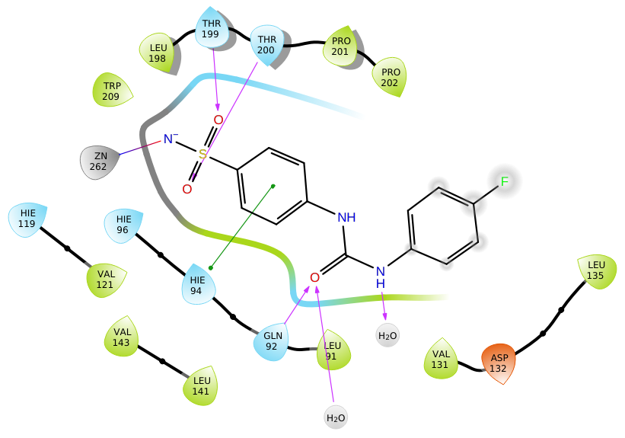
Figure S1: 2D-interaction diagram for the hCAIX-SLC011 complex
The residues considered within 3 Å of the ligand are Val121; A:120; His122; Thr200; Pro202; His107; Glu106; A:244; Trp209; A:246; Gly0; Val131; Val143; Ala142; Leu141; A:95; A:30; Gln92; His119; Leu91; His96; His:94; Leu135; A:245; Leu198; Thr199; Asn2; Trp5; Tyr7; Val207; Asn62; Gln67; Val66; Ser65; and His64.

Z#31 hCA IX
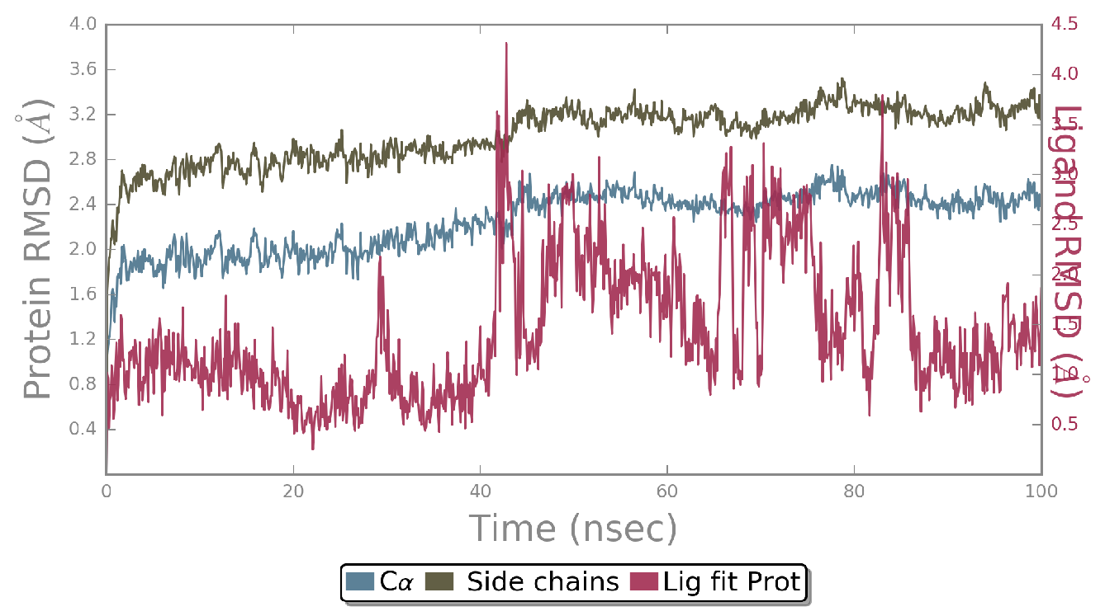
Protein-Ligand RMSD
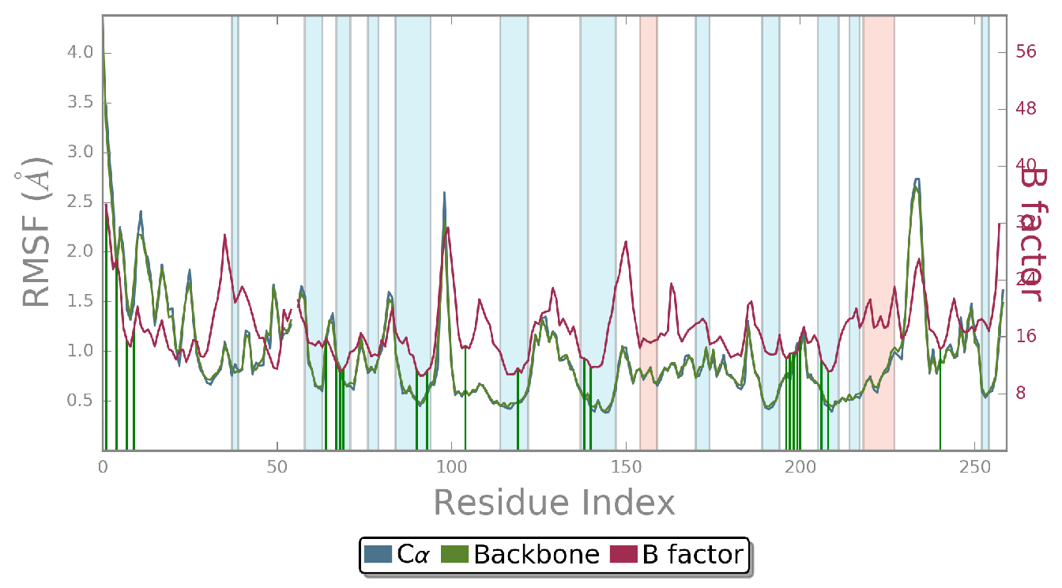
Protein RMSF
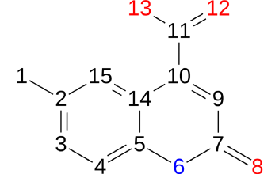
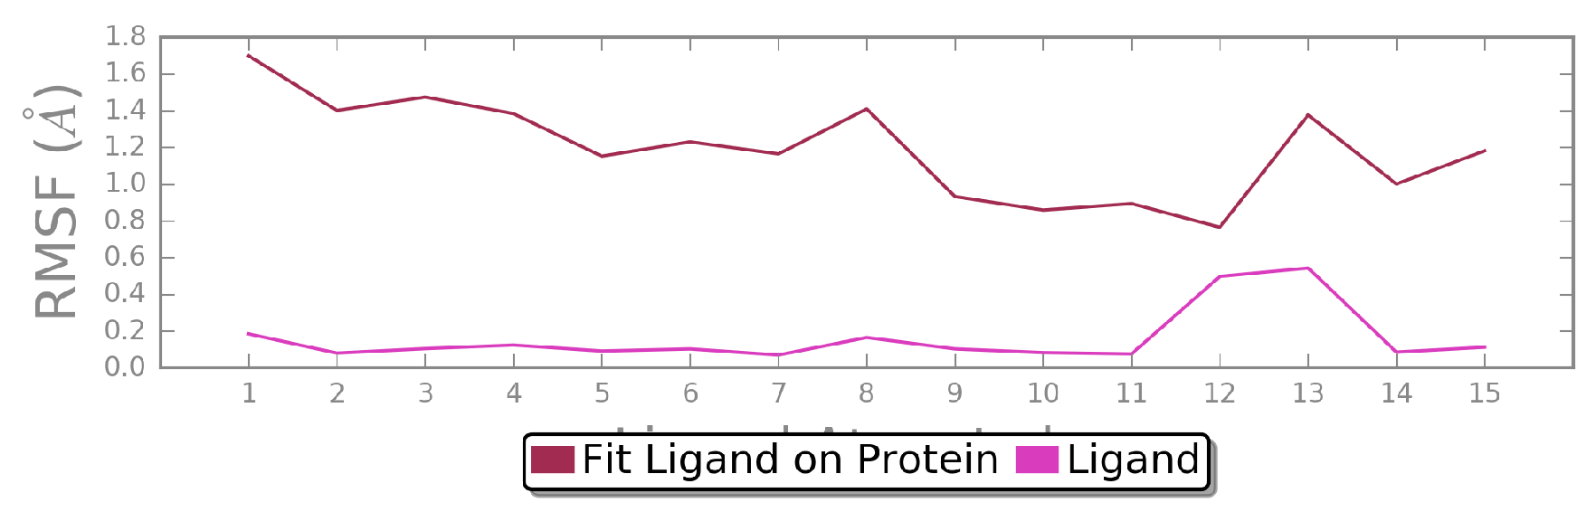
Ligand RMSF
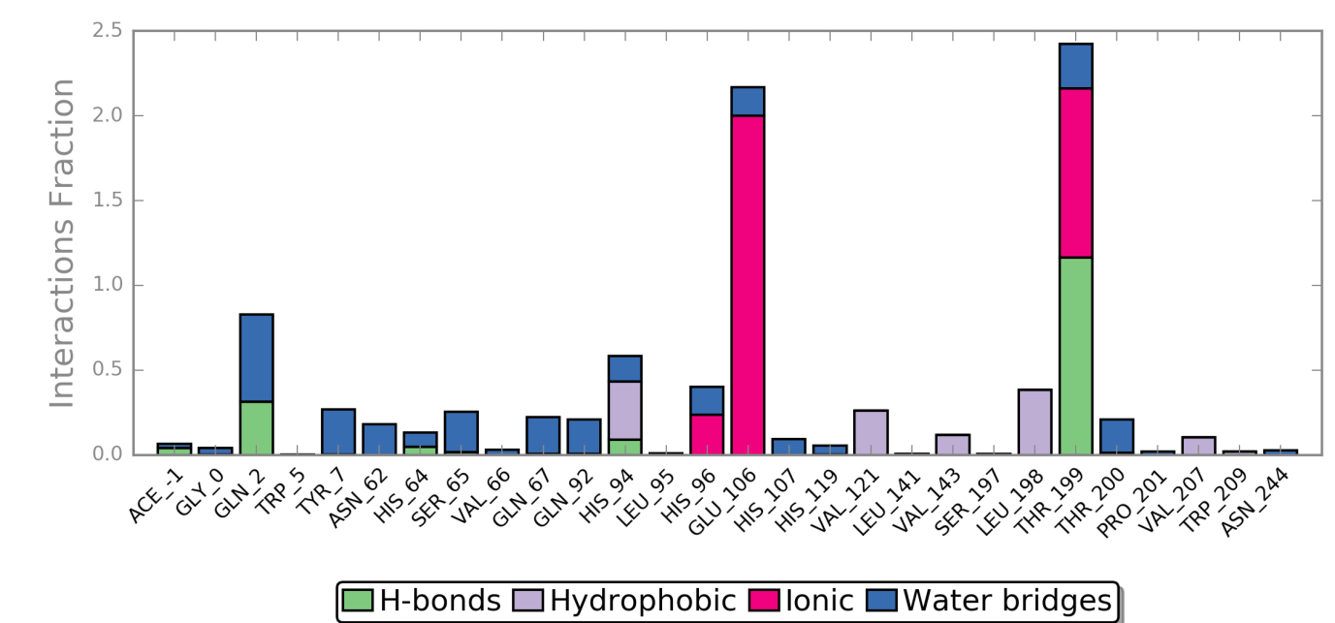
Protein-ligand contacts
Z#46 hCA IX
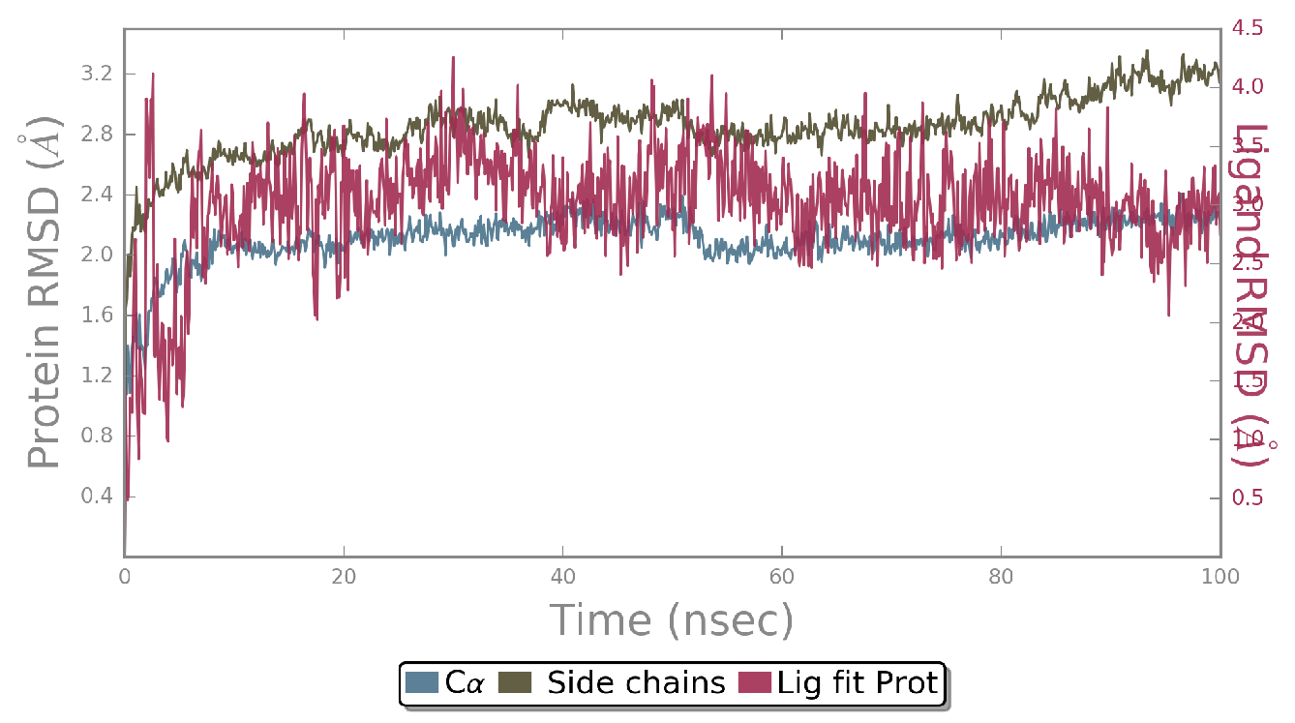
Protein-Ligand RMSD
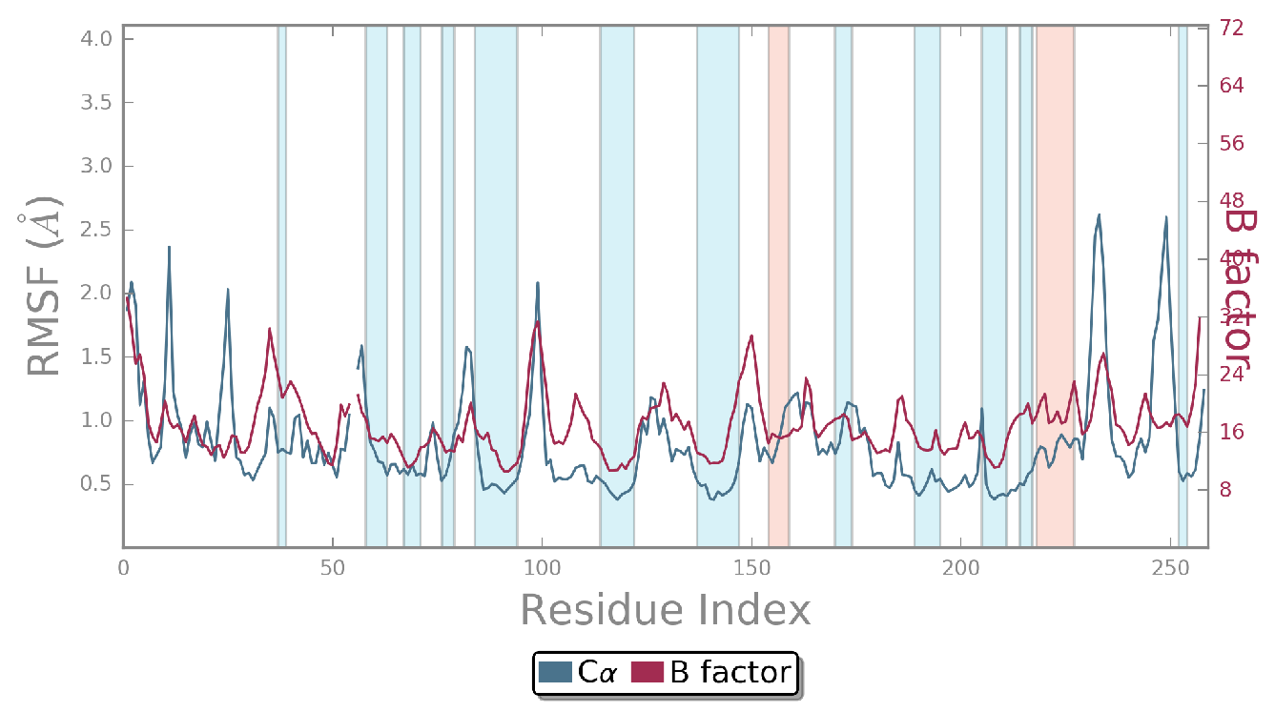
Protein RMSF
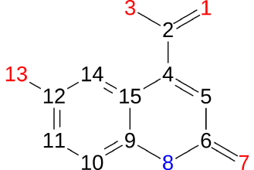
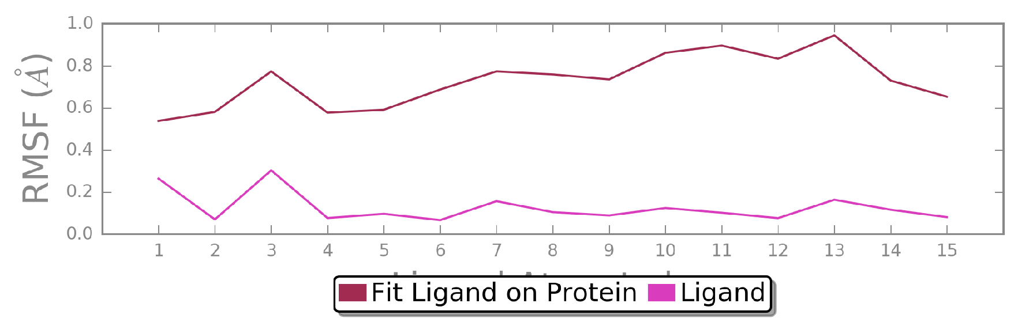
Ligand RMSF
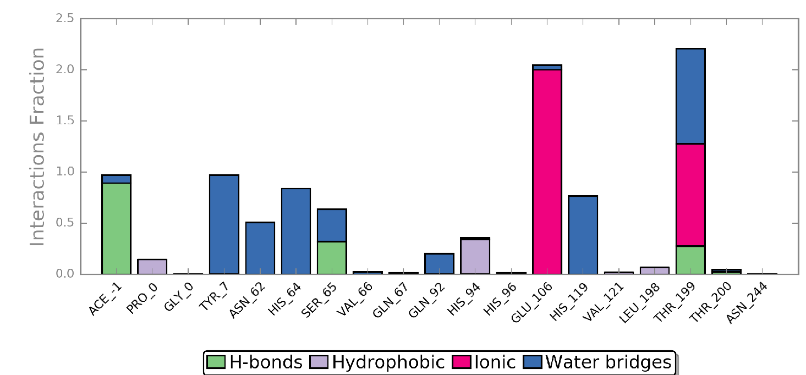
Protein-ligand contacts
Z#31 hCA II
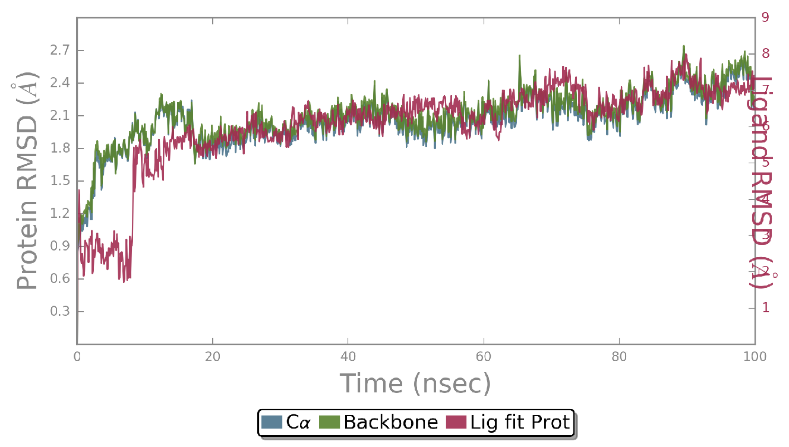
Protein-Ligand RMSD
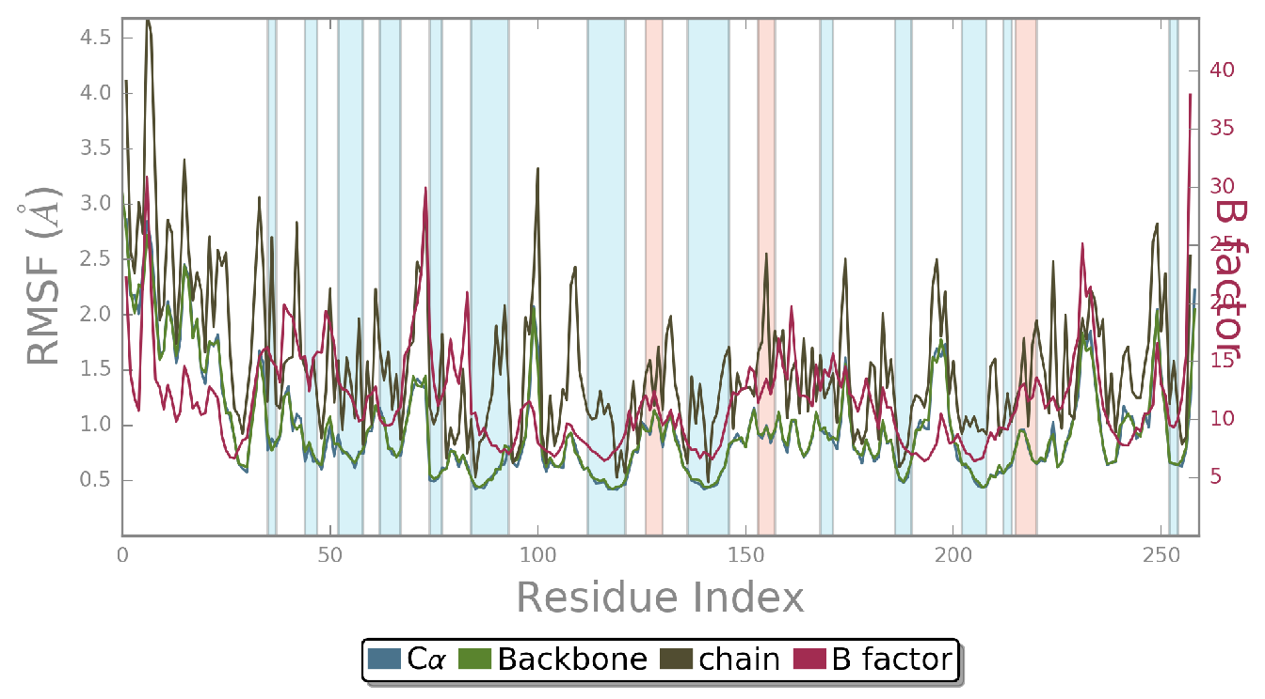
Protein RMSF
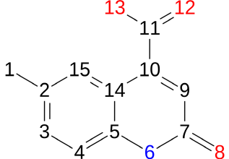
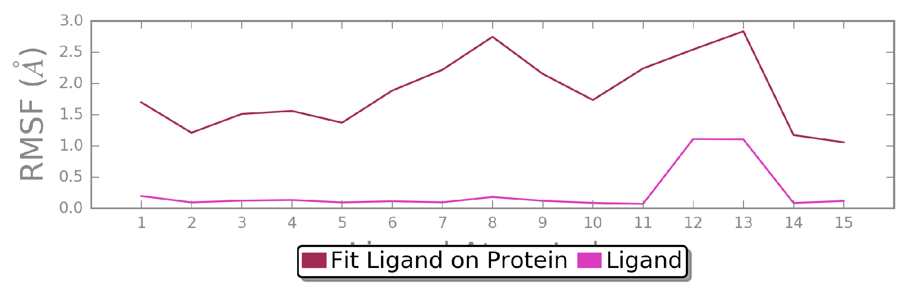
Ligand RMSF
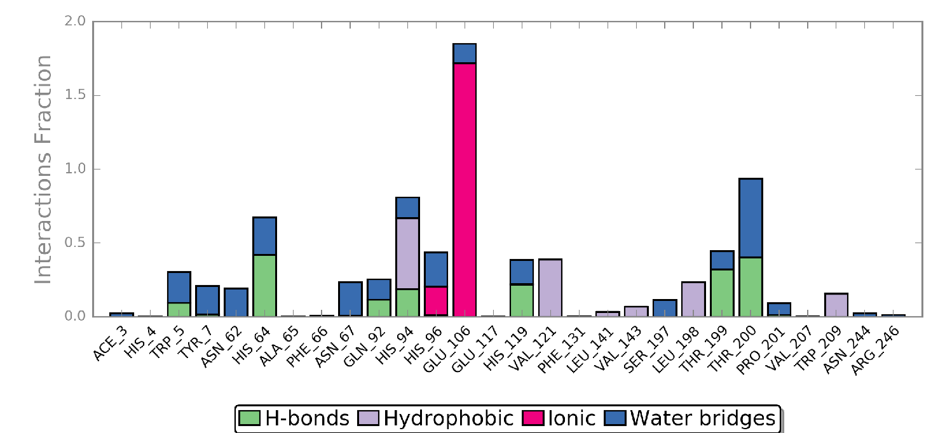
Protein-ligand contacts
Z#46 hCA II
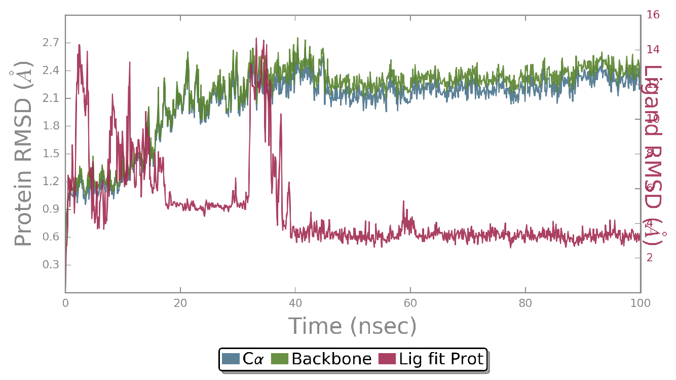
Protein-Ligand RMSD
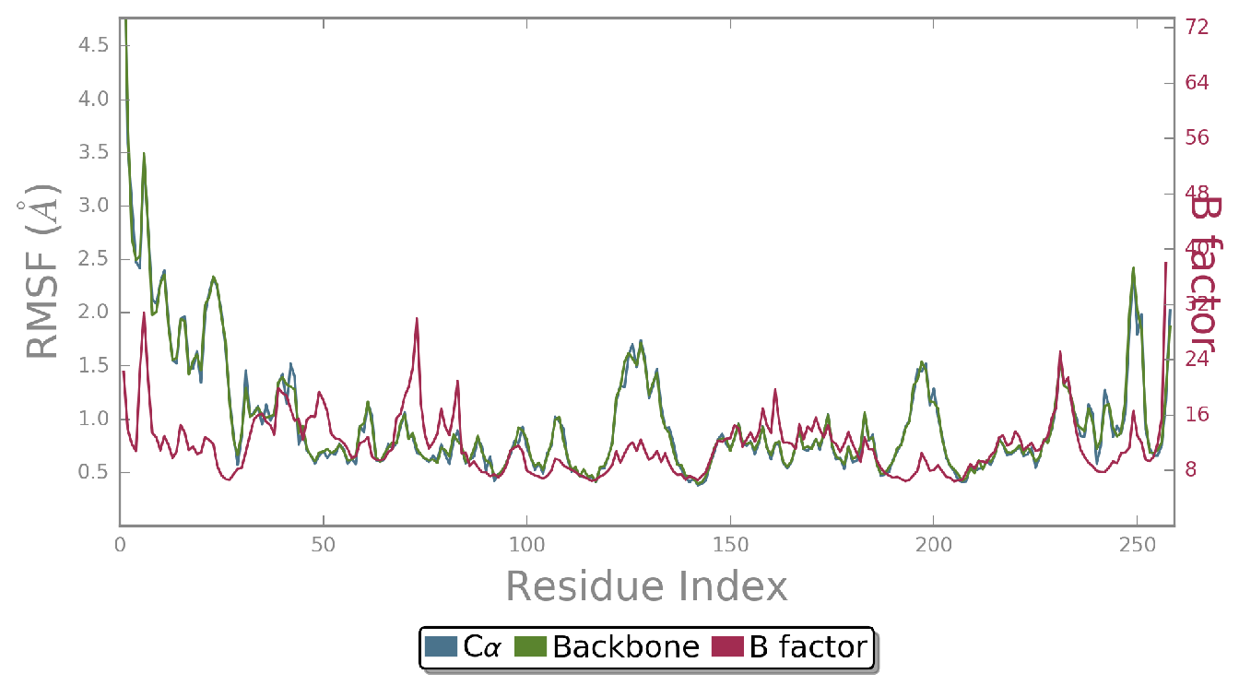
Protein RMSF
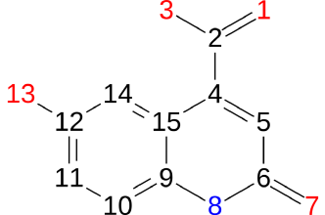
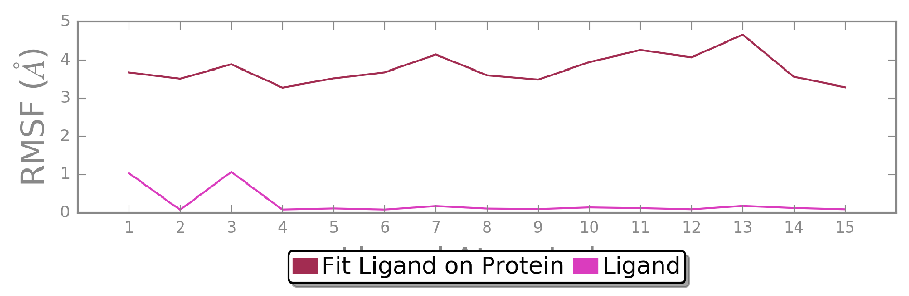
Ligand RMSF
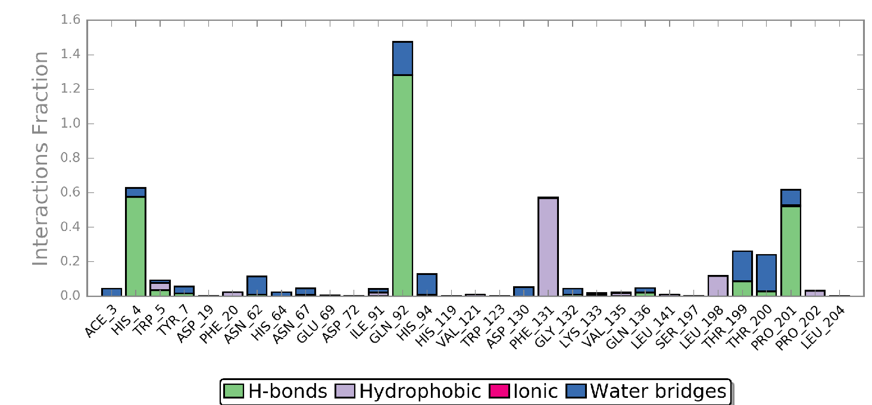
Protein-ligand contacts
Figure S2: Simulation Interaction diagrams of Z#31 and Z#46 with hCA IX and hCA II

Table S7: Predicted ADME properties and principal descriptors calculated for Z#31 and Z#46 by QikProp simulation.
Molecule | #stars | #acid | #rotor | #rtvFG | CNS | mol_MW
Z#31 | 0 | 1 | 1 | 0 | -1 | 203.197
Z#46 | 0 | 1 | 2 | 0 | -2 | 205.17

Molecule | SASA | FOSA | FISA | PISA | WPSA | volume | donorHB | accptHB | ACxDN^.5/SA | glob
Z#31 | 389.251 | 84.508 | 176.934 | 127.81 | 0 | 622.169 | 2 | 4.5 | 0.016349 | 0.90547
Z#46 | 372.264 | 0 | 231.896 | 140.368 | 0 | 590.804 | 3 | 5.25 | 0.024427 | 0.914694

Molecule | QPpolrz | QPlogPC16 | QPlogPoct | QPlogPw | QPlogPo/w | QPlogS | CIQPlogS | QPlogHERG | QPPCaco | QPlogBB | QPPMDCK | QPlogKp
Z#31 | 19.324 | 6.655 | 12.618 | 9.87 | 0.729 | -1.906 | -2.257 | -1.864 | 52.679 | -0.936 | 26.123 | -4.234
Z#46 | 17.546 | 7.112 | 14.377 | 12.271 | -0.148 | -1.434 | -2.064 | -1.774 | 15.865 | -1.405 | 7.139 | -5.107

Molecule | #metab | QPlogKhsa | HumanOralAbsorption | PercentHumanOralAbsorption | PSA | #NandO | RuleOfFive | #ringatoms | #in56 | #nonHatm | RuleOfThree | Jm
Z#31 | 1 | -0.644 | 3 (high) | 62.027 | 87.563 | 4 | 0 | 10 | 10 | 15 | 0 | 0.147
Z#46 | 1 | -0.812 | 2 (medium) | 47.562 | 110 | 5 | 0 | 10 | 10 | 15 | 1 | 0.059

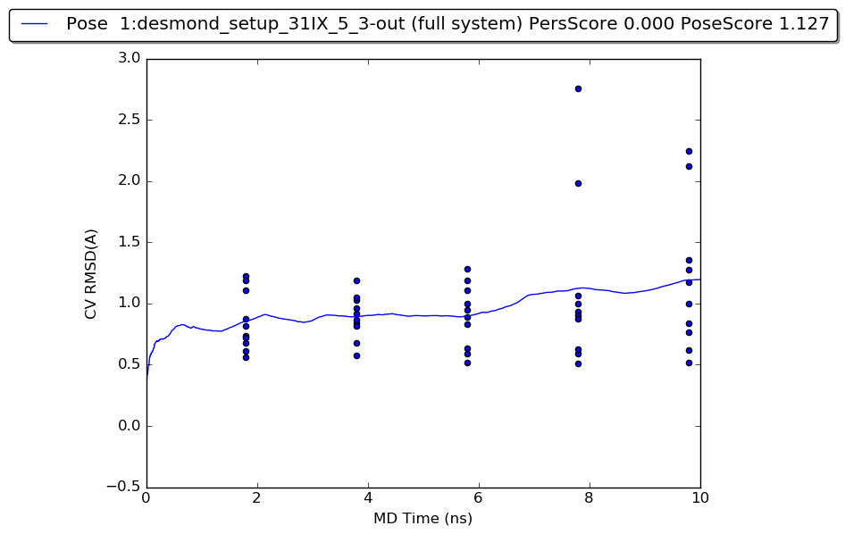 Figure S3: Plot of the RMSD estimate averaged across all 10 trials vs. simulation time for the BPMD run. The blue dots represent the values of the CV RMSD at different times (2 ns, 4 ns, 6 ns, 8 ns, and 10 ns) for the simulation experiment.
Protein-Ligand RMSD
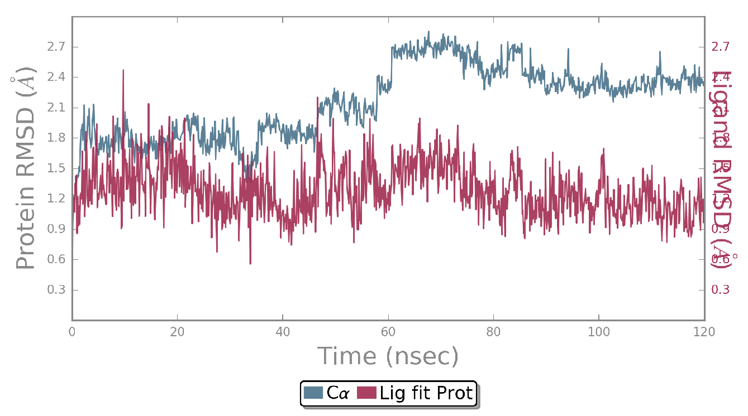
Protein RMSF
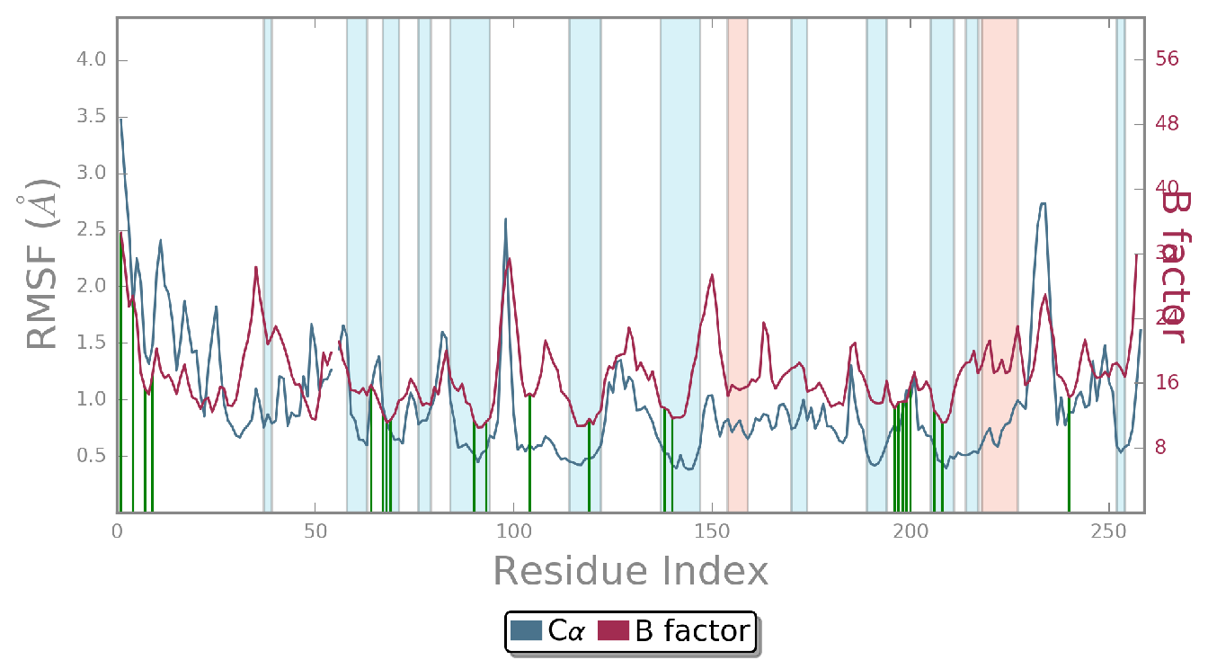
Ligand RMSF
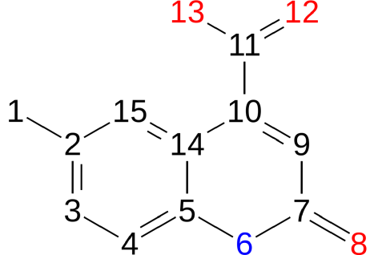
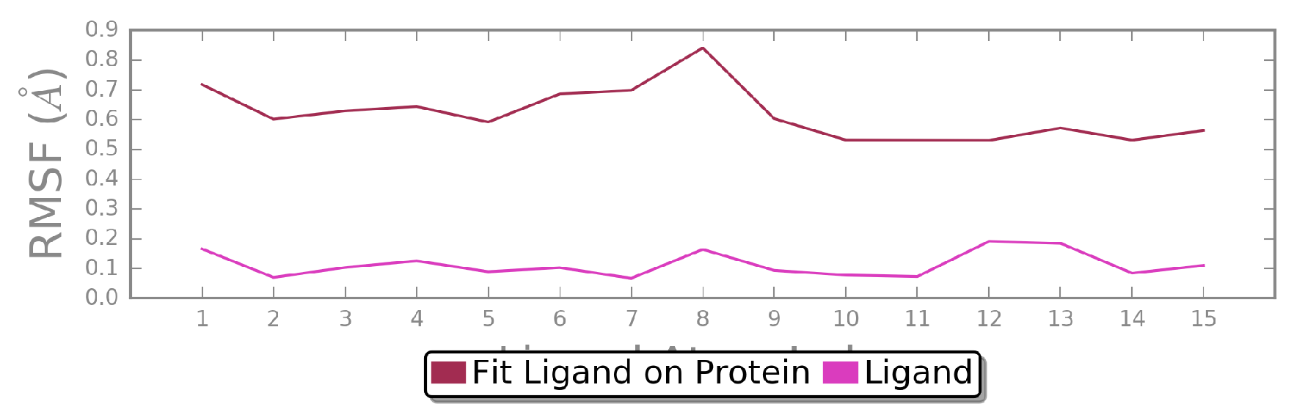
Protein-Ligand Contacts
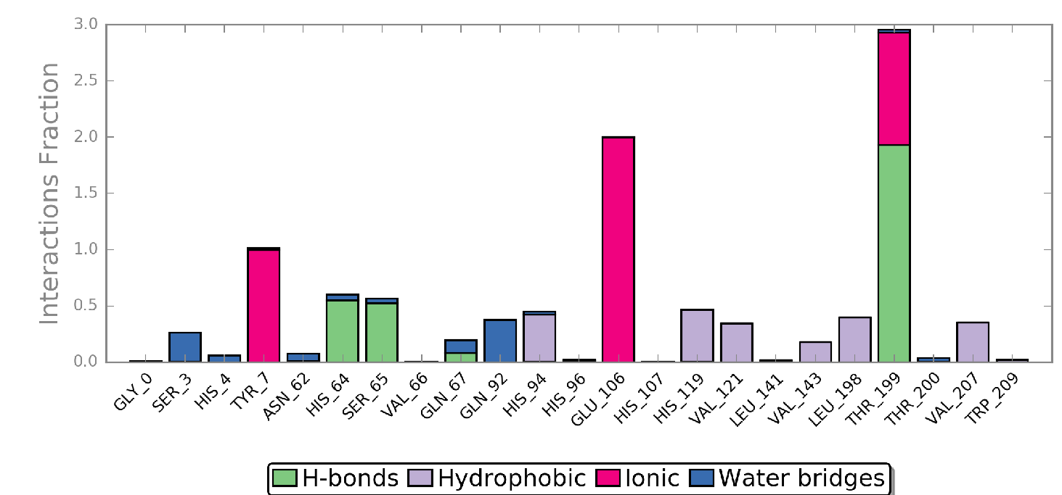
Protein-Ligand Contacts (cont.)
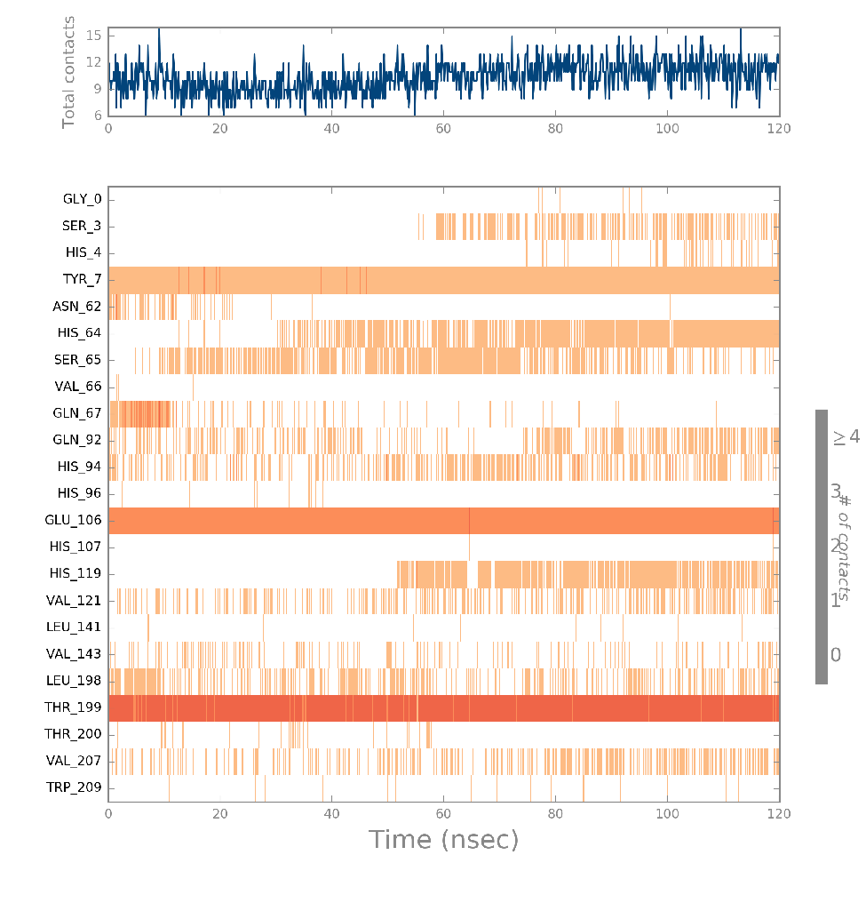
Ligand-Protein Contacts
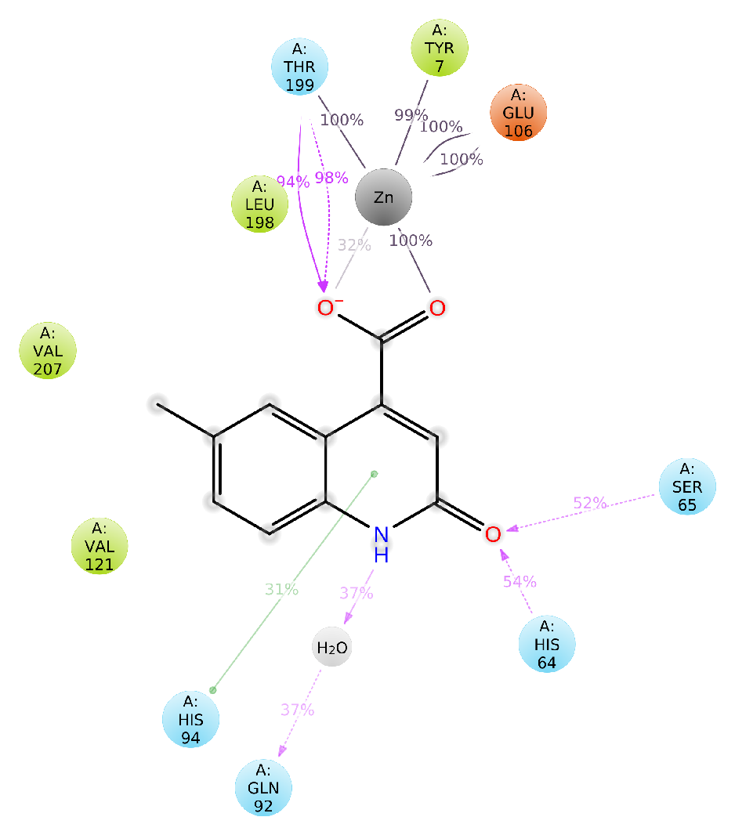
Ligand Torsion Profile
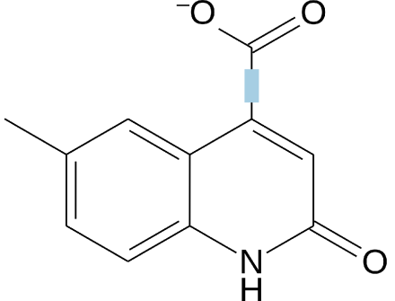
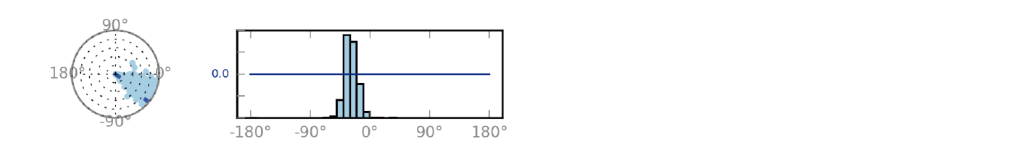
Ligand Properties
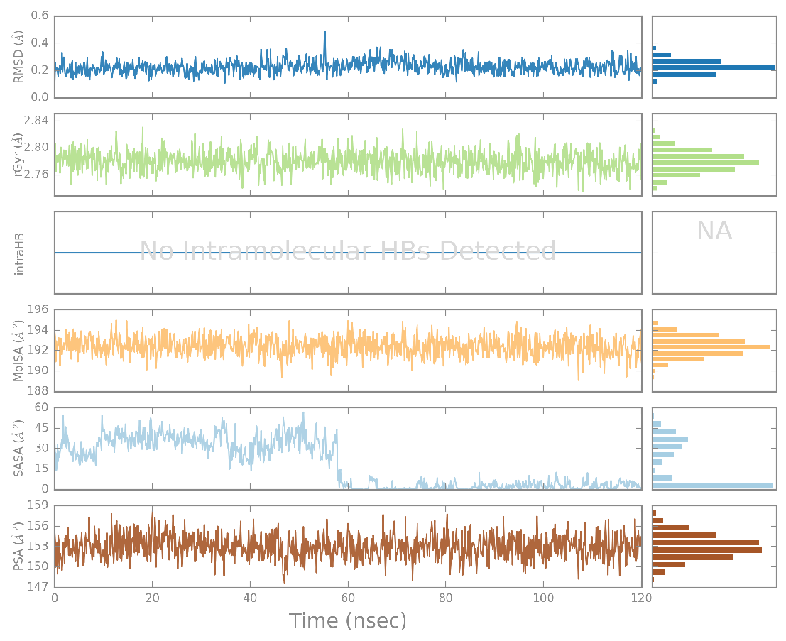
Figure S4: Simulation Interaction Diagrams for the 120 ns MD run of Z#31-hCA IX

