SUPPLEMENTARY MATERIAL

Two new aspidosperma-type alkaloids from Ervatamia officinalis

List of Supplemental Material
Figure S1. HR-ESI-MS spectrum of 1
Figure S2. UV spectrum of 1 (MeOH)
Figure S3. IR spectrum of 1 (KBr disc)
Figure S4. ¹H NMR (400 MHz, DMSO-d₆) of 1
Figure S5. ¹³C NMR (100 MHz, DMSO-d₆) of 1
Figure S6. DEPT-135 spectrum (100 MHz, DMSO-d₆) of 1
Figure S7. HSQC spectrum (400 MHz, DMSO-d₆) of 1
Figure S8. ¹H-¹H COSY spectrum (400 MHz, DMSO-d₆) of 1
Figure S9. HMBC spectrum (400 MHz, DMSO-d₆) of 1
Figure S10: NOESY spectrum (400 MHz, DMSO-d₆) of 1
Figure S11. HR-ESI-MS spectrum of 2
Figure S12. UV spectrum of 2 (MeOH)
Figure S13. IR spectrum of 2 (KBr disc)
Figure S14. ¹H NMR (400 MHz, DMSO-d₆) of 2
Figure S15. ¹³C NMR (100 MHz, DMSO-d₆) of 2
Figure S16. DEPT-135 spectrum (100 MHz, DMSO-d₆) of 2
Figure S17. HSQC spectrum (400 MHz, DMSO-d₆) of 2
Figure S18. ¹H-¹H COSY spectrum (400 MHz, DMSO-d₆) of 2
Figure S19. HMBC spectrum (400 MHz, DMSO-d₆) of 2
Figure S20: NOESY spectrum (400 MHz, DMSO-d₆) of 2

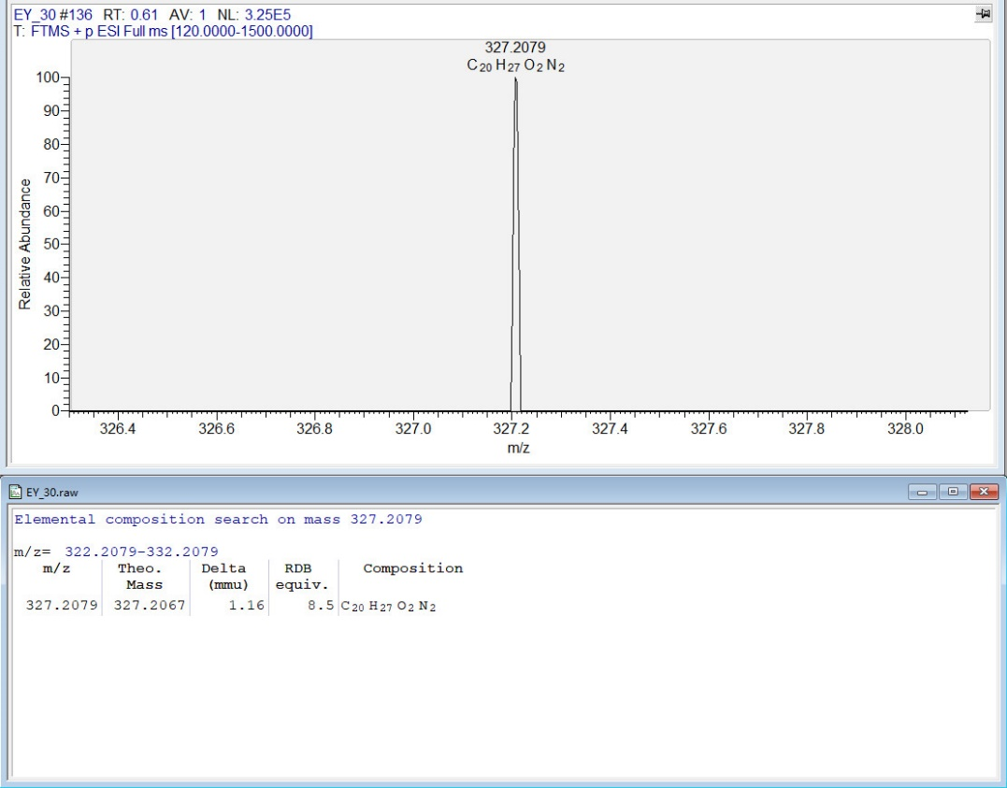
Figure S1. HR-ESI-MS spectrum of 1

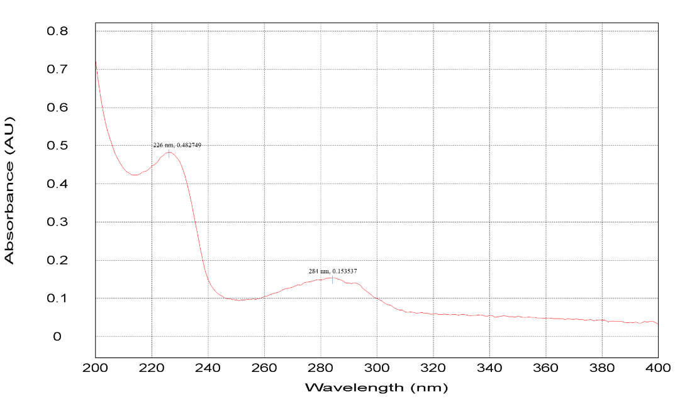
Figure S2. UV spectrum of 1 (MeOH)
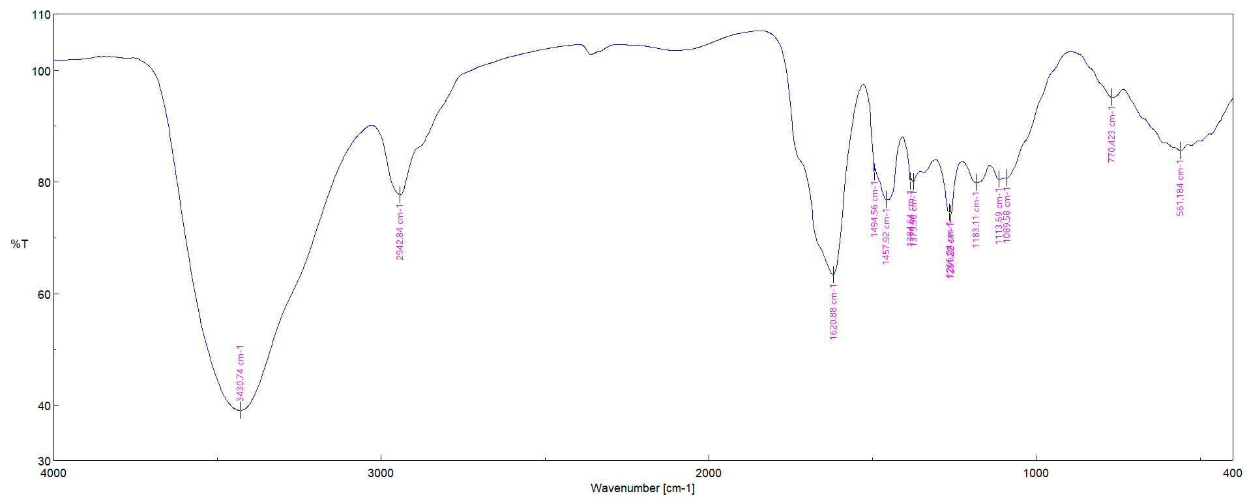

Figure S3. IR spectrum of 1 (KBr disc)

Figure S4. ¹H NMR spectrum (400 MHz, DMSO-d₆) of 1

Figure S5. ¹³C NMR spectrum (100 MHz, DMSO-d₆) of 1

Figure S6. DEPT-135 spectrum (100 MHz, DMSO-d₆) of 1
Figure S7. HSQC spectrum (400 MHz, DMSO-d₆) of 1
Figure S8. ¹H-¹H COSY spectrum (400 MHz, DMSO-d₆) of 1

Figure S9. HMBC spectrum (400 MHz, DMSO-d₆) of 1
Figure S10: NOESY spectrum (400 MHz, DMSO-d₆) of 1

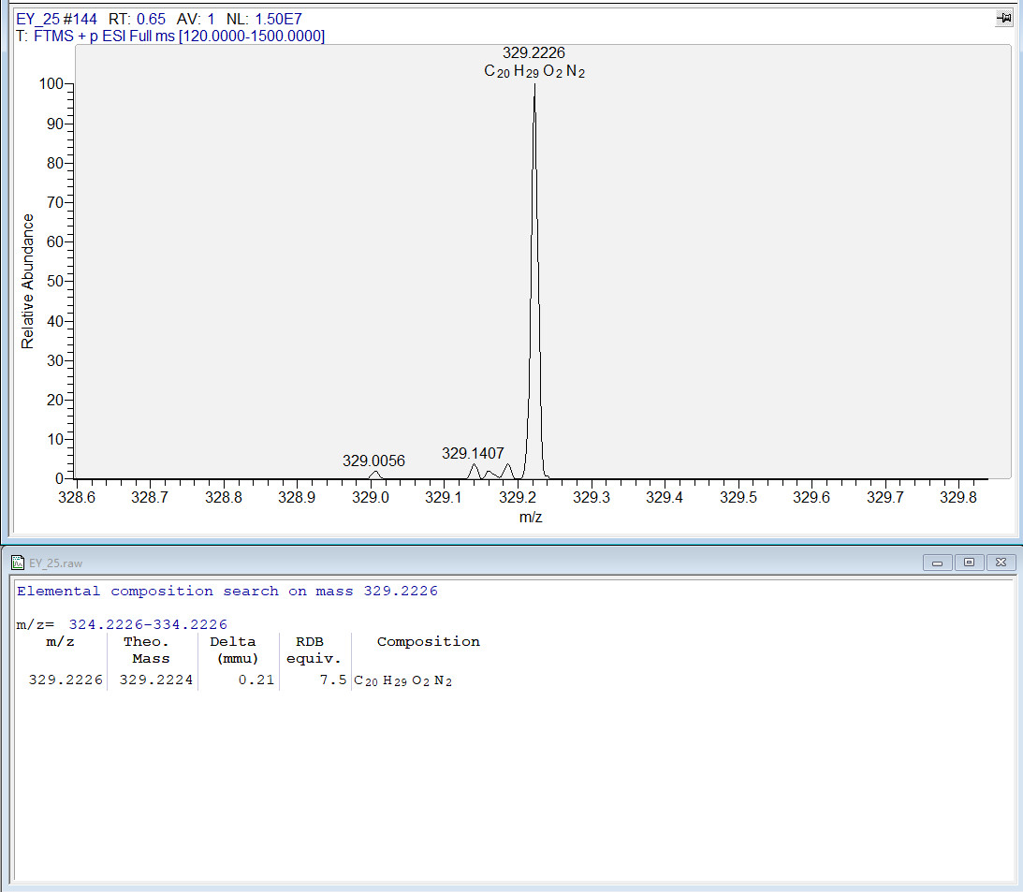
Figure S11. HR-ESI-MS spectrum of 2

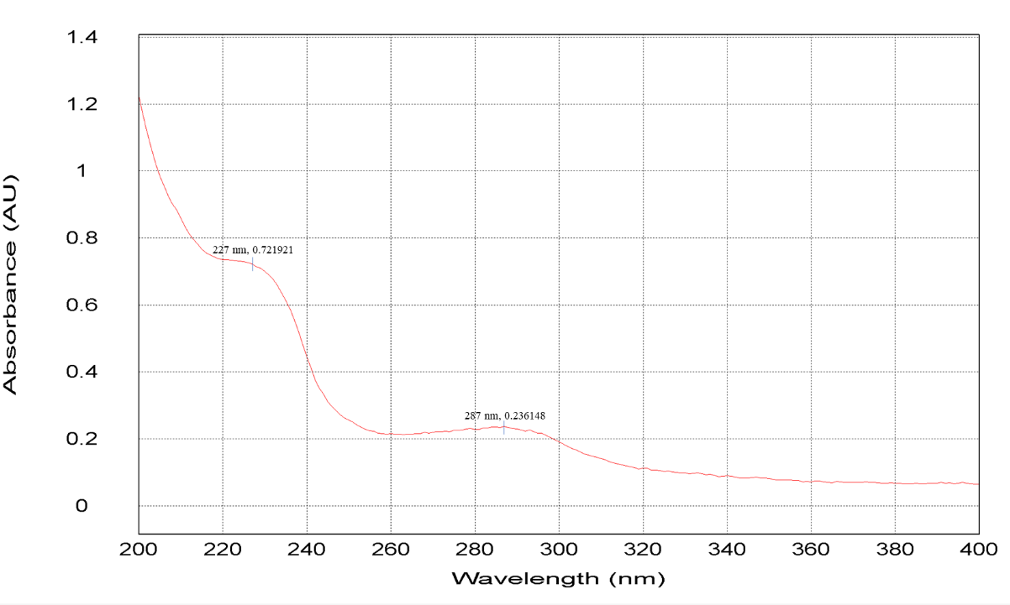
Figure S12. UV spectrum of 2 (MeOH)

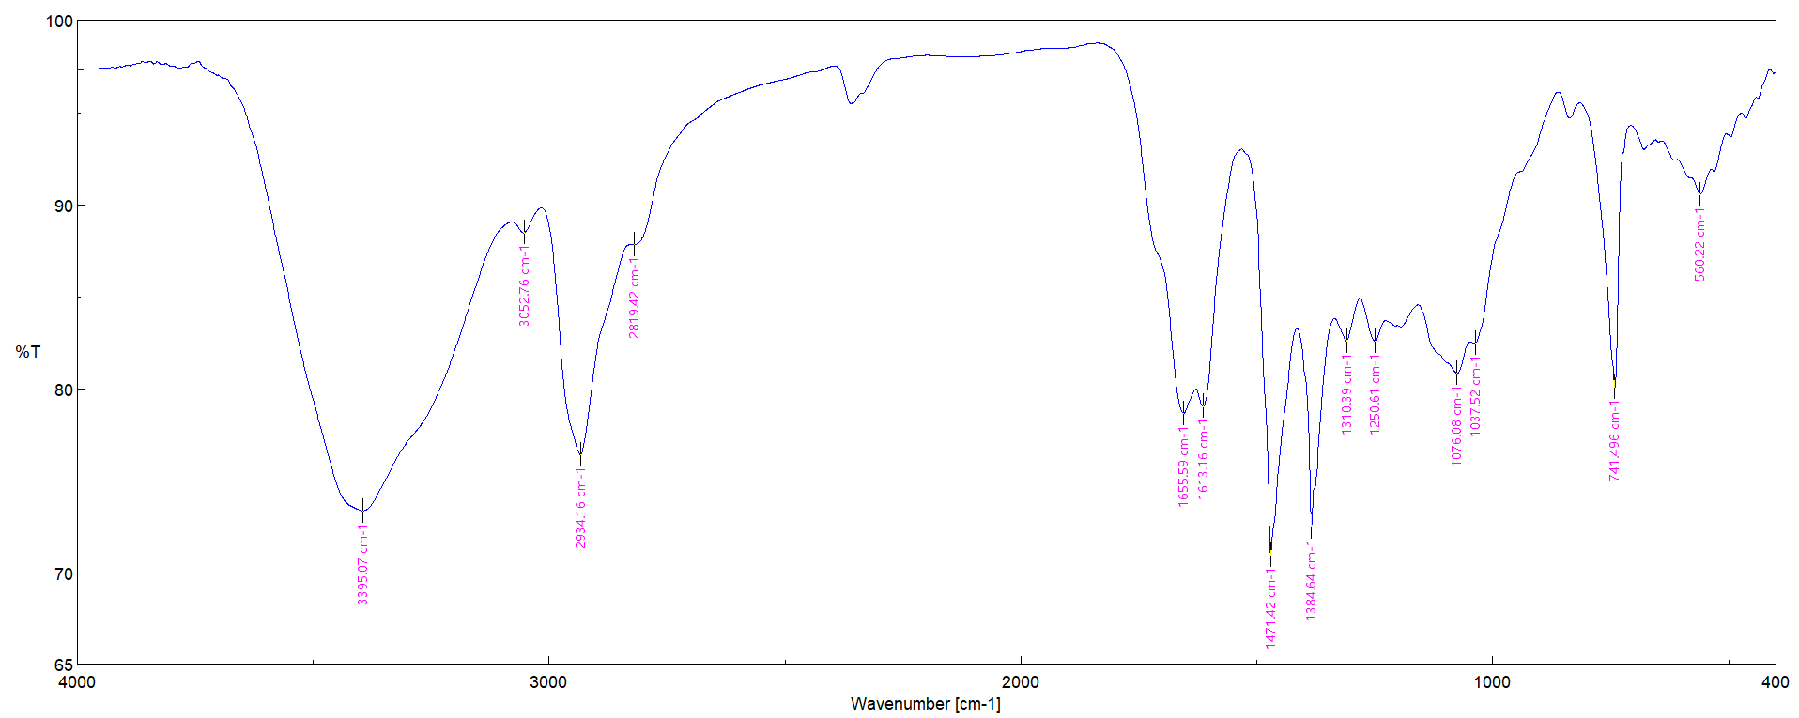
Figure S13. IR spectrum of 2 (KBr disc)

Figure S14. ¹H NMR spectrum (400 MHz, DMSO-d₆) of 2

Figure S15. ¹³C NMR spectrum (100 MHz, DMSO-d₆) of 2

Figure S16. DEPT-135 spectrum (100 MHz, DMSO-d₆) of 2

Figure S17. HSQC spectrum (400 MHz, DMSO-d₆) of 2

Figure S18. ¹H-¹H COSY spectrum (400 MHz, DMSO-d₆) of 2
Figure S19. HMBC spectrum (400 MHz, DMSO-d₆) of 2

Figure S20: NOESY spectrum (400 MHz, DMSO-d₆) of 2

