Online Appendix A1: Variables, Data Sources, and Full Regression Models

Table A1-1: Election-related Internet Shutdowns
Country | Year | Election Type | Duration  (days) | Official Justification | Attributed Cause
Bangladesh | 2018 | Parliamentary | 3 | Fake News/ Hate Speech | Elections
Belarus | 2020 | Presidential | 1 | Unknown | Other^{b}
Beninª | 2019 | Parliamentary | 2 | Fake News / Hate Speech / Incendiary Content or Promoting Violence | Elections
Cameroon | 2018 | Presidential | 2 | Fake News/ Hate Speech | Elections
Chad | 2016 | Presidential | 4 | Unknown | Elections
Congo (Dem. Rep.) | 2019 | Parliamentary | 20 | Fake News / Hate Speech / Incendiary Content or Promoting Violence | Elections
Congo (Dem. Rep.) | 2018 | Presidential | 20 | Fake News/ Hate Speech | Elections
Egypt | 2020 | Parliamentary | 1 | Unknown | Unknown^{b}
Gabon | 2016 | Presidential | 32ª | Other | Protest^{b}
Gambia | 2016 | Presidential | 2 | Unknown | Elections
Guinea | 2020 | Parliamentary & Presidential | 5 | Unknown | Elections
India | 2019 | Parliamentary |  | Precautionary Measure | Religious Holiday / Anniversary, Political Instability^{b}
Indonesia | 2019 | Parliamentary | 3 | Fake News / Hate Speech / Incendiary Content or Promoting Violence | Elections
Indonesia | 2019 | Presidential | 3 | Fake News / Hate Speech / Incendiary Content or Promoting Violence | Elections
Iran | 2017 | Presidential | <1 | Unknown | Elections
Iraq | 2018 | Parliamentary | <1 | School Exams | Unknown^{b}
Kazakhstan | 2019 | Presidential | 1 | Unknown | Information Control^{b}
Kyrgyzstan | 2020 | Parliamentary | <1 | Unknown | Elections
Mali | 2018 | Presidential | <1 | Unknown | Elections
Mauritania | 2019 | Presidential | 11 | Unknown | Elections
Pakistan | 2018 | Parliamentary | 1 | Unknown | Unknown^{b}
Sierra Leone | 2018 | Parliamentary | 1 | Unknown | Information Control^{b}
Sierra Leone | 2019 | Presidential | 1 | Unknown | Information Control^{b}
Togo | 2018 | Parliamentary | 4 | Public Safety | Protest^{b}
Uganda | 2016 | Parliamentary & Presidential | 3 | National Security | Elections
Note
ª curfew shutdowns at night
^{b} Attribution to election based on temporal criterion/coincidence with election.
Table A1-2: Descriptive Statistics of Independent Variables
 | Source | Min | Max | Mean | Median | SD
Capacity | V-Dem  [v2smgovshutcap] | 0.00 | 4.00 | 2.64 | 2.75 | 0.06
Content control | V-Dem  [v2mecenefi; inverted] | -3.33 | 1.96 | 0.24 | 0.43 | 0.09
Electoral violence | V-Dem  [mean: v2elintim, v2elpeace; inverted] | -2.05 | 3.40 | 0.13 | 0.11 | 0.07
Margin of victory | V-Dem | 0.00 | 100.00 | 27.89 | 18.91 | 1.86
presidential | [Difference: v2elvotlrg-v2elvotsml] | 0.37 | 98.06 | 30.10 | 21.25 | 2.94
parliamentary | [Difference: v2ellovtlg-v2ellovtsm] | 0.00 | 100.00 | 26.25 | 42.20 | 2.39
Concurrent | Dummy variable based on election Date | 0.00 | 1.00 | 0.16 | 0.00 | -
Service, % GDP | Worldbank  [NV.SRV.TOTL.ZS] | 28.47 | 80.45 | 52.41 | 53.27 | 0.70
Usage | Worldbank  [IT.NET.USER.ZS] | 2.66 | 100.00 | 44.06 | 46.50 | 1.67

Table A1-3: Correlations across Presidential Elections
 | Capacity | Content control | Electoral violence | Margin | Concurrent | Usage
Capacity
Content control | -0.43***
Electoral violence | 0.51*** | -0.52***
Margin of victory | 0.41*** | -0.50*** | 0.38***
Concurrent | 0.09 | -0.08 | 0.16 | -0.17
Usage | -0.36*** | 0.19 | -0.51*** | -0.08 | -0.21
Service, % GDP | -0.49*** | 0.18 | -0.45*** | -0.22* | -0.05 | 0.49***
Computed correlation used Pearson-method with listwise-deletion.

Table A1-4: Correlations across Parliamentary Elections
 | Capacity | Content control | Electoral violence | Margin | Concurrent | Usage
Capacity
Content control | -0.37***
Electoral violence | 0.33*** | -0.48***
Margin of victory | 0.23* | -0.44*** | 0.31**
Concurrent | 0.15 | -0.10 | 0.17 | -0.02
Usage | -0.24* | 0.21* | -0.53*** | -0.09 | -0.24*
Service, % GDP | -0.23* | 0.22* | -0.45*** | -0.14 | -0.08 | 0.54***
Computed correlation used Pearson-method with listwise-deletion.

Table A1-5: Regression Analyses of Capacity and Incentives to Shut Down the Internet (Log-Odds)
 | Presidential elections | Parliamentary elections
Capacity | 1.19 *  (0.68) | 1.11 *  (0.62)
Content control | -1.29 **  (0.58) | -0.45  (0.51)
Electoral violence | 0.95  (0.62) | 2.32 **  (0.91)
Margin of victory | -2.18 ***  (0.84) | -1.04 **  (0.52)
Concurrent | -0.38  (0.43) | -0.79  (0.49)
Service, % GDP | -1.57 **  (0.61) | -1.14 *  (0.64)
Usage | 1.05  (0.65) | -0.38  (0.54)
Intercept | -3.14 ***  (0.73) | -4.84 ***  (1.33)
Observations | 83 | 106
R2 Tjur | 0.452 | 0.422
AIC | 57.459 | 55.858
* p<0.1 ** p<0.05 *** p<0.01

Online Appendix A2: Robustness of the Findings

Figure A2-1: Cook’s Distance for Presidential Elections
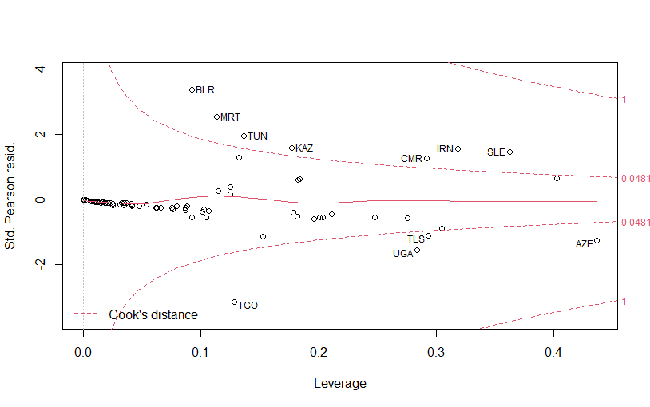

Figure A2-2: Cook’s Distance for Parliamentary Elections
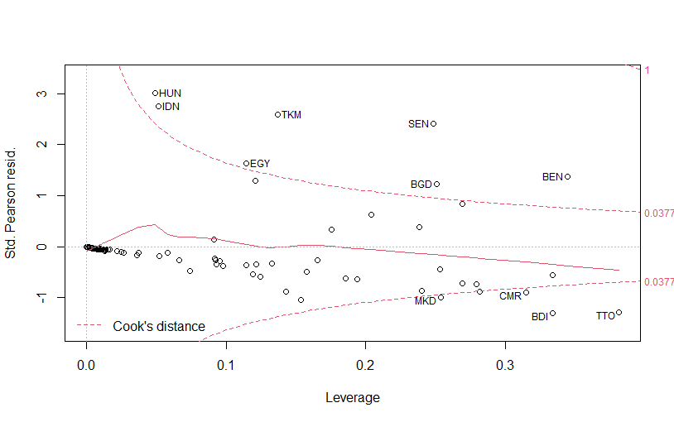
Table A2-1: Jackknife Analysis of Capacity and Incentives to Shut Down the Internet
 | Presidential elections |  |  | Parliamentary elections
 | B_{mean} | B_{min} | B_{max} | B_{mean} | B_{min} | B_{max}
Capacity | 1.20 | 0.90 | 1.64 | -4.85 | -5.67 | -4.65
Content control | -1.29 | -1.73 | -0.91 | 1.11 | 0.72 | 1.46
Electoral violence | 0.95 | 0.67 | 1.36 | -0.45 | -0.82 | -0.33
Margin of victory | -2.19 | -2.81 | -1.99 | 2.33 | 2.02 | 2.81
Concurrent | -0.38 | -0.63 | -0.22 | -1.05 | -1.32 | -0.86
Service, % GDP | -1.58 | -2.14 | -1.33 | -0.79 | -1.25 | -0.64
Usage | 1.06 | 0.82 | 1.50 | -1.14 | -1.50 | -0.89
Intercept | -3.15 | -3.67 | -3.06 | -0.38 | -0.52 | -0.23
Note:
Jackknife resampling of regression models treating countries as observations and leaving one observation out consecutively. For each variable, the mean, smallest, and larges coefficients of resampled regression are displayed. All original coefficients are within the 99% confidence interval of the resampled coefficients and there is in no case a change of sign in the resampled models. Therefore, the coefficients are deemed robust.

Online Appendix A3: Alternative Model Specifications

During the review process, we were encouraged to include further variables into our regression models such as GDP per capita, military strength, oil rents, urbanization, press freedom. In fact, with regard to the debates in autocracy research and concerning authoritarian survival, these variables would be commendable. However, as discussed in the article, we had to take two limitations into account. First, we are restricted by the small number of events in which a shutdown occurred, and second, the further suggested variables correlate with at least one variable in the original model. We therefore analyzed the suggested variables in separate models, which provide further evidence for the robustness of our initial findings.
Tables A3-1 and A3-2 summarize the results of these supplementary models. All additional variables were retrieved from the Quality of Government (QOG) dataset (Teorell et al. 2022). In each table, model 1 refers to the original models as presented in Table A1-5. In some cases, variables from the original model had to be removed due to multicollinearity. For both types of elections, we find the coefficients of our initial models by and large robust.
In presidential elections, the only exception is capacity (Table A3-1, model 3), which slightly exceeds conventional levels of statistical significance (p=.1156) when controlling for the degree of urbanization. Of the added variables, GNI per Capita (Table A3-1, model 2) and press freedom (Table A3-1, model 5) are statistically significant and have a positive effect on probability of the occurrence of a shut down. The former may be explained as part of our model and in reference to the usage of the internet: based on modernization theory, a higher degree of wealth is linked to increases in literacy rates and the usage of the internet. Therefore, autocrats may be incentivized to shut down the internet to affect a larger share of the population. At the same time cost increase, and therefore this finding requires further research. The latter finding concerning press freedom is directly linked to our initial hypothesis for content control (H2) and the hypothesized incentives in the context of lack of autocratic control over reporting. In fact, the variable content control had to be removed from the model, as it was highly correlated to press freedom (Pearson’s r>-.7).
In parliamentary elections, the picture is a bit more mixed. None of the additional variables are significant. However, the p-values of the variables capacity to shut down the internet, the percentage of GDP generated through services, and the margin of victory exceed conventional levels of significance when controlling for military personal and oil rents (Table A3-2, model 4 and 6). In both cases this is likely to be attributed to the smaller number of observations and therefore should not be overstated.
Table A3-1: Regression Analysis with Extended set of IVs (Presidential Elections)
 | (1) | (2) | (3) | (4) | (5) | (6)
Capacity | 1.19 *  (0.68) | 1.16 *  (0.66) | 0.95  (0.60) | 1.66 *  (0.95) | 1.22 *  (0.63) | 1.36 *  (0.70)
Content Control | -1.29 **  (0.58) | -1.20 **  (0.58) | -1.17 **  (0.56) | -2.51 **  (1.11) |  | -1.03 *  (0.54)
Electoral Violence | 0.95  (0.62) | 0.85  (0.58) | 0.62  (0.50) | 0.21  (1.05) | 0.94  (0.57) | 0.60  (0.62)
Margin of Victory | -2.18 ***  (0.84) | -2.01 ***  (0.74) | -1.60 **  (0.63) | -2.79 **  (1.20) | -2.04 ***  (0.76) | -1.70 **  (0.70)
Concurrent | -0.38  (0.43) | -0.38  (0.43) | -0.25  (0.41) | -0.38  (0.62) | -0.50  (0.47) | -0.08  (0.44)
Service, % GDP | -1.57 **  (0.61) | -1.53 ***  (0.59) | -1.26 **  (0.55) | -2.93 **  (1.18) | -1.35 **  (0.57)
Usage | 1.05  (0.65) |  |  | 0.67  (0.71) | 0.65  (0.63) | -0.42  (0.54)
GNI per Capita (QOG:wdi_gnicappppcur) |  | 1.12 *  (0.67)
Urbanization (QOG:wdi_popurb) |  |  | 0.61  (0.53)
Military Personnel (QOG:bicc_milper) |  |  |  | -0.41  (0.62)
Press Freedom (QOG:rsf_pf) |  |  |  |  | 1.28 *  (0.69)
Oil Rent (QOG:wdi_oilrent) |  |  |  |  |  | 0.49  (0.45)
(Intercept) | -3.14 ***  (0.73) | -3.04 ***  (0.68) | -2.89 ***  (0.66) | -4.36 ***  (1.48) | -3.00 ***  (0.69) | -2.92 ***  (0.77)
Observations | 83 | 82 | 82 | 63 | 81 | 69
R2 Tjur | 0.452 | 0.456 | 0.432 | 0.600 | 0.416 | 0.368
* p<0.1 ** p<0.05 *** p<0.01

Table A3-2: Regression Analysis with Extended set of IVs (Parliamentary Elections)
 | (1) | (2) | (3) | (4) | (5) | (6)
Capacity | 1.11 *  (0.62) | 1.07 *  (0.62) | 1.44 **  (0.73) | 1.01  (0.74) | 1.04 *  (0.63) | 0.87  (0.64)
Content Control | -0.45  (0.51) | -0.44  (0.51) | -0.36  (0.51) | -0.65  (0.57) |  | -0.28  (0.44)
Electoral Violence | 2.32 **  (0.91) | 2.36 ***  (0.91) | 2.39 ***  (0.91) | 2.46 **  (1.18) | 2.10 **  (0.89) | 1.75 *  (0.92)
Margin of Victory | -1.04 **  (0.52) | -1.04 **  (0.51) | -1.08 **  (0.52) | -0.71  (0.61) | -1.04 **  (0.52) | -0.48  (0.54)
Concurrent | -0.79  (0.49) | -0.76  (0.49) | -0.83 *  (0.49) | -0.66  (0.52) | -0.87 *  (0.51) | -0.38  (0.49)
Service, % GDP | -1.14 *  (0.64) | -1.14 *  (0.64) | -1.19 *  (0.63) | -1.30  (0.79) | -1.13 *  (0.61)
Usage | -0.38  (0.54) |  |  | -0.86  (0.72) | -0.65  (0.62) | -1.32 *  (0.72)
GNI per Capita (QOG:wdi_gnicappppcur) |  | -0.42  (0.95)
Urbanization (QOG:wdi_popurb) |  |  | -0.60  (0.55)
Military Personnel (QOG:bicc_milper) |  |  |  | -0.45  (0.59)
Press Freedom (QOG:rsf_pf) |  |  |  |  | 0.82  (0.73)
Oil Rent (QOG:wdi_oilrent) |  |  |  |  |  | 0.31  (0.33)
(Intercept) | -4.84 ***  (1.33) | -4.80 ***  (1.31) | -5.14 ***  (1.46) | -5.23 ***  (1.76) | -4.87 ***  (1.31) | -4.15 ***  (1.17)
Observations | 106 | 104 | 105 | 71 | 104 | 77
R2 Tjur | 0.422 | 0.418 | 0.431 | 0.448 | 0.433 | 0.377
* p<0.1 ** p<0.05 *** p<0.01

References Online Appendix A3
Teorell, J., A. Sundström, S. Holmberg, B. Rothstein, N. Alvarado Pachon, and C.M. Dalli. 2022. The Quality of Government Standard Dataset, Version Jan22.

