Cadmium impurities in traditional herbal medicinal products with Thymi herba available in Polish pharmacies – short communication:
the level of Cd impurities and comprehensive toxicological risk assessment
Kamil Jurowskiª* and Mirosław Krośniak^{b}
ªInstitute of Medical Studies, Medical College, University of Rzeszów, Rzeszów, Poland; ^{b}Department of Food Chemistry and Nutrition, Medical College, Jagiellonian University, Kraków, Poland
e-mail for the *corresponding author: jurowski.tox@gmail.com

Traditional herbal medicinal products (THMP) with Thymi herba are very popular as OTC among European population. The aim of this article was the toxicological risk assessment (TRA) of Cd impurities in THMP with Thymi herba from pharmacies in Poland. The estimations of Cd impurities in the single dose (1.10 – 12.90 µg/single dose) and in daily dose (ng/day) were based on the worst-case (WC) scenario, i.e. based on dosage pointed in community herbal monograph on Thymus vulgaris L. and Thymus zygis L., herba by the European Medicines Agency (EMA). The estimated daily exposure (ng/day) meets the standards of ICH Q3D (R1) guideline (5.0 µg/day) according to Cd levels (all results were below 40 ng/day). It can be concluded that all analysed THMP with Thymi herba from Polish pharmacies should not represent any health hazard to the human health.

Keywords: Thymi herba; Cadmium; Risk assessment; herbal product; Thymus vulgaris L.; Thymus zygis L.

Experimental

Samples

In Europe, different herbal-based products with Thymi herba have different indications and are possible to find on the market (tea, infusions, ointments, tinctures, syrups). However, only a few products with Thymi herba (Thymus vulgaris L. and Thymus zygis L.) as THMP registered with the European Medicine Agency (EMA) are available. Therefore, only registered products in Europe such as THMP with Thymi herba from Polish pharmacies were considered in our studies. We analyze all over-the-counter medicines (OTC) with Thymi herba available in Poland (n = 6), where only six manufacturers produce this kind of THMP. Only one specimen of each sample was selected per a given brand of THMP be-cause: 1) THMP with the same serial/ batch number are available during the investigated period; 2) this is a short communication, not a retrospective study; 3) our preliminary study indicates that the results are not statistically different for different samples from the same manufacturer; 4) no more samples from that period are available now. All pharmaceutical products with Thymi herba were purchased in local pharmacies/drug stores located in Poland (Rzeszów, Podkarpackie Voivodeship) in 2021 (in period: June-September). All THMPs purchased were pharmaceutical products classified as OTC of individual manufacturers. An oral dosage, license, and serial numbers have been specified for each product. All samples were coded, that is, A, B, C, D, E, and F. A summary of the THMPs analyzed is shown in Table 1.

Table S1. The briefly summary of analysed THMP with Thymi herba (Thymus vulgaris L. and Thymus zygis L.) from Polish pharmacies/drug stores.

Sample |  | preparation | oral dosage | license | serial number | comment
No. | Code
1. | A | Liquid extract (DER 1:2-2.5), extraction  solvent ammonia solution 10% (m/m) :  glycerol 85% (m/m) : ethanol 90% (V/V) :  water (1:20:70:109) | 10 mL / 3 times daily | NA | 10420 | OTC
2. | B | Liquid extract (DER 1:2-2.5), extraction  solvent ammonia solution 10% (m/m) :  glycerol 85% (m/m) : ethanol 90% (V/V) :  water (1:20:70:109) | 10-15 mL / 2 times daily | IL-4528/LN | 11020 | OTC
3. | C | Liquid extract (DER 1:2-2.5), extraction  solvent ammonia solution 10% (m/m) :  glycerol 85% (m/m) : ethanol 90% (V/V) :  water (1:20:70:109) | 10 mL / 3 times daily | IL-3695/LN | 11020 | OTC
4. | D | Liquid extract (DER 1:1.16), extraction  solvent glycerol 85% (m/m): ethanol 25%  (m/m) (0.1:2) | 10-15 mL / 2 times daily | IL-0995/LN | 20520 | OTC
5. | E | Liquid extract (DER 1:2-2.5), extraction  solvent ammonia solution 10% (m/m) :  glycerol 85% (m/m) : ethanol 90% (V/V) :  water (1:20:70:109) | 10-15 mL / 2 times daily | R/0460 | 40320 | OTC
6. | F | Liquid extract (DER 1:1.16), extraction  solvent glycerol 85% (m/m): ethanol 25%  (m/m) (0.1:2) | 10 mL / 3 times daily | NA | 01AF0820 | OTC

NA – not applicable; OTC – over-the-counter drug.

Chemicals
All applied compounds and certified standard solutions (CSS) for the calibration strategy were purchased from Merck (Darmstadt, Germany). Ultrapure demineralized water from Milli-Q water purification system (Millipore) was used for working solutions. Standard solutions of cadmium (standard solution traceable to SRM from NIST – cadmium(II) nitrate in 0.5 mol·L⁻¹ HNO₃, 1.0 g L⁻¹ Cd CertiPUR®) were made by appropriate CSS dilution (1.0 mg·L⁻¹).
The material prepared from lichen was applied as a certified reference material (CRM; BCR-482; IRMM, Belgium). The application of this CRM for the analysis of Cd in our study was based on studies published by Coufalk et al. (Coufalík et al. 2020). Argon (5N) was applied as a purge gas in the quantitative analysis.

Preparation step
To minimize any potential impurities from other possible sources, preparation was carried out in analytical and clinical purity in the Bioelements Laboratory at the Department of Pharmacy, Collegium Medicum, Jagiellonian University in Kraków. The sampling procedure was carried out using plastic equipment. Laboratory glassware (volumetric flasks, funnels etc.) was kept overnight in a 15% nitric acid (HNO₃) solution and rinsed with deionized water and air dried before application. For the acid digestion of the samples, a microwave oven MDS 2000 (CEM USA) was used. Each investigated THMP was homogenised. From each sample, 0.5 mL (0.5 mL samples containing ethyl alcohol were taken to dryness before digestion) was measured, poured into Teflon vessels and digested with 5.0 mL of concentrated nitric acid (HNO₃, 63%). The closed vessels were digested in a microwave after about 1 h. The samples were later cooled to room temperature (25 °C), and the final volume was diluted to 20 ml. The samples were cooled and stored in plastic bottles as stock sample solutions until analysis. Five replications were performed for all samples to increase the precision of the results.

Quantitative analysis of Cd impurities
Quantitative analysis of cadmium impurities (as total cadmium) in the analyzed samples was conducted applying an atomic absorption spectrometer (the Perkin-Elmer 5100 ZL atomic absorption spectrometer; Perkin-Elmer, Norwalk, CT, USA) with Zeeman background correction). Electrothermal atomization (ETAAS technique) with a hollow cathode lamp
(5.0 mA, 228.8 nm) was applied. Pyrolytically coated graphite tubes with L’vovs platforms were applied. The injection volume was 20 μL and integrated absorbance (peak area) was used for signal evaluation. The specially developed time-temperature programme for Cd quantification was used. The short description of the experimental parameters for the quantitative analysis of Cd is shown in Table S2.

Table S2. The experimental parameters for Cd quantitative analysis.
parameter | value
Lamp current, mA | 5.0
Wavelength, nm | 228.8
Optimum working range [µg/kg] | 0.02 - 0.20
Slit, nm | 0.7
Step 1, °C | 125
Ramp/Hold, s | 10/30
Step 2, °C | 305
Gas flow [mL·min⁻¹] | 265
Ramp/Hold, s | 5/20
Gas flow [mL·min⁻¹] | 270
Step 3, °C | 1700
Ramp / Hold, s | 0/4
Gas flow [mL·min⁻¹] | 0
Step 4, °C | 2500
Ramp/Hold, s | 1/3
Gas flow [mL·min⁻¹] | 255
L’vov platform | Yes
Integration time, s | 5
Injection volume, µL | 20.0

The calibration strategy and quality assessment.
Calibration solutions were made from 1.0 mg/L Merck. Five working solutions at concentration levels: 0.25, 0.5, 1.0, 2.5, 5.0 μg·L-1 were applied. It should be noted thatthe correlation coefficient (R, not R2) is a good indicator of the linearity for the AAS instruments. In our calibration strategy, we obtained a very good value of the correlation coefficient (R = 0.999). Recovery was calculated as 99.6%). The obtained limit of detections (LOD) was 0.16 µg/L and the limit of quantification (LOQ) was 0.33 µg/L.
In certified reference material ((BCR-482; IRMM, Belgium) the target value was 0.560 ± 0.020 mg/kg and the obtained value was 0.527 ± 0.013 mg/kg. Until analysis, samples of certified reference material were dried at 65 ° C for 24 h. After this step, the samples were transferred for microwave digestion. The digestion step was carried out using a programmable microwave oven (model MDS-2000; CEM Corp., Matthews, NC, USA). Firstly, 5 mL of HNO₃ (concentration 65%) was added to 300 mg of the sample in Teflon reaction vessels and left to predigest for 24 h. In the second step, digestion was carried out and after cooling the vessels, the extracts were transferred to Sarstedt vessels and completed with demineralized water to a total volume of 15 ml. The prepared were analyzed using a PerkinElmer 5100 ZL atomic absorption spectrometer with a graphite furnace (in analogy to determine the impurities of Cd in samples). The analysis of the certified reference material was helpful to assess the traceability of the results. Quality assessment was also confirmed by our previously published studies with similar methodology and apparatus (Jurowski et al. 2019 a), (Jurowski et al. 2019 b) and (Jurowski et al. 2022).

Data Analysis / Statistics
The results of five independent replicates were expressed as mean ± standard deviation. The results were analysed using the statistical software: Excel 2010 (Microsoft Office) and Origin 2021 Pro the Ultimate Software for Graphing and Analysis (OriginLab Corporation, One Roundhouse Plaza, Suite 303, Northampton, MA 01060, USA) licensed by Jagiellonian University in Krakow. Data processing, all basic descriptive calculations, compilation, and storage of the data obtained in the laboratory stage were performed using Excel 2010 (Microsoft Office). The results obtained were analysed applying Origin 2021 Pro. The descriptive statistics of the Cd impurities in the THMP products (μg per L of THMP) were performed applying Origin 2021 Pro - Table S3.

Table S3. The descriptive statistics of Cd impurities in THMP products
(μg per L of THMP).
parameter | Minimum, μg/L | Maximum, μg/L | Mean, μg/L | standard deviation | Kurtosis | Skewness
value | 0.11 | 1.29 | 0.61 | 0.08 – 0.22 | 2.75 | 1.63

The applied toxicological risk assessment (TRA) strategy
The comprehensive TRA strategy for Cd impurities in final pharmaceutical products should include reliable sources and reliable benchmarks. For this purpose, very useful seems to be sourced from the European Medicines Agency, i.e. ICH Q3D (R1) guideline on elemental impurities (International Council for Harmonization of Technical Requirements for Pharmaceuticals for Human Use) (ICH guideline Q3D (R1), 2019). Therefore, the applied TRA strategy consists of three crucial steps in analogy to the elements impurities proposed by
ICH Q3D (R1) guideline on elemental impurities (ICH guideline Q3D (R1), 2019):
- The profile of cadmium impurities (raw results) in THMP with Thymi herba available in Polish pharmacies and comparison with the permissible limit set by FAO/WHO (WHO, 2006);
- Estimation of exposure with a single oral dose, including a specific dosage;
- Estimation of a daily oral dose and reference to PDE value (permitted daily exposure) based on the values from the ICH Q3D (R1) guideline on elemental impurities.

The summary of our studies as a workflow of the applied toxicological risk assessment of cadmium impurities in the investigated THMP with Thymi herba collected from Polish pharmacies is presented in Supplementary Figure 2 (Figure S2).

Supplementary figures

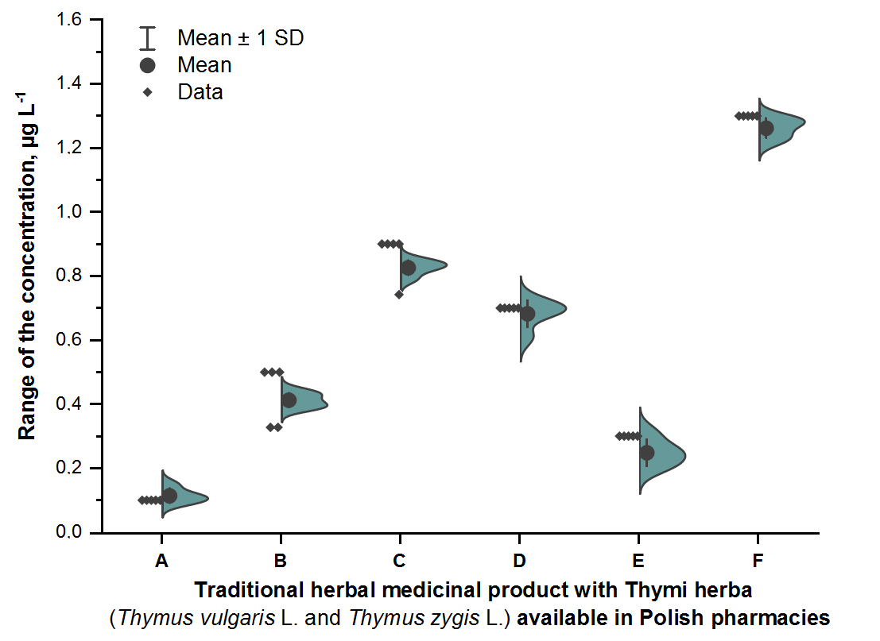
Figure S1. The half violin plot for total Cd content in all analysed THMP (A – F) with Thymi herba (Thymus vulgaris L. and Thymus zygis L.) from Polish pharmacies.

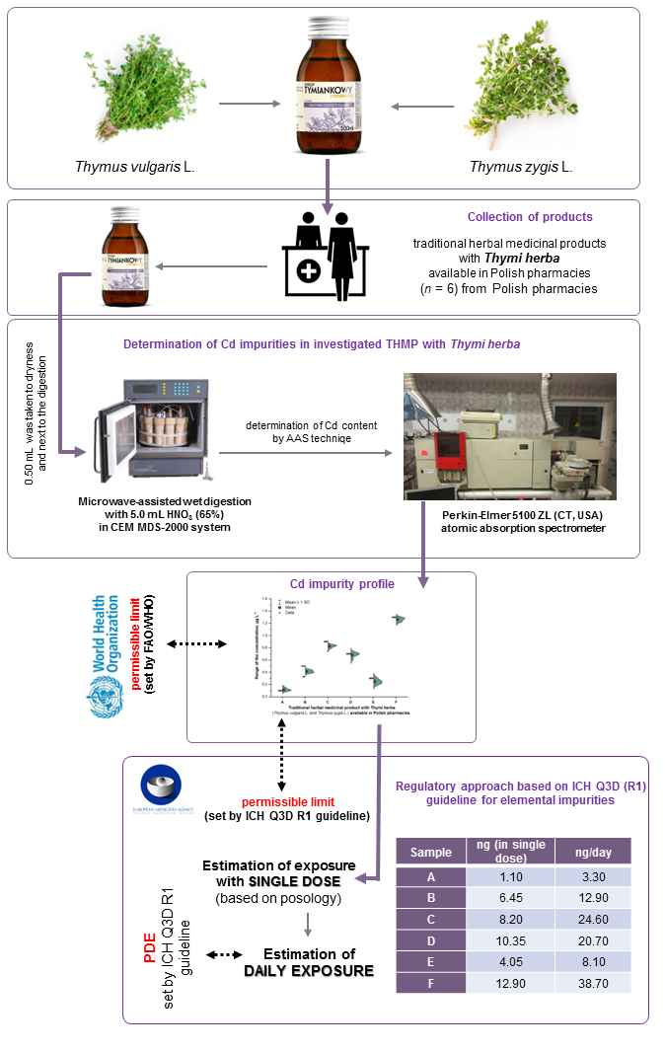
Figure S2 The half violin plot for total Cd content in all analysed THMP (A – F) with Thymi herba (Thymus vulgaris L. and Thymus zygis L.) from Polish pharmacies.
Supplementary References
Coufalík P, Uher A, Zvěřina O, Komárek J. 2020. Determination of cadmium in lichens by solid sampling graphite furnace atomic absorption spectrometry (SS-GF-AAS). Environ Monit Assess. 192(4): 1-7.
ICH guideline Q3D (R1) on elemental impurities. 28 March 2019 EMA/CHMP/ICH/353369/2013 Committee for Human Medicinal Products. https://www.ema.europa.eu/en/ich-q3d-elementalimpurities. Accessed 20.04.2022
Jurowski K, Krośniak M, Fołta M, Cole M, Piekoszewski W. 2019 a. The toxicological analysis of Pb and Cd by ETAAS in local anaesthetics for teething (teething gels) based on herbs available in Polish pharmacies. J Trace Elem Biol Med. 52:18–21.
Jurowski K, Krośniak M, Fołta M, Cole M, Piekoszewski W. 2019 b. The toxicological analysis of lead and cadmium in prescription food for special medical purposes and modified milk products for new-borns and infants available in Polish pharmacies. J Trace Elem Med Biol. 51:73–78.
Jurowski K, Fołta M, Tatar B, Berkoz M, Krośniak M. 2022. The Toxicological Risk Assessment of Lead and Cadmium in Valeriana officinalis L., radix (Valerian root) as Herbal Medicinal Product for the Relief of Mild Nervous Tension and Sleep Disorders Available in Polish Pharmacies. Biol Trace Elem Res. 200: 904–909.

